Supporting Information
Ferroptosis-inducing nanomedicine and targeted short peptide for synergistic treatment of hepatocellular carcinoma

Luyang Wang^{1 ,3 ,5#}, Le Tong^{1, 2, 6#}, Zecheng Xiong^{4#}, Yi Chen³, Ping Zhang³, Yan Gao³, Jing Liu³, Lei Yang³, Chunqi Huang⁷, Gaoqi Ye³, Jing Du^{3*}, Huibiao Liu^{4*}, Wei Yang^{3*}, Ying Wang^{1, 2,3*}

¹ Department of Clinical Research Center, Affiliated Hangzhou First People's Hospital , School of Medicine, Westlake University. Hangzhou, Zhejiang, 310006, P. R. China.
² Department of Laboratory Medicine, Affiliated Hangzhou First People's Hospital , School of Medicine, Westlake University. Hangzhou, Zhejiang, 310006, P. R. China.
³ Laboratory Medicine Center, Department of Clinical Laboratory, Zhejiang Provincial People's Hospital(Affiliated People's Hospital), Hangzhou Medical College, Hangzhou, Zhejiang, 310014, P. R. China.
⁴ CAS Key Laboratory of Organic Solids, Beijing National Laboratory for Molecular Sciences, CAS Research/Education Center for Excellence in Molecular Sciences, Institute of Chemistry Chinese Academy of Sciences, Beijing, 100190, P. R. China.
⁵ Center for Drug Safety Evaluation, Qingdao Center for Pharmaceutical Collaborative Innovation, Qingdao, Shandong, 266209, P. R. China.
⁶ School of Life Sciences, Westlake University, Hangzhou, Zhejiang, 310024, P. R. China.
⁷ Department of Laboratory Medicine, The Second Affiliated Hospital of Zhejiang Chinese Medical University, Xinhua Hospital of Zhejiang Province, Hangzhou, Zhejiang, 310053, P. R. China.
Reagents and materials
DMEM and FBS were obtained from Gibco (Grand Island, USA). siRNA was purchased from RiboBio (Guangzhou, China). LipofectamineTM 3000 and Mitosox were obtained from Invitrogen (Carlsbad, CA, USA). DOX was obtained from Macklin (Shanghai, China). CCK8 kit, BCA kit, CalceinAM/PI staining kit, Hoechst, GSH, DMSO, and (HRP)-conjugated secondary antibody were obtained from Beyotime (Shanghai, China). Sorafenib and ferrostatin-1 were purchased from Selleck Chemicals (Houston, TX, USA). MitoTracker Red, C11-BODIPY (581/591), ECL-Plus kit and were purchased from Thermo Fisher Scientific (Waltham, MA, USA). Deferoxamine (DFO), RIPA buffer, Crystal violet, Monochlorobimane (mBCL) and were obtained from Sigma-Aldrich (St. Louis, MO, USA). Cy5.5 was obtained from MCE (NJ, USA). The antibodies to LDHA (ab52488), VDAC1 (ab306581), NDUFV2 (ab183717), Tfam (ab176558), GAPDH (ab181602), PERK (ab229912), NRF2 (ab62352), SIRT6 (ab191385), GLUD1 (ab168352), HSP70 (ab194360), GPX4 (ab125066), Ki67 (ab15580) and PCNA (ab18197) were purchased from Abcam (Cambridge, UK). The antibody to HSPA5 (A11366) and β-Actin (AC026) was purchased from Abclonal (Wuhan, China). The antibody to SLC7A11 (12691S) was purchased from CST (MA, USA). 96-well plates and transwell were purchased from Corning Incorporated (NY, USA). Confocal dishes (35 mm with 20 mm bottom well) were obtained from Cellvis (CA, USA). XFe24 seahorse cell culture microplate was purchased from Seahorse Bioscience (Agilent, CA, USA).

Apparatus and measurement
Surface morphology and ultrastructures were obtained using FESEM (Talos F200X, FEI, USA), TEM (Gemini 300, ZEISS, Germany), and AFM (Bruker AXS, GER). Zeta potential measurements of the prepared samples were gained with a Zetasizer Nano ZS90 (Malvern, UK) to confirm the DSL and stability of decentralized systems. UV–vis spectra were obtained on Shimadzu UV-1800 (Japan). The XPS profiles were recorded on an Thermo ESCALAB 250Xi (USA). Fluorescent and bright field images of cells were respectively taken with laser confocal microscopy (Leica TCS SP5, German) and light microscopy (Olympus, Japan). The fluorescent intensity of cells was determined by flow cytometry (Beckman coulter, USA). The absorbance at 450 nm and 562 nm was measured by microplate reader (Synergy LX, BioTek, USA). The OCR was acquired by Seahorse XFe24 Bioanalyzer (Agilent, CA, USA). Flow cytometry was performed using BD FACSAria III (USA). Captured protein density was recorded on ECL chemiluminescence system (Bio-Rad, Hercules, CA).

Synthesis of the MNMG
Preparation of GDYO:
The GDY was prepared by professor Yuliang Li, Institute of Chemistry, Chinese Academy of Sciences, Beijing 100080, China. In the case of an ice-water bath, 50 mg of GDY powder was added to a mixture of concentrated H₂SO₄ and concentrated HNO₃ (1:2 by volume) and stirred for 12 hours^{[1]}. The above mixture was centrifuged, and the precipitate was collected. This precipitate was then poured into 200 mL of ddH₂O, collected by centrifugation, and washed five times with ddH₂O to remove residual acids and impurities to obtain a dark brown precipitate. The pellet was redispersed in a mixture of 40 mL ddH₂O and 0.05 mL HCl, and the black-brown suspension was sonicated at 10°C for 24 hours (150 W, 40 kHz). To remove unstripped and large aggregated nanosheets, the suspension was centrifuged (3000 rpm, 5 minutes) to leave the supernatant to obtain ultrathin GDYO nanosheet suspension. Finally, the GDYO nanosheet suspension was freeze-dried and stored in inert gas.
Synthesis of GDYO@SP94:
5 mg of GDYO powder was mixed with H₂N-PEG-NH₂ (15 mg mL⁻¹, 1 mL) (pH = 8.0) and sonicated for 5 minutes. After adding carbodiimide (EDC, 5 mg mL⁻¹, 1 mL) and N-hydroxysuccinimide (NHS, 6 mg mL⁻¹, 1 mL, pH = 8.0) to the mixture, it was sonicated for 30 minutes. After stirring at 4°C for 12 hours, the dark brown precipitate was collected by centrifugation (13,000 rpm, 15 minutes) and redispersed in 500 μL of DMSO. Continuing to add 5 mg of EDC and 6 mg of NHS to the suspension and adjust the pH to 6.0. After stirring the suspension for a further 15 minutes, 1.25 mg of SP94 short peptide powder was added, and stirring was continued at 4°C for 24 hours. Repeated centrifugation and collection yielded GDYO@SP94.
Loading of drugs and genes:
Branched polyethyleneimine (PEI, 12.5 mg mL⁻¹, 1 mL) and EDC (final concentration 2.5 mg mL⁻¹) were incorporated with the redispersed GDYO@SP94 suspension and stirred for 6 hours. DOX (400 μL, 10 mg/mL) and anhydrous ferrous chloride (0.63 mg) were dissolved in 100 μL DMSO and quickly mixed uniformly to obtain black-purple DOX-Fe²⁺ solution^{[2]}. DOX-Fe²⁺, sorafenib (400 μL, 10 mg/mL), and the previously prepared GDYO@SP94 suspension were directly mixed evenly without static and other operations, sonicated at 4°C for 12 hours and stirred for 24 hours. After centrifugation (13000 rpm, 15 minutes), the supernatant and the lower sediment were collected, and the drug-loaded nanocomposite GDYO@SP94/DOX-Fe²⁺/Sorafenib was obtained after freeze drying for 5 hours. The nano complex was re-dispersed in DMSO, the corresponding concentration was calculated, and an equal volume of siRNA (20 nM) was used. The multifunctional nanomedicine GDYO@SP94/DOX-Fe²⁺/Sorafenib/SLC7A11-i (MNMG) was ultimately obtained.

Supplementary figures
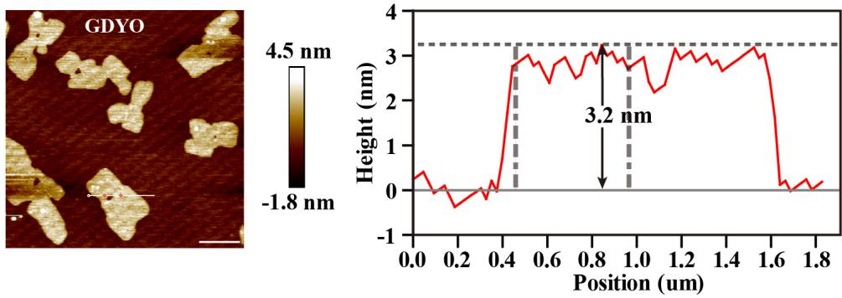
Figure S1. GDYO photographed under an atomic force microscope. Scale bar: 1 μm.
On the right is the corresponding statistical graph.
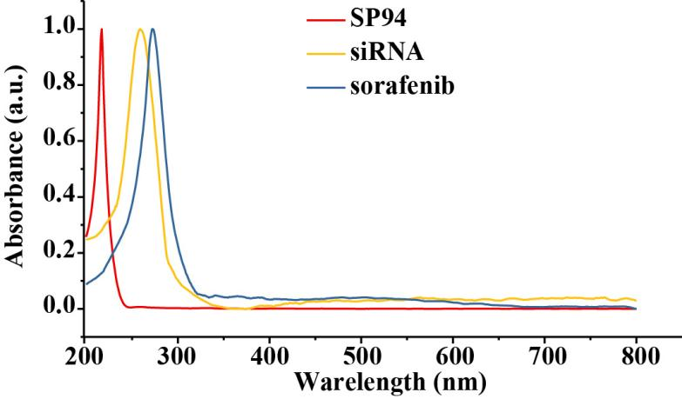
Figure S2. UV-Vis absorption spectra of SP94, siRNA and sorafenib.
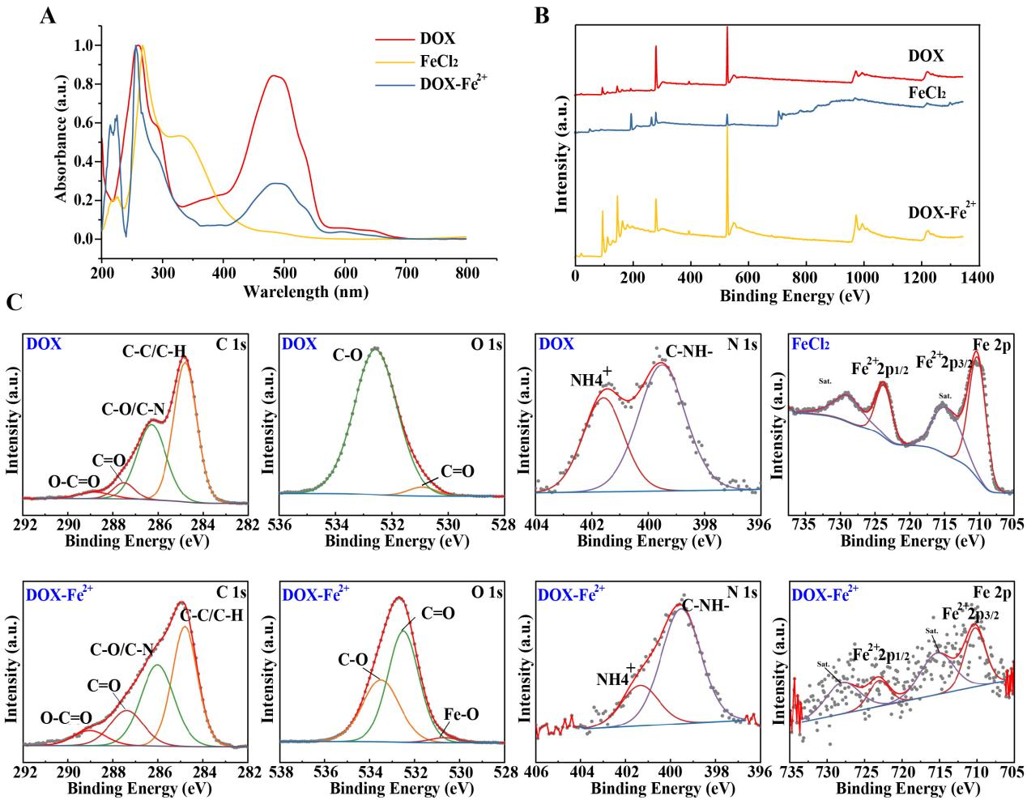
Figure S3. Characterization of DOX-Fe²⁺. (A) UV-Vis absorption spectra of DOX, FeCl₂, DOX-Fe²⁺. (B) XPS full survey spectra of DOX, FeCl₂, DOX-Fe²⁺. (C) XPS high-resolution spectra of DOX, FeCl₂, DOX-Fe²⁺.
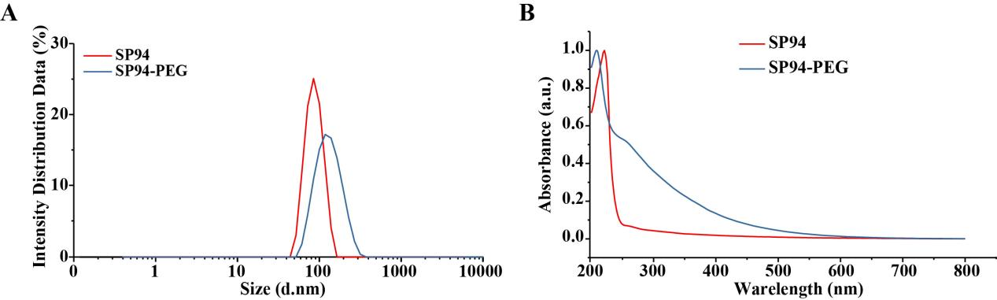
Figure S4. Characterization of SP94-PEG. (A) DSL measurements of SP94 and SP94-PEG. (B) UV-Vis absorption spectra of SP94 and SP94-PEG.
Table S1. DLS and zeta potential measurements of GDY, GDYO, GDYO@SP94, GDYO@SP94/DOX-Fe²⁺/sorafenib and MNMG at different days. Data are expressed as a mean ± standard error.
Nano-complex |  | GDY | GDYO | GDYO@SP94 | GDYO@SP94/DOX-Fe²⁺/sorafenib | MNMG
Day1 | DLS, nm | 114.05 ± 1.45 | 259.70 ± 1.80 | 355.95 ± 0.75 | 568.55 ± 1.55 | 603.10 ± 3.40
Day1 | ζ, mV | -2.16 ± 0.37 | -17.25 ± 0.55 | -15.80 ± 0.30 | -14.95 ± 0.25 | -15.15 ± 0.25
Day2 | DLS, nm | 121.20 ± 0.30 | 300.70 ± 1.20 | 373.50 ± 1.05 | 589.85 ± 3.55 | 603.75 ± 0.45
Day2 | ζ, mV | -2.02 ± 0.23 | -14.05 ± 0.25 | -14.95 ± 0.25 | -10.95 ± 0.15 | -12.15 ± 0.55
Day3 | DLS, nm | 119.45 ± 0.45 | 262.90 ± 1.60 | 374.80 ± 3.00 | 580.20 ± 3.80 | 598.35 ± 5.35
Day3 | ζ, mV | -3.07 ± 0.23 | -13.70 ± 0.50 | -11.40 ± 0.10 | -7.97 ± 0.35 | -8.65 ± 0.01
Day4 | DLS, nm | 120.00 ± 0.30 | 265.30 ± 2.20 | 375.60 ± 0.30 | 637.40 ± 6.40 | 646.00 ± 1.10
Day4 | ζ, mV | -1.83 ± 0.34 | -13.65 ± 0.45 | -11.50 ± 0.20 | -7.73 ± 0.04 | -6.61 ± 0.06
Day5 | DLS, nm | 167.40 ± 0.50 | 260.70 ± 0.40 | 419.65 ± 2.55 | 768.15 ± 0.95 | 770.20 ± 0.50
Day5 | ζ, mV | -2.69 ± 0.07 | -11.10 ± 0.40 | -7.05 ± 0.63 | -5.54 ± 0.25 | -3.96 ± 0.07
DSL: hydrodynamic particle size (nm); ζ: zeta potential (mV).

Experimental Section
Characterization analysis:
The morphologies of GDY, GDYO, GDYO@SP94, GDYO@SP94/DOX-Fe²⁺/sorafenib, and MNMG were analyzed by FESEM, which were monitored in 1 mL of sample solution with a concentration of 1 mg/mL under 200 nA I Probe and 5 kV Extra High Tension (EHT). The TEM images of GDY, GDYO, GDYO@SP94, GDYO@SP94/DOX-Fe²⁺/sorafenib and MNMG were collected by field transmission electron microscopy for morphology and structure analysis, and the element distribution of MNMG was detected for energy spectrum analysis. AFM images of GDYO deposited on silicon wafers were collected in tap mode for thickness and roughness analysis. The hydrodynamic particle size of the particles were obtained by zeta potential experiment. The UV-vis absorption spectra of GDY, GDYO, GDYO@SP94, GDYO@SP94/DOX-Fe²⁺/sorafenib, MNMG, SP94, SP94-PEG, siRNA, sorafenib, DOX, FeCl₂ and DOX-Fe²⁺ were recorded in the range of 200-800 nm. The chemical bindings, electronic state and elementary composition contained in the prepared samples were analyzed by XPS.
Stability of dispersion study：
Five samples of 1ml each of GDY, GDYO, GDYO@SP94, GDYO@SP94/DOX-Fe²⁺/sorafenib and MNMG were taken and placed at 4 ℃ for 5 days to detect the dispersion stability by zeta potential experiment. Dynamic light scattering (DSL) and zeta potentials were monitored under the detection temperature of 25 ℃, the dispersant was anhydrous ethanol, the dispersant RI value was 1.326, and the viscosity (cP) was 0.5476.
Cell culture and transfection:
Human hepatoma cell lines (Huh7, SMMC-7721) were passaged and preserved in our laboratory. The above cells were cultured in DMEM with 10 % FBS at 37 ℃ and 5 % CO₂. Two pairs of siRNAs targeting SLC7A11 (SLC7A11-i), and negative control siRNA-NC (NC-i) were synthesized. The sequence information of the siRNAs is indicated below: SLC7A11-i-1, sense strand, 5′- GGAAGAGAUUCAAGUAUUA, strand, 5′- CCUUCUCUAAGUUCAUAAU; SLC7A11-i-2, sense strand, 5′- CUUGCAAUAUGUAUAUCCA, the antisense strand, 5′- GAACGUUAUACAUAUAGGU. Huh7 and SMMC-7721 cells were plated with appropriate cell density, and further transfection was mediated by LipofectamineTM 3000.
Cell proliferation detection and viability assay:
Cell proliferation and viability were detected by CCK-8. Huh7 and SMMC-7721 cells were seeded in 96-well plates at a density of 5 × 10³ cells/well and cultured in a 10 % FBS medium containing nanomaterials. After culture for 0, 24, 48, and 72 hours, 10 μL CCK-8 reagent was added to the detecting well, and the absorbance at 450 nm of each well was measured with a microplate reader. 1 × 10⁴ cells/well of HCC cells were seeded on 96-well plates and cultured in a serum-free medium containing the drugs to be tested for 24 hours. Finally, 10 μL of CCK-8 was added to each well and incubated for 90 minutes, and the optical density at 450 nm was measured. In experiments to restore cell viability, the MNMG was co-treated with various drug inhibitors ferrostatin-1 (1 μM), DFO (100 μM), and GSH (1 mM) for 24 hours. Then 10 μL of CCK-8 reagent was added to each well and incubated at 37°C for 1.5 hours. The absorbance value was detected with a microplate reader and the ratio of the cell viability in each group to the control was calculated.
Western blotting analysis:
Cells were lysed with RIPA buffer to extract protein solution. The protein concentration was gauged with the BCA kit. Then, the protein was separated by 10 % SDS-PAGE and imprinted onto PVDF membranes. The imprinted PVDF membranes were blocked in 5 % non-fat milk and incubated overnight with primary antibodies, then removed for (HRP)-conjugated secondary antibody incubation. The blotting s were visualized by the ECL-Plus kit.
Live/Dead staining assay:
Huh7 cells (9 × 10⁵ cells/well ) were seeded in a confocal dish and cultured for 24 hours. The MNMG (20 μg/ml, 50 μg/ml) was added to the indicated culture plate wells for 24 hours. Then, cells were subjected to CalceinAM/PI staining kit at 37 °C for 15 minutes. Nuclei were counterstained with Hoechst (10 μM) for 5 minutes. PI was stained for the dead cells, and CalceinAM was stained for the live cells. Single-cell suspensions were subjected to flow cytometry and the percentage of Dead cells was quantified.
Clone formation assay:
HCC cells (500 cells/well) were seeded into 6-well plates and cultured with various concentrations of the MNMG for 14 days. The colonies were fixed with paraformaldehyde and stained with crystal violet for 20 minutes. Whereafter, the field of vision was photographed under a light microscope.
Transwell invasion and wound healing assay:
After HCC cells were inoculated in the upper chamber, 200μL of different concentrations of MNMG were added. Another 500 μL of DMEM medium containing 10% FBS was added to the lower chamber. After 24 hours of culture, the cells were fixed with paraformaldehyde solution and stained with crystal violet for 20 minutes. Finally, the invading cells were captured by a light microscope. HCC cells were seeded into 6-well plates and grew to around 95 % cell density. The monolayer cells were then scratched with the tip of a 10 μL pipette. After adding diverse concentrations of the MNMG and culturing for 48 hours, the wound healing area was photographed with a light microscope.
Mitochondrial morphology:
HCC cells (8 × 10⁵ cells/well ) were seeded in the confocal dish and cultured overnight before treatment. The cells were treated with different concentrations of the MNMG for 6 hours and then incubated with MitoTracker Red (100 nM) in a 37 ℃ incubator for 15 minutes. Nuclei were counterstained with Hoechst (10 μM) for 10 minutes. The morphological changes of mitochondria in living cells were visualized by laser confocal microscopy.
Measurement of intracellular ROS and lipid peroxide accumulation:
Intracellular superoxide accumulation was analyzed by the staining of the fluorescent dye Mitosox. Different concentrations of the MNMG were used to treat huh7 cells seeded in the confocal dish, and huh7 cells were incubated with 5 μM Mitosox at 37°C in the dark for 15 minutes, and then washed with PBS. Photograph the cells under a confocal microscope. Intracellular ROS were determined by flow cytometry, and the fluorescent intensity represents the amount of cellular ROS generation. Huh7 cells were seeded in a chamber confocal dish. After MNMG treatment for 12 hours, cells were incubated with C11-Bodipy (5 μM) in the dark for 30 minutes, and nuclei were counterstained with Hoechst (10 μM). Then cells were photographed under a confocal microscope. Intracellular lipid peroxide was determined by flow cytometry, and the fluorescent intensity represents the amount of cellular lipid peroxide generation.
Determination of GSH production:
Intracellular GSH consumption was analyzed by fluorescent probe Monochlorobimane (mBCL). After drug treatments, cells were incubated with 5 μM mBCL in the dark for 90 minutes at 37 ℃. Then cells were washed three times with PBS and photographed under a confocal microscope.
OCR determination:
Huh7 cells were seeded in XFe 24 seahorse cell culture microplate at a density of 4 × 10⁵ cells/well and OCR was determined as described previously^{[3,4]}. Briefly, the sensor cartridge was hydrated overnight at 37 ℃. The next day, cells were treated with the MNMG at concentrations of 0, 10, 20, and 30 μg/ml for 45 minutes, plates were then incubated in a CO₂-free incubator at 37 ℃ for 1 hour, and OCR has measured in real-time with the sequential injection of 1.5 μM oligomycin, 1.5 μM carbonyl cyanide 4-(trifluoromethoxy) phenylhydrazone (FCCP) and 0.5 μM Antimycin A/Rotenone.
Animal experiments:
BALB/c nude mice (aged 5 weeks) were purchased from Zhejiang Provincial Laboratory Animal Center and kept in SPF condition for one week. The animal use protocol listed below has been reviewed and approved by the Institutional Animal Care and Use Committee (IACUC), ZJCLA. The tumor model was established by subcutaneous injection of 100 µL of serum-free DMEM containing 8×10⁶ Huh7 cells and ABW Matrigel in the right side of each BALB/c nude mouse. After 7 days of feeding, 10 Huh7 tumor-bearing mice were randomly divided into 2 groups of 5 mice each. All tumor-bearing nude mice were injected intraperitoneally once every two days for 28 days. One group was the control group, injected with 100 µL of normal saline each time. The other sample group was the MNMG administration group, and the injection dose of the MNMG was 100 mg kg ⁻ ¹ d ⁻ ¹. Body weight and tumor volume of tumor-bearing nude mice were measured at intervals during the experiments. After 28 days of administration and treatment, the above-mentioned nude mice were euthanized following the guidelines of animal ethics. Finally, 200 µL of blood was collected, the blood cells were removed by centrifugation, and serum was taken to detect serum biochemical indexes.
Fluorescence imaging for the in vivo tracking of the nano samples:
To determine the targeted aggregation and blood circulation stability of tumor sites of the nano samples, MNMG@Cy5.5 were synthesized and injected into the tumor-bearing mice through the tail vein. The dose of the MNMG@Cy5.5 was 100 mg kg⁻¹ d⁻¹. The mice were imaged on a PerkinElmer in vivo imaging system (IVIS Lumina III，USA) at 2, 4, 8, 24, and 48 hours after injection.
H&E analysis and immunohistochemistry:
The transplanted tumor tissue and main organs of each nude mouse in the experiment were collected and fixed with 10 % formalin at 4 °C for 24 hours. Paraffin-embedded tissues were cut to a thickness of 4 μm, deparaffinized with different concentrations of ethanol, and stained with hematoxylin and eosin (H&E). Sections were photographed with a light microscope for staining results. Tumor xenograft tissues were fixed with 4 % paraformaldehyde and embedded in paraffin. Then, the embedded tissues were cut into 4 μm sections and heated at 65 °C for 120 minutes, followed by de-paraffinized, hydrated, and antigen retrieval. Endogenous peroxidases were blocked with 3 % peroxide for 15 minutes, then sections were blocked in 5 % BSA for 1 hour and incubated overnight at 4 °C with primary antibodies. The primary antibodies used were anti-Ki67 and anti-PCNA. Biotinylated goat anti-rabbit IgG was used as a secondary antibody and incubated at room temperature for 30 minutes. Then horseradish peroxidase-labeled streptavidin was added to the sections for 15 minutes at room temperature. DAB substrate was used to perform the chromogenic reaction.
Statistical analysis:
All statistical computing was performed by GraphPad Prism 5.0. Results are expressed as mean ± SD. Comparisons were made using one-way ANOVA or repeated measure design ANOVA. The discrepancies between the two groups were accomplished by the student's t-test. Statistical significance was established at *P < 0.05, **P < 0.01, compared to the corresponding control group.

References
[1] Jiang W, Zhang Z, Wang Q, Dou J, Zhao Y, Ma Y, Liu H, Xu H, Wang Y. Tumor Reoxygenation and Blood Perfusion Enhanced Photodynamic Therapy using Ultrathin Graphdiyne Oxide Nanosheets. Nano Lett. 2019 Jun 12;19(6):4060-4067.
[2] Xue CC, Li MH, Zhao Y, Zhou J, Hu Y, Cai KY, Zhao Y, Yu SH, Luo Z. Tumor microenvironment-activatable Fe-doxorubicin preloaded amorphous CaCO₃ nanoformulation triggers ferroptosis in target tumor cells. Sci Adv. 2020 Apr 29;6(18):eaax1346.
[3] Zhou C, Wang L, Hu W, Tang L, Zhang P, Gao Y, Du J, Li Y, Wang Y. CDC25C is a prognostic biomarker and correlated with mitochondrial homeostasis in pancreatic adenocarcinoma. Bioengineered. 2022 May;13(5):13089-13107.
[4] Yang J, Zhou Y, Li Y, Hu W, Yuan C, Chen S, Ye G, Chen Y, Wu Y, Liu J, Wang Y, Du J, Tong X. Functional deficiency of succinate dehydrogenase promotes tumorigenesis and development of clear cell renal cell carcinoma through weakening of ferroptosis. Bioengineered. 2022 Apr;13(4):11187-11207.

