Additional file 1: Fig S1. Characterization of SHED.
a. Representative images of the primary culture and passage culture of SHED. Scale bars, 100 µm.
b. Colony formation assay. Scale bars, 100 µm.
c. Tissue origin identification. Scale bars, 100 µm.
d. Multiple differentiation ability demonstrated by alizarin red (left) or Oil Red O (right) staining. Scale bars, 100 µm.
e. Surface markers identification.

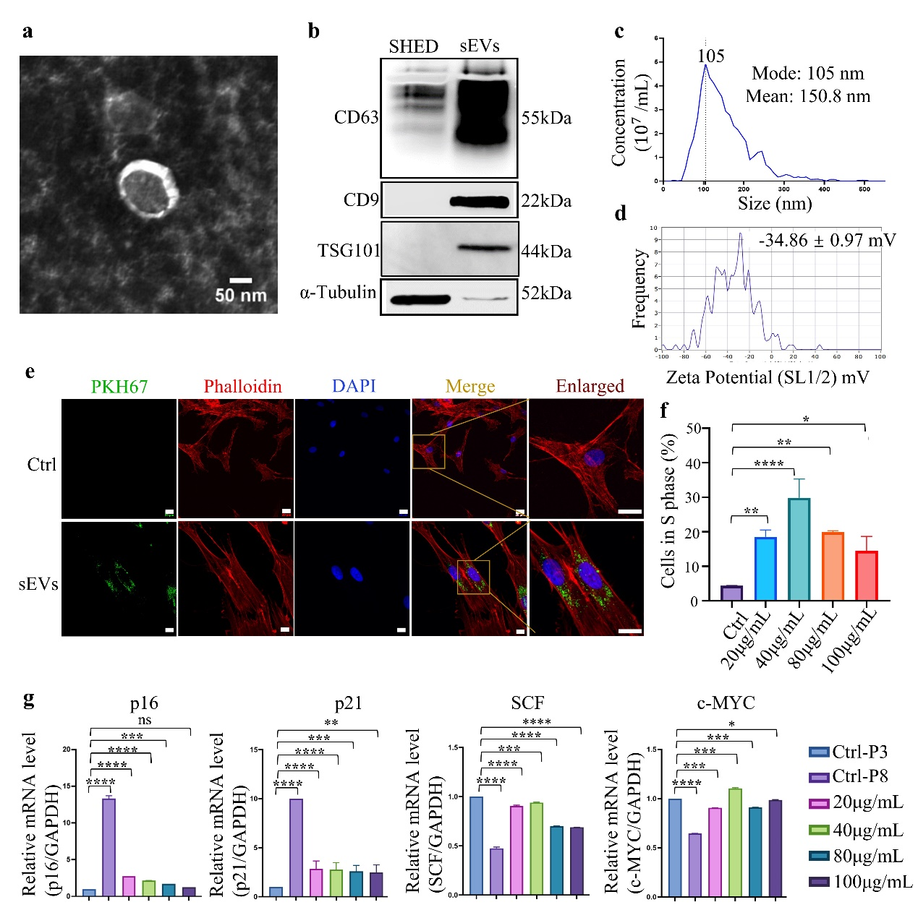
Additional file 1: Fig S2. Characterization and biological effects of young sEVs.
a. Representative TEM images of young sEVs. Scale bars, 50 nm.
b. Representative images of western blot analysis showing the biomarkers of the sEVs, including CD63, CD9, TSG101, and alpha-Tubulin were used as negative controls.
c. The diameter measurements of young sEVs by ZetaView.
d. The zeta potential measurements of young sEVs by ZetaView.
e. Representative images of uptake of young-sEVs by BMSCs.
f. Quantification of EdU positive BMSCs under varying concentration of young sEVs.
g. RT-qPCR assay of senescence markers of p16, p21, and potency markers of SCF, c-MYC.
Data is shown as mean ± SEM. *p<0.05, **p<0.01, ***p<0.001, ****p<0.0001. ns: no significant difference.
Additional file 1: Fig S3. Safety evaluation of replicative senescent BMSCs in vivo.
a. Blood biochemical examination. The normal value range is within two blue lines.
b. Blood routine examination. The normal value range is within two blue lines.
c. Representative quantification of CD45+, CD45+CD68+, CD45+CD3+, CD3+CD4+cells in major tissue analyzed by flow cytometry.
Data are represented as mean ± SEM. *p<0.05, **p<0.01, ***p<0.001, ****p<0.0001. ns: no significant difference from the control group.

Additional file 1: Fig S4. Tracing BMSCs in colitis mice
a. PKH67-labeled BMSCs were injected through tail-vein in mice on day 3 post DSS feeding. In vivo fluorescence images of BMSCs in livers, lungs, hearts, kidneys, colons, and femurs.
b. Flow cytometry illustrated PKH67-labeled BMSCs relocalization in major organs.
Data is shown as mean ± SEM. *p<0.05, **p<0.01, ***p<0.001, ****p<0.0001. ns: no significant difference.

Additional file 1: Fig S5. Young sEVs pretreatment on replicative senescent BMSCs preserves in vitro immunoregulatory properties.
T cells apoptosis assay. BMSCs at P3, P6, and P9 with or without young sEVs were co-cultured with T cells and the percentage of apoptosis T cells was detected by flow cytometry. Control group is set for T cells cultured in complete medium.
Data is shown as mean ± SEM. Comparison with control group: *p<0.05, **p<0.01, ***p<0.001, ****p<0.0001. ns: no significant difference from the control group. Comparisons with P3 BMSCs: #p<0.05, ##p<0.01, ###p<0.001, ####p<0.0001. NS: no significant difference from the P3 group.

