Additional file
Macrophage membrane-camouflaged biomimetic nanoparticles for rheumatoid arthritis treatment via modulating macrophage polarization

Renpeng Zhou ^{a,b,c,#}, Song Xue ^{d,e,#}, Yuanzhi Cheng ^{b,#}, Yong Chen ª, Yan Wang ^{b}, Jing Xing ^{a, b}, Hao Liu ^{a, b}, Yucai Xu ^{a, b}, Yi Lin ^{a, b}, Zejun Pei ^{a, b}, Xin Wei^{f}, Jie Ding ^{a, b}, Shufang Li ª, Ke Wang ª, Feng Yao ª, Yingjie Zhao ^{a, b, c,}*, Changhai Ding ^{e,g,}*, Wei Hu ^{a,b,c,}*
ª Department of Clinical Pharmacology, The Second Affiliated Hospital of Anhui Medical University, Hefei, 230601, China
^{b} The Key Laboratory of Major Autoimmune Diseases, Anhui Institute of Innovative Drugs, School of Pharmacy, Anhui Medical University, Hefei, 230032, China
^{c} The Key Laboratory of Anti-inflammatory and Immune Medicine, Anhui Medical University, Ministry of Education, Hefei, 230032, China
^{d} Department of Sports Medicine, Peking University Shenzhen Hospital, Shenzhen Peking University-The Hong Kong University of Science and Technology Medical Center, Shenzhen, 518036, China.
^{e} Clinical Research Centre, Zhujiang Hospital, Southern Medical University, Guangzhou, 510200, China
^{f} The First Affiliated Hospital of USTC, Division of Life Sciences and Medicine, University of Science and Technology of China, Hefei, 230001, PR China
^{g} Menzies Institute for Medical Research, University of Tasmania, Hobart, Tasmania, Australia
∗Correspondence: Department of Clinical Pharmacology, The Second Affiliated Hospital of Anhui Medical University, Hefei, 230601, China, huwei@ahmu.edu.cn, zyj@ahmu.edu.cn. Clinical Research Centre, Zhujiang Hospital, Southern Medical University, Guangzhou, 510200, China, Changhai.Ding@utas.edu.au.
#These authors contributed equally: Renpeng Zhou, Song Xue, Yuanzhi Cheng.
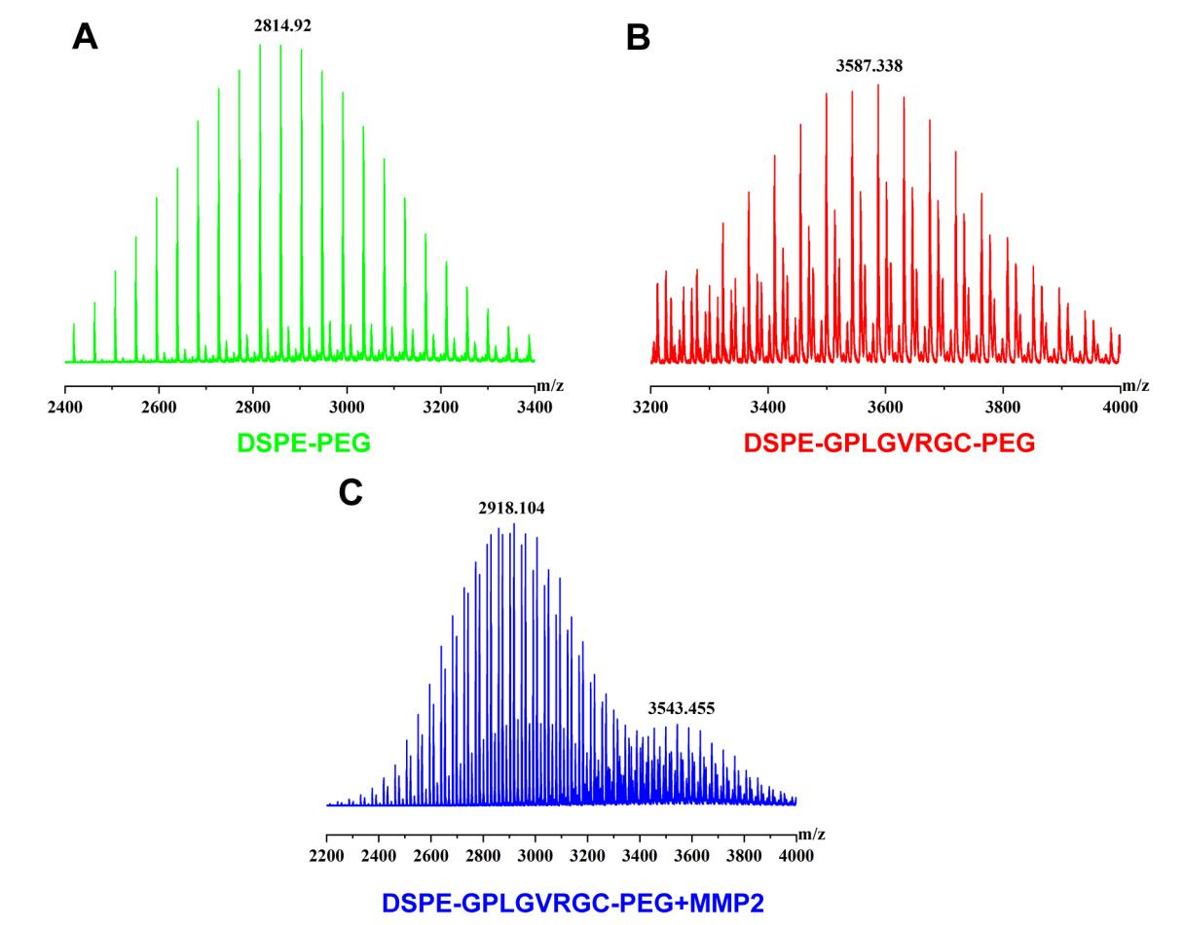
Fig.S1. MALDI-TOF mass spectrometry assay for DSPE-PEG (A), DGP (B), DGP plus MMP2 (C).

Fig.S2. The hemolysis ratio after treated with DGP-MM and 2-APB@DGP-MM for various treatments. Data are shown as the means ± SD or SEM of triplicate independent experiments. ****P < 0.0001; ####P < 0.0001.

Fig.S3. The UV absorption spectrum for 2-APB, DGP, and 2-APB@DGP (Black arrows indicate the characteristic peaks of 2-APB; Red arrows indicate the characteristic peaks of DGP component).

Fig.S4. The uptake efficiency of BMDMs on DGP and DGP-MM. (Scale bar: 40 μm).

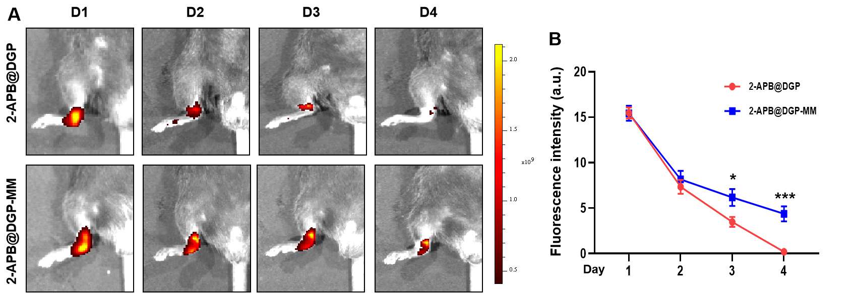

Fig.S5. (A)The IVIS detection of the ankle joint after injection of Cy5-loaded 2-APB@DGP or 2-APB@DGP-MM for consecutive four days. (B) The fluorescence intensity alteration for these groups at different times.

Fig.S6. (A) Representative fluorescence images for cartilage and Cy5-loaded DGP or DGP-MM. There is no significant colocalization of cartilage and DGP or DGP-MM (Scale bar: 100 μm). (B) Representative fluorescence images for synovial macrophage (FITC labled) and DGP-Cy5 or DGP-MM. The colocalization of synovial macrophage and DGP-MM was significantly upregulated compared to the DGP treatment group (Scale bar: 100 μm).

Fig.S7. Fluorescence expression of Aggrecan in joint tissues of mice in different treatment groups (Scale bar: 50 μm).

Fig.S8. HE staining images of major organs in different treatment groups. No visceral damage was observed in any group (Scale bar: 250 μm).

