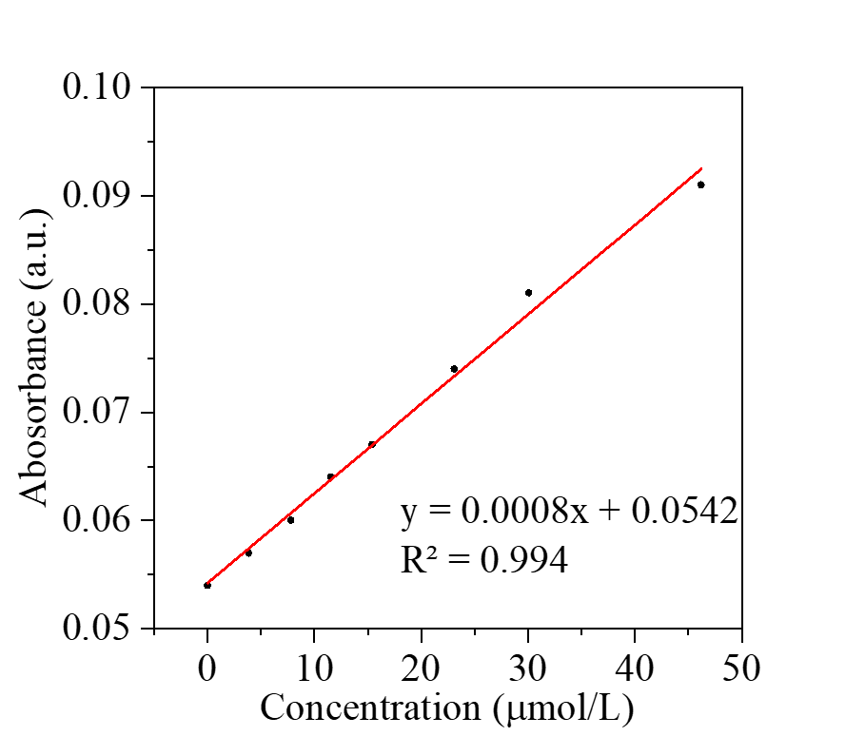
Figure S1. Standard curves for different concentrations of zinc ions.
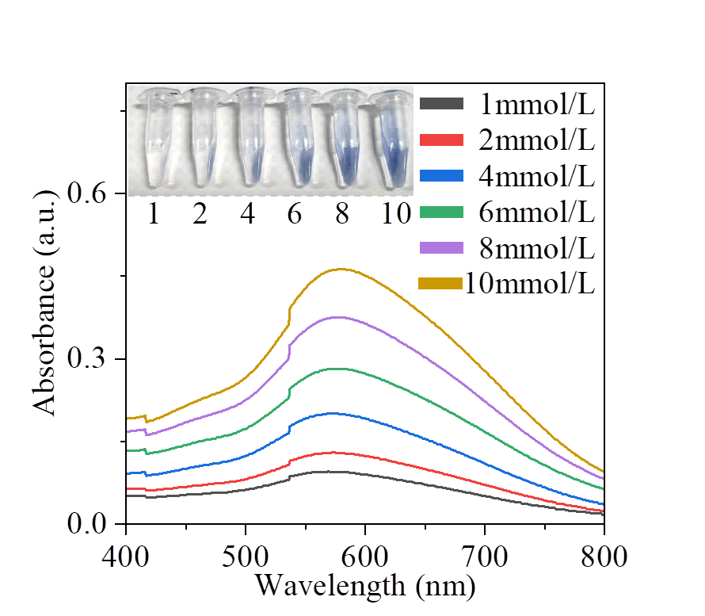
Figure S2. UV spectra of different concentrations of H₂O₂ by potassium iodide iodine blue spectrophotometric method.
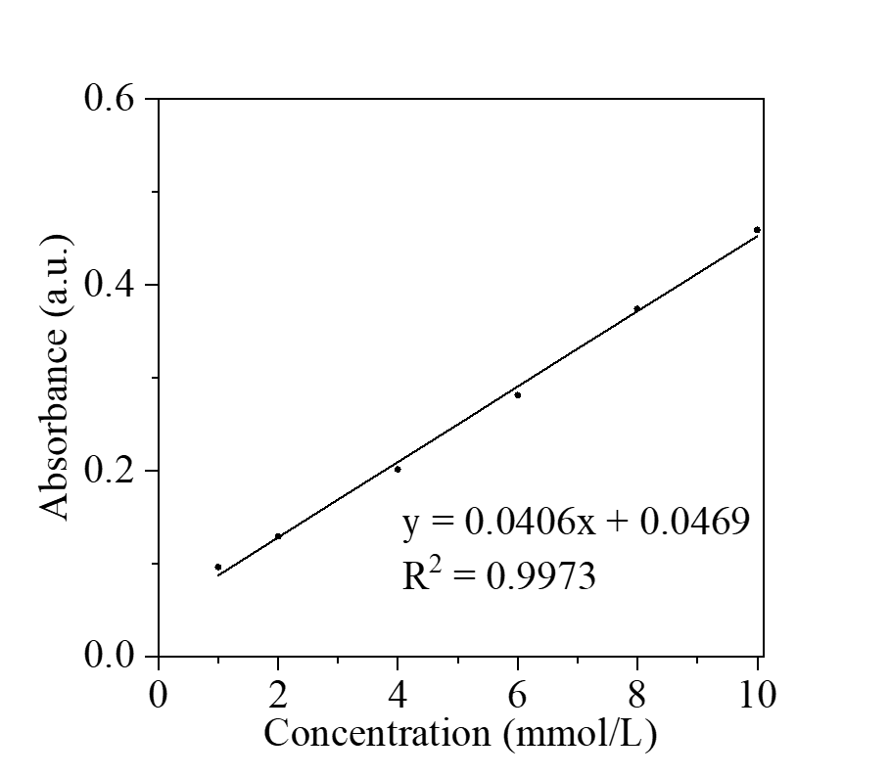
Figure S3. Standard curves of different concentrations of H₂O₂ by potassium iodide iodine blue spectrophotometric method.
Figure S4. CAT activity under different concentrations of Zn-POM.
Figure S5. SOD activity under different concentrations of Zn-POM.
Figure S6. Zeta potential of Zn-POM in different pH and at various time points.

Figure S7. The absorbance of Zn-POM in different pH and at various time points.
Figure S8. Scavenging of ROS by Zn-POM at various time points.
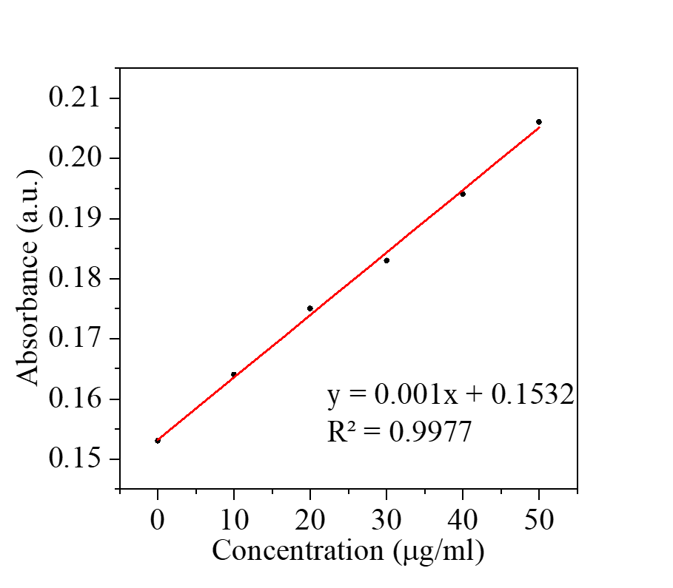
Figure S9. Standard curves of different concentrations of proteins by BCA method.
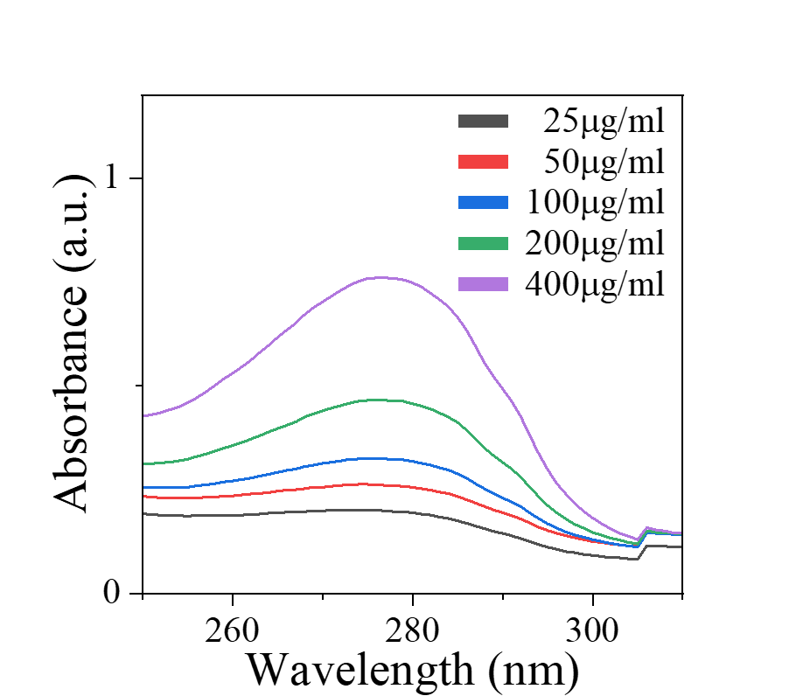
Figure S10. UV spectra of different concentrations of GOx.
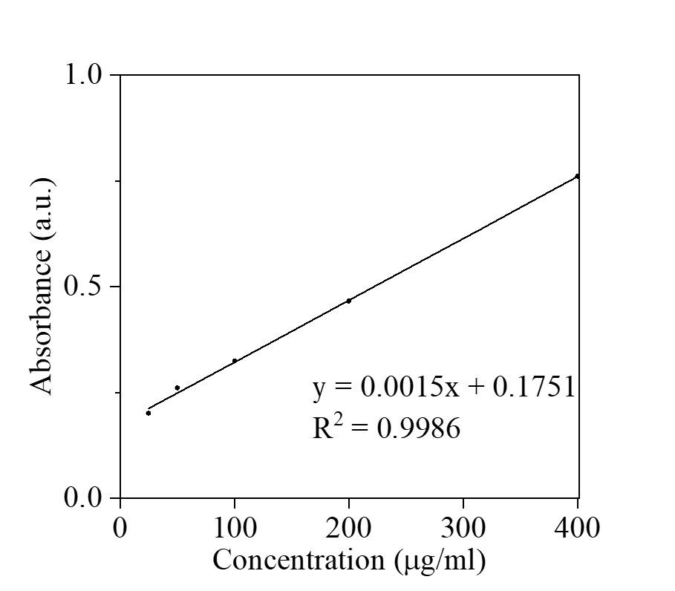
Figure S11. Standard curves of different concentrations of GOx.
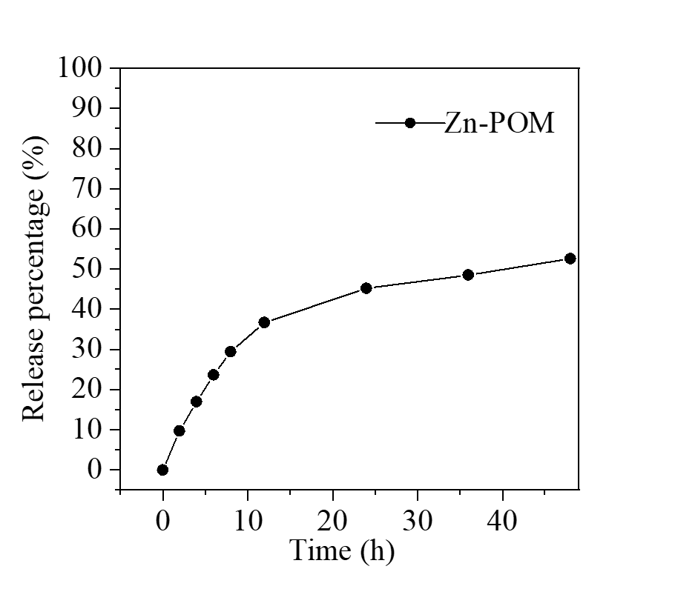
Figure S12. Drug release curve of Zn POM.
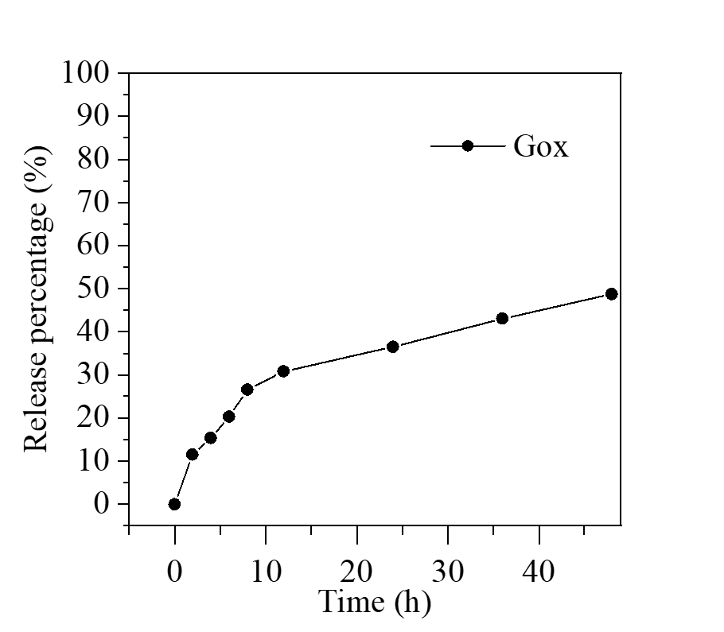
Figure S13. Drug release curve of GOx.
Figure S14. Frequency sweep dynamic rheological data for different samples.
Figure S15. Compression test results for different samples.
Figure S16. Degradation profile of different samples in PBS containing hyaluronidase (100 U/mL).
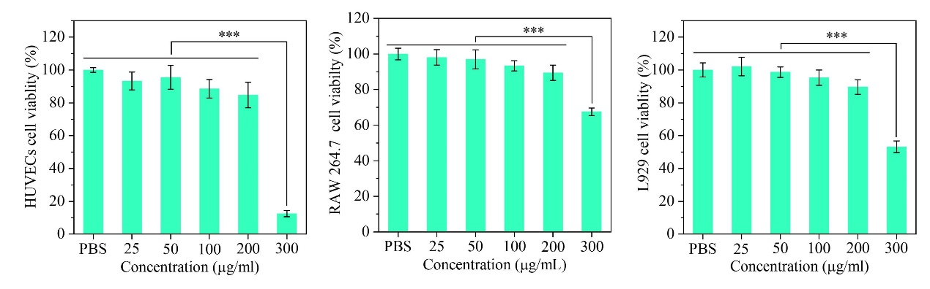
Figure S17. Cell viability of HUVECs, RAW264.7, and L929 cells at different concentrations of Zn POM.
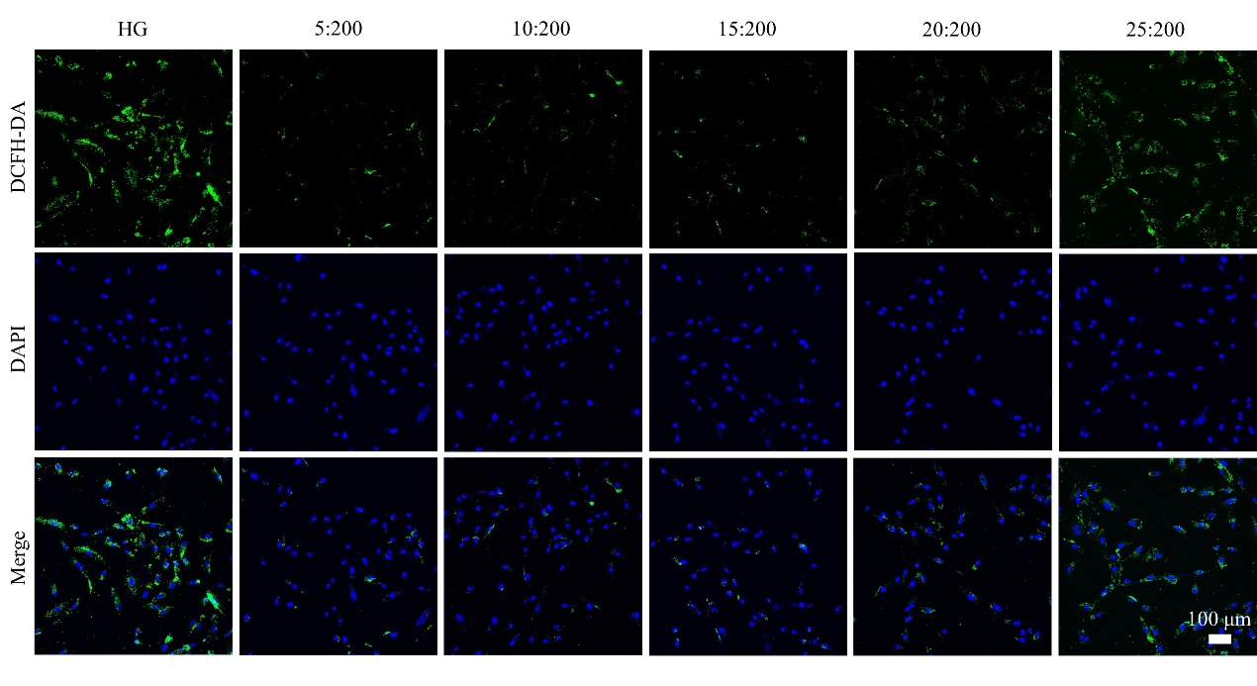
Figure S18. DCFH-DA under different GOx: Zn POM ratios.
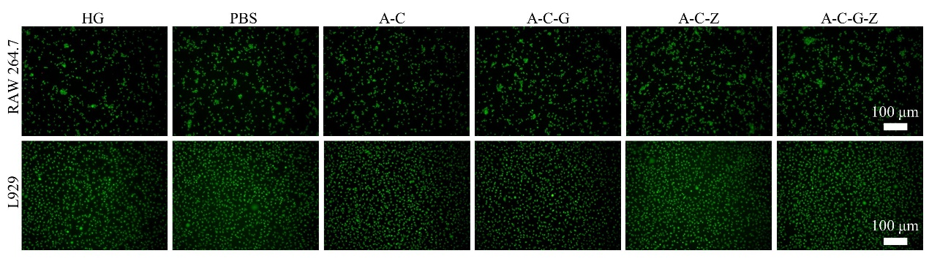
Figure S19. Live death staining of RAW264.7 and L929 in different treatment groups.
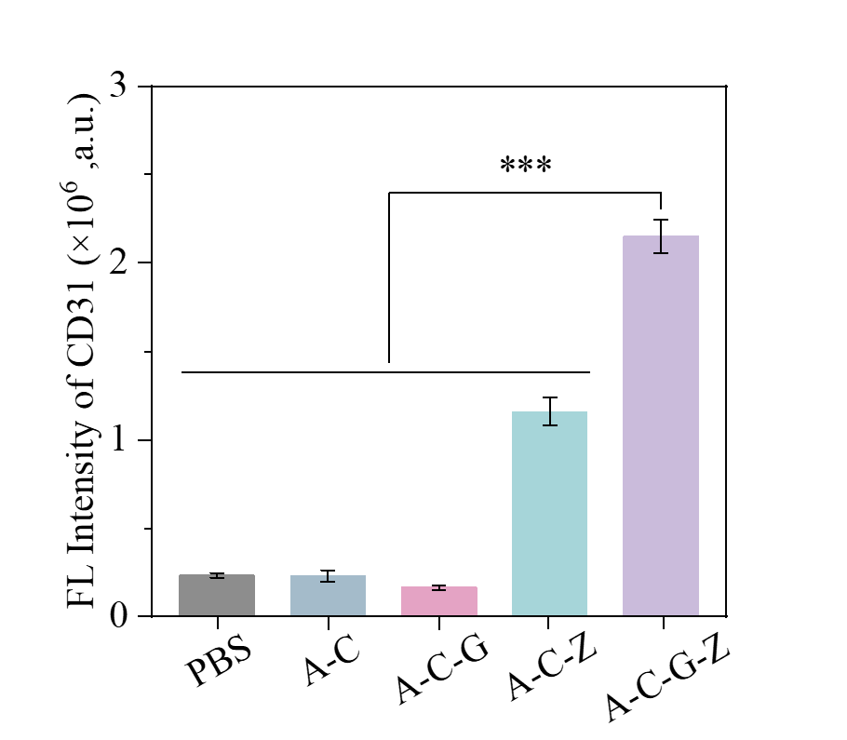
Figure S20. Immunofluorescence quantitative analysis of CD31 in different treatment groups.
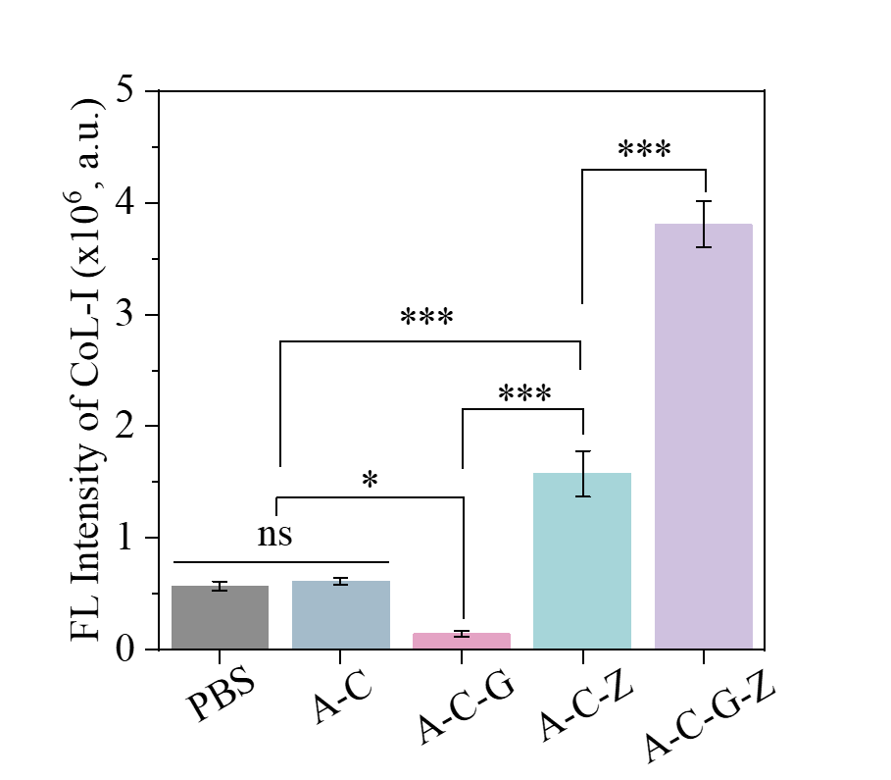
Figure S21. Immunofluorescence quantitative analysis of CoL I in different treatment groups.
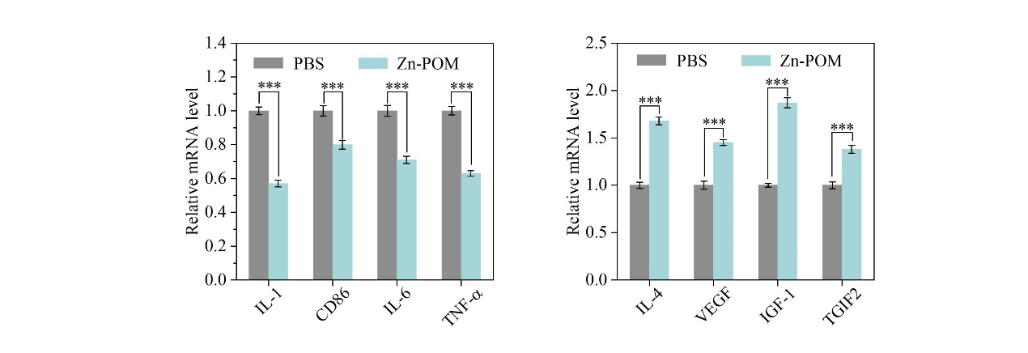
Figure S22. The relative mRNA expression level of pro-inflammatory cytokines (IL-1, CD86, IL-6, and TNF-α) and anti-inflammatory cytokines (IL-4, VEGF, IGF-1, and TGIF2) after treatment with Zn-POM.
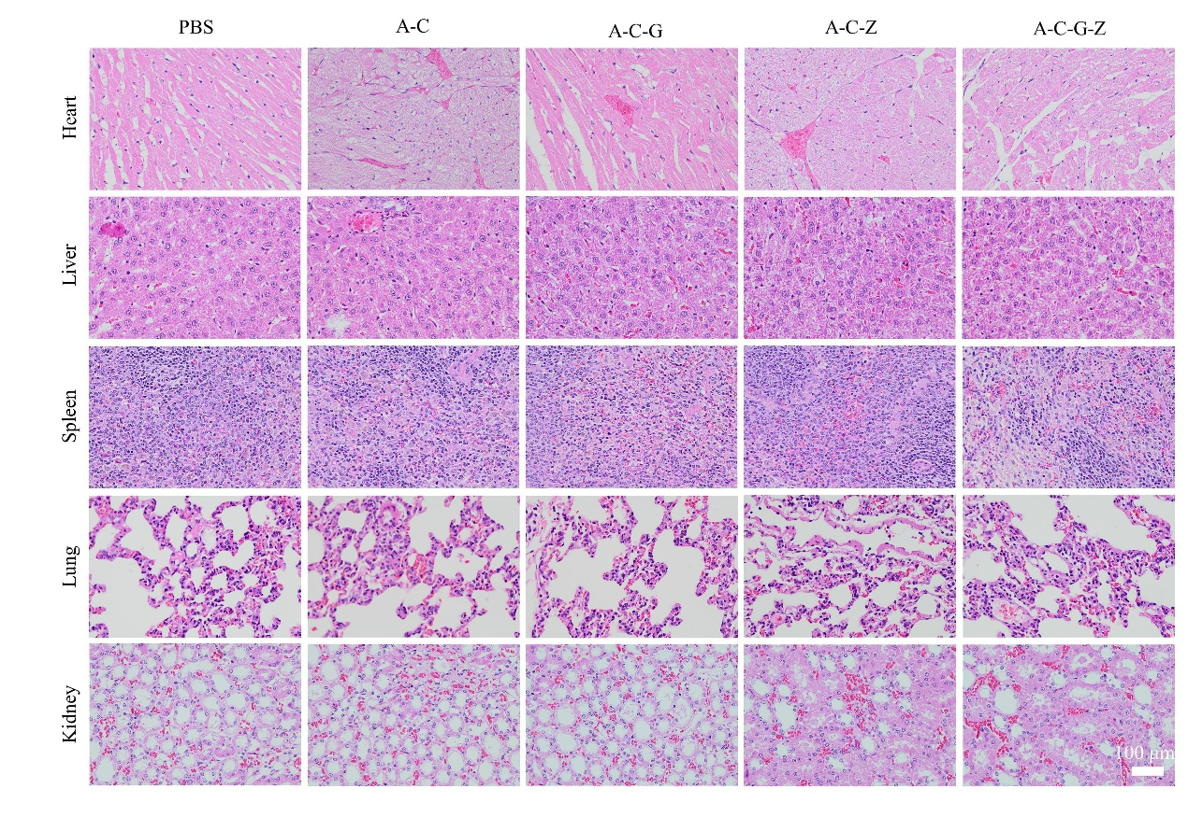
Figure S23. H&E staining of heart, liver, spleen, lung, and kidney tissues in different treatment groups.

