Supplementary Information

A soluble antimicrobial microneedle transdermal delivery patch delivering apoptotic vesicles from adipose tissue to enhance healing of infected wounds

Yue Ma*, Jia Dong, Maojiao Li, Xinya Du, Zhengbin Yan,*, and Weidong Tian,*
(These authors contributed equally: Yue Ma and Jia Dong.)

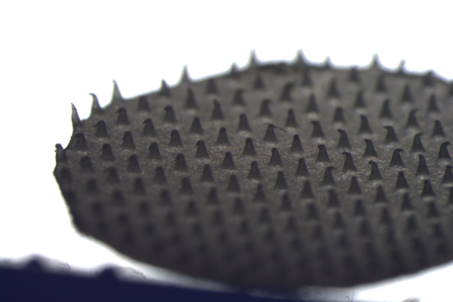
Supplementary Fig. 1. The general overview of the MNP axial compression experiment was observed after utilizing a universal machine.

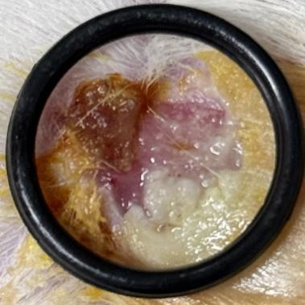
Supplementary Fig. 2. Part of wounds in the blank group showed aggravated infection on day 4, even after routine disinfection.

Table S1. Oligonucleotide primer sequences.

Target  cDNA | Primer sequence (5 ' -- 3 ')
PPARγ2－F | GACCACTCCCACTCCTTTGA
PPARγ2－R | CAGGCTCCACTTTGATTGC
C/EBPα-F | AGGTTTCCTGCCTCCTTCC
C/EBPα-R | CCCAAGTCCCTATGTTTCCA
Adiponectin-F | CCCATTCGCTTTACCAAGAT
Adiponectin-R | GGCTGACCTTCACATCCTTC
FABP4-F | CAGGAAAGTCAAGAGCACCA
FABP4-R | TCCACCACCAGTTTATCATCC

