Lymph node metastasis diagnosis of postoperative OSCC patients by analyzing extracellular vesicles in drainage fluid based on microfluidic isolation

Zi-Zhan Li¹, Ze-Min Cai¹, Wen-Tao Zhu², Nian-Nian Zhong¹, Lei-Ming Cao¹, Guang-Rui Wang¹, Yao Xiao¹, Zhao-Qi Zhu¹, Xuan-Hao Liu¹, Ke Wu⁵, Rong-Xiang He³, Xing-Zhong Zhao⁵, Bing Liu^{1,4*}, Bo Cai^{2*}, Lin-Lin Bu^{1,4,5*}

¹ State Key Laboratory of Oral & Maxillofacial Reconstruction and Regeneration, Key Laboratory of Oral Biomedicine Ministry of Education, Hubei Key Laboratory of Stomatology, School & Hospital of Stomatology, Wuhan University, Wuhan, Hubei, 430079, China
² Hubei Key Laboratory of Environmental and Health Effects of Persistent Toxic Substances, School of Environment and Health, Jianghan University, Wuhan 430056, China
³ School of Electronic and Electrical Engineering, Wuhan Textile University, Wuhan 430200, China
⁴ Department of Oral & Maxillofacial - Head Neck Oncology, School & Hospital of Stomatology, Wuhan University, Wuhan, Hubei, 430079, China
⁵ School of Physics and Technology, Wuhan University, Wuhan, 430072, China.
* Corresponding authors: liubing9909@whu.edu.cn (B. Liu), bcai@jhun.edu.cn (B. Cai), lin-lin.bu@whu.edu.cn (L.-L. Bu);

Experimental Section
Bioinformatics analysis
Gene Expression Profiling Interactive Analysis (GEPIA, http://gepia.cancer-pku.cn/) was used to analyze the data in The Cancer Genome Atlas (TCGA, https://www.cancer.gov/about-nci/organization/ccg/research/structural-genomics/tcga) to determine the mRNA levels and the effects of ASPH on the survival rate of patients with OSCC.
Microbead surface modification and antibody conjugation
To enable the bio-conjugation of anti-EpCAM and anti-ASPH onto the surface of microbeads, streptavidin was at first grafted on the microbeads. Briefly, 0.1 g SiO₂ microbeads with the diameter of 10 μm (KBsphere, Suzhou Knowledge & Benefit Sphere Tech. Co., China) was dispersed in 50 mL ethanol (Sinopharm, China). (3-mercaptopropyl) trimethoxysilane (MPTMS, Merck, Germany) was added into the microbead suspension with the final concentration of 4 % (v/v), and the mixture was gently stirred at room temperature for 3 hours. After washed with ethanol for three times and resuspended in dimethylsulfoxide (DMSO, Sinopharm, China), 4-maleimidobutyric acid N-hydroxysuccinide ester (GMBS, Merck, Germany) was added (with the final concentration of 0.5 mg/mL) and stirred gently at room temperature for another one hour. Subsequently, the microbeads were washed three times with DMSO and phosphate buffered saline (PBS) (1×, Gibco, USA), respectively. And then the microbeads were immersed in streptavidin (SA, Thermo Scientific, USA) solution (50 µg/mL in PBS) for 10 hours at 4 ℃ and the mixture could be stored for at least one month. Before antibody bio-conjugation, the SA-grafted microbeads were washed three times using PBS solution. And then the microbeads were treated with biotinylated anti-EpCAM or anti-ASPH (10 µg/mL in PBS) for another 2 hours at room temperature before implementing EV isolation process.
Patient information and PDF sample collection
This study was approved by the review board of the Ethics Committee of the Hospital of Stomatology, Wuhan University (2018LUNSHENZI#A24). The clinical samples included PDF of 13 OSCC patients with LNM and 13 OSCC patients without LNM collected from 2021 to 2023 (Table S1). For the validation experiment, PDF of 6 additional OSCC patients were collected in 2023 (Table S2), and their pathological status was unknown prior to the experiment. All PDF samples were collected from the drainage tubes of OSCC patients' necks, with 10ml PDF samples collected from each patient and stored in 15mL centrifuge tubes. All collected PDFs are stored at -80 ℃. Patient information was obtained from the online medical record system of the Hospital of Stomatology, Wuhan University. The experiment on human subjects/samples has obtained informed consent and always adheres to the privacy rights of human subjects. For every patient, 5 to 10 mL PDF was collected 24 to 48 hours after neck dissection and were centrifuged at 500×g (5810R, Eppendorf, Germany) at 4 ℃ for 10 minutes and the supernatant was centrifuged at 3000×g for 20 min to remove cells and debris. The cell-free PDF was diluted with PBS (G4202, Servicebio, China) to the concentration of 10% (v/v) and stored at -80 ℃ before subsequent experiments.
Dynamic Light Scattering (DLS)
The hydrodynamic diameter were measured using the Zetasizer Nano ZS (Malvern, Worcestershire, UK) with a fixed 173° scattering angle and a 633 nm helium neon laser. The data were analyzed using Zetasizer software version 7.11 (Malvern, Worcestershire, UK).
Transmission Electron Microscopy (TEM)
TEM was performed at Wuhan Institute of Virology, Chinese Academy of Sciences, Wuhan, China. EV samples isolated were stained with 1% uranyl acetate at room temperature on copper-plated TEM grids. Images were captured using a Hitachi HT7700 transmission electron microscope (Hitachi, Tokyo, Japan) as previously described.
Nanoparticle Tracking Analysis (NTA)
EVs were analyzed at 25 ℃ using a ZetaView® nanoparticle tracking analyzer (Particle Metrix GmbH, Ammersee, Germany), which could measure size distribution and concentration of nanoparticles in a liquid. The size of PDF-EVs was measured in the scatter mode. Samples were diluted in PBS and ten-second-long videos were captured at 30 frames per second, and the movement of EVs was analyzed using NTA software (NanoSight NTA 3.2). The experiments were repeated at least three times to obtain representative results.
Antibody
Rabbit monoclonal ALIX antibody and GM130 antibody were purchased from ABclonal Technology Co. Ltd., China (A2215 and A5344). Rabbit monoclonal CD9 antibody and Calnexin were purchased from Abcam, UK (ab236630 and ab92573). Rabbit Anti-EpCAM/Biotin conjugated antibody was obtained from Bioss, UK (bs-1513R-Bio). Rabbit Anti-ASPH/Biotin conjugated antibody was purchased from Epigentek Group Inc., USA (A54362). Goat anti rabbit HRP binding secondary antibody was obtained from Wuhan Servicebio Technology Co. Ltd., China (gb23303).
Western Blot Analysis
Sample proteins were collected from lysed cells for sodium dodecyl–sulfate polyacrylamide gel electrophoresis and then transferred to a polyvinylidene difluoride membrane, which was blocked with 5% skimmed milk and then incubated with primary and secondary antibodies. The membranes were visualized using the enhanced chemiluminescence detection system (Sigma Aldrich, Darmstadt, Germany).
Microfluidic chip fabrication
Briefly, the chip structure was designed using L-EDIT software (Version 9.00, Tanner Research Inc., USA) and then replicated onto a Cr-mask plate (Changsha Shaoguang Co., China) by a laser lithography system (μPG501, Heidelberg Instruments, Germany). SU-8 3025 photo-resist (Microchem, USA) was employed to manufacture the male mold of the microfluidic chips with the height of about 25 μm on a silicon wafer, according to the manual from manufacturer. Subsequently, the precursor and crosslinker of PDMS (polydimethylsiloxane, Sylgard 184, Dow, USA) was mixed at a ratio of 10:1 and poured onto the silicon mold. After exhausting the air, baking at 80 ℃ for 30 min, peeling from the mold, cutting into chips, punching holes, and bonding to glass slides after PLASMA treatment (PDC-32G, Harrick, USA), the microfluidic chips were obtained. Before the microbead filling and PDF perfusion, the chips were filled with 3% BSA (bovine serum albumin, Aladdin, China) solution, incubated for 24 hours and washed with 1×PBS (phosphate buffered saline, Hyclone, Thermo-Fisher, USA) for 3 times to avoid non-specific absorption.
Cell Culture
The human OSCC cell line SCC-9 (American Type Culture Collection, Manassas, VA, USA) and human immortalized keratinocyte HaCaT cells (CL-0090, Procell, China) were cultured in DMEM (No. 1196044, Gibco, USA) at 37 ℃ in a humidified atmosphere containing 5% CO₂. The culture medium was supplemented with 10% fetal bovine serum (SA101, CellMax, China).
Scanning Electron Microscope (SEM)
SEM images of microbeads with/without EVs and micropillars inside the microfluidic chips were taken by a 3D Dual Beam scanning electron microscope (FEI Versa, USA). The PDMS layer of the microchip with micropillars was coated with 5 nm gold to enhance conductivity.
In order to image the captured EVs on microbeads, extra fixing and staining steps were implemented. Microbeads with EVs were fixed with 2.5% glutaraldehyde in PBS buffer for 30 minutes and then rinsed for 3 times (5 min per time). The samples were post-fixed for another 15 minutes in 1% osmium tetroxide and rinsed with water for 10 min. Finally, the samples were dehydrated in a series of ethanol (30%, 50%, 70%, 95% and 100% v/v) for 2 times and 10 min at each step. After then, the samples were sprayed with gold and examined by SEM.
Enzyme-linked immunosorbent assay (ELISA)
Enzyme-linked immunosorbent assay was performed using human Aspartate Beta Hydroxylase ELISA Kit (HM11805, Bioswamp) according to the manufacturer's instructions. The captured liquid samples were extracted and passed through 0.45 μm filtering device (steriflip, Millipore). The 450 nm absorbance of the sample was calculated by an ELISA reader.
Nano-flow cytometry
EVs were fluorescently labeled with the ASPH-FITC antibody (SNS-622, Miltenyi Biotec GmbH, Germany) for 30 min at room temperature. After washing twice with buffer solution (PBS containing 1% bovine serum albumin (BSA) and 0.1% NaN₃), fluorescence detection was performed immediately using the LSR II flow cytometer (BD, USA). Samples were analyzed until 10000 events were acquired. Gates were established to discriminate between doublet and small-sized debris using forward scatter and side scatter.

Figures and Figure legends
Figure S1 Venn plot of the overlapping and unique proteins in PDF-EVs from OSCC patients with or without LNM. PDF, postoperative drainage fluid; EVs, extracellular vesicles; OSCC, oral squamous cell carcinoma; LNM, lymph node metastasis.

Figure S2 Volcano plot of the significantly upregulated and downregulated proteins in PDF-EVs from OSCC patients with or without LNM. PDF, postoperative drainage fluid; EVs, extracellular vesicles; OSCC, oral squamous cell carcinoma; LNM, lymph node metastasis.

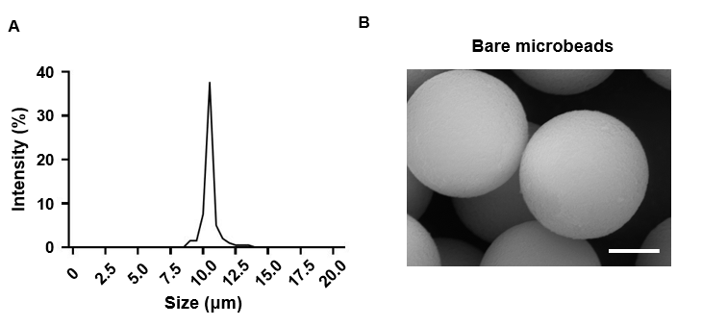
Figure S3 (A) Analysis of the silica microbead size distribution using DLS. (B) Corresponding SEM image of bare microbeads. Scale bars, 2 μm. DLS, dynamic light scattering; SEM, scanning electron microscopy.

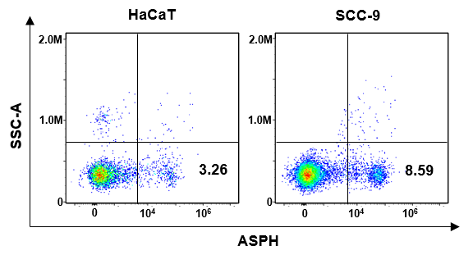
Figure S4 Nano-flow cytometry analysis comparing the level of ASPH⁺ PDF-EVs secreted by HaCaT and SCC-9. EVs, extracellular vesicles; ASPH, aspartate β‑hydroxylase.

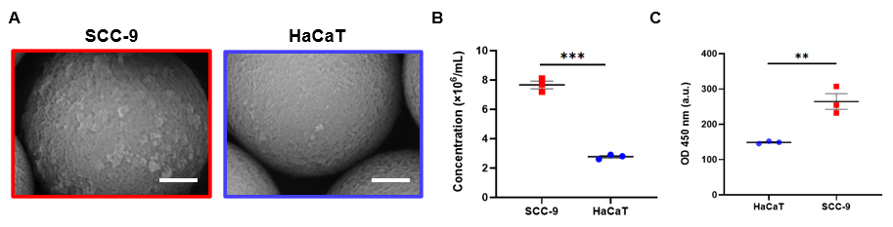
Figure S5 SEM images and quantitative analysis of EVs isolated by anti-ASPH-grafted microbeads treating the supernatant from SCC-9 and HaCaT cells. (A) SEM images of anti-ASPH-grafted microbeads capturing ASPH⁺ PDF-EVs from HaCaT and SCC-9 cells, respectively. Scale bars, 2 μm. (B) NTA analysis of ASPH⁺ PDF-EVs released from anti-ASPH-grafted microbeads treating HaCaT and SCC-9 cells, respectively. ***P＜0.001. (C) ELISA analysis of ASPH⁺ PDF-EVs released from anti-ASPH-grafted microbeads treating HaCaT and SCC-9 cells, respectively. **P＜0.01. PDF, postoperative drainage fluid; EVs, extracellular vesicles; ASPH, aspartate β‑hydroxylase; SEM, scanning electron microscope; ELISA, enzyme-linked immunosorbent assay.

Table S1 Information of the 26 OSCC patients with/without LNM (13/13) providing PDF samples for performance evaluation of our EV-based microfluidic LNM diagnosis strategy.
ID | Gender | Age | Location | T stage | LNM+/- | LNM counts
1 | Male | 52 | Tongue | T₃ | + | 1
2 | Male | 57 | Buccal | T₂ | + | 2
3 | Female | 65 | Tongue | T₃ | + | 1
4 | Male | 51 | Tongue | T₄ | + | 2
5 | Female | 64 | Buccal | T₃ | + | 1
6 | Female | 38 | Palatal | T₃ | + | 2
7 | Male | 55 | Tongue | T₂ | + | 1
8 | Male | 57 | Tongue | T₃ | + | 3
9 | Female | 51 | Tongue | T₃ | + | 2
10 | Female | 61 | Palatal | T₄ | + | 3
11 | Female | 70 | Gingiva | T₂ | + | 1
12 | Male | 58 | Tongue | T₃ | + | 2
13 | Female | 57 | Buccal | T₂ | + | 2
14 | Male | 61 | Gingiva | T₂ | - | 0
15 | Male | 52 | Gingiva | T₁ | - | 0
16 | Male | 48 | Tongue | T₂ | - | 0
17 | Female | 55 | Tongue | T₃ | - | 0
18 | Female | 41 | Gingiva | T₂ | - | 0
19 | Female | 56 | Lip | T₂ | - | 0
20 | Male | 44 | Tongue | T₂ | - | 0
21 | Female | 65 | Buccal | T₃ | - | 0
22 | Male | 65 | Tongue | T₁ | - | 0
23 | Female | 66 | Palatal | T₃ | - | 0
24 | Female | 75 | Tongue | T₄ | - | 0
25 | Female | 56 | Tongue | T₂ | - | 0
26 | Male | 59 | Buccal | T₁ | - | 0

Table S2 Information of the six OSCC patients providing PDF samples for blind testing using the EV-based microfluidic LNM diagnosis strategy.

