Supplement Information:
Table S1: Particle size distribution of NPs under different ultrasonic conditions.

Figure S2:
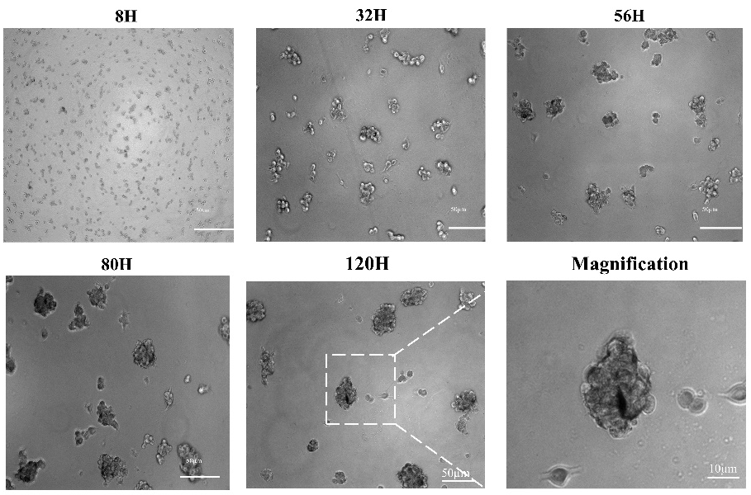

Figure S2 Microscopically photographed U87 cell spheres.
Figure S3:
Figure S3 Effects of different concentrations of nanoplatelets on cell activity.

