Supplementary information
Curcumin/pEGCG-encapsulated nanoparticles enhance spinal cord injury recovery by regulating CD74 to alleviate oxidative stress and inflammation

Tianjun Chen^{1†}, Li Wan^{1†}, Yongchun Xiao^{1†}, Ke Wang¹, Ping Wu¹, Can Li², Caiqiang Huang¹, Xiangge Liu¹, Wei Xue², Guodong Sun³, Xin Ji^{2*}, Hongsheng Lin^{1*}, Zhisheng Ji^{1*}

¹ Department of Orthopedics, The First Afffliated Hospital, Jinan University, Guangzhou, Guangdong, 510632, China
² Key Laboratory of Biomaterials of Guangdong Higher Education Institutes, Engineering Technology Research Center of Drug Carrier of Guangdong, Department of Biomedical Engineering, Jinan University, Guangzhou, 510632, China
³ The First Affiliated Hospital of Jinan University, Guangzhou 510630, China; Guandgong Provincial Key Laboratory of Spine and Spinal Cord Reconstruction, The Fifth Affiliated Hospital (Heyuan Shenhe People's Hospital), Jinan University Heyuan 517000, China

† These authors contributed equally.
* Corresponding to:
Zhisheng Ji (tzhishengji@jnu.edu.cn)
Hongsheng Lin (tlinhsh@jnu.edu.cn)
Xin Ji (jixin@jnu.edu.cn)

Fig. S1. Synthetic route of pEGCG.
Fig. S2. ¹H NMR spectra of pEGCG (top) and EGCG (bottom). Both spectra were recorded in DMSO-d₆.

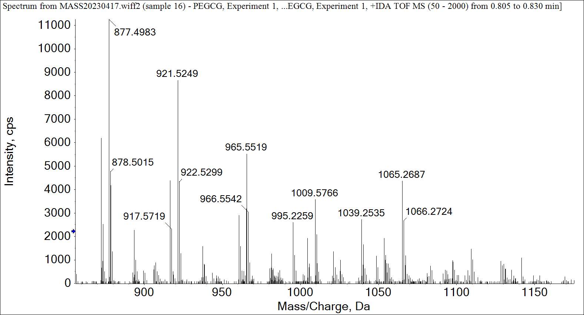
Fig. S3. ESI-MS spectrum of pEGCG.

Fig. S4. The scavenging effect of Cur, CurNPs, and HA-CurNPs on DPPH. (A) Scavenging ability of Cur against reactive oxygen species measured at different concentrations and times through the DPPH radical scavenging assay. (B) Scavenging ability of CurNPs against reactive oxygen species measured at different concentrations and times through the DPPH radical scavenging assay. (C) Scavenging ability of HA-CurNPs against reactive oxygen species measured at different concentrations and times through the DPPH radical scavenging assay.

Fig. S5. To investigate the effects of HA-CurNPs on microglial polarization in mice with SCI, CD206 was used as a marker for M2 polarization, and CD80 was used as a marker for M1 polarization.

Fig. S6. The effects of HA-CurNPs on inflammatory factors. (A) BV2 cells were stimulated with LPS for 24 hours and then treated with HA-CurNPs for another 24 hours. The expression levels of IL-6 and iNOS were measured by western blot. (B) Quantitative evaluation of the relative gray value of IL-6 in figure A. (C) Quantitative evaluation of the relative gray value of iNOS in figure A. All data are presented as the mean ± SEM (*, P < 0.05; **, P < 0.01).

Fig. S7. Using the CCK-8 assay to evaluate the cytotoxicity of Cur, CurNPs, and HA-CurNPs on primary hippocampal neurons.

Fig. S8. The effects of Cur, CurNPs, and HA-CurNPs on cell apoptosis were evaluated using flow cytometry. (A) After glutamate-induced damage, cells were treated with Cur, CurNPs, and HA-CurNPs, followed by apoptosis detection using PI and Annexin V-FITC double staining. (B) Quantitative evaluation of the percentage of apoptotic cells (n = 3). All data are presented as the mean ± SEM (***, P < 0.001).
Fig. S9. Evaluation of motor function in SCI mice using the CatWalk system. (A) CatWalk system analysis of the average ground contact intensity and area for the left hind paw in SCI mice. (B) Quantitative evaluation of the average ground contact intensity for the left hind paw in SCI mice (n = 5). (C) Quantitative evaluation of the average ground contact area for the left hind paw in SCI mice (n = 5). All data are presented as the mean ± SEM (ns, not statistically significant; **, P < 0.01; ***, P < 0.001).
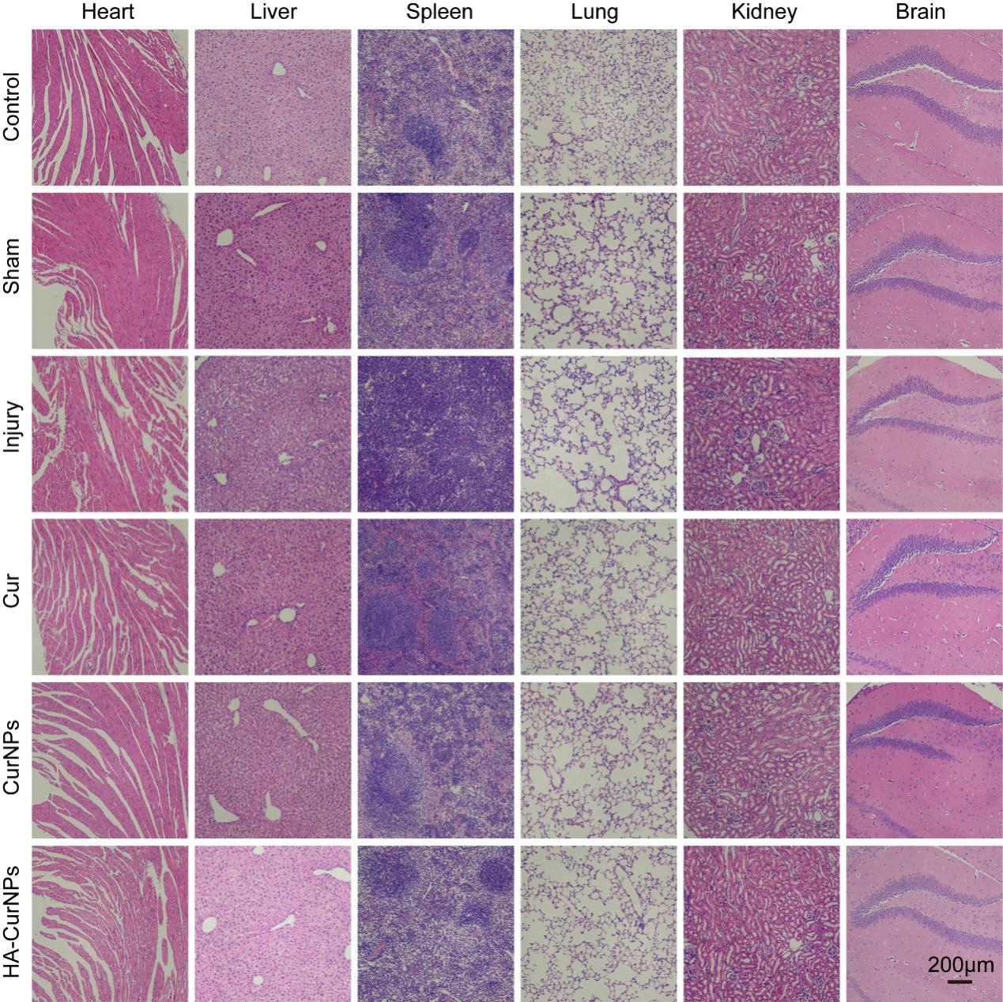
Fig. S10. The sections from heart, liver, spleen, lung, kidney and brain, acquired 2 months after SCI were used to HE staining.
Fig. S11. On the third day after SCI, the expression of CD74 (green) in spinal cord tissue was detected in different groups using immunofluorescence staining.

Fig. S12. Detection of si-CD74 interference efficiency. (A) Transfection of BV2 cells with si-NC and si-CD74, followed by western blot analysis to determine the interference efficiency of si-CD74. (B) Quantitative evaluation of the relative gray value of CD74 in Fig. A (n = 3). The data is presented as the mean ± SEM (**, P < 0.01).

