Supporting Information

A collagenase-decorated Cu-based nanotheranostics: remodeling extracellular matrix for optimizing cuproptosis and MRI in pancreatic ductal adenocarcinoma
Yining Wang^{1†}, Qiaomei Zhou^{1†}, Wangping Luo¹, Xiaoyan Yang¹, Jinguo Zhang¹, Yijie Lou³, Jin Mao¹, Jiayi Chen², Fan Wu⁴, Jue Hou², Guping Tang², Hongzhen Bai²*, Risheng Yu¹*.
¹ Department of Radiology, Second Affiliated Hospital, School of Medicine, Zhejiang University, 88 Jiefang Road, Hangzhou 310009, Zhejiang Province, People’s Republic of China
² Department of Chemistry, Zhejiang University, Hangzhou 310028, People’s Republic of China
³ The First School of Clinical Medicine, Zhejiang Chinese Medical University, Hangzhou, People’s Republic of China
⁴ Department of Neurosurgery, First Affiliated Hospital, School of Medicine, Zhejiang University, 79 Qingchun Road, Hangzhou, 310009 Zhejiang Province, People’s Republic of China
† These authors have contributed equally to this work

*Correspondence: hongzhen_bai@zju.edu.cn; risheng-yu@zju.edu.cn

SUPPLEMENTARY FIGURES

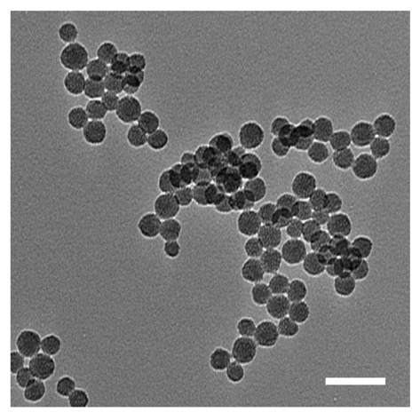
Figure S1. TEM image of unetched dsMN NPs. Scale bar = 200 nm.

Figure S2. SEM elemental mapping (Si, O, S, and Cu) in dsMCu NPs.

Figure S3. EDX spectrum of dsMCu NPs (Si, O, S, and Cu respectively).

Figure S4. Nitrogen adsorption–desorption of dsMN and dsMCu.

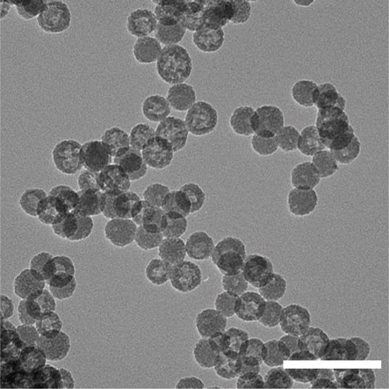
Figure S5. TEM image of dsMCu-D. Scale bar = 200 nm.

Figure S6. Thermogravimetric analysis of dsMCu, DSF and dsMCu-D.

Figure S7. UV-vis-NIR absorption for dsMCu-D, DSF and CuET.

Figure S8. SEM images of dsMCu-D and dsMCu-D@M. Scale bar = 200 nm.

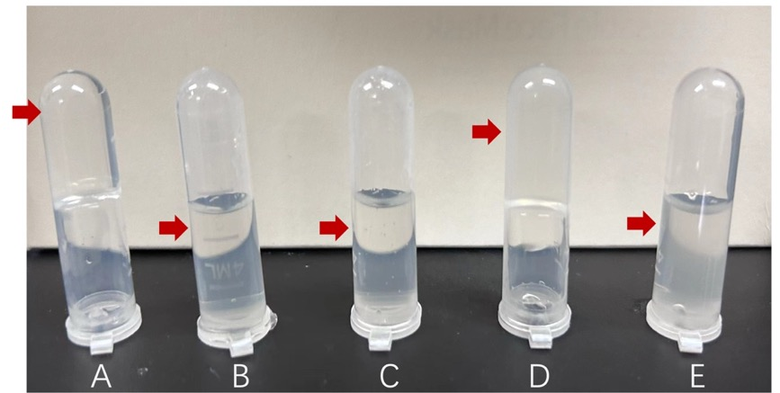
Figure S9. Gelatin solutions were cocultured with different preparations at 37 °C and then stored at 4 °C for 30 min: (A) Pure gelatin; (B) Collagenase; (C) DSPE- Col; (D) dsMCu-D@M; (E) dsMCu-D@M-Co.

Figure S10. Fluorescein released by a FITC‑containing collagen matrix treated with PBS, dsMCu-D@M, dsMCu-D@M-Co and collagenase.

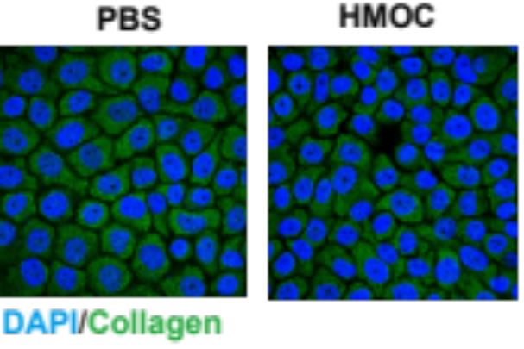
Figure S11. Collagen I expression of BxPC-3 cells treated with PBS by CLSM.

Figure S12. Corresponding quantitative analyses of MFI of collagen.

Figure S13. Images of BxPC-3 MCSs treated with different formulations for 5 days
Figure S14. Diameters of BxPC-3 MCSs treated with different formulations for 5 days

Figure S15. Cell viability of BxPC-3 cells treated with DSF and CuET at different concentration.

Figure S16. Cell viability of BxPC-3 cells treated with different treatments at different concentration.

Figure S17. Fluorescence images of calcein-AM (green) and propidium iodide (PI, red) contained BxPC-3 cells after different treatments.

Figure S18. The percentage of apoptotic cells in BxPC-3 cells after different treatments.

Figure S19. Hemolysis of NPs after incubation with red blood cells with various concentrations, PBS as a negative and ddH₂O as a positive control respectively.

Figure S20. The biodistribution of Cu at 48 h after caudal vein administration based on ICP-MS analysis.
Figure S21. The grey-scale and pseudocolor T1-weighted MR images of versus Cu concentration of dsMCu-D@M-Co solution.

Figure S22. The corresponding 2.5D images show the relative position of the FITC-dsMCu-D, dsMCu-D@M, dsMCu-D@M-Co labeled NPs (green) and CD31-stained tumor vessels (red).

Figure S22. Quantitative analysis of the distance between the FITC-NPs and blood vessels.

Figure S23. Corresponding quantification of the ratio of collagen positive area to full-scale tumor tissues by ImageJ.

Figure S24. H&E-stained images of major organs of BxPC3-bearing mice at 14 days of post-injection of NPs.

Figure S25. Relative body weight change curves of mice from different groups subjected to various treatments.

Figure S26. Photographs of tumors from mice for each group after receiving different treatments.

Figure S27. Serum ALP, AST, ALT, UA, CREA, TBIL, and BUN levels in tumor-bearing mice after intervention.

