Supplementary Material

A minimalist multifunctional nano-prodrug for drug resistance reverse and integration with PD-L1 mAb for enhanced immunotherapy of hepatocellular carcinoma
Ting Zou ^{1, †}, Yun Huang ^{1, †}, Zongtao Zhou ^{1, †}, Shuangyan He ^{1, †}, Jia Liu ¹, Yalan Chen ¹, Hongdu Liu ¹, Zhonghui Luo ¹, Miaoxin Liu ¹, Hua Wei ^{1,} *, CuiYun Yu ^{2,} *

¹ Hunan Province Cooperative Innovation Center for Molecular Target New Drug Study, School of Pharmaceutical Science, Hengyang Medical School, University of South China, Hengyang, China
² Affiliated Hospital of Hunan Academy of Chinese Medicine Hunan Academy of Chinese Medicine Changsha 410013, China

† These authors contributed equally to this work.

E-mail addresses: weih@usc.edu.cn (H. Wei); yucuiyunusc@hotmail.com (C.-Y. Yu)

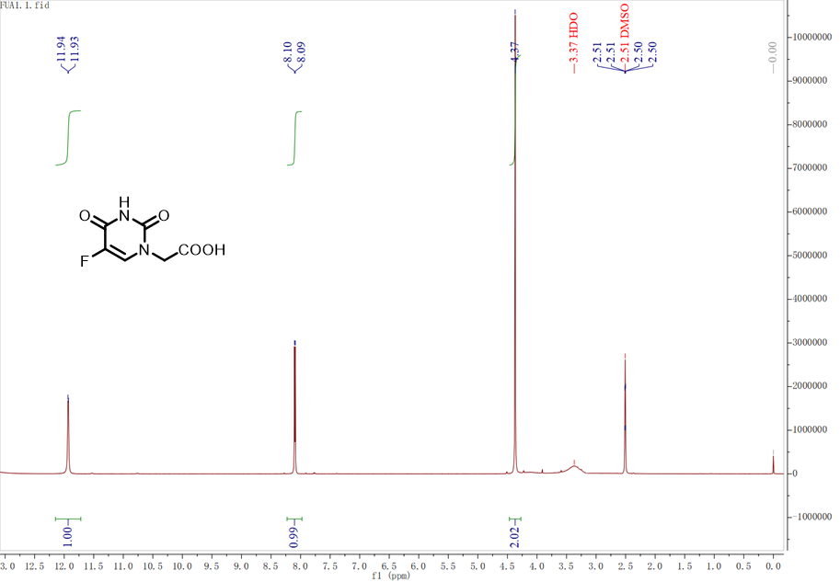
Figure S1. ¹H NMR spectrum of FUA.

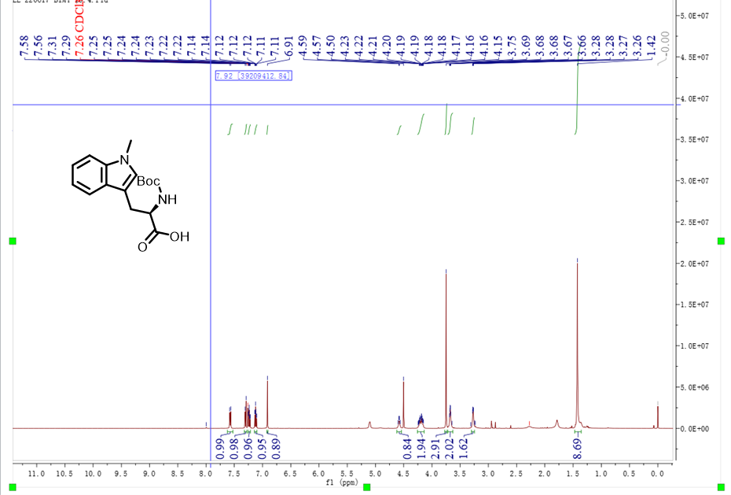
Figure S2. ¹H NMR spectrum of BOC-IND.

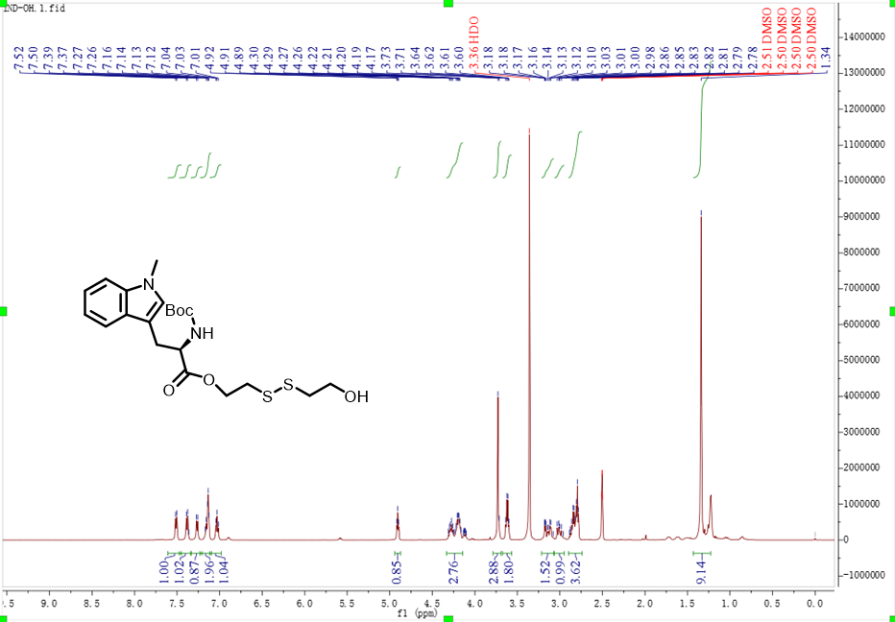
Figure S3. ¹H NMR spectrum of BOC-IND-SS-OH.

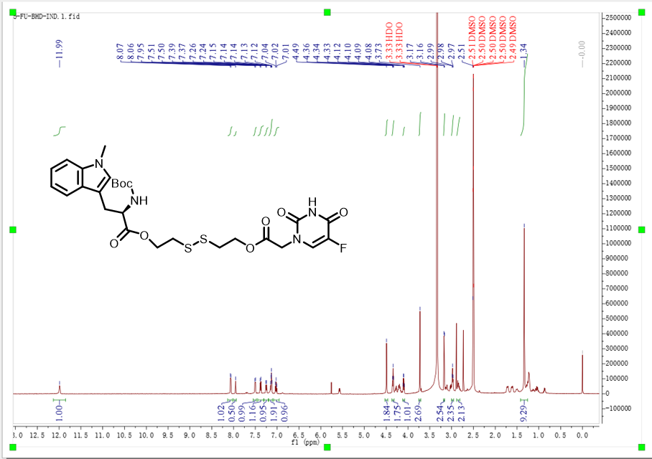
Figure S4. ¹H NMR spectrum of FU-SS-IND-BOC.

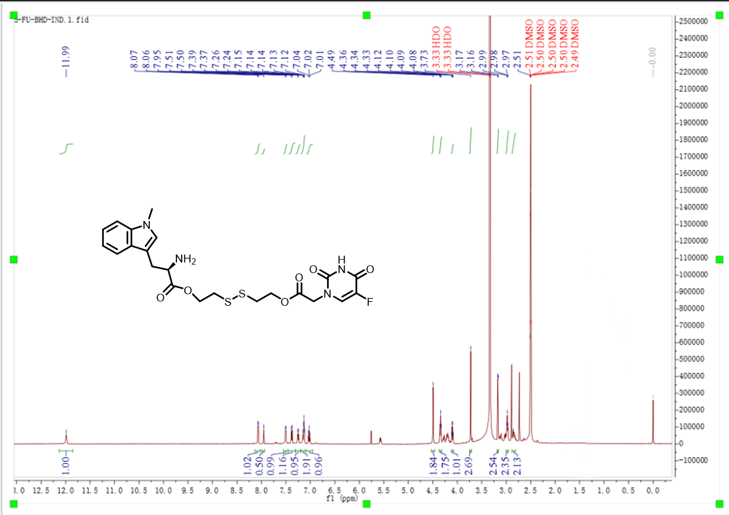
Figure S5. ¹H NMR spectrum of FU-SS-IND.

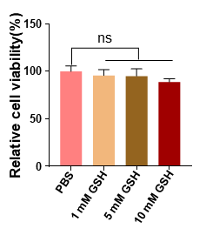
Figure S6. Cell viability of Hepa1-6 cells pretreated with various concentrations (0, 1, 5 and 10 mM) of GSH. n = 3, *p <0.05; **p <0.01; ***p <0.001, ****p <0.0001; ns, not significant.

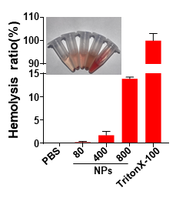
Figure S7. Hemolysis rate and corresponding digital images from the hemolysis test (inset) of PBS (negative control), FU-SS-IND NPs at concentrations of 80, 400, and 800 μg/mL, and the 0.1% TritonX-100 (positive control) (arranged from left to right) (n = 3).

