Supplementary materials
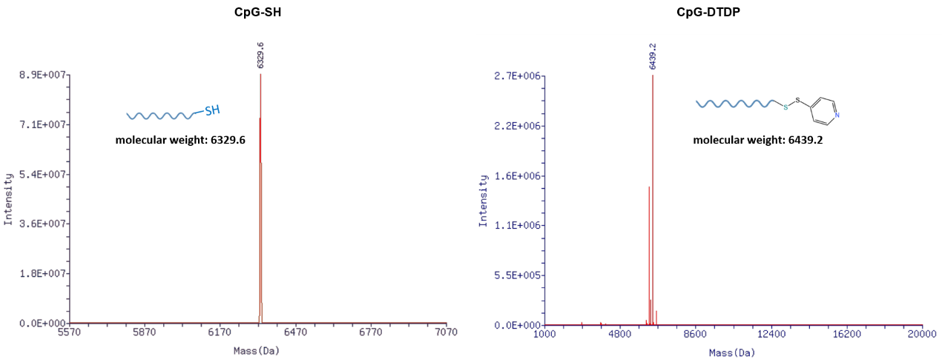
Figure S1: The mass spectrometry of CpG-SH and CpG-DTDP.

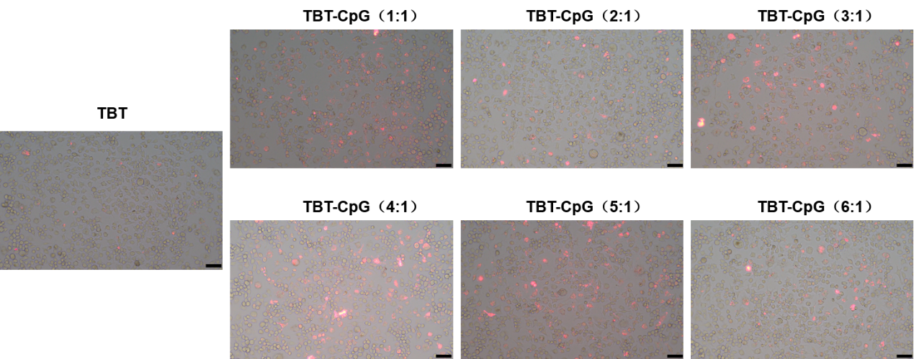
Figure S2: Fluorescence microscopy was used to assess the uptake capacity of DC2.4 cells for the peptide TBT. TBT was labeled with 5TAMRA, and 200 nM TBT-5TAMRA was combined with CpG ODN at varying molar ratios before being applied to DC2.4 cells for 2 h. Scale bars represent 50μm.
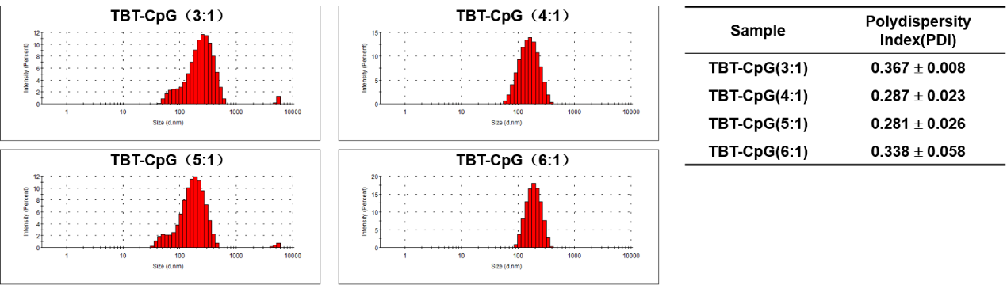
Figure S3: Particle size and PDI of different molar ratios of TBT-CpG.
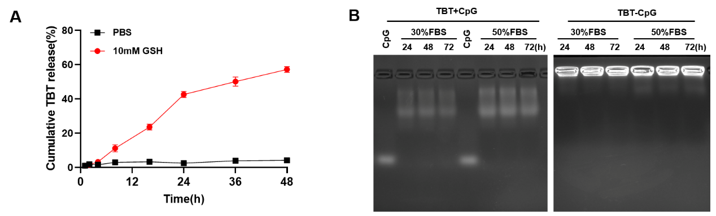
Figure S4: A The pan-epitope peptide TBT released from TBT-CpG NaVs in PBS containing 1mM GSH at 37℃. B Agarose gel electrophoresis to test the serum stability of TBT-CpG NaVs and the physically mixed TBT+CpG at 24h, 48h, and 72h in DMEM medium with 30% and 50% FBS.
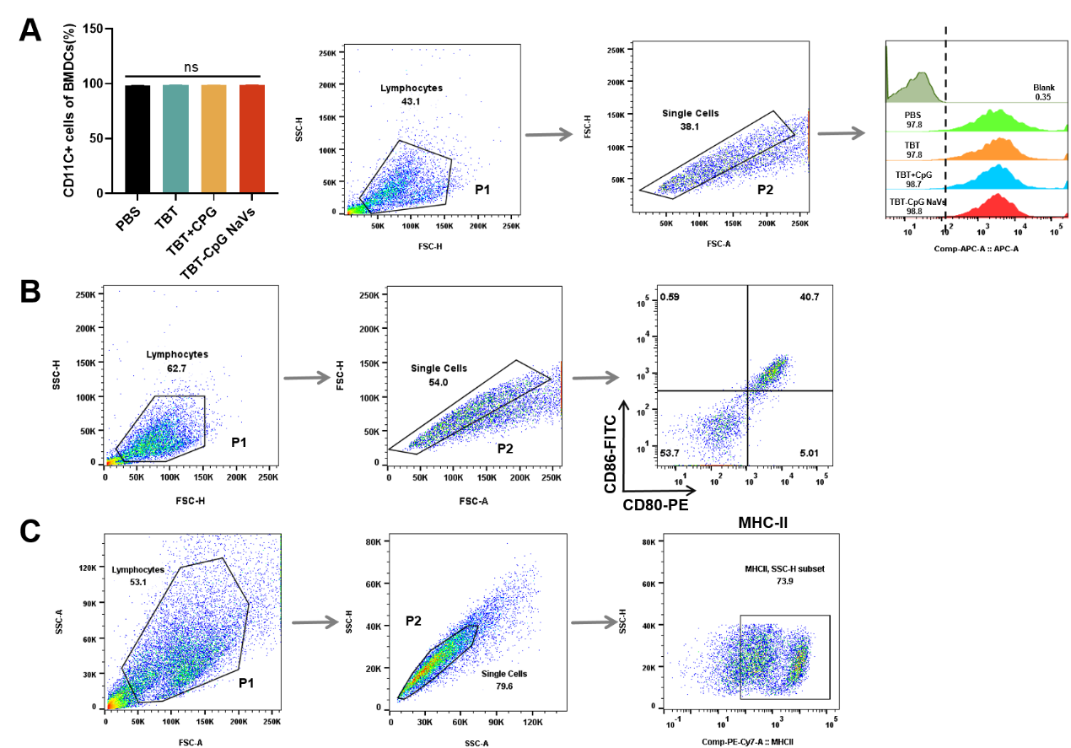
Figure S5: Flow cytometry was utilized to evaluate the maturation of BMDCs after co-culturing with different stimuli for 24 h. A The expression and flow cytometry gating strategy of CD11C in BMDCs. B Flow cytometry gating strategy for Figure 3A. C Flow cytometry gating strategy for Figure 3B.
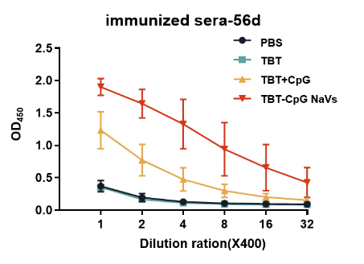
Figure S6: The serial dilution method was employed to measure the serum-specific IgG antibody titer in mice on day 56 after first immunization.

