Supplementary files:
Novel Cocktail Therapy Based on Multifunctional Supramolecular Hydrogel Targeting immune-angiogenesis-nerve Network for enhanced diabetic wound Healing

Ruiyin Zeng^{†1}, Yuan Xiong^{†2}, Ze Lin^{†1}, Xiangyu Chu^{†1}, Bin Lv¹, Li Lu¹, Chuanlu Lin¹, Jiewen Liao¹, Lizhi Ouyang¹, Yun Sun*³, Guandong Dai*⁴, Faqi Cao*¹, Guohui Liu*¹

[1] Department of Orthopedics, Union Hospital, Tongji Medical College, Huazhong University of Science and Technology, Wuhan 430022, China
[2] Department of Orthopedics, Tongji Hospital, Tongji Medical College, Huazhong University of Science and Technology, Wuhan 430030, China
[3] Department of Neurosurgery, Union Hospital, Tongji Medical College, Huazhong University of Science and Technology, Wuhan 430022, China
[4] Department of Orthopaedics, Pingshan District People’s Hospital of Shenzhen, Pingshan General Hospital of Southern Medical University, Shenzhen, Guangdong, 518118, China
† These authors contributed equally to this article.
* Address correspondence to: liuguohui@hust.edu.cn (G. Liu); 13971293030@qq.com (F. Cao); kerdong1976@hotmail.com (G. Dai); 627224540@qq.com (Y. Sun)

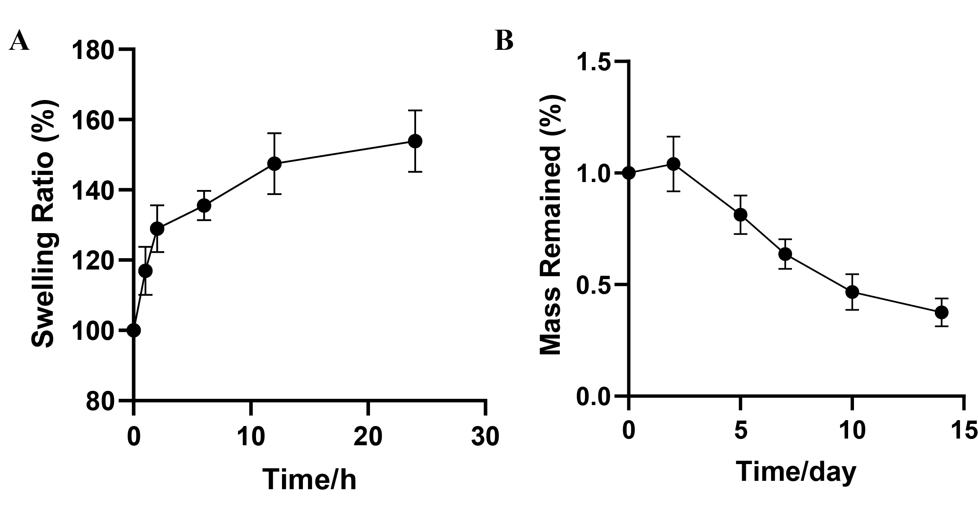
Figure S1. (A) Swelling ratio of the hydrogel in PBS at 37 °C. (B) Degradation ratio of the hydrogel at 37 °C.

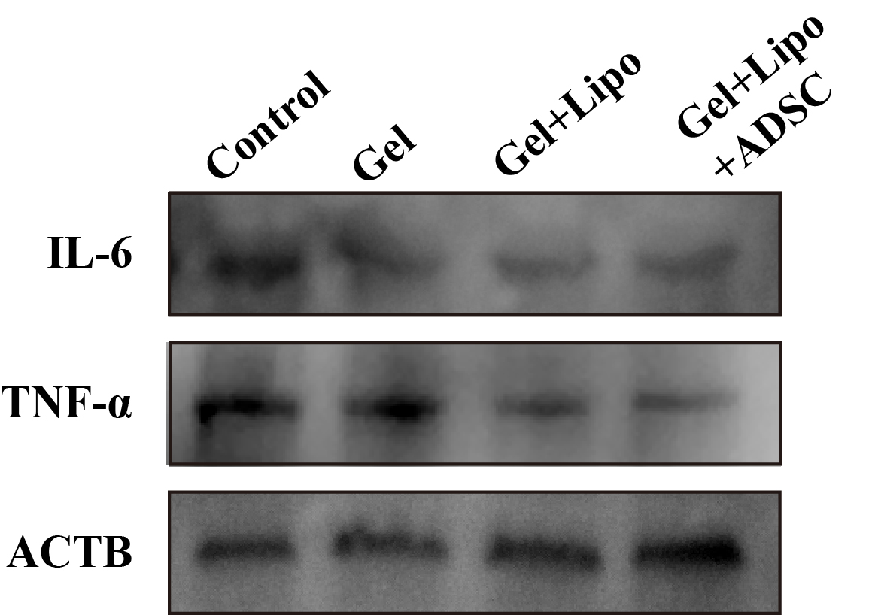
Figure S2. The expression of IL-6 and TNF-α in the wound tissue were evaluated using Western Blot (WB).

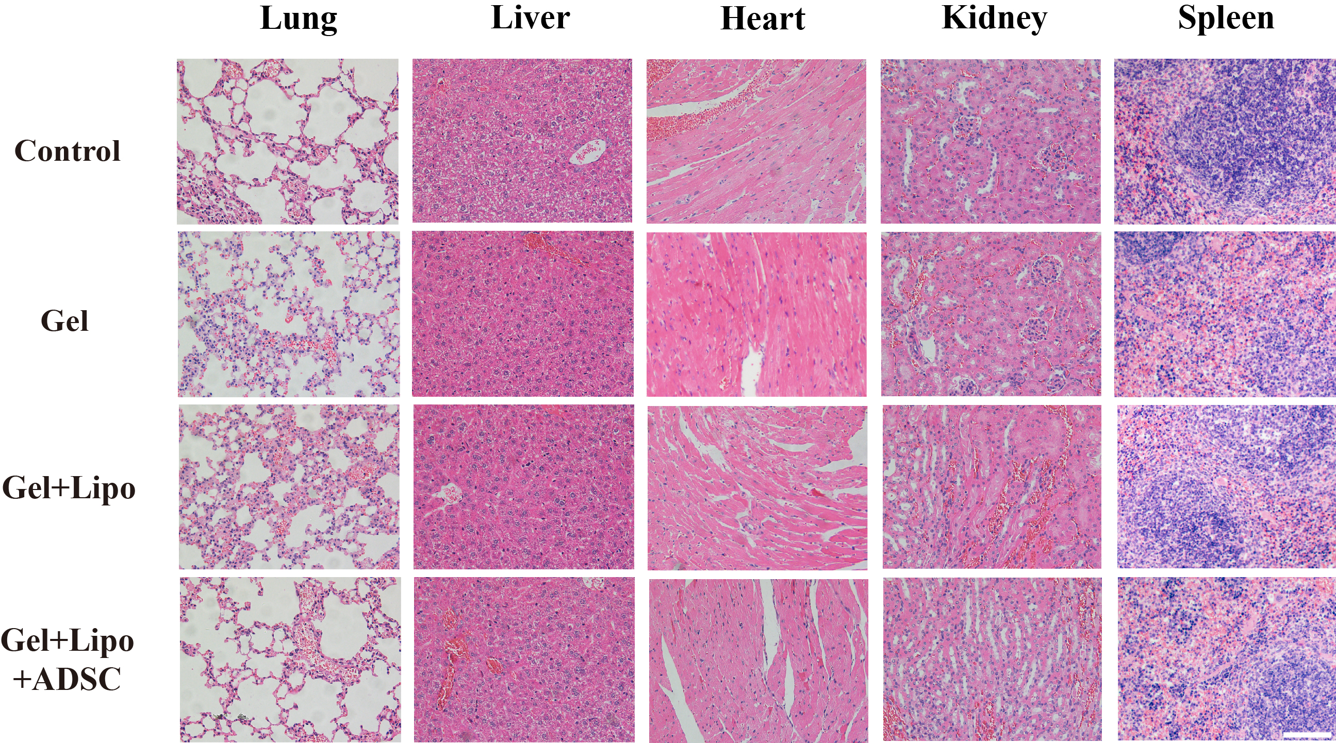
Figure S3. The biocompatibility of the hydrogel system assessed in mice model. Scale bar: 100μm

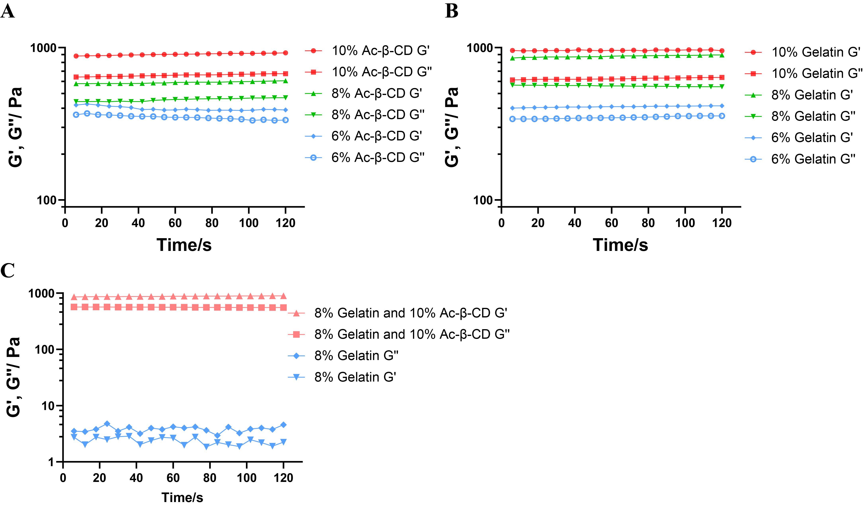
Figure S4. (A) A dynamic rheology study conducted through time sweep on hydrogels containing varying concentrations of Ac-β-CD alongside 8% gelatin at 37 °C. (B) Another time sweep analysis of dynamic rheology was performed on hydrogels with 10% Ac-β-CD and differing levels of gelatin concentration at 37 °C. (C) Time sweep of dynamic rheology study on hydrogels with 10% Ac-β-CD and 8% gelatin or only 8% gelatin at 37 °C.
With an increase in Ac-β-CD content, both the storage modulus and loss modulus of the gelatin hydrogels exhibit an upward trend (Figure S4A). Simultaneously, enhancing the concentration of gelatin also contributes to improvements in both moduli for the gelatin hydrogels (refer to Figure S4B). Notably, when the gelatin concentration rises from 8% to 10%, there is no significant change observed in either the storage or loss modulus of these hydrogels. Consequently, based on this information, we selected gelatin-based hydrogels formulated with 8% gelatin and 10% Ac-β-CD for subsequent experiments.
Figure S4C presents the time sweep dynamic rheology analysis of natural gelatin hydrogels (8% gelatin) compared to our synthesized hydrogels. At 37°C, natural gelatin behaves as a viscous solution, exhibiting a loss modulus that exceeds its storage modulus. In contrast, the hydrogels formed from our synthesized gelatin and Ac-β-CDs demonstrate a storage modulus greater than their loss modulus.

