Supporting Information
Hyaluronic acid-functionalized supramolecular nanophotosensitizers for targeted photoimmunotherapy of triple-negative breast cancer
Haiyan Zhang¹, Hongxin Liu³, Zhigang Xie^{3*}, Jianshi Du^{2*} and Chunxiang Jin^{1*}
¹ Department of Ultrasound, China–Japan Union Hospital of Jilin University, Changchun, China
² Key Laboratory and Engineering Laboratory of Lymphatic Surgery Jilin Province, China-Japan Union Hospital of Jilin University, Changchun, China
³State Key Laboratory of Polymer Physics and Chemistry, Changchun Institute of Applied Chemistry, Chinese Academy of Sciences, Changchun, China
* Correspondence:
Zhigang Xie
xiez@ciac.ac.cn
Jianshi Du
dujs@jlu.edu.cn
Chunxiang Jin
jincx722@jlu.edu.cn

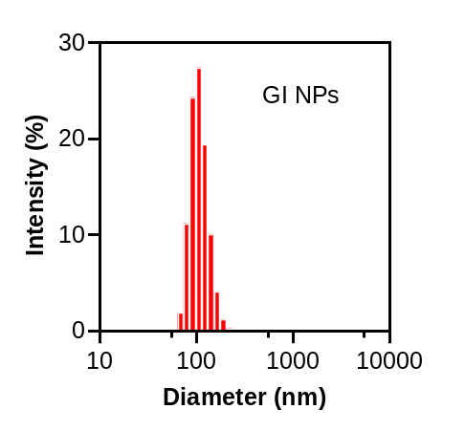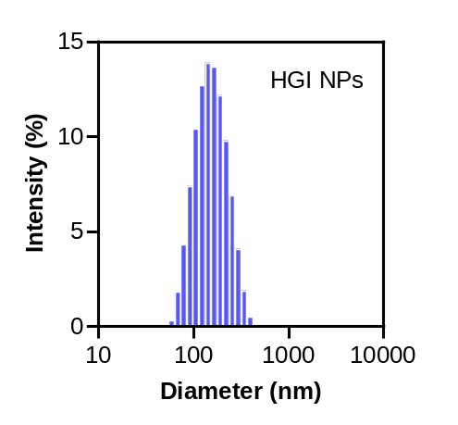
Fig S1 Particle size distributions of GI and HGI NPs.
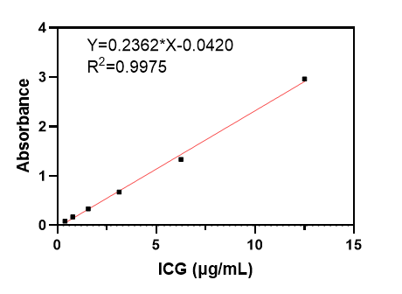
Fig S2 Standard curve of ICG by calculating the absorbance of ICG standard solutions at 790 nm.
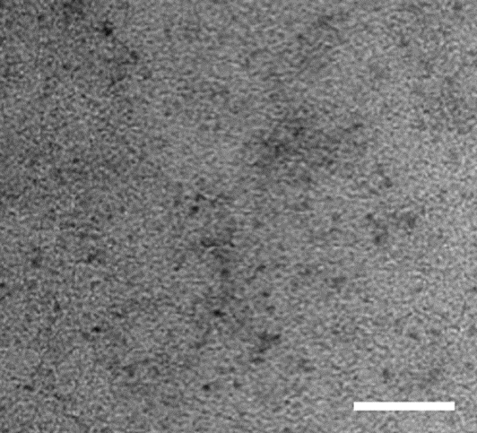
Fig S3 TEM imaging of HGI NPs decomposition. (Scale bar=50 nm)
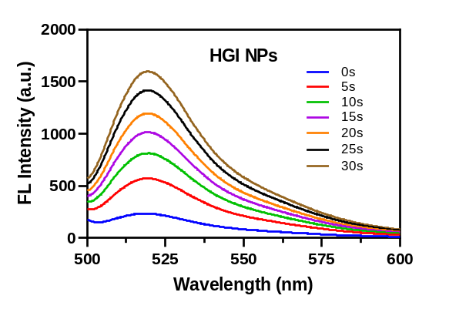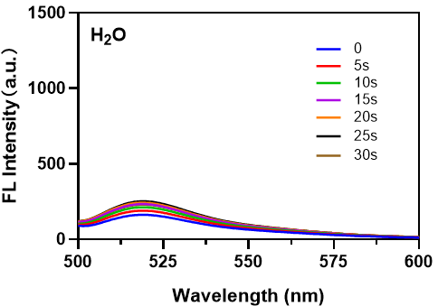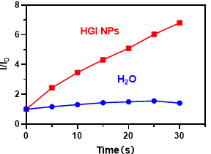
Fig S4 Generation of ROS after HGI NPs with laser irradiation.
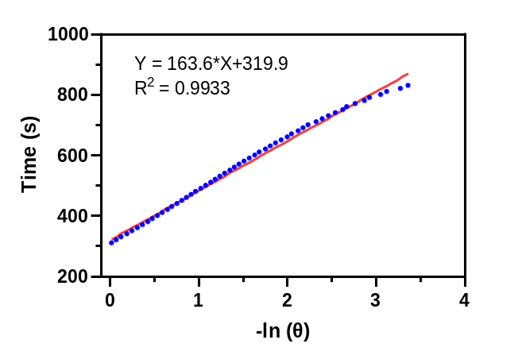
Fig S5 Linear relationship between time (s) and -𝑙n (θ) in photothermal conversion capacity.
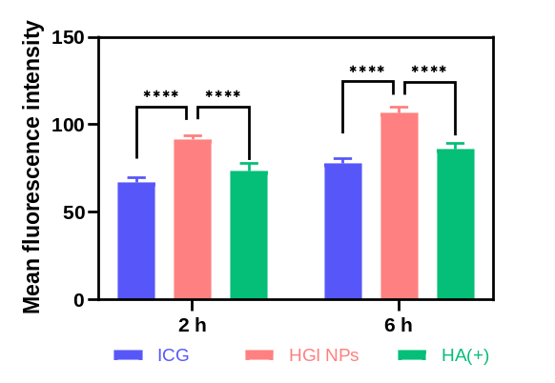
Fig S6 Mean fluorescence quantification of cellular uptake of different groups. (n=3)

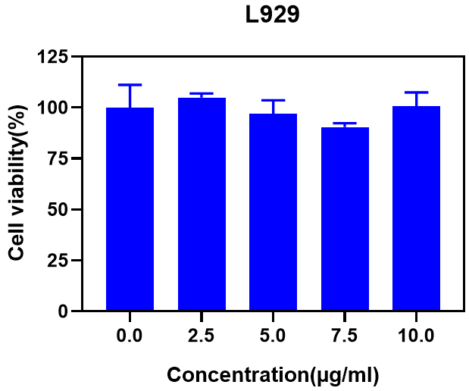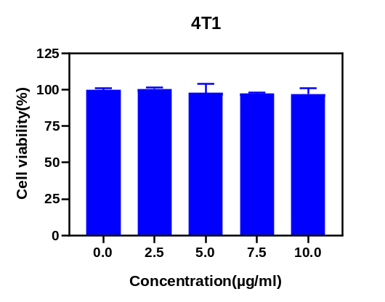
Fig S7 L929 and 4T1 cells vitality at different concentrations of HGI NPs. (n=3)
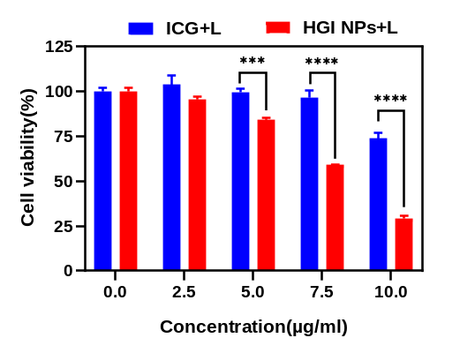
Fig S8 Vitality of 4T1 cells treated with different concentrations of ICG and HGI NPs after laser irradiation (808 nm, 0.8 W/cm²). (n=3)
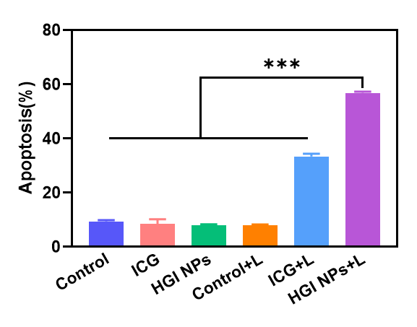
Fig S9 Cell apoptosis after different treatments. (n=3)
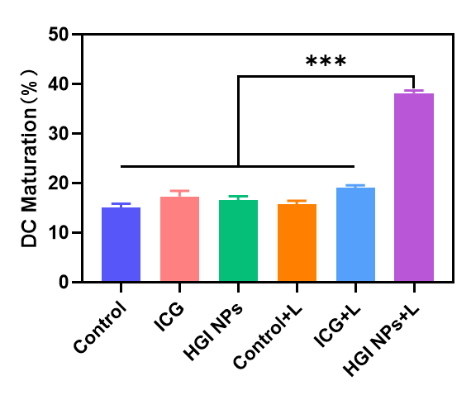
Fig S10 Maturation of DCs after treatments with different formulations. (n=3)
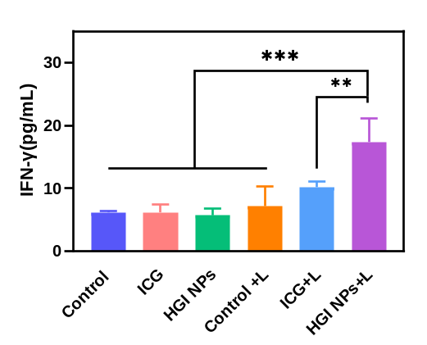
Fig S11 IFN-γ levels after different treatments by ELISA.
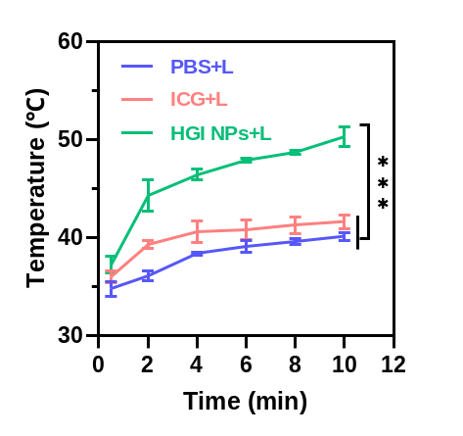
Fig S12 Temperature changes of 4T1 tumor-bearing mice injected with PBS, ICG and HGI NPs under 808 nm laser irradiation (0.8 W/cm², 10 min).
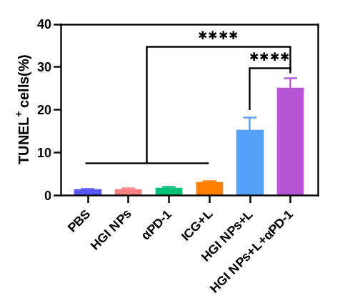
Fig S13 Quantitative evaluation of the percentage of TUNEL positive cells in tumors from different groups.
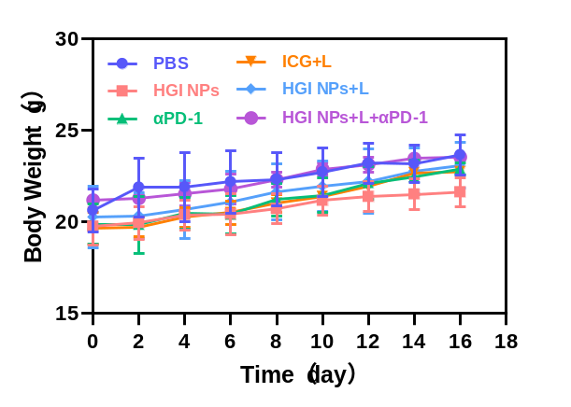
Fig S14 Body weights of 4T1 tumor-bearing mice after various treatments within 16 days (n =4).
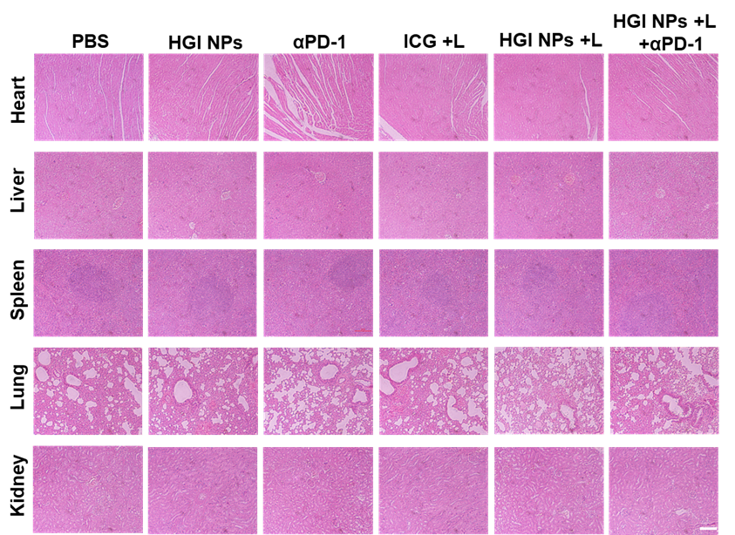
Fig S15 H&E staining of the main organs (heart, liver, spleen, lung and kidney) from different groups. (Scale bar:100 µm)
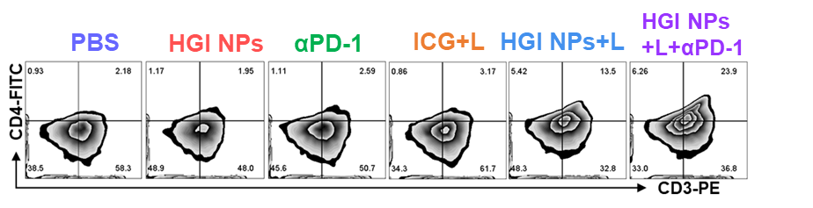Fig S16 FCM analysis of CD4⁺ T cells in tumors of different groups.
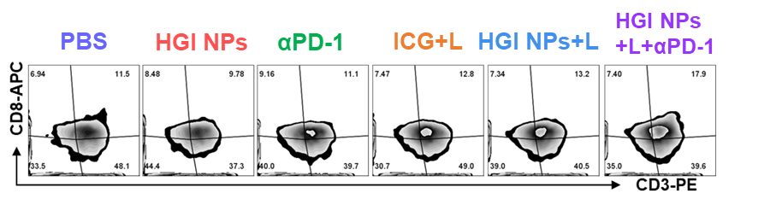
Fig S17 FCM analysis of CD8⁺ T cells in tumors of different groups.
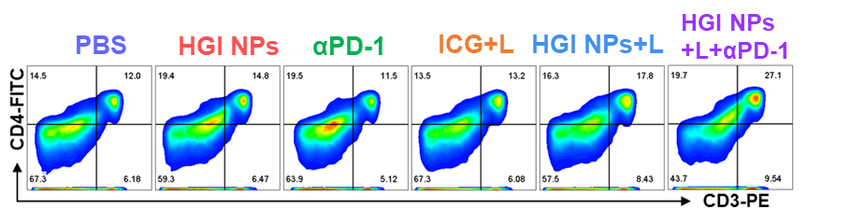
Fig S18 FCM analysis of CD4⁺ T cells in spleen of different groups.
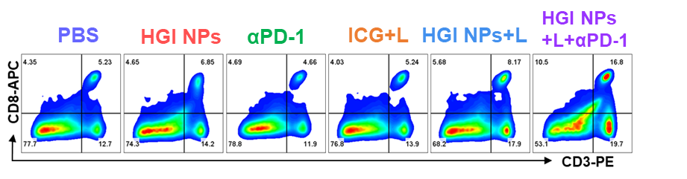
Fig S19 FCM analysis of CD8⁺ T cells in spleen of different groups.

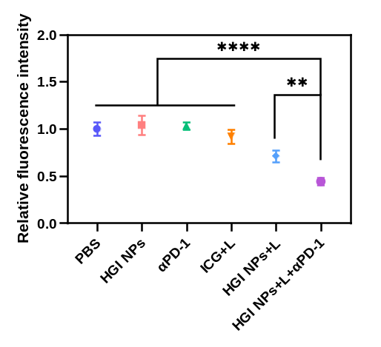
Fig S20 Relative fluorescence intensity of Treg cells in tumors from different groups.

