Supporting Information

An antioxidant nanozyme for targeted cardiac fibrosis therapy post myocardial infarction

Ziyi Gu^{1#}, Xueliang Liu^{1, 4#}, Zhen Qi², Zhou Fang¹, Yiting Jiang¹, Yuting Huang¹, Yongyi Wang^{1*}, Lianming Wu^{3*}, Yu Yang^{1*}
1. Institute of Molecular Medicine (IMM), department of Cardiovascular Surgery, Shanghai Key Laboratory for Nucleic Acid Chemistry and Nanomedicine, Renji Hospital, School of Medicine, Shanghai Jiao Tong University, Shanghai, 200240, China.
2. Department of Cardiovascular Surgery, The Second Xiangya Hospital, Central South University, Changsha, 410008, China.
3. Department of Radiology, Renji Hospital, School of Medicine, Shanghai Jiao Tong University, Shanghai, 200240, China.
4. Punan Branch of Renji Hospital, Shanhai jiaotong University School of Medicine, Shanghai 200125, China.

#Ziyi Gu and Xueliang Liu contributed equally to this work

Methods
Materials and animals
Anti-α-SMA (Boster, BM0002, 1:500), anti-Fibronectin (ab2413) were purchased from Abcam. TA (molecular weight: 1701.20Da) and elastin (soluble from human aorta) were obtained from Sigma-Aldrich. Collagen type I from rat tail was purchased from Corning. Hyaluronic acid (500–749 kDa) was purchased from Lifecore Biomedical. MnCl₂ and 2'-Azinobis-(3-ethylbenzthiazoline-6-sulphonate) (ABTS) were procured from J&K Scientific Co., Ltd (Beijing, China). Cell Counting Kit-8 (CCK-8) was obtained from Dojindo Laboratories (Kumamoto, Japan). BSA, SOD and CAT enzyme activity assay kits were purchased from Beyotime (Shanghai, China).
C57BL/6 mice (male, age of 6-8 weeks) were obtained from Shanghai Laboratory Animal Center (China). Ethical approval for all experiments with mice was obtained from the Animal Care and Use Committees at Ren Ji Hospital (RJ2020-0505), Shanhai Jiao Tong University School of Medicine.
Synthesis of MnO₂@TA
The synthesis of MnO₂ was prepared by biomineralization method. 1 mL MnCl₂ solution (100 mM) was titrated to 10 mL of BSA solution (20 mg/mL) under stirring. The solution pH was then adjusted to 12 using NaOH (1 mM) and further incubated at 37° for 4 hours. The product was subsequently dialyzed with deionized water for purification. Tannic acid modified MnO₂ was synthesized using TANNylation. Tannic acid solution was prepared then mixed with MnO₂ solution with stirring and incubated at room temperature for 30 min followed by ultrafiltration to remove free TA.
Characterization of MnO₂@TA
Nanoparticle morphology was characterized by transmission electron microscopy. UV-Vis spectra from 230 to 1000 nm were recorded by spectrophotometer. Malvern Zetasizer nano ZS90 (UK) was used to measure nanoparticle hydrodynamic size and Zeta potential. Turbidimetric assay was measured at A600 by ultraviolet-visible (UV-Vis) spectroscopy as an indication of particle aggregation after TA modification.
ABTS free radical scavenging assay
According to the previous method. 7 mM ABTS solution was mixed with 2.45 mM potassium persulfate solution and incubated overnight. Different concentrations of MnO₂@TA solution were mixed with ABTS radical solution. The ABTS scavenging efficiency was measured at 734 nm after 10 min of incubation. ABTS scavenging efficiency (%) = ((A_{ABTS} - A_{sample})/A_{ABTS})*100%. A_{ABTS} is the absorbance of the ABTS radical working solution, and the A_{sample} is the absorbance of the solution after the addition of MnO₂@TA.
MB assay
The absorbance of MB solution was decreased by ·OH produced by Fenton reaction, and the OH. scavenging ability of MnO₂@TA was back-calculated by detecting the absorbance of MB. Different concentrations of MnO₂@TA were mixed with MB and added to the Fenton reaction solution containing H₂O₂ and Fe²⁺.The absorbance of MB was measured at 660 nm after 15 min. ·OH scavenging efficiency (%) = (A_{Sample}/A_{MB})*100%. A_{MB} denotes the absorbance of MB without treatment. A_{Sample} denotes the absorbance of MB after reaction.
Detection of Oxygen Generation
Oxygen concentration in aqueous solutions was measured using a portable dissolved oxygen meter (Rex, JPBJ-608, China). 5 mL 1 mM H₂O₂ solution was added to a glass vial and rubber stoppered closed. MnO₂@TA was injected into the closed system. An oxygen electrode probe was inserted through this rubber stopper below the liquid level to record the oxygen concentration in real time.
Enzyme Activity Assay
Enzyme activities were assayed as described in the SOD and CAT enzyme activity assay kit. After addition of different concentrations of nanoparticles, the absorbance changes at 450 and 520 nm were monitored by UV-vis spectrometer for further evaluation of SOD and CAT enzyme activities.
Primary Mouse Cardiac Fibroblast Extraction
Neonatal suckling mice were executed and the skin was sterilized with 75% ethanol. The thoracic cavity of the mice was cut open and the hearts were removed and immersed in Hanks' solution. Extrude blood from the heart chambers and remove excess tissue. The tips of the hearts were minced and added to 1% collagenase type II solution and shaken overnight at 4°. The hearts were centrifuged at 1000 rpm for 5 minutes, the supernatant discarded, and resuspended in medium. the medium was changed 1 hour later to remove floating cells.
Cell Viability Assay
MCFs and H9C2 were cultured in 96-well plates. After treatment, cell viability was assessed using the Cell Counter Kit-8 (CCK-8) assay (dojindo, Japan). Each well was incubated for 2 h after adding 100 μl of CCK-8 solution. Absorbance was measured at 450 nm using an enzyme label analyzer. Three wells in each group were measured as replicates and used to calculate the average cell viability.
Cell Uptake Assay
To detect the uptake of nanoparticles by MCFs. MCFs cells inoculated in 12-well plates were co-incubated with MnO₂ and MnO₂@TA for different time periods (0.5 h, 1 h, and 2 h), washed, and then subjected to confocal imaging and flow cytometry assay.
Antioxidant Ability of MnO₂@TA
MCFs were inoculated in 12-well plates and cultured for 12 h. Cells were then incubated with MnO₂@TA (25 μg/mL) for 2 h. The cells were then stimulated with 10 ng/mL TGFβ for 24 h to induce oxidative stress. Cells were washed and incubated with 1 μM DCFH-DA solution for 20 min. ROS levels were measured using fluorescence microscopy and flow cytometry after washing.
Western Blot Analysis
Treated MCFs were collected and cells were lysed with RIPA. Protein quantification was performed using BCA kit. Protein samples were separated on a 10% SDS-PAGE gel and transferred to a PVDF membrane. After sealing with 5% bovine serum albumin for 2 h, the membranes were incubated overnight at 4°C in primary antibodies. After three 15-minute washes in TBST, the membranes were incubated in horseradish peroxidase (HRP)-coupled secondary antibody for 1 hour at room temperature. After three 15-minute washes in TBST, the membranes were imaged by enhanced chemiluminescence.
5-ethynyl-2’-deoxyuridine (EDU) Assay
MCFs were processed in 12-well plates and cell proliferative capacity was determined using the EDU Alexa Flour 555 Cell Proliferation Assay Kit. After washing and fixing permeabilized cells 1000 μL of EDU working solution was added to each well and incubated for 2 hours. Subsequently 250 μL Click reaction solution was added and incubated for 30 minutes. Images were taken using a fluorescence microscope after washes.
Wound Healing Migration Assay
MCFs were inoculated in 12-well plates. The plates were lightly scraped with a 200 μL pipette tip after the cell density reached 90%. Images were taken by inverted microscope 24 hours after treatment at the same position as at 0 hours.
Biodistribution of Nanozyme In Vivo
200 μL of IR1061-labeled MnO₂@TA was injected into each mouse (2 mg/kg) via tail vein. Major organs including heart, liver, spleen, lungs and kidneys were collected at 1h, 2h, 4h,8h and 16h for ex vivo imaging on a near-infrared optical imaging system. The degree of cardiac aggregation of MnO₂ and MnO₂@TA was also compared.
Animal model
C57BL/6J wild-type mice aged 6-8 weeks were purchased from Shanghai Rise Bio-technology Co. The mice were anesthetized with isoflurane by inhalation, and the 3rd and 4th intercostal spaces on the left side of the sternum were propped open. The LAD of the left anterior descending branch was identified through the intersection of the greater cardiac vein and the contour of the left auricle. myocardial infarction was caused by permanent ligation of the LAD with an 8-0 nylon suture. Autonomous respiration was restored to the mice after suturing the thoracic cavity. According to the grouping, the mice after AMI were injected with 200 μL of saline, MnO₂, and MnO₂@TA (1 mg/kg) in the tail vein every three days, respectively.
Echocardiography Assay.
Mice were anesthetized by inhalation of isoflurane after removal of chest hair. Cardiac function was assessed and echocardiographic images were taken in M-mode using a high-resolution imaging system for small animals (Vevo 3100 imaging system, Visual Sonics Japan). Data statistics were subsequently performed.
Histologic Analysis
Myocardium in the ischemic area under the transient resection suture line along the ventricle was subsequently fixed in 4% paraformaldehyde. Paraffin-embedded and sectioned sections were made, and the area of collagen deposition and fibrosis was determined by Masson staining. Images were taken by inverted microscopy. The level of myocardial hypertrophy was observed by Wheat Germ Agglutinin (WGA) staining. Slice fresh myocardial samples and incubate with Dihydroethidium (DHE) staining solution for 30 minutes. Tissue reactive oxygen levels were observed under a fluorescence microscope after washes.
MDA assay
Grind myocardial tissue and perform BCA quantification. Tissue malondialdehyde (MDA) levels were subsequently assayed according to the method of the MDA assay kit.
AST, ALT, CREA assay
Venous blood was collected by orbital blood sampling method after 28 days of treatment in mice. Subsequently, blood biochemical analyses were performed to compare the liver and kidney functions of healthy mice with those of the administered mice.
Tunel assay
The liver was fixed with 4% paraformaldehyde (PFA) for 24h, and then soaked in 30% glucose for more than 48 hours for dehydration. Tunel staining was performed following a standard protocol.
Measurement of TNF-α, IL-6
Blood was collected and centrifuged at 3,000 rpm for 15 min. The supernatant was collected. The levels of TNF-α and IL-6 in serum were determined using the Elisa Kit (Yobibio, Shanghai, China) according to the manufacturer’s instructions.
Hemolysis assay
200 μL blood and 100 μL water or different concentrations of MnO₂@TA were added in to a 1.5 mL centrifuge tube. 5 minutes later the tubes were centrifuged at 3000 rpm for 5 minutes. The supernatant was collected and spectra was detected.
Statistical Analysis
Statistical analysis was conducted using GraphPad Prism 9.0 software (La Jolla CA). All data were presented as mean ± SD, and statistical analysis was performed using Student’s t test. Differences between the two groups were determined to be significant at *P < 0.05 and very significant at **P < 0.01 and ***P < 0.001.

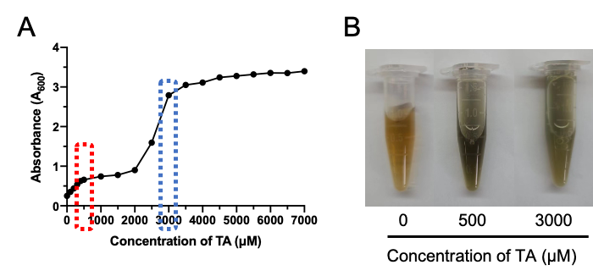
Figure S1. (A) Turbidimetric assay for determining the optimal concentration of tannic acid to modifiy on the surface of the MnO₂. (B) Changes of solution color after addition of different concentrations of tannic acid.

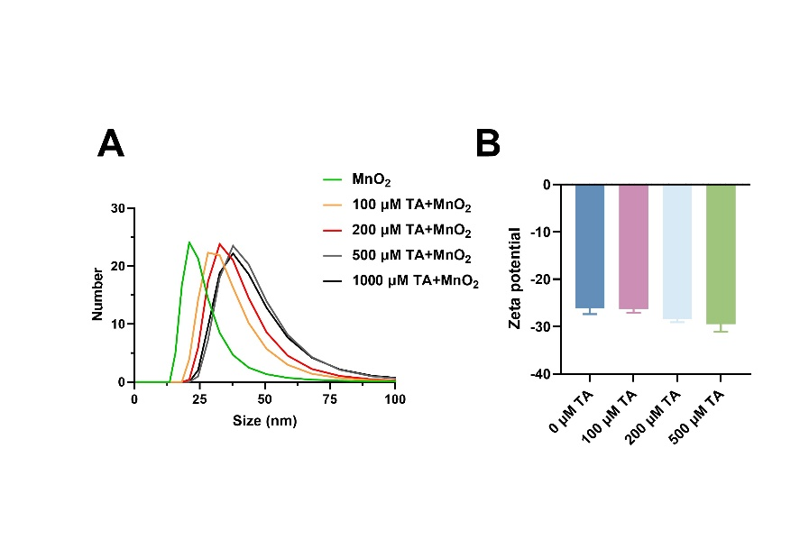
Figure S2. (A) Changes of DLS after addition of different concentrations of tannic acid. (B) Changes of zeta potential after addition of different concentrations of tannic acid.

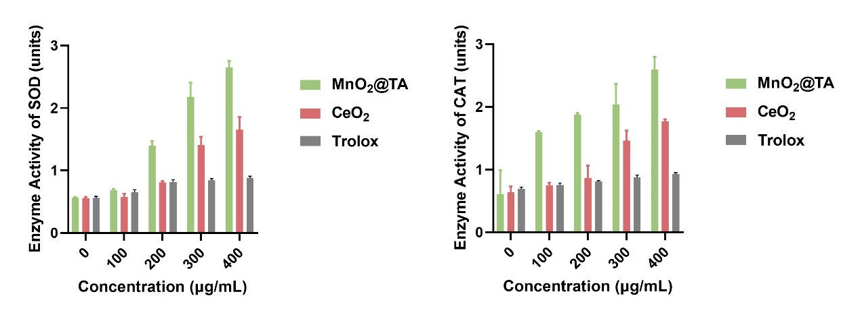
Figure S3. SOD and CAT enzyme activities assay of different nanozyme.
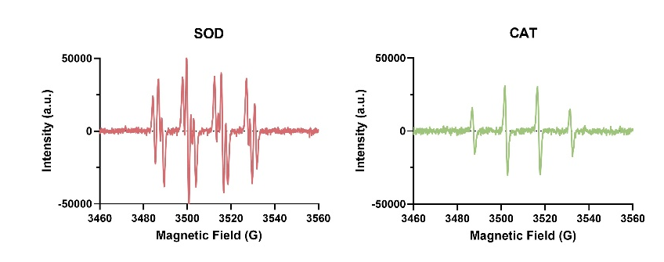
Figure S4. EPR of MnO₂@TA.

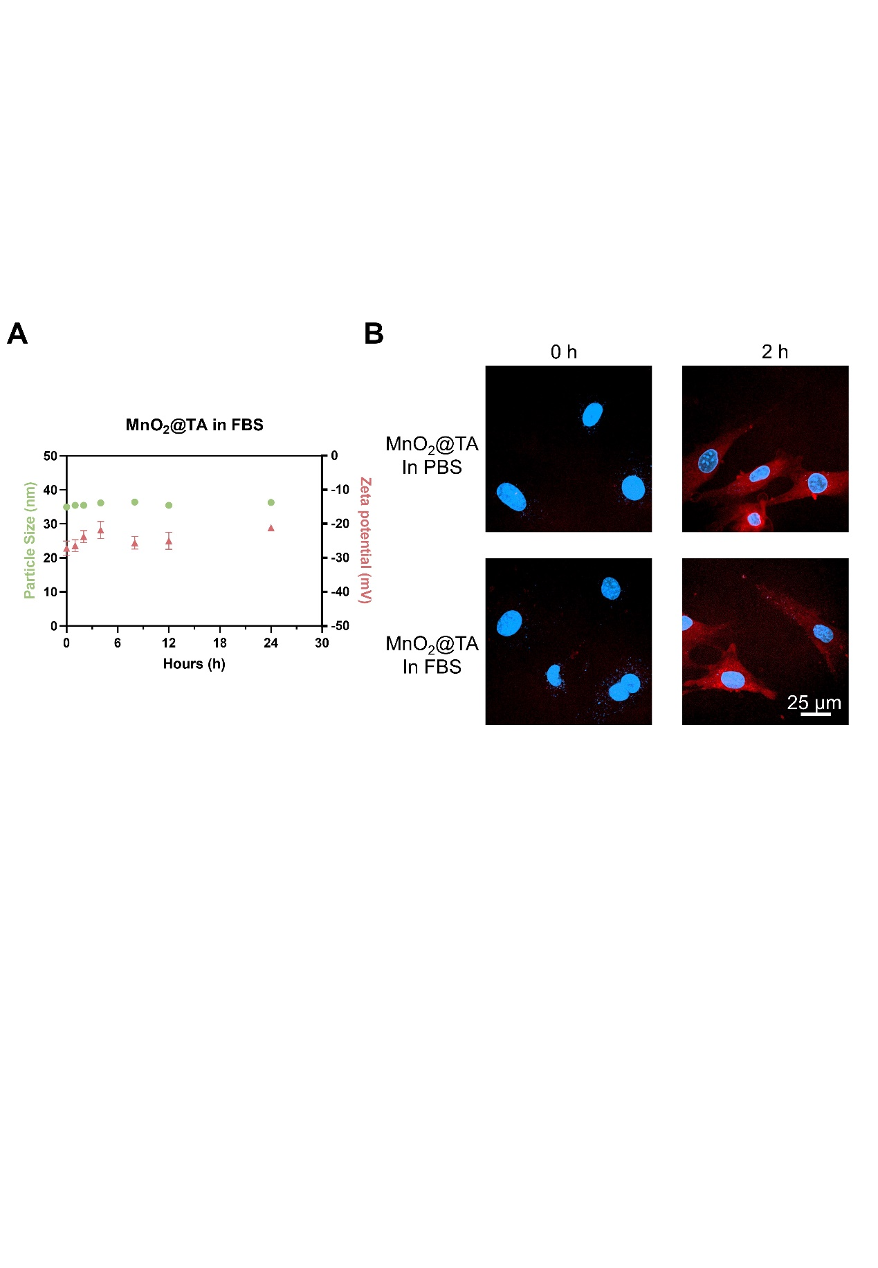
Figure S5. Particle size and zeta potential of MnO₂@TA in FBS. Data are presented as mean ± s.d.

Figure S6. Comparing cellular uptake of MnO₂@TA when FBS is added to the medium.

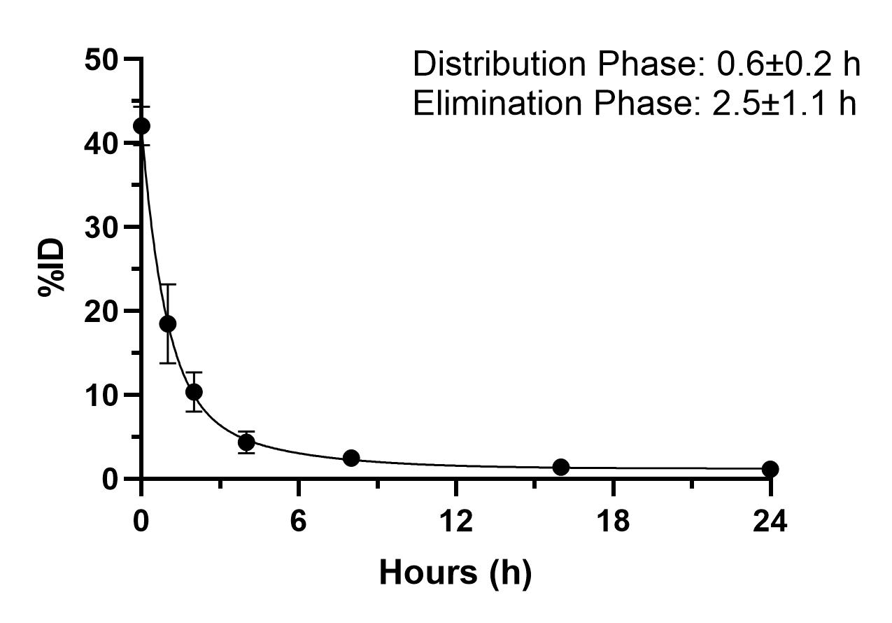
Figure S7. Blood clearance curves of the MnO₂@TA in C57 mouse. Data are presented as mean ± s.d. *P < 0.05, **P < 0.01, and ***P < 0.001.

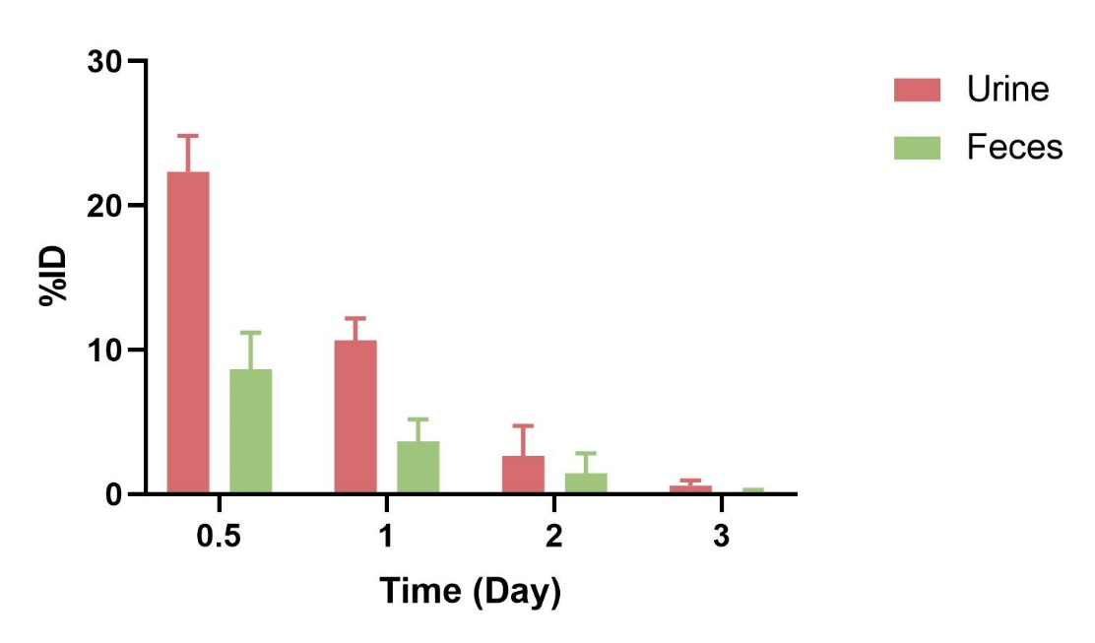
Figure S8. Time-dependent excretion profiles of Mn²⁺ in healthy mice after injection of MnO₂@TA.

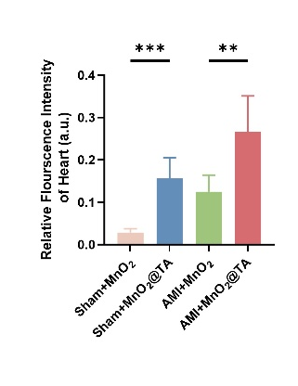
Figure S9. Quantitative statistics of cardiac fluorescence intensity in different groups after injection of MnO₂ and MnO₂@TA. Data are presented as mean ± s.d. *P < 0.05, **P < 0.01, and ***P < 0.001.

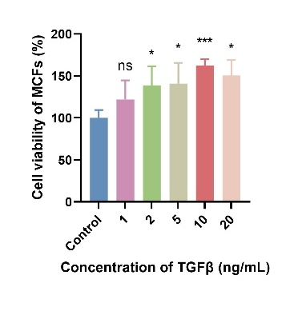
Figure S10. Changes of cell viability after stimulation of MCFs with different concentrations of TGFβ. Data are presented as mean ± s.d. *P < 0.05, **P < 0.01, and ***P < 0.001.

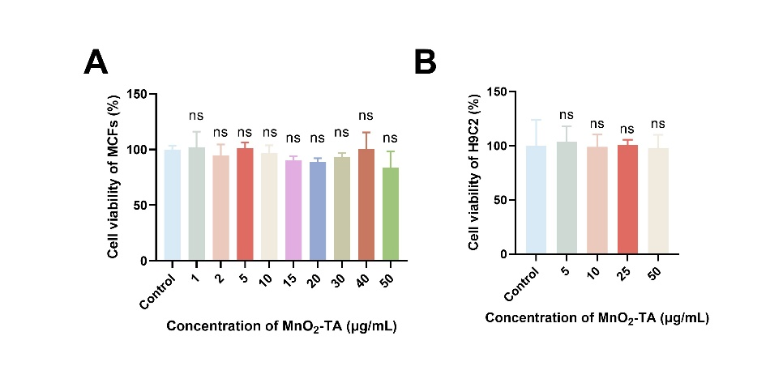
Figure S11. (A) Changes of cell viability after stimulation of MCFs with different concentrations of MnO₂@TA. (B) Changes of cell viability after stimulation of H9C2 with different concentrations of MnO₂@TA. Data are presented as mean ± s.d. *P < 0.05, **P < 0.01, and ***P < 0.001.

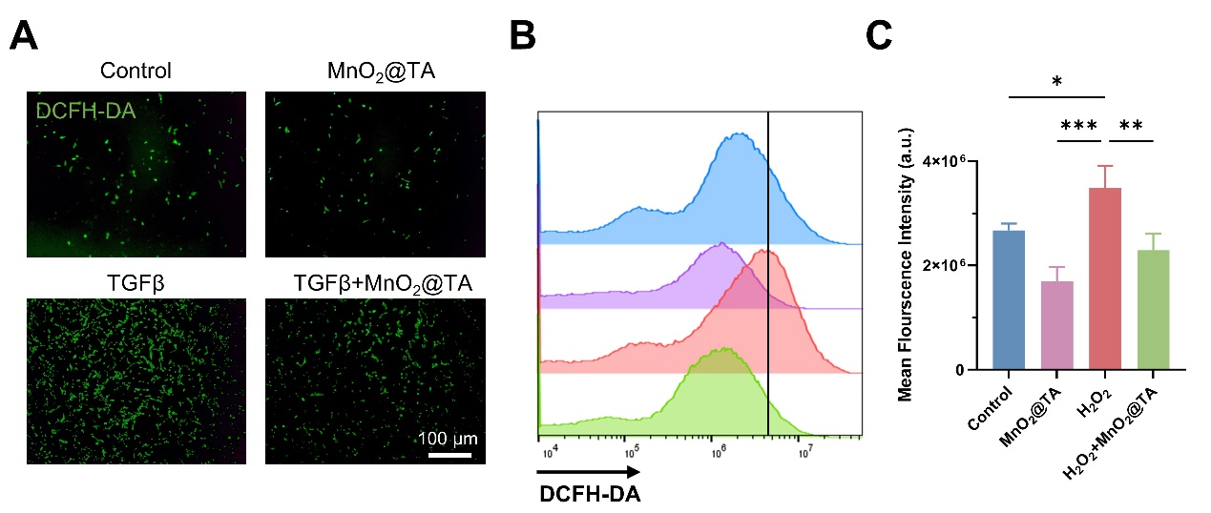
Figure S12. (A) DCFH-DA reflects the ROS level of H9C2 cells after different treatments. Scale bar, 100 μm. (B) Flow cytometry was performed to detect DCFH-DA fluorescence intensity after different treatments of H9C2. (C) Quantitative statistics of fluorescence intensity in panel (B). Data are presented as mean ± s.d. *P < 0.05, **P < 0.01, and ***P < 0.001.
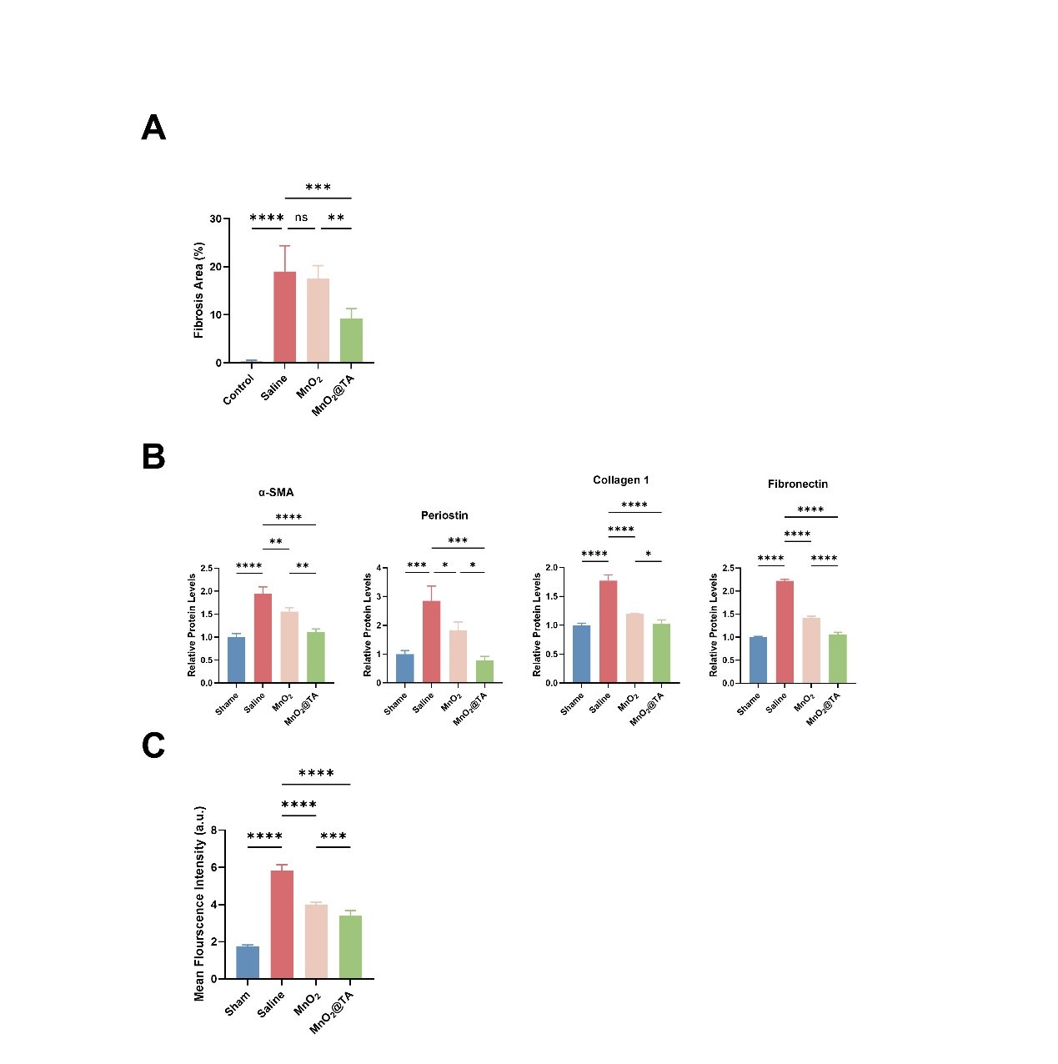
Figure S13. (A) Quantitative statistics of fibrosis area. (B) Quantitative statistics of protein expression levels of fibrosis-related genes including α-SMA, Periostin, Collagen1 and fibronectin. (C) Quantitative statistics of DHE staining. Data are presented as mean ± s.d. *P < 0.05, **P < 0.01, and ***P < 0.001.

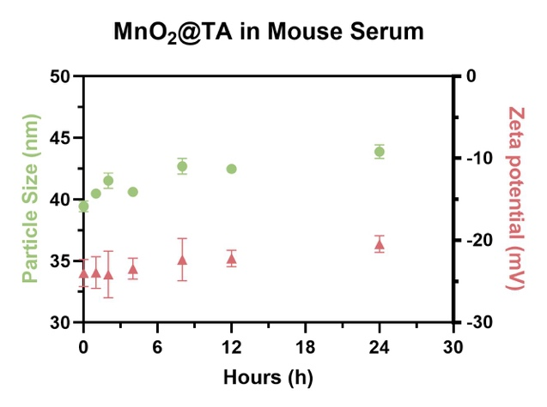
Figure S14. Particle size and zeta potential of MnO₂@TA in mouse serum. Data are presented as mean ± s.d.

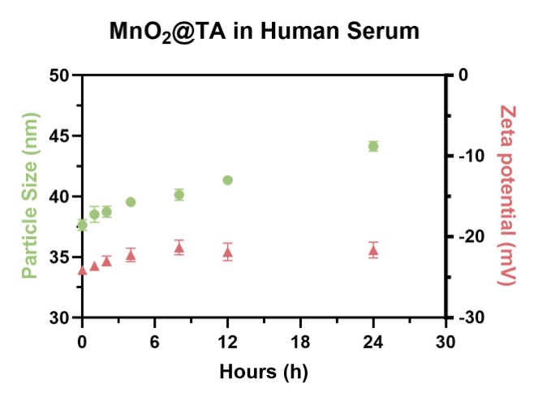
Figure S15. Particle size and zeta potential of MnO₂@TA in human serum. Data are presented as mean ± s.d.
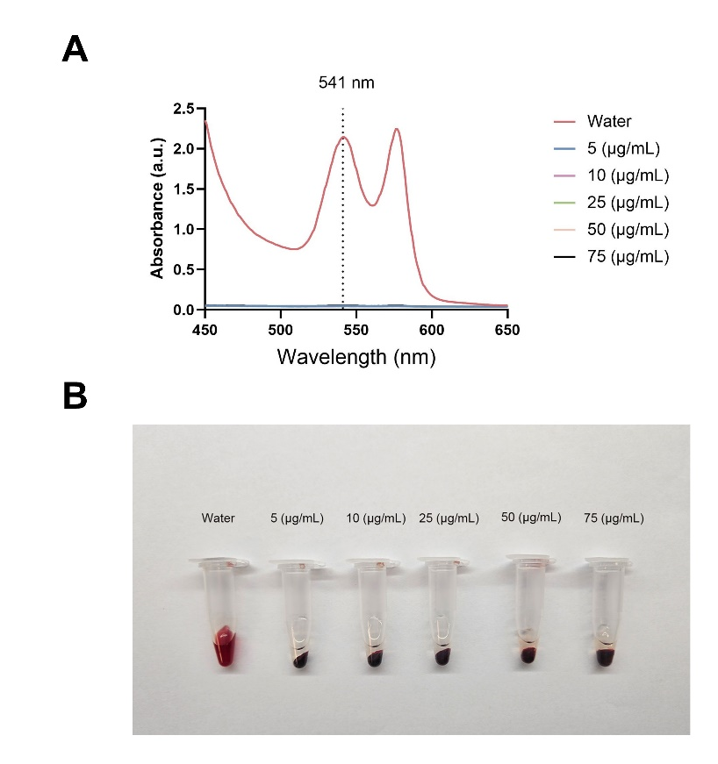
Figure S16. (A) Absorption spectroscopy of the supernatant of blood treated with different concentrations of MnO₂@TA. (B) The corresponding photos of blood treated with different concentrations of MnO₂@TA.

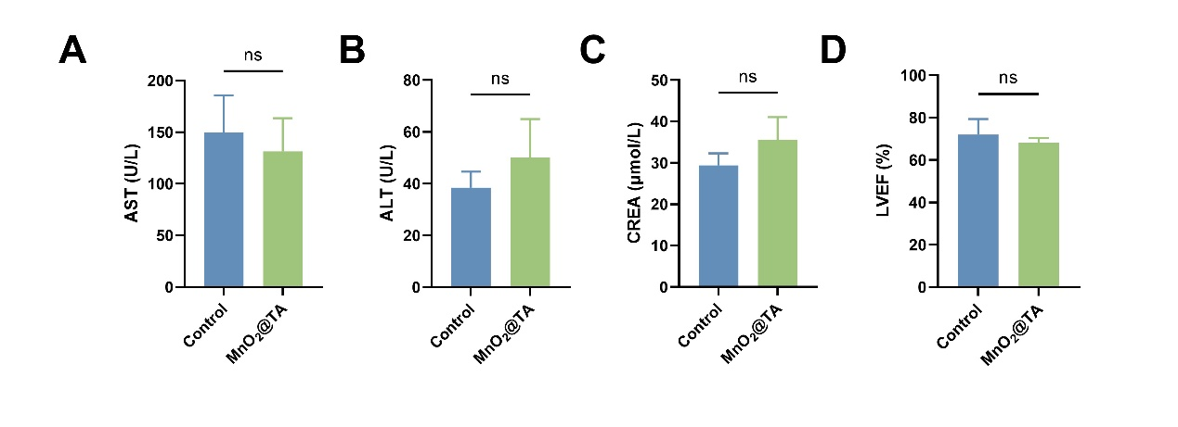
Figure S17. (A) Detection of AST level in mice after 28 days of MnO₂@TA treatment. (B) Detection of ALT level in mice after 28 days of MnO₂@TA treatment. (C) Detection of CREA level in mice after 28 days of MnO₂@TA treatment. (D) Detection of LVEF level in mice after 28 days of MnO₂@TA treatment. Data are presented as mean ± s.d. *P < 0.05, **P < 0.01, and ***P < 0.001.

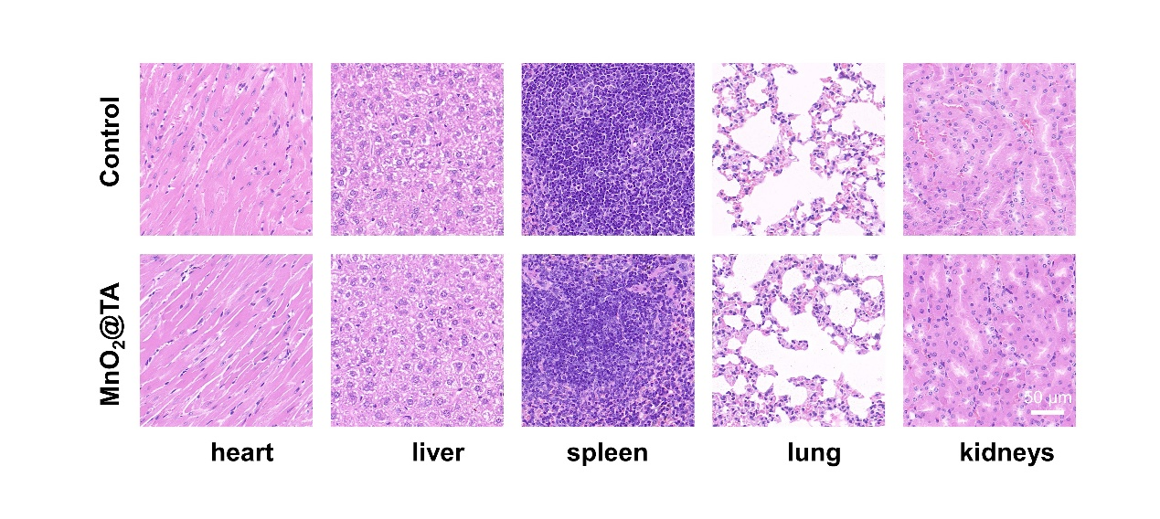
Figure S18. HE staining of heart, liver, spleen, lung, kidney after 28 days of MnO₂@TA treatment.

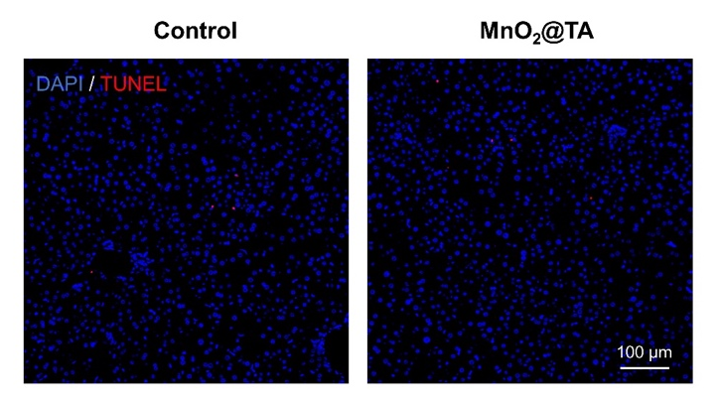
Figure S19. Tunel staining showed the level of liver cell apoptosis. Scale bar, 100μm.

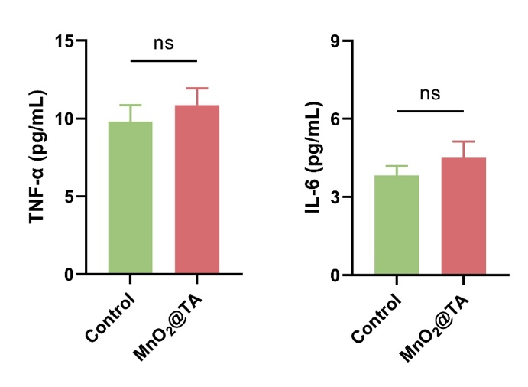
Figure S20. The levels of TNF-α and IL-6 in mice after 28 days of MnO₂@TA treatment. Data are presented as mean ± s.d. *P < 0.05, **P < 0.01, and ***P < 0.001.

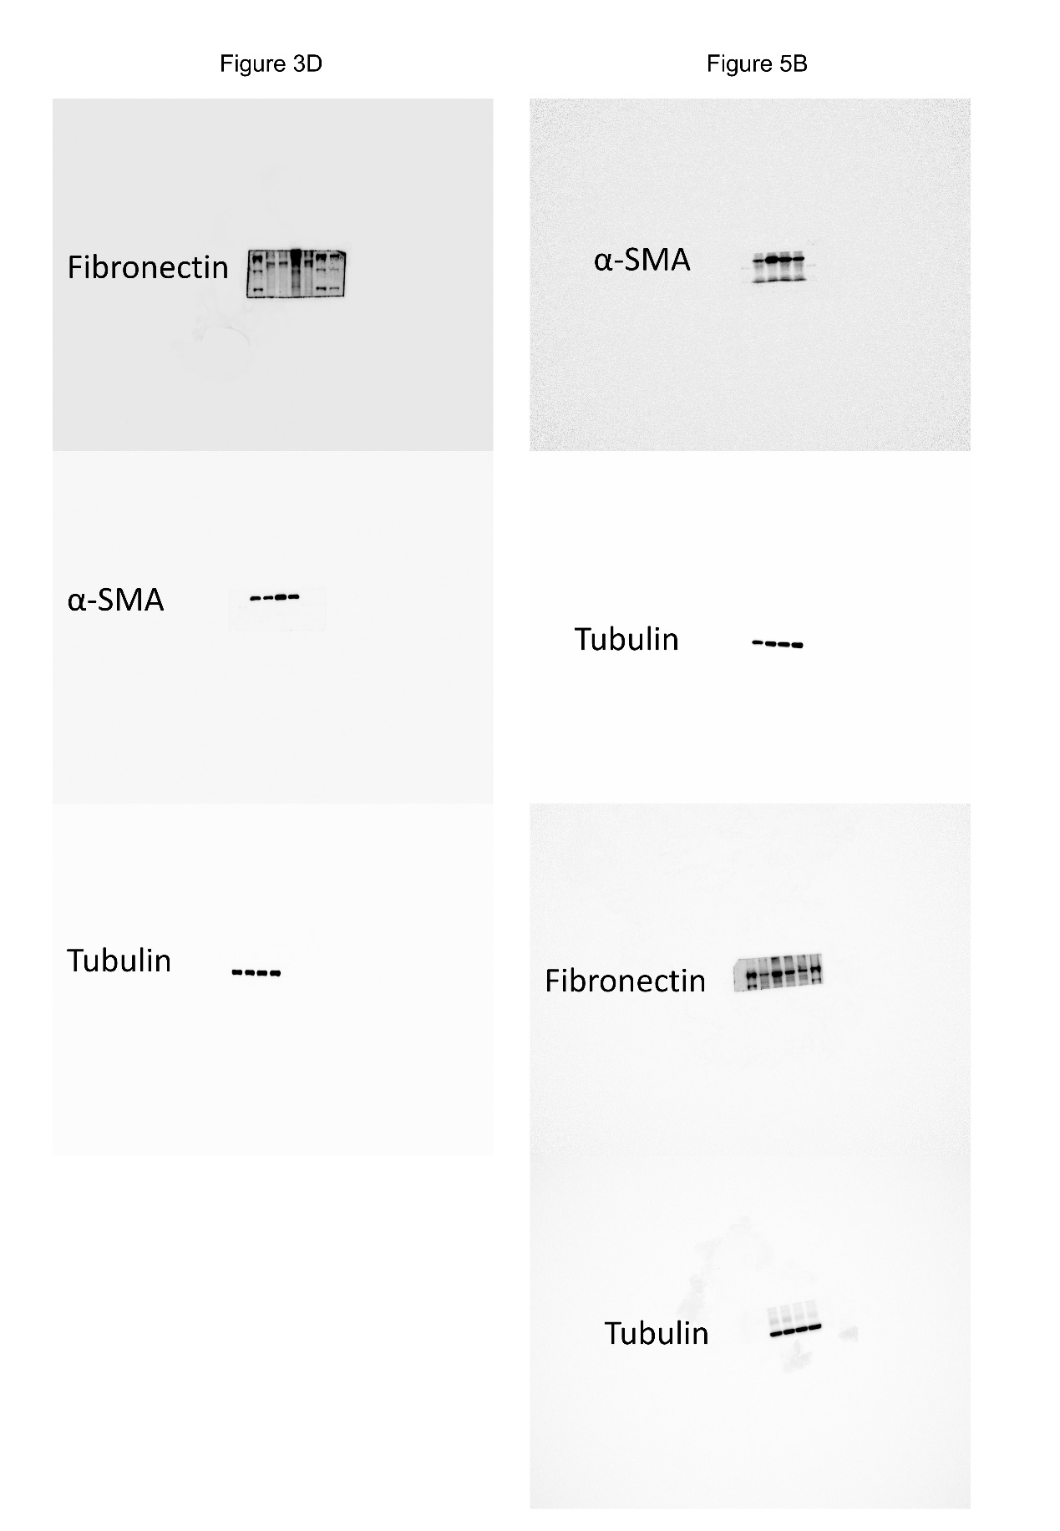
Figure S21. Uncropped original images of WB in Figure3D and Figure5B.

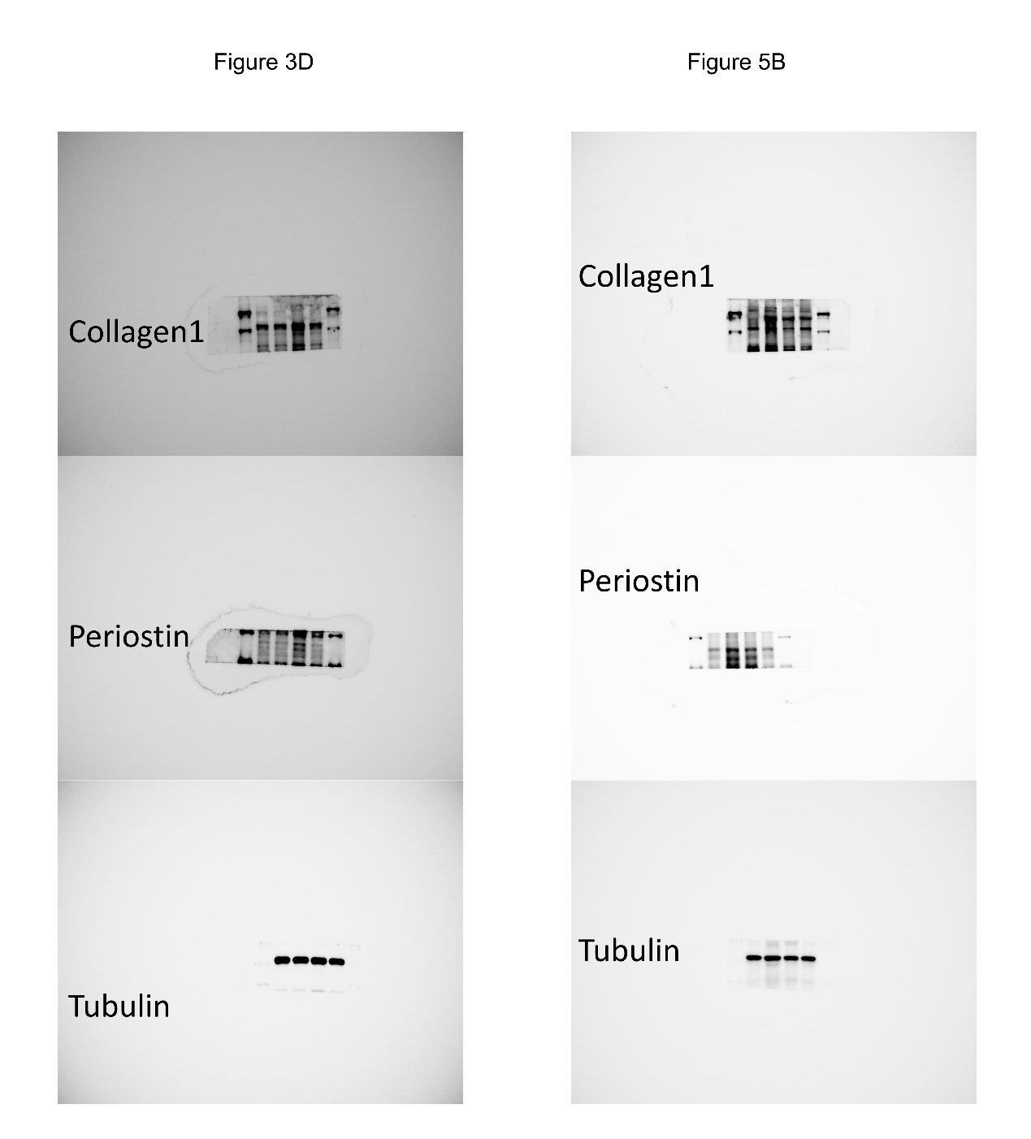
Figure S22. Uncropped original images of WB in Figure3D and Figure5B.

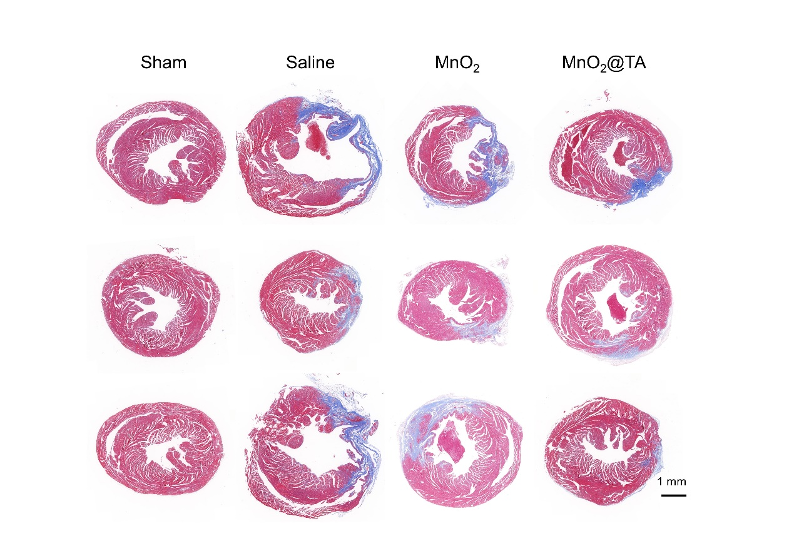
Figure S23. Three typical sections of hearts about Masson staining. Scale bar, 1mm.

