Synergic Effects of Core-Shell Nanospheres and Magnetic Field for Sciatic Nerve Regeneration in Decellularized Artery Conduits with Schwann Cells

Majid Sharifi, Majid Salehi, Somayeh Ebrahimi-Barough, Morteza Alizadeh, Hossein Kargar Jahromi, Mohammad Kamalabadi-Farahani

S1. Indirect cytotoxicity analysis
In order to determine the CMC hydrogel cytotoxicity, the indirect MTT assay for NIH 3T3 cell viability was used. Briefly, 0.5 g CMC hydrogel with concentrations of 0.5, 1.0, 1.5 and 2.0% (w/v) was immersed in 500 μL of DMEM medium with 10% FBS, 1% penicillin–streptomycin at 37 °C for 48 h. The extract was then added to each well of a 96-well plate containing NIH 3T3 cells (4×10³/well) and incubated at 37°C with 5% CO₂ for 24 and 48 hours. At the designated times, the culture medium was removed, and 100 μL of MTT solution (1 mg/mL in PBS) was added to each well, followed by a 4-hour incubation. After replacing the medium with 100 μL of DMSO, absorbance was measured at 570 nm using an ELISA reader (Expert 96, Asys Hitch, Ec Austria). Relative cell viability (%) was calculated using Equation (3):
Cell viability (%)=[[Optical density of treated SCs-Optical density of blank]÷[ Optical density of control-Optical density of blank]]×100
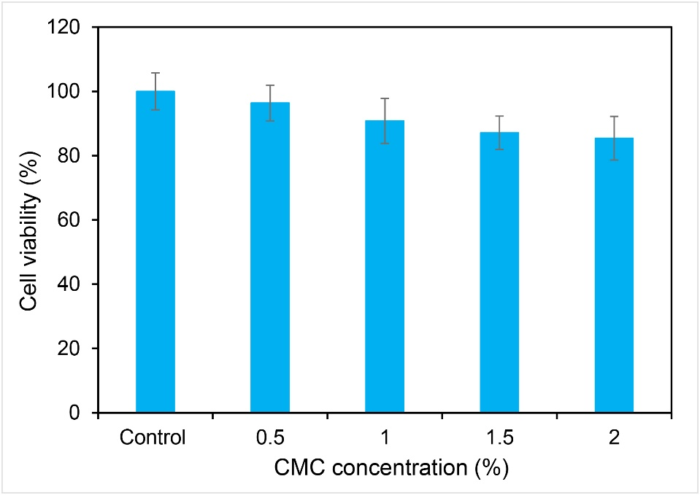
Figure S1: Indirect cytotoxicity test. Viability of NIH 3T3 cells with different concentrations of CMC hydrogel extracts.

S2. Degradation rate study
Freeze-dried samples from each group, measuring 1 cm in diameter and 0.02 cm in height, were weighed with an accuracy of 0.0001 g. They were then immersed in 10 ml of PBS solution at 37°C for 12, 24, 48, and 72 hours. After each time period, the samples were dried at 50°C, and their weight was measured again. The remaining weight was calculated using the formula where W₁ is the initial weight and W₂ is the final weight. This experiment was repeated three times.
Weight loss % = [[W₁-W₂] ÷ [W₁]]×100
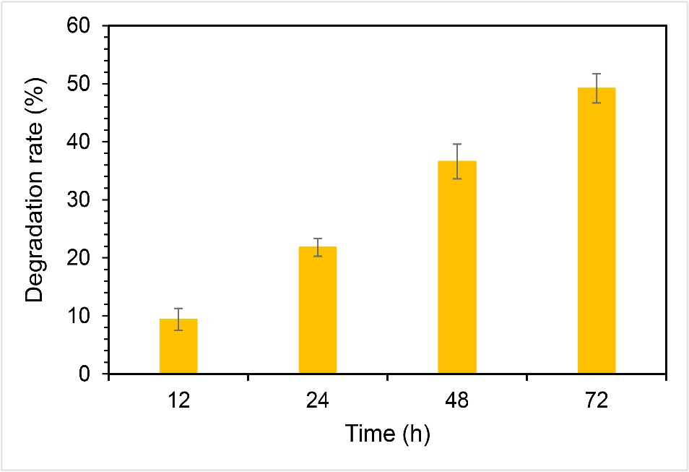
Figure S2: Degradation rate of 1.0% CMC hydrogel.

