Supporting information

Copper-coordination Driven Brain-targeting Nanoassembly for Efficient Glioblastoma Multiforme Immunotherapy by Cuproptosis-mediated Tumor Immune Microenvironment Reprogramming
Yang Chen^{1#}, Hailong Tian^{2#}, Xiaodian Zhang^{3#}, Edouard C. Nice⁴, Canhua Huang^{1,2}, Haiyuan Zhang⁵*, Shaojiang Zheng³*

¹School of Basic Medical Sciences, Chengdu University of Traditional Chinese Medicine, Chengdu 611137, China;
²Department of Biotherapy, Cancer Center and State Key Laboratory of Biotherapy, West China Hospital, Sichuan University, Frontiers Medical Center, Tianfu Jincheng Laboratory, Chengdu 610041, China;
³Key Laboratory of Emergency and Trauma of Ministry of Education, Engineering Research Center for Hainan Biological Sample Resources of Major Diseases, the Hainan Branch of National Clinical Research Center for Cancer, the First Affiliated Hospital, Hainan Medical University, Haikou 570102, China;
⁴Department of Biochemistry and Molecular Biology, Monash University, Clayton, VIC 3800, Australia;
⁵School of Basic Medicine, Health Science Center, Yangtze University, Jingzhou 434023, China

#These authors contributed equally to this work.
*Corresponding authors.
Email Addresses: zhy02141003@163.com (H. Zhang); zshaojiang@muhn.edu.cn (S. Zheng)

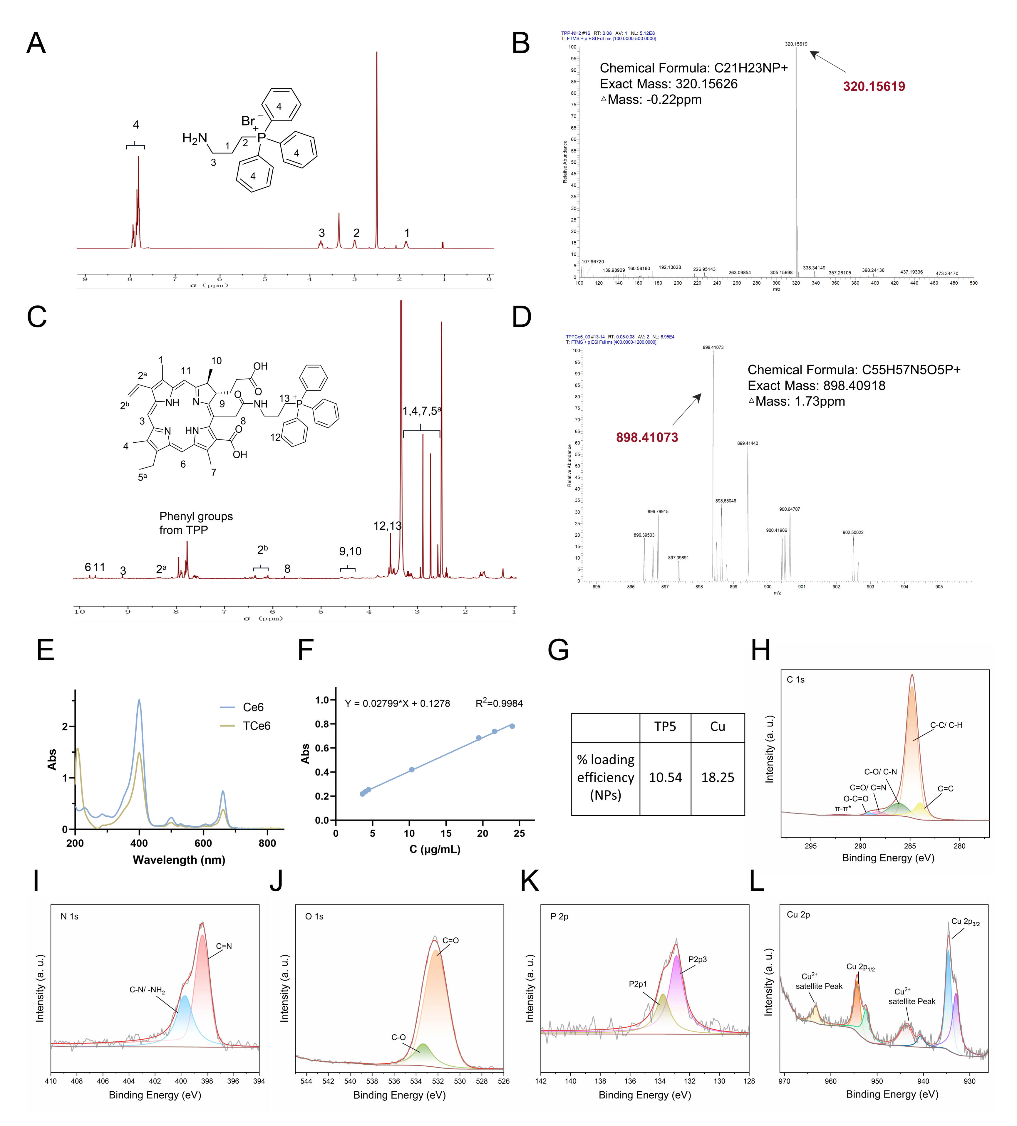
Fig. S1 The preparation and characterization of TCe6@Cu/TP5 NPs. A, B ¹H-NMR and mass spectrum of TPP-NH₂. C, D ¹H-NMR and mass spectrum of TCe6. E The UV–vis absorption spectra of Ce6 and TCe6. F Standard curves for TCe6 using the UV–vis absorption spectra. G The loading efficiency of TP5 and Cu in NPs. H-L The high-resolution XPS of C 1s, N 1s, O 1s, P 2p, and Cu 2p spectra of TCe6@Cu/TP5.
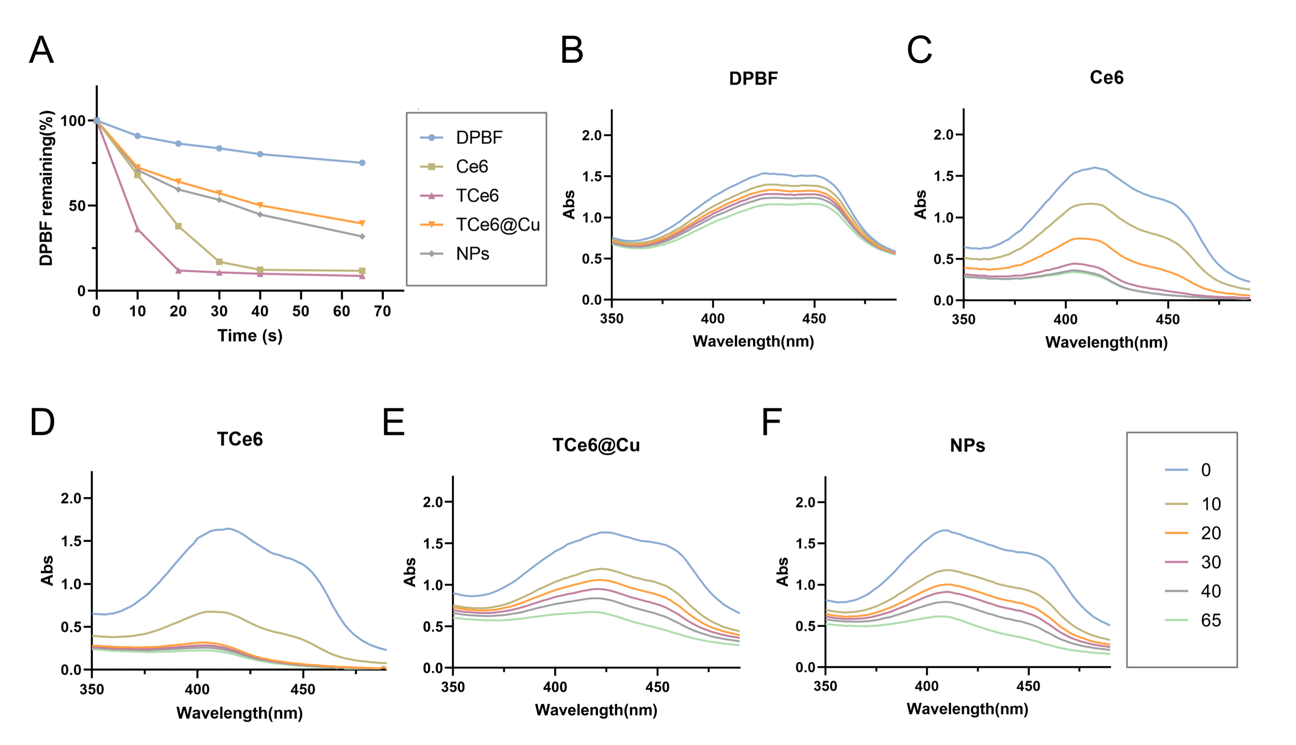Fig. S2 The photodynamic effects of photosensitizers. A The total relative amount of DPBF in different groups. B-F Photodynamic effects of DPBF, Ce6, TCe6, TCe6@Cu, and NPs in different time points. “NPs” represents “TCe6@Cu/TP5 NPs”.
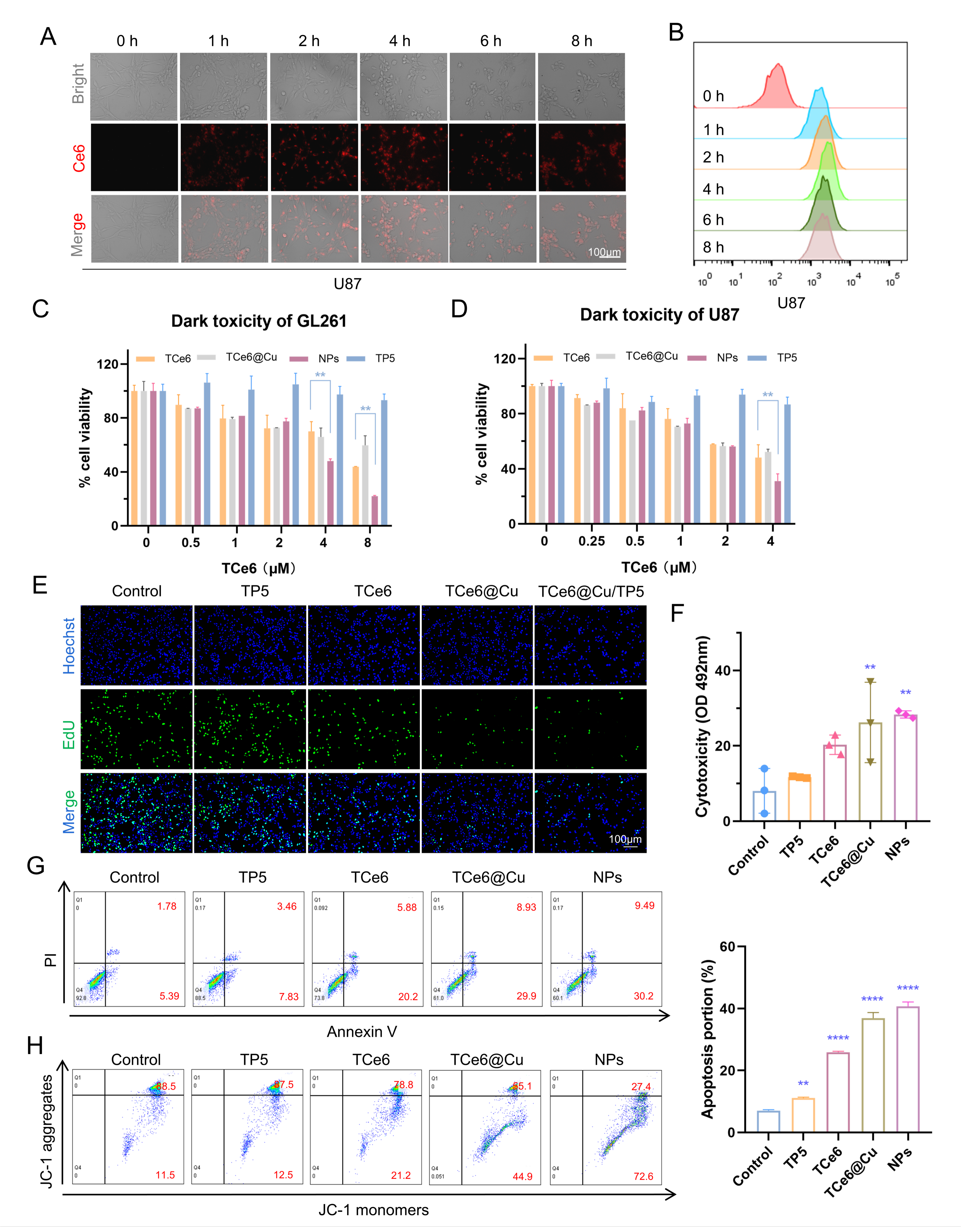Fig. S3 The therapeutic effect of GBM cells. A, B The fluorescence images and flow cytometry of U87 cells treated with NPs. C, D Cell viability of GL261 and U87 cells without NIR irradiation. E Edu assay of U87 cells with NIR irradiation. F LDH assay of U87 cells with NIR irradiation. G, H Flow cytometry analysis of apoptosis and JC-1 staining on U87 cells with NIR irradiation. The 660 nm laser power is 1.0 W·cm⁻² and all data are shown as the mean ± SD. (*p < 0.05; **p <0.01; ***p < 0.001; ****p < 0.0001). “NPs” represents “TCe6@Cu/TP5 NPs”.
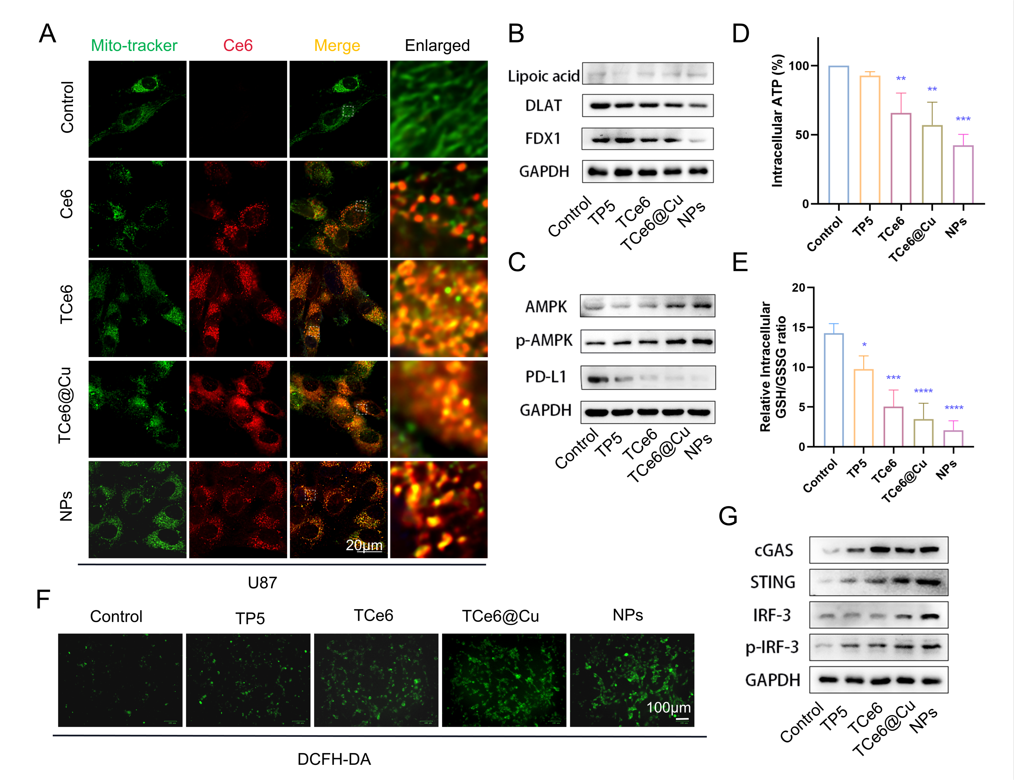
Fig. S4 The mechanism of anti-U87 cell activity. A Mitochondrial co-localization in U87 cells. B Western blotting of lipoylated DLAT, DLAT, and FDX1 proteins in U87 cells. C The intracellular ATP level in U87 cells. D Western blotting of AMPK, p-AMPK, and PD-L1 proteins in U87 cells. E The relative ratio of GSH/GSSG level in U87 cells. F The fluorescence images of ROS generation in U87 cells. G Western blotting of cGAS-STING signaling pathway in U87 cells. Data were shown as mean ± SD. (*p < 0.05; **p <0.01; ***p < 0.001; ****p < 0.0001). “NPs” represents “TCe6@Cu/TP5 NPs”.
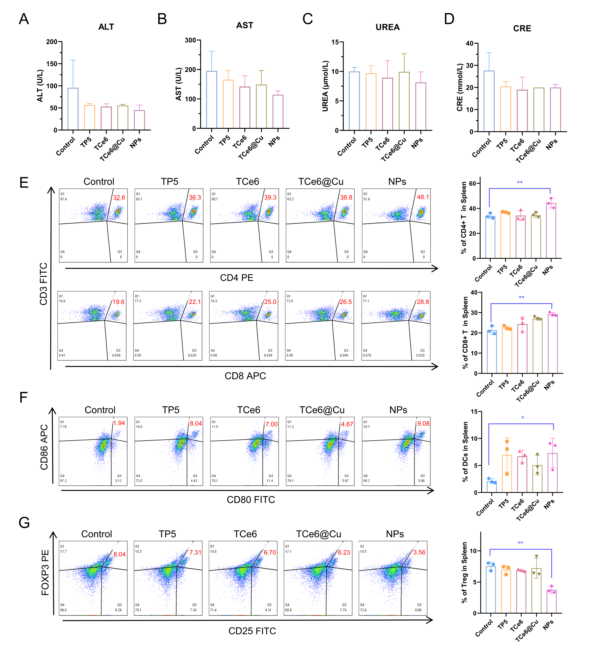
Fig. S5 The mechanism of the orthotopic GBM in mice. A, B Liver ALT and AST levels in serum. C, D Kidney UREA and CRE levels in serum. E-G Flow cytometry analysis of CD4⁺, CD8⁺ T cells, DC cells, and Tregs in spleen tissue. Data were shown as mean ± SD. (*p < 0.05; **p <0.01). “NPs” represents “TCe6@Cu/TP5 NPs”.
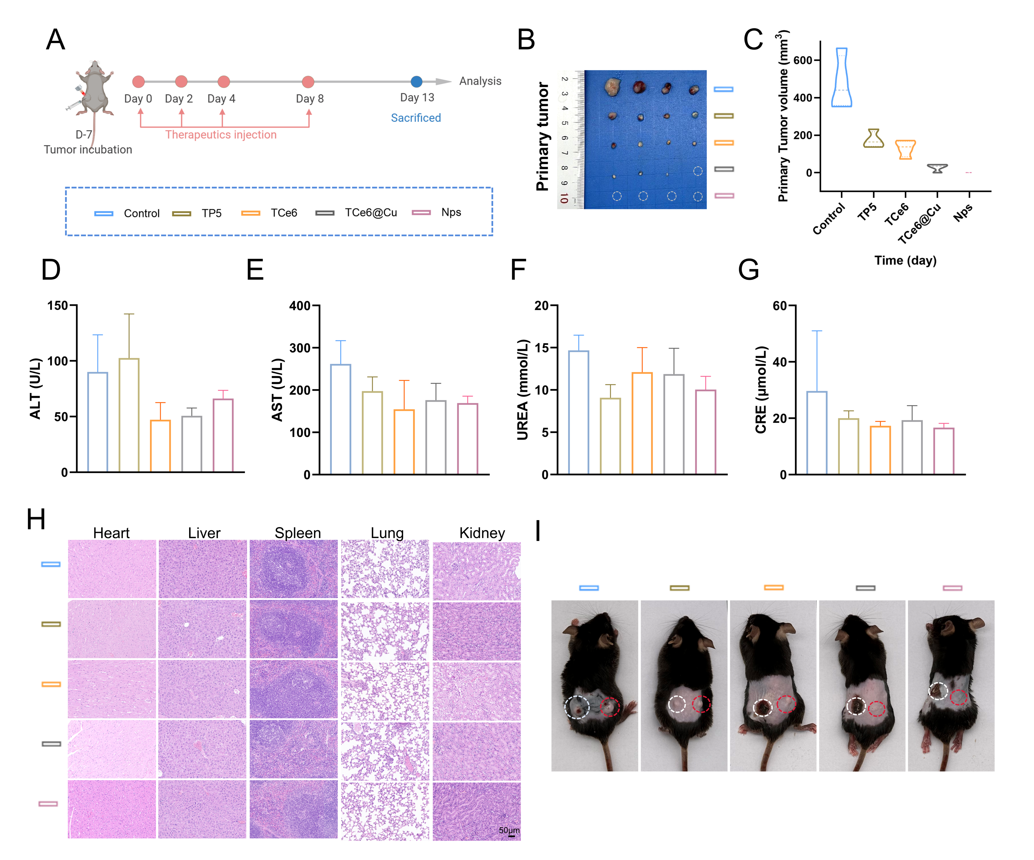Fig. S6 The photoimmunotherapy with TCe6@Cu/TP5 in bilateral GBM mice. A Treatment timeline depiction of GBM treatment. B Primary tumor volume of different groups on the 13th day. D, E Liver ALT and AST levels in serum. F, G Kidney UREA and CRE levels in serum. H H&E staining of main organs including heart, liver, spleen, lung, and kidney. I bilateral GBM mice on the ninth day are depicted, with the white circle marking the primary tumor and the red circle marking the distant tumor. Data were shown as mean ± SD. (*p < 0.05; **p <0.01). “NPs” represents “TCe6@Cu/TP5 NPs”.

