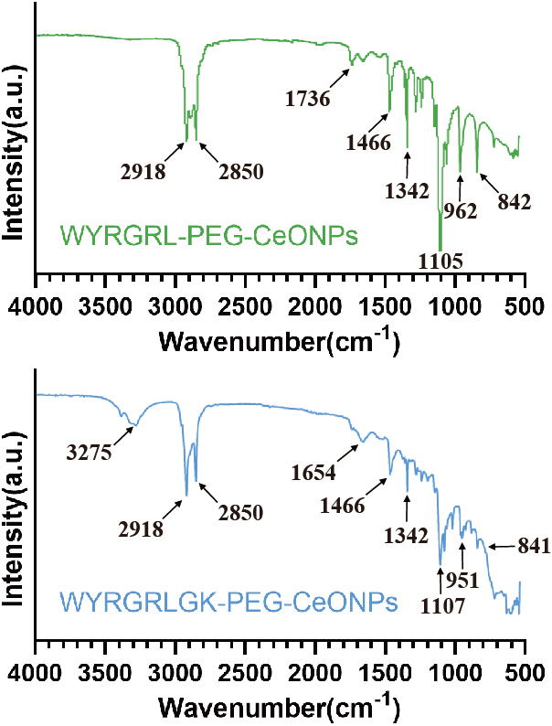
Figure S1. FTIR was utilized to analyze the spectral properties of WYRGRL-PEG-CeONPs and WYRGRLGK-PEG-CeO.

