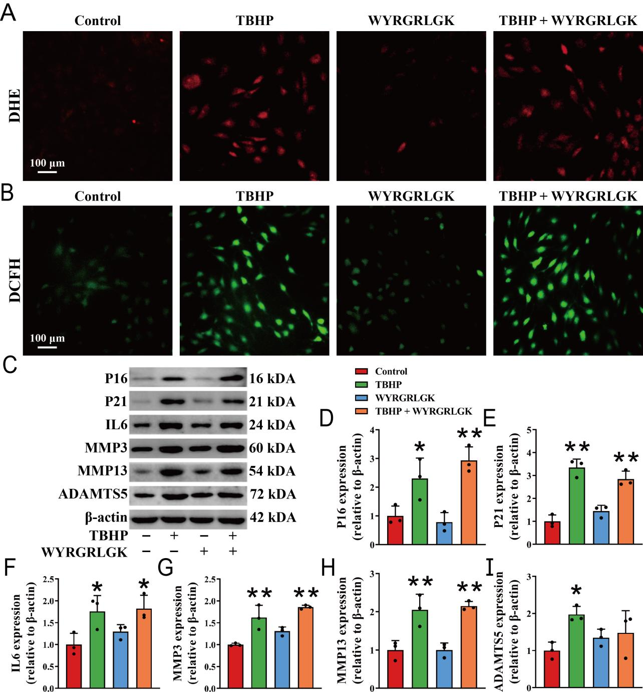
Figure S2. WYRGRLGK intervention alone did not alleviate oxidative stress or inhibit chondrocyte senescence. (A, B) WYRGRLGK were co-incubated with TBHP-intervened chondrocytes and then intracellular ROS levels were detected by DCFH-DA and DHE probes. (C-I) The protein expression levels of P16, P21, IL6, MMP3, MMP13, and ADAMTS5 in chondrocytes were investigated by western blotting. * means p < 0.05 vs the Control group, ** means p < 0.01 vs the Control group.

