Supporting Information

Natural Epigallocatechin-3-gallocarboxylate Nanoformulation Loaded Doxorubicin to Construct a Novel and Low Cardiotoxicity Chemotherapeutic Drug for High-Efficiency Breast Cancer Therapy

Ke Wang ^{1, 2}, Siqi Geng ^{1, 2}, Fang Wang ^{3, 2}, Baoru Fang ^{1, 2}, Huifeng Qian ⁴, Ying Li ², Yiqing Zhou ², Yanping Chen ^{1, 2}, Zhangsen Yu ^{2, 1*}
Affiliations:
¹ School of Life and Environmental Sciences, Shaoxing University, Shaoxing City, Zhejiang Province, 312000, China
² Laboratory of Nanomedicine, Medical Science Research Center, School of Medicine, Shaoxing University, Shaoxing City, Zhejiang Province, 312000, China
³ The First Clinical Medical College, Wenzhou Medical University, Wenzhou, Zhejiang Province, 325000, China
⁴ Department of Clinical Laboratory, Shaoxing Second Hospital, Shaoxing City, Zhejiang Province, 312000, China

∗ Author for correspondence

Zhangsen Yu: (ORCID: 0000-0003-4301-5192)
Email address: yzs@usx.edu.cn

Experimental Section
Materials. Doxorubicin hydrochloride (98%), L-cysteine, 2, 2'-Azinobis (3-ethylbenzothiazoline-6-sulfonic Acid Ammonium Salt) (ABTS), potassium persulfate (K₂S₂O₈), methanol, 2, 2-diphenyl-1-picrylhydrazyl (DPPH) and ethanol (AR) were purchased from Aladdin. (-)-Epigallocatechin gallate (EGCG) was purchased from Sigma-Aldrich. One Step TUNEL Apoptosis Assay Kit, 4% Paraformaldehyde Fix Solution, DAPI Staining Solution, enhanced cell mitochondrial membrane potential assay kit with JC-1, DiO labeled cytoplasmic membrane staining kit, Hematoxylin and Eosin Staining Kit were obtained from Beyotime Biotechnology (Jiangsu, China). The reactive oxygen species assay kit, Masson’s trichrome stain kit, and Cysteine (Cys) Content Assay Kit were the products of Solarbio Science & Technology Co. Ltd. (Beijing, China). The Annexin V-FITC/7-AAD Apoptosis Kit was purchased from Pricella Life Sciences Co., Ltd. (Wuhan, China). HL-1 mouse cardiomyocytes and MEM Medium purchased from iCell Bioscience Inc (Shanghai, China). 4T1 murine breast cancer was purchased from the Shanghai Cell Bank of the Chinese Academy of Sciences. A tea polyphenol (TP) detection kit (Folin-Phenol microplate method) was purchased from Enzyme-linked Biotechnology Co., Ltd (Shanghai, China). ICR mice (License No. 20230621Abbb0100999819) and Balb/c mice (License No. 20230621Abbb0100999819) were purchased from Hangzhou Qi zen Laboratory Animal Technology Co., Ltd. (Hangzhou, China; Production License No.: SCXK (Zhe) 2022-0005). All animal procedures described above were performed according to protocols approved by the Animal Care Research Committee of Shaoxing University. Animal experiments were performed in the pathogen-free condition at the First Affiliated Hospital of the University of Shaoxing.
Preparation and Characterization of EGCG&Cys(DOX) nano chemotherapeutic drug
Preparation of EGCG&Cys nanoformulation
Typically, EGCG (91.5 mg, 0.002 M) and 80 μL of formaldehyde solution were dissolved in 40 mL of deionized water with vigorous stirring at 30℃ for 10 min. Then, L-cysteine (5 mg, 0.008 M) was added to the solution and stirred for 6 h. The color of the reaction solution changed from colorless to milky white. EGCG&Cys nanoformulations were obtained by centrifugation (10000 rpm, 10 min), washed three times with deionized water, resuspended in 40 mL of deionized water, and stored at 4℃ for future use.
Determination of EGCG and Cys mass concentration
The mass concentration of EGCG in EGCG&Cys nanoformulation was determined by a tea polyphenol (TP) detection kit (Folin-Phenol microplate method). The diluted EGCG&Cys nanoformulation suspension is added to the freshly prepared Folin-Phenol working solution. Shake the mixture well and store at 25°C for 8 min in the dark. Then, the TP chromogenic solution was added, and the mixture was shaken, kept at 25°C for 60 min in the dark, and prepared for measurement. The mixture absorbance was determined using a SpectraMax i3x multimode microplate reader at 765 nm. Establish a standard curve for EGCG within the concentration range of 5 ~ 100 μg/mL (A_{765 nm} = 0.00561 × C_{EGCG} + 0.03391, R² = 0.9984). Then, the EGCG concentration will be calculated based on the absorbance value of the mixed solution at 765 nm and the standard curve.
A cysteine content detection kit determined the mass concentration of Cys in EGCG&Cys nanoformulation. First, the diluted nanoparticle suspension was added to the freshly prepared assay solution. The mixture was shaken and incubated at 25°C for 15 min, and absorbance values were determined at 600 nm using a SpectraMax i3x multimode microplate reader. Calculate the concentration of Cys using the standard curve (A_{600 nm} = 0.0763 × C_{cys} + 0.0257, R² = 0.9943) within the concentration range of 0 ~ 2 μg/mL. The Cys concentration will be calculated based on the absorbance value of the mixed solution at 600 nm and the standard curve.
Reaction kinetic curve
Briefly, the SpectraMax i3x multimode microplate reader was designed to measure the absorbance value of the reaction solution at 660 nm every min for 4 h, which helped us obtain reaction kinetics curves of EGCG&Cys nanoformulation. To determine the EGCG&Cys reaction kinetics curves under different reaction conditions, we varied the synthesis parameters in the experiment, such as reactant concentration, the ratio of EGCG to Cys, and various proportions of formaldehyde and ethanol in the reaction system. To better understand the synthesis mechanism of EGCG&Cys nanoformulation, we used the Hill equation to fit its reaction kinetics curve and obtain characteristic parameters that characterize the reaction process. The Hill equation is shown as follows:
Where n is the Hill coefficient that characterizes the synergy between different reaction conditions; t is the reaction time; k is half the time required for the reaction to reach the equilibrium state; and is the maximum absorbance value at 660 nm of the EGCG nanoparticles generated when the reaction reaches equilibrium state.
Synthesis of EGCG&Cys(DOX) nano chemotherapeutic drug
EGCG&Cys(DOX) was prepared by mixing EGCG&Cys nanoformulation dispersion and small molecule chemotherapy drug DOX solution in different mass ratios (M_{DOX} : M_{EGCG&Cys} = 1 : 8, 1 : 4, 1 : 2), and stirring in the dark at room temperature for 24 h. After the synthesis reaction, EGCG&Cys(DOX) was collected, centrifuged at 11000 rpm for 10 min, and washed with deionized water until the supernatant was colorless. The loading efficiency and capacity of DOX are calculated as follows:
Loading efficiency = (M_{DOX} - m_{DOX}) / M_{DOX} × 100%
Loading capacity = (M_{DOX} - m_{DOX}) / (M_{EGCG&Cys} + M_{DOX} - m_{DOX}) × 100%
M_{DOX} and M_{EGCG&Cys} are the total DOX and EGCG&Cys in the reaction solution, respectively, and m_{DOX} is the mass of DOX in the collected supernatant. m_{DOX} was calculated by the standard curve of the DOX concentration and its absorbance value at 488 nm. After comparing the dispersibility, DLS, Zeta potential, loading efficiency, and loading capacity of EGCG&Cys(DOX) synthesized under different mass ratio conditions, we chose a mass ratio 1:2 to synthesize EGCG&Cys(DOX) for future use. Finally, we have obtained sufficient EGCG&Cys(DOX) with a loading efficiency of 99.2% and a loading capacity of 33.1% for subsequent cell and animal experiments.
Characterization of EGCG&Cys(DOX)
The morphology and size of EGCG&Cys nanoformulation were characterized by transmission electron microscopy (JEM-2100F, Japan). Nano Measure 1.2 software was used to calculate the mean and standard deviation of the particle sizes of 50 EGCG&Cys nanoparticles. A Malvern Zetasizer Nano ZS (Malvern Instruments Ltd., UK) was utilized to determine the mean dynamic light scattering (DLS) sizing, polydispersity index, and zeta potential of both EGCG&Cys and EGCG&Cys(DOX). Fluorescence spectra were obtained by a fluorescence spectrometer (RF-6000, SHIMADZU). The UV-vis spectrometer (UV-1900, Shimadzu, Japan) recorded the absorption spectra of EGCG&Cys nanoformulation. EGCG, Cys, DOX, and polyphenol nanoparticles (lyophilized powder) are mixed in potassium bromide and compressed into glassy flakes. Fourier Transform Infrared (FTIR) Spectrum measurements were performed using a Nicolet 6700 spectrometer in the 400 - 4000 cm⁻¹ range at 4 cm⁻¹ solution with 32 scans.
In vitro DOX release experiment
The dialysis method was used to evaluate the kinetics of DOX release under pH stimulation and set three groups as follows: (1) pH = 7.4, (2) pH = 6.5, (3) pH = 5.0. 2 mL EGCG&Cys(DOX) at a concentration of 0.625 mg mL⁻¹ was packed in a dialysis bag (MWCO = 3.5 kDa), immersed and stirred in 200 mL PBS. In addition, remove 300 μL of the supernatant at different time points and add the same amount of fresh PBS. The DOX concentration in the supernatant is measured by fluorescence intensity at 580 nm. Finally, the cumulative release percentage of DOX is calculated to assess release kinetics.
Time-dependent stability of EGCG&Cys(DOX) at different pH solutions
EGCG&Cys(DOX) is dispersed in buffer solutions at pH 7.4, 6.5, and 5.0, respectively. After slowly stirring for 0, 6, 12, and 24 hours, the DLS and transmission electron microscopy (TEM) of EGCG&Cys(DOX) were tested to evaluate their dispersivity and morphological changes.
Antioxidant capacity
Evaluate the antioxidant performance of EGCG&Cys nanoformulation by detecting its ability to scavenge ABTS and DPPH free radicals produced in methanol solution. In the DPPH radical scavenging experiment, various concentrations of EGCG&Cys(DOX) (2, 4, 6, 8, and 10 μg/mL) and same mass concentrations of EGCG&Cys (1.34, 2.68, 4.02, 5.36, and 6.7 μg/mL) were added to a freshly prepared methanol DPPH solution (0.04 mM). The mixture was left in the dark for 30 min, and the absorbance value at 517 nm was measured using a UV-vis spectrometer (UV-1900, Shimadzu, Japan). For the ABTS total antioxidant capacity experiment, ABTS stock solution was prepared by mixing ABTS aqueous solution (7 mM, 2.5 mL) with potassium persulfate in water (140 mM, 44 μL) and keeping it in the dark for 14 h. The stock solution was diluted about 20 times with methanol (80%) to create a fresh ABTS working solution. Then, 100 μL of the working solution and 100 μL of methanol solution were mixed to adjust the absorbance to 0.75 ± 0.05 at 734 nm. Store in the dark at 25°C for 30 min. After 30 min, the absorbance values are determined with a microplate reader (SpectraMax i3, Molecular Devices, USA) at 734 nm. The formula calculates free radical scavenging activity and total antioxidant capacity: Y = (1 - (A_{sample} - A_{control}) / A₀) × 100%.
Where Y is the free radical scavenging activity or total antioxidant capacity, Where A_{sample} is the absorbance values of samples with different concentrations mixed with DPPH or ABTS, A_{control} is the absorbance values of samples with various concentrations, and A₀ is the absorbance value of the antioxidant free DPPH or ABTS solution.
Cell experiments
Cell culture
There are two cell lines: the mouse breast cancer 4T1 cell line and the mouse cardiomyocyte line (HL-1). 4T1 and HL-1 cells were cultured in RPMI-1640 medium and MEM medium, respectively, containing 10% fetal bovine serum and 1% penicillin/streptomycin, 37°C, and 5% CO₂.
Cytotoxicity assays
Determine the relative cell viability of drugs with different concentrations co-cultured with 4T1 and HL-1 cells by the standard MTT assay. First, cells are incubated in 96-well plates at 10⁴ cells per well and overnight at 37°C under humidified 5% CO₂. Different concentrations of EGCG&Cys(DOX), DOX, and EGCG&Cys were added to the wells for 24 h (the final DOX concentrations were 0.775, 1.55, 3.1, 6.2, and 12.4 μg/mL, respectively). Then, the cells were washed twice with PBS and treated with MTT to form formazan dye. After 4 h, dissolve the purple formazan in each well with DMSO and shake for 10 min. Finally, a microplate reader (SpectraMax i3, Molecular Devices, USA) measured the absorbance of formazan at 490 nm and calculated the relative cell viability. The half maximal inhibitory concentration (IC50) values were calculated using GraphPad Prism version 7.0.
Cell uptake observation
Detection of DOX and EGCG&Cys(DOX) uptake by 4T1 and HL-1 cells using fluorescence staining and co-localization methods. Cells were seeded into four-well chamber coverslips with a density of 8×10⁴ per well. After ensuring cell adherence, DOX or EGCG&Cys(DOX) was added to the wells with a final concentration of 2.5 and 5.0 μg/mL (in terms of EGCG&Cys(DOX)). Then, after 2 h or 4 h, the PBS is washed 3 times, and 4% paraformaldehyde fixation solution is added to each well for 30 min. After washing with PBS, the cell membrane was stained with DiO staining solution and incubated at 37°C in the dark for 10 min. Then, the DAPI staining solution for the cell nucleus was added and stained at room temperature for 4 min. Finally, it was washed with PBS three times for 4 min each. Laser scanning confocal microscopy (ZEISS, LSM 900) was used to capture cell fluorescence co-localization images and analyze the intensity distribution of three different colored fluorescence in a single cell.
Cells apoptosis assays
The Annexin V-FITC/7-AAD Apoptosis Assay Kit assessed the apoptosis ratio of 4T1 and HL-1 cells. First, cells were seeded into 6-well plates at a density of 5×10⁵ per well. After cell adhesion, DOX (0.775, 1.55 μg/mL) or EGCG&Cys(DOX) (2.5, 5 μg/mL) were added to the wells. After 24 h, the cells were collected and diluted in 1 × binding buffer to prepare a single-cell suspension. And then, 100 μL of the cell suspension was stained with Annexin V-FITC staining (5 μL) and 7-AAD (5 μL) for 15 min. Finally, 400 μL of PBS was added for flow cytometry (Beckman Coulter, Cytoflex, USA) analysis.
Assessment of the degree of oxidative stress imbalance
DCFH-DA staining is used to detect the ROS level by cells due to oxidative stress imbalance. First, HL-1 and 4T1 cells are seeded into four-well cavity lid glass at a density of 8×10⁴ per well and cultured overnight until adherent. Then, DOX or EGCG&Cys(DOX) was added to the wells with concentrations of 0.05 and 1 μg/mL (in terms of EGCG&Cys(DOX)). The treated cells were cultured for 4 h, and then the ROS level in the cells was assessed by fluorescent DCF using the Reactive Oxygen Species Assay Kit. After 20 min of DCFH incubation, HL-1 cells were washed three times by MEM and 4T1 cells by RPMI-1640 three times. Finally, fluorescence images were taken by laser scanning confocal microscopy.
The JC-1 Enhanced Mitochondrial Membrane Potential Assay Kit was used to test mitochondrial membrane potential. First, HL-1 and 4T1 cells (8×10⁴ per well) were seeded overnight in four-well chamber coverslips until adhesion. Then, DOX or EGCG&Cys(DOX) was added to the wells with EGCG&Cys(DOX) concentrations of 0.5 and 0.1 μg/mL. After 24 h of incubation, the cell culture medium was discarded, and the cells were incubated with JC-1 staining solution at 37°C for 20 min. After that, it was washed twice with JC-1 dye buffer and observed under a laser scanning confocal microscope.
Mitochondrial respiratory chain complex I/NADH-CoQ reductase activity assay
Firstly, HL-1 cells (4×10⁶ per dish) were inoculated into dishes overnight to allow them to adhere. Subsequently, DOX at concentrations of 1.96 and 3.92 μg/mL, EGCG&Cys(DOX) at a concentration of 5.92 μg/mL, and EGCG&Cys at 7.92 μg/mL were added to the wells. After incubation for 12 hours, the cells were digested with trypsin and collected. The mitochondrial respiratory chain complex I/NADH-CoQ reductase activity was measured using the assay kit method. Finally, the absorbance value at 340 nm was measured to calculate the mitochondrial respiratory chain complex I/NADH-CoQ reductase activity.
Western blot analysis
Western blotting was used to detect the expression of Keap-1, HO-1, and Nrf2 (Affinity Biosciences, China) in HL-1 cells and Bax, Bcl-2, and caspase-3 proteins in 4T1 cells. The antibodies corresponding to the above proteins were purchased from the Proteintech Group (Chicago, USA). First, HL-1 cells or 4T1 cells (5×10⁵ per well) are seeded in six-well plates overnight until adherence. Then, the drugs were added to the wells at concentrations of 1.96 and 3.92 μg/mL DOX, EGCG&Cys(DOX) at a concentration of 5.92 μg/mL, and EGCG&Cys at a concentration of 7.92 μg/mL, respectively. After incubation for 24 hours, 80 μL of prepared lysate (RIPA : protease inhibitor : phosphatase inhibitor : trypsin = 50 : 1 : 1 : 1) is added to each well to lyse the cells. After resting on ice for 10 min, scrape the cells with a cell scraper (proceed on ice) and collect the cells. Total cell protein was extracted by centrifugation (12000 rpm/min, 30 min). Then, the target protein was subjected to sodium dodecyl sulfate-polyacrylamide gel electrophoresis (SDS-PAGE), membrane replica, blocking, and addition of diluted primary antibody, and then incubated at 4°C overnight. After washing with TBST, add the secondary antibody and incubate at 25°C for 1.5 h. Finally, a chemiluminescence reagent for chemiluminescence imaging detection will be added. The band’s gray value was calculated using Image J software to analyze the protein expression.
Transmission electron microscopy (TEM) observation of mitochondria from HL-1 cells
HL-1 cells were incubated in Petri dishes at 6×10⁶ per dish overnight at 37°C, and after ensuring cell adherence, DOX or EGCG&Cys(DOX) were added to the dishes to achieve a final concentration of DOX of 6.2 μg/mL and a final concentration of EGCG&Cys(DOX) of 18.73 μg/mL. After 24 h of drug incubation, the cells were trypsinized. Then, the cells were collected in a centrifuge tube by centrifugation at 1200 rpm for 5 min, and 2 mL of 2.5% glutaraldehyde solution with pH = 7.4 was added, and the cells were fixed at room temperature for 2 h. Then dehydration, osmosis embedding, polymerization, and sectioning were carried out at room temperature and then stained with 2% uranium acetate saturated alcohol solution for 10 min, washed with ultrapure water for 3 times, dried overnight at room temperature, and observed under a transmission electron microscope.
Evaluation of antitumor efficacy in vivo
Tumor model
The 4T1 mouse mammary cancer cell line (10⁶ cells in 50 μL serum-free cell culture medium) was injected into female Balb/c mice (4-6 weeks old) in the lower right side of the back to construct a subcutaneous breast cancer model. When the tumor volume grew to 50-60 mm³, mice were used for further experiments.
Evaluation of chemotherapy efficacy for breast cancer
4T1 tumor-bearing mice were randomly divided into 5 groups (n = 8 per group): saline, 2.5 mg/kg DOX, 5 mg/kg DOX, 7.58 mg/kg EGCG&Cys(DOX), and 10.16 mg/kg EGCG&Cys. The corresponding drug was injected intravenously when the tumor volume reached 50-60 mm³. Within 14 days, intravenous chemotherapy drugs are given 7 times. During chemotherapy, tumor-bearing mice were weighed, and tumor volumes were measured every other day. Tumor size is measured with a digital vernier caliper and calculated volume by the following equation: V = (L × W²) / 2, where W and L are tumor width and length, respectively. The tumor growth inhibition index (TGI) is calculated as follows: TGI (%) =[1-RTV (treatment group) / RTV (control group)] × 100%, relative tumor volume (RTV) = V_{t} / V₀, where V_{t} is the average tumor volume at the end of one experimental cycle, and V₀ is the average tumor volume at the start of the experiment. After chemotherapy, blood samples were collected from the mouse eye sockets to detect the essential indicators of blood routine and serum biochemistry. Implement euthanasia, dissect and remove major organs, weigh and calculate organ coefficients, and make histotomy sections.
Evaluation of cardiac function
The cardiac function of tumor-bearing mice in each group during chemotherapy experiments was assessed using the electrocardiogram (ECG) and ultrasound echocardiography (UCG) results. The heart rate was calculated by measuring the changes in the ECG pattern of the QT interval and by performing spectral analysis of the R-R interval of the ECG signal. Morphofunctional parameters assessed by cardiac function by echocardiography include diastolic left ventricular diameter (LVIDd), left ventricular diameter systolic (LVIDs), left ventricular ejection fraction (LVEF), and left ventricular shortening fraction (LVFS). Furthermore, Various serum biochemical indexes related to cardiac function, such as alanine aminotransferase (ALT), aspartate aminotransferase (AST), lactate dehydrogenase (LDH), creatine kinase (CK), creatine kinase isoenzyme (CKMB), etc. were determined by a biochemical analyzer (AU480, Beckman Coulter).
Assessment of acute toxicity in vivo
Healthy male ICR mice (4-6 weeks) were used to assess the acute toxicity of EGCG&Cys(DOX). Mice are randomly divided into four groups (n = 5 for each group): saline, 10 mg/kg, 50 mg/kg, and 100 mg/kg EGCG&Cys(DOX). The first day is given intravenously in different doses of EGCG&Cys(DOX). The mice were weighed and observed every other day, recording their weight gain, food intake, mental state, and mortality rate for 35 days. On the last day, blood was collected from the eyeballs of mice for routine blood tests and serum biochemical analyses. Furthermore, major organs, including the heart, liver, spleen, lungs, and kidneys, were taken to calculate organ coefficients, make sections, and then hematoxylin and eosin (H&E) staining.
Determination of pharmacokinetic curves and tissue distribution
Determination of pharmacokinetic curves in mice: Healthy ICR mice were randomly divided into two groups. Each group was injected with either a DOX solution at a 15 mg/kg concentration or an EGCG&Cys(DOX) solution at a 50 mg/kg concentration via the tail vein. Blood samples were collected from the mouse eyeball at 2.5, 5, 7.5, 10, 15, 20, 30, 45, and 60 minutes post-administration and placed into heparinized 1.5 mL centrifuge tubes. The tubes were centrifuged at 4°C at 3000 rpm for 5 min to separate the plasma samples. Subsequently, 50 μL of plasma sample was aliquoted, and 150 μL of acetonitrile-5 mmol/L ammonium acetate (60:40, V/V) extract containing 10 μL of 15 μg/mL Daunorubicin (DNR) was added to precipitate proteins. The mixture was vortexed and mixed for 3 minutes at 13000 rpm, followed by centrifugation for 10 minutes. Finally, 50 μL of the supernatant was taken for LC-MS (Liquid Chromatography-Mass Spectrometer, FH-6000MD, Thermo Fisher, USA) injection and detection analysis.
Determination of Drug Distribution in Mouse Tissues: The tumor-bearing Blab/c mice were injected with DOX at a concentration of 15 mg/kg and EGCG&Cys(DOX) at 50 mg/kg via tail vein. At 1 hour and 24 hours post-administration, heart, liver, spleen, lung, kidney, and tumor tissues were excised, washed with normal saline, weighed, and homogenized with normal saline at a mass:volume ratio of 1:5. To the homogenized samples, 80% acetonitrile and methanol, were added at a volume ratio of 2:3:1, vortexed and shaken for two minutes, then centrifuged at 4000 rpm in a pre-set 4°C high-speed refrigerated centrifuge for 5 minutes. The supernatant was collected for purification. Methanol was added at a volume ratio of 3:2 (supernatant : methanol), vortexed for 5 minutes, and sonicated for 15 minutes. The filtrate was passed through a 0.45 μm membrane filter, and the filtrate was collected. To 50 μL of the filtrate, 150 μL of acetonitrile-5 mmol/L ammonium acetate (60:40, V/V) extract containing 10 μL of 15 μg/mL Daunorubicin (DNR) was added to precipitate proteins. Finally, the mixture was vortexed and mixed for 3 minutes at 13000 rpm, centrifuged for 10 minutes, and 50 μL of the supernatant was used for LC-MS injection and detection analysis.
The standard curve is obtained by fitting the ratio of the peak area of doxorubicin measured under the same conditions to the peak area of the internal standard erythromycin to the concentration of DOX, which is used to calculate the concentration of DOX in the sample.
Histological analysis (H&E, Masson, TUNEL, and Ki67 staining)
H&E staining is used to examine the pathological changes in primary organ tissues. Masson and TUNEL staining were used to analyze the degree of cardiac tissue damage in the chemotherapy group mice further. Evaluate chemotherapy-induced apoptosis and proliferation of tumor cells through TUNEL and Ki67 staining. Cut the paraffin-embedded organ tissue into 4 μm thick sections. For H&E staining, tissue sections were deparaffinized with xylene, gradient dehydrated with absolute ethanol, and then stained with hematoxylin and eosin at room temperature.
Cardiac histology sections were first deparaffinized for Masson staining and stained with Weigert's iron hematoxylin solution and aniline blue stains. Finally, the sections are quickly dehydrated and sealed with neutral gum.
For TUNEL staining, heart and tumor tissue sections are deparaffinized with xylene and dehydrated with absolute ethanol. Then, incubate with proteinase K (without DNase) for 25 min, respectively. After washing with PBS, incubate with TUNEL detection solution for 1 h at 37°C in the dark and stain with DAPI for 4 min. Finally, the antifade mounting medium is placed into cardiac and tumor tissue sections for further observation.
For Ki67 staining, deparaffinize tumor sections to water. Moreover, the primary antibody dilution was added and incubated overnight at 4°C for antigen retrieval. Then, add the secondary antibody dilution, set at 25°C for 50 min, and add the freshly prepared DAB chromogenic solution. Finally, it was stained with a hematoxylin staining solution for 3 min, and the slides were observed after gradient dehydration with absolute ethanol.
H&E, Masson, and Ki67 stained images were observed and captured using a Leica DM 3000 microscope. TUNEL-stained fluorescence images were observed and photographed by laser scanning confocal microscopy (ZEISS, LSM 900).
Statistical analysis
Results were presented as the mean value ± SD. Ordinary one-way analysis of variance (ANOVA) was adopted for statistical analysis. Differences were considered statistically significant at *p < 0.05, **p < 0.01, and ***p < 0.001.

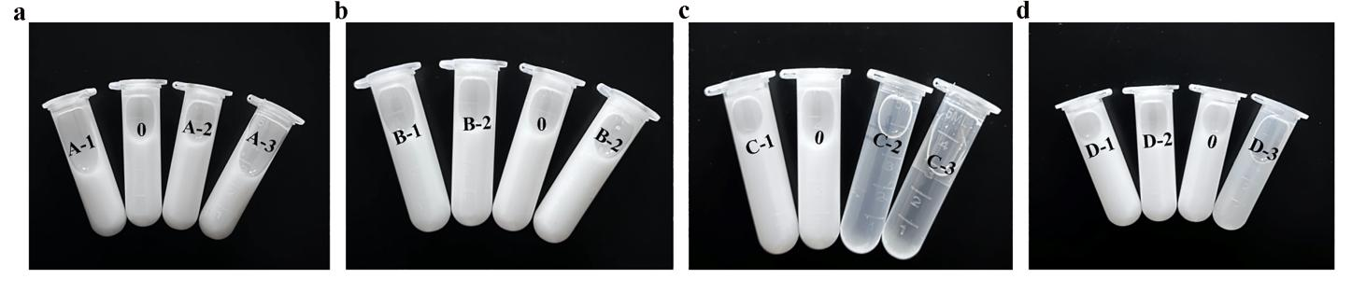
Figure S1. Photos of EGCG&Cys nanoformulation after 4 h reaction at different synthesis parameters.

Table S1. Dynamic light scattering (DLS) and polydispersity index (PDI) of EGCG&Cys nanoformulations were obtained under different synthesis conditions.
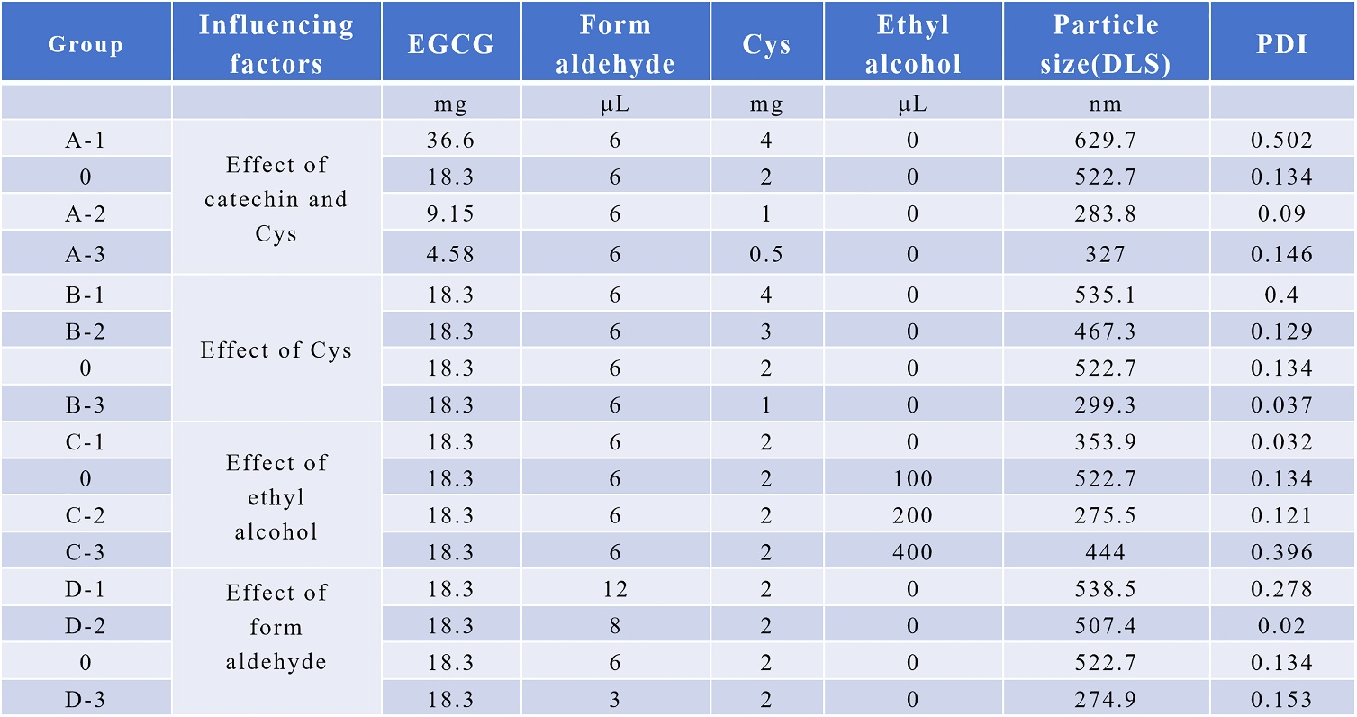

Table S2. The results of fitting the reaction kinetics curves of EGCG&Cys nanoformulations under different synthesis conditions using the Hill function, including the non-curve fitting equations, correlation coefficient, maximum reaction rate, and reaction-onset time.
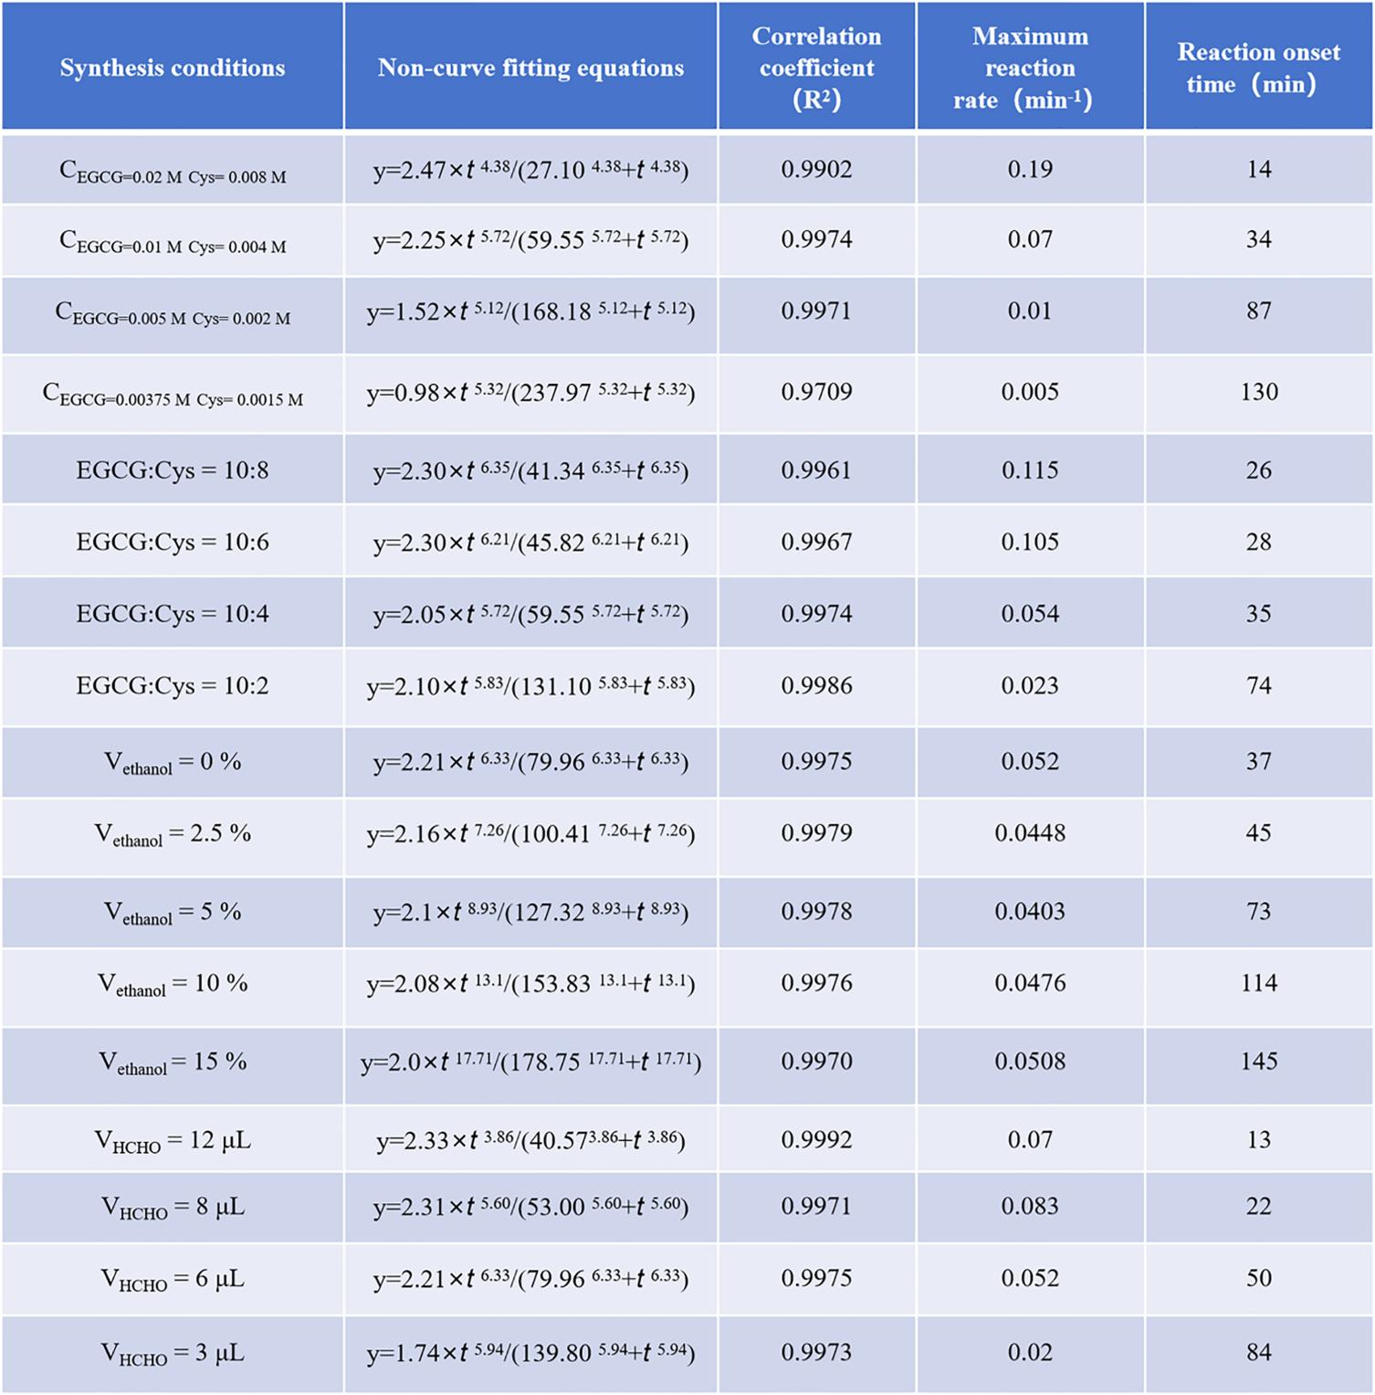

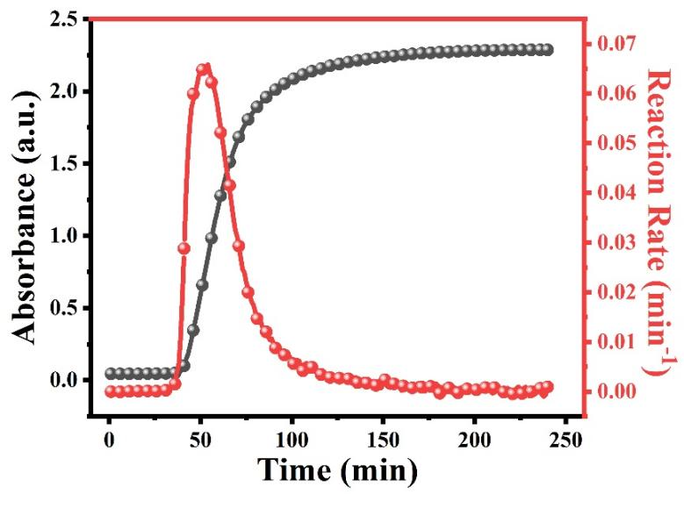
Figure S2. The reaction kinetics process of synthesizing EGCG&Cys nanoformulation under C_{EGCG} = 0.01 M, Cys = 0.004 M condition, the curve fitted by the Hill function, and the calculated reaction rate curve.

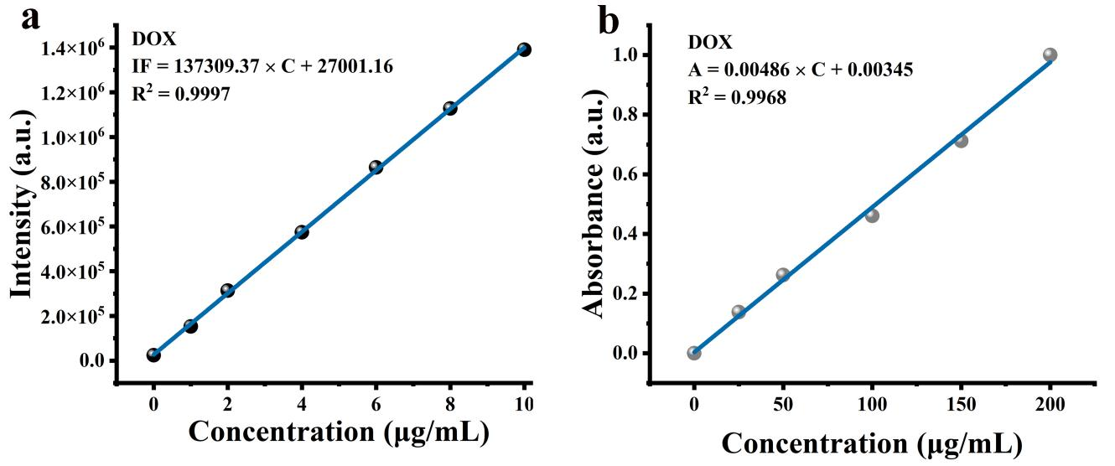
Figure S3. (a) The standard curve of the relationship between the mass concentration of the DOX and its fluorescence intensity value at 588 nm; (b) The standard curve between the DOX mass concentration and its absorbance value at 488 nm.

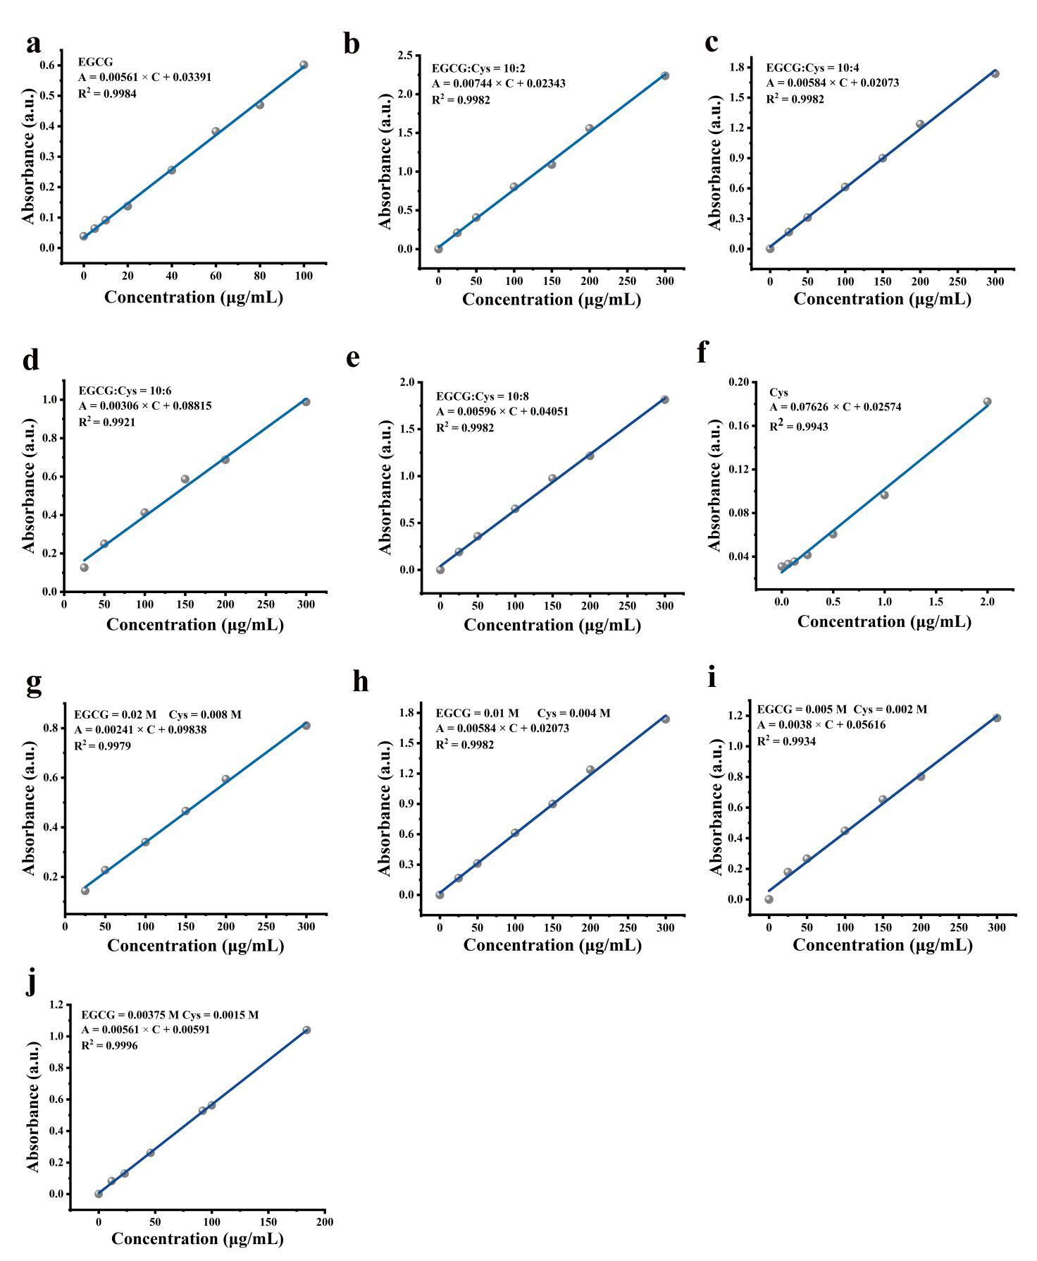
Figure S4. The standard curve of the relationship between the mass concentration of EGCG&Cys nanoformulation obtained with different reaction conditions and the absorbance values of their dispersion at 660 nm wavelength. (a) EGCG; (b) EGCG : Cys = 10 : 2; (c) EGCG : Cys = 10 : 4; (d) EGCG : Cys = 10 : 6; (e) EGCG : Cys = 10 : 8; (f) Cys; (g) EGCG = 0.02 M, Cys = 0.008 M; (h) EGCG = 0.01 M, Cys = 0.004 M; (i) EGCG = 0.005 M, Cys = 0.002 M; (j) EGCG = 0.00375 M, Cys = 0.0015 M.

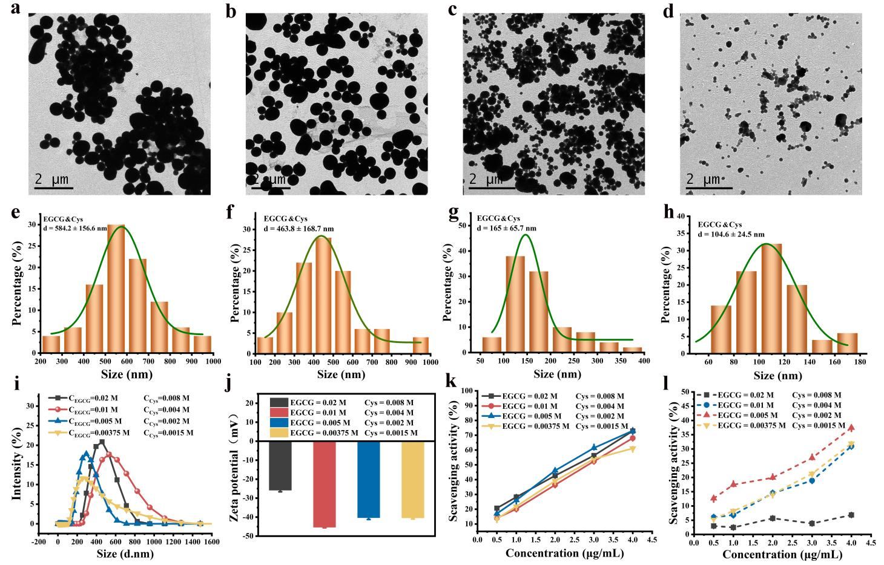
Figure S5. (a, e) Images of TEM and particle size distribution of EGCG&Cys nanoformulation obtained with a mass concentration of EGCG = 0.02 M and Cys = 0.008 M; (b, f) EGCG = 0.01 M and Cys = 0.004 M; (c, g) EGCG = 0.005 M and Cys = 0.002 M; (d, h) EGCG = 0.00375 M and Cys = 0.0015 M; (i, j) DLS and zeta potential of EGCG&Cys nanoformulation synthesized at different reactant concentrations; (k) ABTS and (l) DPPH free radical were scavenged by EGCG&Cys nanoformulation prepared at various reactant concentrations.

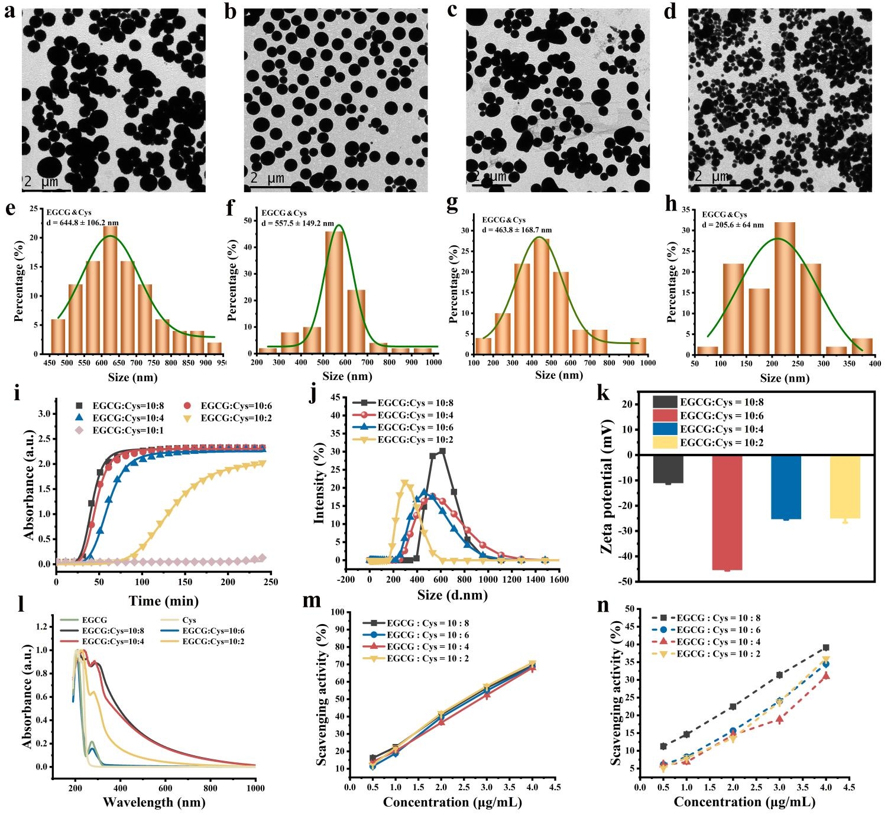
Figure S6. (a, e) Images of TEM and particle size distribution of EGCG&Cys nanoformulation synthesized with a different reactant ratio of EGCG : Cys = 10 : 2; (b, f) EGCG : Cys = 10 : 4; (c, g) EGCG : Cys = 10 : 6; (d, h) EGCG : Cys = 10 : 8; (i) The reaction process of synthesizing EGCG&Cys nanoformulation with different reactant ratios and the reaction kinetics curves fitted by the Hill function; (j, k) DLS and zeta potential of EGCG&Cys nanoformulation obtained at different reactant ratios; (l) UV-Visible-Near infrared absorption spectra of EGCG, Cys, and EGCG&Cys synthesized under different reactant ratios; (m) ABTS and (n) DPPH free radical were scavenged by EGCG&Cys nanoformulation obtained at different reactant ratios.

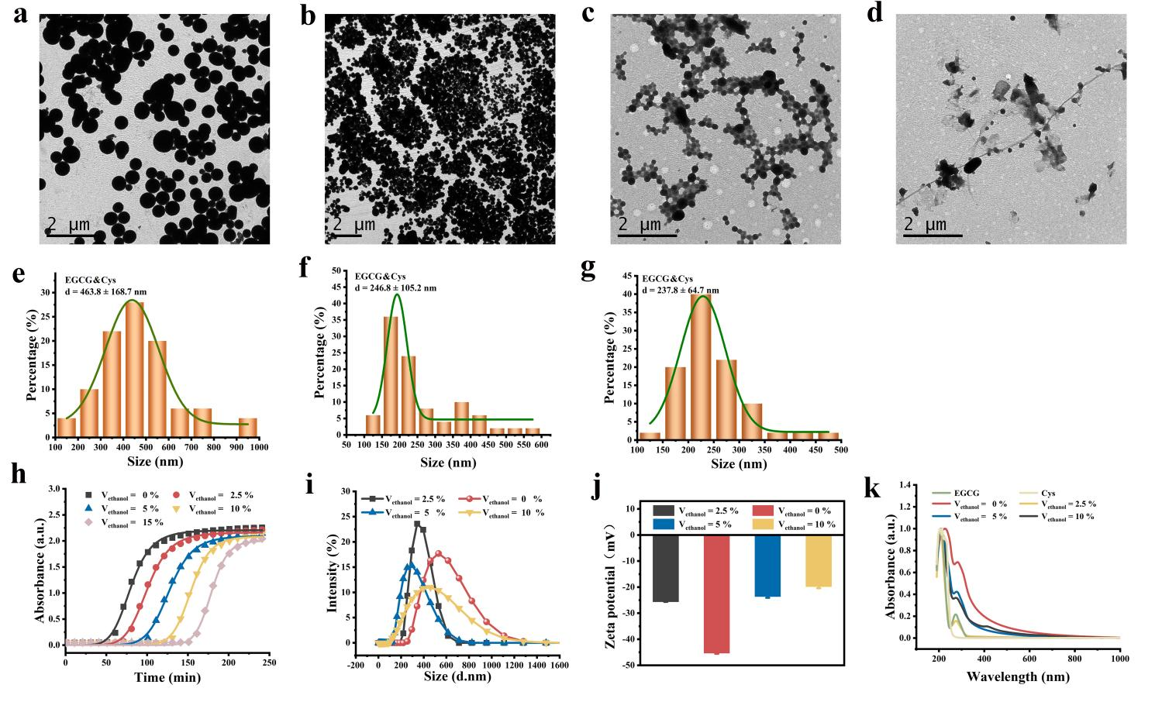
Figure S7. (a, e) Images of TEM and particle size distribution of EGCG&Cys nanoformulation synthesized with 0% ethanol content; (b, f) V_{ethanol} =2.5 %; (c, g) V_{ethanol} =5%; (d) V_{ethanol} =10%; (h) The reaction process of synthesizing EGCG&Cys nanoformulation under different ethanol content conditions and the reaction kinetics curves fitted by the Hill function; (i, j) DLS and zeta potential of EGCG&Cys nanoformulation obtained at different ethanol content reaction conditions; (k) UV-Visible-Near infrared absorption spectra of EGCG, Cys, and EGCG&Cys nanoformulation synthesized by different ethanol content.

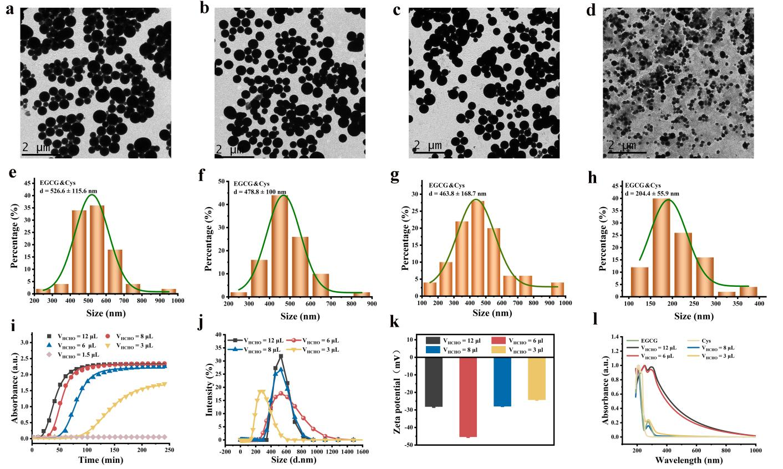
Figure S8. (a, e) Images of TEM and particle size distribution of EGCG&Cys nanoformulation synthesized with the addition of formaldehyde in a volume of 12 μL; (b, f) V_{HCHO} = 8 μL; (c, g) V_{HCHO} = 6 μL; (d, h) V_{HCHO} = 3 μL; (i) The reaction process of synthesizing EGCG&Cys nanoformulation under different amounts of formaldehyde added and the reaction kinetics curves fitted by the Hill function; (j, k) DLS and zeta potential of EGCG&Cys nanoformulation to varying quantities of formaldehyde added; (l) UV-Visible-Near infrared absorption spectra of EGCG, Cys, and EGCG&Cys obtained under different formaldehyde content reaction condition.

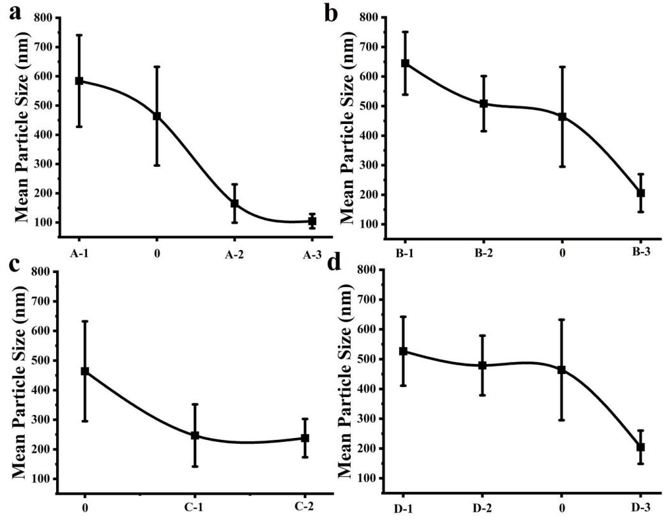

Figure S9. The correlation between the average particle size (TEM characterization) of EGCG&Cys nanoformulation and reaction conditions. (a) Different mass concentrations of reactants (EGCG and Cys); (b) Different Cys concentrations; (c) Different ethanol contents; (d) Different levels of formaldehyde content.

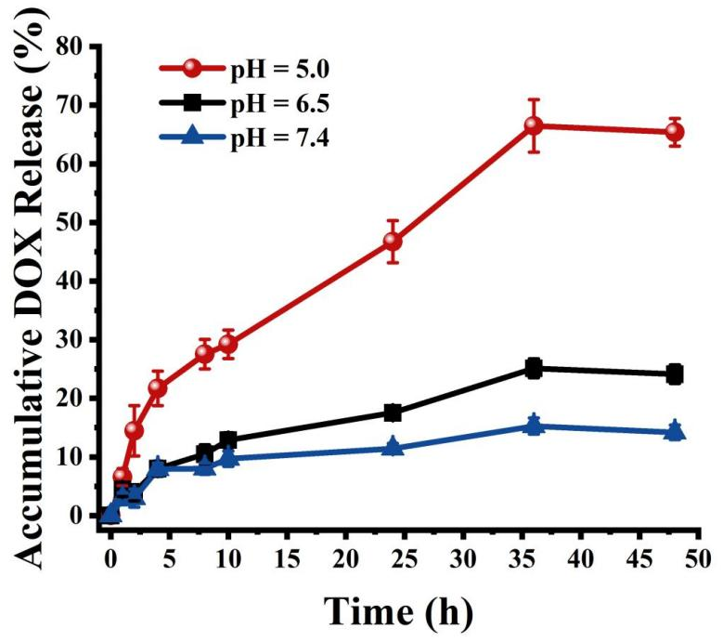
Figure S10. Release kinetics curves of DOX from EGCG&Cys(DOX) nanoformulation in PBS buffer solution at different pH values.

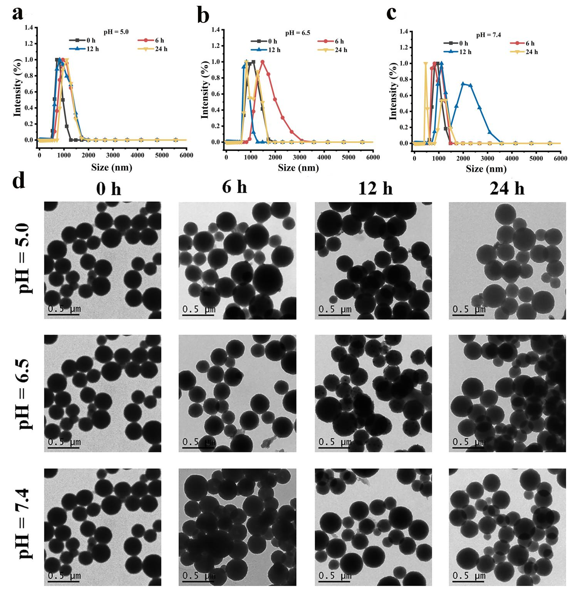
Figure S11. DLS and TEM characterization results of EGCG&Cys(DOX) nanoformulation in PBS with different pH values at various times. (a-c) DLS results of EGCG&Cys(DOX) nanoformulation in the buffer pH of 5.0, 6.5, and 7.4 at different times (0, 6, 12, and 24 h); (d) TEM images of EGCG&Cys(DOX) nanoformulation in the buffer pH of 5.0, 6.5 and 7.4 at different times (0, 6, 12 and 24 h).

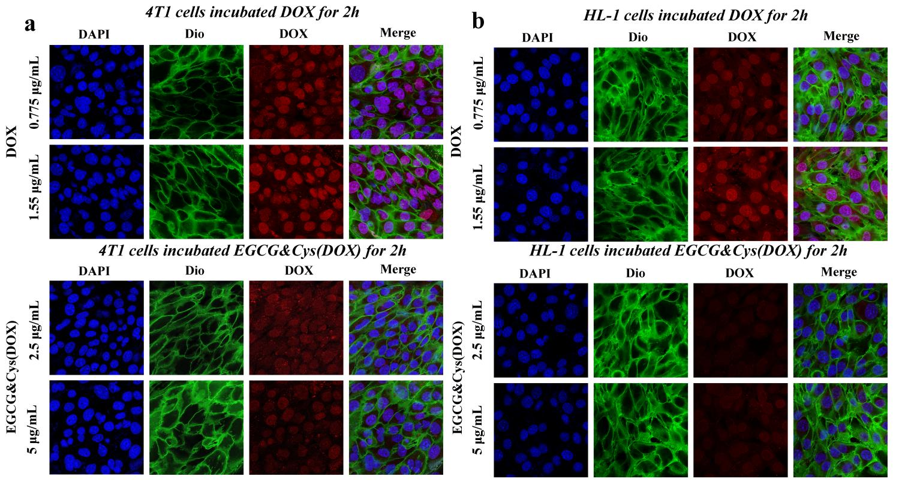
Figure S12. Cellular uptake by confocal microscopy images analysis of 4T1 and HL-1 cells coincubated with different concentrations of DOX and EGCG&Cys(DOX) for 2 h.

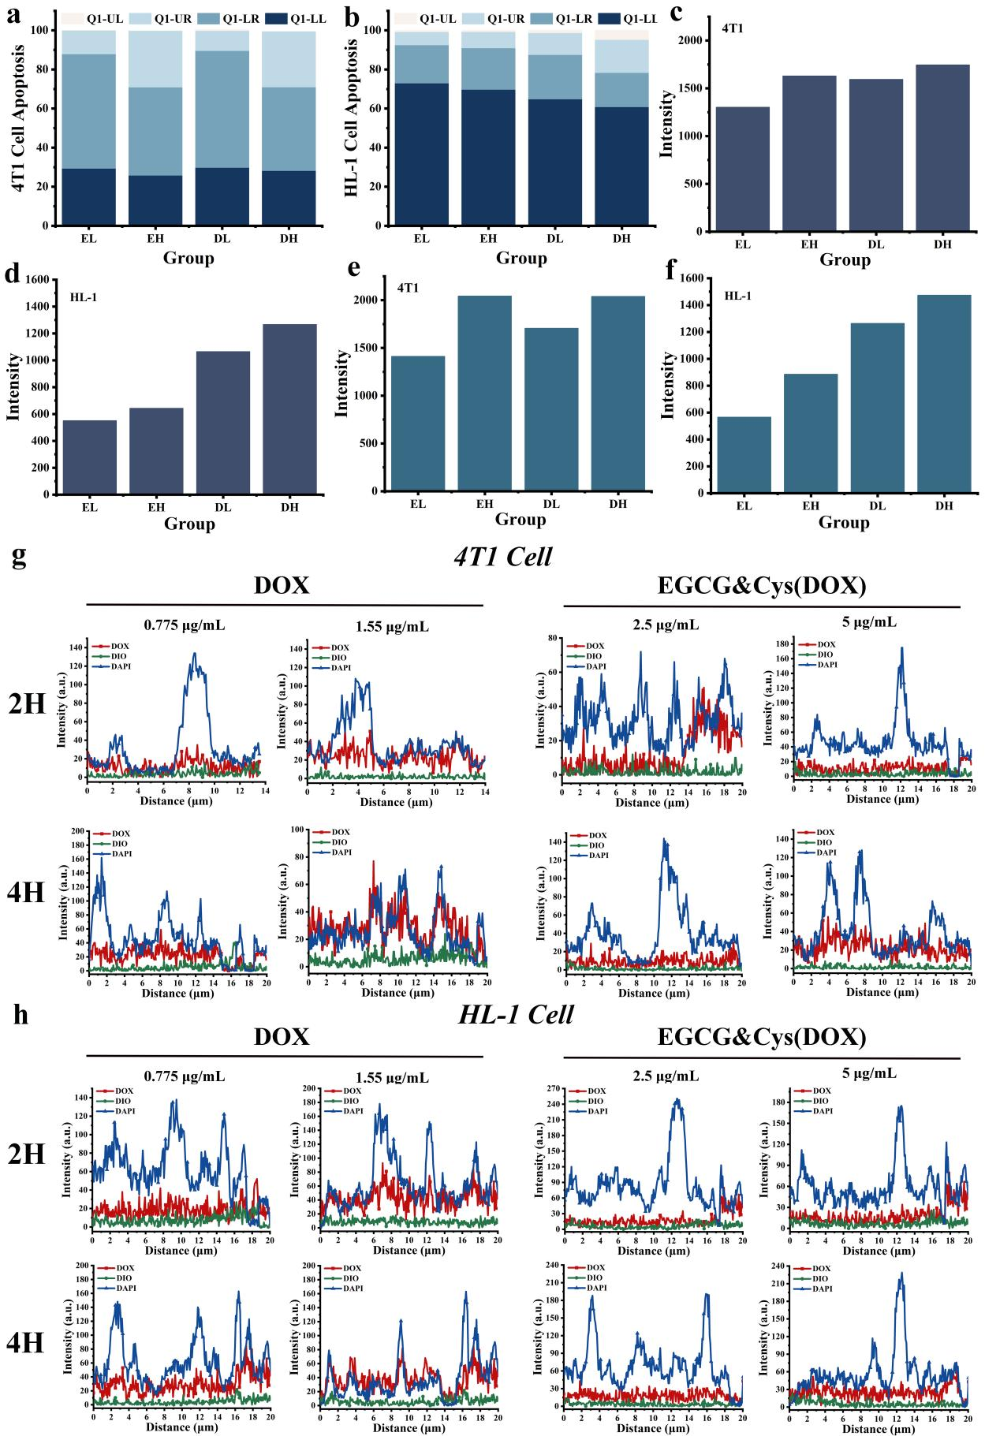
Figure S13. (a, b) Flow cytometry analysis of the apoptotic ratio of 4T1 and HL-1 cells after 24 hours of incubation with DOX or EGCG&Cys(DOX) by Annexin V-FITC/7-AAD dual dye (EL: EGCG&Cys(DOX) 2.5 μg/mL, EH: EGCG&Cys(DOX) 2.5 μg/mL, DL: DOX 0.775 μg/mL, DH: DOX 1.55 μg/mL; Q1-UL is the debris and damaged cells, Q1-UR is the late apoptotic and dead cells, Q1-LL is the normal cells of the negative control, and Q1-LR is the early apoptotic cells); (c, d) Fluorescence intensity of DOX and EGCG&Cys(DOX) in 4T1 cells and HL-1 cells was detected by ImageJ software after 2 h of drug uptake; (e, f) Fluorescence intensity of DOX and EGCG&Cys(DOX) in 4T1 cells and HL-1 cells 4 h after drug uptake; (g, h) The fluorescence intensity distribution of DOX and EGCG&Cys(DOX) in 4T1 cells and HL-1 cells was detected using confocal software after 2 h and 4 h of drug uptake by cells.

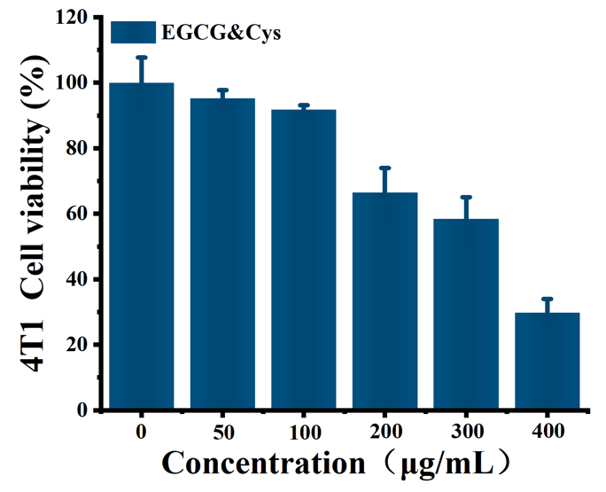
Figure S14. 4T1 cell viability under different concentrations of EGCG&Cys nanoformulation.

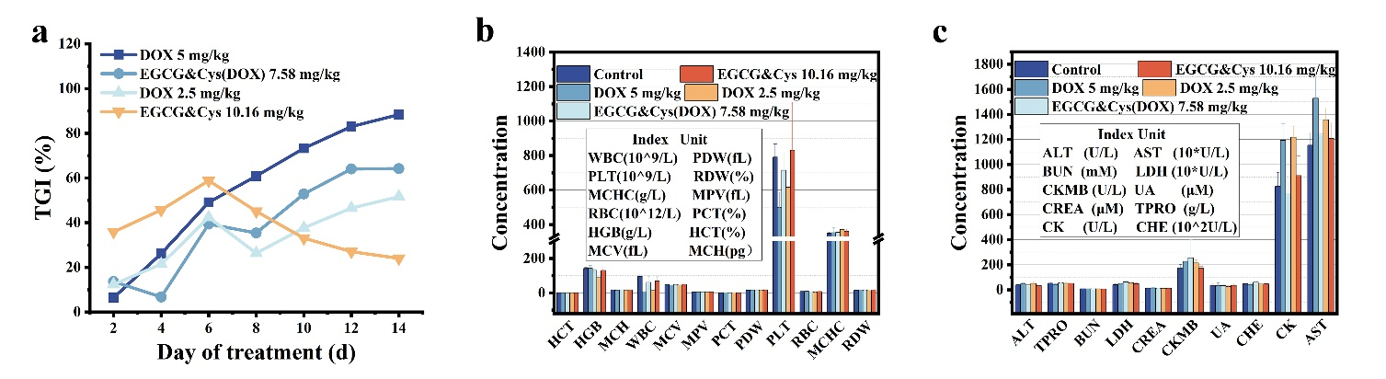
Figure S15. (a) Tumor growth inhibition rates in different experimental groups of mice; (b, c) Routine blood tests and primary serum biochemical indexes of different chemotherapy groups.
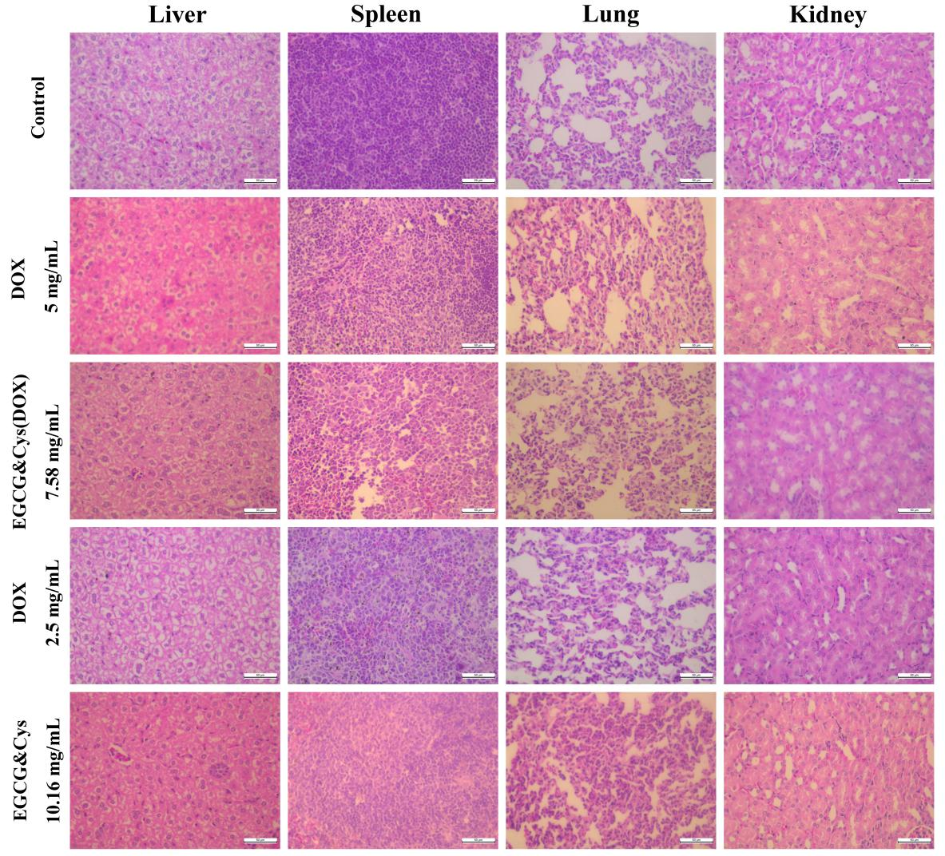
Figure S16. H&E staining images of tissue sections from the major organs (Liver, Spleen, Lung, and Kidney) of mice in different chemotherapy groups.
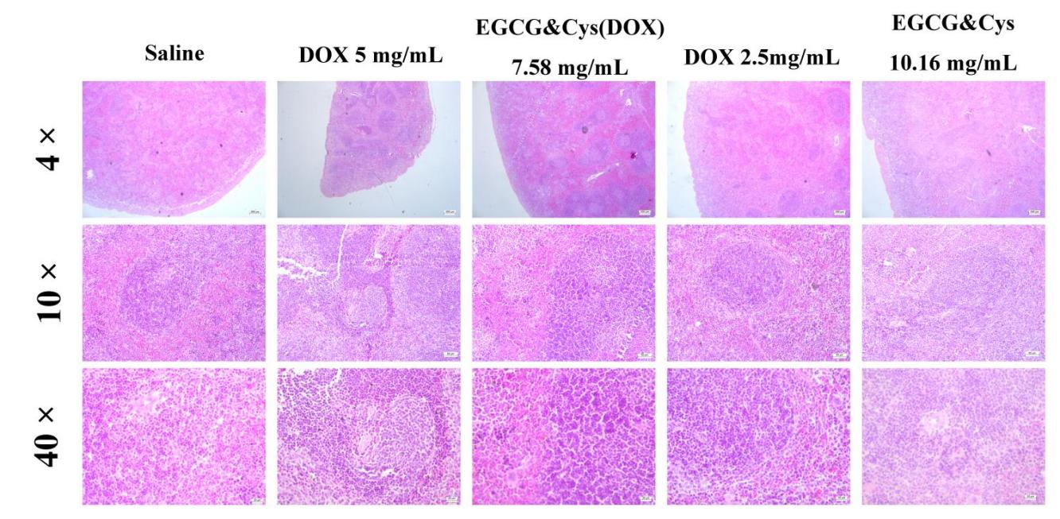
Figure S17. H&E staining images of tissue sections from the spleen of mice in different chemotherapy groups at different folds.
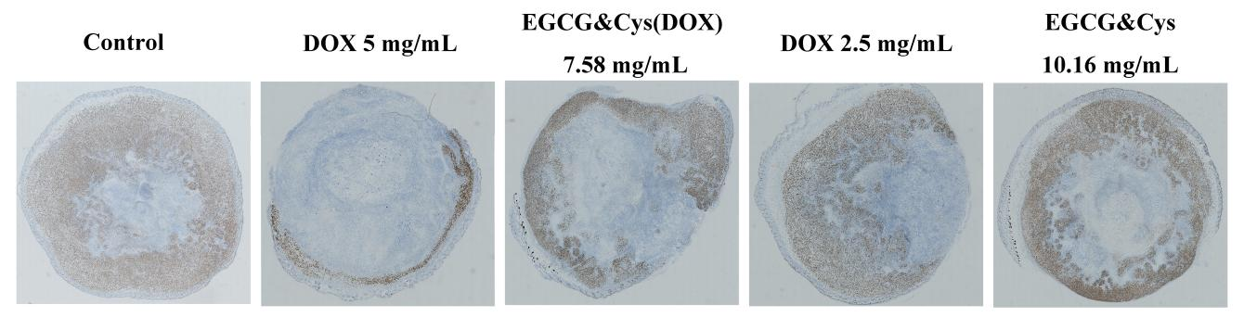
Figure S18. Ki67 staining images of tumor tissue specimens by immunohistochemistry in different chemotherapy groups.
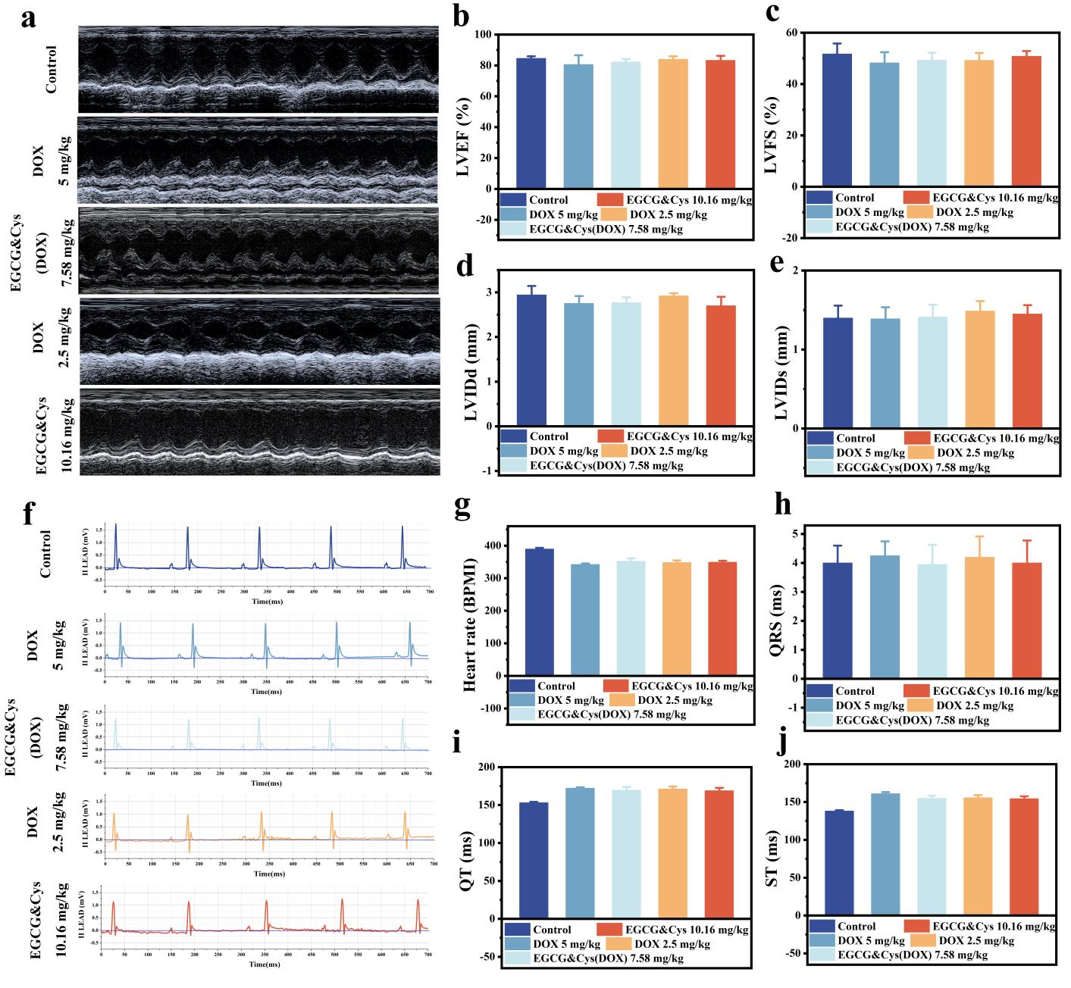
Figure S19. (a) Echocardiographic images of mice in different groups the day before chemotherapy; (b-e) The levels of LVEF, LVFS, LVIDd, and LVIDs were detected by echocardiography in various groups of mice; (f) Electrocardiogram of mice in different groups; (g-j) The heart rate, QRS, QT, and ST interval data of different chemotherapy groups were calculated based on electrocardiogram data.
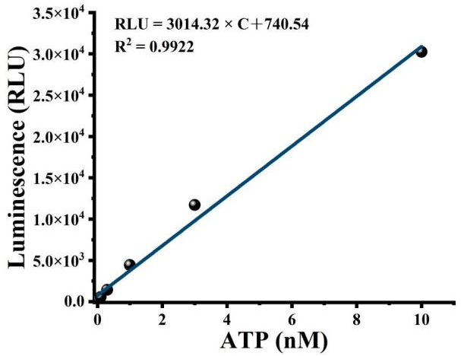
Figure S20. The standard curve between the ATP concentration released by mitochondria in HL-1 cells and the relative light units (RLU) value.

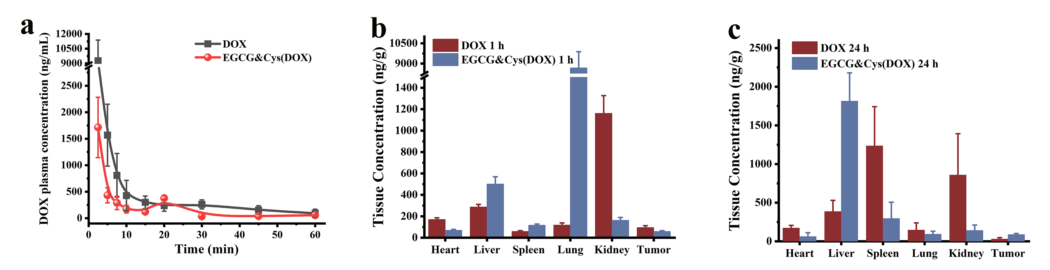
Figure S21. Pharmacokinetic and tissue distribution analysis. (a) Pharmacokinetic curves: DOX and EGCG&Cys(DOX) mean plasma concentration-time curves; (b, c) Tissue distribution: DOX concentrations in heart, liver, spleen, lung, kidney, and tumor tissues in mice 1 h and 24 h after tail vein administration.

