Supporting Information
A novel self-assembling peptide nanofiber hydrogel with glucagon-like peptide-1 functionality enhances islet survival to improve islet transplantation outcome in diabetes treatment
Xiangheng Cai^{1,4†}, Mengnan Zhang^{1,2†}, Jiaqi Zou^{1†}, Le Wang¹, Yixiang Zhan¹, Dandan Li^{1,2}, Tingsheng Jiang¹, Nijat Alim¹, Zhaoce Liu¹, Jiuxia Yang¹, Na Liu¹, Tengli Liu¹, Peng Sun¹, Xuejie Ding¹, Boya Zhang¹, Zewen Liu¹, Xuelian Wang¹, Rui Liang¹, Jinzhen Cai⁴, Jie Gao²*, Jinglin Cao³*, Shusen Wang¹*

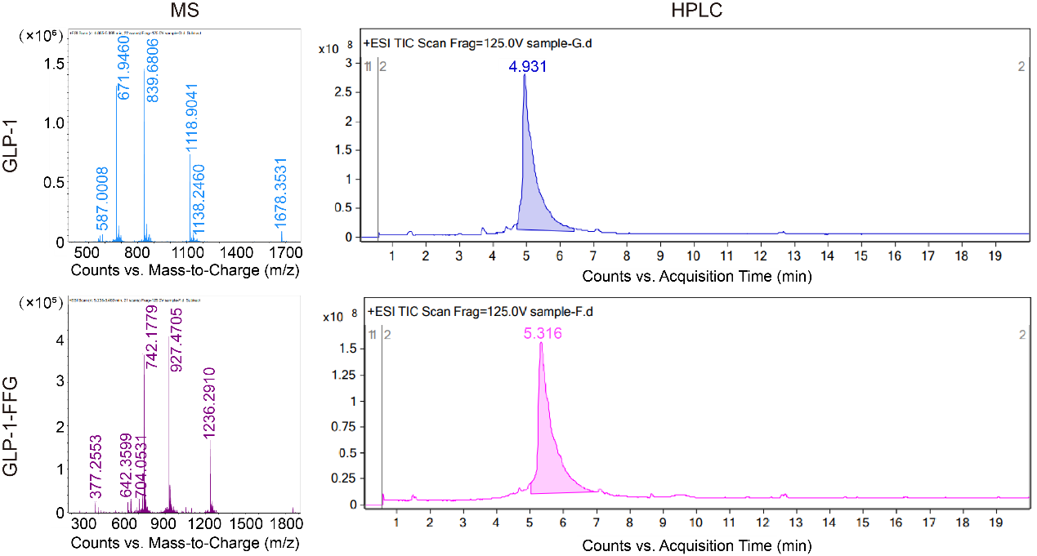
Figure S1. Mass spectrometry (MS) and high-performance liquid chromatography (HPLC) analysis of GLP-1 and GLP-1-FFG.
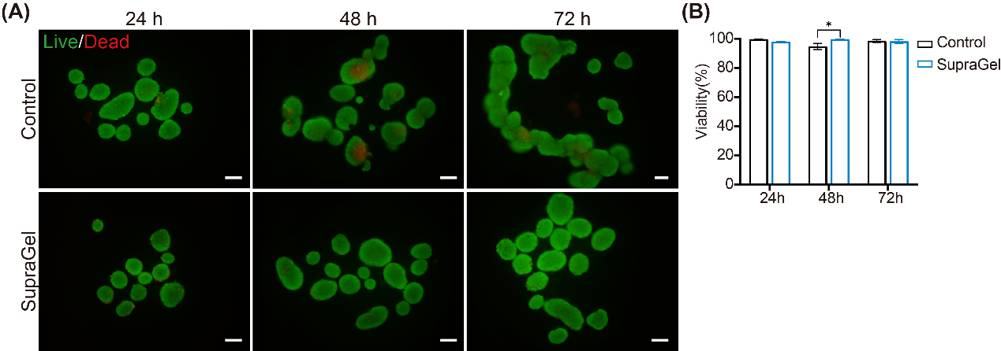
Figure S2. Biocompatibility of SupraGel hydrogel. A: Fluorescein diacetate (FDA)/propidium iodide (PI) fluorescence staining to evaluate cell viability of the mouse islets cultured freely or within SupraGel hydrogel at corresponding time points. Green: live cells. Red: dead cells. Scale bar, 150 μm. B: Quantitative analysis of the islet viability (n=3). *P < 0.05.

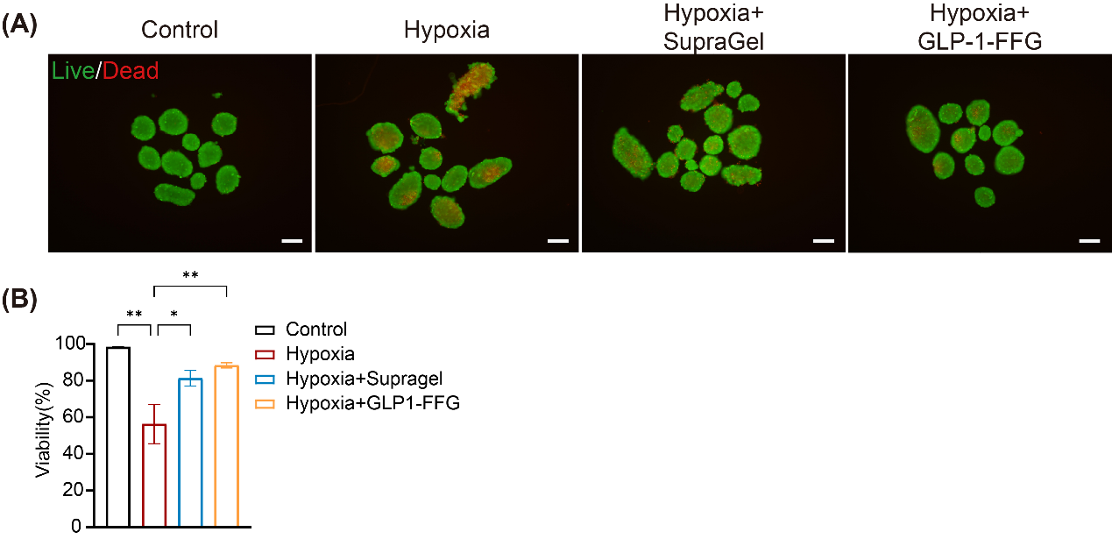
Figure S3. Protective effects of SupraGel and GLP-1-FFG on mouse islet under hypoxic conditions. A: Representative images of fluorescein diacetate (FDA)/propidium iodide (PI) fluorescence staining to evaluate the viability of mouse pislets cultured under hypoxic conditions. Green: live cells. Red: dead cells. Scale bar, 150 μm. B: Quantitative analysis of the islet viability (n=3). *P < 0.05, **P < 0.01.

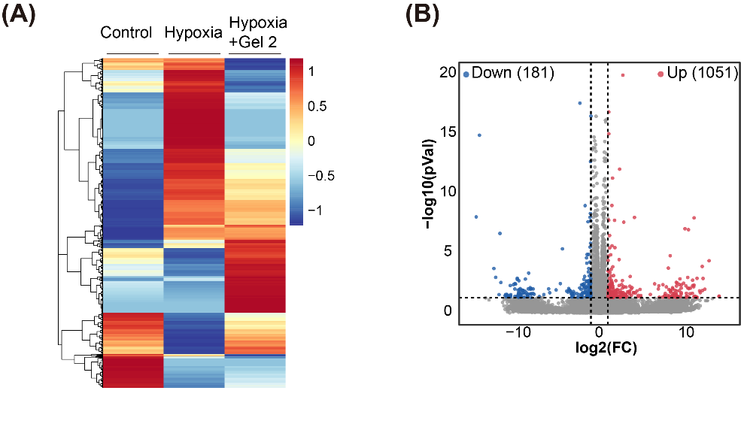
Figure S4. RNA-seq analysis of mouse islets from hypoxic model. A: Heatmap of differentially expressed genes. B: Volcano diagram showcasing differentially expressed genes in the Hypoxia groups compare to Control groups.

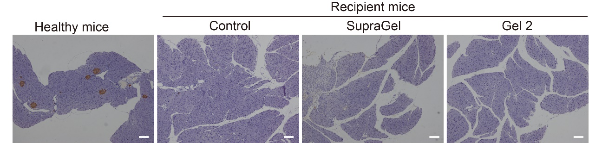
Figure S5. Immunohistochemistry staining of insulin of pancreas in healthy mice and recipient mice. Scale bar, 100 μm.

