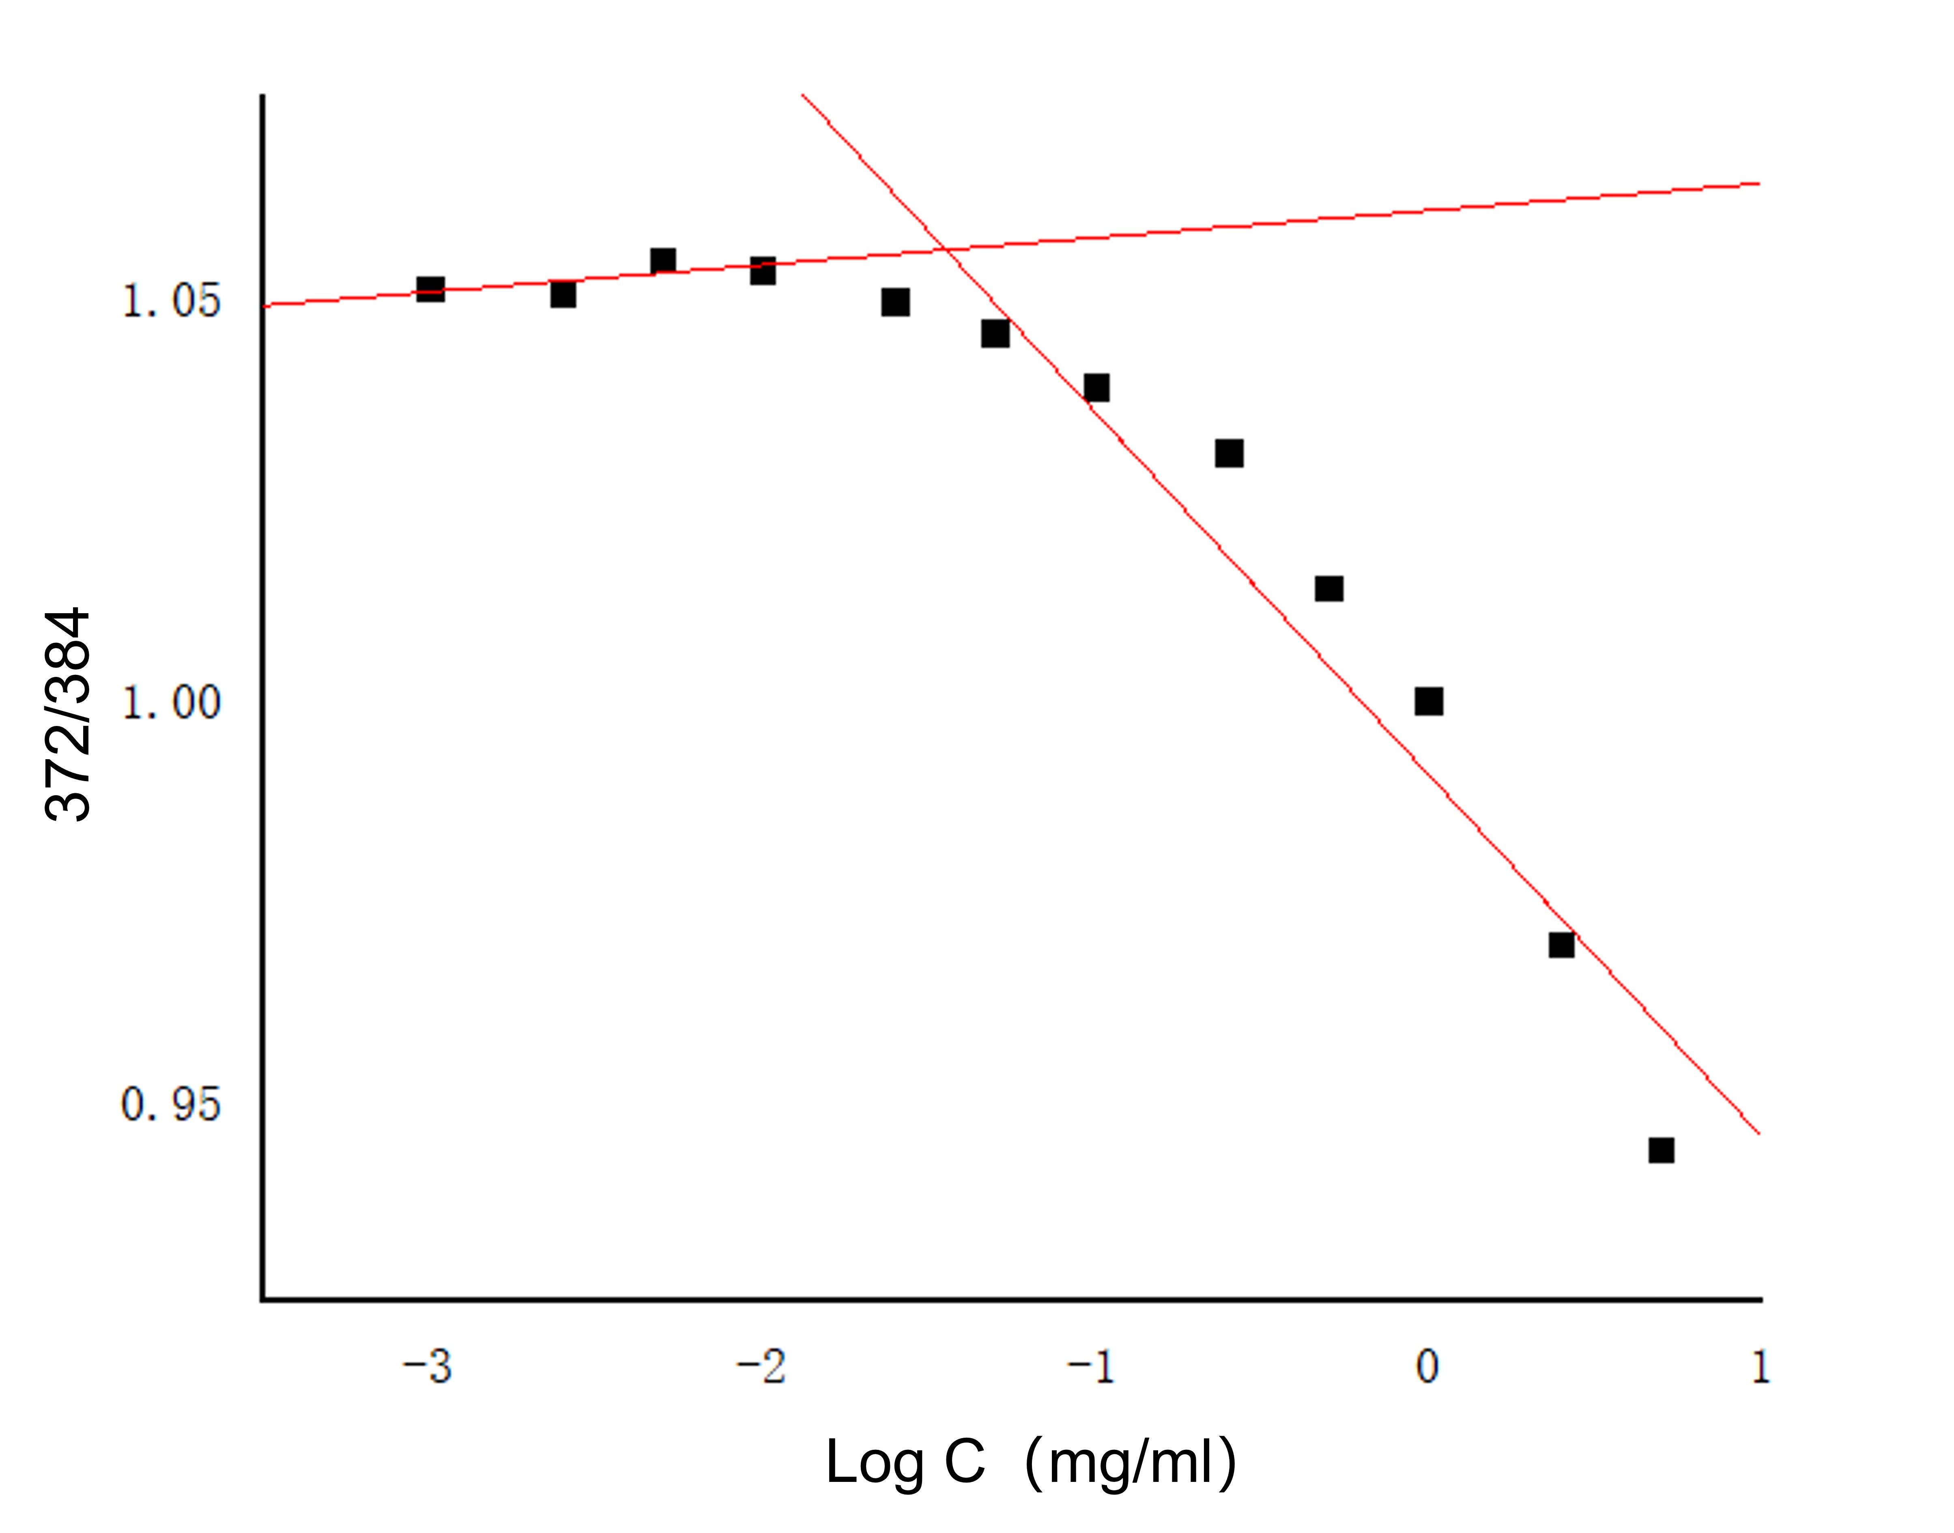
Fig. S1 The variations in fluorescence intensity ratio (I372/I384) as a function of the concentration of polymeric micelles.
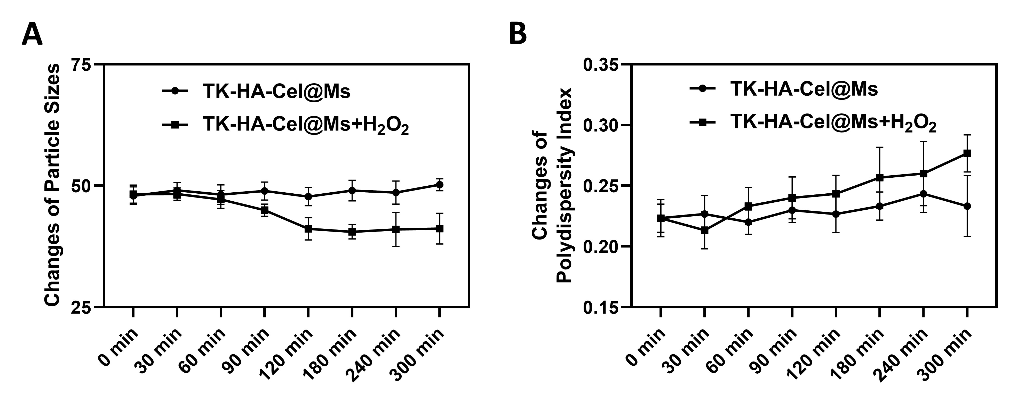 Fig. S2 Changes in particle size (A) and PDI (B) of oxidative response of TK-HA-Cel@Ms at different time points.
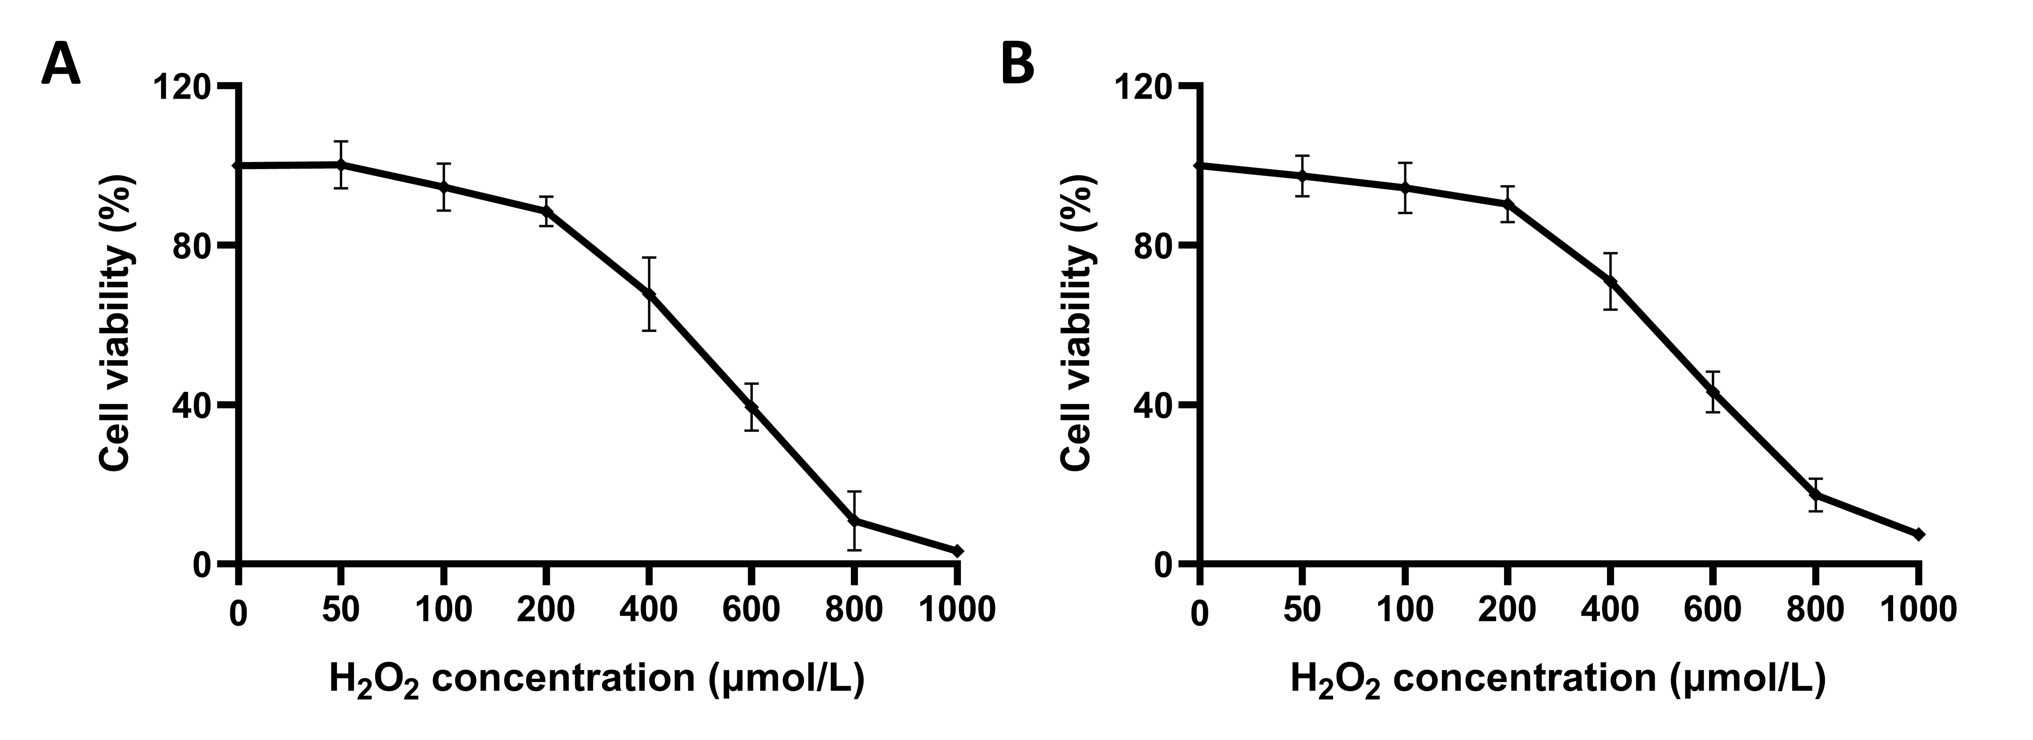
Fig. S3 Growth curves of varying formulations of RAW264.7 cells (A) and RA-FLSs cells (B) at varying concentrations of H₂O₂.
Fig. S4 Effect of varying formulations on inflammatory cytokines in the serum of CIA rats. (A-C) The levels of pro-inflammatory cytokines (IL-1β, IL-8, and TNF-α) in the serum of CIA rats; (D-E) The levels of anti-inflammatory cytokines (IL-10 and TGF-β) in the serum of CIA rats. Data were presented as mean ± SD (n = 6). #, vs. Blank; *, vs. Model. P < 0.05.
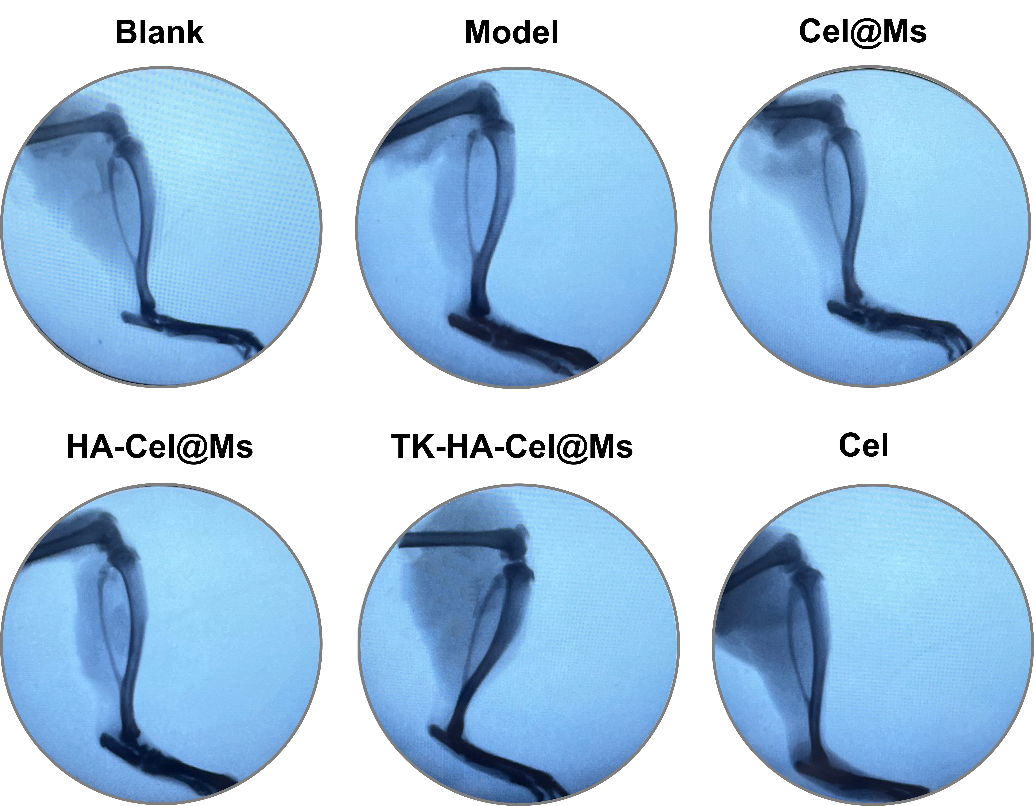
Fig. S5 Representative X-ray images of CIA rats in the different groups (n=6).
Fig. S6 Effect on macrophage polarization in CIA rats with varying formulations. (A) Representative flow cytometric analysis of surface F4/80 and CD86. (B) Representative flow cytometric analysis of surface F4/80 and CD206. (C) Quantification of F4/80+CD86+ macrophages. (C) Quantification of F4/80+CD206+ macrophages. Data were presented as mean ± SD (n = 3). #, vs. Blank; *, vs. Model. P < 0.05.
Fig. S7 HE staining assay of major organs (n=6).

