Engineered biomimetic cisplatin-polyphenol nanocomplex for chemo-immunotherapy of glioblastoma by inducing pyroptosis

Xinyan Hao ^{1, 2}, Yucheng Tang ^{1, 2}, Wenjie Xu ^{1, 2}, Ming Wang ⁴, Jiayi Liu ⁵, Yongjiang Li ⁶, Jun He ⁷, Yanjin Peng ^{1, 2}, Pengcheng Sun ^{1, 2}, Dehua Liao ⁸, Xiongbin Hu ^{1, 2}, Tiantian Tang ^{1, 2},Min Zhou ^{1, 2}, Ruyue Han ^{1, 2}, Jiemin Wang ⁹, João Conde ¹⁰, Daxiong Xiang ^{1, 2, *}and Junyong Wu ^{1, 2, 3, *}

* Corresponding authors. E-mail addresses: xiangdaxiong@csu.edu.cn (D. Xiang), wujunyong@csu.edu.cn (J. Wu)

Fig. S1. Stability of CuCCT in 14 days.
Fig. S2. UV−vis spectrum of CuCCT in A) SDS, B) NaCl and C) urea solution. D) Size change of CuCCT in various solutions.

Fig. S3. Serum stability of CuCCT and CuCCT @CM in 72 h.
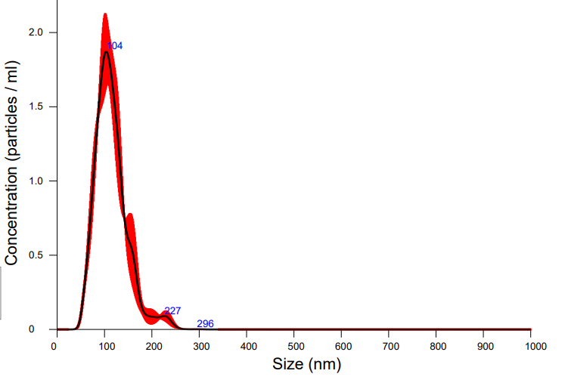
Fig. S4. Size distribution of CuCCT@CM-Ang detected by NTA.
Fig. S5. Release of CDDP from CuCCT@CM-Ang in serum solution.
Fig. S6. Line scanning of P element in CuCCT@CM-Ang.

Fig. S7. SDS-PAGE protein analysis of (1) BV2 cell lysate, (2) PD-1-BV2 cell lysate, (3) PD-1-BV2 cell membrane, (4) CAT, (5) CuCCT, (6) CuCCT@CM and (7) CuCCT@CM-Ang.

Fig. S8. Representative fluorescence images of bEnd.3 cells after incubation with CuCCT, CuCCT@CM and CuCCT@CM-Ang for 3 h. Blue: nuclei stained with DAPI; red: DiI.

Fig. S9. Oxygen production after incubation with H₂O₂ (500 μM). Concentrations of CuCCT@CM varied from 0 to 200 ng/ml.
Fig. S10. Correlated upregulation pathway in RNA-Seq analysis of CuCCT@CM-Ang-treated U87-MG cells.

Fig. S11. LDH levels in GL261 cells after different treatment.

Fig. S12. Representative images of pyroptosis of U87-MG cells treated with CuCCT@CM-Ang.

Fig. S13. Representative images of pyroptosis of GL261 cells treated with CuCCT@CM-Ang.
Fig. S14. HMGB1 release of GL261 cells after different treatments.
Fig. S15. FCM analysis of CRT-positive GL261 cells after treatment of PBS, CDDP, CuCCT, CuCCT@CM and CuCCT@CM-Ang.
Fig. S16. Representative images of CRT immunofluorescence in GL261 cells after treatment. Scale bar = 20 μm.
Fig. S17. Investigation of BMDC maturation after incubation with GL261 cells post-treatment with PBS, CDDP, CuCCT, CuCCT@CM and CuCCT@CM-Ang.

Fig. S18. Fluorescence images of GL261 in the lower chamber after incubation for 8 h. Blue: nuclei stained with DAPI; red: DiI. Scale bar = 50 μm.
Fig. S19. Quantification of CDDP concentration in plasma and excised tumors. Data are presented as mean ± SD (n = 3).
Fig. S20. Biochemical analysis of A) ALT, B) AST, C) ALP, D) UA, E) BUN and F) CR in serum . Data are presented as mean ± SD (n = 3). G) H&E images of major organs in different groups. PBS (G1), CDDP (G2), CuCCT (G3), CuCCT@CM (G4), CuCCT@CM-Ang (G5) and TMZ (G6).
Fig. S21. Levels of A) IFN-γ, B) TNF-α, C) IL-1β and D) IL-18 after different treatment. Results are presented as mean ± SD (n = 3). P values were analysed by one-way ANOVA test.
Fig. S22. Gating strategy of CD3⁺ CD8⁺ T cells in tumors/lymph nodes.
Fig. S23. Gating strategy of CD86⁺ macrophages in tumors.

Fig. S24. Gating strategy of CD80⁺ CD86⁺ DCs in lymph nodes.

