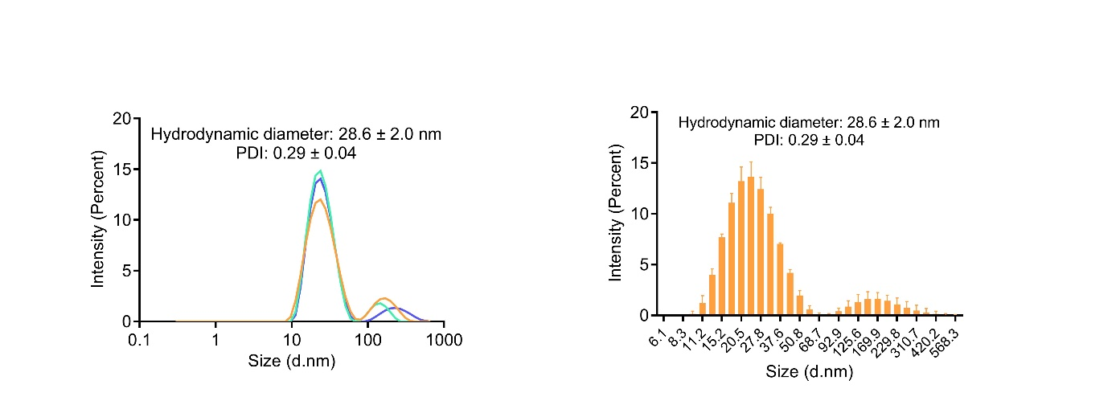
Figure S1. The CeMn NP-PEG hydrodynamic size represented by intensity distribution.
The size of peak 1 is 25.6 ± 0.4 nm, accounting for 87.29 ± 0.05%. The size of peak 2 is 187.5 ± 51.5 nm, accounting for 10.4 ± 2.68%. The average hydrodynamic size is 28.6 ± 2.0 nm, and the PDI is 0.29 ± 0.04.

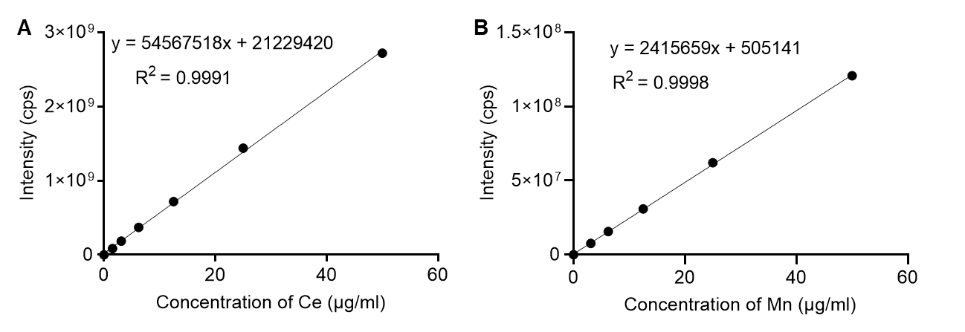
Figure S2. Standar curve measured by ICP-MS.
(A) Standard curve of Ce, showing the linear regression equation and the correlation coefficient. (B) Standard curve of Mn, showing the linear regression equation and the correlation coefficient.

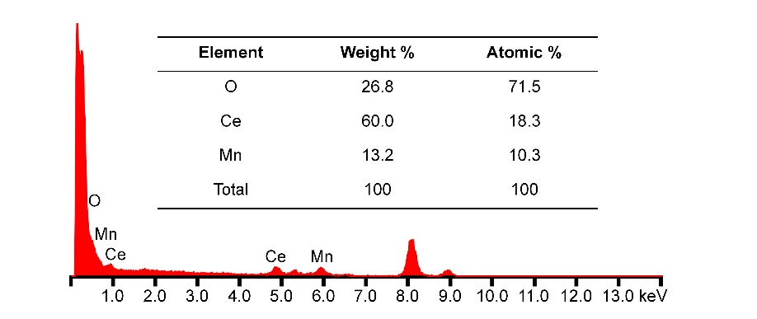
Figure S3. Chemical composition analysis of the CeMn NP using energy dispersive spectrometer (EDS).
The EDS spectra confirmed the presence of of Ce, Mn, and O as the primary constituents of the CeMn NP, verifying the successful synthesis of the material with the expected elemental composition.

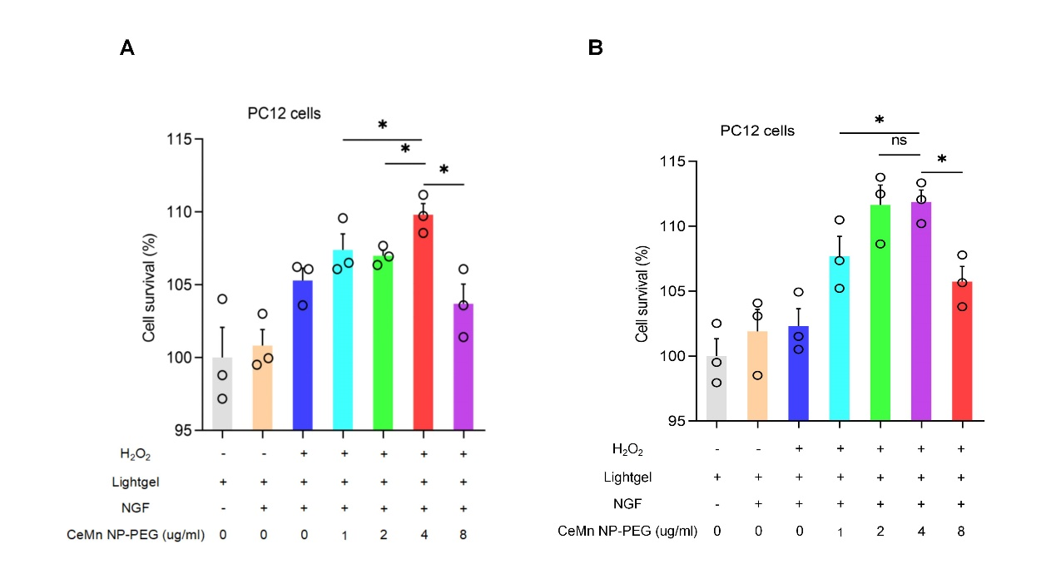
Figure S4: Optimization of CeMn NP-PEG Concentration for Biological Activity
(A) Cell survival percentages of PC12 cells treated with H₂O₂ and various concentrations of CeMn NP-PEG, measured by CCK8 assay. (B) Cell survival percentages of BV2 cells treated with H₂O₂ and various concentrations of CeMn NP-PEG, measured by CCK8 assay. Data are presented as mean ± SD. *p < 0.05, **p < 0.01.

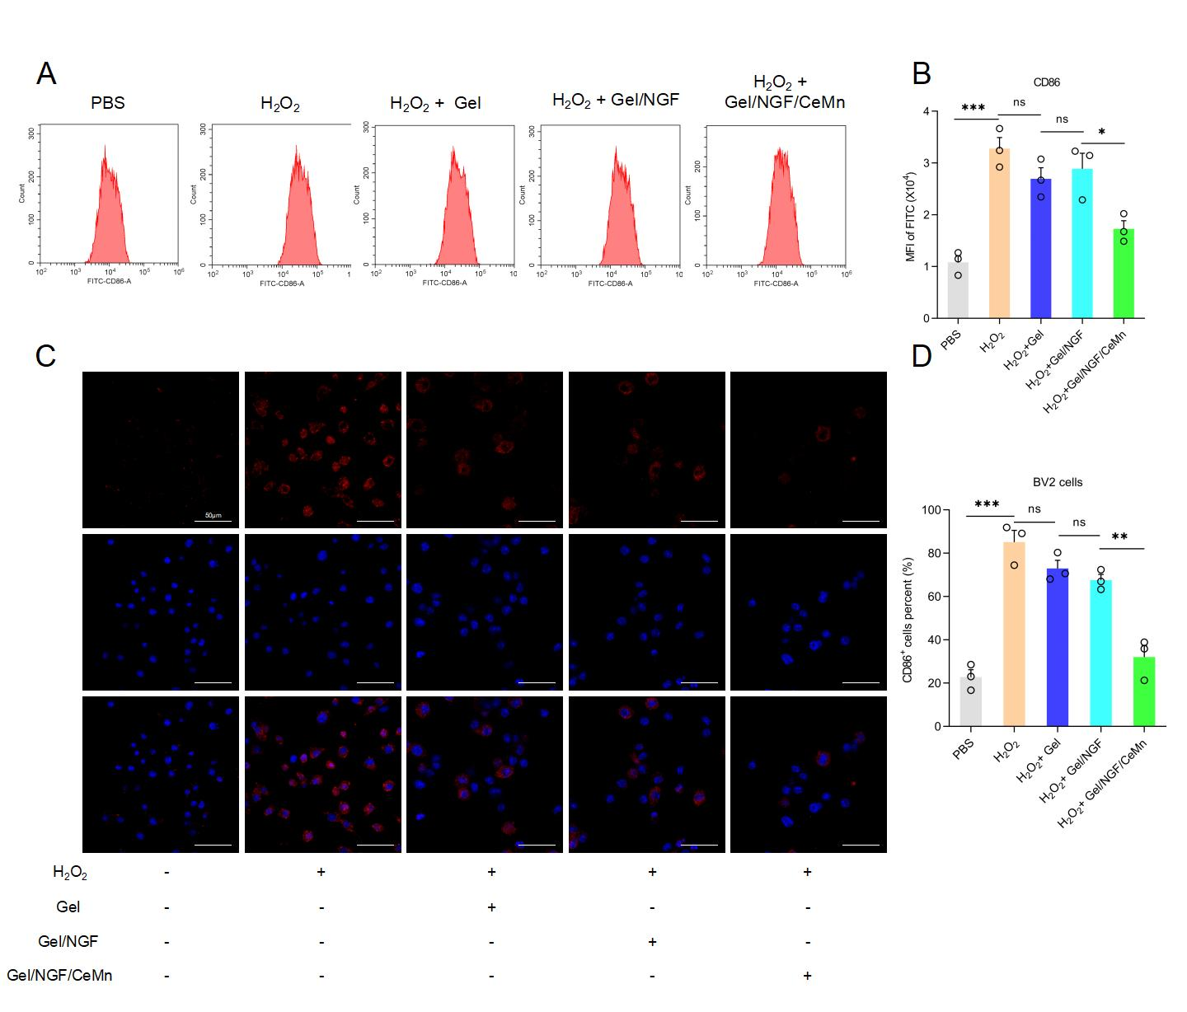
Figure S5: Reduction of M1 Polarization in H₂O₂-treated BV2 Cells by Nano-enzyme Hydrogel Composites
(A) Flow cytometry analysis of CD86 expression in BV2 cells treated with PBS, H₂O₂, H₂O₂ + Lightgel, H₂O₂ + Lightgel/NGF, and H₂O₂ + Lightgel/NGF/CeMn NP-PEG. (B) Quantification of mean fluorescence intensity (MFI) of CD86 in BV2 cells. (C) Immunofluorescence staining images of CD86 in BV2 cells under various treatments. (D) Quantification of CD86-positive BV2 cells. Data are presented as mean ± SD. *p < 0.05, **p < 0.01, ***p < 0.001.

Primer Sequences