Supplementary Materials For
Nanocarriers Boost Non-Systemic Fluazinam Transportation in Plants and Microbial Community Enrichment in Soil
Wenhui Xiao^{1,2,6}, Jiang Du^{3,6}, Yuxin Zheng¹, Shanshan Chen¹, Zhanyun Liu¹, Fengping Chen², Feng Liu³, Beixing Li^{3,4*}, Xili Liu^{1,5*}, Can Zhang^{1*}

¹ Department of Plant Pathology, China Agricultural University, Beijing 100193, China
² State Key Laboratory of Agricultural and Forestry Biosecurity & Key Lab of Biopesticide and Chemical Biology, Ministry of Education, College of Plant Protection, Fujian Agriculture and Forestry University, Fuzhou 350002, Fujian, China
³ Shandong Provincial Key Laboratory for Biology of Vegetable Diseases and Insect Pests, College of Plant Protection, Shandong Agricultural University, Tai'an, Shandong 271018, China
⁴ State Key Laboratory of Green Pesticide, Key Laboratory of Green Pesticide and Agricultural Bioengineering, Ministry of Education, Guizhou University, Guiyang 550025, China
⁵ State Key Laboratory of Crop Stress Biology for Arid Areas, Northwest A&F University, Yangling 712100, China
¹ These authors contributed equally: Wenhui Xiao, Jiang Du*
Authors for correspondence: Can Zhang, Email: czhang@cau.edu.cn; Xili Liu, Email: seedling@cau.edu.cn; Beixing Li, Email: beixingli@sdau.edu.cn.

The file includes:
Tabel. S1 to S5
Legends for Tabel. S1 to S5
Figs. S1 to S4
Legends for Fig. S1 to S4
Legends for Tabel. S1 to S5
Table S1
The bioassay of Phytophthora nicotianae by using various fluazinam formulations
Sampleª | Fitted  equation | R² | EC₅₀ (mg/L) | 95% confidence interval/ (mg/L)^{b}
 |  |  |  | lower limit | pper limit
TC | y=4.88+1.41x | 0.9016 | 1.22 | 0.59 | 2.53
MCs | y=4.33+1.78x | 0.9801 | 2.38 | 1.49 | 3.82
SubMCs | y=4.56+1.40x | 0.9028 | 2.08 | 1.13 | 3.85
NCs | y=4.87+1.44x | 0.9582 | 1.23 | 0.67 | 2.25
NEW | y=4.73+1.19x | 0.9070 | 1.70 | 0.90 | 3.19
SC | y=4.77+0.95x | 0.9909 | 1.76 | 0.77 | 4.01
ª Various fluazinam formulations. of technical (TC), microcapsule(s) (MCs), submicroncapsule(s) (SubMCs), nanocapsule(s) (NCs), nanoemulsion (NEW) and suspension concentrate (SC)
^{b} ANOVA was used to evaluate the difference among six samples. Values of each parameter followed by different letters indicate that the data points are significantly different at p < 0.05

Table S2
The bioassay of Phytophthora sojae by using various fluazinam formulations
Sampleª | Fitted  equation | R² | EC₅₀ (mg/L) | 95% confidence interval/ (mg/L)^{b}
 |  |  |  | lower limit | pper limit
TC | y=5.68+1.67x | 0.9435 | 0.39 | 0.09 | 1.71
MCs | y=4.34+1.26x | 0.9813 | 3.33 | 1.39 | 7.96
SubMCs | y=4.59+1.57x | 0.9559 | 1.83 | 1.02 | 3.28
NCs | y=4.78+1.95x | 0.9791 | 1.29 | 0.73 | 2.29
NEW | y=4.87+1.13x | 0.9894 | 1.30 | 0.42 | 4.01
SC | y=4.62+1.36x | 0.9274 | 1.89 | 0.85 | 4.19
ª Various fluazinam formulations. of technical (TC), microcapsule(s) (MCs), submicroncapsule(s) (SubMCs), nanocapsule(s) (NCs), nanoemulsion (NEW) and suspension concentrate (SC)
^{b} ANOVA was used to evaluate the difference among six samples. Values of each parameter followed by different letters indicate that the data points are significantly different at p < 0.05

Table S3
The bioassay of Phytophthora capsici (RJ-6) by using various fluazinam formulations
Sampleª | Fitted  equation | R² | EC₅₀ (mg/L) | 95% confidence interval/ (mg/L)^{b}
 |  |  |  | lower limit | pper limit
TC | y=4.72+1.20x | 0.9729 | 1.71 | 0.71 | 4.12
NCs | y=4.76+0.54x | 0.9016 | 2.75 | 0.67 | 11.28
NEW | y=4.51+0.38x | 0.9097 | 17.90 | 0.75 | 428.49
SC | y=3.50+0.83x | 0.9833 | 64.67 | 15.93 | 262.59
ª Various fluazinam formulations. of technical (TC), nanocapsule(s) (NCs), nanoemulsion (NEW) and suspension concentrate (SC)
^{b} ANOVA was used to evaluate the difference among six samples. Values of each parameter followed by different letters indicate that the data points are significantly different at p < 0.05

Table S4
Linear equation, average recoveries of the at fluazinam fortified levels of 5, 10, 50 and 100 mg kg⁻¹
Samples | Regression Equation | R² | Spiked level  (mg/kg) | Average recoveryª % | RSD %
Capsicum leaf stems | y =16.821x - 49.686 | 0.993 | 5 | 96.29 ± 6.74 | 6.99
Capsicum leaf stems | y =16.821x - 49.686 | 0.993 | 10 | 105.10 ± 3.57 | 3.40
Capsicum leaf stems | y =16.821x - 49.686 | 0.993 | 100 | 96.60 ± 4.83 | 5.00
Capsicum roots | y =16.821x - 49.686 | 0.993 | 10 | 95.94 ± 4.70 | 4.80
Capsicum roots | y =16.821x - 49.686 | 0.993 | 50 | 86.99 ± 4.91 | 5.00
Capsicum roots | y =16.821x - 49.686 | 0.993 | 100 | 101.78 ± 5.21 | 4.91
ª Mean value of three determinations

Table S5
Primers used for qRT-PCR
Gene | GenBank accession | Primer (5’-3’) | Origin
Actin | LOC107842967 | F:TCAAAGGACAGATTCAAGAGAGA  R:TAGTTGGCGCGGCTCTTAAT | In this study
FACP | XM_016696430.2 | F:AGTCGTCAGGCTCGTTCAAT  R:GGGCCTCAGAGTACAAACCA | In this study
RABF2a | XM_016703818.2 | F:TGGGTGCAAGAATTGCAGAAG  R:TTCCTGCCGGATTTTGAGCAG | In this study

Fig. S1. Particle size distribution of formulations. (a) Particle size of microcapsules (MCs). (b) submicroncapsules (SubMCs), (c) nanocapsules (NCs). (d) suspension concentrate(SC) and (e) nanoemulsion (NEW) (n = 3 independent experiments, data are presented as mean values ± SE, Tukey’s HSD test, p < 0.05)

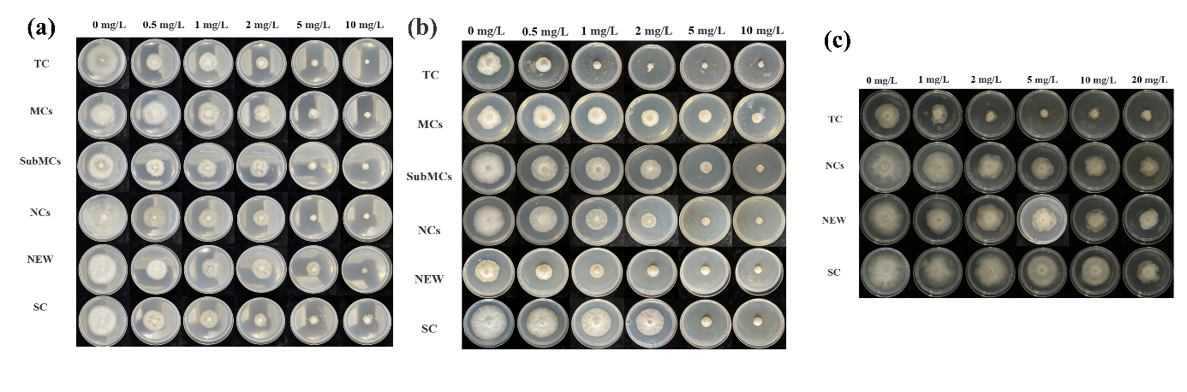
Fig. S2. Bioactivity of different fluazinam formulations. (a) Bioassays of technical material (TC), microcapsules (MCs), submicroncapsules (SubMCs), nanocapsules (NCs), nanoemulsion (NEW), and suspension concentrate(SC) treatment on Phytophthora nicotianae. (b) Bioassays of TC, MCs, SubMCs, NCs, NEW, and SC treatment on Phytophthora sojae. (c) Bioassays of TC, NCs, NEW, and SC treatment on Phytophthora capsici (RJ-6)

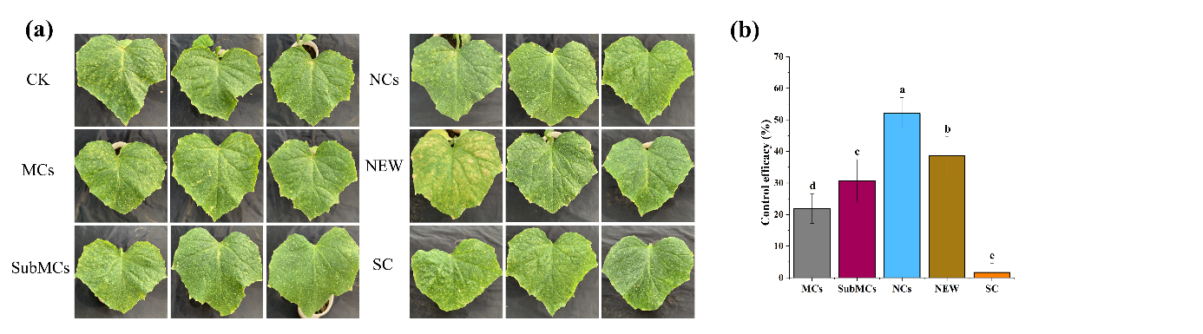
Fig. S3. Control efficacy of different fluazinam formulations. (a) Translocation of various fluazinam formulations in cucumber from the hypocotyl to leaves. Disease lesions on cucumber leaves. (b) Control efficacy against cucumber downy mildew (n = 3 independent experiments, data are presented as mean values ± SE, Tukey’s HSD test, p < 0.05)

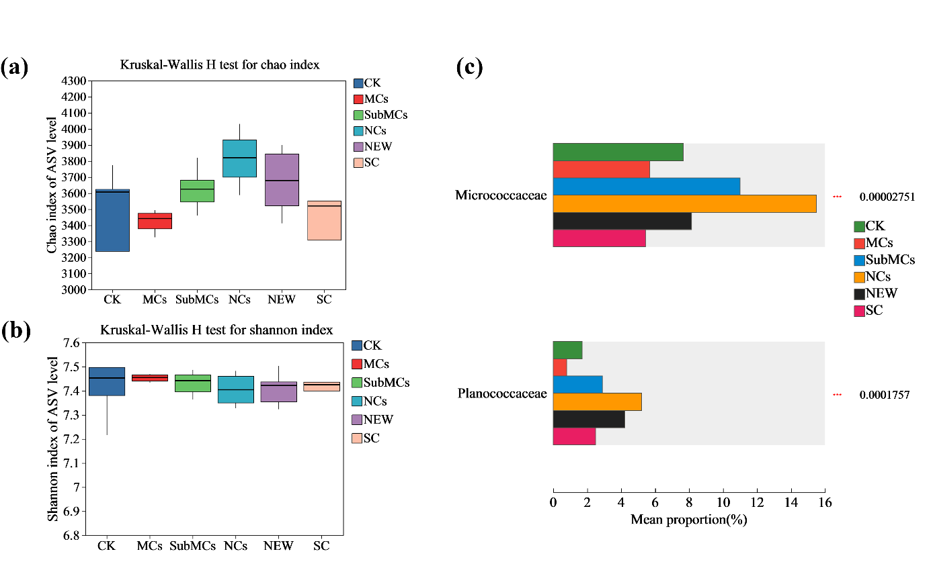
Fig. S4. Differences in soil microbiota treated with five fluazinam formulations. (a) Bacterial richness estimated using the Chao index. (b) Bacterial diversity estimated using the Shannon index. (c) Kruskal–Wallis H test on the two most abundant family in NCs among five fluazinam formulations. ***, p < 0.001

