Supporting Information

Enzymatically Responsive Nanocarriers Targeting PD-1 and TGF-β Pathways Reverse Immunotherapeutic Resistance and Elicit Robust Therapeutic Efficacy

Ying-Tzu Yen, Zhifan Zhang, Anni Chen, Yuling Qiu, Qin Liu, Qin Wang, Chunhua Li, Chun Wang, Xiaoping Qian, Jie Shao, Fanyan Meng, Lixia Yu, Baorui Liu* and Rutian Li*

Fig. S1. Characterization of GPNPs. (A) ¹HNMR spectrum of mPEG-PVGLIG-PCL with PEG (-CH2-CH2-O-, 3.65ppm)；PCL (-CH2-O-, 4.06ppm). (B) Hydrodiameter stability of nanoparticles with different drug formulations. (C) In vitro CIK cells/H1299 cells killing assay (D) In vitro murine splenocytes/LLC cells killing assay. (E) Dio-loaded nanoparticles biodistribution over time.
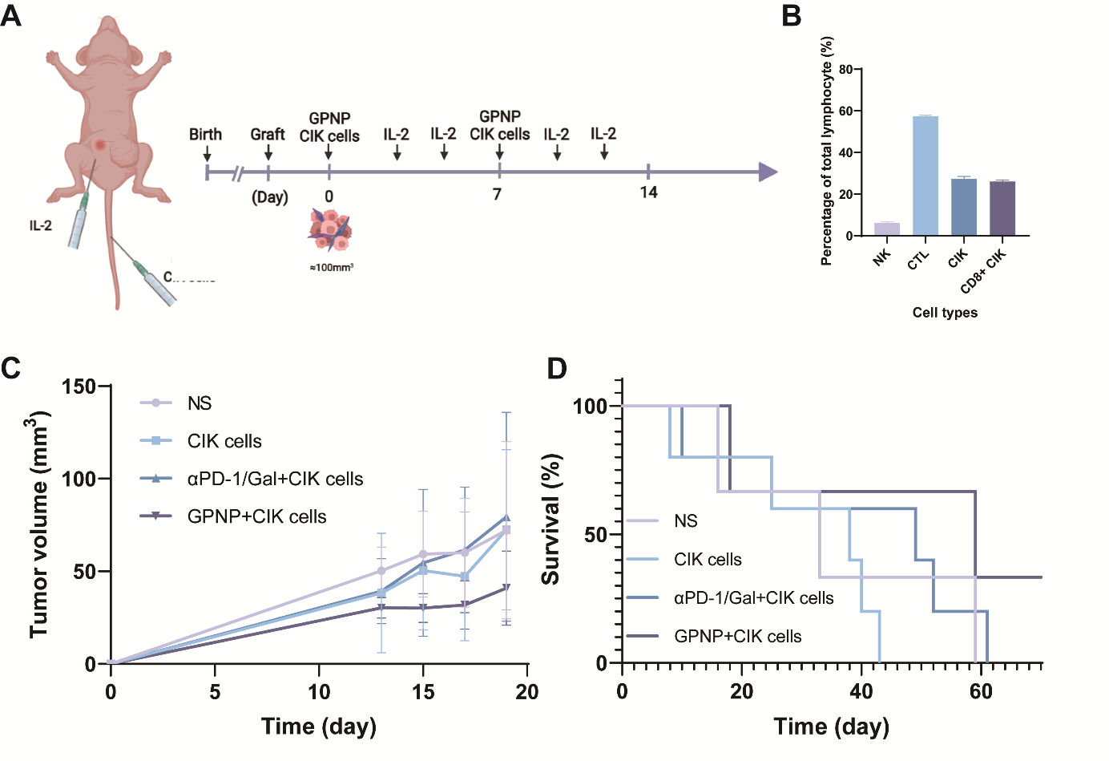
Fig. S2. In vivo therapeutic efficacy of GPNP and CIK transfusion combinative treatment in A549 model. (A) Treatment regimen. BALB/c nude mice were implanted subcutaneously with A549 cells (10⁷) and were intravenously administered cytokine-induced killer cells (10⁸/ml) and intrapertoneally administered different formulations supplemented with IL-2 (40,000 U) when tumor reached ~100mm³. The weekly dosage of PD-1 antibody and Gal were 10mg/kg and 150mg/kg, respectively. Gal in aPD-1/Gal group was given 3 times a week. The rest of treatments were given once a week. (B) Composition of lymphocytes after stimulation with cytokines. (C) Tumor growth curves after different treatments. (n=4) (D) Survival curve. (n=4)
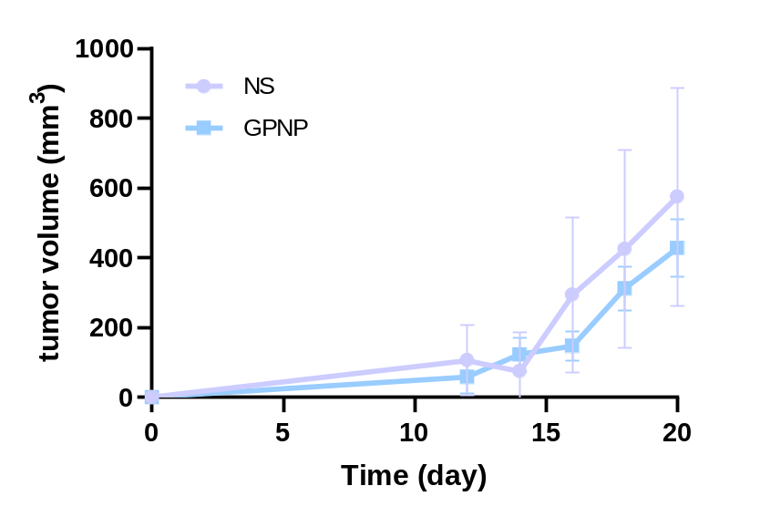
Fig. S3. Tumor growth curves after reseeding of tumors after saline or GPNP treatment. The NS- and GPNP-treated tumors were excised and subcutaneously injected to healthy mice (n=4-5). The retard growth of tumors was discovered in GPNP group.

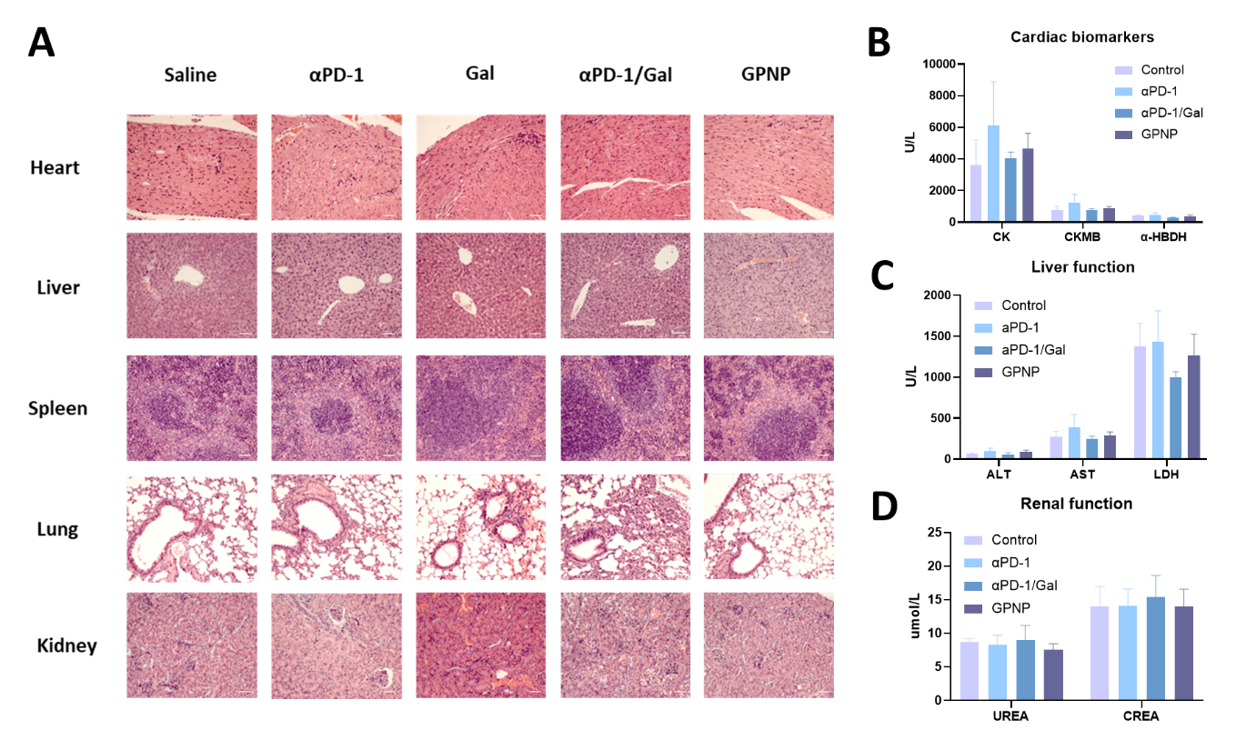
Fig. S4. Treatment toxicities. (A) Hematoxylin and eosin (H&E) staining of major organs of mice treated with different regimens. (B) Serum test of cardiac biomarkers including creatine kinase (CK), creatine kinase-MB (CKMB), α-hydroxybutyrate dehydrogenase (α-HBDH). (n=3-4). (C) Serum test of liver function, including alanine aminotransferase (ALT), aspartate transaminase (AST) (n=3-4). (D) Serum test of renal function, including lactate dehydrogenase (LDH), urea and creatine (CREA) (n=3-4).

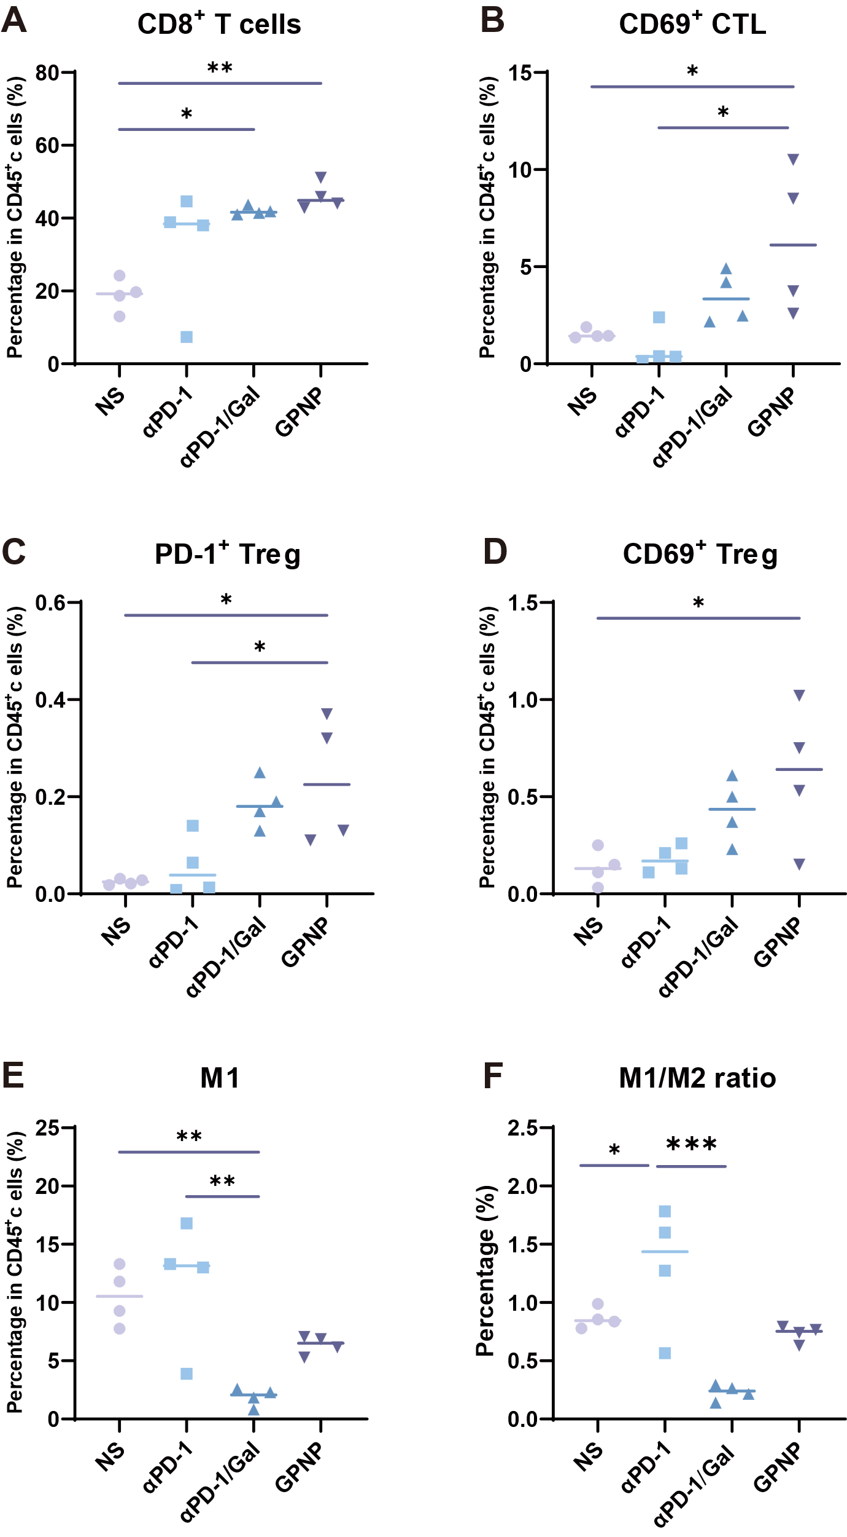
Fig. S5. Flow cytometry results of TME. The prepotion of (A) CD8⁺ T cells; (B) CD69⁺CTL; (C) PD1⁺Treg; (D) CD69⁺ Treg; (E) M1. (F) The ratio of M1/M2. *p < 0.05, **p < 0.01, ***p < 0.001.

Fig. S6. GPNPs elicit distinct immune profile in LLC tumor-bearing mice. (A) Histogram displaying cell proportion in each group. (B) tSNE plots per treatment.
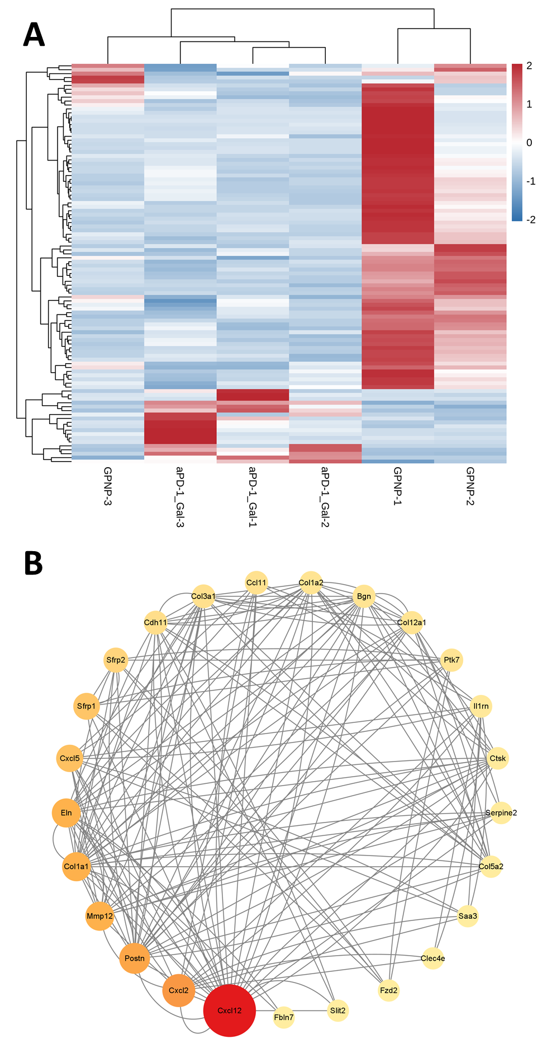
Fig. S7. An overview of bulk RNAseq (A) Differential gene expression of tumors receiving aPD-1/Gal or GPNP treatment. (B) Protein-protein interaction network for 42 enriched genes.

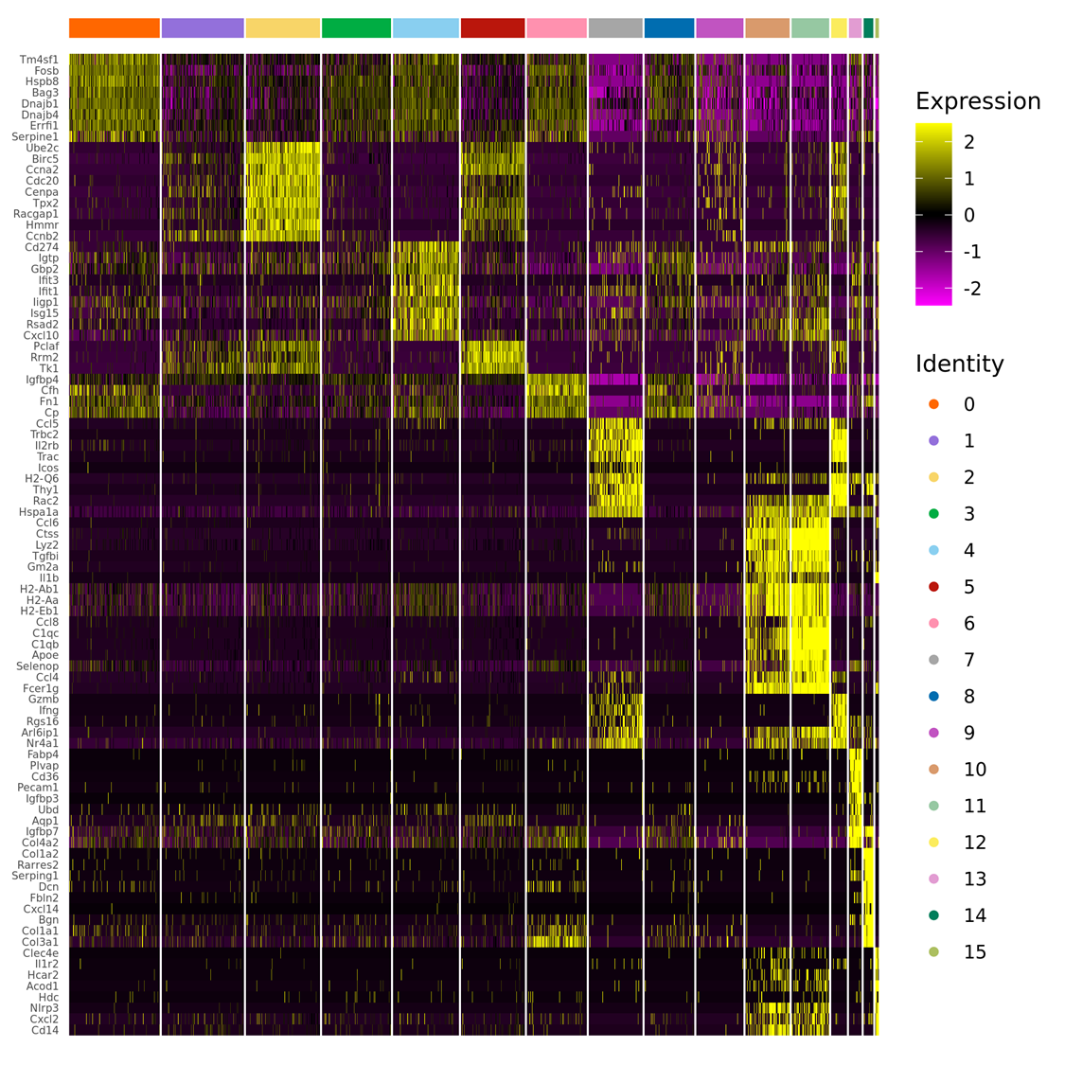
Fig. S8. Heat map of gene markers identified by clusters. (yellow: high expression, purple: low expression).

Fig. S9. GO enrichment scRNAseq of GPNP-treated tumor. (n=1) (A) Scatter plot of GO enrichment cellular component. (B) Scatter plot of GO enrichment molecular functions. The vertical axis represents the name of the terms and the horizontal axis represents the rich factor. The size of the dots indicates the number of differentially expressed genes in the pathway, and the color of the dots corresponds to different Qvalue ranges.

Fig. S10. scRNAseq results of GPNP-treated tumor (GO enrichment analysis focusing on cellular behavior). The vertical axis represents the terms and the horizontal axis represents the rich factor. The size of the dots indicates the number of differentially expressed genes in the pathway, and the color of the dots corresponds to different Qvalue ranges.

Fig. S11. scRNAseq results of GPNP-treated tumor (GO enrichment analysis focusing on metabolic effects). The vertical axis represents the terms and the horizontal axis represents the rich factor. The size of the dots indicates the number of differentially expressed genes in the pathway, and the color of the dots corresponds to different Qvalue ranges.

Fig. S12. scRNAseq results of GPNP-treated tumor (GO enrichment analysis focusing on homeostasis and others). The vertical axis represents the terms and the horizontal axis represents the rich factor. The size of the dots indicates the number of differentially expressed genes in the pathway, and the color of the dots corresponds to different Qvalue ranges.

Fig. S13. KEGG enrichment scRNAseq of GPNP-treated tumor. (n=1) Scatter plot of KEGG enrichment. The vertical axis represents the name of the pathway and the horizontal axis represents the rich factor. The size of the dots indicates the number of differentially expressed genes in the pathway, and the color of the dots corresponds to different Qvalue ranges.

Fig. S14. Reactome enrichment scRNAseq of GPNP-treated tumor. (n=1) Scatter plot of Reactome enrichment. The vertical axis represents the name of the pathway and the horizontal axis represents the rich factor. The size of the dots indicates the number of differentially expressed genes in the pathway, and the color of the dots corresponds to different Qvalue ranges.
Fig. S15. Genotyping and validation of Pdgfra-Cre; Rosa26-CA- LSL-tdTomato murine model. (A) Genotyping with agarose gel electrophoresis. (n=8) (B) Co-localization of PDGFRα (blue: DAPI, red: PDGFRα-tdTomato, green: PDGFRα-FITC). (C) Tumor tracing capability of Pdgfra-Cre; Rosa26-CA- LSL-tdTomato murine model. (D) Tracing capability of Pdgfra-Cre; Rosa26-CA- LSL-tdTomato murine model in major organs (blue: DAPI, red: PDGFRα-tdTomato).

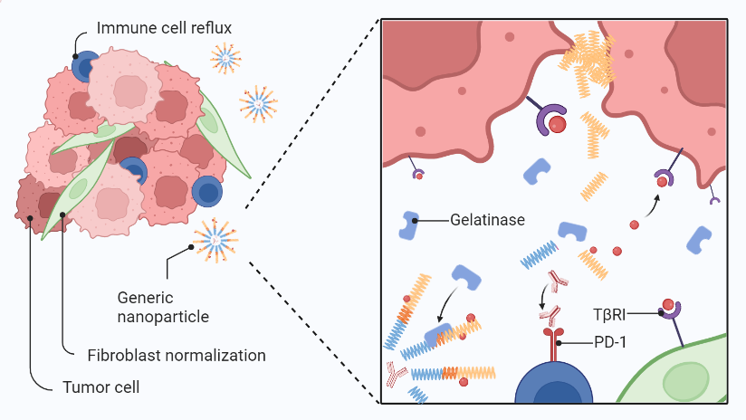
Fig. S16. Schematic figure. Gelatinase-responsive nanoparticles coated with TGF-β inhibitors(TβRI in the figure) and PD-1 monoclonal antibodies, upon infiltration into the tumor microenvironment (TME), are recognized by MMP2,9 enzymes that are highly abundant in tumor tissue, triggering drug release. This mechanism not only inhibits tumor growth but also promotes immune cell infiltration by normalizing fibroblasts, thereby enhancing therapeutic efficacy.

Table S1. Tumorigenesis rate of saline- and GPNP-treated group in reseeding assay.
Group | Tumorigenesis | Rate
NS | 5/5 | 100%
GPNP | 4/5 | 80%

Table S2. Cell references for flow cytometry.
Cell | Markers
Cytotoxic T cell | CD45⁺ | CD3⁺ | CD8⁺
Regulatory T cell | CD45⁺ | CD3⁺ | CD4⁺ | CD25⁺ | CD127^{-/dim}
Type I Macrophage | CD45⁺ | CD11b⁺ | F4_80⁺ | CD86⁺ | MHCII⁺
Type II Macrophage | CD45⁺ | CD11b⁺ | F4_80⁺ | CD163⁺ | CD206⁺

Table S3. Cell references for cyTOF. Plasmacytoid dendritic cell (pDC), monocyte/macrophage (Mo/Mf), double negative T cell (DNT), regulatory T cell (Treg).

Table S4. Antibodies and reagents for mass cytometry, flow cytometry and immunofluorescence
Product | Clone | Supplier
Cell-ID™ Cisplatin-194Pt | - | FLUIDIGM
eBioscienceTM Fixation/Permeabilization Concentrate | - | Thermo Fisher Scientific
eBioscienceTM Fixation/Permeabilization Diluent | - | Thermo Fisher Scientific
Maxpar Antibody Labeling Kit | - | FLUIDIGM
Maxpar Fix and Perm Buffer | - | FLUIDIGM
89Y anti-mouse CD45 | 30-F11 | Biolegend
113In anti-mouse CD44 | IM7 | Biolegend
115In anti-mouse CD3e | 145-2C11 | Biolegend
141Pr anti-mouse CD103 | 2E7 | Biolegend
142Nd anti-mouse TCR γ/δ | GL3 | Biolegend
143Nd anti-mouse CD45R (B220) | RA3-6B2 | Biolegend
144Nd anti-mouse CD40 | HM40-3 | Biolegend
145Nd anti-mouse Gr-1 | RB6-8C5 | Biolegend
146Nd anti-mouse CD27 | LG.3A10 | Biolegend
147Sm anti-mouse CD86 | GL-1 | Biolegend
148Nd anti-mouse Ly-6C | HK1.4 | Biolegend
149Sm anti-mouse CD38 | 90 | Biolegend
150Nd anti-mouse CD127 | A7R34 | Biolegend
151Eu anti-mouse CD62L | MEL-14 | Biolegend
152Sm anti-mouse CD11c | N418 | Biolegend
153Eu anti-mouse IgD | 11-26c.2a | Biolegend
154Sm anti-mouse CD194 (CCR4) | 2G12 | Biolegend
155Gd anti-mouse CD184 (CXCR4) | L276F12 | Biolegend
156Gd anti-mouse CD317 (BST-2) | 44E9R | RD
157Gd anti-mouse TIGIT | 2190A | RD
158Gd anti-mouse CD19 | 6D5 | Biolegend
159Tb anti-mouse F4/80 | CL:A3-1 | BioRAD
160Gd anti-mouse CD274 (PD-L1) | 10F.9G2 | Biolegend
161Dy anti-mouse TCR β | H57-597 | Biolegend
162Dy anti-mouse CD183 (CXCR3) | CXCR3-173 | Biolegend
163Dy anti-mouse CD25 | 3C7 | Biolegend
164Dy anti-mouse CD4 | RM4-5 | Biolegend
165Ho anti-mouse CD278 (ICOS) | C398.4A | Biolegend
166Er anti-mouse Ly-6G | 1A8 | Biolegend
167Er anti-mouse CD206 (MMR) | C068C2 | Biolegend
168Er anti-mouse CD185 (CXCR5) | L138D7 | Biolegend
169Tm anti-mouse CD69 | H1.2F3 | Biolegend
170Er anti-mouse CD169 (Siglec-1) | 3D6.112 | Biolegend
171Yb anti-mouse CD163 | S15049I | Biolegend
172Yb anti-mouse CD279 (PD-1) | 29F.1A12 | Biolegend
173Yb anti-mouse Granzyme B | QA16A02 | Biolegend
174Yb anti-mouse CTLA-4 | UC10-4B9 | Biolegend
175Lu anti-mouse CD196 (CCR6) | 29-2L17 | Biolegend
176Yb anti-mouse MHC-II | M5/114.15.2 | Biolegend
198Pt anti-mouse CD8a | 53-6.7 | Biolegend
209Bi anti-mouse CD11b | M1/70 | Biolegend
CBA human IFNγ Kit | - | BD Biosciences
CFSE | - | TONBO Biosciences
PI | - | Sigma
Zombie NIRTM Fixable Viability Kit | - | Biolegend
Cytofix/Cytoperm Fixation and Permeabilization Kit | - | BD Pharmaingen
Brilliant Violet 421™ anti-mouse CD45 | 30-F11 | Biolegend
Brilliant Violet 510™ anti-mouse CD3 | 17A2 | Biolegend
Alexa Fluor® 700 anti-mouse CD4 | GK1.5 | Biolegend
KIRAVIA Blue 520™ anti-mouse CD25 | PC61 | Biolegend
PE anti-mouse CD127 (IL-7Rα) | SB/199 | Biolegend
PerCP/Cyanine5.5 anti-mouse CD69 | H1.2F3 | Biolegend
APC anti-mouse CD317 (BST2, PDCA-1) | 927 | Biolegend
PE/Cyanine7 anti-mouse CD274 (B7-H1, PD-L1) | 10F.9G2 | Biolegend
PE/Dazzle™ 594 anti-mouse CD279 (PD-1) | 29F.1A12 | Biolegend
PE anti-mouse CD3 | 17A2 | Biolegend
APC anti-mouse CD8a | 53-6.7 | Biolegend
Alexa Fluor® 700 anti-mouse CD38 | 90 | Biolegend
Alexa Fluor® 488 anti-mouse Ly-6C | HK1.4 | Biolegend
Brilliant Violet 510™ anti-mouse/human CD11b | M1/70 | Biolegend
PerCP/Cyanine5.5 anti-mouse F4/80 | BM8 | Biolegend
PE anti-mouse CD86 | GL-1 | Biolegend
APC anti-mouse I-A/I-E | M5/114.1 | Biolegend
PE anti-mouse CD163 | S15049I | Biolegend
APC anti-mouse CD206 (MMR) | C068C2 | Biolegend
Anti-vimentin antibody | - | Abcam
Anti-laminin 1+2 antibody | - | Abcam
Anti-alpha smooth muscle actin antibody | EPR5368 | Abcam
Anti-fibronectin antibody | F14 | Abcam
Alexa Fluor 488Goat Anti-Rabbit IgG(H+L) | - | Beyotime
DAPI | - | Beyotime

Table S5. PCR primers for genotyping.
Primer | Sequence (5’→3’) | PCR size
14633 | TCA GCC TTA AGC TGG GAC AT | Transgene=492bp
oIMR9377 | ATG TTT AGC TGG CCC AAA TG | Transgene=492bp
oIMR7338 | CTA GGC CAC AGA ATT GAA AGA TCT | Internal Positive Control=324bp
oIMR7339 | GTA GGT GGA AAT TCT AGC ATC ATC C | Internal Positive Control=324bp
rosa26-gt5F1 | AGC ACT TGC TCT CCC AAA GTC GCT C | Knock in=694bp
CAG-5tR1 | TGC CAA GTA GGA AAG TCC CAT | Knock in=694bp
rosa26-gt5F1 | AGC ACT TGC TCT CCC AAA GTC GCT C | Knock in=11241bp  Wild type=353bp
rosa26-gt3R1 | AAA CTT CCC GAC AAA ACC GAA | Knock in=11241bp  Wild type=353bp

