Supporting Information

An antibacterial, antioxidant and hemostatic hydrogel accelerates infectious wound healing

Ziyi Zhou^{a, †}, Dengjun Zhang^{a, †}, Xuchao Ning ^{C, †}, Linbo Jinª, Yijing Lin ª, Chen Liangª, Xin Wenª, Tianhao Huang ª, Junli Zhou^{b,} *, Yiming Zhang^{a,} *

ª Department of Plastic and Cosmetic Surgery, Xinqiao Hospital, Army Medical
University, Chongqing, 400037, China
^{b} Department of Burn and Plastic surgery, The Tenth Affiliated Hospital of Southern
Medical University (Dongguan People's Hospital), China
^{C} Department of Plastic Surgery, Qilu Hospital Qingdao, Cheeloo College of Medicine, Shandong University, Qingdao 266035, China

† Z. Zhou, D. Zhang and X. Ning contributed equally to this work.
*Corresponding authors: 13993185891@163.com (J. Zhou), zhangyiming@tmmu.edu.cn (Y. Zhang).

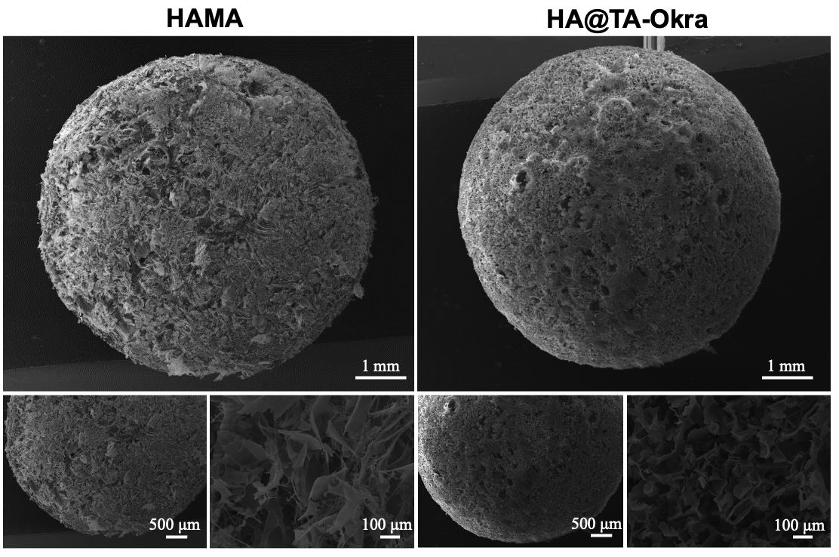
Fig S1. Frontal SEM images of HAMA and HA@TA-Okra

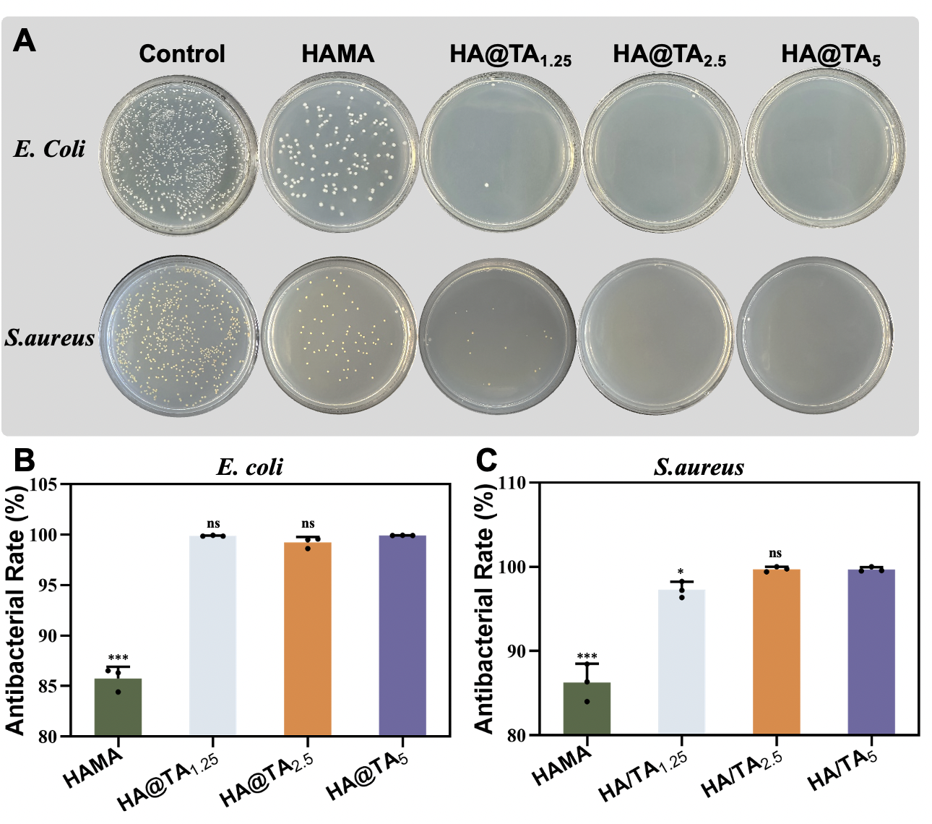 Fig S2. Determination of antibacterial activity of HA@TA_{1.25/2.5/5} hydrogel against E. coli and S. aureus. (A) Bacterial plate counting. Viability of different hydrogels against (B) E. coli and (C) S. aureus. (***P < 0.001).

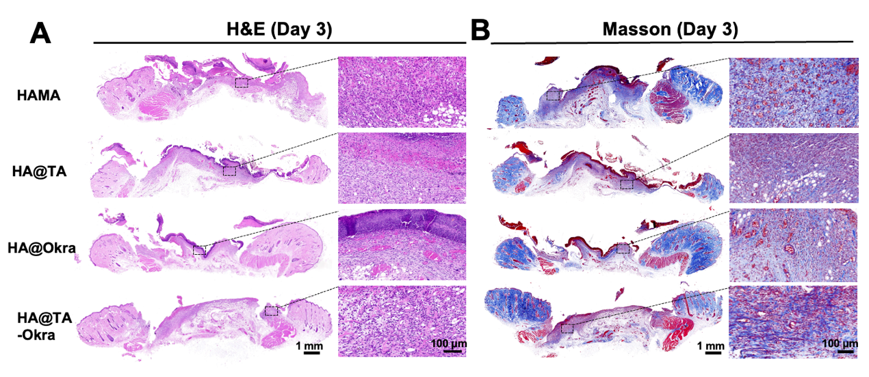
Fig S3. (A) H&E and (B) Masson staining images of infected wound defects in different groups on day 3.

Table 1
