Supplementary data
Avian influenza mRNA vaccine encoding hemagglutinin provides complete protection against divergent H5N1 viruses in specific-pathogen-free chickens
Zhaoyang Wang^{1,2,3,#}, Chongyu Tian^{4,#}, Jiahang Zhu^{1,2,3,#}, Shiqian Wang^{1,2,3}, Xiang Ao^{1,2,3}, Yanjuan He^{1,2,3}, Huixin Chen^{1,2,3}, Xiuying Liao^{1,2,3}, Deming Kong^{1,2,3}, Yongfei Zhou⁵, Wanbo Tai⁴*, Ming Liao^{1,2,3}*, and Huiying Fan^{1,2,3}*
¹College of Veterinary Medicine, South China Agricultural University, Guangzhou, 510642, China
²Key Laboratory of Zoonosis Prevention and Control of Guangdong Province, Guangzhou, 510642, China
³Key Laboratory of Veterinary Vaccine Innovation of the Ministry of Agriculture and Rural Affairs, Guangzhou, 510642, China
⁴Institute of Infectious Diseases, Shenzhen Bay Laboratory, Shenzhen, 518132, China.
⁵Institute of Hemu Biotechnology, Beijing Hemu Biotechnology Co., Ltd, Beijing, 102206, China.
*Corresponding author:
Huiying Fan, College of Veterinary Medicine, South China Agricultural University, Guangzhou 510642, China. Email: fanhy@scau.edu.cn
Ming Liao, College of Veterinary Medicine, South China Agricultural University, Guangzhou 510642, China. E-mail: mliao1968@163.com
Wanbo Tai, Institute of Infectious Diseases, Shenzhen Bay Laboratory, Shenzhen, 518132, China. E-mail: taiwb@szbl.ac.cn

# These authors contributed equally to this work. Author order was determined by friendly negotiation.
Supplementary Table 1. Sequences of primers used for qPCR.
Gene | Primer sequences (5′-3′) | Product size (bp) | Accession no.
IFN-γ (mouse) | F: GTGGCATAGATGTGGAAGA | 173 | NM_008337.4
IFN-γ (mouse) | R: GTGTGATTCAATGACGCTTA | 173 | NM_008337.4
TNF-α (mouse) | F: CTCATGCACCACCATCAAGG | 96 | M13049.1
TNF-α (mouse) | R: ACCTGACCACTCTCCCTTTG | 96 | M13049.1
IL-6 (mouse) | F: AGCGAGAGTCCTTCAGAG | 157 | DQ788722.1
IL-6 (mouse) | R: GATGGTCTTGGTCCTTAGC | 157 | DQ788722.1
IL-4 (mouse) | F: GCTAGTTGTCATCCTGCTCTTC | 169 | M25892.1
IL-4 (mouse) | R: GGTGTTCTTCGTTGCTGTGA | 169 | M25892.1
IL-13 (mouse) | F: GCTCTTGCTTGCCTTGGT | 117 | NM_008355.3
IL-13 (mouse) | R: AGTCTGGTCTTGTGTGATGTT | 117 | NM_008355.3
GAPDH (mouse) | F: TCAAGCTCATTTCCTGGTATGAC | 140 | BC023196.2
GAPDH (mouse) | R: GGATAGGGCCTCTCTTGCTC | 140 | BC023196.2
IFN-γ (chicken) | F: ACCTTCCTGATGGCGTGAAG | 102 | AJ634956.1
IFN-γ (chicken) | R: TGAAGAGTTCATTCGCGGCT | 102 | AJ634956.1
IL-4 (chicken) | F: ATGACATCCAGGGAGAGGTTT | 235 | GU119892.1
IL-4 (chicken) | R: ATTGGAGTAGTGTTGCCTGCT | 235 | GU119892.1
IL-17 (chicken) | F: ACAGGAGATCCTCGTCCTCC | 95 | AY744450.1
IL-17 (chicken) | R: TGACACATGTGCAGCCCAC | 95 | AY744450.1
β-actin (chicken) | F: TGGGTATGGAGTCCTGTGGT | 136 | NM_205518.1
β-actin (chicken) | R: CTGTCAGCAATGCCAGGGTA | 136 | NM_205518.1

Legend for supplementary figure
Figure S1. Long-term antibody level detection in SPF chickens immunized with mRNA-LNPs candidate vaccine. Ten three-week-old SPF chickens were immunized with 15 μg mRNA-LNPs vaccine through chest muscle in weeks 0 and 3. Another 3 SPF chickens were immunized with an equal volume of PBS via chest muscles in weeks 0 and 3. Beginning at week 3 after the first immunization, blood was collected weekly to separate serum for HI titers.

Figure S2. In vitro expression of 6 candidate sequences mRNA encoding H5N1-SD57 strain hemagglutinin. Protein expression of DF1 cells transfected with mRNA encoding the HA of H5N1-SD57 strain was analyzed via Western blot. (a) Western blot analysis of HA protein expression using anti-HA monoclonal antibody under reducing conditions; detection of β-actin was used as a control. (b) The gray value of the strips was analyzed using Image J software, and the bar chart was drawn using GraphPad Prism 9.5.

Figure S3. Structures of HA protein and key structural domains of the RBD. HA sequence of H5N1-SD57 and H5N1-D889 were modeled by SWISS-MODEL and drawn by PyMOL software obtained from https://pymol.org/2/. (a) The trimeric HA of H5N1-SD57 is shown in cartoon representation with HA1 displayed in blue and HA2 in green. (b) Key structural domains in the RBD (including three loops and one helix) are shown in red, and mutation sites are shown in blue (H5N1-SD57). (c) Trimeric HA of H5N1-D889 is shown in cartoon representation with HA1 displayed in blue and HA2 in green. (d) Key structural domains in the RBD (including three loops and one helix) are shown in red, and mutation sites are shown in blue (H5N1-D889).
Figure S1
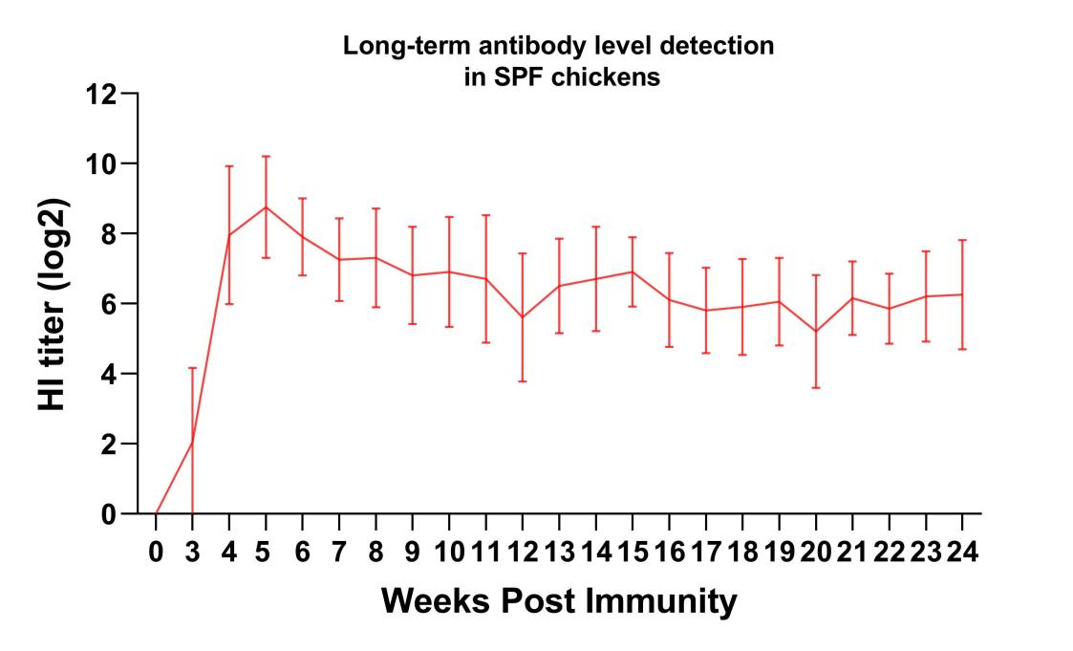

Figure S2

Figure S3

