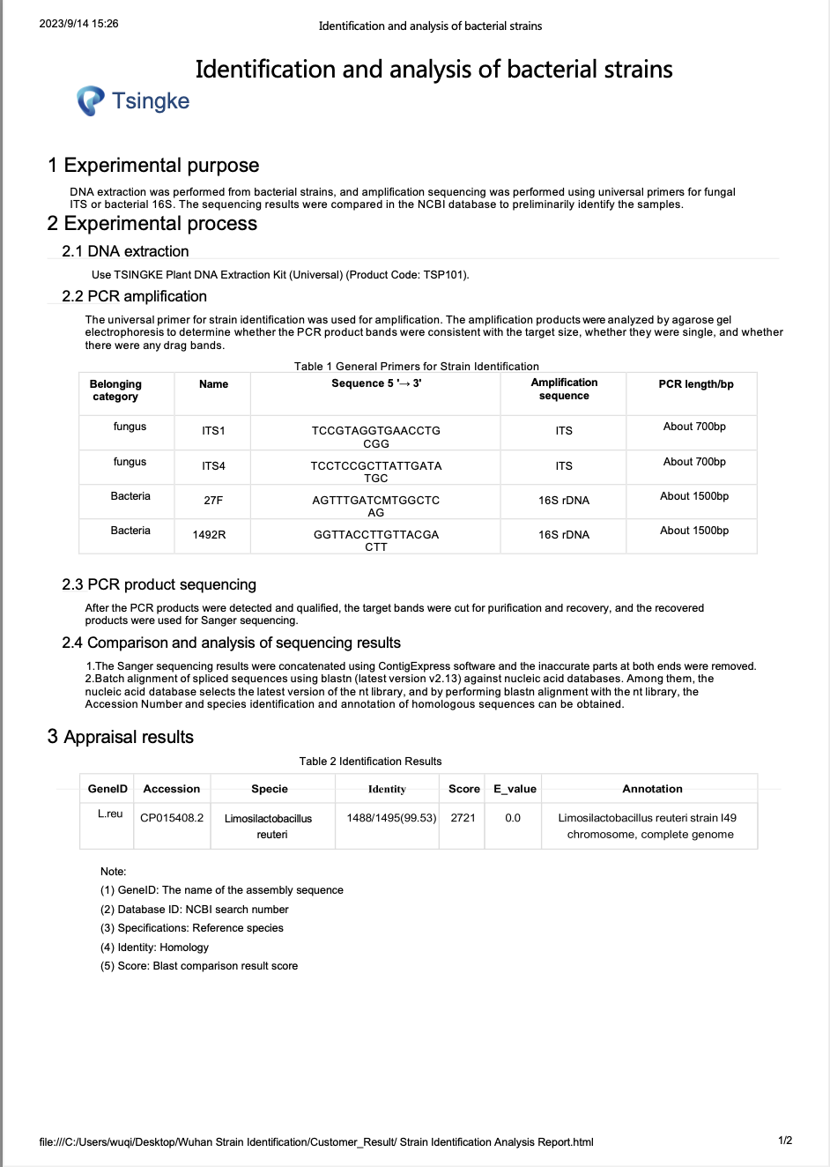
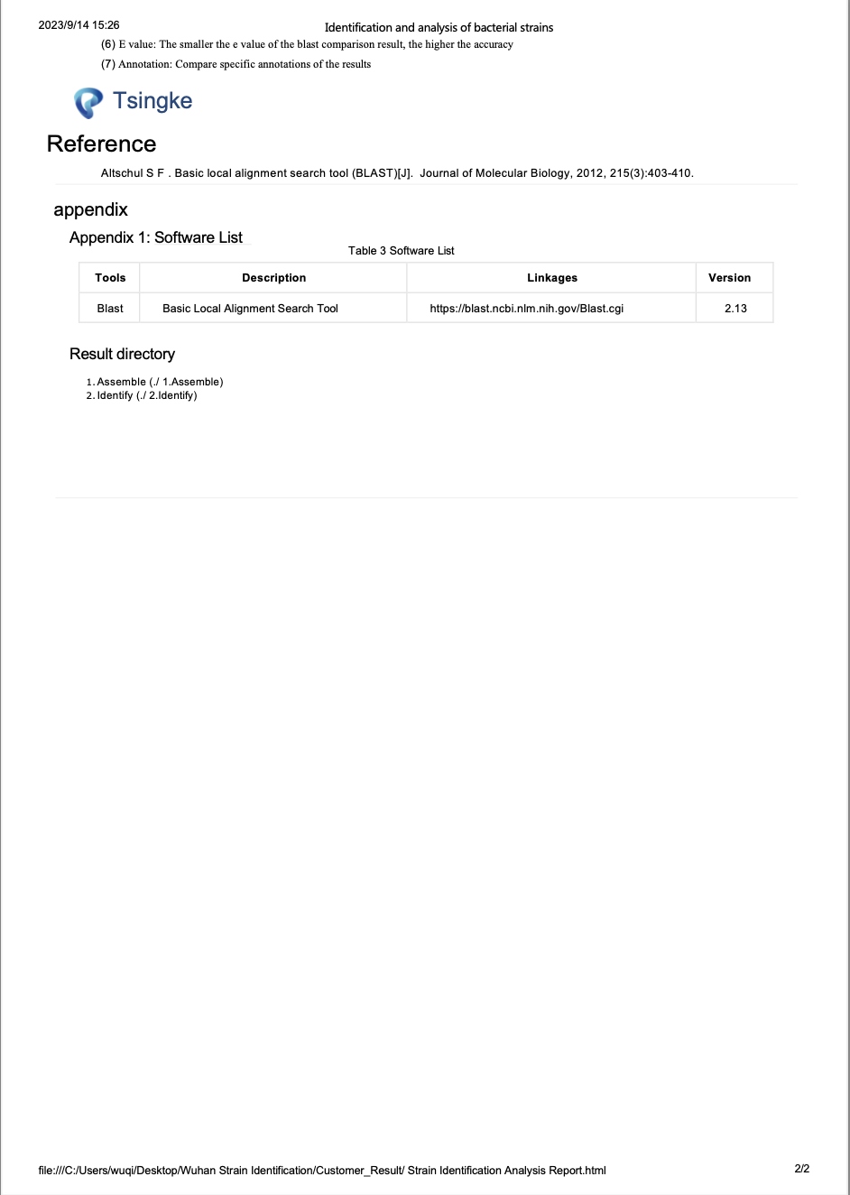
Table 1: Primer sequences used for qRT-PCR
Mice primer
Actin-F | CATTGCTGACAGGATGCAGAAGG
Actin-R | TGCTGGAAGGTGGACAGTGAGG
Cdh1-F | TCCTTGTTCGGCTATGTGTC
Cdh1-R | GGCATGCACCTAAGAATCAG
Ocln-F | TTGAAAGTCCACCTCCTTACAGA
Ocln-R | CCGGATAAAAAGAGTACGCTGG
ZO-1-F | GTTGGTACGGTGCCCTGAAAGA
ZO-1-R | GCTGACAGGTAGGACAGACGAT
MUC2-F | AGGGCTCGGAACTCCAGAAA
MUC2-R | CCAGGGAATCGGTAGACATCG
IL-10-F | CGGGAAGACAATAACTGCACCC
IL-10-R | CGGTTAGCAGTATGTTGTCCAGC
TNF-α-F | GGTGCCTATGTCTCAGCCTCTT
TNF-α-R | GCCATAGAACTGATGAGAGGGAG
IL-6-F | TACCACTTCACAAGTCGGAGGC
IL-6-R | CTGCAAGTGCATCATCGTTGTTC
IL-12-F | CTGTGCCTTGGTAGCATCTATG
IL-12-R | GCAGAGTCTCGCCATTATGATTC
IL-1β-F | TGGACCTTCCAGGATGAGGACA
IL-1β-R | GTTCATCTCGGAGCCTGTAGTG
IFN-γ-F | ATGAACGCTACACACTGCATC
IFN-γ-R | CCATCCTTTTGCCAGTTCCTC
Human primer
Actin-F | CACCATTGGCAATGAGCGGTTC
Actin-R | AGGTCTTTGCGGATGTCCACGT
Cdh1-F | GTCTTTGACTCCTTGCTGAATCTG
Cdh1-R | CACCTCATCGTCTTCCAAGCAC
ZO-1-F | GTCCAGAATCTCGGAAAAGTGCC
ZO-1-R | CTTTCAGCGCACCATACCAACC
HMOX1-F | CCAGGCAGAGAATGCTGAGTTC
HMOX1-R | AAGACTGGGCTCTCCTTGTTGC
Bacteria primer
EUB1114-F | CGGCAACGAGCGCAACCC
EUB1221-R | CCATTGTAGCACGTGTGTAGCC
Sg-L.reu-F | GAACGCAYTGGCCCAA
Sg-L.reu-R | CATTGCTACCCACTTCCTTTACGTCCATTGTGGCCGATCAGT
beta-N-acetylhexosaminidase-F | CTGGCTAAAAACGCCATCCG
beta-N-acetylhexosaminidase-R | GGTACTGTTCCTCCAACCCG
alpha-N-acetylglucosaminidase-F | TGGCTGTGTACAGGAAGCAG
alpha-N-acetylglucosaminidase-R | CGGGAATCACCCCAATCCAA

Figure S1
Figure S1. Physicochemical characterization of L. reuteri-CMVs.
(A) Morphology of L. reuteri-CMVs. (B) The size distribution of L. reuteri-CMVs. (C) The zeta potential of L. reuteri-CMVs. (D) Changes in size of L. reuteri-CMVs in PBS (a), stomach-like solution (b), and intestine-like solution (c). (E) The fluorescence signals emitted by Dil-labeled L. reuteri-CMVs in PBS (a), stomach-like solution (b), and intestine-like solution (c). (F) The lipidomic component analysis of L. reuteri-CMVs. (G) The protein composition profiles in L. reuteri-CMVs and L. reuteri. (H) The top 43 proteins in L. reuteri-CMVs.

Figure S2
Figure S2. Oral administration of L. reuteri-CMVs and L. reuteri has similar effects on the retardation of DSS-induced colitis.
(A) Schematic diagram for the treatment of DSS-induced C57BL/6 colitis mice. (B) Daily body weight over 7 days. (C) DAI scores. (D) Photographs of colons. (E) Colon length. (F) H&E staining for colons. (G) Histological scores. Data are mean ± SEM (n=5). *p < 0.05; **p < 0.01; ***p < 0.001; ****p < 0.0001; ns, non-significance.

Figure S3
Figure S3. L. reuteri-CMVs alleviate DSS-induced colitis in IL-10^{-/-} mice.
(A) Schematic illustration for the administration regimen of DSS-induced colitis in IL-10^{-/-} C57BL/6 mice. (B) Daily body weight over 6 days. (C) DAI scores. (D) Photographs of colons. (E) Colon length. (F) H&E staining for colons. (G) Histological scores. (H) The mRNA expression levels of pro-inflammatory cytokines (TNF-α, IL-6, IL-1β, IL-12, and IFN-γ). Data are mean ± SEM (n=5). *p < 0.05; **p < 0.01; ***p < 0.001; ****p < 0.0001; ns, non-significance.

Figure S4
Figure S4. L. reuteri-CMVs reshape gut microbiota dysbiosis in DSS-induced colitis in L. reuteri-depleted mice.
(A, B) 𝛼-diversity analysis by Shannon index and Simpson index. (C) Microbial composition analysis of different species on Phylum level. (D-F) Histograms of microbial community composition on Phylum, Family, and Genus levels. (G, H) Circos plot and heat map of gut microbiota in different groups on Family level. (I) LDA for demonstrating dominant bacterial communities in different groups. (J) Venn diagram of the gut microbiota in different groups. (K) PCoA of the gut microbiota in different groups. (L) The relative abundance of AKK in different groups. Data are mean ± SEM (n=5). *p < 0.05; ns, non-significance.
Figure S5
Figure S5. L. reuteri-CMVs inhibit intestinal barrier dysfunction in DSS-induced colitis in L. reuteri-depleted mice.
(A) FITC-dextran levels in serum. (B) AB staining of goblet cells in colons. (C) The goblet cell count. (D) The mRNA expression levels of ZO-1, Ocln, Cdh1, and Muc2. (E) Western blot analysis of ZO-1, Ocln, and Cdh1. (F, G) IF images of ZO-1, Ocln, Cdh1, and Muc2. Data are mean ± SEM (n=5). *p < 0.05; **p < 0.01; ***p < 0.001; ****p < 0.0001; ns, non-significance.

Figure S6
Figure S6. In vivo distribution of L. reuteri-CMVs.
(A) Fluorescence images of the gastrointestinal tract and six main organs (brain, heart, liver, lung, kidney, and spleen) revealing in vivo bio-distribution of orally administered IRDye® 800CW-labeled L. reuteri-CMVs at different time points (4, 8 and 12 h) in health and colitis mice. (B) Fluorescence images of the stomach, small intestine, and colon showing Dil-labeled L. reuteri-CMVs mainly accumulated in colon tissues of colitis mice, especially in colonic epithelial cells. (n=3).

Figure S7
Figure S7. Biosafety of orally administered L. reuteri-CMVs.
(A, B) The viabilities of HT-29 and Caco2 cells after treatment with L. reuteri-CMVs at different concentrations (n=3). (C) H&E staining of vital organs (heart, liver, spleen, lung, and kidney) in the healthy control group, PBS group and CMVs group. (D) Heart, liver, and kidney function (n=5). Data are mean ± SEM. ns, non-significance.

