Supplementary material
Zinc-Copper Bimetallic Nanoplatforms Trigger Photothermal-Amplified Cuproptosis and cGAS-STING Activation for Enhancing Triple-Negative Breast Cancer Immunotherapy

Bangyi Zhou ^{1,2†}, Mengyao Chen ^{1,2†}, Zhixing Hao ^{1†}, Lili Li ^{1,2}, Yixin Zhang ^{1,2}, Baoru Fang ³, Miner Shao^{1,2}, Guohong Ren ^{1,4}, Ke Wang ³, Huiying Liu ^{1,2}, Jingxuan Zhu ^{1,2}, Xinyi Zhang ^{1,2}, Shuyan Yuan ^{1,2}, I Sitou ^{1,2}, Jing Zhao ^{1,2}, Jian Huang ^{1,4*}, Zhangsen Yu ^{3*}, Fuming Qiu ^{1,2*}

¹ Key Laboratory of Tumor Microenvironment and Immune Therapy of Zhejiang Province, The Second Affiliated Hospital, Zhejiang University School of Medicine, Hangzhou, 310009, P.R. China;
² Department of Medical Oncology, The Second Affiliated Hospital, Zhejiang University School of Medicine, Hangzhou, 310009, P.R. China;
³ Laboratory of Nanomedicine, Medical Science Research Center, School of Medicine, Shaoxing University, Shaoxing, Zhejiang Province, 312000, P. R. China;
⁴ Department of Breast Surgery, The Second Affiliated Hospital, Zhejiang University School of Medicine, Hangzhou, 310009, P.R. China;
* Corresponding author.
Email addresses: qiufuming@zju.edu.cn (F. Qiu); yzs@usx.edu.cn (Z. Yu); drhuangjian@zju.edu.cn (J. Huang)
† These authors contributed equally to this work

Experimental Section
Materials
Zinc acetate dihydrate, polyvinylpyrrolidone (PVP, MW=58000), cupric chloride dihydrate and dopamine hydrochloride (98%) were purchased from Shanghai Aladdin Biochemical Technology Co., Ltd. Hydrogen Peroxide Assay Kit, Annexin V-FITC Apoptosis Detection Kit, Reactive Oxygen Species Assay Kit, Cell Mitochondria Isolation Kit were purchased from Shanghai Beyotime Biotechnology Co., Ltd. Genomic DNA Purification Kit was purchased from Sangon Biotech (Shanghai) Co., Ltd. Cell Counting Kit-8 (CCK-8) was purchased from Selleck Chemicals. InVivoMAb anti-mouse PD-L1 Antibody was purchased from Bio X Cell. Zombie red, anti-mouse CD45-APC-Cy7, anti-mouse CD3-PE-Cy7, anti-mouse CD4-BV421, anti-mouse CD86-PE, anti-mouse CD80-PE-Cy7, anti-mouse CD45-APC, anti-mouse CD206-FITC, anti-mouse PD-L1-APC, anti-mouse CD8-AF700, anti-mouse CD11b-BV510, anti-mouse CD25-APC, anti-mouse Foxp3-AF488, anti-mouse F4/80-BV421, and anti-mouse CD11c-AF700 were purchased from Biolegend. Anti-LIAS antibody, anti-ACO-2 antibody and anti-SDHB antibody were obtained from Proteintech. Anti-FDX1 antibody was purchased from Abcam. Anti-STING antibody, anti-TBK1 antibody, anti-Phospho-STING antibody, and anti-Phospho-TBK1 antibody were purchased from Cell Signaling Technology.
Synthesis of ZnO₂ NPs
ZnO₂ NPs were synthesized according to the previous report [1]. Briefly, 100 mg each of zinc acetate dihydrate and PVP were dispersed in 5 mL deionized (DI) water, followed by the dropwise addition of 0.5 mL H₂O₂ under continuous stirring at room temperature. After 24 hours of reaction, the mixture was centrifugated at 10000 g for 30 min and the precipitate was washed twice with DI water.
Synthesis of Cu-ZnO₂ NPs (CZ NPs)
ZnO₂ NPs (15 mg in 3 mL DI water) and CuCl₂·2H₂O (30 mg in 15 mL DI water) were mixed and stirred for 4h at room temperature. The suspension was centrifuged at 10000 g for 30 min and washed twice.
Synthesis of Cu-ZnO₂ @PDA NPs (CZP NPs)
30 mg of CZ NPs and 30 mg of dopamine hydrochloride were dispersed in 100 mL DI water and sonicated for 1 hour. After centrifuging at 10000 g for 30 min and washing twice, the CZP NPs were collected and stored at 4 ℃ for future experiments.
Characterization
The morphology and element mapping of different nanoplatforms were evaluated by transmission electron microscopy (JEM-2100F, Japan). The dynamic light scattering (DLS) and Zeta potential of ZnO₂, CZ and CZP NPs were measured via a Zetasizer Nano ZS analyzer (Nano ZS, Malvern Instruments Ltd., U.K.). The Fourier transform infrared spectroscopy (FT-IR) was detected using a NEXUS-670 FTIR spectrometer (Nicolet Co., Ltd., USA). The UV-Vis -NIR absorbance spectra were recorded on the UV-Vis spectrometer (UV-1900, Shimadzu, Japan)
Photothermal performance evaluation
The photothermal performance of various nanoparticles was evaluated using a thermal imaging system (PI400, Optris, Germany). The temperature variations of ZnO₂, CZ, and CZP aqueous solution with different concentrations (100, 200, 300, 400, and 500 µg/mL) under 808 nm NIR irradiation (2.0 and 3.0 W/cm²) were recorded at 10-second intervals to plot temperature rise curves. Furthermore, the photothermal stability was evaluated through five laser irradiation on/off cycles with the CZP concentration of 500 µg/mL and power density of 3.0 W/cm². Moreover, a 500 µg/mL CZP aqueous solution was exposed to 808 nm NIR irradiation at 3.0 W/cm² for 20 minutes, followed by a 10-minute cooling period to determine the photothermal conversion efficiency (η). The absorption spectra of CZP within the 300-1000 nm range were detected pre- and post-laser exposure.
pH-responsive release of zinc, copper ions, and H₂O₂ from CZP NPs
To evaluate the acid-induced release of zinc and copper ions, CZP NPs were dispersed in buffer solutions at different pH (7.4, 6.5, and 5.5). The supernatants were collected at predetermined time points following centrifugation (10000 g, 10 min) and analyzed for released zinc and copper ions using an inductively coupled plasma-atomic emission spectrometer (ICP-AES).
To determine H₂O₂ release, the CZP NPs were dispersed in buffer solutions at pH levels of 7.4 and 6.5 and stirred at room temperature. At multiple time points, the solutions were centrifuged (10000 g, 10 min) and the supernatants were analyzed for H₂O₂ content with the Hydrogen Peroxide Assay Kit.
Fenton-like reaction performance assessment
Different concentrations of ZnO₂, CZ, and CZP NPs (50 and 100 µg/mL) containing 30 mM H₂O₂ and 20 µg/mL methylene blue (MB) were incubated at room temperature for 30 min. Then, the absorption spectrum of the mixture was detected in the wavelength range of 450 to 750 nm and degradation rates of MB were calculated. The influence of temperature was further investigated by incubating the mixture at 37 or 45℃.
Cell culture
The mouse breast cancer 4T1 cell line was cultured in RPMI-1640 medium containing 10% fetal bovine serum (FBS) and 1% penicillin/streptomycin at 37 °C under 5% CO₂.
Cellular uptake
The 4T1 cells were seeded in Laser confocal cell culture dishes and incubated overnight, and then the cells were treated with FITC labeled CZP (FITC-CZP, 60 µg/mL) for 4h. After incubation, the cells were stained with DAPI and Dil for 15 min to visualize the nucleus and cell membrane. Finally, the images were performed using a confocal laser scanning microscope (CLSM). In addition, 4T1 cells were exposed to varying concentrations of CZP NPs (0, 20, 40, and 60 µg/mL) for different times (0, 1, 2, 4, 6, and 8 hours). The intracellular fluorescence intensity of FITC was quantified using flow cytometry.
Cell cytotoxicity assay
The 4T1 cells were seeded in 96-well plates at a density of 1×10⁴ cells per well and cultured overnight. Subsequently, the spent culture medium in each well was replaced with fresh medium containing varying concentrations of ZnO₂, CZ and CZP NPs (0, 5, 10, 15, 20, 30, 40, 60, 80, and 100 µg/mL) and the cells were treated with different power density of 808 nm laser (0 and 2 W/cm²). The relative cell viabilities at various time points were assessed using the CCK-8 solution.
Cell apoptosis and necrosis assay
The 4T1 cells were seeded in 12-well plates at a density of 1×10⁵ cells per well and cultured overnight. The cells were then allocated into six groups: (1) Control, (2) Control + NIR, (3) ZnO₂, (4) CZ, (5) CZP, and (6) CZP + NIR. The concentration of nanoparticles for each group was standardized to 60 µg/ml, and the 808 nm laser power was set at 1 W/cm². After an 8-hour incubation, the cells were collected and stained using an Annexin V-FITC Apoptosis Detection Kit before flow cytometric analysis.
Intracellular ROS detection
The 4T1 cells were seeded in 6-well plates at a density of 6×10⁴ cells per well and cultured overnight. After incubated with various nanoparticles (100 µg/ml) for 4 hours, the cells were washed gently with PBS three times and incubated with DCFH-DA for 20 min at 37 ℃. Subsequently, fluorescence intensity variations among the groups were evaluated using fluorescence microscopy or flow cytometry.
Bio-TEM analysis
4T1 cells were seeded into 12-well plates at a density of 1×10⁵ cells per well and incubated overnight. Following this, cells were treated with CZP NPs at 60 µg/ml and exposed to an 808 nm NIR laser at 1 W/cm² for 5 minutes, then further incubated for 6 hours. Subsequently, cells were collected, fixed with lectron microscope fixative and observed using Bio-TEM.
Western blotting
The proteins of cells after various treatments were extracted and separated using 12% sodium dodecyl sulfate-polyacrylamide gel electrophoresis (SDS-PAGE) and transferred to polyvinylidene ﬂuoride (PVDF) membranes. The membranes were blocked with a 5% nonfat milk solution for 1 hour at room temperature, then incubated with primary antibodies against various proteins overnight at 4°C on a shaker. Afterward, the membranes were incubated with HRP-conjugated secondary antibodies for 1 hour before imaging.
mtDNA release measurement
4T1 cells were treated as follows: (1) Control, (2) Control + NIR, (3) ZnO₂, (4) CZ, (5) CZP, and (6) CZP + NIR. Mitochondria were isolated from 4T1 cells using a Cell Mitochondria Isolation Kit. Subsequently, genomic DNA, devoid of mitochondrial interference, was extracted using a Genomic DNA Purification Kit to quantify cytosolic mtDNA. qPCR was performed using the mtDNA ND1 primer, with results normalized to β-actin and analyzed using the 2^{−ΔΔCt} method.
DCs maturation
The BMDCs were harvested from the bone marrow of six to eight weeks old BALB/c mice and cultured in RPMI 1640 medium contained with 10% FBS, IL-4 (5 ng/mL) and GM-CSF (10 ng/mL), to explore DCs maturation in vitro.
4T1 cells were plated at a density of 1×10⁵ cells per well in 12-well plates and treated with various agents at a concentration of 60 µg/ml. Laser irradiation groups applied 1 W/cm² 808 nm laser for 5 minutes. Following 24 hours of incubation, the supernatant from the 4T1 cell cultures was collected and co-incubated with the BMDCs for another 24 hours. Subsequently, the BMDCs were stained with anti-mouse CD11c-AF700, anti-mouse CD80-PE-Cy7, and anti-mouse CD86-PE antibodies for 20 minutes. The maturation status of the BMDCs was then determined using flow cytometry.
Quantitative real-time PCR (qPCR)
RNA was extracted from cells that underwent various treatments, and gene expression was quantified using a real-time quantitative PCR instrument (Bio-Rad). Relative gene expression was calculated using the 2^{−ΔΔCt} method after normalization to the endogenous control gene β-actin. Primer sequences are provided in Table S1.
PD-L1 expression
4T1 cells treated with diverse nanoparticles were digested into single-cell suspensions and stained with anti-mouse PD-L1-APC for 30 minutes. Then, the PD-L1 expression levels were analyzed using flow cytometry.
RNA sequencing
4T1 cells were allocated to two groups: a control group with no treatment and an experimental group treated with CZP + NIR. The RNA was extracted from different samples and sent to Majorbio Bio-pharm Technology Co., Ltd. (Shanghai, China) for transcriptomics analyses. Genes with a p-value ≤ 0.05 and |fold change| ≥ 1.5 were identified as differentially expressed.
Animals and tumor model
Healthy ICR and BALB/c mice (6-8 weeks old) were purchased from Shanghai SLAC Laboratory Animal Center. To establish the orthotopic 4T1 breast tumor model, 4T1 cells (2 × 10⁵ per mouse in 100 µL) were injected into the left fourth mammary fat pad of BALB/c mice. Further experiments were initiated once tumors reached a volume of 60-100 mm³.
In vivo biosafety evaluation
Healthy female ICR mice were randomly assigned to different groups. Each mouse received a single intravenous (i.v.) injection of saline or CZP NPs at 10, 20, 30, 40, or 50 mg/kg doses. The mice were weighed and monitored every other day. At 28 days post-administration, the mice were euthanized, and blood samples were collected for blood routine and serum biochemical analysis. The major organs (heart, liver, spleen, lung, and kidney) were also harvested, photographed, and weighed to calculate the organ coefficients. Histological sections of these organs were stained with hematoxylin and eosin (H&E) to assess pathological changes.
In vivo biodistribution
The 4T1 tumor-bearing mice were i.v. injected with CZP-ICG, and its biodistribution was tracked using IVIS at multiple time points post-injection. Meanwhile, the mice were sacrificed after in vivo imaging at 4 and 24 hours. The main organs and tumor tissues were then harvested for ex vivo IVIS imaging under the same parameters, and the total fluorescence intensity of each excised organ was quantified using IVIS.
In vivo antitumor therapeutic effect evaluation
The 4T1 tumor-bearing mice were randomly assigned into six groups (n = 5): (1) Control, (2) Control + NIR, (3) ZnO₂, (4) CZ, (5) CZP, and (6) CZP + NIR. On days 0, 2, 4, and 6, each mouse received intratumoral (i.t.) injections of saline, ZnO₂, CZ, or CZP at 3 mg/kg dose. Mice in groups (2) and (6) received 808 nm NIR irradiation (1 W/cm², 5 minutes) one hour after injection on day 0. On day 1, 4T1 cells (2 × 10⁵ per mouse in 100 µL) were inoculated in the dorsal region opposite the primary tumor to establish distant tumors. Tumor volumes and mouse weight were monitored every other day. On day 12, mice were sacrificed to collect tumor-draining lymph nodes (TDLNs) and tumor tissue. Histopathological analysis was conducted on the tumor tissues, including H&E, TUNEL, and immunofluorescence staining.
Reprogramming the tumor immune microenvironment in vivo
The tumors and TDLNs (n = 4) harvested above were digested to single-cell suspensions and subsequently labeled by various antibodies. The tumors were labeled by zombie red, anti-mouse CD45-APC-Cy7, anti-mouse CD3-PE-Cy7, anti-mouse CD4-BV421, anti-mouse CD8-AF700, anti-mouse CD25-APC, anti-mouse Foxp3-AF488, anti-mouse CD11b-BV510, anti-mouse F4/80-BV421, and anti-mouse CD206-FITC. The TDLNs were labeled by zombie red, anti-mouse CD45-APC, anti-mouse CD11c-AF700, anti-mouse CD80-PE-Cy7, and anti-mouse CD86-PE. Finally, the infiltrations of immune cells were evaluated by flow cytometry.
Lung metastasis inhibition
The 4T1 tumor-bearing mice, randomly assigned to six groups (n = 3), were treated for primary tumors as detailed above. Notably, on day 1, mice were i.v. injected with 4T1-luc cells (2 × 10⁵ per mouse in 100 µL) to establish a tumor metastasis model. After 12 days of injection, the mice were administered D-luciferin potassium salt intraperitoneally and the fluorescent signal intensities were evaluated using the IVIS system. Following this, the mice were sacrificed, and their lung tissues were collected, sectioned, and subjected to H&E staining to assess the size of the metastatic nodules.
CZP + NIR + αPD-L1 combined therapy
The 4T1 tumor-bearing mice were randomly allocated into four treatment groups: (1) Control, (2) αPD-L1, (3) CZP + NIR, and (4) CZP + NIR + αPD-L1. Throughout the treatment period, Mice received i.t. injections of saline or CZP NPs (3 mg/kg) on days 0, 2, 4, and 6, and intraperitoneal injections of saline or αPD-L1 (2 mg/kg) on days 1, 3, 5, and 7. Additionally, groups 3 and 4 were exposed to 5 minutes of 808 nm NIR irradiation (1 W/cm²) one hour after the injection of CZP NPs on day 0. Tumor volumes and body weights were monitored every other day.
On day 12, mice were euthanized for the collection of tumor-draining lymph nodes (TDLNs) and tumor tissue. Single-cell suspensions were prepared and labeled as follows: TDLNs (n = 4) with zombie red, anti-mouse CD45-APC, anti-mouse CD11c-AF700, anti-mouse CD86-PE, and anti-mouse CD80-PE-Cy7; tumor tissues (n = 5) with zombie red, anti-mouse CD45-APC-Cy7, anti-mouse CD3-PE-Cy7, anti-mouse CD8-AF700, anti-mouse CD4-BV421, anti-mouse Foxp3-AF488, anti-mouse CD25-APC, anti-mouse F4/80-BV421, anti-mouse CD11b-BV510, anti-mouse CD11c-AF700, anti-mouse CD80-PE-Cy7, anti-mouse CD86-PE, and anti-mouse CD206-FITC. Flow cytometry analysis was conducted to assess immune cell subset distribution across the groups.
Statistical analysis
Data are expressed as mean value ± standard deviation. All statistical analyses were performed with GraphPad Prism 9.0 software and statistical signiﬁcance was assessed via one-way ANOVA or two-way ANOVA. Differences of p < 0.05 (*), p < 0.01 (**), p < 0.001 (***), and p < 0.0001 (****) were considered statistically significant.

References
1. Lin L S, Wang J F, Song J, Liu Y, Zhu G, Dai Y, et al. Cooperation of endogenous and exogenous reactive oxygen species induced by zinc peroxide nanoparticles to enhance oxidative stress-based cancer therapy. Theranostics. 2019;9(24):7200-7209.

Figure S1. (a) Survey XPS spectrum of CZP NPs. (b) High-resolution Zn 2p and (c)Cu 2p XPS spectra of CZP NPS.

Figure S2. Concentration-dependent (power density set at 2.0 W cm²) photothermal heating curves of (a) ZnO₂, (b) CZ, and (c) CZP solutions. (d) Temperature-time curves of CZP solutions (concentration set at 500 μg/mL) under 808 nm NIR irradiation (2.0 W cm²). Concentration-dependent (power density set at 3.0 W cm²) photothermal heating curves of (e) ZnO₂ and (f) CZ solutions.

Figure S3. Temperature rise and fall curves of H₂O and CZP solutions (concentration set at 500 μg/mL) under 808 nm NIR irradiation (power density set at 3.0 W cm²).

Figure S4. UV-Vis spectra of CZP solution before and post laser irradiation.

Figure S5. The release of (a) copper and (b) zinc ions from CZ or CZP NPs under various pH conditions (pH 7.4, 6.5, and 5.5).

Figure S6. UV-vis absorption spectra of different solutions with (a) ZnO₂ and (b) CZ NPs at different concentrations. (c) MB degradation rate under the different reaction conditions. UV-vis absorption spectra of solutions containing (d) ZnO₂ and (e) CZ at different temperatures.

Figure S7. The proportion of zinc and copper ions in CZ and CZP NPs.

Figure S8. The apoptotic and necrotic rate of 4T1 cells (Annexin V-FITC⁺PI⁻ + Annexin V-FITC⁺PI⁺ cells) following various treatment (n = 3; ****, p < 0.0001; ns, no significance).

Figure S9. Statistical analysis of mature DCs (CD11c⁺CD80⁺CD86⁺) after different treatment (n = 3; *, p < 0.05; **, p < 0.01; ***, p < 0.001; ns, no significance).

Figure S10. Statistical analysis of PD-L1 expression in 4T1 cells following different treatment (n = 3; ****, p < 0.0001; ns, no significance).

Figure S11. Chord diagram of GO enrichment analysis.

Figure S12. Chord diagram of KEGG enrichment analysis.
Figure S13. Body weight changes of mice following tail vein injection of CZP NPs at various doses over 28 days (n = 5; ns, no significance).

Figure S14. Main organ coefficients of mice administered various doses of CZP NPs. (n = 5; ns, no significance).

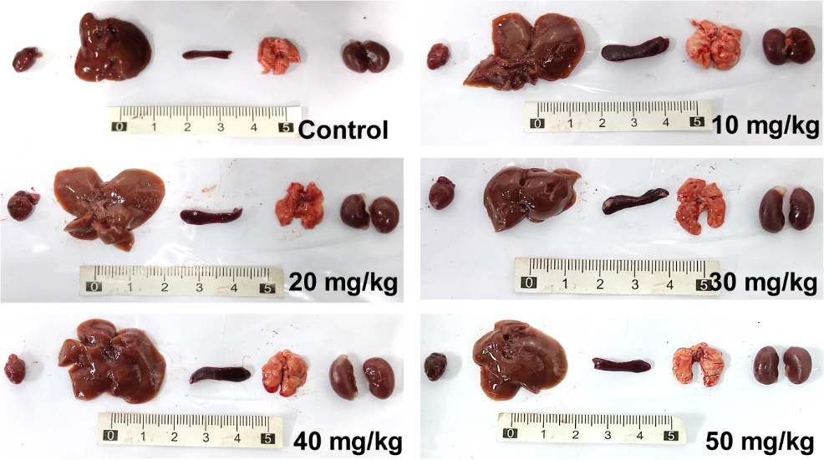
Figure S15. Photographs of main organs (heart, liver, spleen, lung, and kidney) from mice treated with multiple doses of CZP NPs.

Figure S16. Serum biochemical analysis of mice treated with multiple doses of CZP NPs (n = 4-5).

Figure S17. Blood routine analysis of mice treated with multiple doses of CZP NPs (n = 4-5).

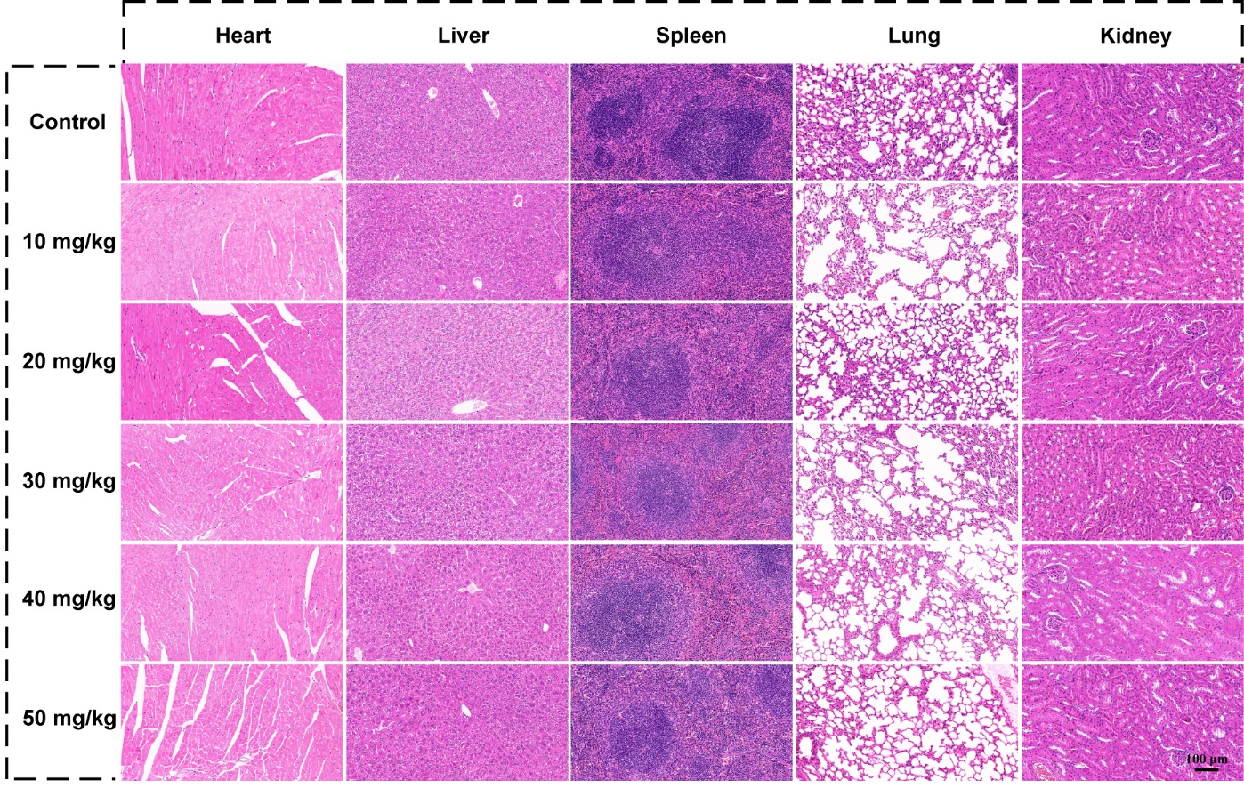
Figure S18. H&E staining of main organs (heart, liver, spleen, lung, and kidney) obtained from mice receiving different treatments.

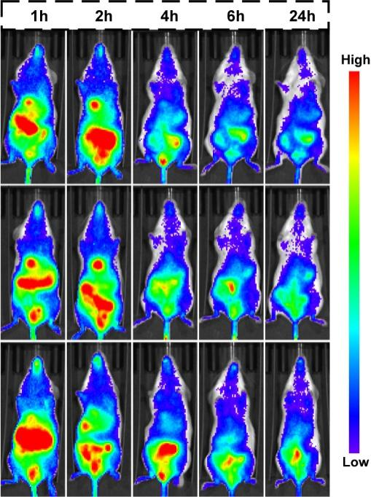
Figure S19. In vivo fluorescence images of 4T1 tumor-bearing mice at various time points post-tail vein injection of CZP-ICG NPs.

Figure S20. (a) Ex vivo fluorescence imaging of tumors (T) and major organs, including heart (H), liver (L), spleen (S), lung and kidney (K) collected at 4 and 24 h post-injection, and (b-c) the corresponding fluorescence intensity (n = 3).

Figure S21. Individual tumor growth curves of 4T1 tumor-bearing mice post various treatments (n = 5).

Figure S22. (a) The corresponding quantification of CD8⁺ T cells immunofluorescence staining. (**, p < 0.01; ns, no significance).

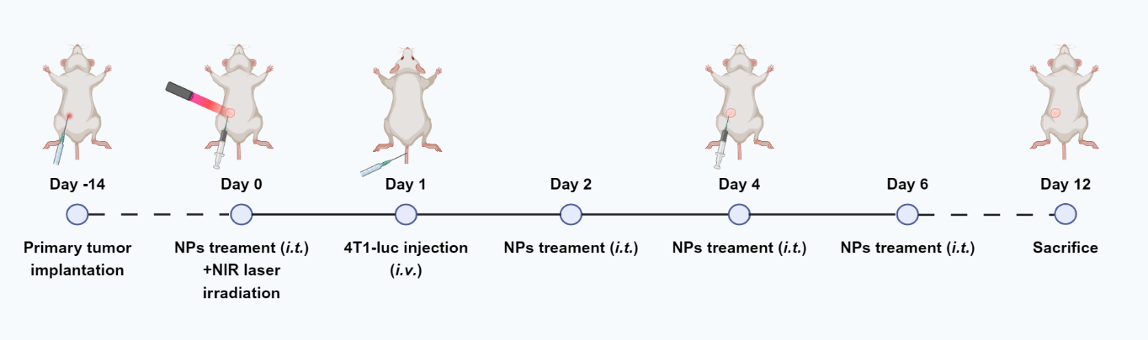
Figure S23. Schematic diagram of the experimental schedule for 4T1 metastatic tumor model treatment.

Figure S24. (a) In vivo fluorescence images of tumor-bearing mice at day 12 and (b) quantification of the pulmonary fluorescence intensity (n = 3).

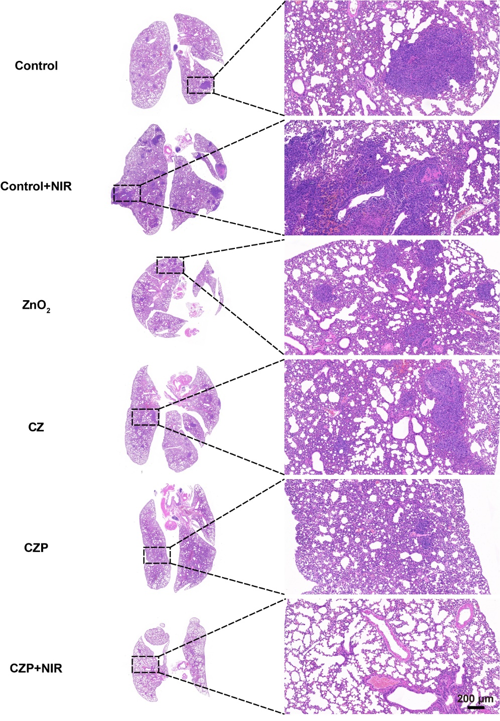
Figure S25. H&E staining of lung tissues collected from tumor-bearing mice post various treatments.

Figure S26. Individual tumor growth curves of 4T1 tumor-bearing mice post various treatments (n = 5).

Figure S27. (a) Representative ﬂow cytometry plots and (b) corresponding percentages of M1 (CD11b⁺F4/80⁺CD86⁺) phenotype tumor-associated macrophages in tumors from mice following various treatments. (n = 5; **, p < 0.01; ns, no significance).

Table S1. Sequences of the primers used for qPCR in this study.
Gene | Primer | Sequence (5’- 3’)
m-cGAS | Forward | GCTACTATGAGCACGTGAAGATTT
m-cGAS | Reverse | TGAATTCTGGGGACTTCCAGT
m-ISG56 | Forward | ACAGCAACCATGGGAGAGAATGCTG
m-ISG56 | Reverse | ACGTAGGCCAGGAGGTTGTGCAT
m-IFNB1 | Forward | TCCTGCTGTGCTTCTCCACCACA
m-IFNB1 | Reverse | AAGTCCGCCCTGTAGGTGAGGTT
m-CXCL10 | Forward | ATCATCCCTGCGAGCCTATCCT
m-CXCL10 | Reverse | GACCTTTTTTGGCTAAACGCTTTC
m-ISG15 | Forward | GGTGTCCGTGACTAACTCCAT
m-ISG15 | Reverse | CTGTACCACTAGCATCACTGTG
m-PD-L1 | Forward | GCTCCAAAGGACTTGTACGTG
m-PD-L1 | Reverse | TGATCTGAAGGGCAGCATTTC
m-MT-ND1 | Forward | CTCAACCCTAGCAGAAACAAACC
m-MT-ND1 | Reverse | CGGAAGCGTGGATAAGATGC
m-β-actin | Forward | GGCTGTATTCCCCTCCATCG
m-β-actin | Reverse | CCAGTTGGTAACAATGCCATGT

