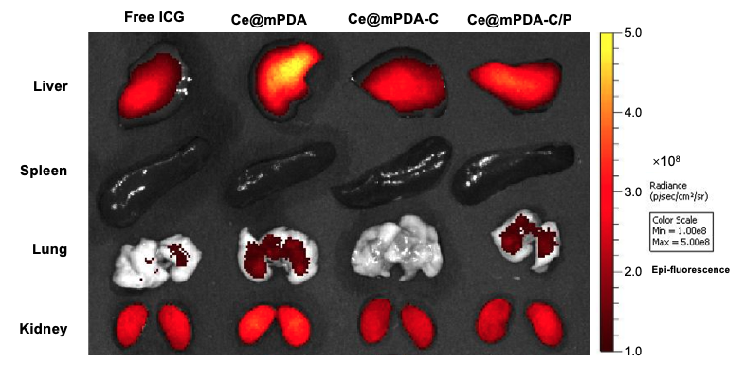
Figure S1, In vivo biodistribution of free ICG and ICG-modified Ce@mPDA, Ce@mPDA-C, and Ce@mPDA-C/P nanoparticles. The fluorescence images show the distribution of the nanoparticles in major organs, including the liver, spleen, lung, and kidney, at 4 hours post-injection.

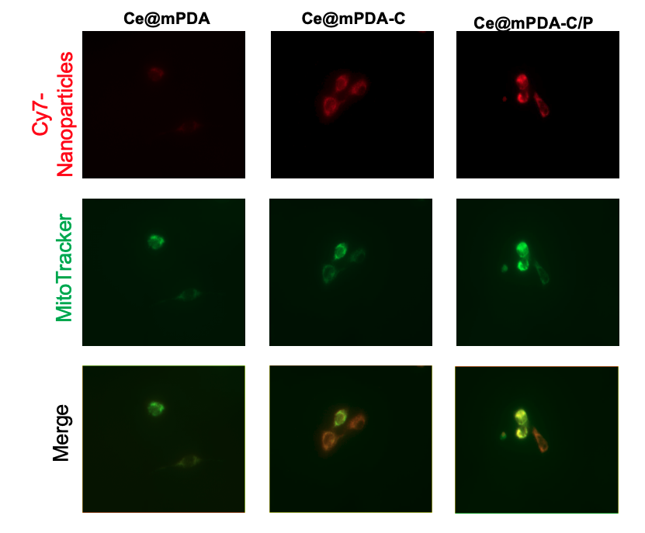
Figure S2. Cellular uptake and mitochondrial targeting of Ce@mPDA, Ce@mPDA-C, and Ce@mPDA-C/P nanoparticles. Fluorescence images show the distribution of Cy7-labeled nanoparticles (red) and MitoTracker-labeled mitochondria (green) in cells. The merged images (orange) demonstrate the co-localization of nanoparticles with mitochondria.

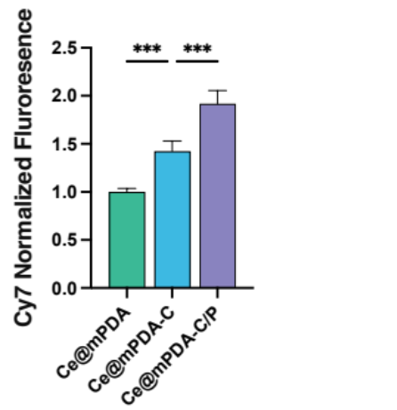
Figure S3. Quantification of Cy7 fluorescence intensity in H/R H9C2 cells treated with Ce@mPDA, Ce@mPDA-C, and Ce@mPDA-C/P nanoparticles. ***p < 0.001. Data are presented as the mean ± standard deviation, n = 8.

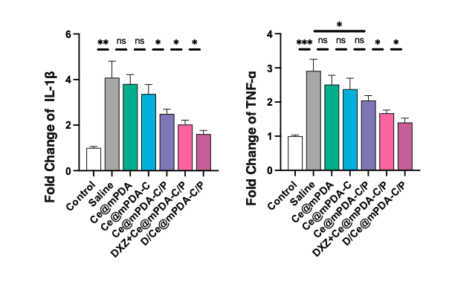
Figure S4. Quantification of mRNA expression of IL-1β and TNF-α in MIRI myocardium across different treatment groups. The bar graphs show the expression levels of IL-1β (left) and TNF-α (right). Statistical significance is indicated as *p < 0.05, **p < 0.01, ***p < 0.001, ns = not significant. Data are presented as the mean ± standard deviation, n = 3.

