Supporting Information
Probiotic nanocomposite materials with excellent resistance, inflammatory targeting, and multiple efficacies for enhanced treatment of colitis in mice
Yuewen Huang^{a,#}, Hongting Cai^{a,#}, Huipeng Liu^{a,#}, Lixiang Wang^{a,#}, Guangfu Feng^{a,}*, Zizi Dingª, Yanquan Feiª, Aike Li^{b,}*, Jun Fang^{a,}*
ª College of Bioscience and Biotechnology, Hunan Agricultural University, Changsha 410128, China
^{b} Feed Research Institute/Grain Quality & Nutrition Institute, Academy of National Food and Strategic Reserves Administration; Key Laboratory of Grain and Oil Biotechnology of National Food and Strategic Reserves Administration, Beijing 100037, China
# These authors contributed equally to this work.
* Corresponding authors: Guangfu Feng, Email: GuangfuFeng@hunau.edu.cn;
Aike Li, Email: lak@AGS.AC.CN;
Jun Fang, Email: fangjun1973@hunau.edu.cn
Supplementary Figure 1. Element mapping analysis for Spore, Spore-RA, and Spore-RA-SF. Scale bar: 1 μm.

Supplementary Figure 2. Loading rate of RA evaluated by the UV absorption at 330 nm. Data were presented as the mean ± standard deviation (n = 3 biologically independent samples).

Supplementary Figure 3. Fluorescence retention time of FITC-labeled Spore-RA-SF in ultrapure water and MRS medium. Scale bar: 10 μm.
Supplementary Figure 4. Inhibitory effects of Spore, Spore-RA, and Spore-RA-SF on the growth of E. coli DH5α (2 mL).

Supplementary Figure 5. (a) ABTS^{•+}, (b) DPPH•, and (c) PTIO• scavenging ratios after SGF incubation in different groups. Data were presented as the mean ± standard deviation (n = 3 biologically independent samples). Statistical analysis was evaluated with two-tailed Student’s t tests (*P < 0.05, **P < 0.01, ***P < 0.001, ****P < 0.0001).

Supplementary Figure 6. (a) ABTS^{•+}, (b) DPPH•, and (c) PTIO• scavenging ratios after SIF incubation in different groups. Data were presented as the mean ± standard deviation (n = 3 biologically independent samples). Statistical analysis was evaluated with two-tailed Student’s t tests (*P < 0.05, **P < 0.01, ***P < 0.001, ****P < 0.0001).

Supplementary Figure 7. (a) ABTS^{•+}, (b) DPPH•, and (c) PTIO• scavenging ratios after SCF incubation in different groups. Data were presented as the mean ± standard deviation (n = 3 biologically independent samples). Statistical analysis was evaluated with two-tailed Student’s t tests (*P < 0.05, **P < 0.01, ***P < 0.001, ****P < 0.0001).
Supplementary Figure 8. Original photographs of mouse colons on day 10 after different treatments. (n = 5 biologically independent samples)
Supplementary Figure 9. Dilution curves of 16S rRNA gene sequencing of colonic contents in different groups of mice. Data were presented as the mean ± standard deviation (n = 5 biologically independent samples).

Supplementary Figure 10. (a) Ace index, (b) Chao1 index, and (c) Simpson index (α-diversity) of gut microbiota in different groups of mice. Data were presented as the mean ± standard deviation (n = 5 biologically independent samples). Statistical analysis was evaluated with two-tailed Student’s t tests (*P < 0.05, **P < 0.01, ***P < 0.001, ****P < 0.0001).

Supplementary Figure 11. PCoA (β-diversity) of gut microbiota in different groups of mice. (n = 5 biologically independent samples)
Supplementary Figure 12. GSEA plots indicated the suppressed signaling pathways (NF−κB signaling pathway, TNF signaling pathway, IL-17 signaling pathway, and Cytokine−cytokine receptor interaction) in the colon of colitis mice after Spore-RA-SF treatment. (n = 3 biologically independent samples)

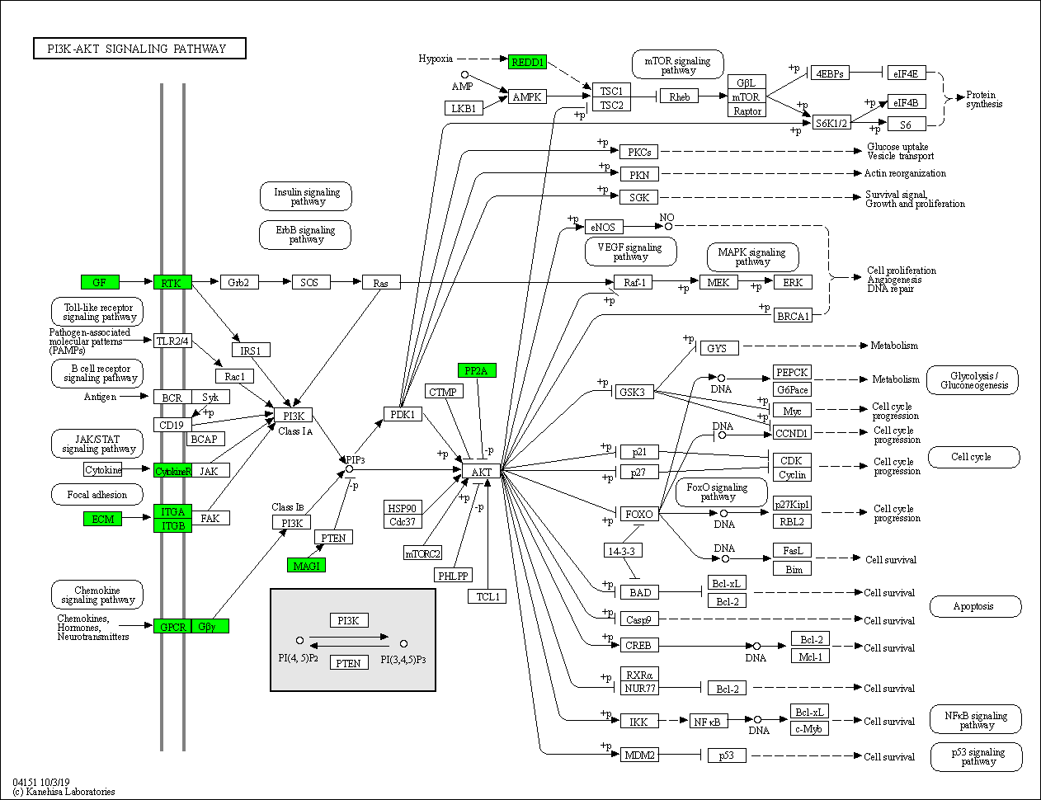
Supplementary Figure 13. KEGG annotation revealed the remarkably downregulated genes (green background) in PI3K−AKT signaling pathway of the Spore-RA-SF-treated group. (n = 3 biologically independent samples)

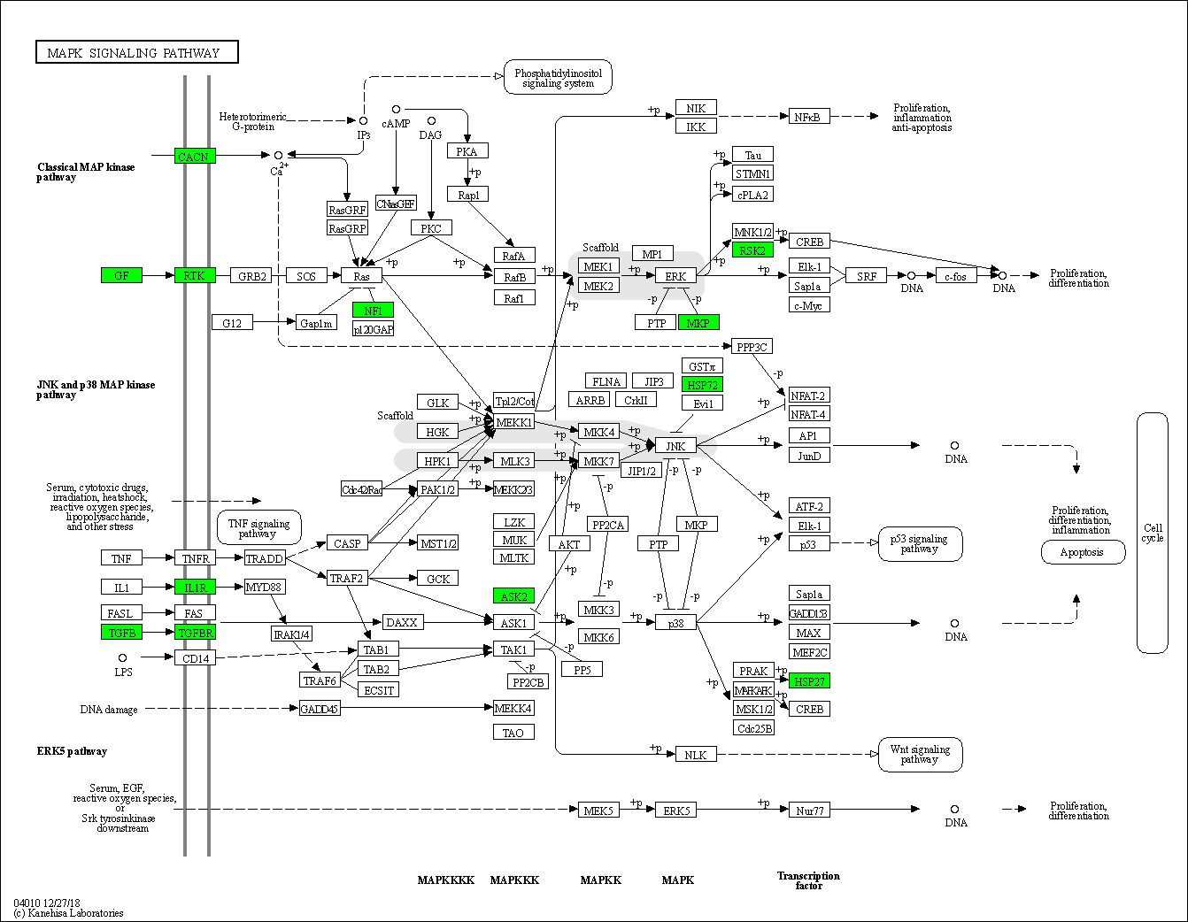
Supplementary Figure 14. KEGG annotation revealed the remarkably downregulated genes (green background) in MAPK signaling pathway of the Spore-RA-SF-treated group. (n = 3 biologically independent samples)

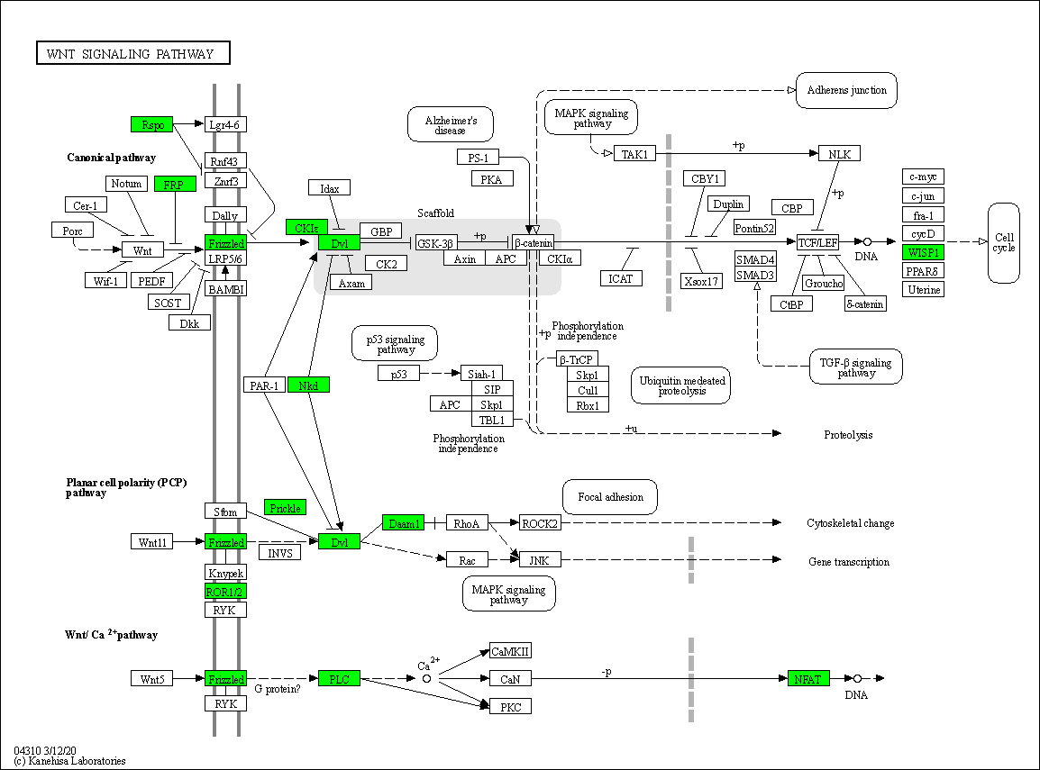
Supplementary Figure 15. KEGG annotation revealed the remarkably downregulated genes (green background) in WNT signaling pathway of the Spore-RA-SF-treated group. (n = 3 biologically independent samples)

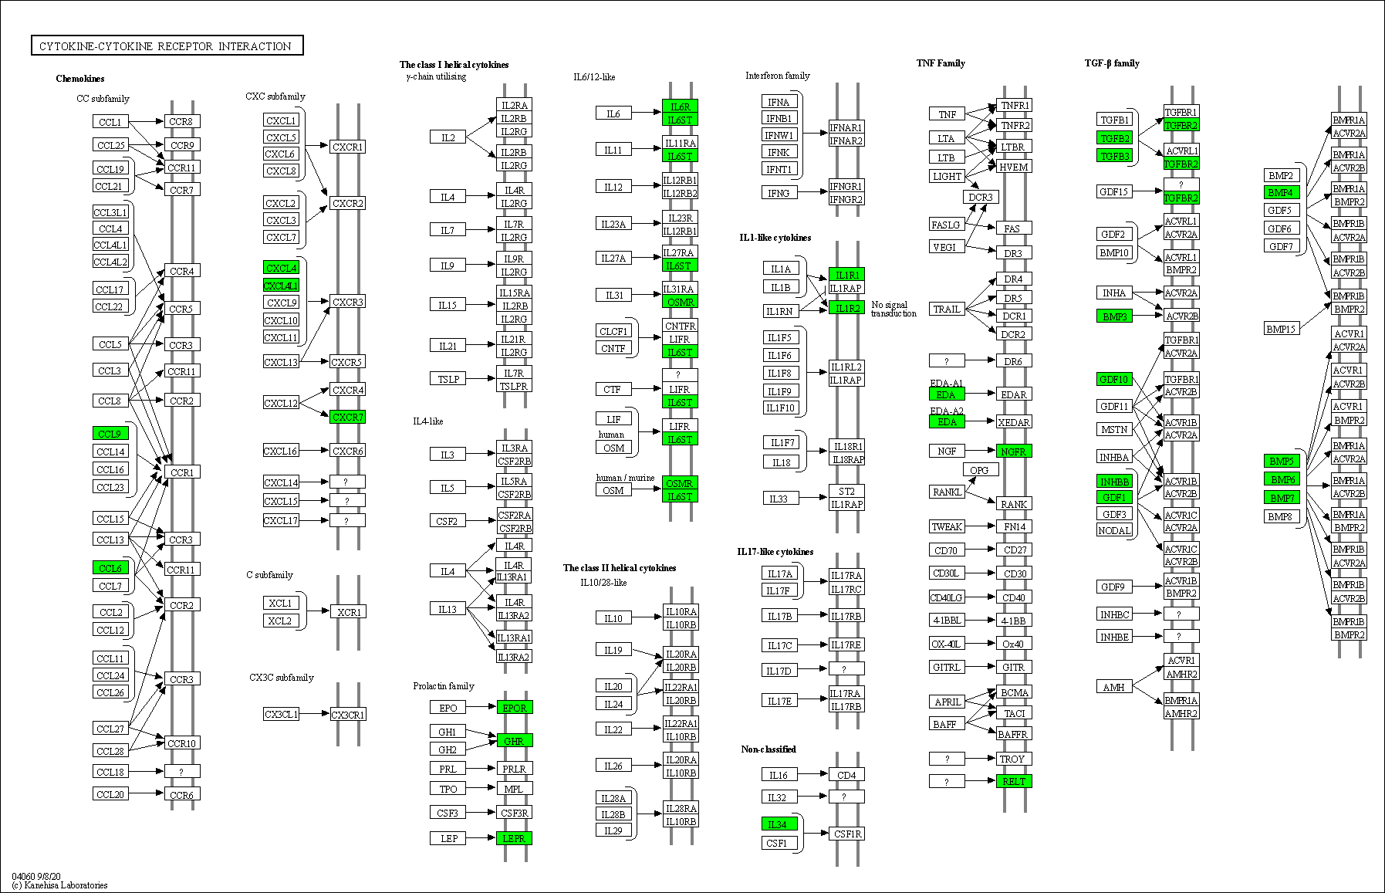
Supplementary Figure 16. KEGG annotation revealed the remarkably downregulated genes (green background) in Cytokine−cytokine receptor interaction of the Spore-RA-SF-treated group. (n = 3 biologically independent samples)

Supplementary Table 1. DAI parameters and their associated scoring schemes.
Score | Weight loss (%) | Stool consistency | Hematochezia
0  1  2  3  4 | None  1–5  5–10  10–20  > 20 | Normal  Loose stool  Diarrhea | Normal  Slight hematochezia  Significant hematochezia

Supplementary Table 2. Histological grading schemes for colitis.
Score | Colonic epithelial damage | Inflammatory cell infiltration  Mucosa Submucosa Muscle/serosa
0  1  2  3  4  5  6 | Normal  Hyperproliferation, irregular crypts, and goblet cell loss  Mild to moderate crypt loss (10–50%)  Severe crypt loss (50–90%)  Complete crypt loss, surface epithelium intact  Small-to medium-sized ulcers (< 10 crypt widths)  Large ulcers (≥ 10 crypt widths) | Normal  Mild  Modest  Severe | Normal  Mild to modest  Severe | Normal  Moderate to severe

Supplementary Table 3. RT-qPCR primers in this study.
Organism | Target genes | Sequence (5’ to 3’)
Mus musculus  Mus musculus  Mus musculus  Mus musculus  Mus musculus  Mus musculus  Mus musculus | Gapdh  Mmp9  Fgf2  Itgb3  Cdh2  Tgfb3  Thbs1 | Forward: AGGTCGGTGTGAACGGATTTG; Reverse: GGGGTCGTTGATGGCAACA  Forward: GCAGAGGCATACTTGTACCG; Reverse: TGATGTTATGATGGTCCCACTTG  Forward: GCGACCCACACGTCAAACTA; Reverse: CCGTCCATCTTCCTTCATAGC  Forward: GGCGTTGTTGTTGGAGAGTC; Reverse: CTTCAGGTTACATCGGGGTGA  Forward: AGGCTTCTGGTGAAATTGCAT; Reverse: GTCCACCTTGAAATCTGCTGG  Forward: GGACTTCGGCCACATCAAGAA; Reverse: TAGGGGACGTGGGTCATCAC  Forward: CCTGCCAGGGAAGCAACAA; Reverse: ACAGTCTATGTAGAGTTGAGCCC

