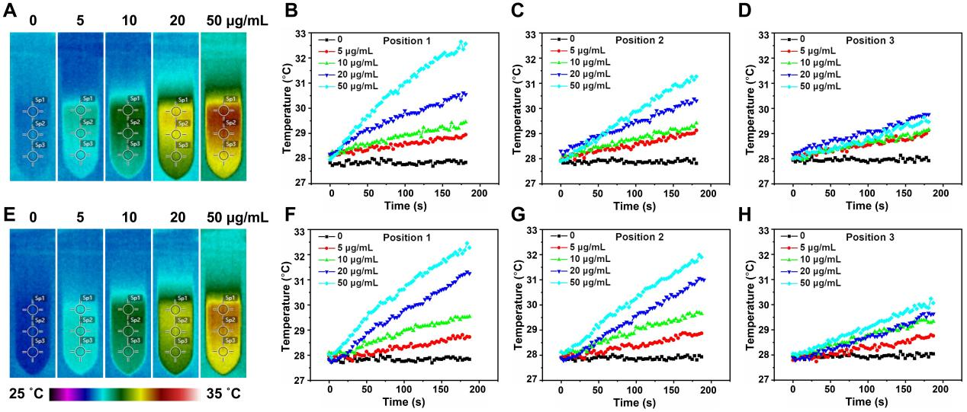
Fig. S6. In vitro temperature curves for different concentration and position of (A-D) BP and (E-H) BP-BA.

