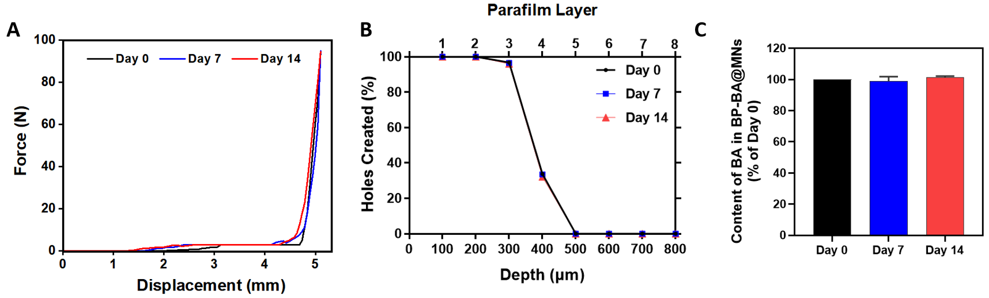
Fig. S12. The mechanical strength (A), insertion depth (B) and BA content (C) of BP-BA@MNs storage at room temperature for 0, 7 and 14 days.

