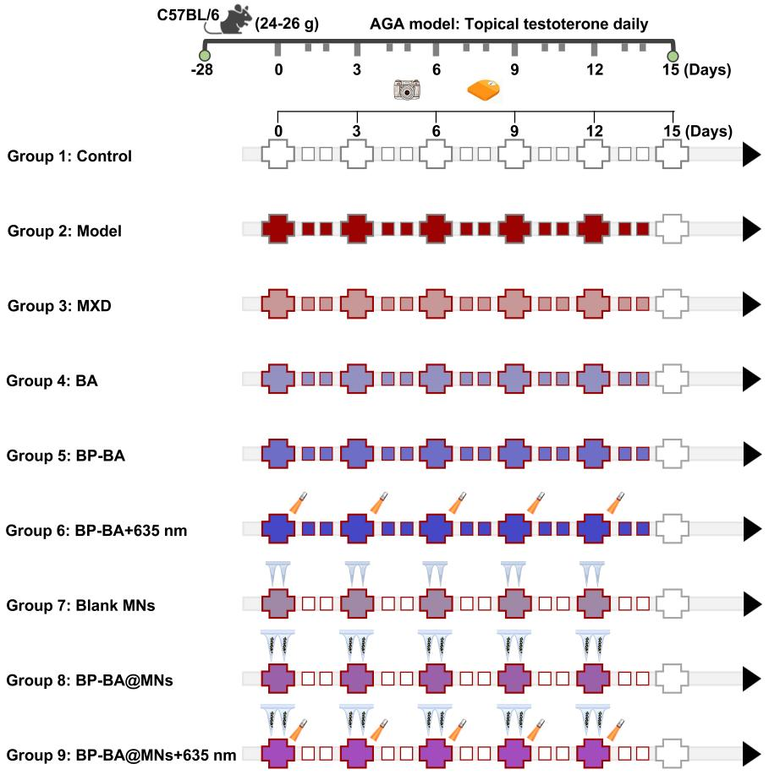
Fig. S14. Schematic illustration of experimental protocols.

