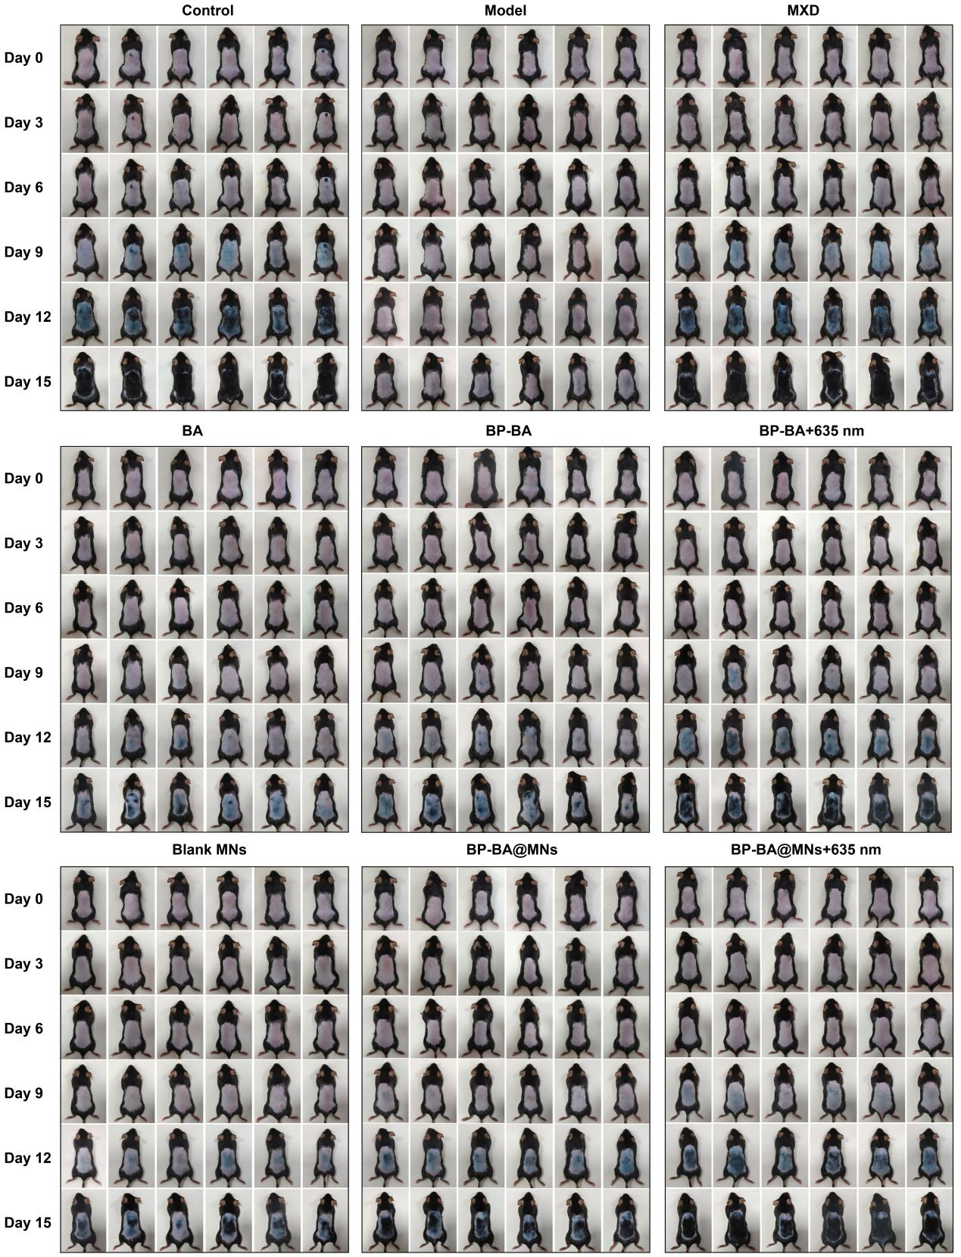
Fig. S15. Overall photographs of hair growth status in the different groups (n=6).

