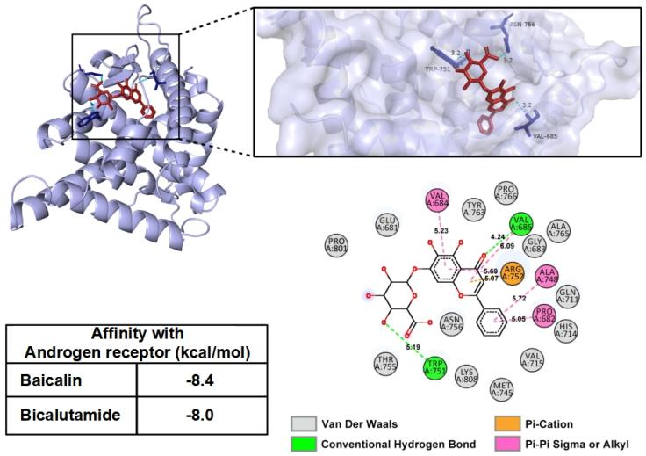
Fig. S16. Molecular dynamics simulation of BA and bicalutamide (as a positive drug) binding to the androgen receptor.

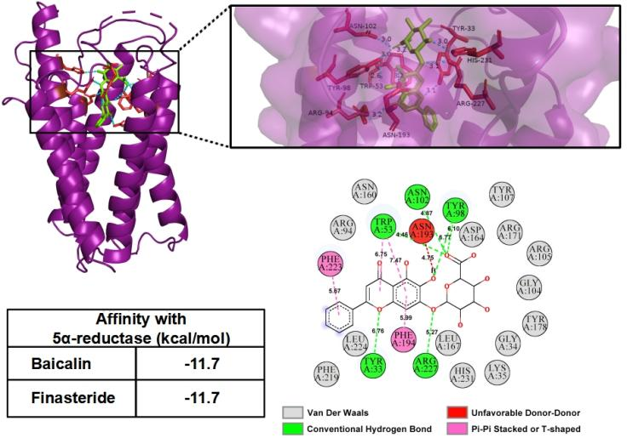
Fig. S17. Molecular dynamics simulation of BA and finasteride (as a positive drug) binding to the 5α-reductase.

