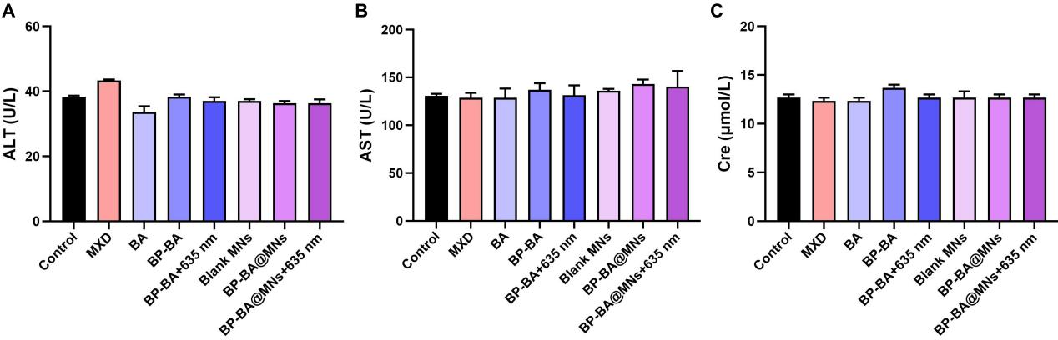
Fig. S18. Blood panel analysis and serum biochemistry assay of mice treated with different groups. Data are means ± SD (n=3).

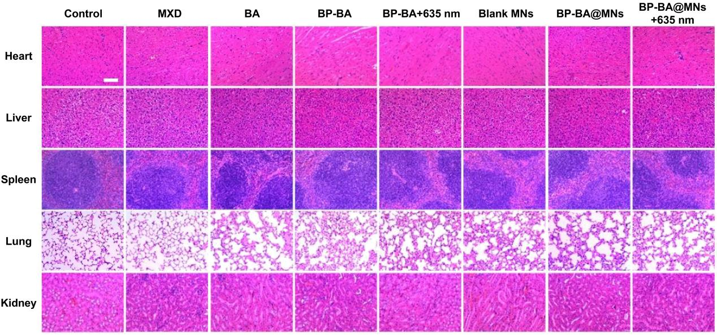
Fig. S19. In vivo biocompatibility analysis. H&E staining of heart, liver, spleen, lung, and kidney tissue sections from animals in the indicated treatment groups (Scale bar: 100 μm).
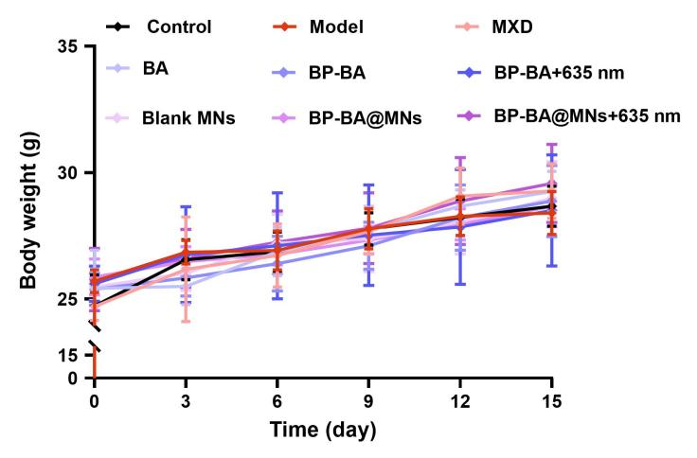
Fig. S20. Body weight of treated mice were monitored (n=6).

