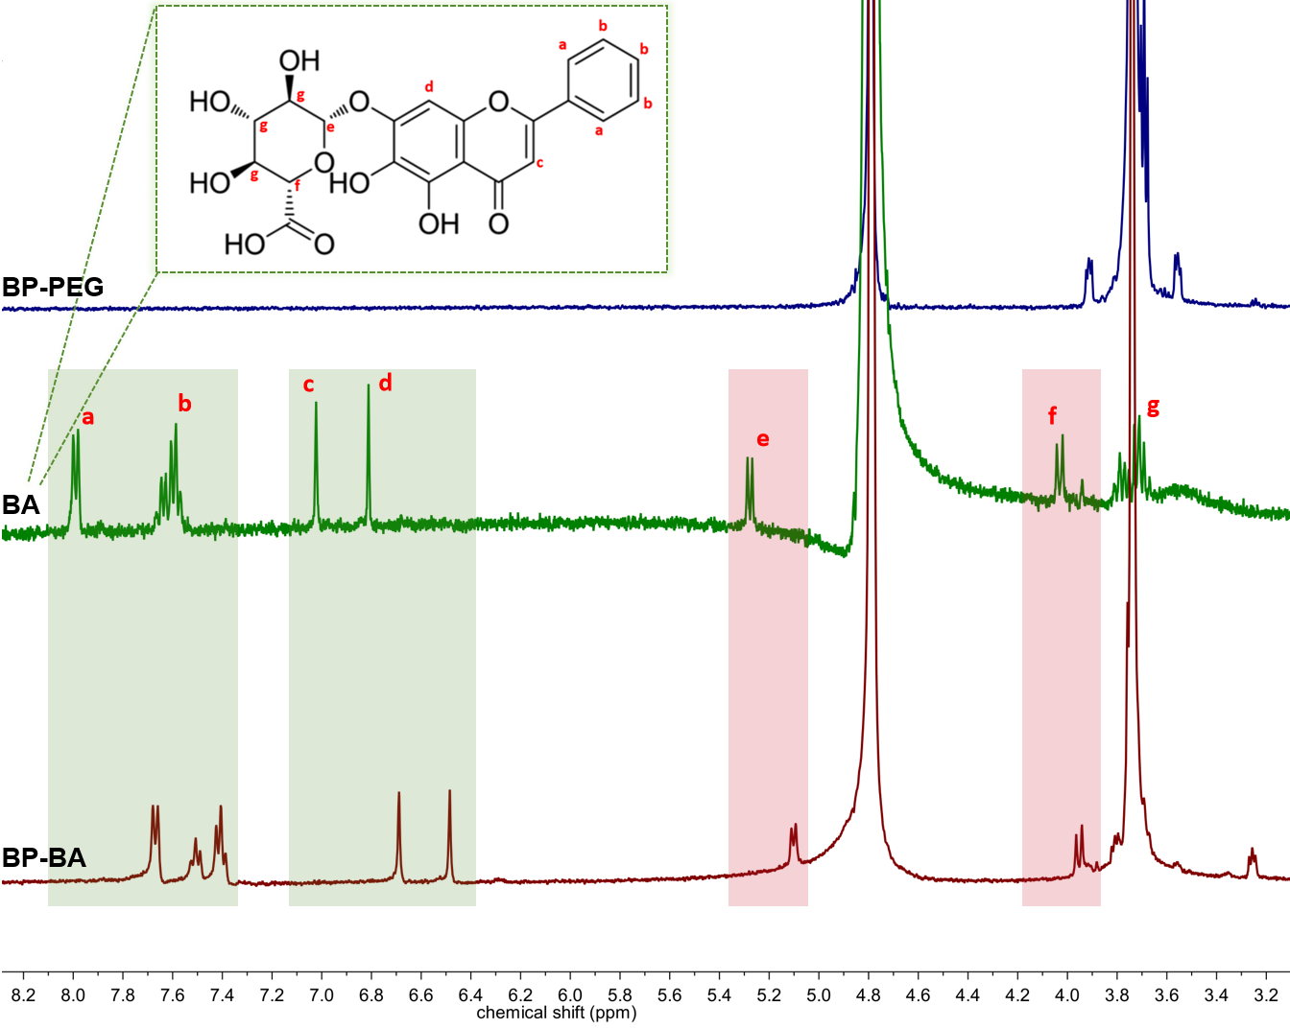
Fig. S2. ¹H-nuclear magnetic resonance spectra of (A) BP-PEG, (B) BA, and (C) BP-BA.

