Supplementary Material

Fig. S1 XRD patterns of NM@PB-Ce
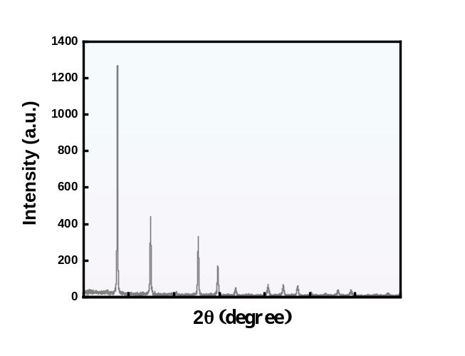

Fig.S2 X-ray photoelectron spectroscopy (XPS) spectra exhibiting the surface elemental composition. First panel: Survey scan showing peaks corresponding to O 1s, C 1s, N 1s, and Ce 3d. Second panel: High-resolution scan of O 1s peak. The binding energy is presented in electron volts (eV), and intensity is measured in arbitrary units (a.u.). The spectra reveal the electronic state and atomic composition of the analyzed material surface.
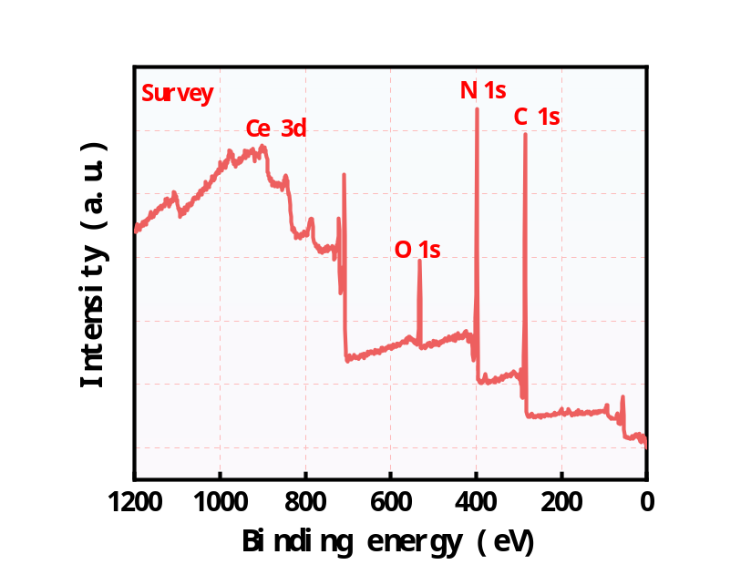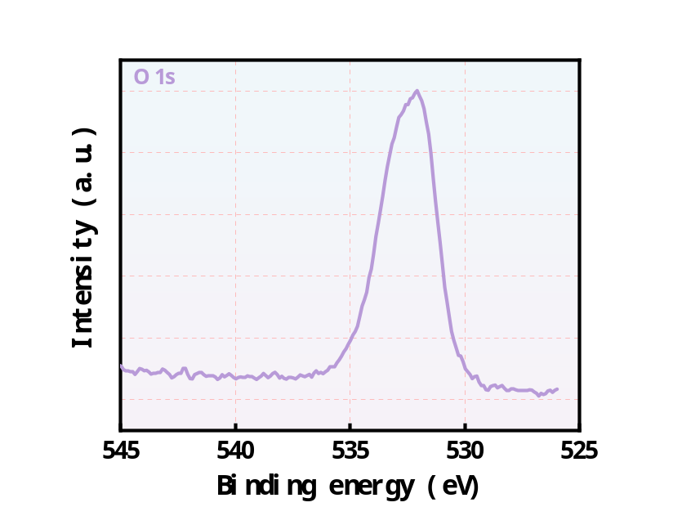

Fig. S3 Characteristic protein expression (Integrin β2, Mac-1, LFA-1) from the unactivated HL-60 cell membrane and activated HL-60 cell membrane.
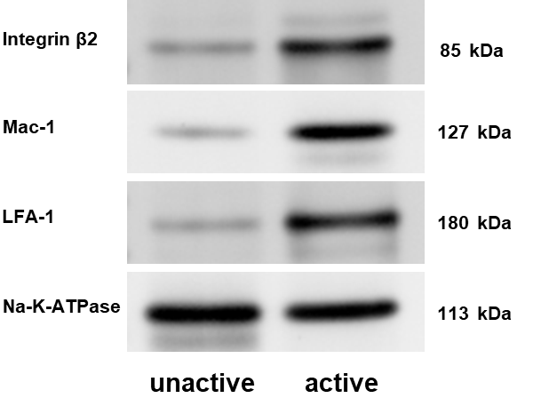

Fig. S4 TEM images of activated R-NM membrane encapsulated the NM@PB-Ce nanoparticles.
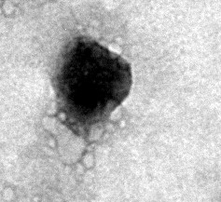

Table S1: Raw data tables with average and standard deviation (SD) of particle size, polydispersity index (PDI).
Sample | Hydrodynamic diameter ± SD | PDI
PB-Ce
Deionized Water | 21±2.02 | 0.121±0.015
PBS pH 7.2 | 23±2.15 | 0.182±0.027
DMEM | 26±2.31 | 0.312±0.024
DMEM+FBS | 28±2.25 | 0.442±0.018
NM@PB-Ce
Deionized Water | 142±2.33 | 0.167±0.022
PBS pH 7.2 | 144±2.45 | 0.173±0.025
DMEM | 148±2.52 | 0.336±0.027
DMEM+FBS | 151±2.61 | 0.395±0.029

Fig. S5 Dynamic light scattering (DLS) size change of PB-Ce and NM@PB-Ce nanoparticles over seven days.
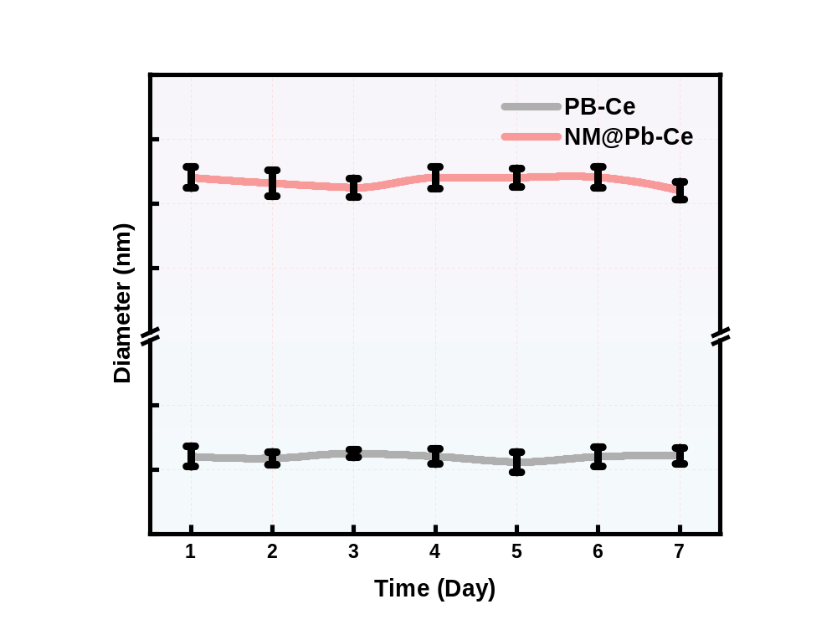

Fig. S6 Time-dependent blood circulation profile showing the relative fluorescence intensity of NM@PB-Ce in blood over a period of 500 min.
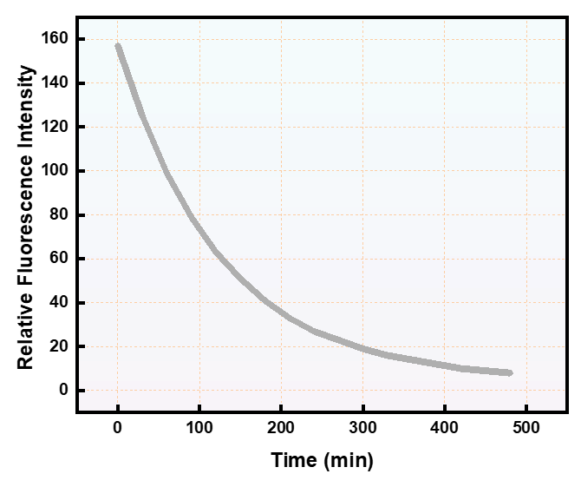

Fig. S7 Determination of cellular viability in SH-SY5Y cells using Aβ1-42 oligomers assay across varying concentrations of Aβ1-42 oligomers
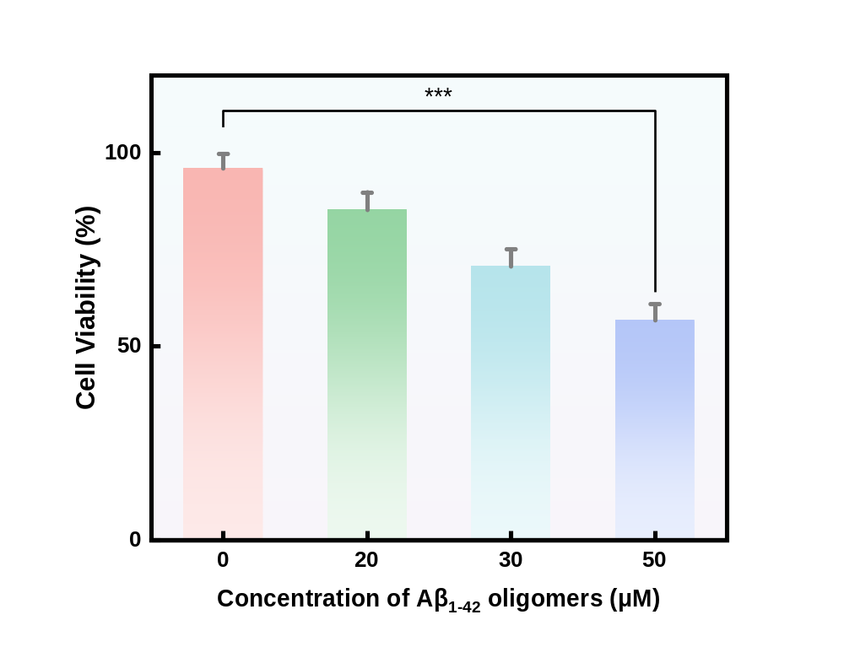

Fig. S8 Crystalline violet staining of SH-SY5Y cells in different subgroups
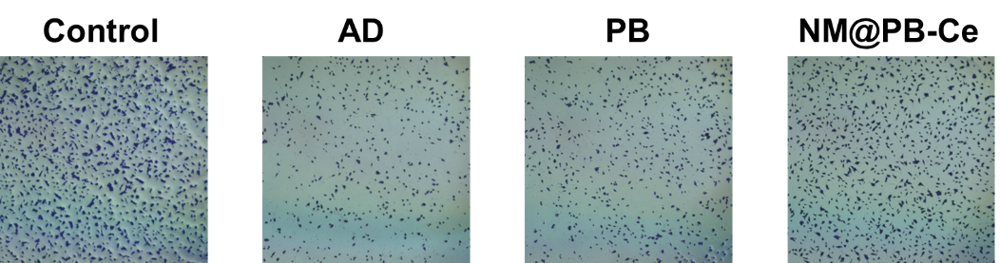

Fig. S9 Analysis of relative fluorescence intensity of intracellular ROS generation after different treatments visualized by CLSM. 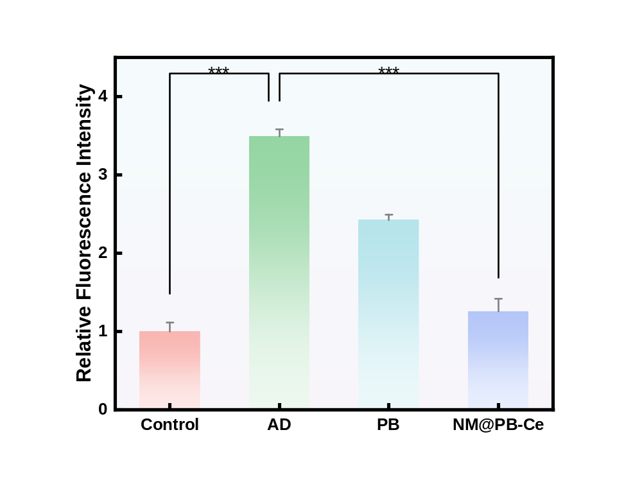

Fig. S10 Analysis of the relative expression of NLRP3, Capase-1, GSDMD-NT, IL-18, IL-1β protein in different groups after treatment.
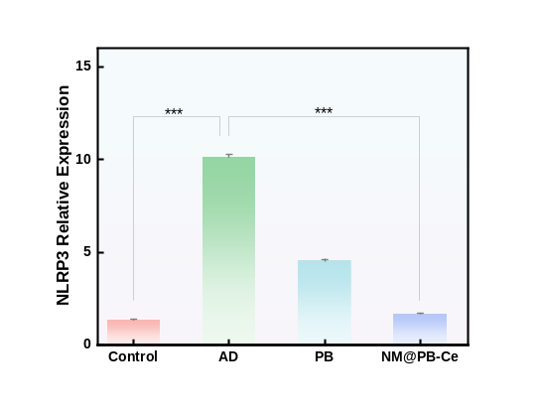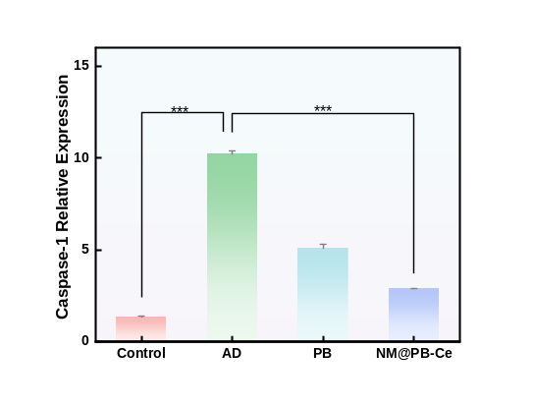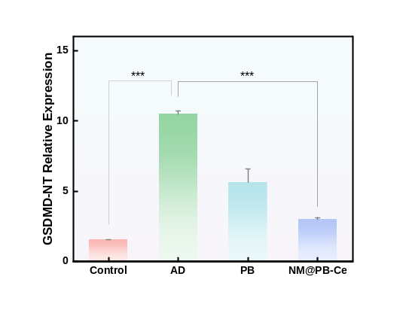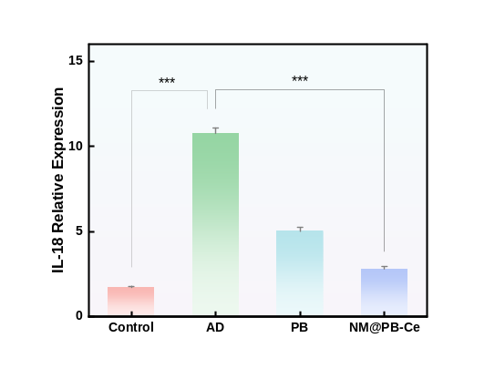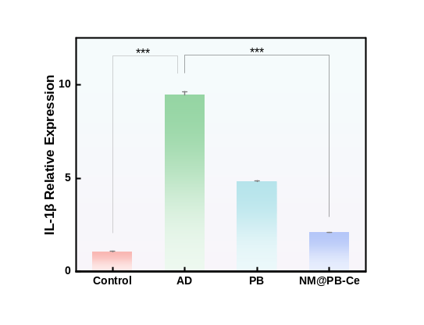

Fig. S11 Analysis of relative fluorescence intensity of intracellular P^{S396}-Tau generation after different treatments visualized by CLSM. 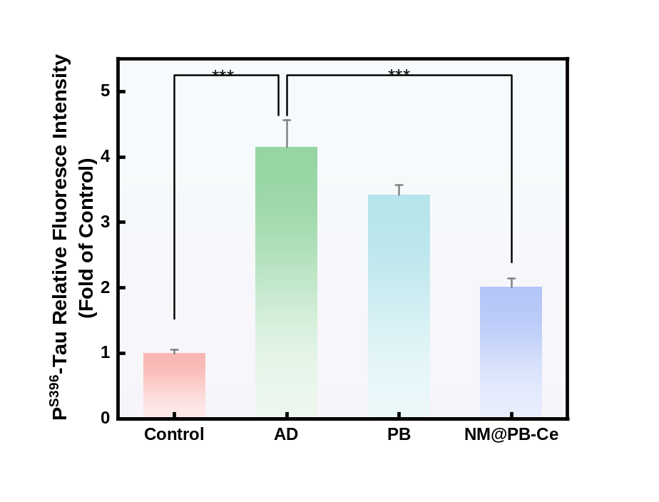

Fig. S12 Analysis of the relative expression of Aβ protein in different groups after treatment.
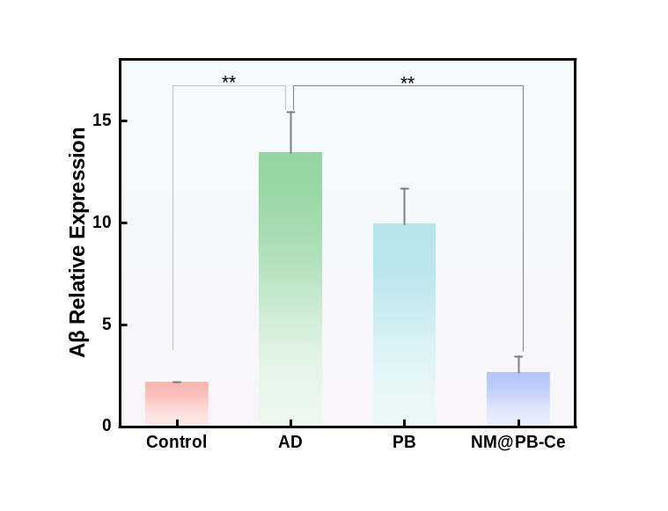

Fig. S13 Overview of the red blood cell hemolysis assay depicted above: Red blood cells are incubated with H2O (positive control) and PBS (negative control), as well as with varying concentrations of NM@PB-Ce (0, 25, 50, 100, 200, 400, 800, 1600 μg/ml). The hemolysis rate (%) is calculated using the formula: Hemolysis Rate (%) = [(OD experimental – OD negative control) / (OD positive control – OD negative control)] × 100% at an optical density of 540 nm. The absorbance changes of red blood cells incubated with H2O, PBS and varying concentrations of NM@PB-Ce, within the 500-600 nm wavelength range.
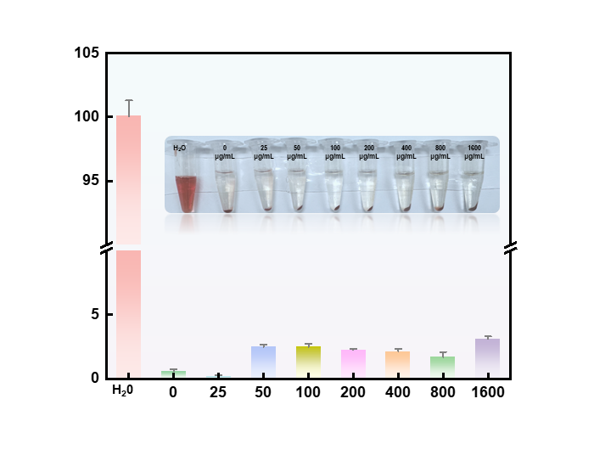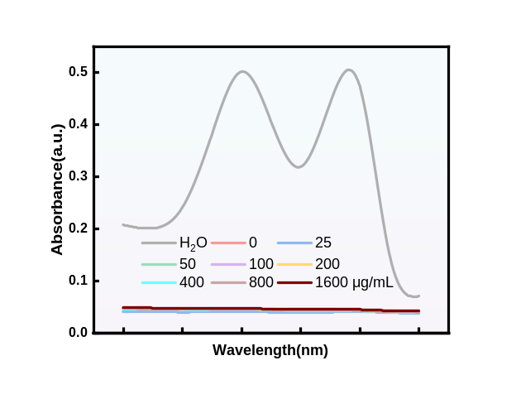

Fig. S14 Hematological profiles following intravenous administration of NM@PB-Ce (Comprehensive blood count parameters).
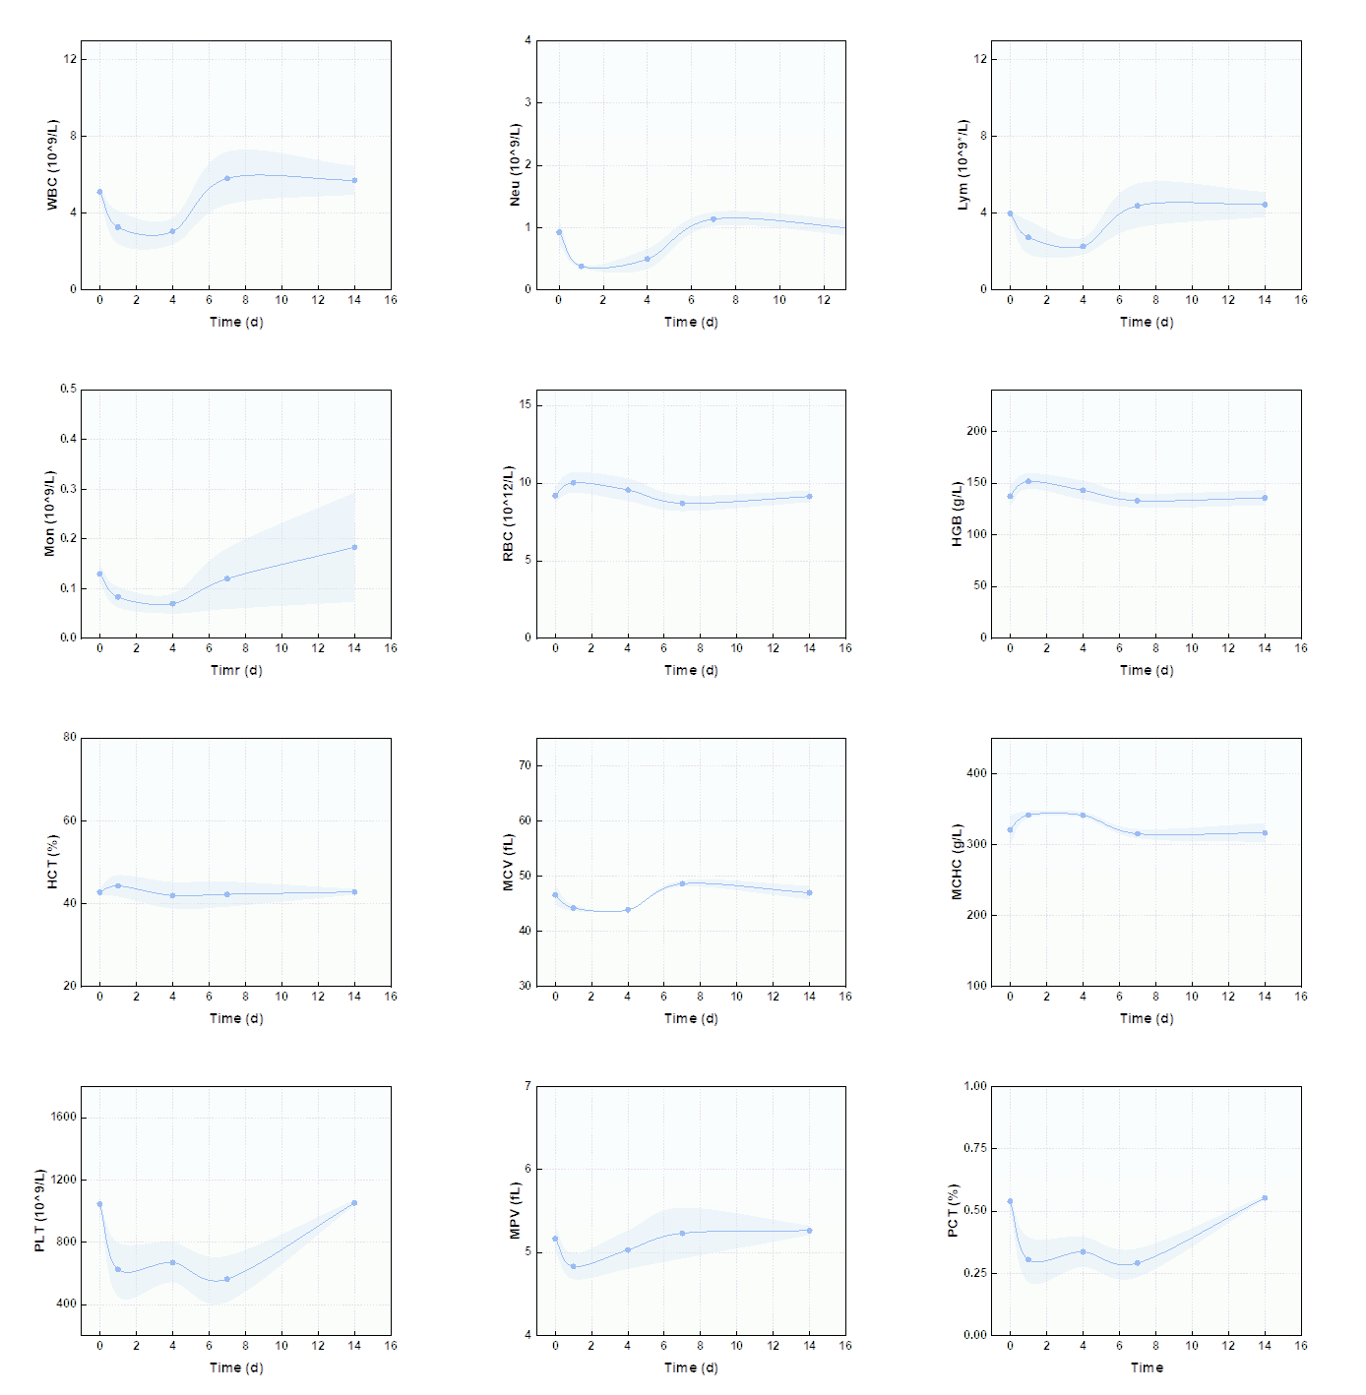
Fig. S15 Blood biochemical analysis post-intravenous administration of NM@PB-Ce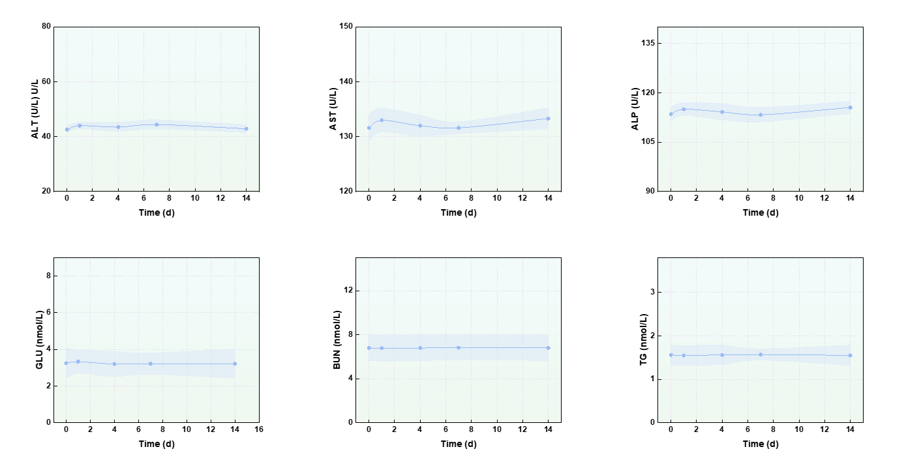

Fig. S16 Hematoxylin and eosin staining of major organs (heart, liver, spleen, lungs, kidneys, and brain) revealed no structural or morphological damage (200X).
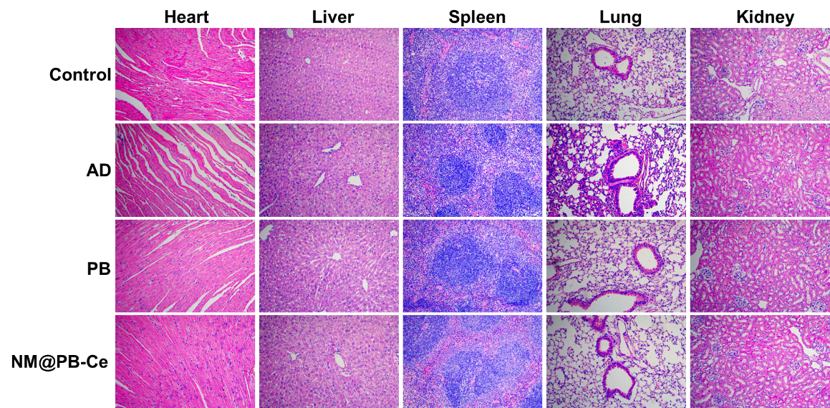

Fig. S17 The fluorescence intensity of major organs (heart, liver, lung, kidney, spleen, and brain) collected from AD, Sham and Control mice at 5 h post-injection
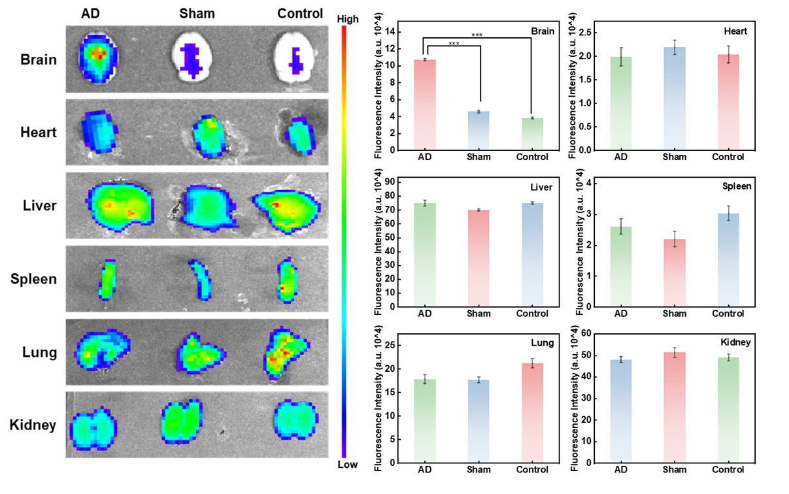

Fig. S18 At Day 0 before treatment initiation, baseline behavioral assessment in open field performance
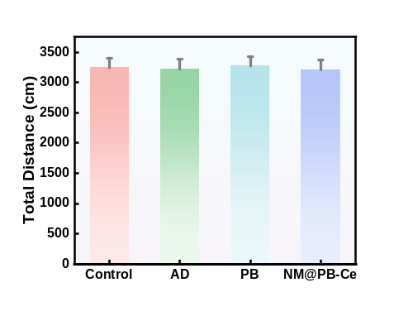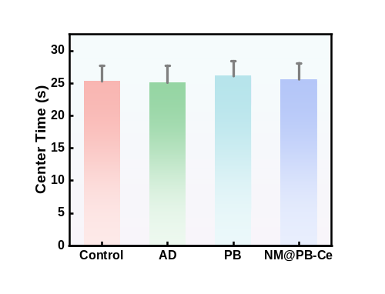

Fig. S19 The escape latency of different group in the 5 day
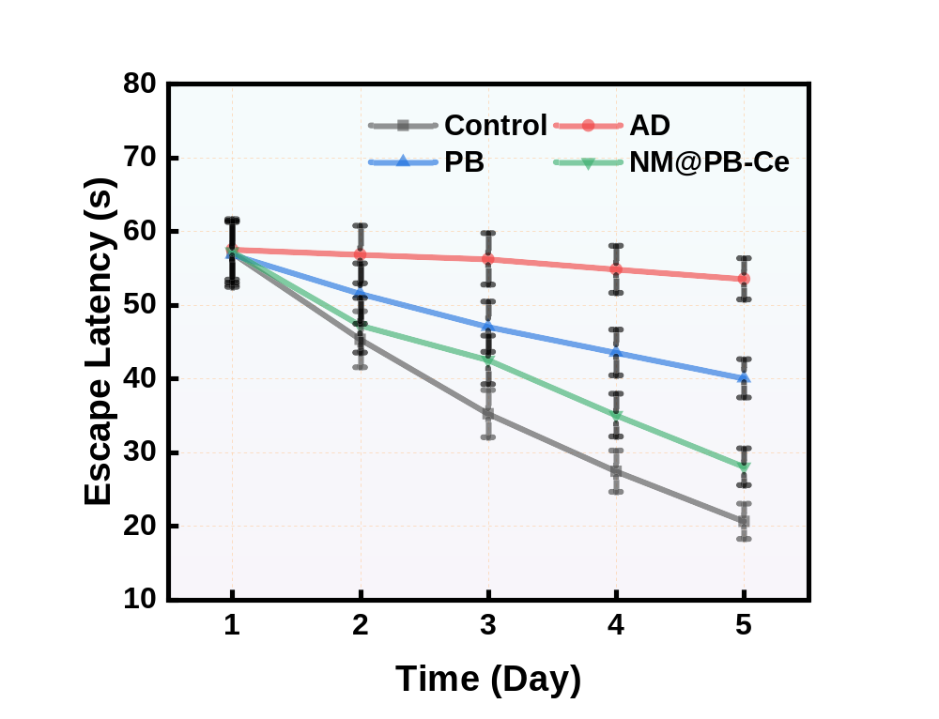

Fig. S20 Analysis of Y-maze performance focused on total arm entries
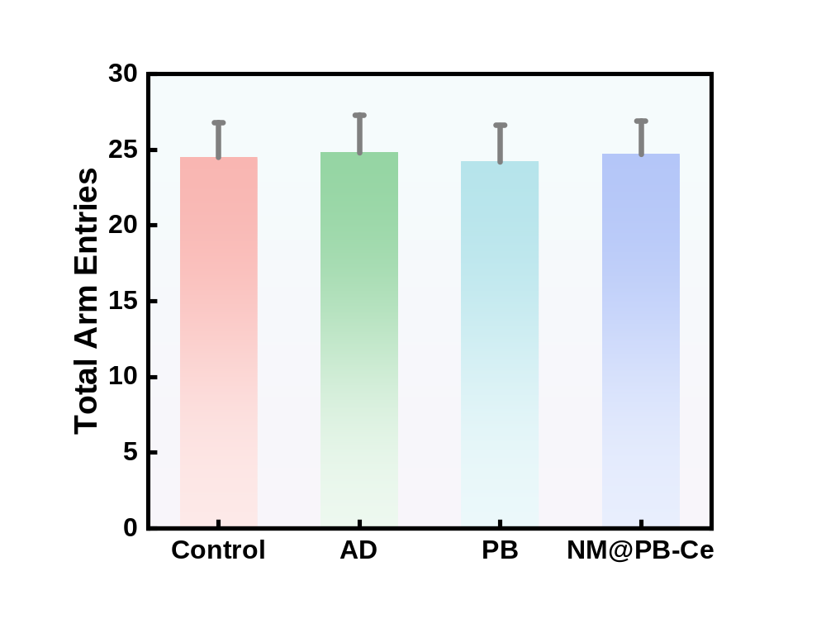

Fig. S21 Physiological Parameter Monitoring Throughout Study Duration
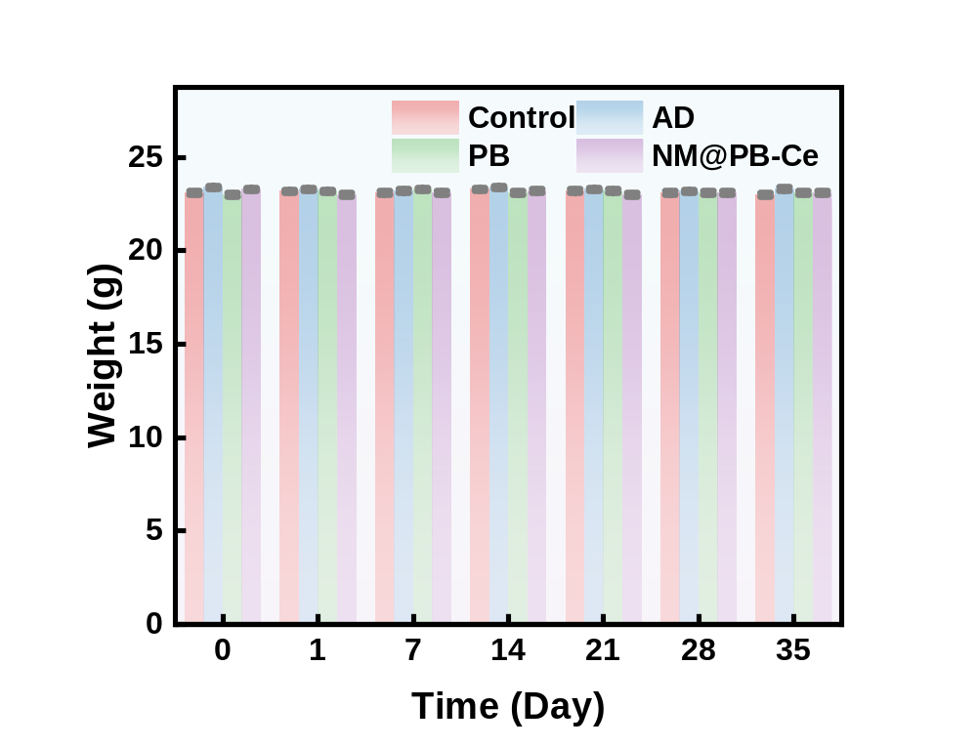

Fig. S22 Analysis of the relative expression of NLRP3, Capase-1, GSDMD-NT, IL-18, IL-1β protein in different groups after treatment in mice.
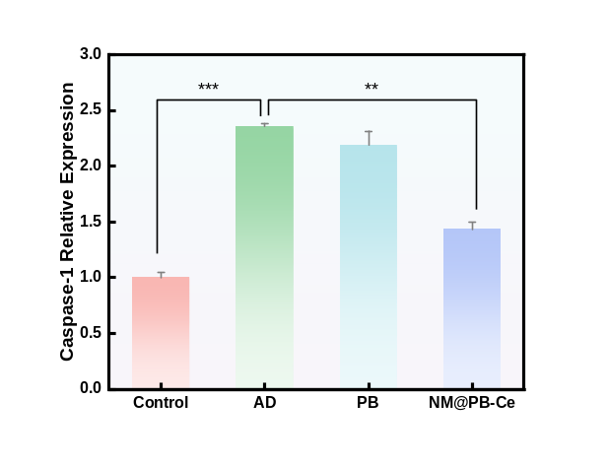
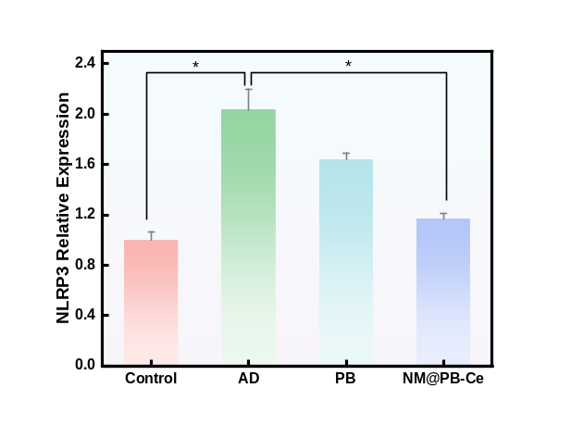
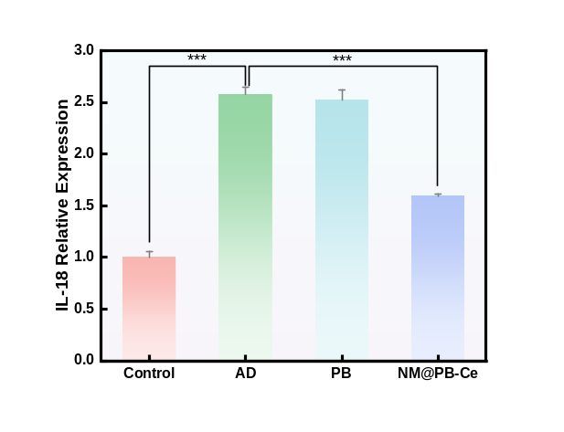
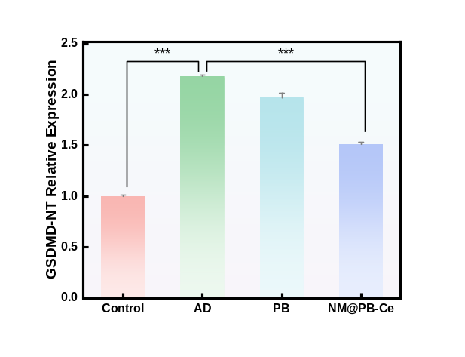
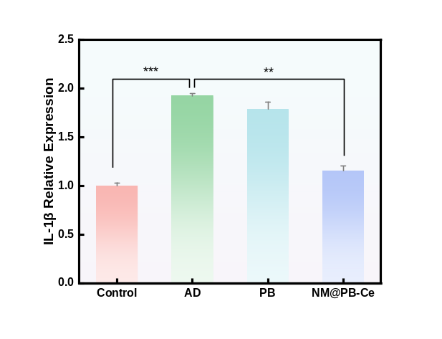
Fig. S23 Analysis of the relative expression of Aβ protein in different groups after treatment in mice.
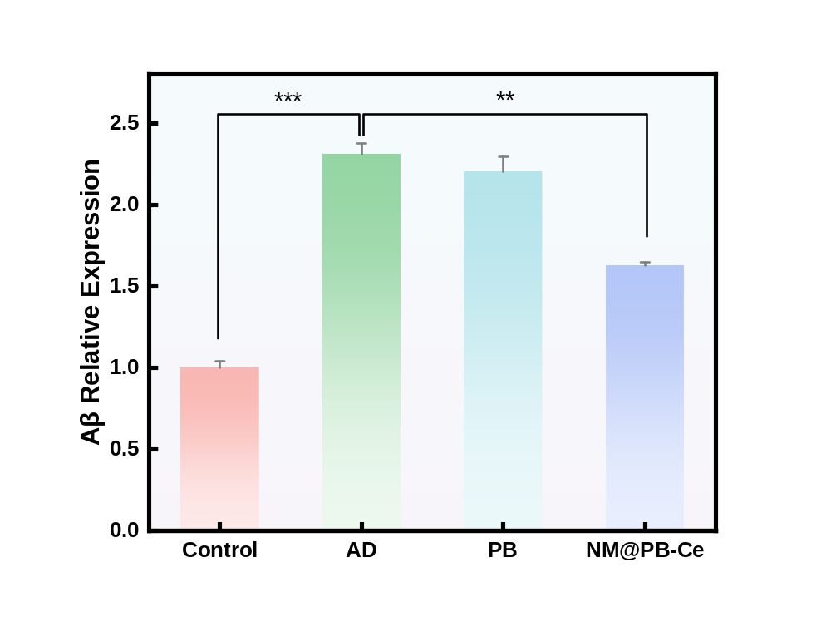

Fig. S24 Analysis of relative fluorescence intensity of intracellular ACS, Caspase-1, GFAP, Iba-1 generation after different treatments visualized by CLSM.
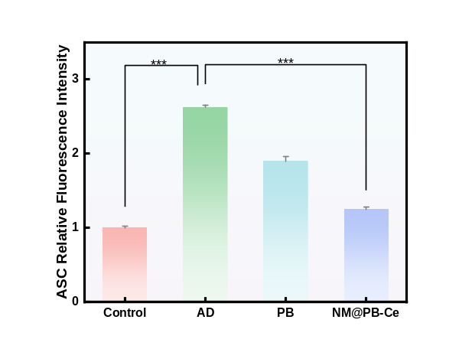
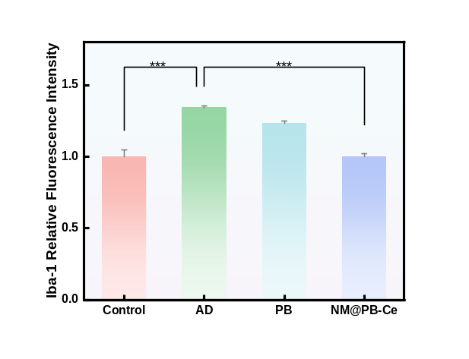
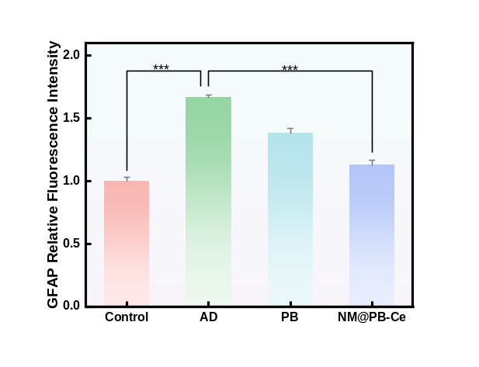
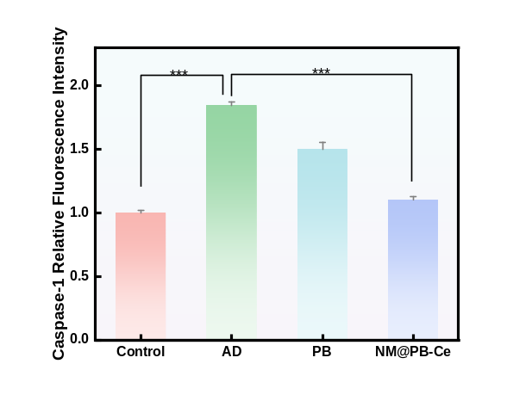

Fig. S25 Analysis of relative fluorescence intensity of intracellular Aβ and Th-T generation after different treatments visualized by CLSM.
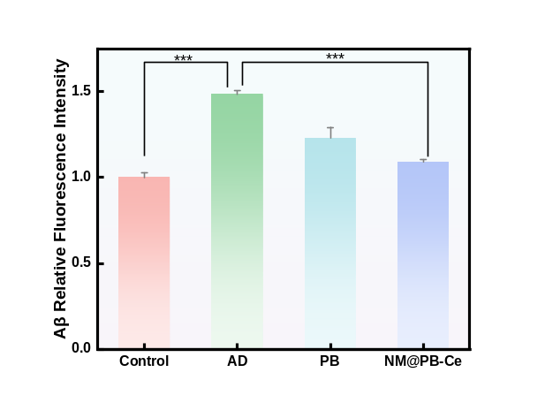
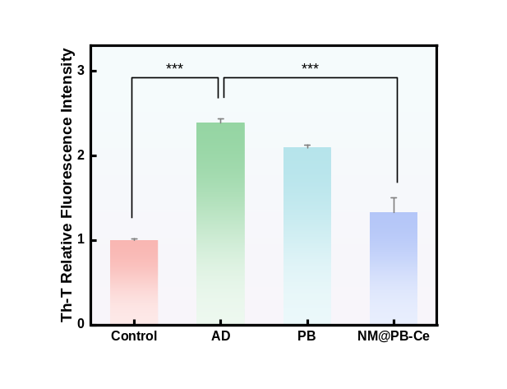

Fig. S26 H&E slices from CA1 region of different groups of mice
