Supporting Information for

Renal-clearable and tumor-retained nanodots overcoming metabolic reprogramming to boost mitochondrial-targeted photodynamic therapy in triple-negative breast cancer
Defan Yao^{#,1,2}, Yanshu Wang^{#,1}, Xue Dong^{#,1}, Yanhong Chen¹, Ding-Kun Ji³, Rongfeng Zou⁴, Yuelin Huang¹, Weixi Huang¹, and Dengbin Wang ^{1,2,}*
¹ Department of Radiology, Xinhua Hospital, Shanghai Jiao Tong University School of Medicine, Shanghai 200092, China
² College of Health Science and Technology, Shanghai Jiao Tong University School of Medicine, Shanghai, 200025, China.
³ Institute of Molecular Medicine (IMM), Renji Hospital, Shanghai Jiao Tong University School of Medicine, Shanghai, 200240, China.
⁴ Department of Physics and Astronomy, Uppsala University, Box 516, Uppsala SE-751 20, Sweden
# Defan Yao, Yanshu Wang and Xue Dong contributed to this work equally.
*Corresponding authors
E-mail addresses: wangdengbin@xinhuamed.com.cn (D. Wang)

Materials and Characterization.
The following reagents were purchased for the study: DCFH-DA, DPBF, SOSG reagent, Lyso-Tracker green, Mito-Tracker green, JC-1, CCK-8, ATP, and BeyoClickTM EdU-488 Kit Assay Kit from Beyotime Ltd. (Shanghai, China); Annexin V-FITC Apoptosis Kit from BD Biosciences (San Jose, USA); Lactate Content Assay Kit from Solarbio (Shanghai, China); Dimethyl sulfoxide (DMSO) from Adamas-beta® Ltd. (Shanghai, China); and zinc nitrate hexahydrate, 2-methylimidazole, CORM-401, and PEITC from Sigma-Aldrich (St. Louis, USA). The ultrapure water was purified by Millipore filtration system. The ¹H-NMR was obtained at room temperature with a Bruker AV 400 spectrometer. High-resolution mass spectra were obtained on a Waters Micromass® Q-TOF (electronic spray ionization, ESI) spectrometer.
Synthesis of Squaraine Dyes (SQ-675).
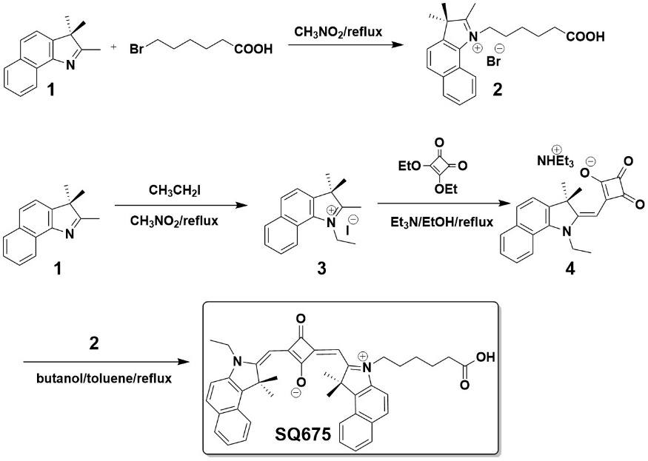
Figure S1 Synthetic route of SQ675.
Synthesis of compound 2.
A suspension containing compound 1 (5 g, 23.89 mmol, 1 eq) and 6-bromohexanoic acid (13.98 g, 71.68 mmol, 3 eq) in nitromethane (50 mL) was subjected to reflux overnight. The heating process was then terminated, and the resulting reaction mixture was introduced into 200 mL of ether. The resulting precipitate was collected by filtration and rinsed with 100 mL ether to give compound 2 as an off-white solid (8.5 g, 88.5%). ¹H NMR (400 MHz, DMSO-d₆): δ = 1.47 (m, 2 H), 1.58 (m, 2 H), 1.77 (s, 6H), 1.91 (m, 2H), 2.24 (t, J = 7.1 Hz, 2H), 2.95 (s, 3H), 4.59 (t, J = 7.5 Hz, 2H), 7.74 (t, J = 7.4 Hz, 1H), 7.80 (t, J = 7.4 Hz, 1H), 8.17 (d, J = 8.9 Hz, 1H), 8.23 (d, J = 8.1 Hz, 1H), 8.30 (d, J = 8.9 Hz, 1H), 8.39 (d, J = 8.3 Hz, 1H), 12.06 (s, 1H). HRMS-ESI (m/z): calcd for C₂₁H₂₆NO₂Br, 403.1147, found [M-Br]⁺, 324.1964.
Synthesis of compound 3.
A suspension containing compound 1 (5 g, 47.79 mmol, 1 eq) and iodoethane (13 g, 83.6 mmol, 3.5 eq) in nitromethane (50 mL) was subjected to reflux overnight. The heating process was then terminated, and the solvent was cooled to room temperature. The precipitate was collected through filtration and washed with ethanol (100 mL) to yield compound 3 as a yellowish-green solid (8.7 g, 91.6%). ¹H NMR (400 MHz, CDCl₃): δ = 1.68 (t, J = 7.5 Hz, 3H), 1.86 (s, 6H), 3.21 (s, 3H), 4.84 (q, J = 7.42 Hz, 2H), 7.66 (t, J = 7.27 Hz, 1H), 7.74 (t, J = 7.12 Hz, 1H), 7.88 (d, J = 8.87 Hz, 1H), 8.05 (d, J = 8.22 Hz, 1H), 8.11 (t, J = 9.63 Hz, 2H). HRMS-ESI (m/z): calcd for C₁₇H₂₀NI, 365.0640, found [M-I]⁺, 238.1588.
Synthesis of compound 4.
A portion of compound 3 (7 g, 19.2 mmol, 1 eq), diethyl squarate (4.9 g, 28.8 mmol, 1.5 eq), and triethylamine (7 mL) were dissolved in ethanol (25 mL). The reaction mixture was subjected to reflux for 1 h. Subsequently, the solvent was evaporated under reduced pressure, yielding compound 4 (5.8 g, 84.1%) in the form of a red solid. ¹H NMR (400 MHz, CDCl₃): δ = 1.39 (t, J = 7.2 Hz, 3H), 1.57 (t, J = 7.1 Hz, 3H), 1.91 (s, 6H), 4.0 (q, J = 7.2 Hz, 2H), 4.90 (q, J = 7.1 Hz, 2H), 5.45 (s, 1H), 7.23 (d, J = 8.7 Hz, 1H), 7.38 (t, J = 7.4 Hz,, 1H), 7.54 (t, J = 7.4 Hz, 1H), 7.87 (m, 2H), 8.11 (d, J = 8.5 Hz, 1H). HRMS-ESI (m/z): calcd for C₃₀H₃₄N₄O₂, 482.2682, found [M-NHEt₃]⁻, 380.1400.
Synthesis of SQ675.
A portion of compound 4 (3.4 g, 7.1 mmol, 1 eq) and compound 2 (4.0 g, 9.9 mmol, 1.4 eq) were heated under reflux in an n-butanol/benzene mixture (30 mL, 1:1 v/v) overnight. The solvent was removed under reduced pressure and the residue was purified by column chromatography on silica gel to afford SQ675 (2.6 g, 58%). ¹H NMR (400 MHz, DMSO) δ = 1.36 (t, J = 7.1 Hz, 3H), 1.46 (dd, J = 13.8, 7.2 Hz, 2H), 1.57 (dt, J = 14.7, 7.3 Hz, 2H), 1.79 (dd, J = 14.5, 7.4 Hz, 2H), 1.98 (s, 12H), 2.20 (t, J = 7.2 Hz, 2H), 4.22 (dt, J = 14.8, 7.0 Hz, 4H), 6.40 (s, 2H), 7.51 (t, J = 7.5 Hz, 2H), 7.66 (t, J = 7.6 Hz, 2H), 7.77 (d, J = 8.9 Hz, 2H), 8.07 (dd, J = 12.3, 6.3 Hz, 4H), 8.31 (d, J = 8.5 Hz, 2H), 12.00 (s, 1H). ¹³C NMR (100 MHz, DMSO-d₆): δ = 12.01, 13.26, 18.35, 24.04, 25.27, 25.43, 26.61, 29.89, 25.51, 33.27, 43.66, 50.56, 50.58, 63.16, 87.25, 87.54, 111.06, 111.30, 118.25, 118.32, 122.27, 122.29, 124.48, 127.40, 127.44, 127.50, 129.50, 129.74, 129.81, 131.04, 131.07, 133.92, 134.03, 138.52, 138.94, 163.26, 163.28, 165.98, 171.91, 172.21, 172.53, 174.07. HRMS-ESI (m/z): calcd for C₄₂H₄₂N₂O₄, 639.8080, found [M+H]⁺, 639.7998.

Figure S2 The ¹H NMR of compound 2 (400 MHz, DMSO-d₆).
Figure S3 The ¹H NMR of compound 3 in CDCl₃.
Figure S4 The ¹H NMR of compound 4 (400 MHz, CDCl₃).
Figure S5 ¹H NMR spectrum of SQ-675 (400 MHz, DMSO-d₆).
Figure S6 ¹³C NMR spectrum of SQ-675 (100 MHz, DMSO-d₆).
Synthesis of MOFs Nanodots.
MOFs nanodots were successfully prepared according to the methodology described in the previous report, with a slight modification. Specifically, a solution was prepared by dissolving 2-MIM (243 mg) in 2 mL of ultrapure water, and adding SQ-675 (2 mg), PEITC (2 mg), and CORM-401 (2 mg) in DMSO (0.5 mL) to the reaction bottle. Additionally, zinc nitrate hexahydrate (12.5 mg) was dissolved in 1 mL of ultrapure water and added to the solution, which was then thoroughly stirred for a duration of 10 min. Subsequently, DSPE-PEG₂₀₀₀ (10 mg) was mixed with the nanoMOFs in 10 mL of ultrapure water, and the resulting mixture was subjected to sonication for a period of 2 min. The MOFs nanodots were collected by centrifugation (8000 rpm, 5 min), and washed for three times. The encapsulation efficiencies (EEs) of the drugs were calculated using the formula: EE (%) = (Amount of drug in nanodots/Total amount of drug added) × 100. The encapsulation efficiencies were determined to be 97.65% for SQ-675, 95.81% for CORM-401, and 96.07% for PEITC. Consequently, the mass ratio of SQ-675, CORM-401, and PEITC in the MSPC nanodots was approximately 1:1:1.
Photophysical Properties of SQ-675.
The UV/vis spectra of free SQ-675 and MSPC were acquired with a Varian Cary 100 Conc UV-visible spectrometer. The fluorescence spectra of free SQ-675 and MSPC were measured using a Varian Cary Eclipse Fluorescence Spectrometer.
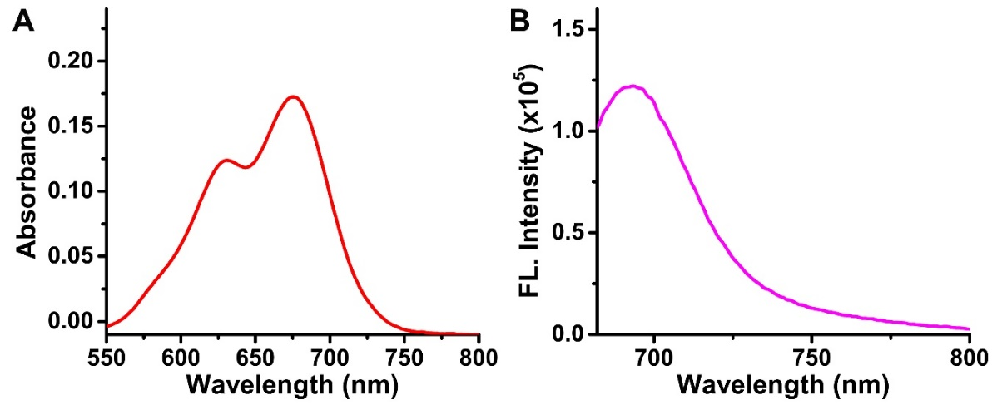
Figure S7 (A) Absorption spectra of SQ-675 in the DMF solution. (B) Fluorescence spectra of SQ-675 in the DMF solution, λ_{ex}: 675 nm.
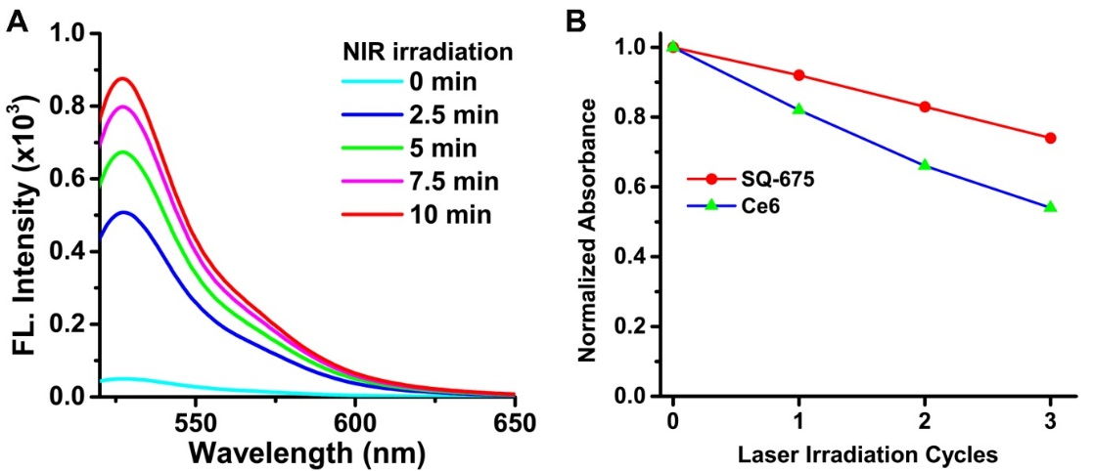
Figure S8 (A) ROS generation of SQ-675 (10 μM) incubation in aqueous solution with 660 nm laser (10 min, 1.0 mW/cm²) using SOSG as a ROS indicator. (B) Absorbance intensity change of SQ-675 and Ce6 after repeated 660 nm laser irradiation (10 min, 1.0 mW/cm²), respectively.
Zeta Potential Measurement.
The zeta potentials of MOFs, DSPE-PEG₂₀₀₀ and MSPC were measured with Nano-ZS (Zatasizer, Malvern) instrument. Samples were dissolved in PBS buffer. All data were corrected by subtracting the value tested for a blank scan of the buffer system.
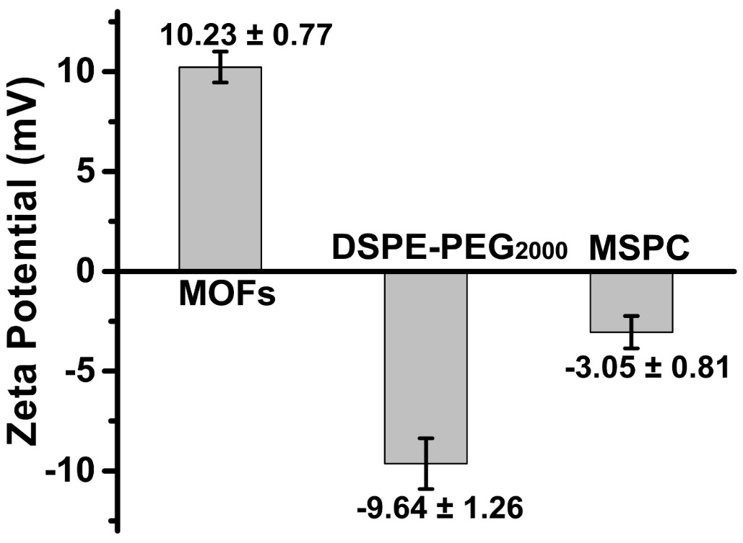
Figure S9 Zeta potentials of MOFs, DSPE-PEG₂₀₀₀ and MSPC.
Dynamic Light Scattering (DLS) and Transmission Electron Microscopy (TEM).
The hydrodynamic diameters of the MOFs nanodots were measured using a dynamic light scattering spectrometer (DLS) on Nano-ZS (Zatasizer, Malvern) instrument. Samples of 10.0 μg/mL MOFs nanodots in PBS buffer in a total sample volume of 1.0 mL. The morphology of the nanodots was observed using a transmission electron microscope (JEM-2100, JEOL, Japan).
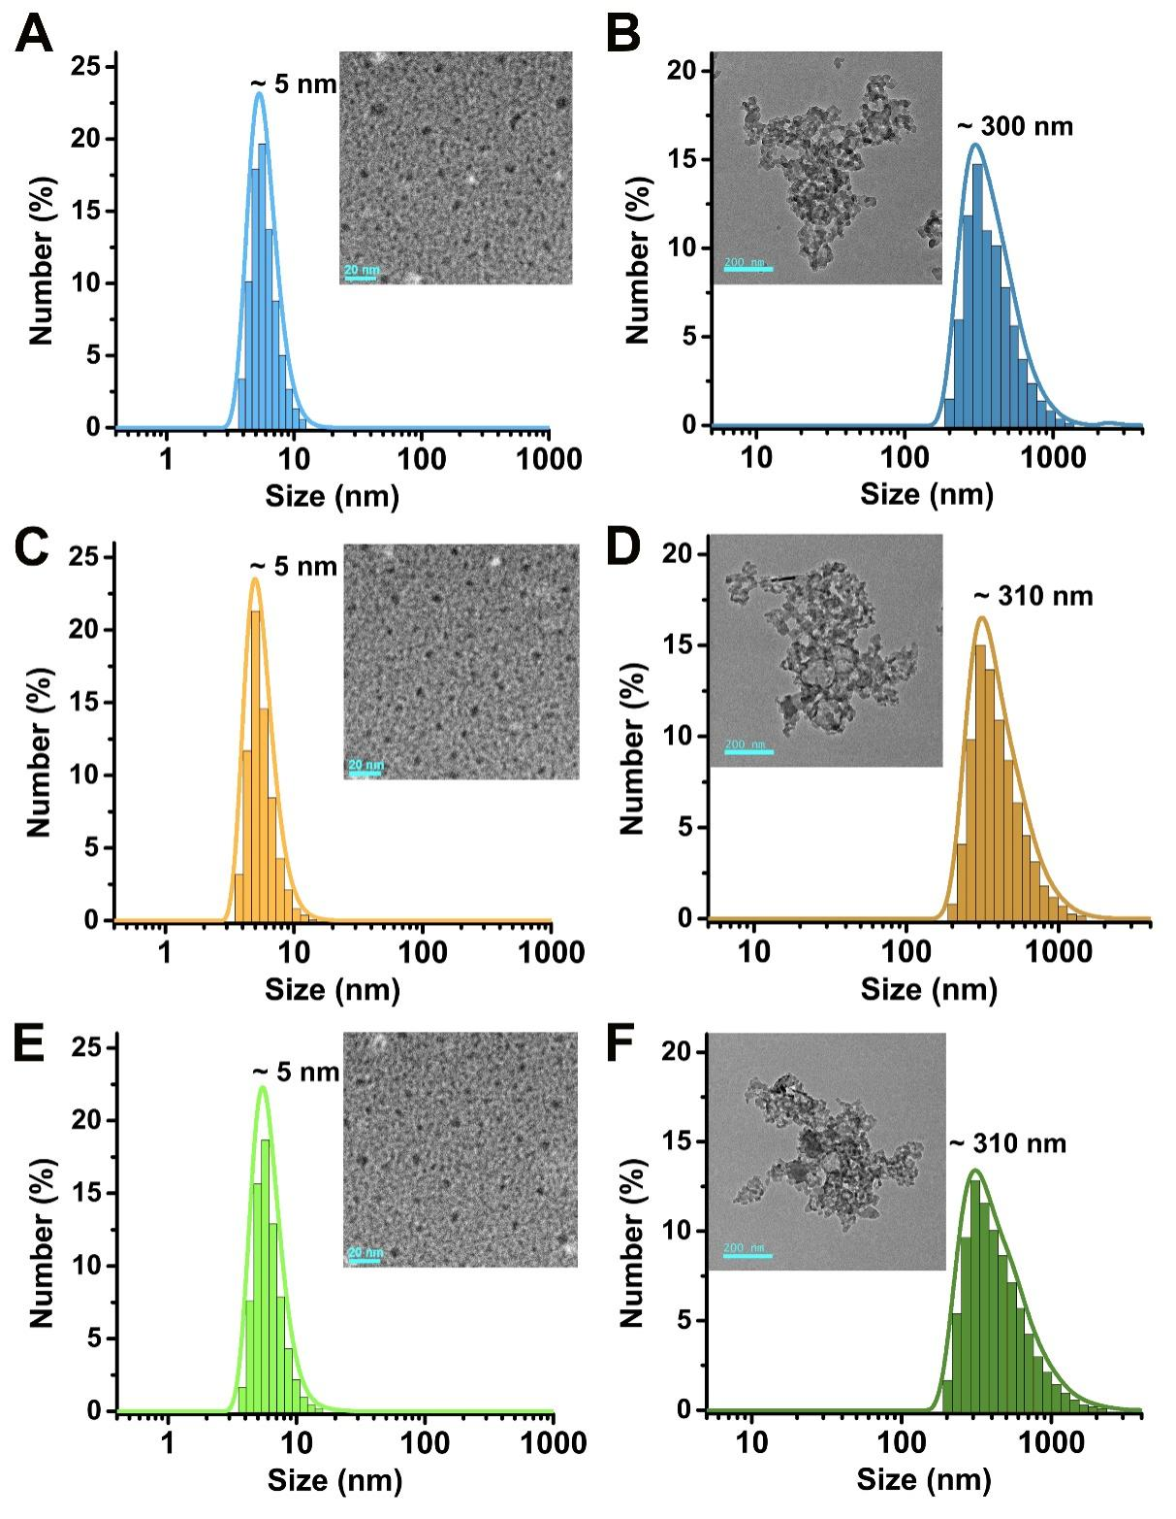
Figure S10 Morphology properties of nanodots in the response of pH. (A, B) DLS and TEM of MS in PBS at (A) pH 7.4 and (B) pH 6.0. (C, D) DLS and TEM of MSC in PBS at (C) pH 7.4 and (D) pH 6.0. (E, F) DLS and TEM of MSP in PBS at (E) pH 7.4 and (F) pH 6.0.
Density Functional Theory (DFT) Calculation.
In this study, we optimized the geometry of a single SQ-675 molecule using the extended tight-binding (XTB) method. Molecular dynamics simulations were performed with the GROMACS 2023.1 software package. The force field parameters for SQ-675 were derived using acpype, while water and ions were modeled using the AMBER force field.
Our simulated system comprised 60 SQ-675 molecules, 54,253 water molecules, 216 Na⁺ ions, and 156 Cl⁻ ions. The system underwent a 50,000-step energy minimization to ensure stability. This step was followed by temperature equilibration for 100 ps and pressure equilibration for another 100 ps, with the temperature maintained at 300 K and the pressure at 1 atm to replicate physiological conditions. Subsequently, the production phase of the simulation was conducted under the NPT (constant number of particles, pressure, and temperature) ensemble for a duration of 100 ns. Post-simulation, we extracted and visualized the final snapshot using PyMOL to analyze the results.
Drug release profile.
The release profiles of PEITC were determined through dialysis of MSPC nanodots in PBS at varying pH levels (6.0, 6.5 and 7.4). The dialysis process was conducted using a dialysis tube with a molecular weight cutoff of 1000 for 10 h. At specific time intervals, the released PEITC was quantified by high-performance liquid chromatography (HPLC).
Determination of CO release.
The CO detector and MSPC were placed within a cylindrical separable container and the detection system was subsequently sealed. The samples within the light group were exposed to NIR light (60 min, 1.0 mW/cm²). Conversely, the samples within the control group were shielded from light and did not undergo laser irradiation. The readings obtained from the detector were documented, and the quantity of CO was determined according to the Beer-Lambert law.
Cell culture.
The 4T1 cells, which were derived from mice, were acquired from the Cell Bank of Chinese Academy of Sciences located in Shanghai, China. The cells were grown in RPMI-1640 medium, which was supplemented with 10 % fetal bovine serum, and kept in an incubator at 37°C with 5 % CO₂.
Cell cytotoxicity test (CCK-8).
4T1 cells were placed in 96-well dishes with a concentration of 10,000 cells per well, and left to incubate for a duration of 12 h. The cells were incubated with MS, MSC, MSP, and MSPC for 6 h. Then, the original culture medium was substituted with fresh complete culture medium. The experimental group was treated with light irradiation (5 min, 1.0 mW/cm²), while the control group was shielded from light. Following a 24-hour period, the cells were rinsed two times using PBS. Afterward, 10 μL of CCK-8 solution was introduced into every well. After incubation for 2 h, the absorbance value at 450 nm was measured using a microplate instrument to determine the cell survival rate.
Calcein-AM/PI double staining.
4T1 cells at a concentration of 1×10⁶/mL were introduced into a 15 mm glass Petri dish. Upon reaching a cell density of approximately 60%, the identical concentration of MS, MSC, MSP, and MSPC was introduced. After incubating for 6 h, the cells were gently washed with PBS three times. Subsequently, the experimental groups were exposed to NIR light (5 min, 1.0 mW/cm²), while the control group remained in darkness. After a 2-hour interval, the cells were subjected to staining with Calcein-AM/PI for 15 min, and captured using a microscope.
Flow cytometry.
4T1 cells (1×10⁵) were exposed to MS, MSP, and MSPC (800 μg/mL) for 6 h. Subsequently, the experimental groups underwent light irradiation (5 min, 1.0 mW/cm²), while the control group remained shielded from light. Following conventional culture for 2 h, the cells were harvested and suspended in PBS. The cells were then centrifugated and subsequently incubated with Annexin V-FITC cell apoptosis detection working solution for 20 min. The samples were then placed in an ice bath and analyzed using flow cytometry.
Confocal laser scanning microscopy (CLSM).
Cells were exposed to MS, MSC, MSP, or MSPC at a concentration of 400 ug/mL for 2 h, 4 h, and 6 h, respectively. Subsequently, the cells were incubated with Mito-Tracker green or Lyso-Tracker green, following established protocols. After PBS washing, CLSM analysis was conducted. The green channel was excited at 488 nm and emitted light within 500-550 nm, while the red channel was excited at 630 nm and emitted light within 650-680 nm.
To further investigate the mitochondrial targeting properties of SQ-675, 4T1 cells were exposed to SQ-675 for 6 h. Subsequently, the cells were incubated with Mito-Tracker green or Lyso-Tracker green, following established protocols. After PBS washing, CLSM analysis was conducted. The green channel was excited at 488 nm and emitted light within 500-550 nm, while the red channel was excited at 630 nm and emitted light within 650-680 nm.
To investigate the generation of ROS by MSPC, 4T1 cells were subjected to different treatments: MSPC alone or MSPC combined with NIR light irradiation (5 min, 1.0 mW/cm²). Following treatment, the cells were stained with DCFH-DA and CLSM was performed.
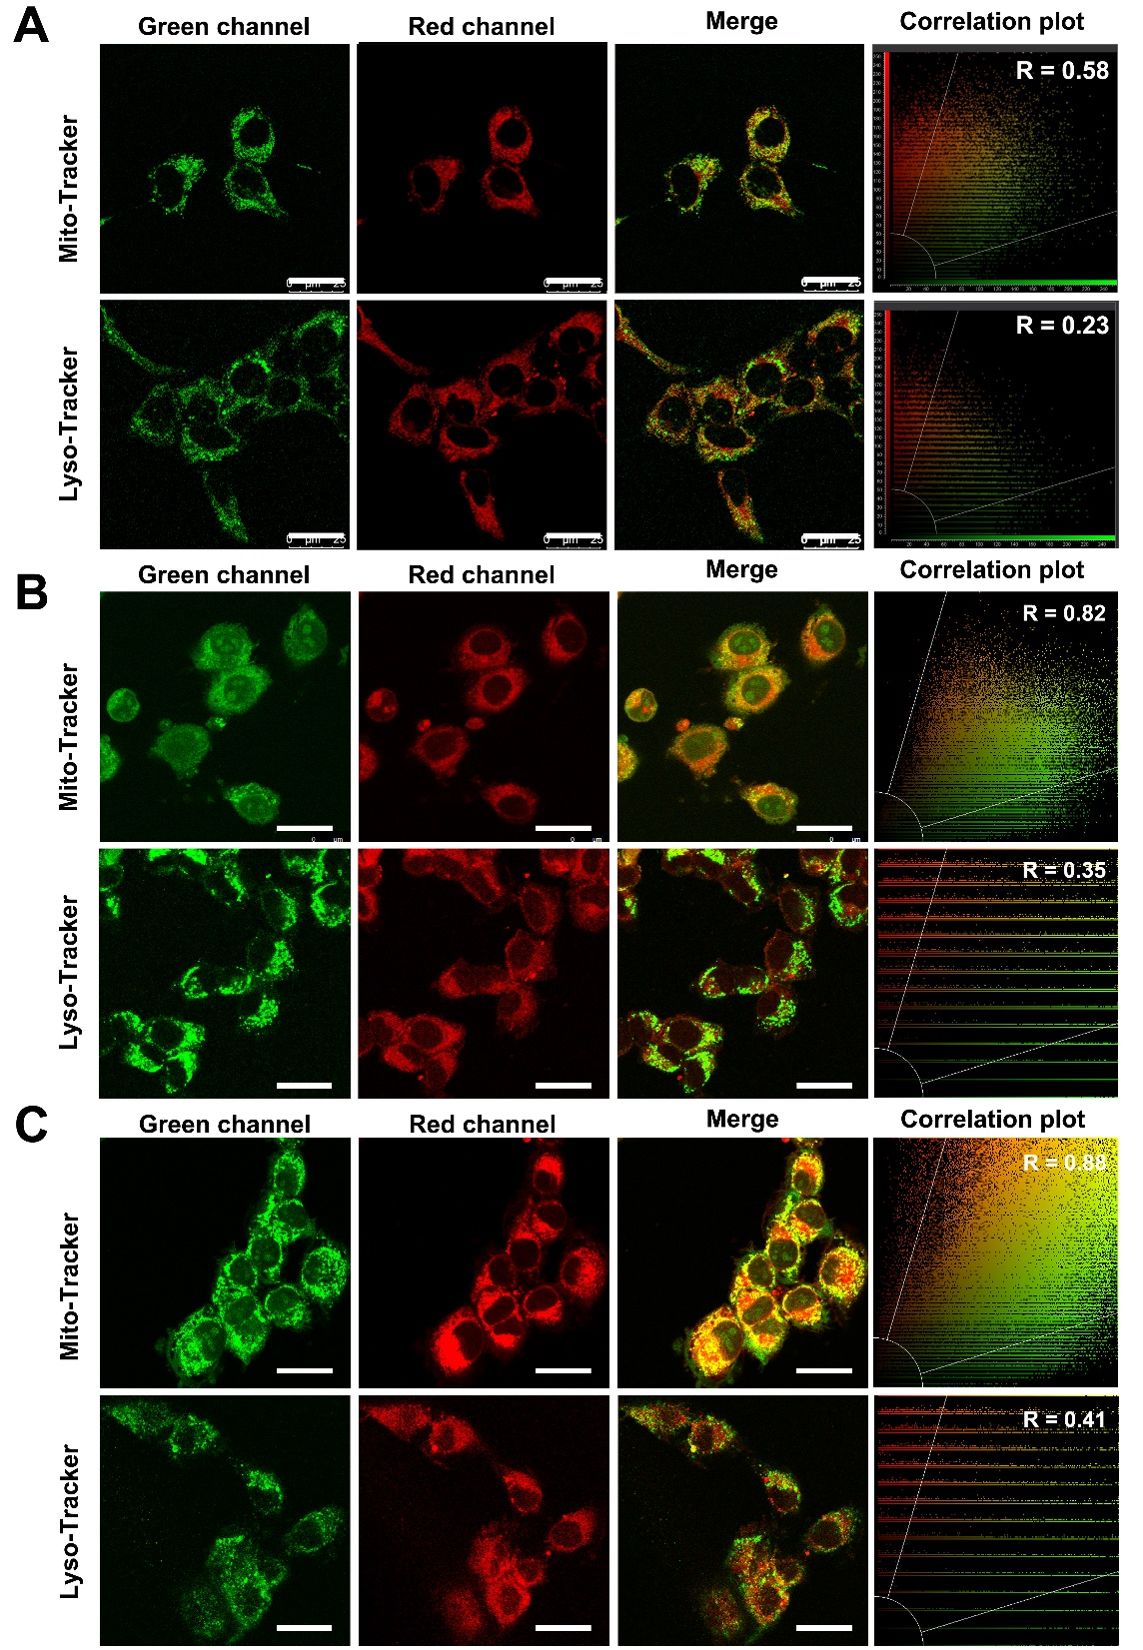
Figure S11 CLSM of 4T1 cells exposed to MSPC for (A) 2 h, (B) 4 h and (C) 6 h, which were co-stained with Mito-Tracker or Lyso-Tracker, along with the corresponding correlation plot depicting the relationship between the red fluorescence and the green fluorescence. Scale bars, 25 µm.
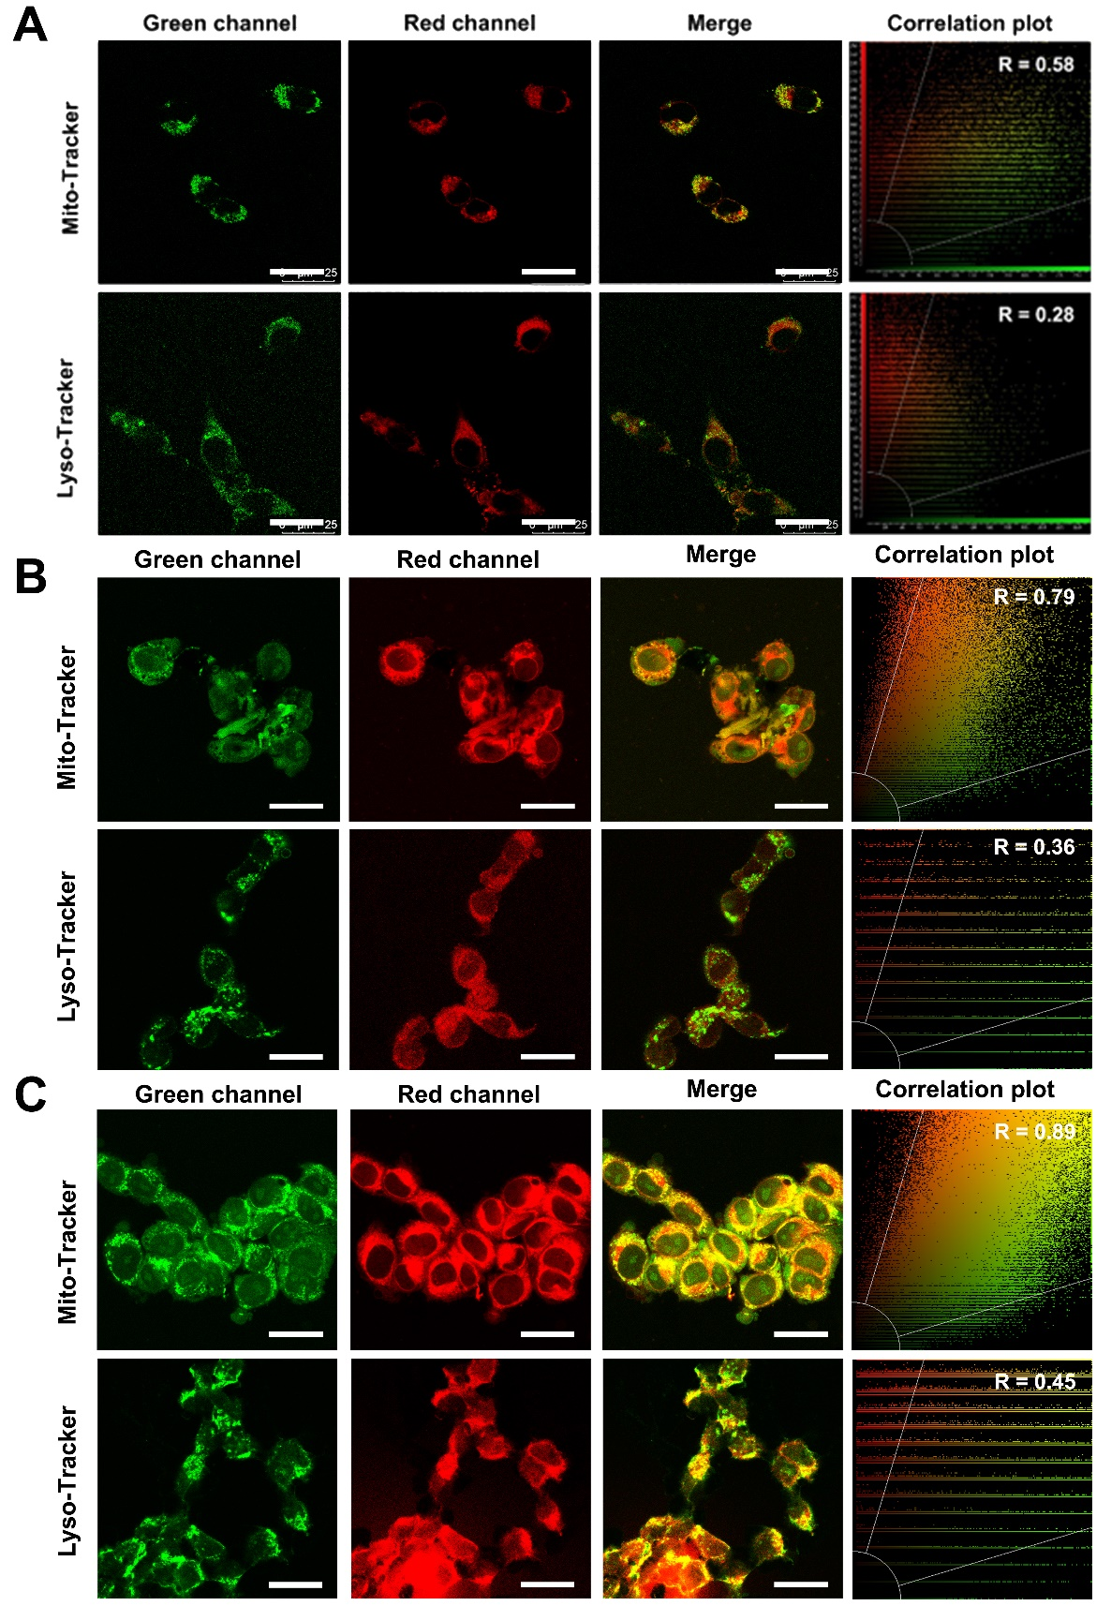
Figure S12 CLSM of 4T1 cells exposed to MS for (A) 2 h, (B) 4 h and (C) 6 h, which were co-stained with Mito-Tracker or Lyso-Tracker, along with the corresponding correlation plot depicting the relationship between the red fluorescence and the green fluorescence. Scale bars, 25 µm.
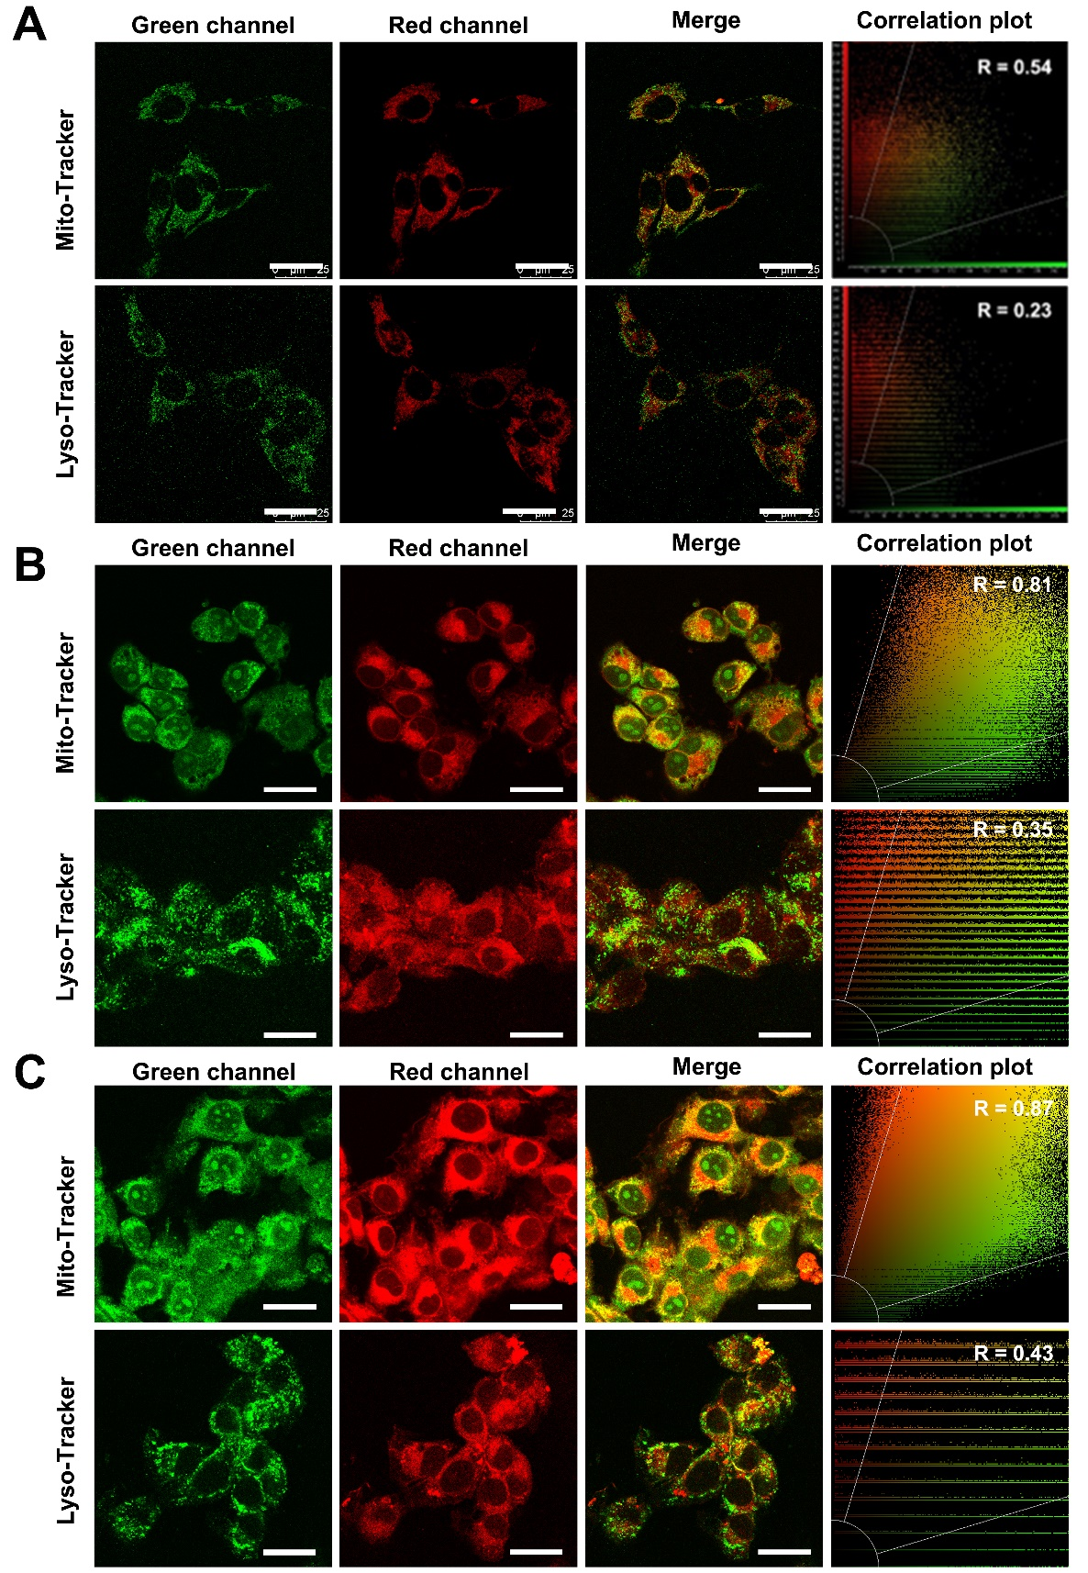
Figure S13 CLSM of 4T1 cells exposed to MSC for (A) 2 h, (B) 4 h and (C) 6 h, which were co-stained with Mito-Tracker or Lyso-Tracker, along with the corresponding correlation plot depicting the relationship between the red fluorescence and the green fluorescence. Scale bars, 25 µm.
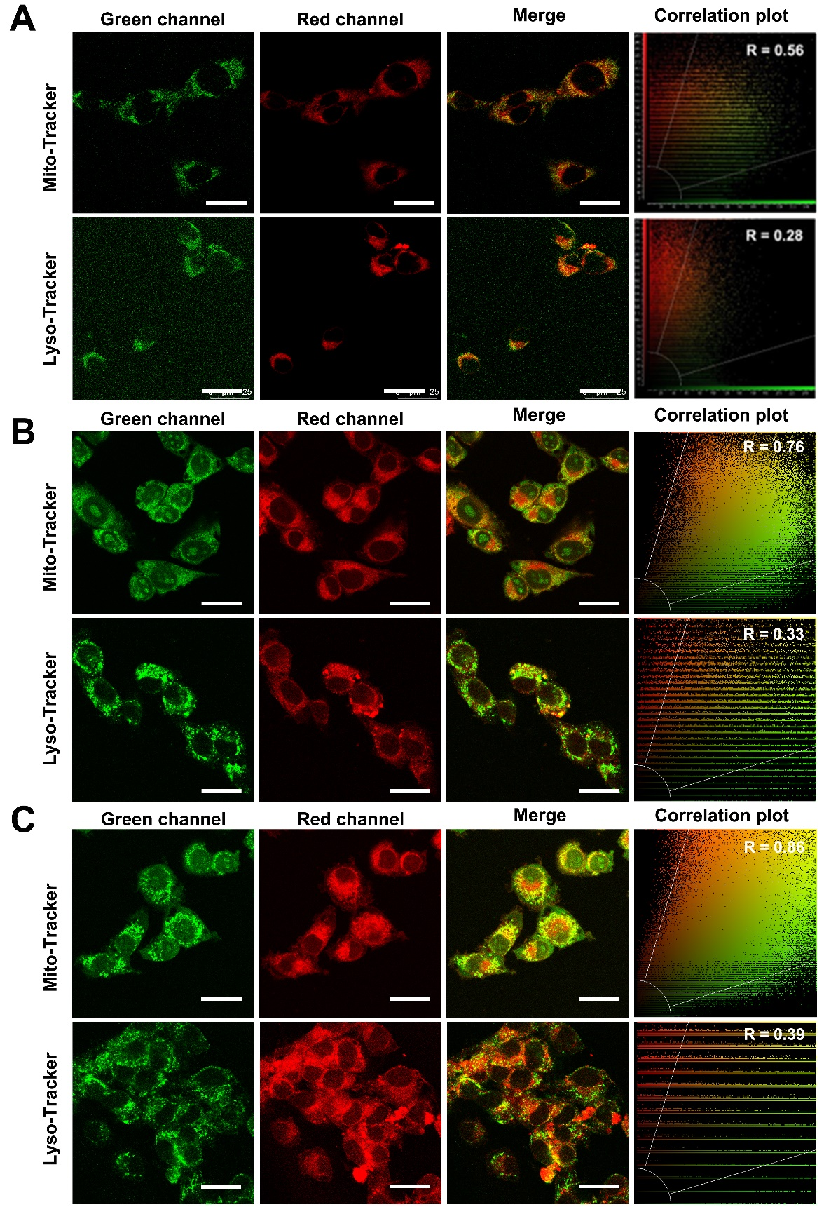
Figure S14 CLSM of 4T1 cells exposed to MSP for (A) 2 h, (B) 4 h and (C) 6 h, which were co-stained with Mito-Tracker or Lyso-Tracker, along with the corresponding correlation plot depicting the relationship between the red fluorescence and the green fluorescence. Scale bars, 25 µm.
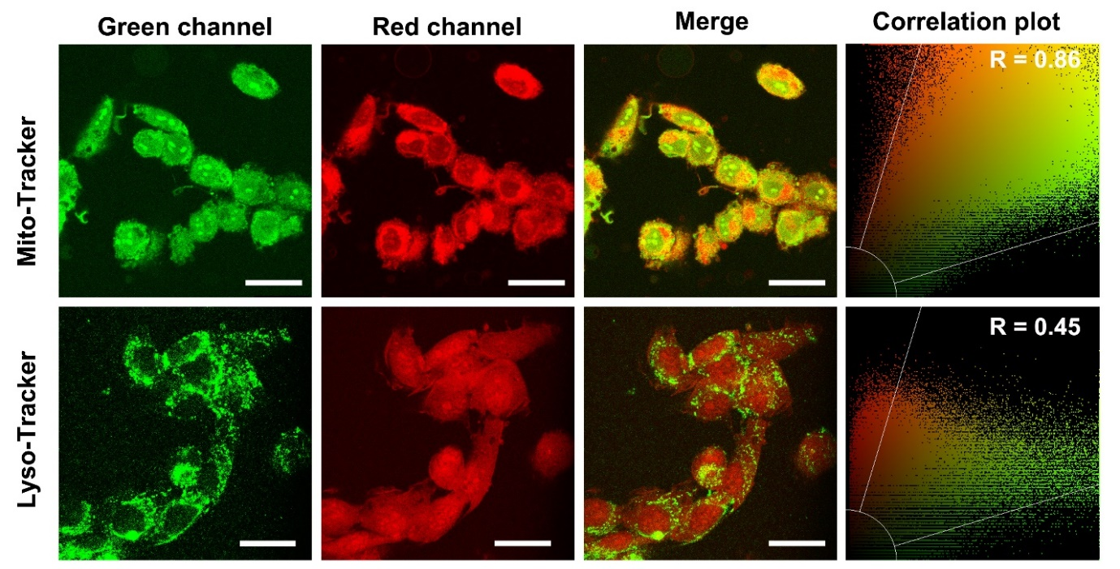
Figure S15 CLSM of 4T1 cells exposed to SQ-675 for 6 h, co-stained with either Mito-Tracker Green or Lyso-Tracker Green, along with the corresponding correlation plot analyzing the colocalization between red fluorescence (SQ-675) and green fluorescence. Scale bars: 25 µm.
EdU cell proliferation staining.
4T1 cells (1×10⁵) were incubated with MS, MSC and MSPC (800 ug/mL) for 6 h. The experimental groups were exposed to NIR laser (5 min, 1.0 mW/cm²), while the control group remained in the dark. The EdU-488 working solution (20 μM) was introduced and incubated for 2 h. The cells were fixed with fixed solution for 15 min. The stationary liquid was discarded, and osmotic solution was added to each well and incubated for 15 min. To each well, 0.5 mL of Click reaction solution, prepared according to the instructions provided with the kit, was added. After washing with PBS, DAPI dye was introduced to each group and allowed to act for 5 min. After washing with PBS twice, fluorescence imaging of cells was performed.
Imaging of CO release in 4T1 cells.
To investigate the release of CO, 4T1 cells were subjected to different treatments: MS, MSP, MSC, MSPC alone (400 μg/mL) for 6 h or combined with NIR light irradiation (5 min, 1.0 mW/cm²). Then, the cells were stained with a mixture of CO probe (1 μM) and PdCl₂ (1 μM) at 37 °C for 30 min. The fluorescence imaging was then carried out after washing the cells with PBS.
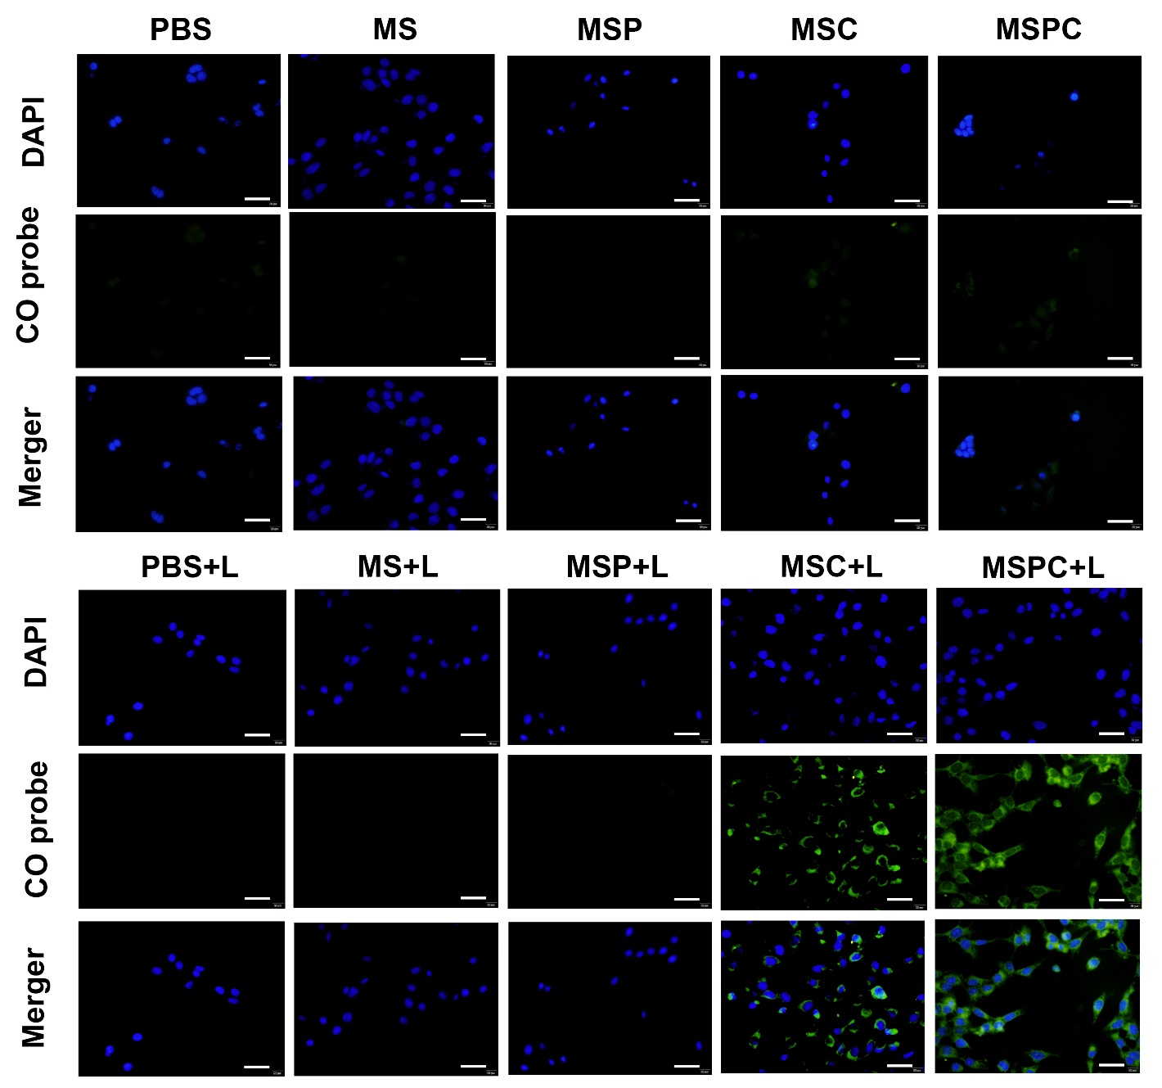
Figure S16 Fluorescent imaging of CO release in 4T1 cells after different treatments by the CO probe system. Scale bars, 50 μm.
GSH levels measurement.
4T1 cells (5×10⁵) were subjected to treatment with MS, MSC, MSP, and MSPC at a concentration of 400 μg/mL for a duration of 6 hours. The experimental groups underwent light irradiation for 5 minutes at an intensity of 1.0 mW/cm², whereas the control group was maintained in darkness. Subsequently, 100 μL of cell lysate was added to each sample and allowed to react for 30 minutes. The lysates from each subgroup were then transferred to Eppendorf tubes and centrifuged at 12,000 rpm for 15 minutes, after which the supernatant was collected. A working solution for glutathione peroxidase assay (Beyotime, Shanghai, China) was prepared in accordance with the instructions. In a 96-well plate, 10 μL of supernatant was combined with 190 μL of the working solution per well. Following an incubation period of 1 hour, the glutathione peroxidase enzyme activity was quantified for each subgroup using an enzyme marker, with a detection wavelength set at 412 nm.
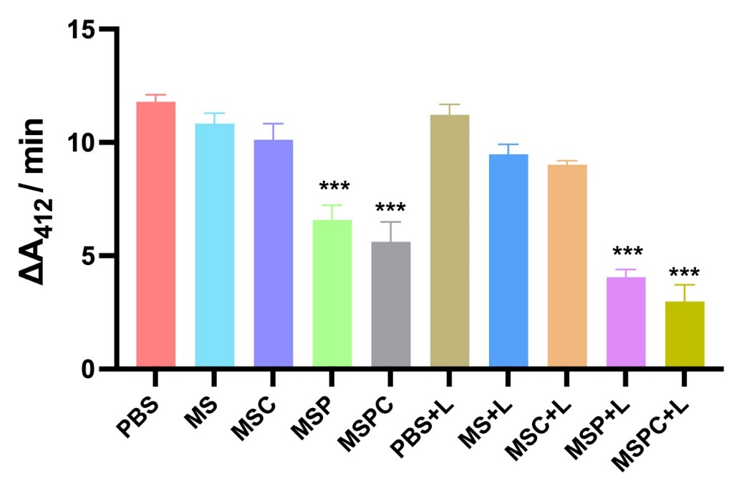
Figure S17 GSH levels in 4T1 cells after different treatments. Data presents as mean ± SD, n = 3 (*p < 0.05, **p < 0.01, ***p < 0.001).
Cellular ATP-level measurement.
4T1 cells (1×10⁵) were treated with MS, MSC, MSP, and MSPC (400 μg/mL) for 6 h. The experimental groups were exposed to light irradiation (5 min, 1.0 mW/cm²), while the control group remained in the dark. The culture medium was replaced with 200 μL of cell lysate, which was then fully lysed and centrifuged for 5 min to obtain the supernatant. The supernatant was subjected to analysis by adding 100 μL of a working solution into the detection hole, and the concentration of ATP in the sample was determined using the standard curve in accordance with the biological fluorescence method.
Lactate levels measurement.
4T1 cells (1×10⁵) were cultured in the presence or absence of MSPC (400 μg/mL) for 6 h. Following PBS (pH 7.4) washing, the cells were subjected to NIR laser treatment (5 min, 1.0 mW/cm²). Subsequently, the cells were cultured for varying time intervals (4 h, 12 h, 24 h) and then extracted using a working solution. The obtained supernatant was centrifuged for 10 min and subsequently measured. The absorbance at 570 nm of the sample was determined, and the concentration of lactic acid was calculated based on the standard curve.
Cellular energy metabolism analysis.
4T1 cells were exposed to MS, MSC, MSP, and MSPC (400 ug/mL) for 6 h. After washed with XF buffer (pH 7.4), the experimental group was irradiated with NIR laser (5 min, 1.0 mW/cm²), while the control group was in the dark. After culturing in a CO₂-free incubator for 1 h, the culture plate was put into an XFe24 cell energy metabolism analyzer for detection.
Mitochondrial membrane potential measurement.
4T1 cells (1×10⁵) were treated with MS, MSC, MSP, and MSPC (400 μg/mL) for 6 h. The experimental groups were exposed to light irradiation (5 min, 1.0 mW/cm²), while the control group remained in the dark. The mitochondrial dye JC-1 was used to determine the mitochondrial membrane potential (Ψm). The JC-1 solution was added and incubated with cells for 20 min. The fluorescence microscopy of cells was then carried out after washing with JC-1 dyeing.
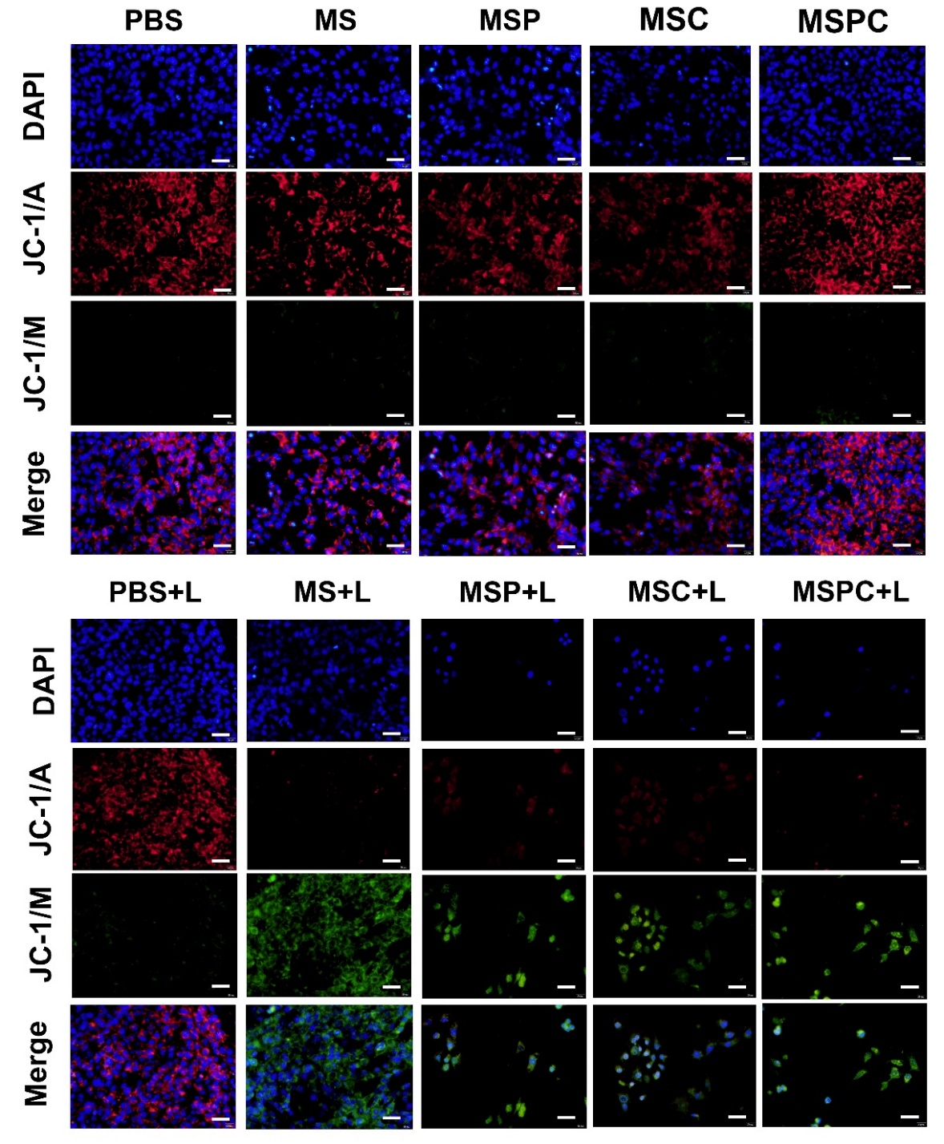
Figure S18 Hyperpolarization of mitochondrial membrane as detected via JC-1 in 4T1 cells after different treatments. Scale bars, 50 μm.
Cell scratch experiment.
4T1 cells (1×10⁵) were inoculated into a 12-well plate. Once the cells adhered to the plate surface, cell scratches were created using a 200 μL gun head in a perpendicular manner to the orifice plate. Subsequently, MS, MSC, and MSPC (800 μg/mL) were added and allowed to incubate for 6 h. The cells were then exposed to light irradiation (5 min, 1.0 mW/cm²), while control groups remained untreated. Following incubation for 18 h, the cells were captured in photographs.
Western blot analysis.
The 4T1 cells were cultured in a six-well plate for 24 h and subsequently treated with MSPC (400 ug/mL) and NIR light irradiation (5 min, 1.0 mW/cm²). The cells were then collected and lysed in RIPA buffer containing protease inhibitors. Western blot analysis was conducted to quantify the expression levels of GSDMD, GSDMD-N, and cleaved caspase-1.
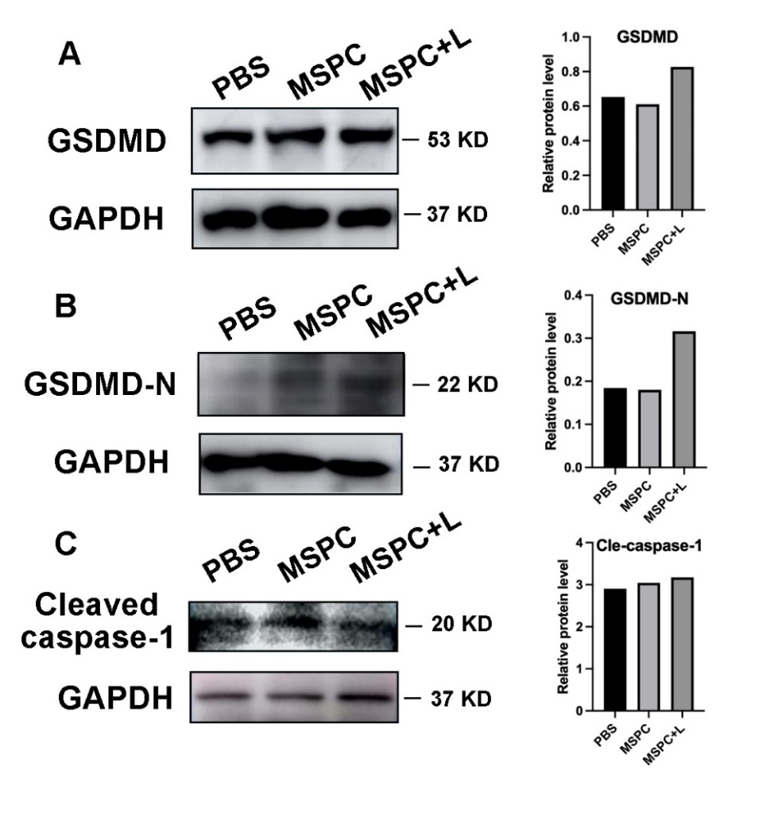
Figure S19 Western blot analysis of (A) GSDMD, (B) GSDMD-N and (C) cleaved caspase-1.
Animal experiment.
Approval for the animal experiment was granted by the Ethics Committee of Shanghai Jiao Tong University School of Medicine, Xinhua Hospital. Female BALB/c nude mice, aged 4-5 weeks, were acquired from the Shanghai Experimental Animal Center, and placed in a specific pathogen-free animal laboratory.
In vivo FL and BL imaging.
Mice with tumors were created by injecting 4T1-Luc cells (1×10⁶/mice) under the skin of the mice. When the tumor volume reached 150-200 mm³, mice in each group were injected with SQ-675, MS, MSP, MSC, or MSPC (100 μL, 1 mg/mL) via tail vein. Fluorescence imaging was conducted using IVIS spectrum (PerkinElmer) before and after injection. Subsequently, the tumor and main organs of mice were also photographed by fluorescence imaging system (excitation wavelength 630 nm, emission wavelength 640-700 nm). To monitor tumor growth, mice carrying 4T1-Luc tumors were given an intraperitoneal injection of D-luciferin potassium, followed by BL imaging conducted with the IVIS spectrum.
In vivo PA imaging:
To conduct in vivo PA imaging, mice with 4T1-Luc tumors were administered with either MS or MSPC (100 μL, 1 mg/mL) through the tail vein. Subsequently, PA images of mice were captured at various time intervals (2, 6, 12, and 24 h) and PA signal intensities of the tumor site at 680 nm were recorded using a PA instrument (TomoWave Laboratories, LOIS-3D, USA). The software ImageJ was utilized to analyze the PA signals within specific regions of interest.
Pharmacokinetic and renal clearance analysis.
Mice were intravenously administered MSPC nanodots (100 μL, 1 mg/mL) via the tail vein, and blood samples were collected at intervals of 5-, 10-, 15-, 30-, 45-, 60-, 90-, and 120-minutes post-injection. The zinc content in the collected blood samples was quantified using inductively coupled plasma-mass spectrometry (ICP-MS) following microwave digestion of the samples.
To assess the clearance of MSPC, urine and feces were collected from the mice over a 24-hour period and analyzed using ICP-MS. At 24 hours post-injection, the mice were euthanized, and the residual MSPC nanodots in various organs, including the kidneys, bladder, liver, intestine, spleen, lungs, and heart, were quantified by ICP-MS after microwave digestion of the tissues.
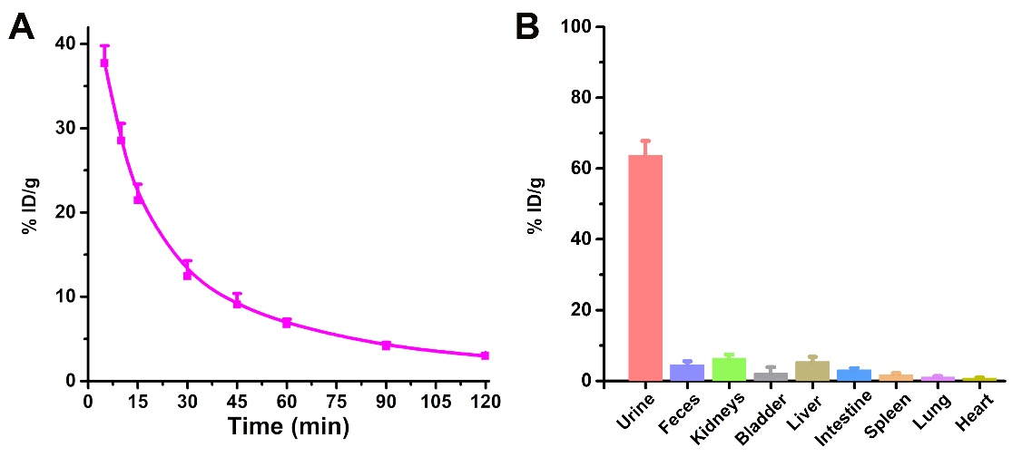
Figure S20 (A) The pharmacokinetic profile of zinc ions from MSPC in the blood of mice following intravenous administration, and (B) the ICP-MS analysis of zinc ions from MSPC excreted in urine and feces, as well as residual zinc in major organs of mice 24 hours post-injection. Data are presented as mean ± standard deviation (n = 3).
Hemolysis test.
Blood was collected from healthy mice and combined with PBS to prepare a 2% red blood cell suspension. Various concentrations of MSPC and the 2% erythrocyte suspension were prepared and incubated at 37 °C for 2 hours. The supernatant was then centrifuged at 5000 rpm for 10 minutes at 4 °C. UV absorbance was measured at 540 nm to calculate hemolysis. PBS at pH 7.4 served as a negative control, while a 2% erythrocyte lysate was utilized as a positive control.
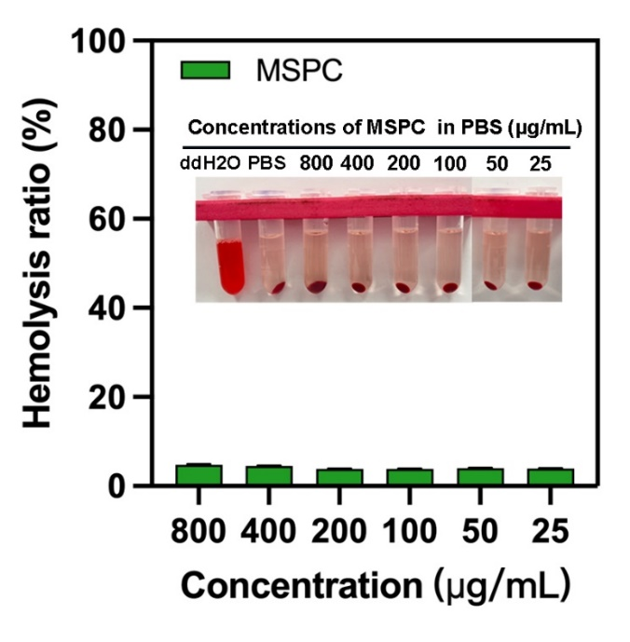
Figure S21 Hemolytic activity of different concentrations of MSPC on erythrocytes.
Blood biochemistry assessment.
MSPC nanodots (100 μL, 1 mg/mL) were administered into mice via tail vein. After 24 h, whole blood was centrifuged at 3240 rpm for 15 minutes. Serum biochemical levels, including alkaline phosphatase (ALP), alanine aminotransferase (ALT), aspartate aminotransferase (AST), creatinine (CREA), urea, and creatine kinase (CK), were analyzed using an automatic biochemical analyzer (C501, Cobas, USA).
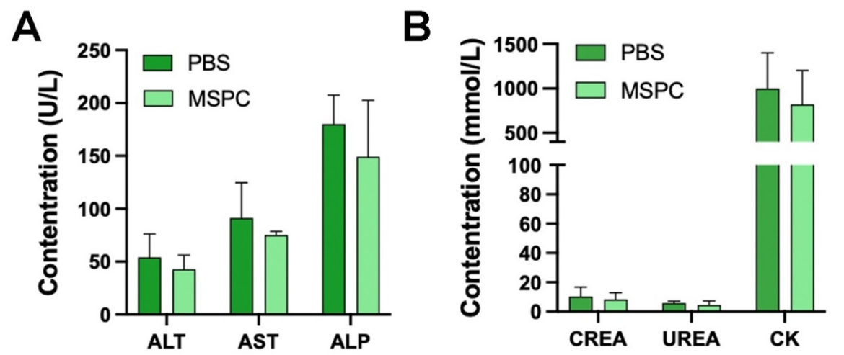
Figure S22 (A) Comparison of metabolic indices of liver function pre- and post-MSPC injection. (B) Comparison of metabolic indices of kidney function pre- and post-MSPC injection.
Anti-tumor efficacy evaluation.
Mice bearing 4T1-Luc tumors were used for anti-tumor efficacy study. When the subcutaneous tumors had grown up to 60-90 mm³, 4T1-Luc tumor-bearing mice in 10 groups (n=4) were injected with PBS, MS, MSC, MSP, and MSPC (100 μL, 1 mg/mL) via the tail vein, respectively. Afterwards, mice in PBS+L, MS+L, MSP+L, MSC+L, MSPC+L groups were irradiated with NIR laser (5 min, 2.0 mW/cm²). The tumors were measured every other day using vernier calipers, and performed BL imaging during the treatment. After 14 days, the mice were euthanized using excessive carbon dioxide anesthesia.
Histology examination.
Freshly dissected tumors and major organs obtained from mice were fixed using a 4% paraformaldehyde solution. Subsequently, the specimens were embedded in paraffin and sliced for H&E, and immunofluorescence staining. As for immunofluorescence staining, the paraffin-embedded slides were subjected to overnight incubation at 4°C with the Ki67 antibody (Abcam, 1:200) after blocking with 5% BSA for 1 h. The slides were further stained with Horseradish peroxidase (HRP)-labeled secondary antibody for 1 h and detected with DAB Horseradish Peroxidase Color Development Kit.
Statistical analysis.
The statistical analysis was conducted using SPSS 23 (IBM Corp, Armonk, NY), and the results of all statistical analyses were presented as the mean plus standard deviation. The comparison between the two groups was conducted using an independent t-test. Comparison among groups was conducted using one-way ANOVA, followed by the Dunnett test. A significance level of less than 0.05 indicates statistical significance. Data presents as mean ± SD, n = 3 (*p < 0.05, **p < 0.01, ***p < 0.001).
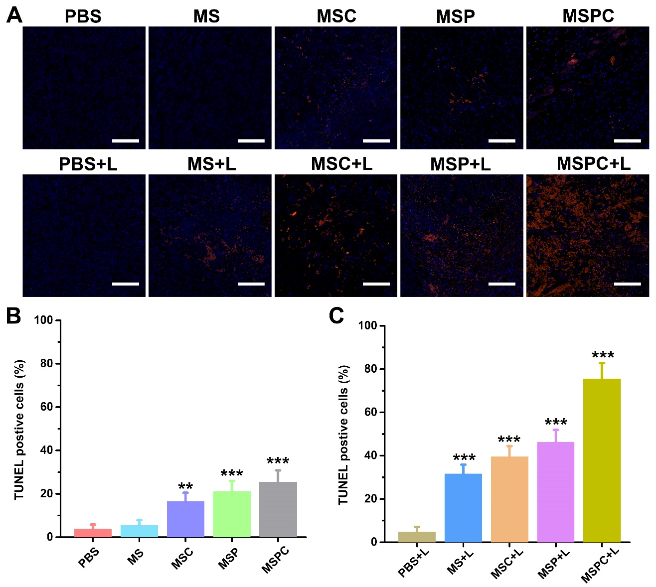
Figure S23 (A) Representative TUNEL staining images of tumor sections in each group. Scale bar: 50 μm. (B) TUNEL positive cells (%) in PBS, MS, MSC, MSP, and MSPC groups. (C) TUNEL positive cells (%) in PBS+L, MS+L, MSC+L, MSP+L, MSPC+L groups. Data presents as mean ± SD, n = 3 (*p < 0.05, **p < 0.01, ***p < 0.001).

