Supporting Information

Regulation of Immune Microenvironments by Polyetheretherketone Surface Topography for Improving Osseointegration

Yuqing Zhao^{‡, a}, Yanxin An^{‡, b}, Fan Wuª, Lipeng Liu^{c}, Franklin R. Tay^{d}, Yang Jiao^{*, e}, Jing Wang^{*, a}

Figure S1. FTIR spectra of different specimens.
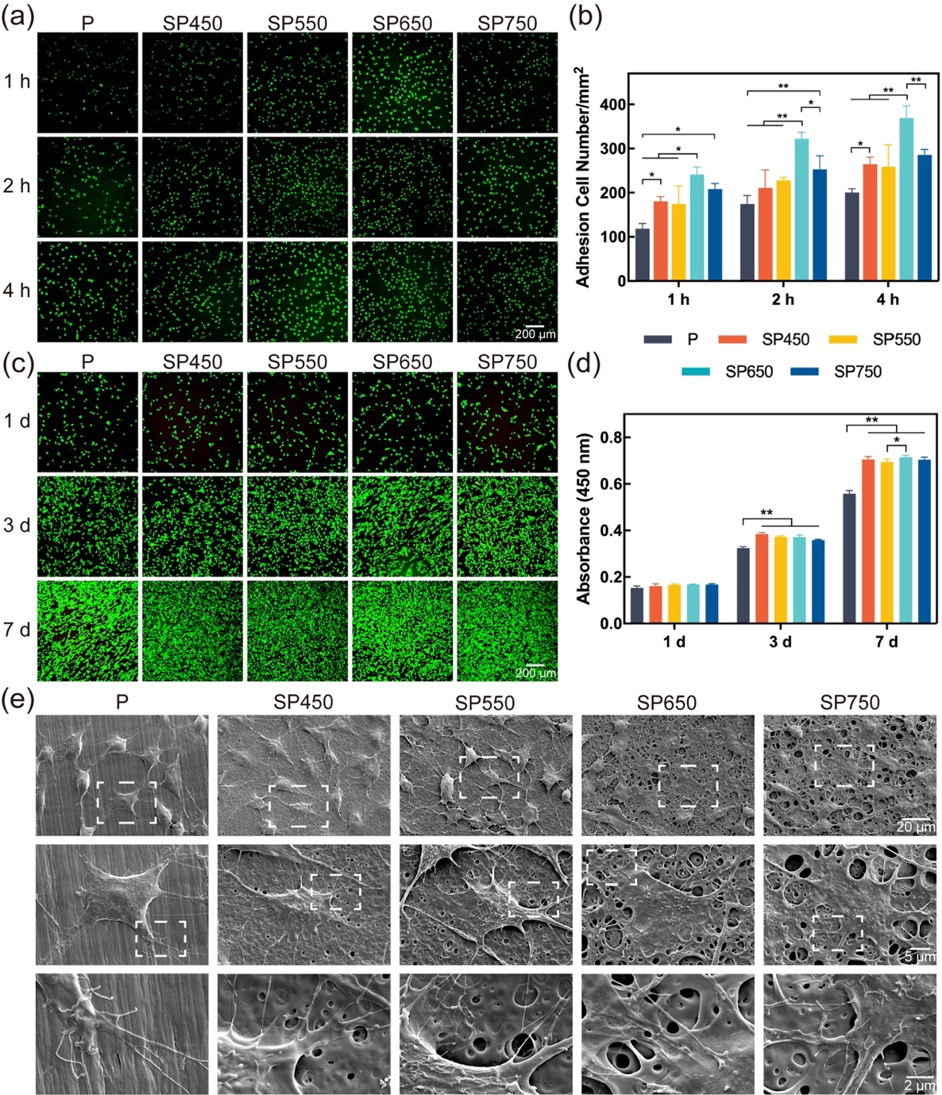
Figure S2. In vitro behaviors of MC3T3-E1 pre-osteoblasts on various nanostructures. (a) Adherent pre-osteoblasts that adhered to different PEEK specimens at 1 h, 2 h, and 4 h. Cell nuclei were stained with DAPI; Scale bars: 200 μm. (b) Histogram of pre-osteoblasts population that adhered to the PEEK specimens. (c) Representative CLSM images of live/dead staining of pre-osteoblasts on different specimens. (d) CCK-8 assay results of the proliferation of pre-osteoblasts after 1 d, 3 d, and 7 d of culture on PEEK specimens with different dimensions. (e) SEM of the MΦs morphology on different specimens after culturing for 3 days. n = 3 independent experiments per group; *P < 0.05 and **P < 0.01. 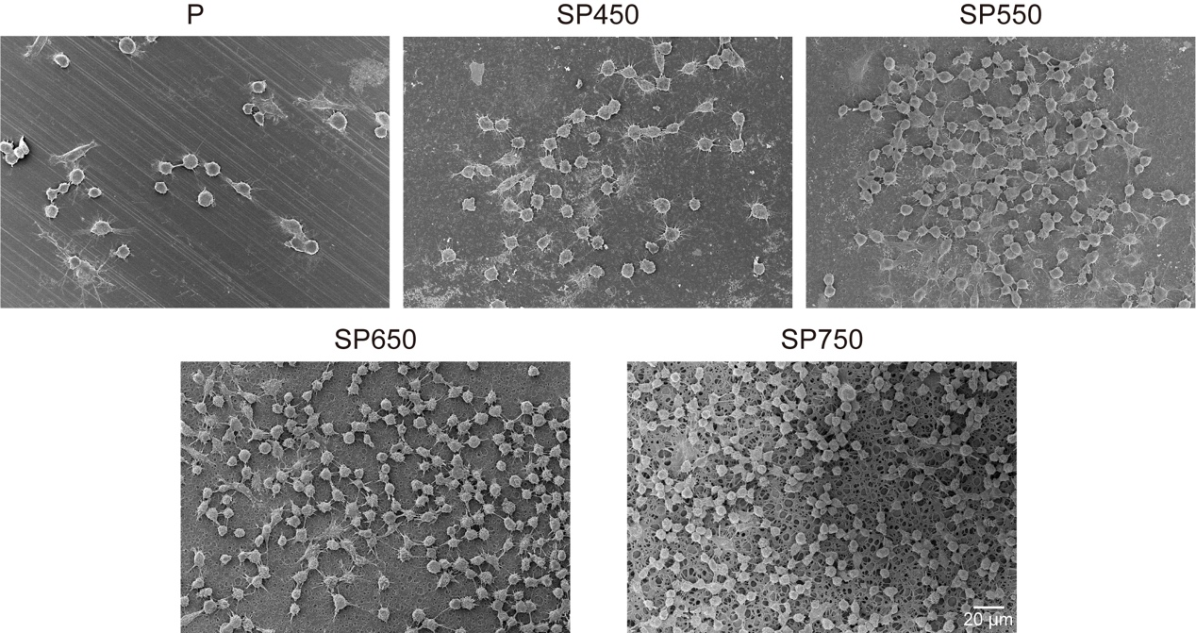
Figure S3. Cell morphologies of MΦs on different samples under SEM.

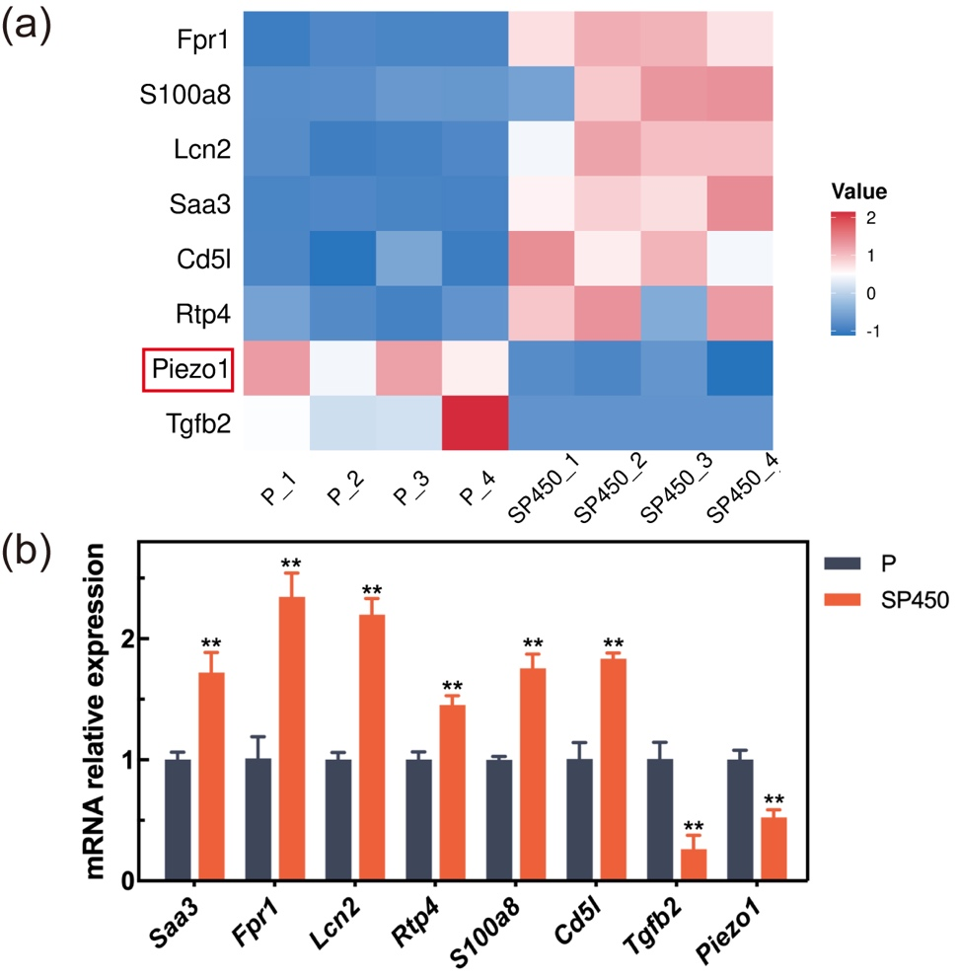
Figure S4. (a) Heat map of DEGs. (b) Validation of DEGs by qRT-PCR analysis.

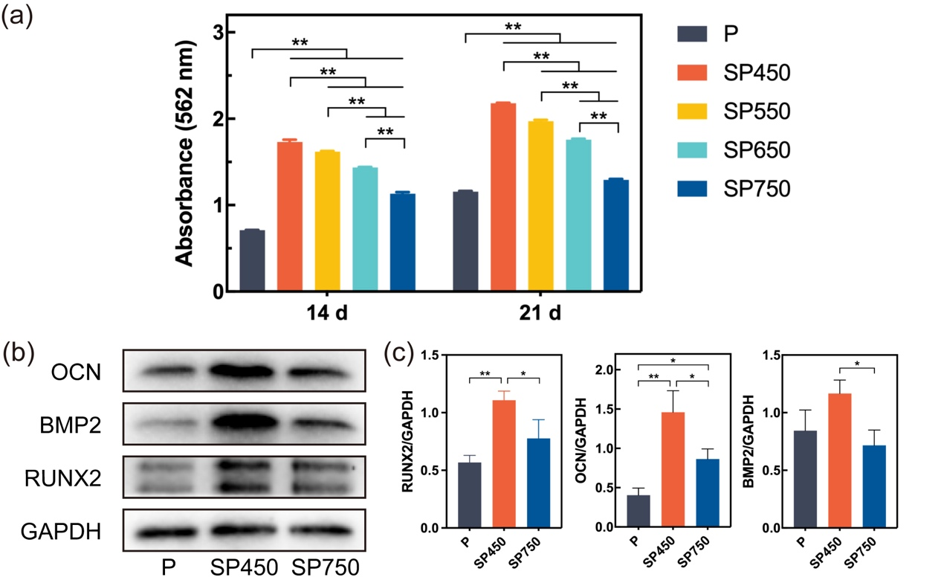
Figure S5. (a) Quantitative analysis of Alizarin red staining on day 14 and day 21. (b) Western blot images showing the levels of osteogenesis-related proteins in MC3T3-E1 pre-osteoblasts cultured on different PEEK specimens with MΦ supernatants collected on day 7. (c) Quantification analysis of RUNX2, BMP2, and OCN. n = 3 independent experiments per group; *P < 0.05 and **P < 0.01. 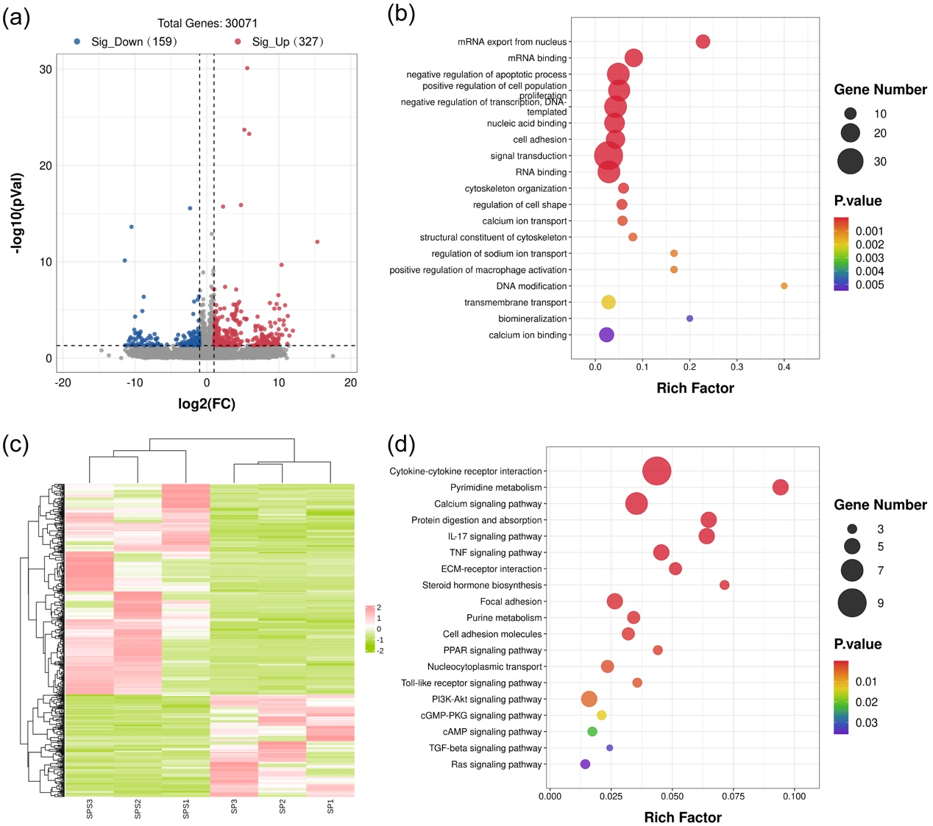
Figure S6. Bioinformatic analysis of MC3T3-E1 pre-osteoblasts cultured with and without MΦ supernatants collected from corresponding samples. (a) Volcano plot of DEGs. (b) GO term enrichment analysis of DEGs. (c) Heatmap of DEGs among the two groups. (d) KEGG pathway enrichment analysis of DEGs. n = 3 independent experiments per group.

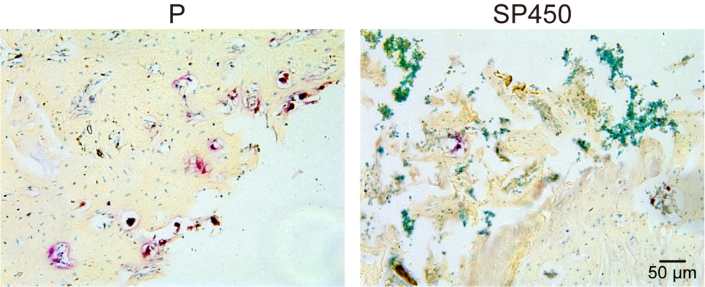
Figure S7. Trap staining of paraffin sections of smooth PEEK and SP450 implants. **P < 0.01.

Table S1. Real-time PCR primers of MΦs used in the present study
Target Gene | Primer sequences
iNOS | Forward: 5’-CAAGCTGAACTTGAGCGAGGA-3’
iNOS | Reverse: 5’-TTTACTCAGTGCCAGAAGCTGGA-3’
IL-1β | Forward: 5’-GAAATGCCACCTTTTGACAGTG-3’
IL-1β | Reverse: 5’-TGGATGCTCTCATCAGGACAG-3’
CD206 | Forward: 5’-TACTTGGACGGATAGATGGAGG-3’
CD206 | Reverse: 5’-CATAGAAAGGAATCCACGCAGT-3’
IL-4 | Forward: 5’-GGTCTCAACCCCCAGCTAGT-3’
IL-4 | Reverse: 5’-GCCGATGATCTCTCTCAAGTGAT-3’
RUNX-2 | Forward: 5’-GCCGGGAATGATGAGAACTA-3’
RUNX-2 | Reverse: 5’-GGACCGTCCACTGTCACTTT-3’
ALP | Forward: 5’-CCAACTCTTTTGTGCCAGAGA-3’
ALP | Reverse: 5’-GGCTACATTGGTGTTGAGCTTTT-3’
OPN | Forward: 5’-AGCAAGAAACTCTTCCAAGCAA-3’
OPN | Reverse: 5’-GTGAGATTCGTCAGATTCATCCG-3’
OST | Forward: 5’-ATTCTCCCATTCTCCCTCCCT-3’
OST | Reverse: 5’-GGAAGGGTGGGTAGTCATTTGC-3’
SAA3 | Forward: 5’-GAAGCTGGTCAAGGGTCTAGAGA-3’
SAA3 | Reverse: 5’-CATTGGCAAACTGGTCAGCTCTT-3’
FPR1 | Forward: 5’-GCTGTTGGAAAGTTCAGGAGTCT-3’
FPR1 | Reverse: 5’-CAGAACGATGTAGCCAGCAGATA-3’
LCN2 | Forward: 5’-GCACCATCTATGAGCTACAAGAGA-3’
LCN2 | Reverse: 5’-TGTGCATATTTCCCAGAGTGAACT-3’
RTP4 | Forward: 5’-CGTGAATTGCCTGATGTGGATTC-3’
RTP4 | Reverse: 5’-GGGTCCAGAATCACGGTAGTTAT-3’
S100a8 | Forward: 5’-GAAATCTTTCGTGACAATGCCGT-3’
S100a8 | Reverse: 5’-ATTCTGCACAAACTGAGGACACT-3’
CD5l | Forward: 5’-ACAAGGAAGATGTGGAGGTGATC-3’
CD5l | Reverse: 5’-GGCTGAGGGAAAGGTGTCTAAAG-3’
TGF-β2 | Forward: 5’-CTGTACCTTCGTGCCGTCTAATA-3’
TGF-β2 | Reverse: 5’-CCCAGCACAGAAGTTAGCATTGT-3’
Piezo1 | Forward: 5’-GTTACCCCCTGGGAACATCT-3’
Piezo1 | Reverse: 5’-TTCAGGAGAGAGGTGGCTGT-3’
TRAP | Forward: 5’-TCGGCTTCTTCTCCAATC-3’
TRAP | Reverse: 5’-GACCTCCAAGTTCTTATCCT-3’
CTSK | Forward: 5’-TTGTGACCGTGATAATGTG-3’
CTSK | Reverse: 5’-TTATTCCGAGCCAAGAGA-3’
GAPDH | Forward: 5’-CCAATGTGTCCGTCGTGGATCT-3’
GAPDH | Reverse: 5’-GTTGAAGTCGCAGGAGACAACC-3’

