Injectable hydrogels with ROS-triggered drug release enable the co-delivery of antibacterial agent and anti-inflammatory nanoparticle for periodontitis treatment

Yujing Zhu^{1, 2}, Ziliang Xiu^{1, 2}, Xiaoxi Jiang³, Huifang Zhang¹, Xiaofeng Li^{1, 2}, Yunru Feng^{1, 2}, Bojiang Li¹, Rui Cai^{1, 4}*, Chunhui Li^{1, 2, 4}*, Gang Tao^{1, 4}*
¹ Oral & Maxillofacial Reconstruction and Regeneration of Luzhou Key Laboratory, The Affiliated Stomatological Hospital, Southwest Medical University, Luzhou 646000, China
² Department of Periodontics & Oral Mucosal Diseases, The Affiliated Stomatological Hospital, Southwest Medical University, Luzhou, 646000, China.
³ Department of Oral Medicine, Deyang Stomatological Hospital, Deyang 618000, China.
⁴ Institute of Stomatology, Southwest Medical University, Luzhou 646000, China
*Correspondence:
Rui Cai, Oral & Maxillofacial Reconstruction and Regeneration of Luzhou Key Laboratory, The Affiliated Stomatological Hospital, Southwest Medical University, Luzhou 646000, China, E-mail: cairui@swmu.edu.cn
Chunhui Li, Oral & Maxillofacial Reconstruction and Regeneration of Luzhou Key Laboratory, The Affiliated Stomatological Hospital, Southwest Medical University, Luzhou 646000, China, Email: lch10221022@163.com
Gang Tao, Oral & Maxillofacial Reconstruction and Regeneration of Luzhou Key Laboratory, The Affiliated Stomatological Hospital, Southwest Medical University, Luzhou 646000, China, E-mail: taogang@swmu.edu.cn

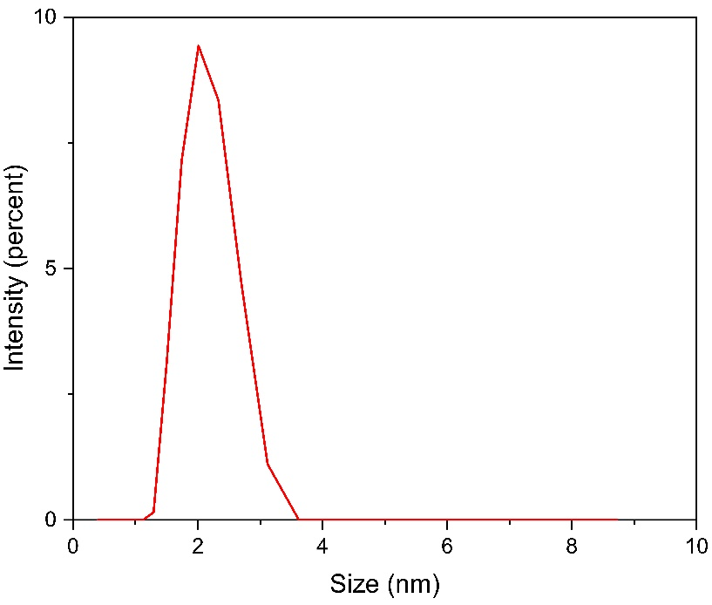
Fig. S1 Diameters of Fe-Que NPs.

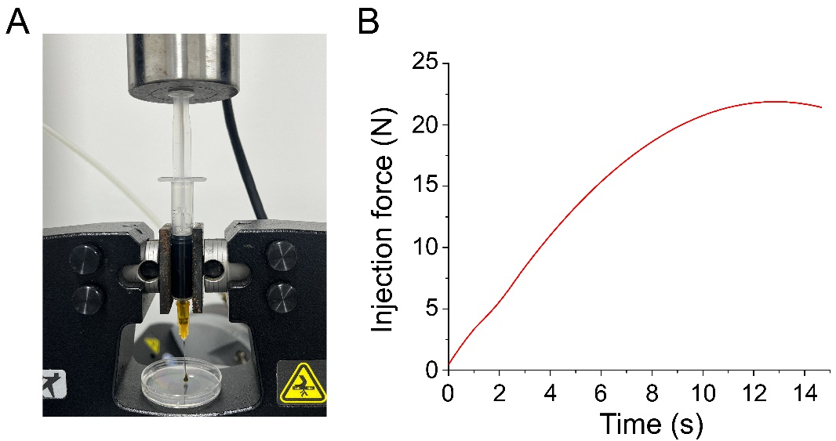
Fig. S2 Injection force of the HP/PVA@MH/Fe-Que hydrogels. (A) Photograph of the setup for measuring injection force with a mechanical tester. (B) Plot showing injection force over time for hydrogels injected from a 2 mL syringe.

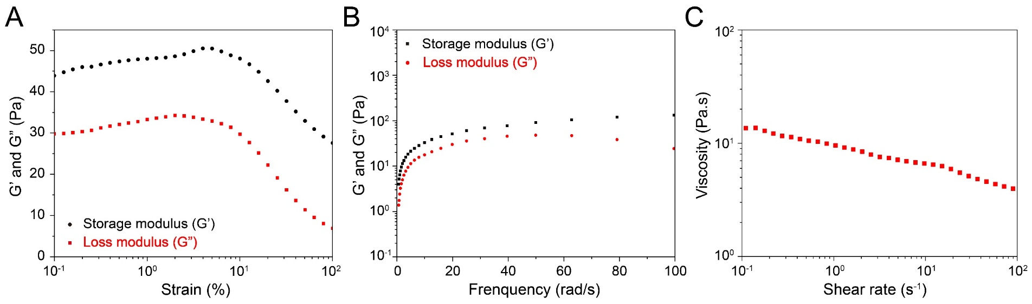
Fig. S3 The rheological property of the HP-PVA@MH/Fe-Que hydrogels. (A) Strain amplitude sweep curves. (B) Variations of storage and loss modulus (G’ and G”, respectively) versus angular frequency (0.1-100 rad/s). (C) The viscosity of hydrogels with the shear rate (0.1-100 s⁻¹).

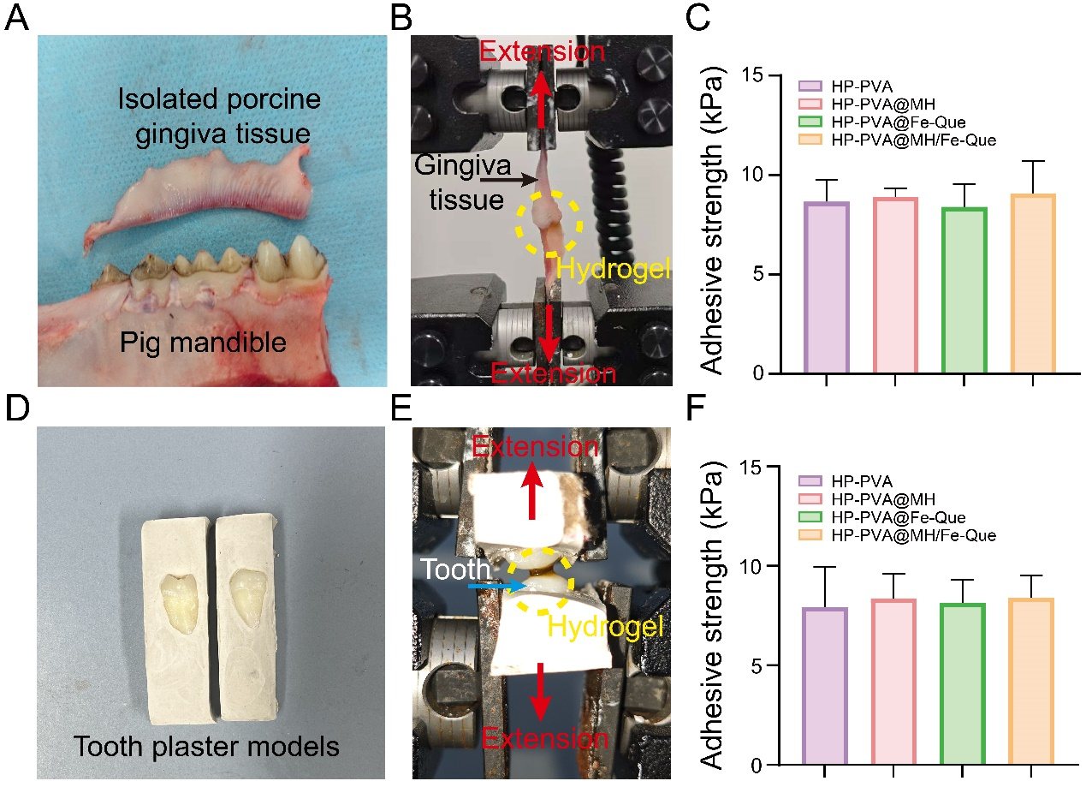
Fig. S4 Adhesion assay of hydrogels to porcine gingiva tissue and premolars. (A) Photograph of the gingiva tissue isolated from pig mandible. (B) Representative images of the lap-shear adhesive strength test using pig gingiva tissue. (C) Adhesion strength of hydrogel to the pig gingiva tissue. (D) Photograph of teeth plaster model to fix the teeth. (E) Representative images of the hydrogel adhered to the teeth. (F) Adhesion strength of hydrogel to the teeth.

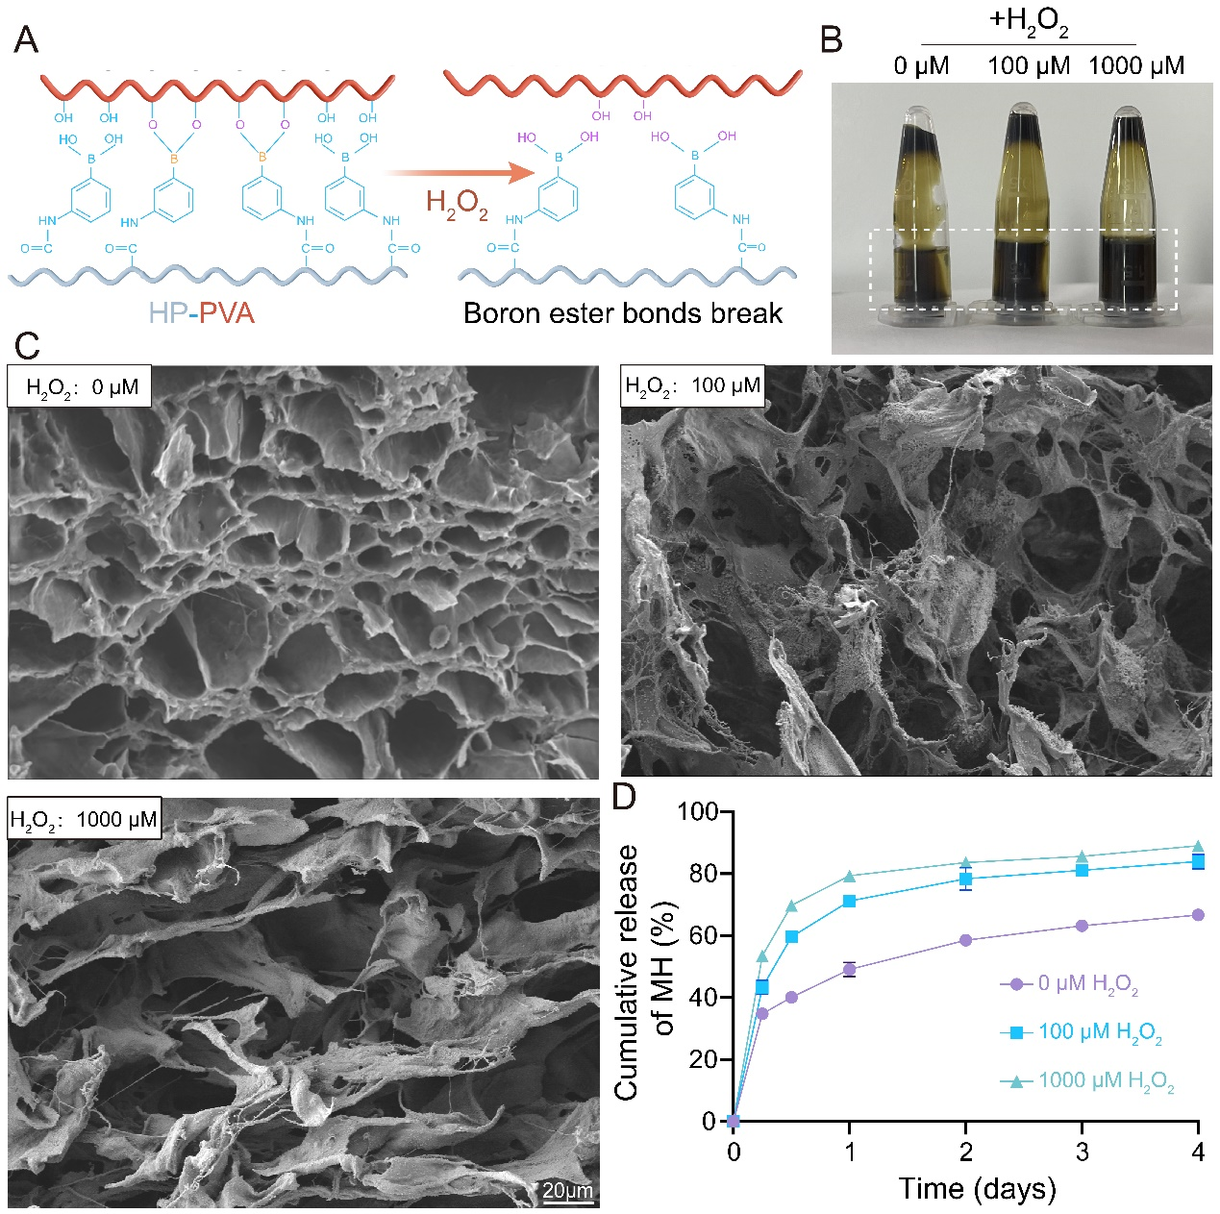
Fig. S5 ROS responsive properties of the HP-PVA@MH/Fe-Que hydrogels. (A) Schematic diagram of the reaction mechanism of hydrogel to ROS. (B) Photograph and (C) SEM images of the HP-PVA@MH/Fe-Que hydrogel treated with different H₂O₂ concentrations (0, 100, and 1000 μM) for 3 h. (D) Release curves of MH in the HP-PVA@MH/Fe-Que hydrogel treated with different H2O2 concentrations (0, 100, and 1000 μM).

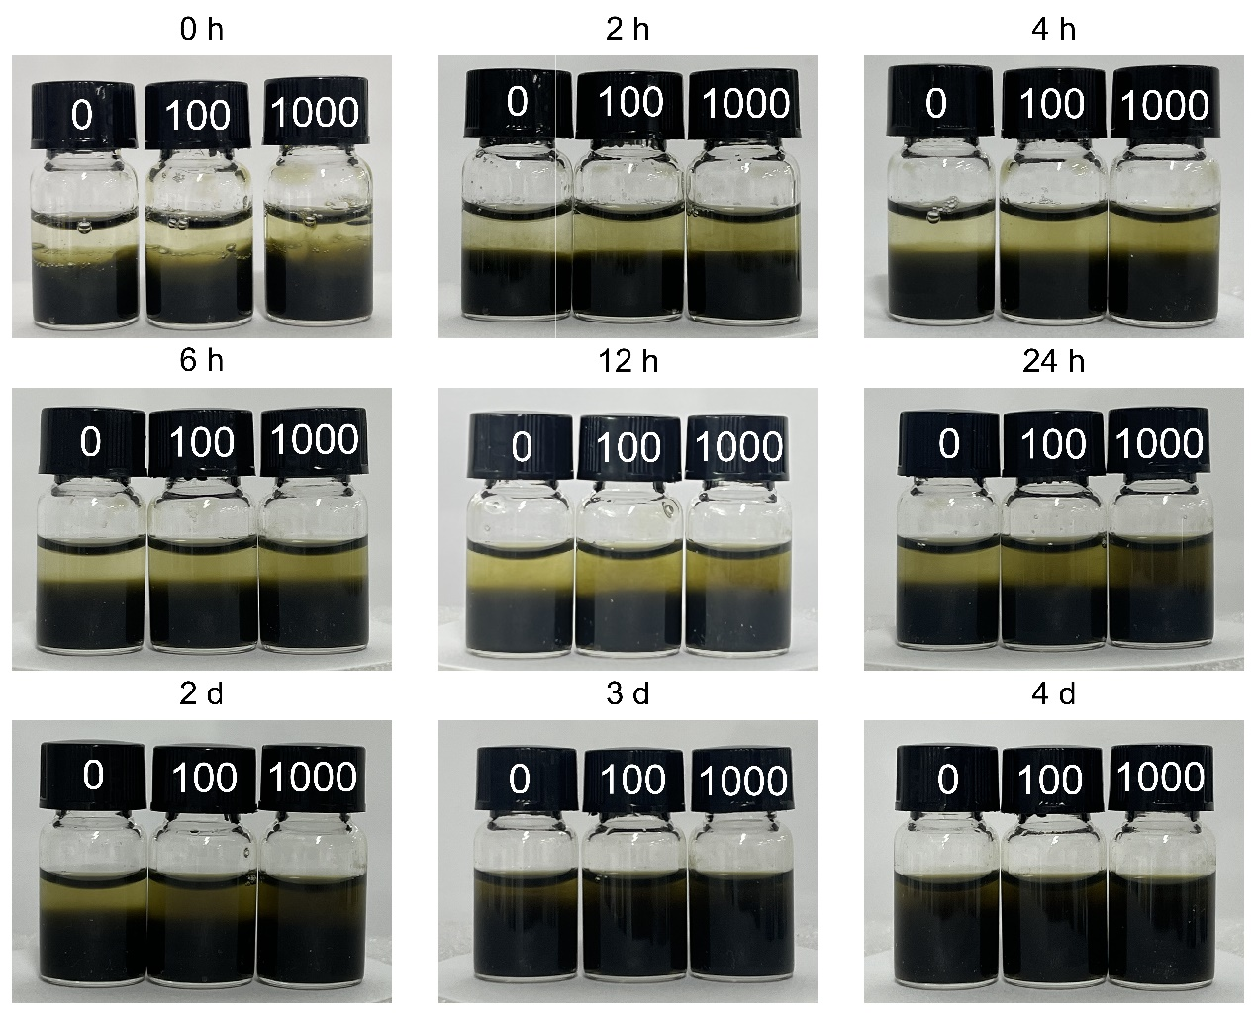
Fig. S6 Morphology changes of HP/PVA@MH/Fe-Que hydrogels in PBS with different concentrations of H₂O₂ (0, 100, and 1000 μM).

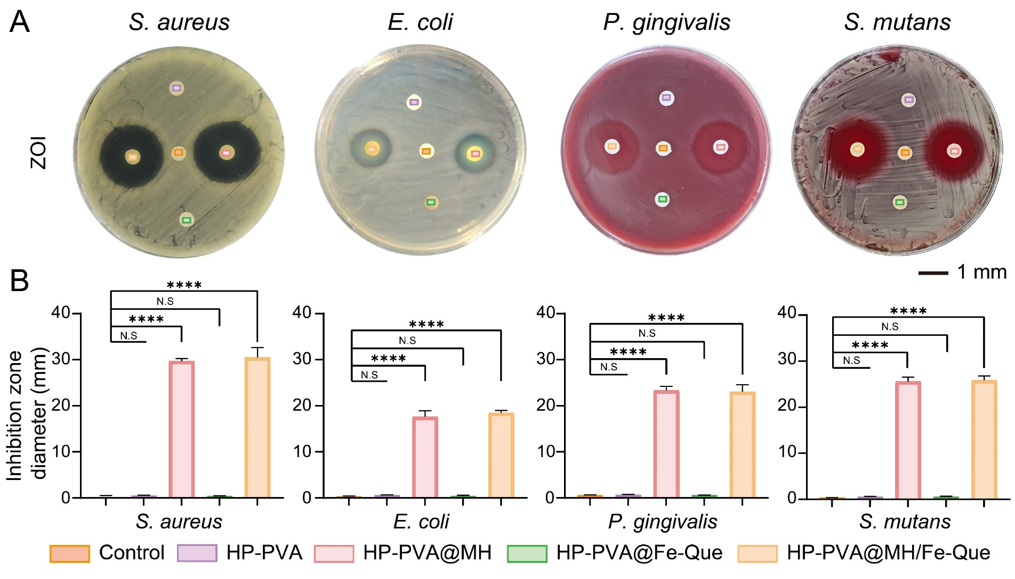
Fig. S7 Antibacterial activity testing by zone of inhibition assay. (A) Representative images and (B) Inhibition zone diameter for the hydrogels of S. aureus, E. coli, P. gingivalis, and S. mutans.

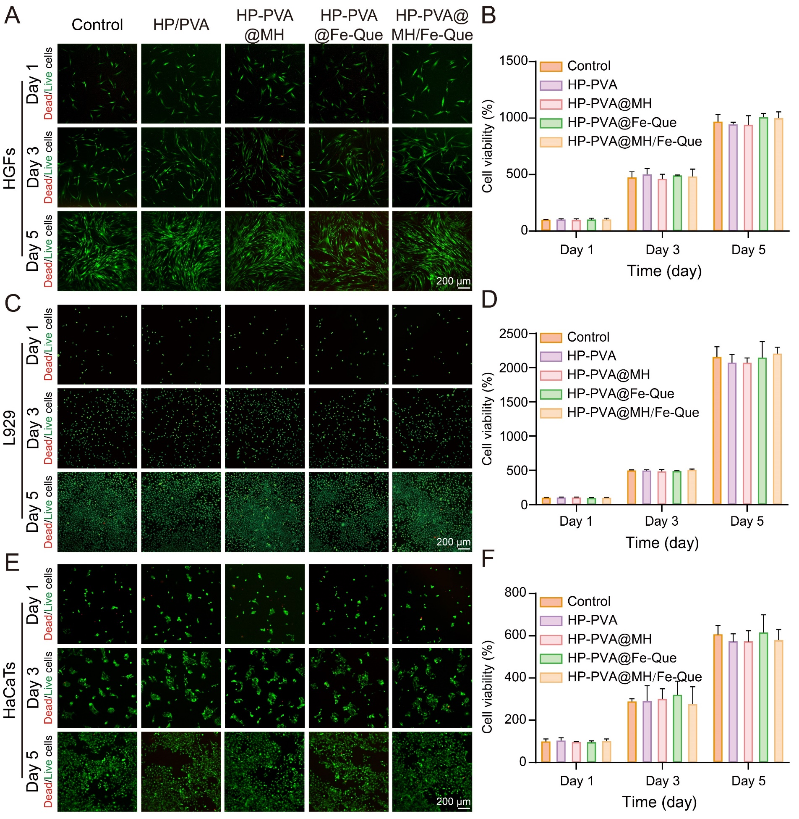
Fig. S8 Cytocompatibility of the HP-PVA@MH/Fe-Que hydrogels. (A) The Live/Dead staining images, (B) CCK-8 assays of HGFs. (C) The Live/Dead staining images, (D) CCK-8 assays of L929 cells. (E) The Live/Dead staining images, (F) CCK-8 assays of HaCaTs.

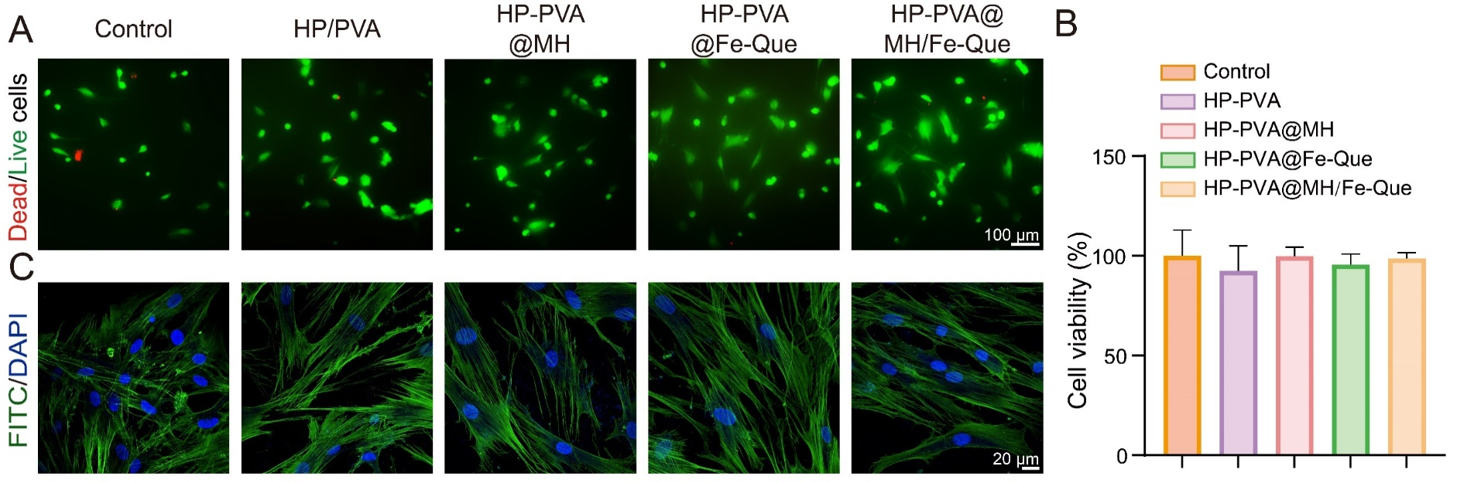
Fig. S9 Biocompatibility of the hPDLSCs co-cultured on HP-PVA@MH/Fe-Que hydrogels. (A) Live/Dead staining images. (B) CCK-8 assays. (C) Cytoskeleton staining images.

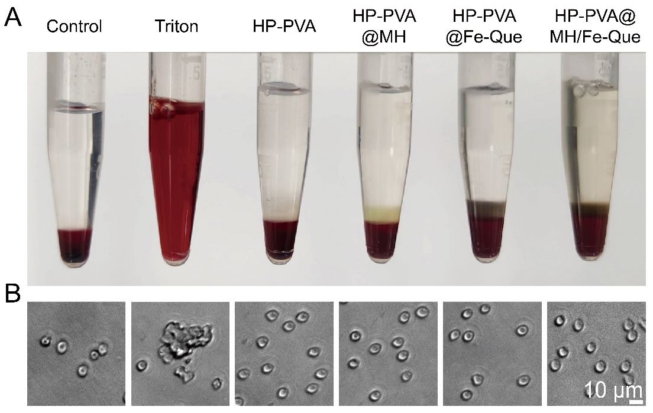
Fig. S10 Blood compatibility of the HP-PVA@MH/Fe-Que hydrogels. (A) Hemolysis photographs. (B) Morphology of erythrocyte after incubating with the hydrogels.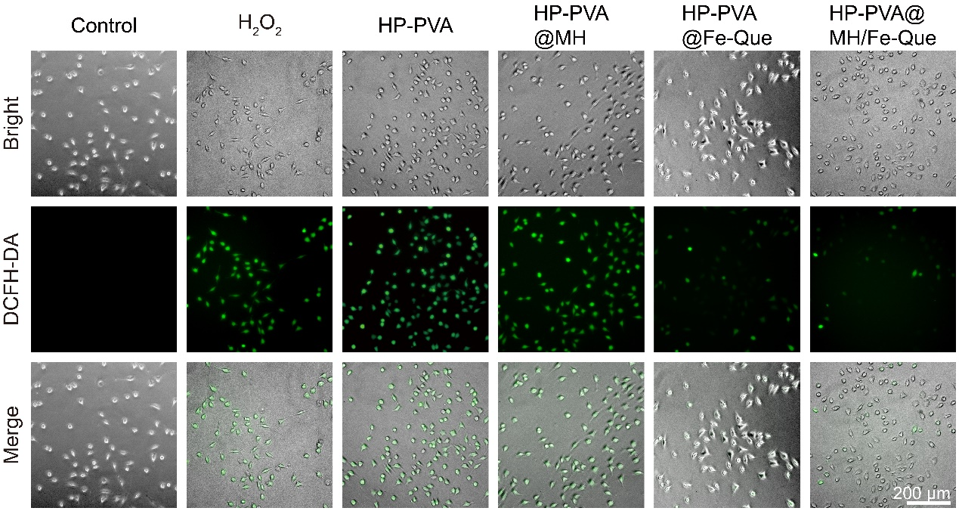
Fig. S11 DCFH-DA staining of the L929 cells.

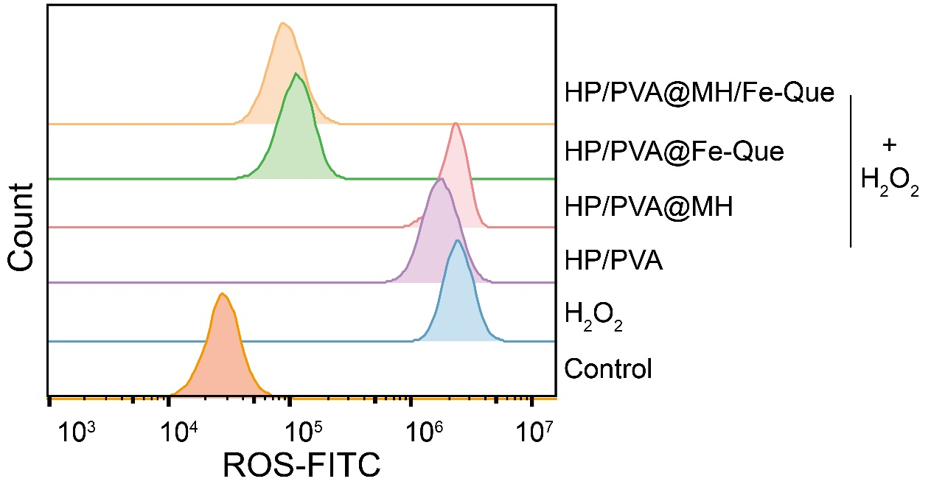
Fig. S12 Flow cytometry of ROS levels in RAW264.7 cells.
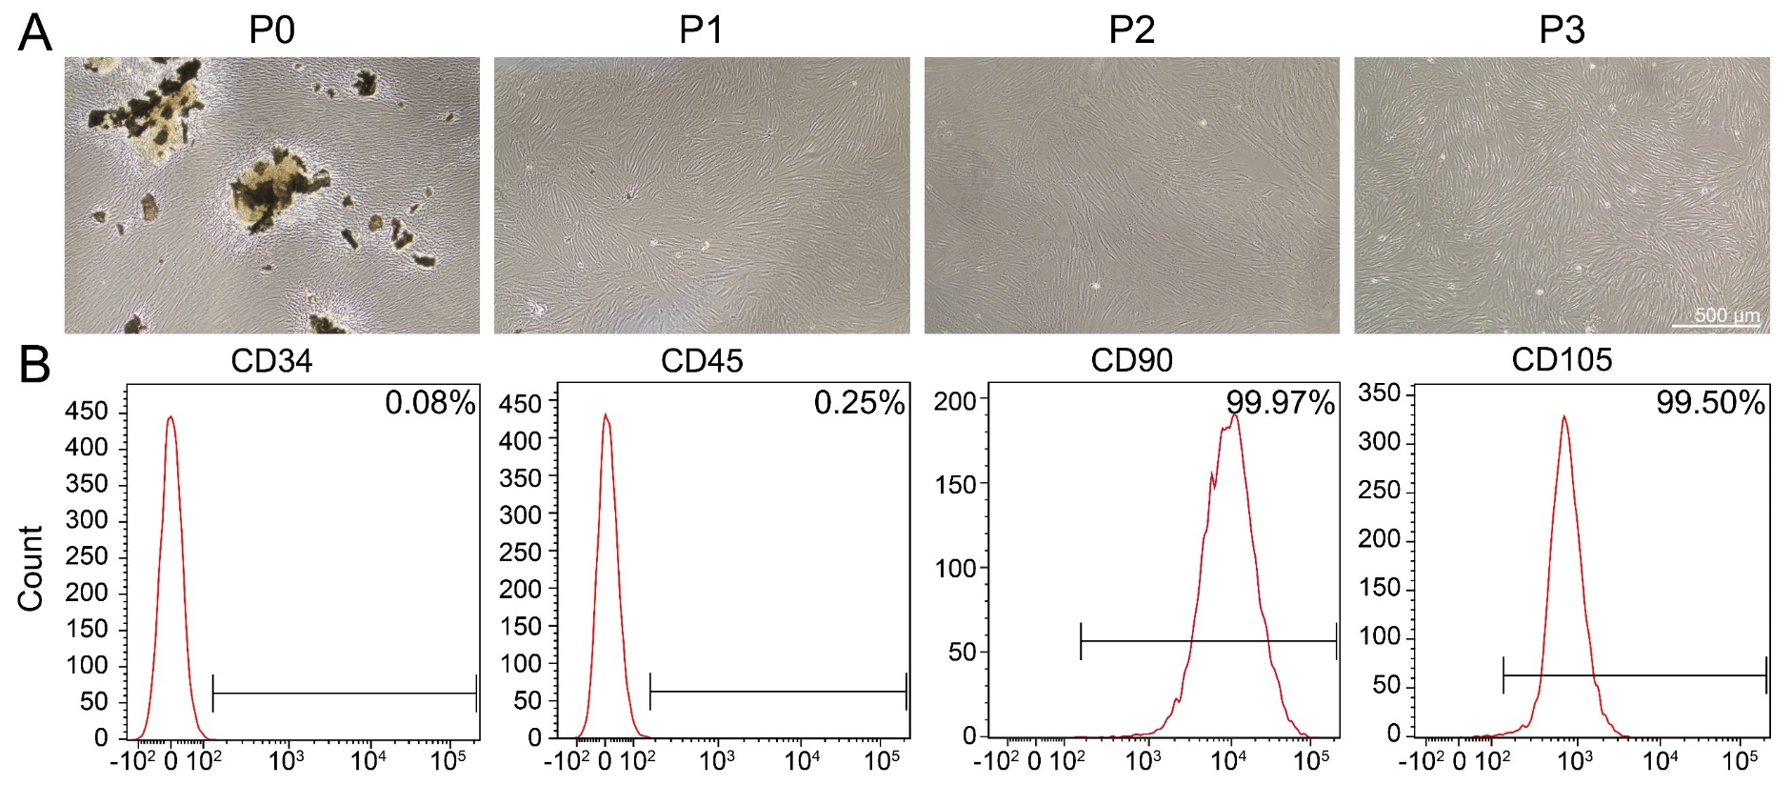Fig. S13 Culture and identification of hPDLSCs. (A) Morphology of hPDLSCs. (B) Flow cytometry analysis of the indicated cell surface marker including CD34, CD45, CD90, and CD105 expression in hPDLSCs.

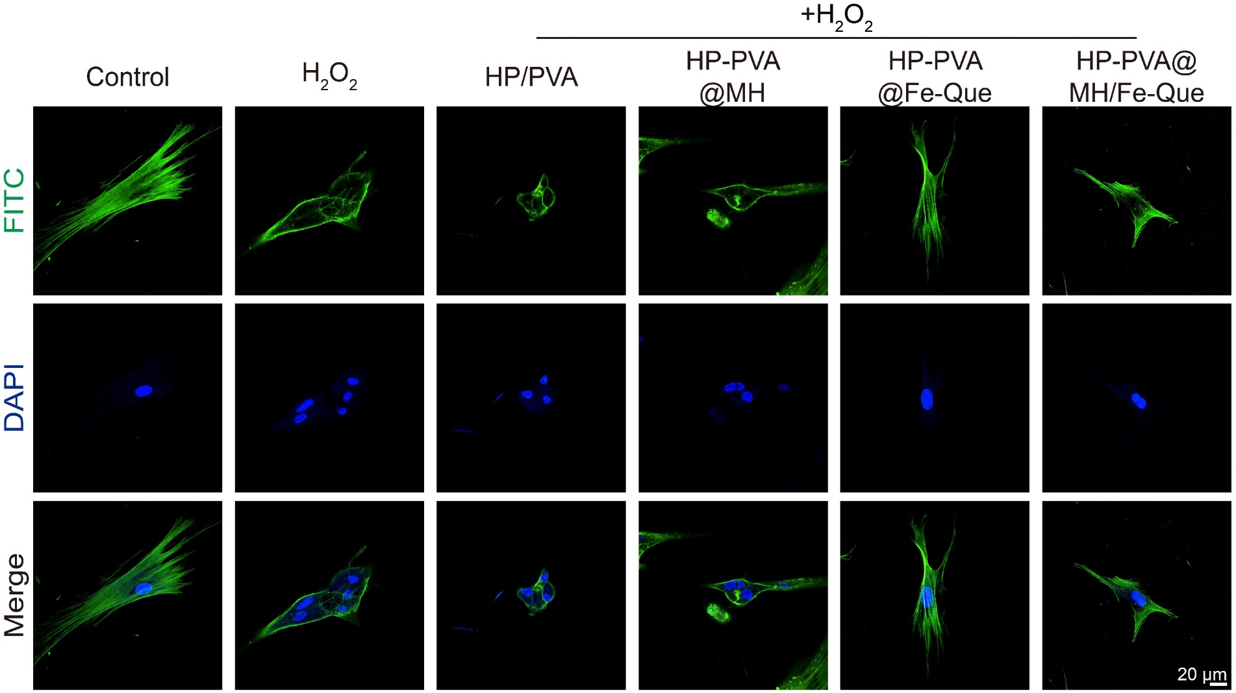
Fig. S14 Morphology of hPDLSCs in the high ROS environment.
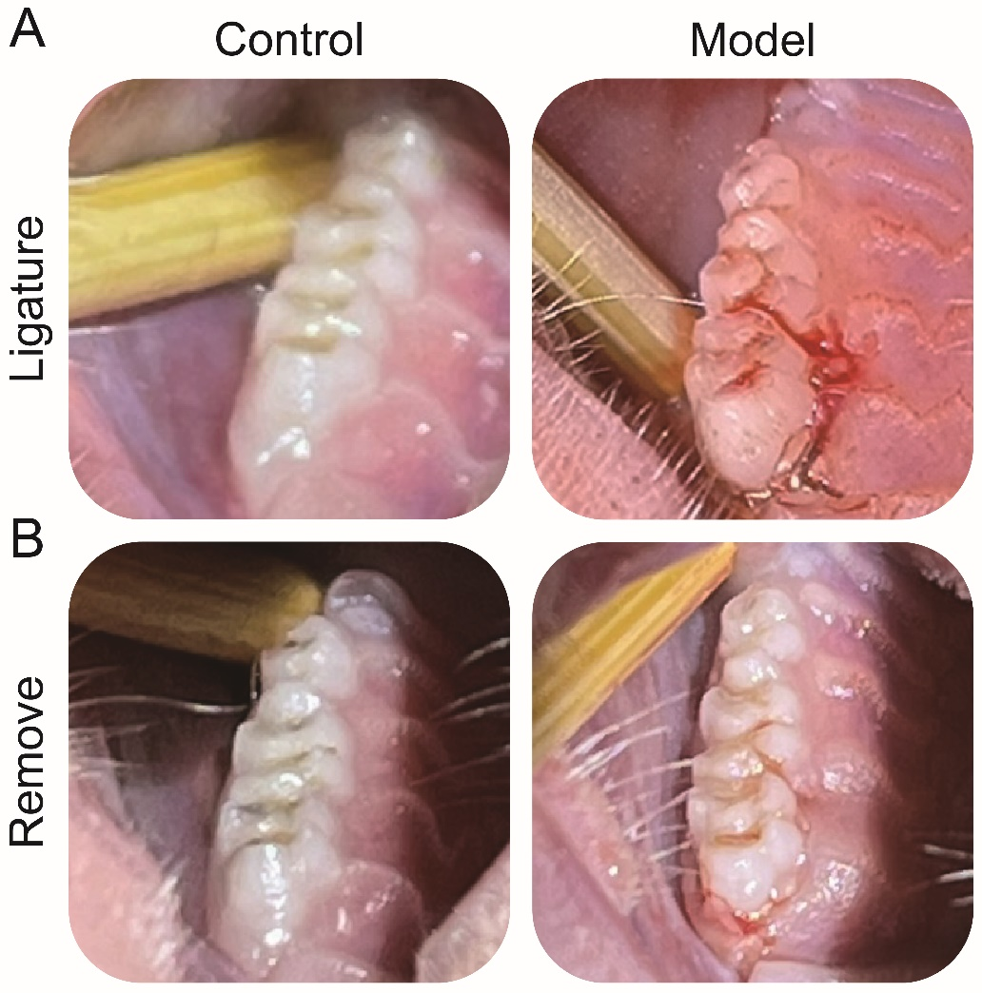
Fig. S15 Establishment of periodontitis model. (A) Ligation images of rats. (B) The images after removal of the ligature wire two weeks later.

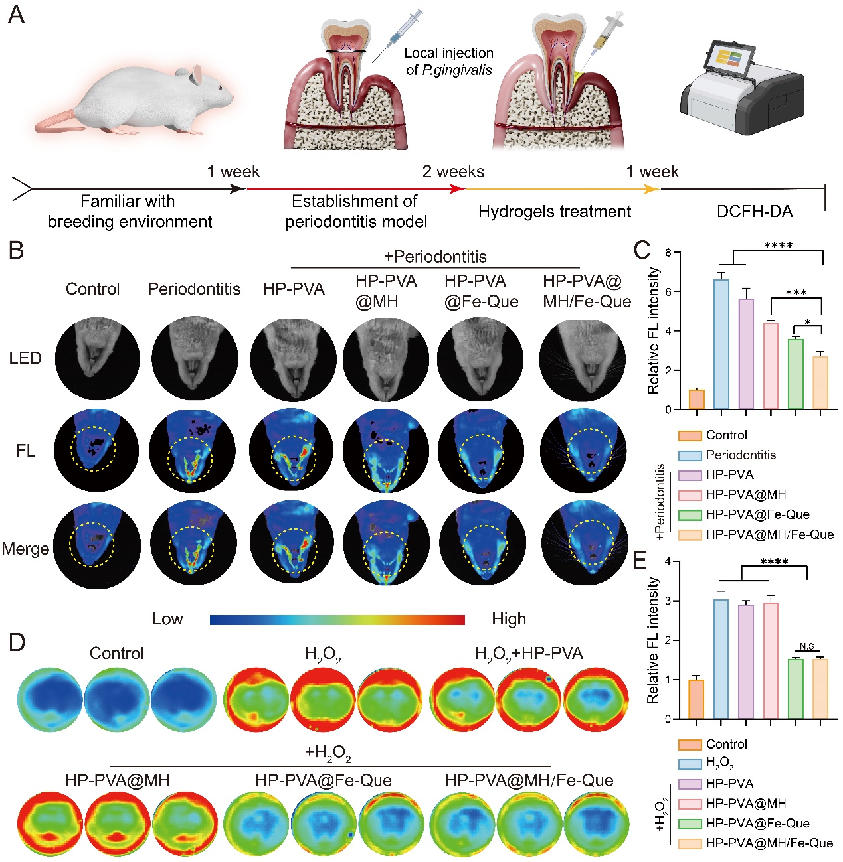
Fig. S16 ROS removal ability of the hydrogels against P. gingivalis-induced rat periodontitis model. (A) Schematic diagram of experimental design. (B) Fluorescence images of ROS in infected periodontal tissue with different treatments in vivo, and (C) quantitative assessment of ROS levels through fluorescence intensity analysis. (D) Fluorescence images of hydrogels scavenging ROS by H₂O₂-stimulated macrophages in vitro and (E) statistics of fluorescence intensity of images.
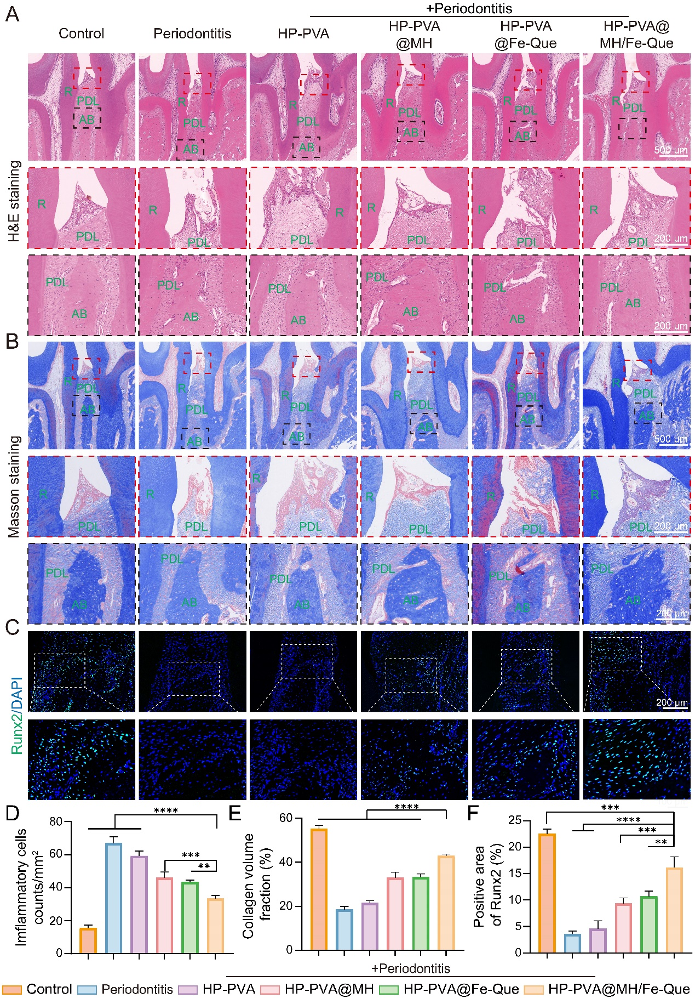
Fig. S17 HP-PVA@MH/Fe-Que hydrogels promoted periodontal tissue remodeling in rat models of periodontitis after 2 weeks of treatment. (A) Images of H&E staining. (B) Masson’s trichrome staining images of the alveolar bone. (C) IF staining of osteoinductive marker Runx2 in the alveolar bone. (D-F) The corresponding quantitative analysis of inflammation cells, collagen volume fraction and Runx2. R: root, PDL: periodontal ligament, AB: alveolar bone.

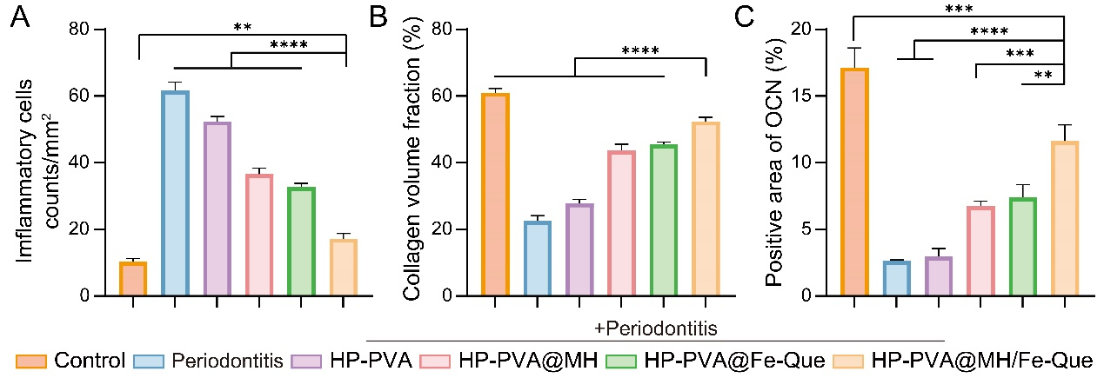
Fig. S18 HP-PVA@MH/Fe-Que hydrogels promoted periodontal tissue remodeling in rat models of periodontitis after 4 weeks of treatment. (A-C) The corresponding quantitative analysis of inflammation cells, collagen volume fraction and OCN.

Table S1. Primers of inflammation-related genes
Gene | Primer sequence (5'-3'）
β-actin (F) | GGCTGTATTCCCCTCCATCG
β-actin (R) | CCAGTTGGTAACAATGCCATGT
IL-1β (F) | TGGTGTGTGAVGTTCCC
IL-1β (R) | TGTCCATTGAGGTGGAGAG
TNF-α (F) | CGCTGAGGTCAATCTGC
TNF-α (R) | GGCTGGGTAGAGAATGGA
IL-10 (F) | GCCCTTTGCTATGGTGTC
IL-10 (R) | TCTCCCTGGTTTCTCTTCC
Arg-1 (F) | GGGCTCCTTTCAGGACTAGATA
Arg-1 (R) | CGAAGCAAGCCAAGGTTAAAG
SOD-1 (F) | CACTTCGAGCAGAAGGCAAG
SOD-1 (R) | CCCCATACTGATGGACGTGG
CAT (F) | GTGCCCCCAACTATTACCCC
CAT (R) | AGAATGTCCGCACCTGAGTG

