Additional file 1
Rationally Designed NIR-II Excitable and Endoplasmic Reticulum-targeted Molecular Phototheranostics for Imaging-Guided Enhanced Photoimmunotherapy of Triple-negative Breast Cancer

Fen Liu^{1,2#}, Qiang Kang^{1#}, Hao Xiao¹, Yinying Liu¹, Sengyou Tan¹, Kun Fan², Jianchun Peng², Xiaofeng Tan^{1,3*}, Guilong Wu^{1*}, Qinglai Yang^{1,3*}

¹Department of Hepatopancreatobiliary Surgery, The First Affiliated Hospital & Center for Molecular Imaging Probe, Cancer Research Institute, Hengyang Medical School, University of South China, Hengyang, Hunan 421001, China.
² Department of Radiology, The Second Affiliated Hospital, University of South China, Hengyang, Hunan 421001, China.
³NHC Key Laboratory of Birth Defect Research and Prevention & MOE Key Lab of Rare Pediatric Disease & Hunan Engineering Research Center for Early Diagnosis and Treatment of Liver Cancer Hengyang Medical School, University of South China, Hengyang, Hunan, 421001, China.
Correspondence should be addressed to: tanxiaofeng@usc.edu.cn, 2018000014@usc.edu.cn, qingyu513@usc.edu.cn.

Synthesis and characterization of the molecular fluorophores

Scheme S1. Synthetic route of IR-FCD and IR-FCD-Ts.
Compound 2: compound 2 was synthesized according to the reference [1].
Compound 4: compound 3 (4.00 g, 22.47 mmol) and 1,6-dibromohexane (21.69 g, 88.90 mmol) were added to a 250 mL single-necked flask, followed by the addition of 100 mL of 50% w/w KOH solution, and then Bu₄NBr (0.72 g, 2.22 mmol). The mixture was stirred under a nitrogen atmosphere at 75 ℃ for 3 h. After the reaction, the mixture was returned to room temperature, poured into water, and extracted twice with ethyl acetate. The combined organic phase was dried over anhydrous magnesium sulfate, and the resulting product was purified by column chromatography on silica gel to obtain compound 4 as a light brown oil (8.2 g, 72.7%). Characterization data: ¹H NMR (500 MHz, CDCl₃) δ 7.16 (d, J = 4.9 Hz, 2H), 6.92 (d, J = 4.9 Hz, 2H), 3.32 (t, J = 6.8 Hz, 4H), 1.86 – 1.81 (m, 4H), 1.75 – 1.69 (m, 4H), 1.30 – 0.91 (m, 12H). ¹³C NMR (500 MHz, CDCl₃) δ 157.73, 136.62, 124.71, 121.52, 53.12, 37.73, 34.01, 32.69, 29.07, 27.91, 24.28. HRMS (ESI) calcd for C₂₁H₂₉Br₂S₂⁺, ([M+H⁺]) 503.0048, Found 503.00719.
Compound 5: compound 4 (2.50 g, 4.98 mmol) was added to THF (25.00 mL), and under nitrogen conditions at -78 ℃, a solution of n-BuLi (2.50 M, 2.10 mL, 5.25 mmol) was gradually added. After stirring 2.0 h, tin (IV) chloride was added (1.7 g, 5.23 mmol). The reaction mixture was then slowly warmed to room temperature and stirred overnight. The mixture was then poured into water, extracted twice with ethyl acetate, and the combined organic phases were dried over MgSO₄ and vacuum evaporated to obtain compound 5.
Compound 6: The obtained stannylated product of compound 5 was added to compound 2 (2.0 g, 3.52 mmol) in a 100 mL single-necked flask. Under a nitrogen atmosphere, Pd (PPh₃)₄ (200 mg) was added, followed by the addition of 40 mL of dried toluene solvent. The mixture was stirred at 130 ℃ for 3 h. Then, the mixture was cooled to room temperature and poured into water. Extraction with ethyl acetate was performed twice, and the combined organic phases were dried over anhydrous magnesium sulfate. The crude product was purified by column chromatography using PE/DCM (5:1) as eluent to yield compound 6, a yellow-brown solid (2.78 g, 79.8%). ¹H NMR (500 MHz, CDCl₃) δ 7.69 (dd, J = 7.3, 4.1 Hz, 2H), 7.62 (d, J = 7.8 Hz, 1H), 7.54 (s, 1H), 7.36 – 7.30 (m, 3H), 7.25 (s, 1H), 7.19 (d, J = 4.7 Hz, 1H), 6.95 (d, J = 4.8 Hz, 1H), 3.34 (t, J = 6.7 Hz, 4H), 3.27 (t, J = 6.8 Hz, 4H), 2.05 – 1.99 (m, 4H), 1.93 – 1.86 (m, 4H), 1.74 (dd, J = 14.4, 7.1 Hz, 4H), 1.67 – 1.63 (m, 4H), 1.32 (dd, J = 15.4, 7.5 Hz, 6H), 1.20 (d, J = 7.5 Hz, 6H), 1.11 – 1.02 (m, 6H), 0.89 – 0.83 (m, 6H). ¹³C NMR (500 MHz, CDCl₃) δ 158.67, 151.29, 150.43, 140.70, 140.39, 137.28, 136.85, 134.31, 134.10, 133.59, 129.05, 128.24, 127.69, 127.15, 127.00, 125.07, 124.36, 124.23, 122.99, 122.80, 121.97, 121.56, 120.20, 119.72, 119.14, 117.28, 77.28, 77.03, 76.78, 55.07, 54.67, 53.66, 44.89, 40.26, 39.20, 37.82, 34.89, 34.02, 33.60, 32.70, 32.63, 32.27, 31.94, 30.76, 29.34, 29.11, 29.04, 28.35, 27.90, 27.74, 27.38, 24.32, 23.92, 23.52, 23.19, 22.71, 19.74, 14.14, 13.91, 13.62. HRMS (ESI) calcd for C₄₆H₅₉Br₄S₂⁺, ([M+H⁺]) 995.0745, Found 995.0745.
Compound 7: compound 6 (2.78 g, 2.81 mmol) was added to THF (15 mL). Under nitrogen conditions at -78 ℃. a solution of n-BuLi (2.50 M in hexane, 2.25 mL, 5.62 mmol) was added gradually. After stirring for 2.0 h, tributylchlorostannane (1.82 g, 5.60 mmol) was added. The reaction mixture was then slowly warmed to room temperature and stirred overnight. The mixture was poured into water, and extraction with ethyl acetate was performed twice. The combined organic phases were dried over MgSO₄. Vacuum evaporated to yield compound 7.
IR-FCD: The tin-containing product of compound 7 obtained was combined with BBTD (348 mg, 1 mmol) in a 100 mL single-necked flask. Under a nitrogen atmosphere, Pd (PPh₃)₂Cl₂ (150 mg) was added, followed by the addition of 40 mL of dried toluene solvent. The mixture was stirred at 130 ℃ for 3 h, then cooled to room temperature. The mixture was poured into water and extracted with ethyl acetate twice. The combined organic phases were dried over anhydrous magnesium sulfate. The crude product was purified by column chromatography using PE/DCM (2:1) to yield IR-FCD, a black solid (1.59 g, 73.4%). ¹H NMR (500 MHz, CDCl₃) δ 7.71 (s, 10H), 7.35 (s, 8H), 3.31 (m, 16H), 2.05 (m, 20H), 1.78 – 1.66 (m, 20H), 1.35 (m, 20H), 0.94 – 0.77 (m, 20H). ¹³C NMR (500 MHz, Chloroform-d) δ 173.39, 152.15, 150.55, 145.47, 140.64, 139.30, 138.95, 135.88, 131.18, 124.80, 124.40, 123.51, 122.85, 119.87, 119.03, 118.89, 114.11, 64.66, 60.43, 55.16, 45.14, 40.28, 39.44, 39.04, 38.17, 36.55, 35.01, 34.47, 34.41, 34.32, 34.04, 32.75, 32.65, 31.96, 31.90, 31.54, 30.34, 30.16, 29.74, 29.40, 29.36, 29.31, 29.23, 29.07, 27.97, 27.78, 24.52, 23.57, 22.73, 14.17. HRMS (ESI) calcd for C₉₈H₁₁₅N₄Br₈S₆⁺, ([M+H⁺]) 2181.0767, Found 2181.0805.
IR-FCD-Ts: The compound IR-FCD (100 mg, 0.045 mmol) and sodium azide (46.8 mg, 0.72 mmol) were dissolved in dry DMF (10 mL) and heated at 70 $℃$ under anhydrous and oxygen-free conditions for 3 h. Afterward, a large amount of water was added and stirred until all solids dissolved. The mixture was then extracted twice with ethyl acetate, and the organic phase was dried over MgSO₄, followed by vacuum evaporation. The crude product was subjected to flash column chromatography on silica gel (PE/DCM = 2), yielding a dark brown solid (95 mg, 0.051 mmol). The dark brown solid was dissolved in 5 mL of THF, copper(I) thiophene-2-carboxylate (CuTc) (10 mg), N-(but-3-yn-1-yl)-4-methylbenzenesulfonamide (250 mg), and tri[(1-benzyl-1H-1,2,3-triazol-4-yl) methyl] amine (TBTA) (5 mg) were added. The mixture was stirred at room temperature for 0.5 h; then the crude product was subjected to silica gel column chromatography, followed by recrystallization in methyl tert-butyl ether, yielding IR-FCD-Ts as a dark brown solid (110 mg, 66.78%). ¹H NMR (500 MHz, CDCl₃) δ 7.69 (d, J = 8.2 Hz, 26H), 7.28 (s, 8H), 7.24 (d, J = 8.1 Hz, 32H), 4.77 (s, 10H), 3.25 – 3.22 (m, 16H), 3.04 (d, J = 6.5 Hz, 22H), 2.36 (s, 24H), 2.00 (s, 10H), 1.69 (m, 10H), 1.60 (m, 10H), 1.30 (m, 20H), 1.11 (m, 30H). ¹³C NMR (500 MHz, CDCl₃) δ 159.23, 150.96, 150.53, 147.11, 143.64, 136.95, 129.82, 127.11, 124.50, 124.02, 122.86, 120.34, 119.87, 119.11, 80.35, 77.35, 77.09, 76.84, 70.94, 55.21, 55.16, 54.14, 45.17, 41.64, 34.09, 32.74, 32.64, 31.47, 30.22, 29.73, 29.06, 27.96, 27.77, 24.50, 23.57, 22.69, 22.67, 21.58, 19.82, 14.18, 14.13.
Density functional theory calculations
All the calculations were conducted utilizing the Gaussian 09 software. To mitigate computational costs, alkyl substituent groups on fluorene units were substituted with methyl groups. The ground-state (S₀) geometries of the simplified structures IR-FTT and IR-FCD were initially optimized using the B3LYP/6-31G(d) method and subsequently re-optimized at the tuned-ωB97XD*/6-31G(d) level [2-4]. The corresponding range-separation parameter (ω, in Bohr−1) for each molecule was optimally determined through the GAP-tuning method, with values provided in Table S2. The excited-state (S₁) geometries of these molecules were optimized using the time-dependent (TD)-ωB97XD*/6-31G(d) method. The ground-state (S₀) geometries of the simplified structures IR-FTT and IR-FCD were firstly optimized using the B3LYP/6-31G(d) method and re-optimized at the tuned-ωB97XD*/6-31G(d) level.

Molecular dynamics (MD) simulations.
Classical molecular dynamics (MD) simulations [5-7] were carried out to investigate IR-FTT and IR-FCD molecules. The initial configuration of the simulated box had dimensions of 9.48 × 9.48 × 31.1, 18.96 × 18.96 × 20, and 18.96 × 18.96 × 14, with IR-FTT or IR-FCD molecules positioned at the center of the box. The number of molecules was 100. The initial configurations were constructed using PACKMOL43 software. The Charmm force field was utilized to model the system, encompassing both nonbonded and bonded interactions. Nonbonded interactions include van der Waals (vdW) and electrostatic interactions, represented by Equation 1 and Equation 2, respectively.
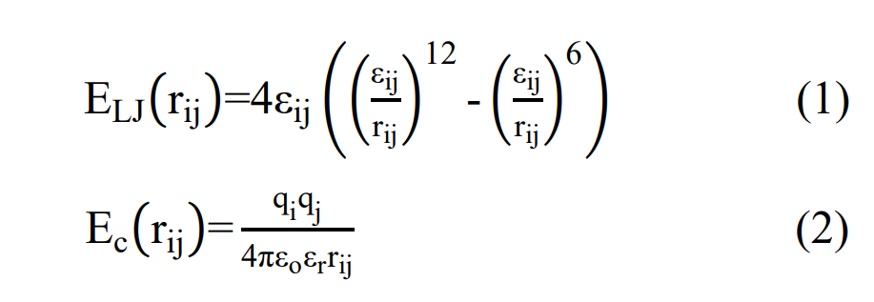
For vdW interactions among different atom types, the Lorentz−Berthelot mixing rules were applied, as outlined in Equation 3. A cutoff distance of 1.2 nm was established for both vdW and electrostatic interactions, with the particle mesh Ewald (PME) method employed to compute long-range electrostatic interactions.
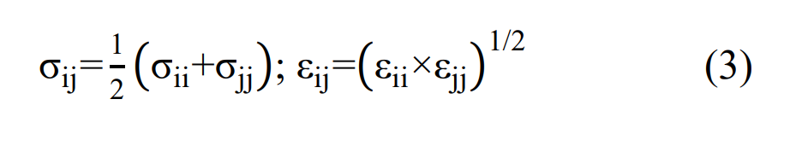
In the simulation process, energy minimization was initially applied to relax the simulation box. Subsequently, a canonical (NVT) ensemble with a time step of 1.0 fs was utilized to optimize the simulation box, maintaining the temperature at 298 K. The temperature was controlled at 300 K using the Nose−Hoover thermostat. The optimization duration was set to 20.0 ns, deemed sufficient to achieve a stable system. Molecular trajectory coordinates were recorded at intervals of every 20,000 steps. Throughout all molecular dynamics simulations, atomic motion was described by classical Newtonian mechanics, which was solved using the velocity−Verlet algorithm. All simulations were performed using the Gromacs 2019.6 package.

Supplementary Figures

Fig. S1 ¹H NMR of compound 4.

Fig. S2 ¹³C NMR of compound 4.

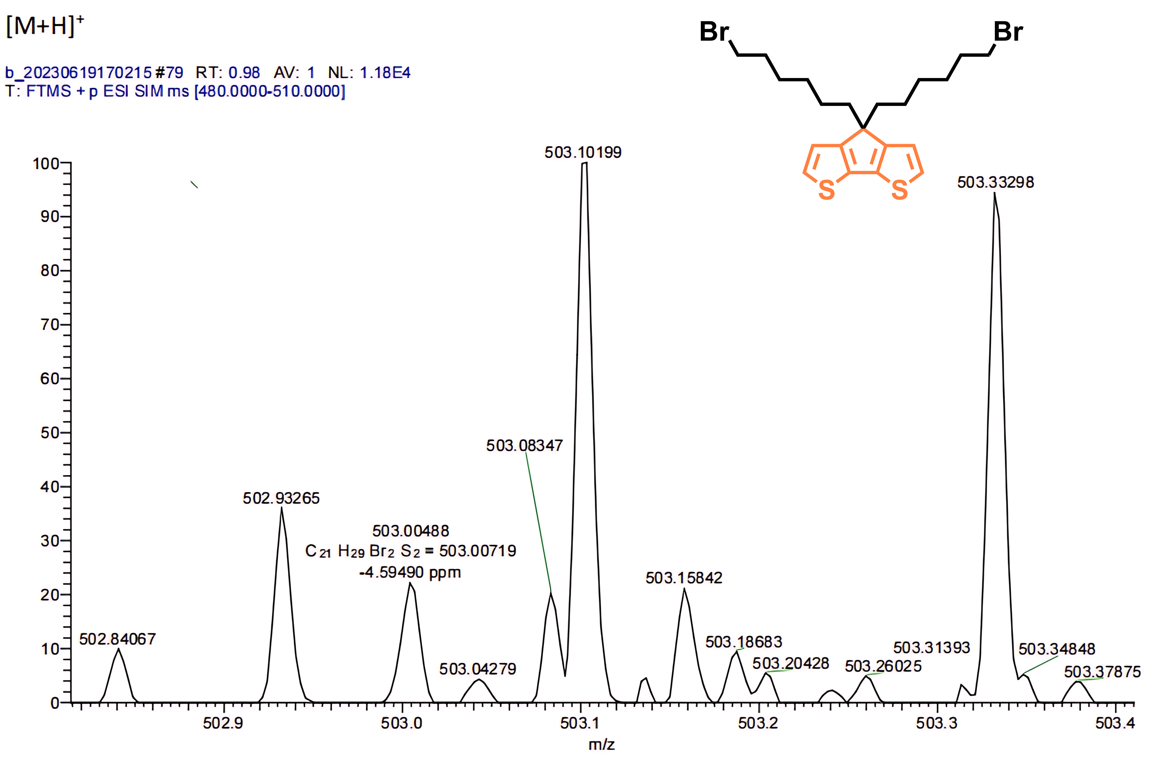

Fig. S3 HRMS of compound 4.

Fig. S4 ¹H NMR of compound 6.

Fig. S5 ¹³C NMR of compound 6.

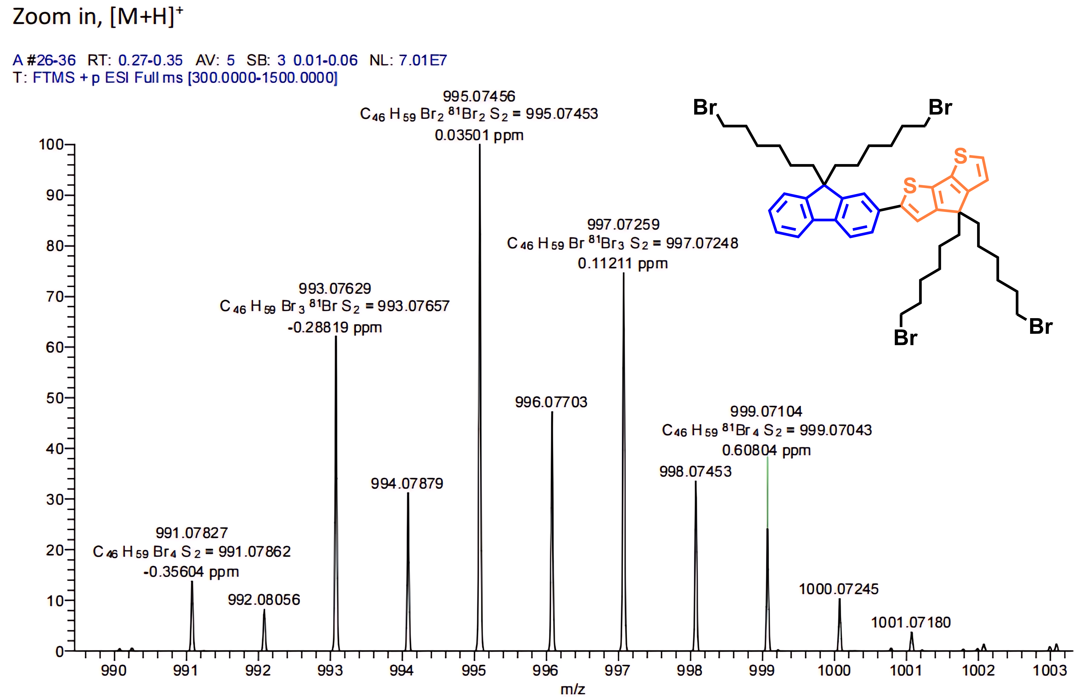

Fig. S6 HRMS of compound 6.

Fig. S7 ¹H NMR of compound 8.

Fig. S8 ¹³C NMR of compound 8.

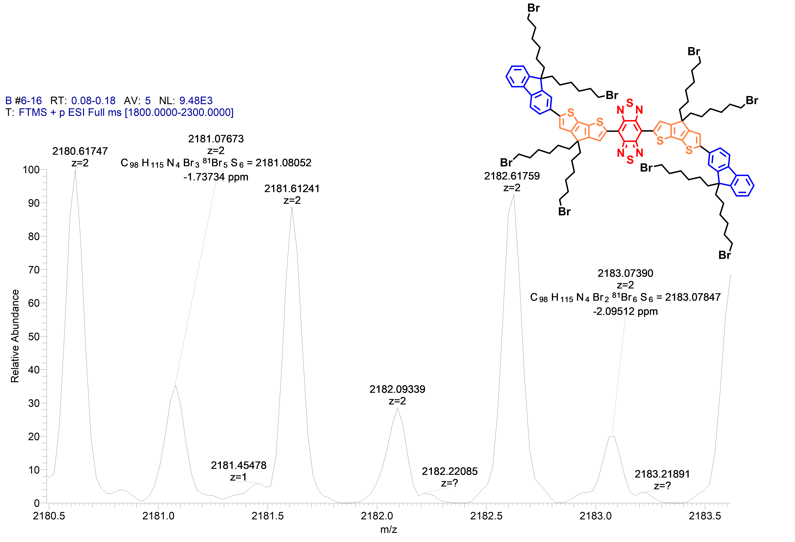

Fig. S9 HRMS of compound 8.

Fig. S10 ¹H NMR of compound 9.

Fig. S11 ¹³C NMR of compound 9.

Fig. S12 Absorption spectra of (A) IR-FTT and (B) IR-FCD in DCM and water, respectively.

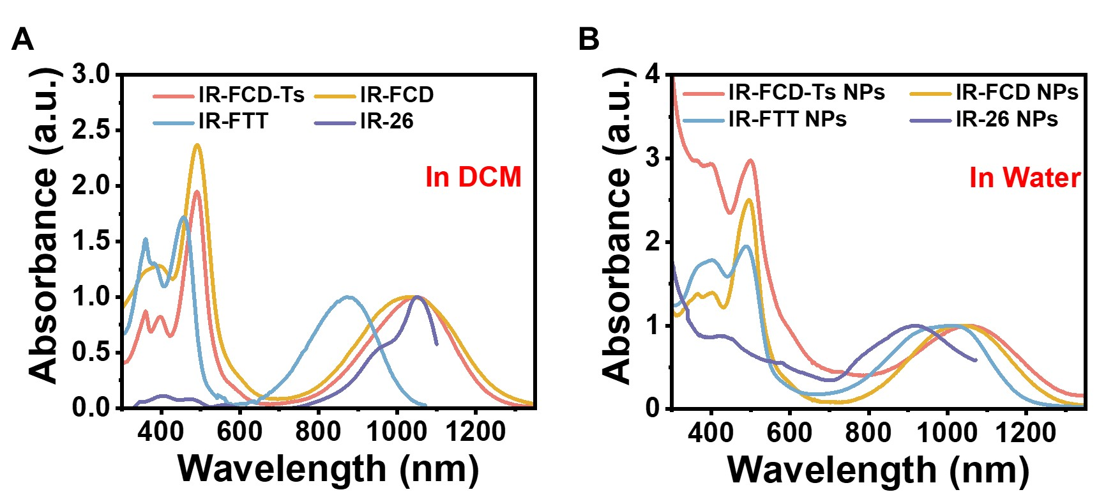
Fig. S13 The absorption spectra (300-1300 nm) of molecular fluorophores IR-26, IR-FTT, IR-FCD, and IR-FCD-Ts in (A) DCM and (B) water.

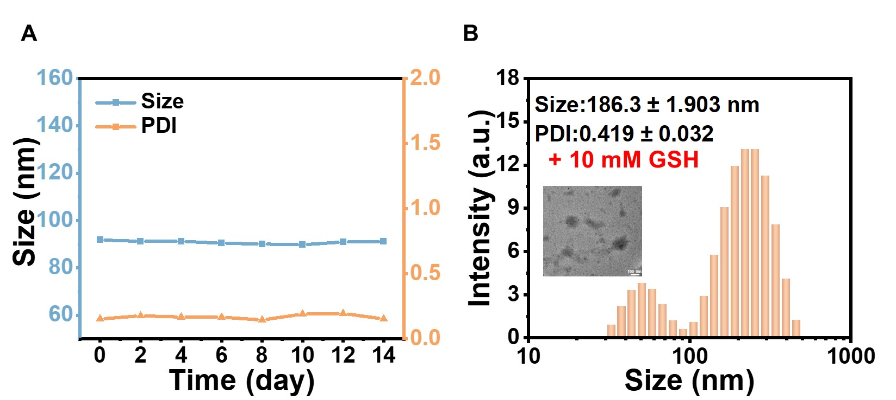

Fig. S14 (A) Size and PDI stability of IR-FCD-Ts NPs in deionized water for 14 days. (B) DLS and TEM of IR-FCD-Ts NPs after 4 h incubation with 10 mM GSH solution.

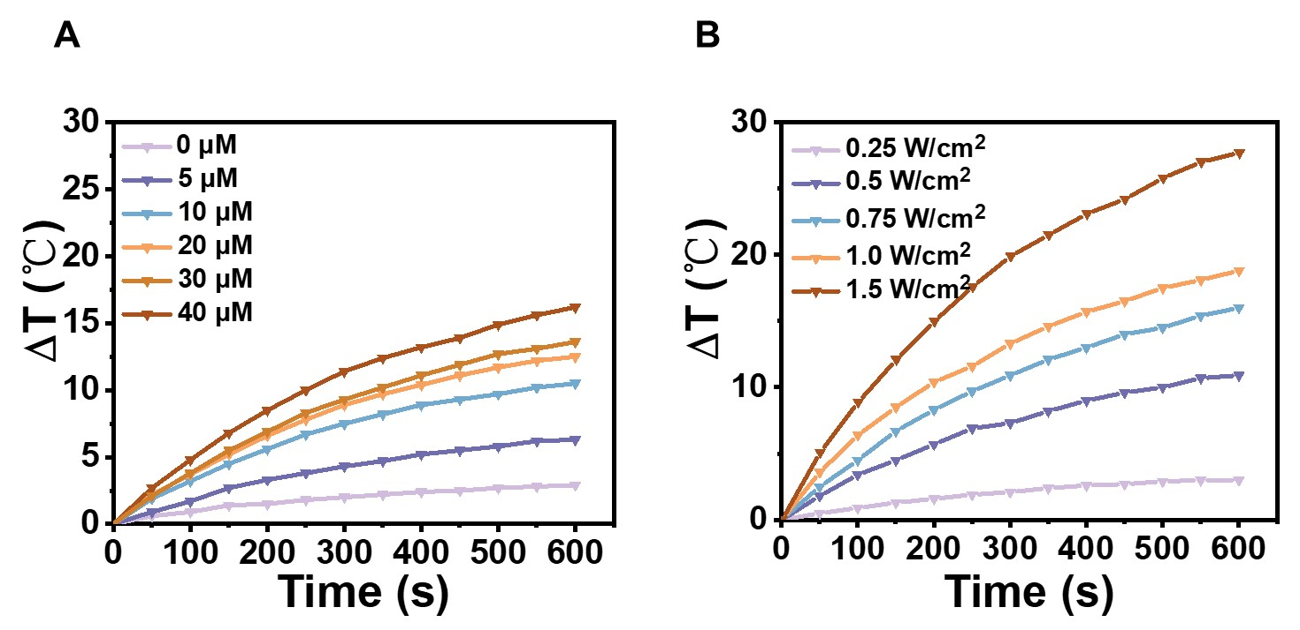

Fig. S15 (A) The temperature changes of different concentrations of IR-FCD NPs under 1064 nm laser irradiation (1.0 W/cm²). (B) The heating curve of IR-FCD NPs (30 µM) under 1064 nm laser irradiation of different power densities.

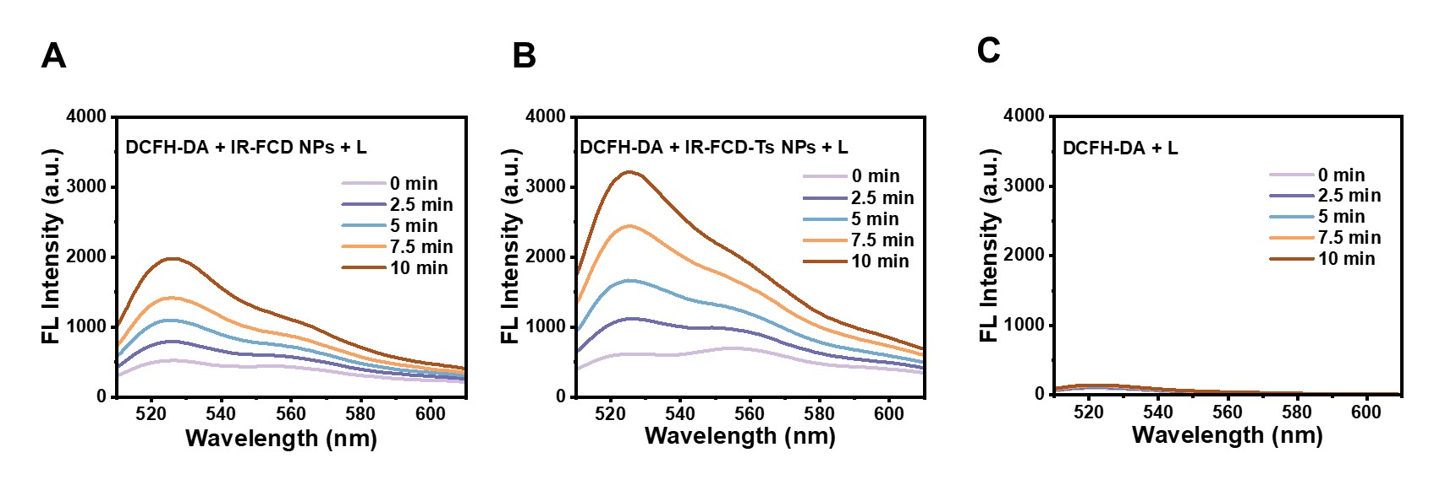

Fig. S16 (A-C) ROS production by nanoparticles was assessed under 1064 nm laser irradiation at different time points.

Fig. S17 (A) Cellular uptake of IR-FCD-Ts NPs by 4T1 cells at different incubation times. Scale bar: 50 µm. (B) The MFI data of (A). Error bars, mean ± SD (n = 3).

Fig. S18 Cell viability of HC11 cells after incubating with different concentrations of IR-FCD NPs and IR-FCD-Ts NPs without laser irradiation. Error bars, mean ± SD (n = 3).

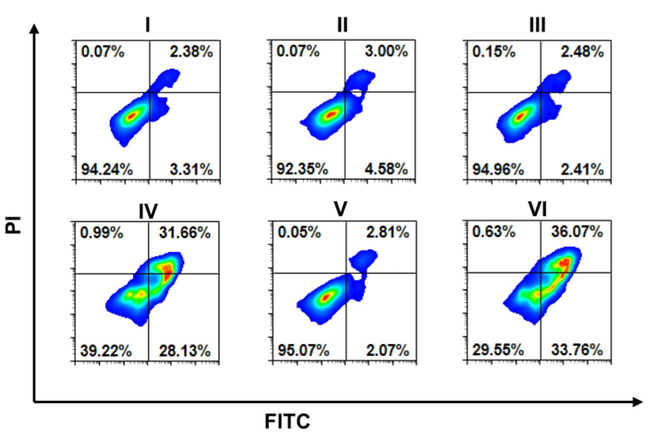

Fig. S19 Flow cytometric analysis of apoptosis levels in 4T1 cells after different treatments (I: PBS, II: PBS + L, III: IR-FCD NPs, IV: IR-FCD NPs + L, V: IR-FCD-Ts NPs, VI: IR-FCD-Ts NPs + L. + L represents 1064 nm laser irradiation at 1.0 W/cm² for 10 min).

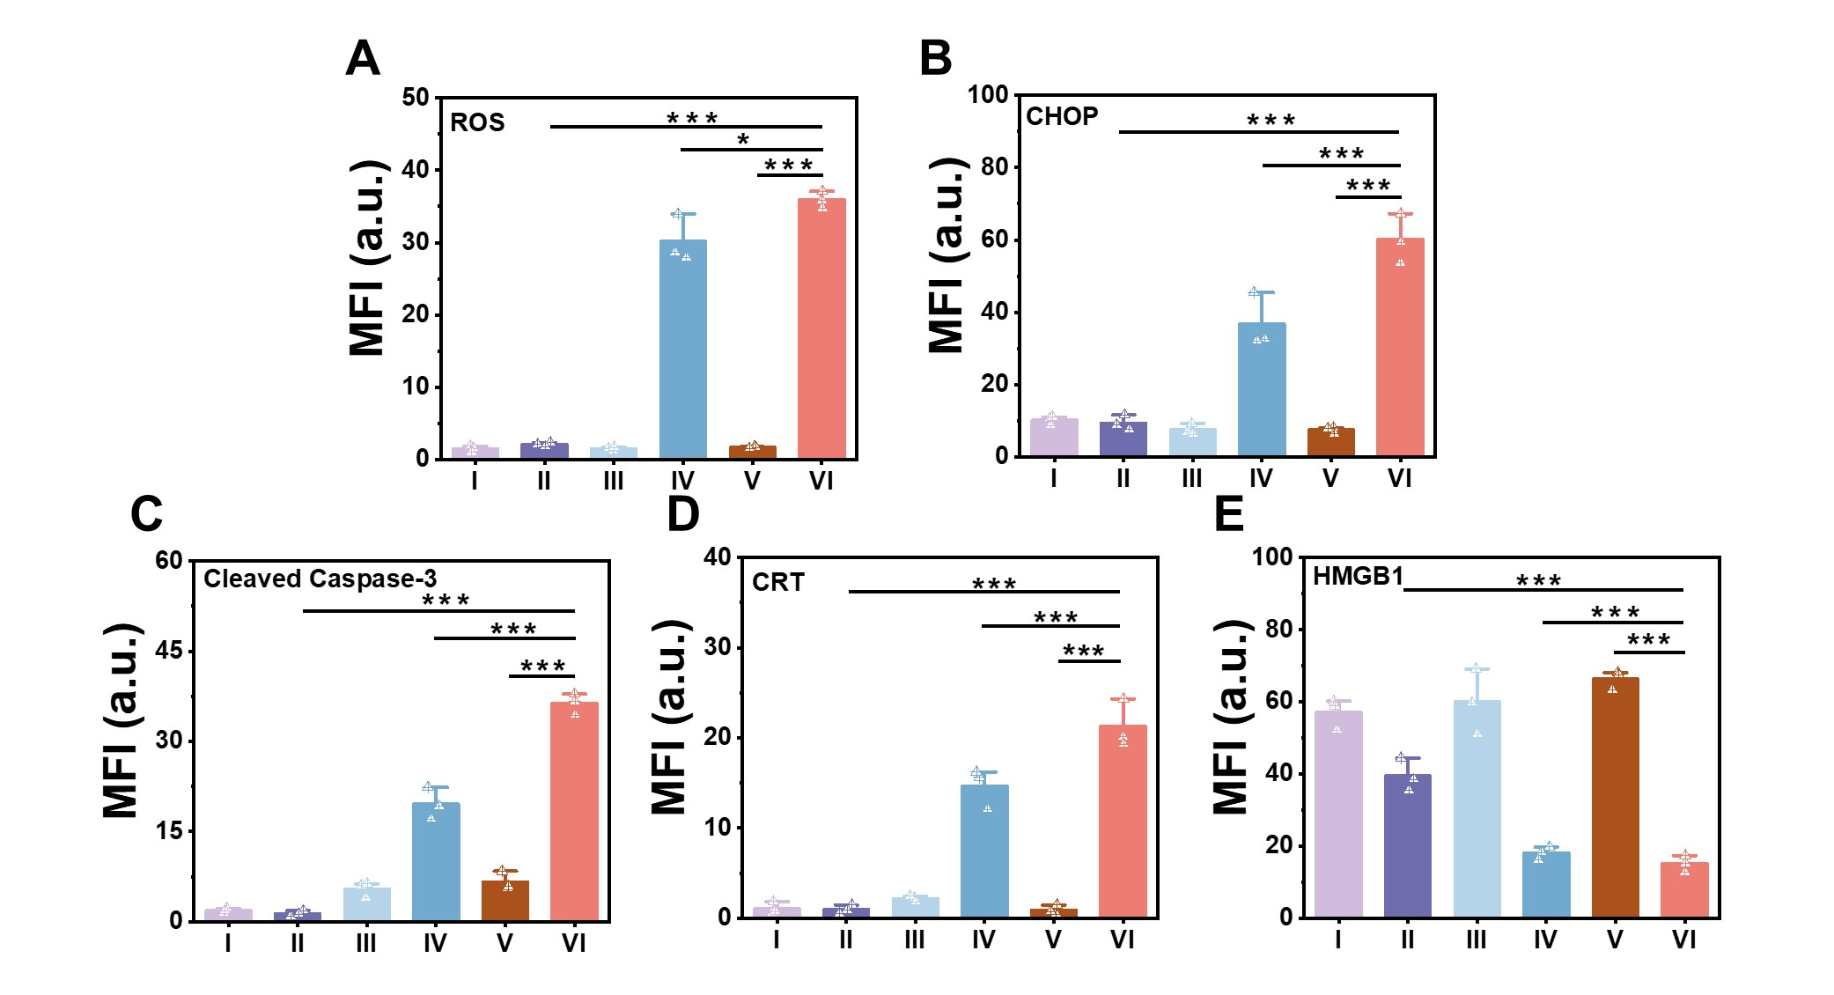
Fig. S20 (A-E) The MFI data of Fig. 3F-3J. Error bars: mean ± SD (n = 3).

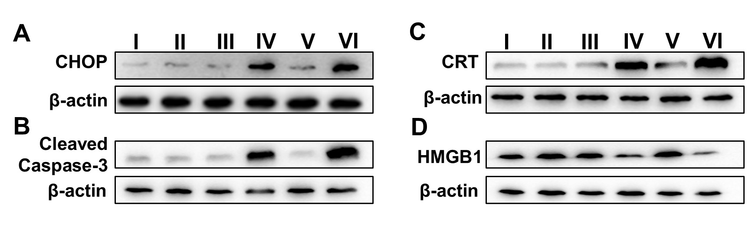

Fig. S21 (A-D) Western blot analysis was conducted to evaluate the expression levels of CHOP, Cleaved Caspase-3, CRT, and HMGB1 in 4T1 cells subjected to different treatments (I: PBS, II: PBS + L, III: IR-FCD NPs, IV: IR-FCD NPs + L, V: IR-FCD-Ts NPs, VI: IR-FCD-Ts NPs + L. + L represents 1064 nm laser irradiation at 1.0 W/cm² for 10 min).

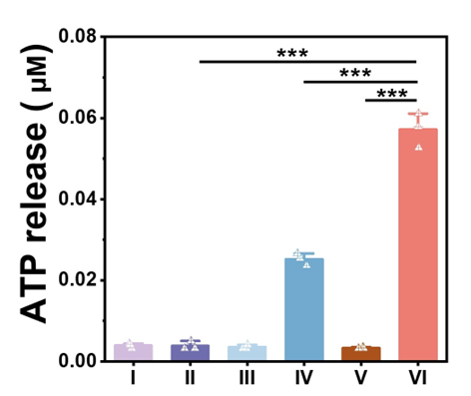

Fig. S22 Analysis of ATP levels in 4T1 cell culture supernatants after different treatments (I: PBS, II: PBS + L, III: IR-FCD NPs, IV: IR-FCD NPs + L, V: IR-FCD-Ts NPs, VI: IR-FCD-Ts NPs + L. + L represents 1064 nm laser irradiation at 1.0 W/cm² for 10 min). Error bars, mean ± SD (n = 3).

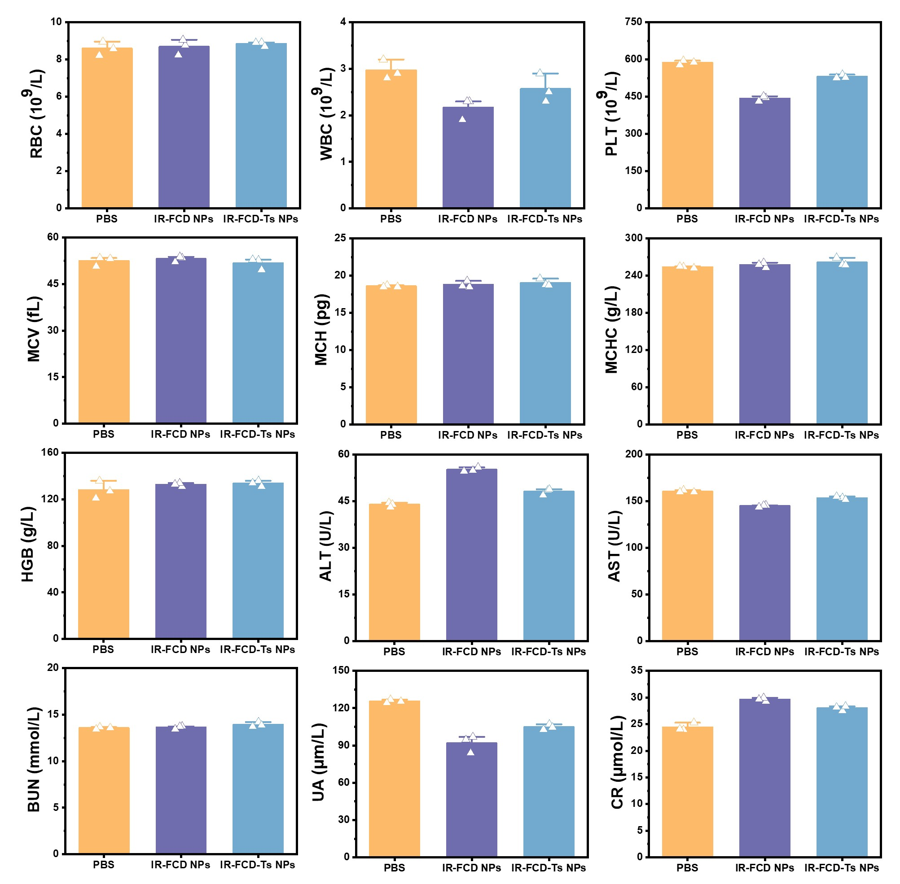

Fig. S23 Complete blood count and blood biochemical analysis of healthy mice on the 15th day after injection of nanoparticles and PBS. Error bars, mean ± SD (n = 3).

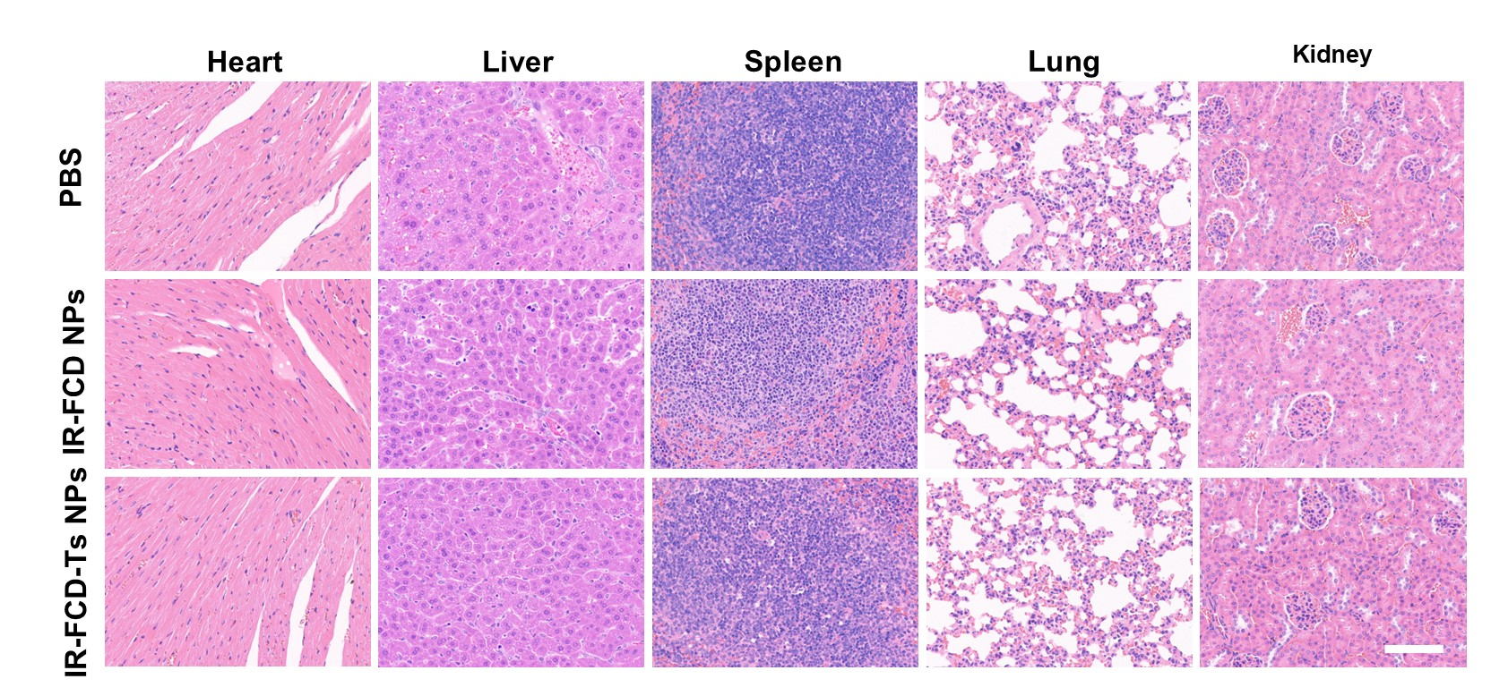

Fig. S24 H&E staining images of major organs (heart, liver, spleen, lung, and kidney) after the injection with PBS and nanoparticles in healthy mice on day 15. Scale bar: 100 μm.

Fig. S25 The tumor-to-normal tissue (T/N) ratio of NIR-II fluorescence imaging in 4T1 tumor-bearing mice was assessed at various time points following injection.

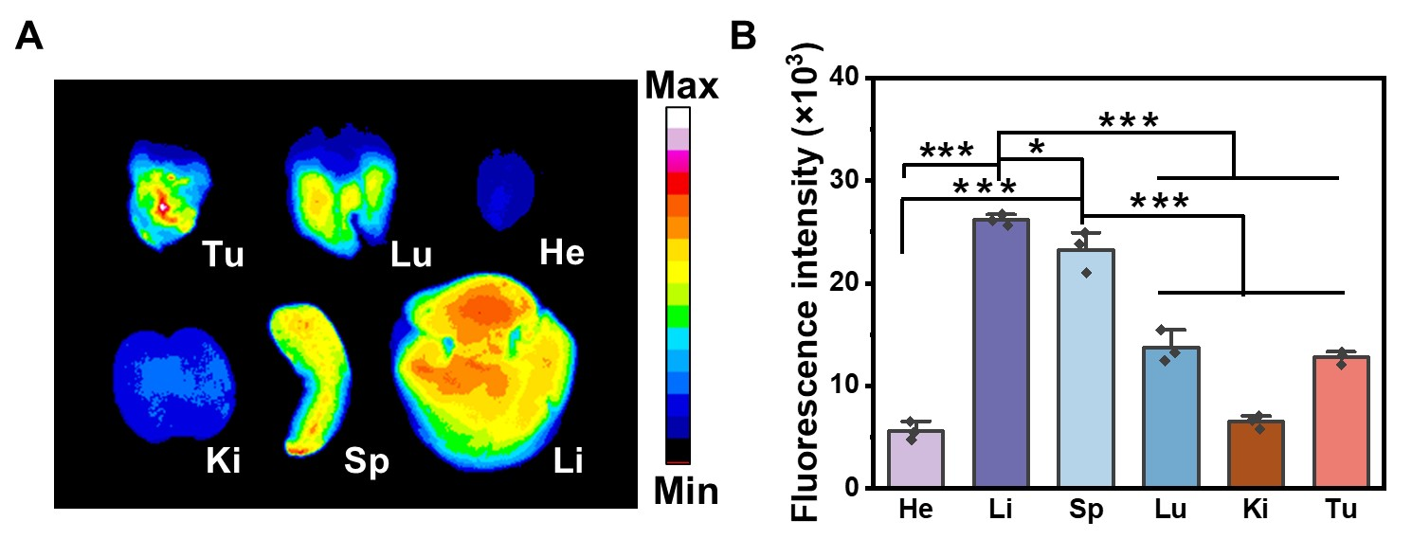

Fig. S26 (A) Fluorescent imaging of primary organs and tumor tissues taken 48 h following injection. (B) Semi-quantitative biodistribution analysis was conducted based on the fluorescence intensities of tumors and major organs at 48 h. Error bars, mean ± SD (n = 3).
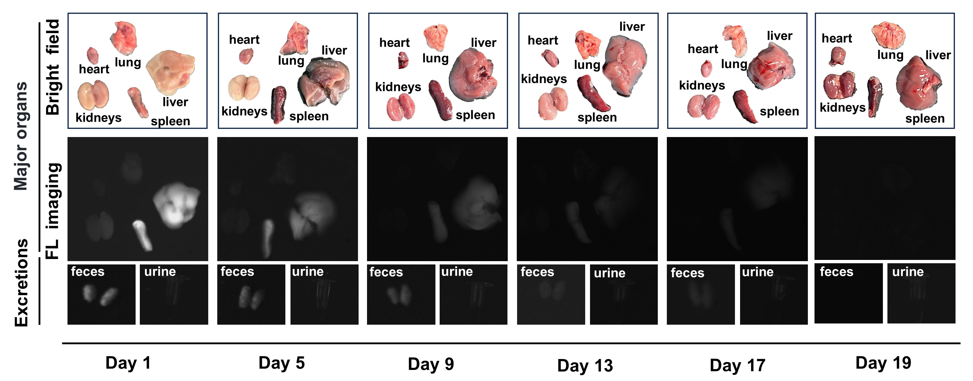

Fig. S27 NIR-II fluorescence imaging of major organs and excretions in mice at different time points after injection of IR-FCD-Ts NPs.

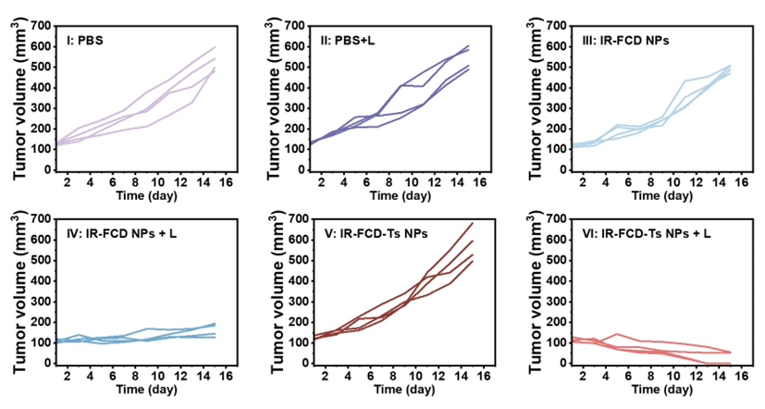

Fig. S28 Individual growth curves of the primary tumors in mice following different treatments (I: PBS, II: PBS + L, III: IR-FCD NPs, IV: IR-FCD NPs + L, V: IR-FCD-Ts NPs, VI: IR-FCD-Ts NPs + L. + L represents 1064 nm laser irradiation at 1.0 W/cm² for 10 min).

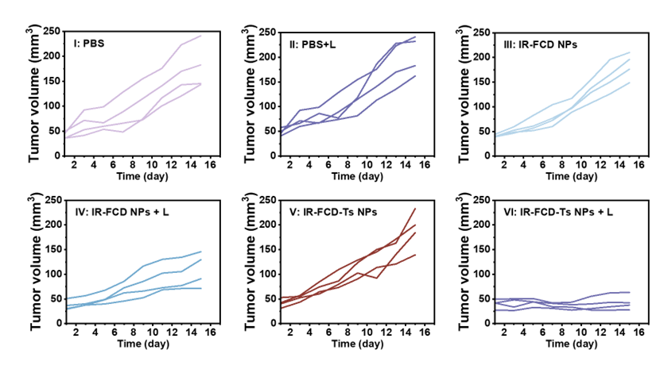

Fig. S29 Individual growth curves of the distant tumors in mice following different treatments (I: PBS, II: PBS + L, III: IR-FCD NPs, IV: IR-FCD NPs + L, V: IR-FCD-Ts NPs, VI: IR-FCD-Ts NPs + L. + L represents 1064 nm laser irradiation at 1.0 W/cm² for 10 min).

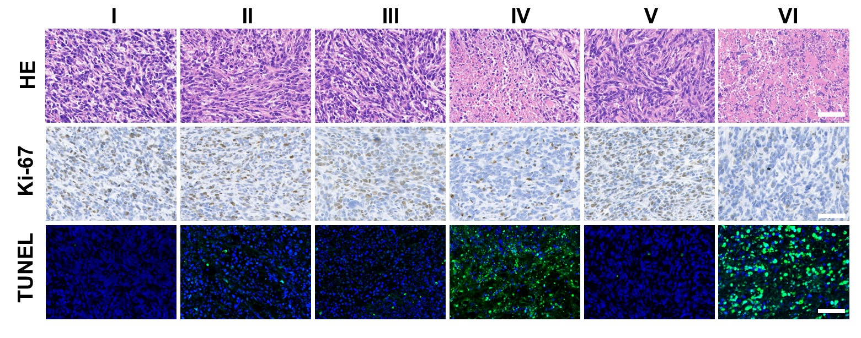

Fig. S30 H&E, Ki-67, TUNE staining images of the dissected primary tumor tissues after various treatments (I: PBS, II: PBS + L, III: IR-FCD NPs, IV: IR-FCD NPs + L, V: IR-FCD-Ts NPs, VI: IR-FCD-Ts NPs + L. + L represents 1064 nm laser irradiation at 1.0 W/cm² for 10 min). Scale bar: 50 μm.

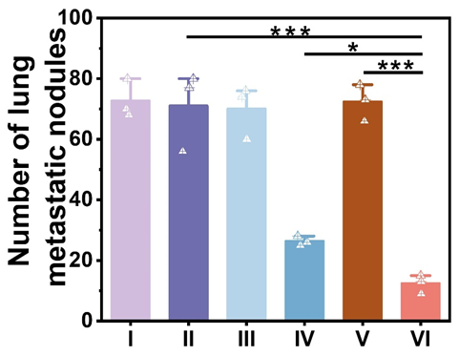
Fig. S31 Quantification of lung metastatic nodules in different treatment groups (I: PBS, II: PBS + L, III: IR-FCD NPs, IV: IR-FCD NPs + L, V: IR-FCD-Ts NPs, VI: IR-FCD-Ts NPs + L. + L represents 1064 nm laser irradiation at 1.0 W/cm² for 10 min).

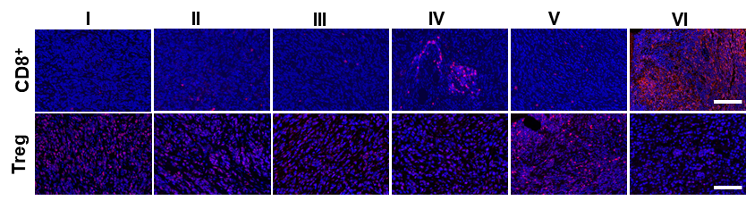

Fig. S32 Representative immune fluorescence staining images to show CD8⁺ T cells and Tregs in primary tumors of different treated mice (I: PBS, II: PBS + L, III: IR-FCD NPs, IV: IR-FCD NPs + L, V: IR-FCD-Ts NPs, VI: IR-FCD-Ts NPs + L. + L represents 1064 nm laser irradiation at 1.0 W/cm² for 10 min). Scale bar: 50 μm.

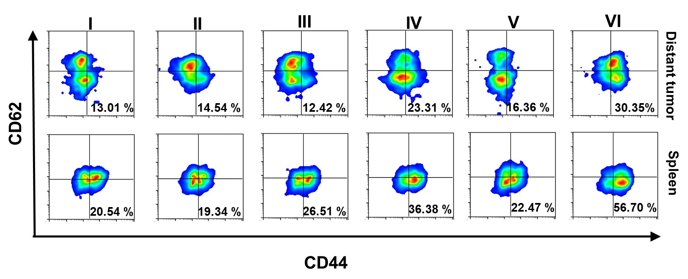

Fig. S33 The representative flow cytometric analyses of effector memory cells (CD44⁺ CD62L⁻) in CD8⁺ T cells in distant tumors and spleens after different treatments (I: PBS, II: PBS + L, III: IR-FCD NPs, IV: IR-FCD NPs + L, V: IR-FCD-Ts NPs, VI: IR-FCD-Ts NPs + L. + L represents 1064 nm laser irradiation at 1.0 W/cm² for 10 min).

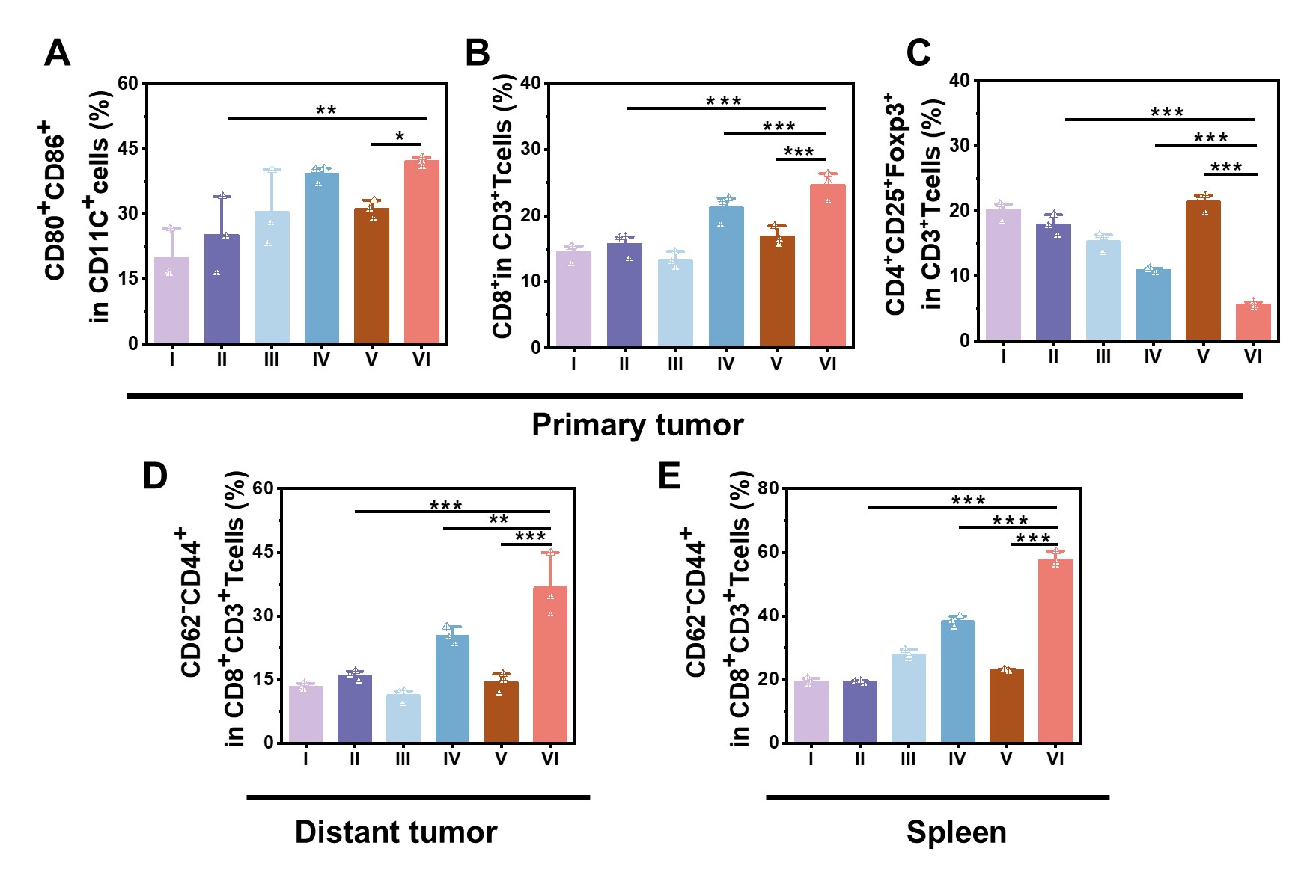

Fig. S34 (A) Proportions of mature DCs (CD80⁺ CD86⁺ CD11C ⁺) in primary tumor tissues. (B) Proportions of CTLs (CD3⁺ CD8⁺) in primary tumor tissues. (C) Proportions of Tregs (CD4⁺ CD25⁺ Foxp3⁺) in primary tumor tissues. Proportions of effector memory T cells (CD3⁺ CD8⁺ CD44⁺ CD62L⁻) in (D) distant tumors and (E) spleens. (I: PBS, II: PBS + L, III: IR-FCD NPs, IV: IR-FCD NPs + L, V: IR-FCD-Ts NPs, VI: IR-FCD-Ts NPs + L. + L represents 1064 nm laser irradiation at 1.0 W/cm² for 10 min). Error bars: mean ± SD (n = 3).

Fig. S35 Representative immune fluorescence images staining images to show CD8⁺ T cells in distant tumors and spleens after different treatments (I: PBS, II: PBS + L, III: IR-FCD NPs, IV: IR-FCD NPs + L, V: IR-FCD-Ts NPs, VI: IR-FCD-Ts NPs + L. + L represents 1064 nm laser irradiation at 1.0 W/cm² for 10 min). Scale bar: 50 μm.

Supplementary tables
Table S1. LUMO composition analysis results of the molecular fluorophores IR-FTT IR-FCD based on the Hirshfeld method by Multiwfn.
Dye | Acceptor | Donor 1 | Donor 2 | Shielding unit
IR-FTT | 73.10% | 19.20% | 6.30% | 1.40%
IR-FCD | 74.20% | 17.10% | - | 1.426%

Table S2. Calculated first vertical S₀-S₁ excitation energies (E₀₁), first vertical S₁-S₀ emission energies (E₁₀), electronic configurations, and reorganization energies determined at the TD-ωB97XD*/6-31G (d) level of theory in vacuum.
Compound | ω* | Absorption (S₀ → S₁) |  |  | Emission (S₁ → S₀)
Compound | ω* | E₀₁ eV (nm) | ƒ₀₁ | Elec.  Config. | E₁₀ eV (nm) | ƒ₁₀ | Reorganization energy (nm)  Exp
IR-FTT | 0.111 | 1.27 (977) | 0.89 | H→L 97% | 1.01 (1227) | 0.75 | 0.26 (250)
IR-FCD | 0.118 | 1.14  (1080) | 1.00 | H→L 100% | 0.9171 (1352) | 0.83 | 0.23 (272)
The reorganization energies are obtained as E₀₁ minus E₁₀.

Reference
1. Yang Q, Hu Z, Zhu S, Ma R, Ma H, Ma Z, Wan H, Zhu T, Jiang Z, Liu W, et al: Donor Engineering for NIR-II Molecular Fluorophores with Enhanced Fluorescent Performance. J Am Chem Soc 2018, 140:1715-1724.
2. Chai JD, Head-Gordon M: Long-range corrected hybrid density functionals with damped atom-atom dispersion corrections. Phys Chem Chem Phys 2008, 10:6615-6620.
3. Moore B, 2nd, Sun H, Govind N, Kowalski K, Autschbach J: Charge-Transfer Versus Charge-Transfer-Like Excitations Revisited. J Chem Theory Comput 2015, 11:3305-3320.
4. Sun H, Zhang S, Zhong C, Sun Z: Theoretical study of excited states of DNA base dimers and tetramers using optimally tuned range-separated density functional theory. J Comput Chem 2016, 37:684-693.
5. Abraham MJ, Murtola T, Schulz R, Páll S, Smith JC, Hess B, Lindahl E: GROMACS: High performance molecular simulations through multi-level parallelism from laptops to supercomputers. SoftwareX 2015, 1-2:19-25.
6. Wang Z, Wu C, Liu W: NAC-TDDFT: Time-Dependent Density Functional Theory for Nonadiabatic Couplings. Accounts of Chemical Research 2021, 54:3288-3297.
7. Frisch MJ, G.W, Trucks, H.B Schlegel, G E, Scuseria, M.A Robb, J.R Cheeseman, Jr, Montgomery et.al: In Gaussian 09, Revision D01, Gaussian, Inc: Wallingford, CT; 2013.

