Supplementary Materials for
MXene-based nanosheet for enhanced gliomatherapy via photonic hyperthermia to boostthe abscopal effect of radioimmunotherapy
Huan Zhu^{1,2}, Zhaoyuan Zhang¹, Rong Jiang¹, Liangfu Xu¹, Xiangdi Yang¹, Jie Chen¹, Zhenning Wang¹, Xiao Xu^{1,}*, Zhigang Liu^{1,}*
¹ Cancer Center, Dongguan Key Laboratory of Precision Diagnosis and Treatment for Tumors, the 10th Affiliated Hospital of Southern Medical University, Southern Medical University, Guangzhou 510280, China.
² Department of Oncology, Affiliated Hospital (Clinical College) of Xiangnan University, Chenzhou City, Hunan Province, 423000, China.
H. Zhu, Z. Zhang and R. Jiang contributed equally to this work.

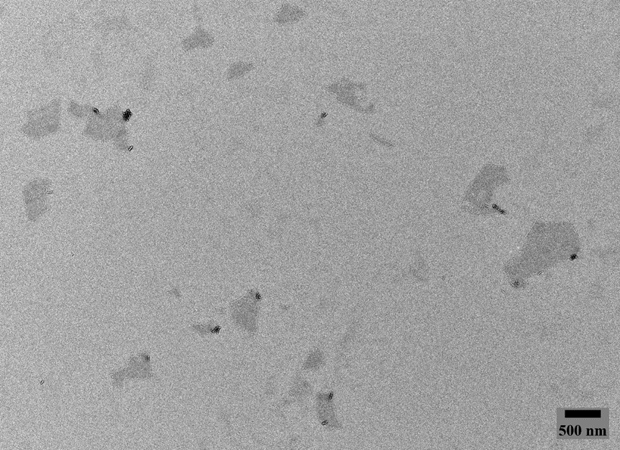
Figure S1. TEM Image of Mxene.

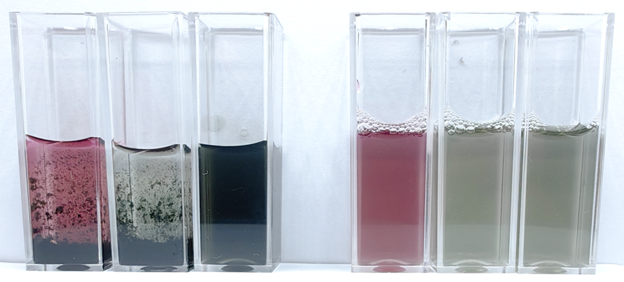
Figure S2. Photos of Ti3C2-Mxene and APMP in DMEM medium solution, PBS and water.
Figure S3. XPS of Mxene.
Figure S4. XPS of Ti.

Figure S5. XPS of APMP
Figure S6. XPS of Pt
Figure S7. XPS of Au

Figure S8. UV-vis absorption spectra of Ti3C2 nanosheets and APMP
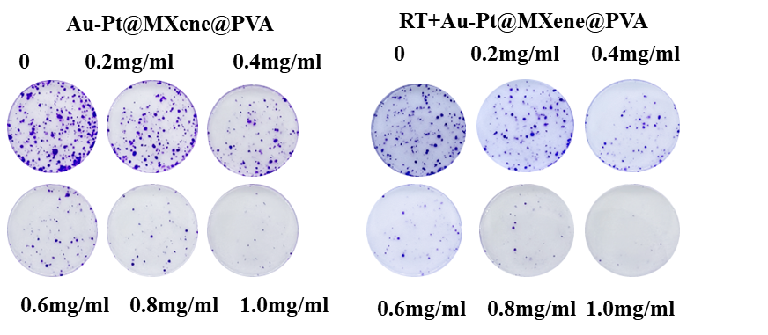
Figure S9. Clonogenic Formation Images Following 2 Gy Irradiation of Various APMP Concentrations.
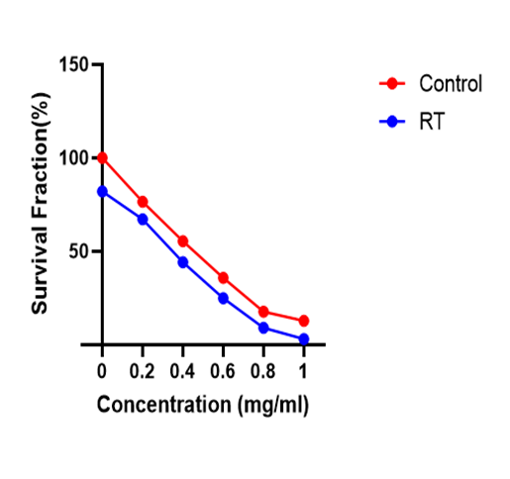
Figure S10. Clonogenic Survival Curve of Cells Treated with Various Concentrations of APMP Following 2 Gy of Radiation Exposure.
Figure S11. Colony formation images and survival fraction (SF) fitting curve of Gl261 cells treated with PBS or APMP receiving various X-ray radiation doses. P <0.05, **P <0.01, and ****P<0.0001.
Figure S12. Fluorescence images of live (green) and dead (red) cells stained by Calcein-AM and PI after being treated with PBS or Ti3C2@Au with the laser irradiation or not.
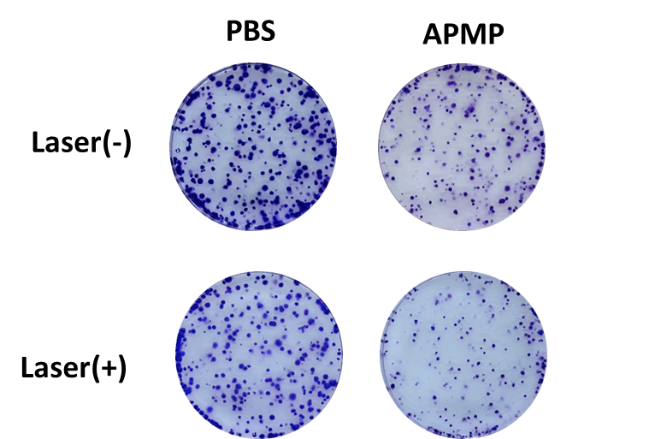
Figure S13. Clonogenic Formation Image of GL261 Cells.
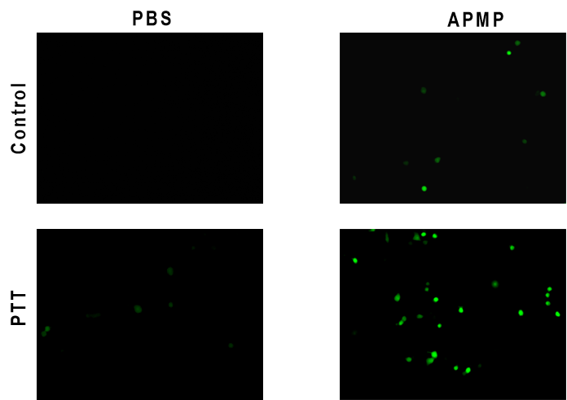

Figure S14. Fluorescence Images of Reactive Oxygen Species (ROS) in GL261 Cells Treated with Different Conditions.
Figure S15. Hemolysis Assay of APMP, with the PBS, Water, APMP.
Figure S16. Quantitative bioluminescence Imaging of Mice, I-IV represent control, APMP+PTT, APMP+RT, and APMP+RT+PTT respectively.

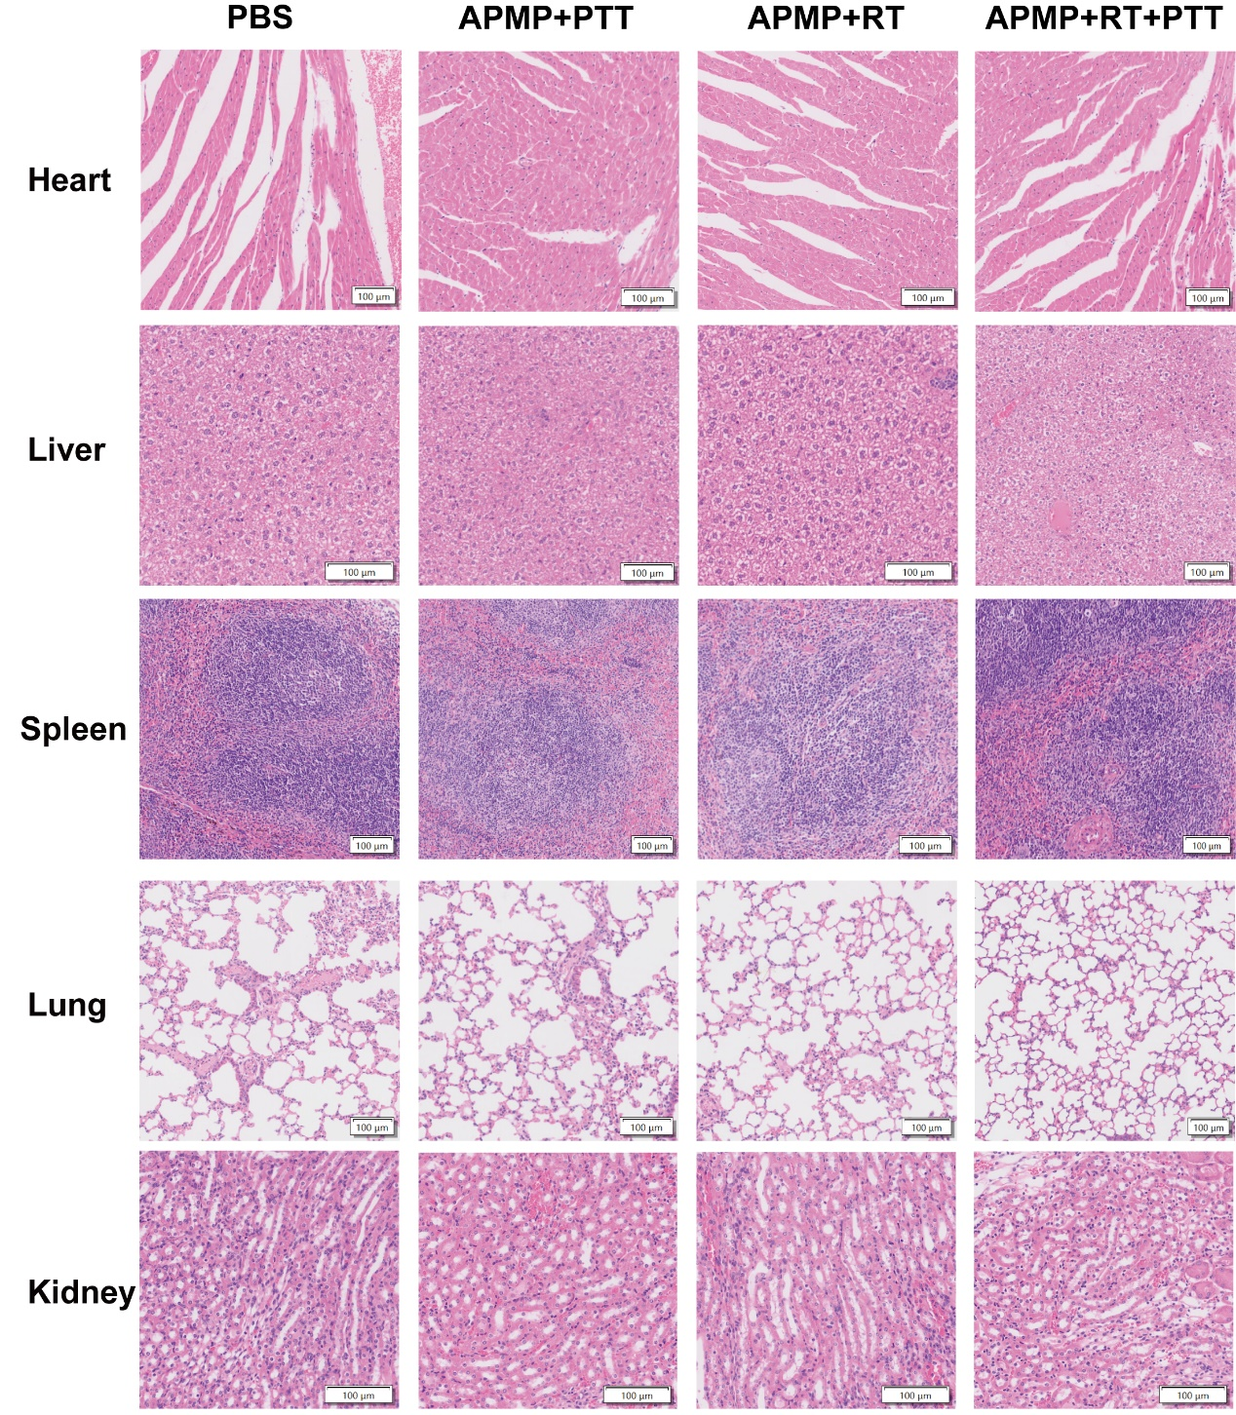
Figure S17. H&E stained slices of major organs of the healthy mice (Control) and the mice post iv injection of APMP with combined therapies at 21 days.
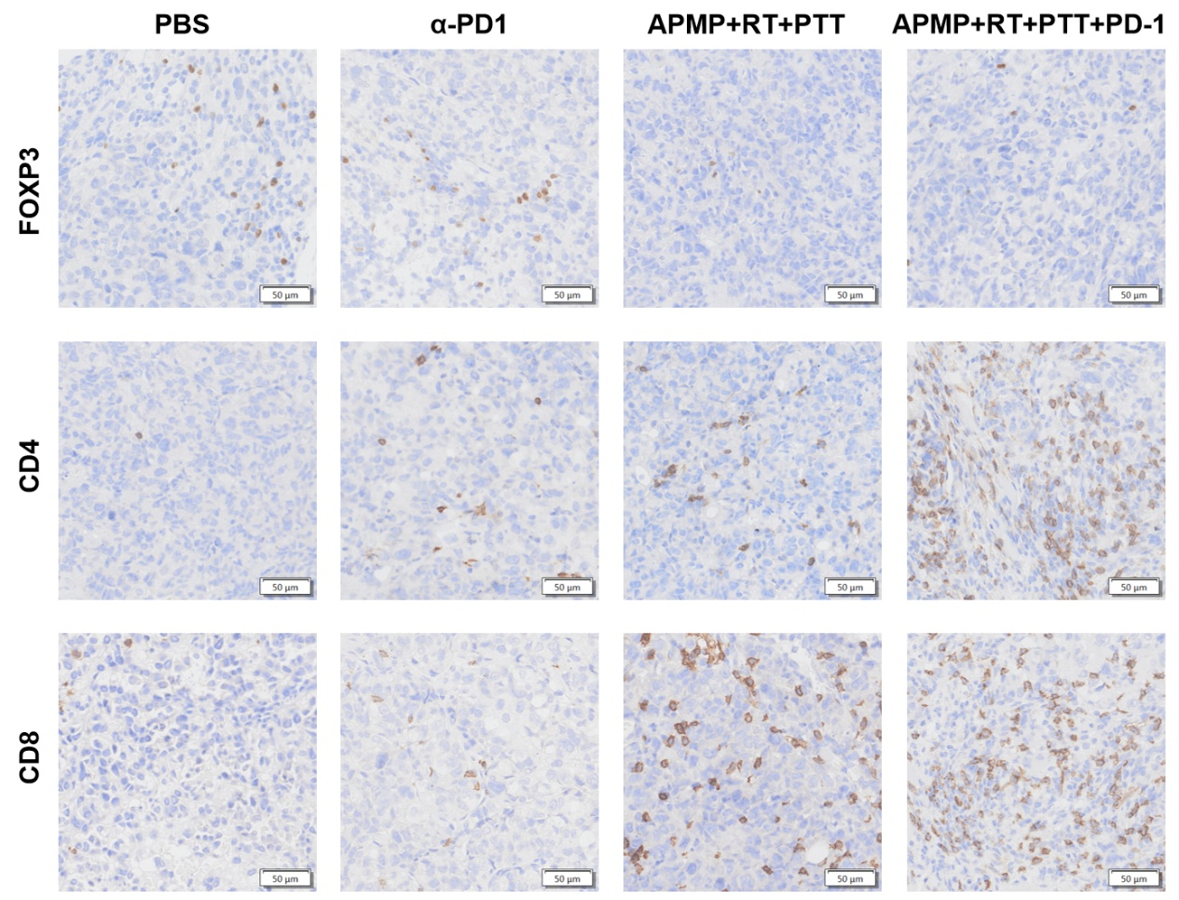
Figure S18. IHC staining of Foxp3, CD4, CD8 of distant tumors collected from mice in different groups on day 21. scale bar: 50 μm.

