Supplementary figures
Supplementary figure 1
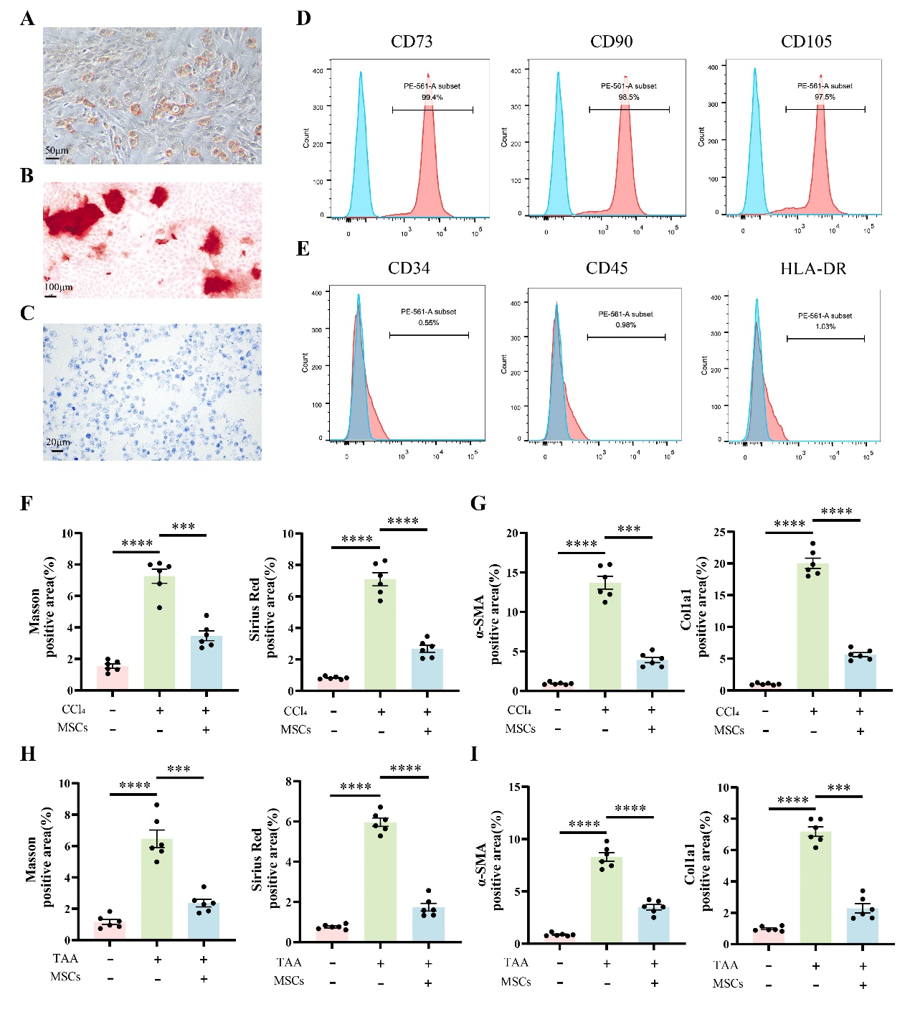

Supplementary figure 2
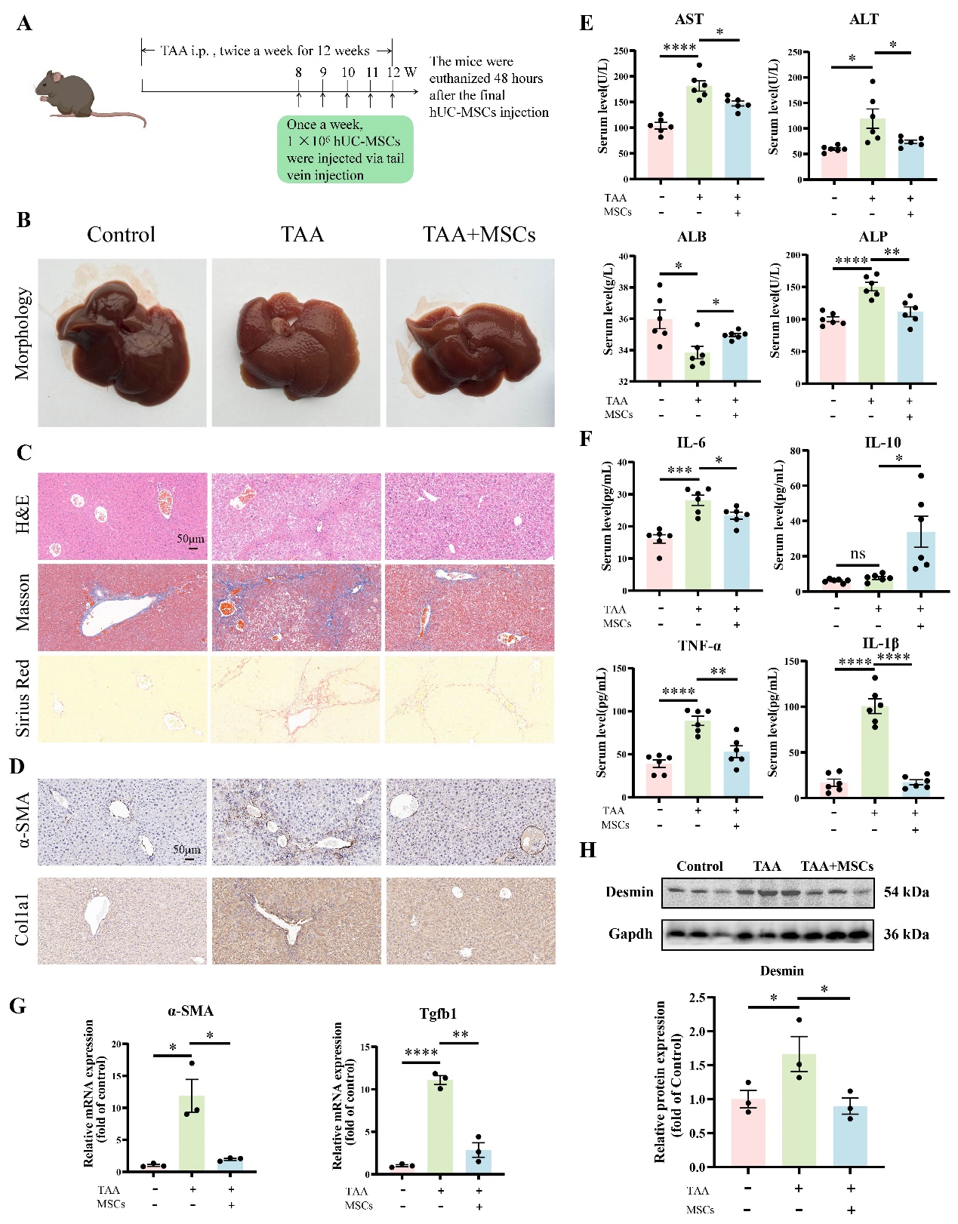

Supplementary figure 3
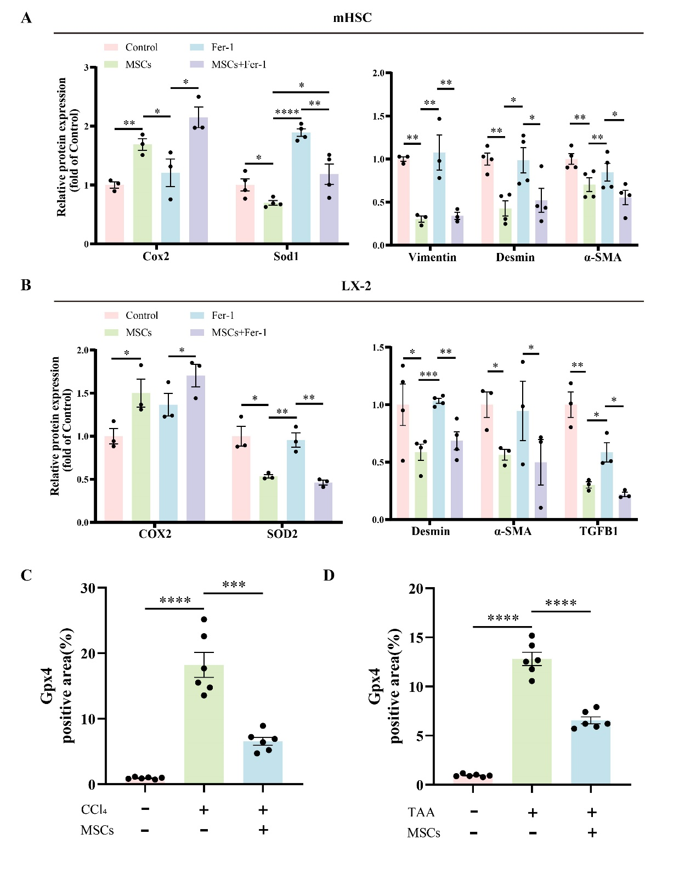

Supplementary figure 4
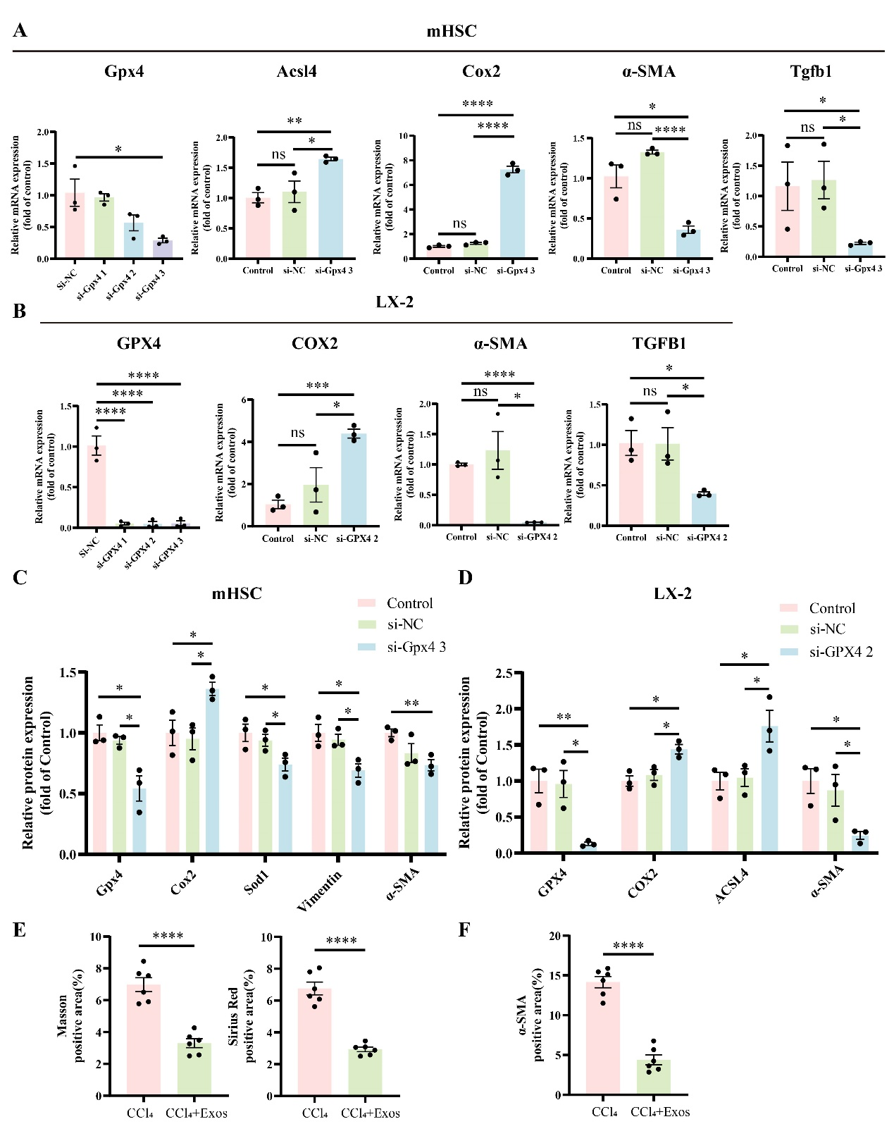

Supplementary figure 5

Supplementary figure 6
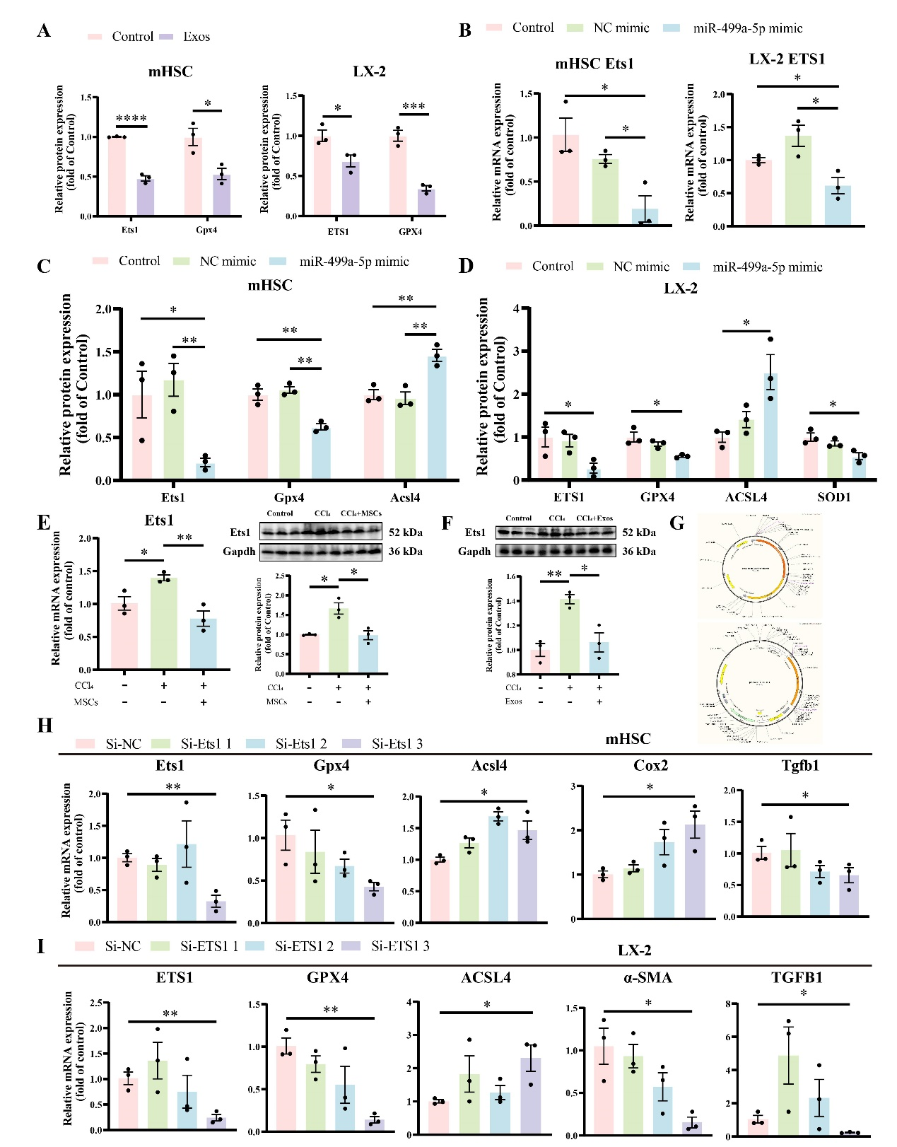

Supplementary figure 7
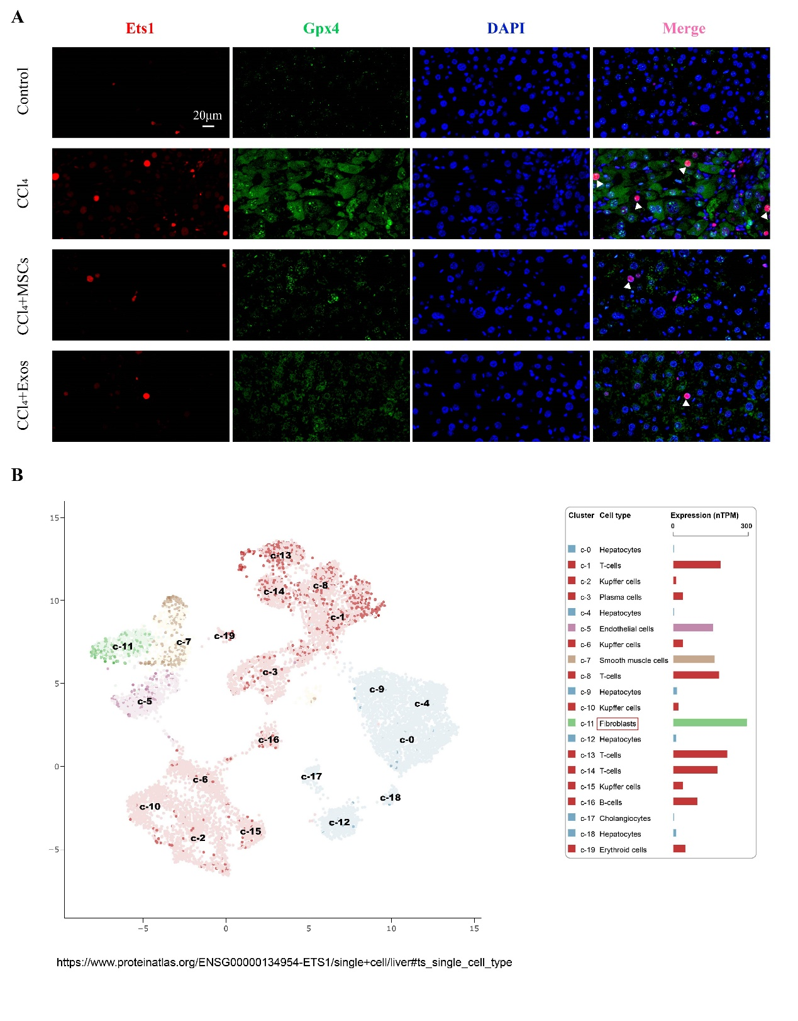

Supplementary figure legends
Supplementary figure 1. (A) Adipogenic differentiation of MSCs. Scale bar = 50μm. (B) Osteogenic differentiation of MSCs. Scale bar = 100μm. (C) Chondrogenic differentiation of MSCs. Scale bar = 20μm. (D) Flow cytometry analysis of CD73, CD90, and CD105 expression. (E) Flow cytometry analysis of CD34, CD45, and HLA-DR expression. (F) Quantification of collagen-positive areas in Masson and Sirius Red-stained sections in Control, CCl₄, and CCl₄ + MSCs groups. (G) Quantification of α-SMA and Col1a1 positive areas in Control, CCl₄, and CCl₄ + MSCs groups. (H) Quantification of collagen-positive areas in Masson and Sirius Red-stained sections in Control, TAA, and TAA + MSCs groups. (I) Quantification of α-SMA and Col1a1 positive areas in Control, TAA, and TAA + MSCs groups. ***P < 0.001, ****P < 0.0001 indicate significant differences between the indicated groups.

Supplementary figure 2. MSC treatment mitigates TAA-induced liver fibrosis in mice.
(A) Schematic of the experimental timeline for TAA induction. (B) Representative liver morphology in the Control, TAA, and TAA + MSCs groups. (C) Liver sections were stained with H&E, Masson, and Sirius Red. Scale bar = 50μm. (D) Immunohistochemical staining for α-SMA and Col1a1 in liver sections. Scale bar = 50μm. (E) Serum levels of ALT, AST, ALP, and ALB as assessed by liver function tests. (F) ELISA analysis of IL-6, IL-10, TNF-α, and IL-1β levels in serum. (G) qRT-PCR analysis of α-SMA and Tgfb1 mRNA expression in liver tissue. (H) Western blot analysis of Desmin expression in liver tissue. The data are presented as the mean ± SEM from at least three independent experiments. *P < 0.05, **P < 0.01, ***P < 0.001, ****P < 0.0001 indicate significant differences between the indicated groups.

Supplementary figure 3. (A) Western blot results for Cox2, Sod1, Vimentin, Desmin, and α-SMA in mHSCs. (B) Western blot results for COX2, SOD2, TGFB1, Desmin, and α-SMA in LX-2 cells. (C) Quantification of Gpx4 positive areas in Control, CCl₄, and CCl₄ + MSCs groups. (D) Quantification of Gpx4 positive areas in Control, TAA, and TAA + MSCs groups. The data are presented as the mean ± SEM from at least three independent experiments. *P < 0.05, **P < 0.01, ***P < 0.001, ****P < 0.0001 indicate significant differences between the indicated groups.

Supplementary figure 4. (A) qRT-PCR analysis of Gpx4, Acsl4, Cox2, α-SMA, and Tgfb1 mRNA expression levels in Control, si-NC, and si-Gpx4 groups of mHSCs. (B) qRT-PCR analysis of GPX4, COX2, α-SMA, and TGFB1 mRNA expression levels in Control, si-NC, and si-GPX4 groups of LX-2 cells. (C) Western blot analysis of Gpx4, Cox2, Sod1, Vimentin, and α-SMA protein levels in mHSCs. (D) Western blot analysis of GPX4, COX2, ACSL4, and α-SMA protein levels in LX-2 cells. (E) Quantification of collagen-positive areas in Masson and Sirius Red-stained sections in CCl₄ and CCl₄ + Exos groups. (F) Quantification of α-SMA positive areas in CCl₄ and CCl₄ + Exos groups. The data are presented as the mean ± SEM from at least three independent experiments. *P < 0.05, **P < 0.01, ***P < 0.001, ****P < 0.0001 indicate significant differences between the indicated groups.

Supplementary figure 5. (A) GO analysis of miR-127-5p target genes. (B) KEGG analysis of miR-127-5p target genes. (C) and (D) qRT-PCR analysis of miR-499a-5p expression in mHSCs and LX-2 cells under different conditions: Control, MSCs, Exos, and GW4869 treatment. (E) qRT-PCR analysis of miR-499a-5p expression in mouse liver tissue. (F) Venn diagram showing the intersection of miR-127-5p target genes predicted by miRDB, TargetScan, and miRTarBase. (G) Venn diagram showing the intersection of 11 target genes with GPX4 transcription factors predicted by GTRD, human TFBD, and animal TFBD databases of miR-127-5p. (H) Schematic representation of the pGL6-miR-H-ETS1-3'UTR plasmid. (I) Electrophoresis gel showing ChIP-qPCR products using different primers. The data are presented as the mean ± SEM from at least three independent experiments. *P < 0.05, **P < 0.01, ***P < 0.001, ****P < 0.0001 indicate significant differences between the indicated groups.

Supplementary figure 6. (A) Analysis of ETS1 and GPX4 protein levels in mHSCs and LX-2 cells following Exos intervention. (B) ETS1 mRNA expression in mHSCs and LX-2 cells transfected with the miR-499a-5p mimic. (C) Protein levels of Gpx4, Ets1, and Acsl4 in mHSCs after miR-499a-5p mimic transfection. (D) Protein levels of GPX4, ETS1, SOD1, and ACSL4 in LX-2 cells after miR-499a-5p mimic transfection. (E) Ets1 mRNA and protein expression in Control, CCl₄, and CCl₄ + MSCs groups. (F) Ets1 protein expression in Control, CCl₄, and CCl₄ + Exos groups. (G) Schematic representation of the pGL3-Basic-GPX4-Promoter plasmid and the pcDNA 3.1-H-ETS1 plasmid. (H) qRT-PCR analysis of Ets1, Gpx4, Acsl4, Cox2, and Tgfb1 mRNA levels in si-NC and si-Ets1 mHSC groups. (I) qRT-PCR analysis of ETS1, GPX4, ACSL4, α-SMA, and TGFB1 mRNA levels in si-NC and si-ETS1 LX-2 groups. The data are presented as the mean ± SEM from at least three independent experiments. *P < 0.05, **P < 0.01, ***P < 0.001, ****P < 0.0001 indicate significant differences between the indicated groups.

Supplementary figure 7. (A) Immunofluorescence staining of Ets1 (red) and Gpx4 (green) in Control, CCl₄, CCl₄ + MSCs, and CCl₄ + Exos groups. The white triangular region indicates colocalization. Scale bar = 20μm. (B) Single-cell RNA sequencing analysis of ETS1 gene expression in human liver samples (data sourced from the Human Protein Atlas [HPA] database).

