Supporting Information
Exogenous nano-silicon enhances the ability of intercropped faba bean to alleviate cadmium toxicity and resist Fusarium wilt
Chaosheng Luo¹ ²†, Ting Li¹†, You Huang¹, Taiqin Liu¹, Yan Dong^{1*}
Luo, C. S. (ORCID: https://orcid.org/0000-0001-5248-2791)
¹ College of Resources and Environment, Yunnan Agricultural University, Kunming 650201, China
² College of Plant Protection, Yunnan Agricultural University, Kunming 650201, China
† These authors contributed equally to this work.
*Corresponding author．E-mail addresses: dongyanyx@163.com (Y. Dong)

Supplementary materials:
2.4.5 Determination of rhizosphere soil bacteria
The PCR reaction mixture including 4 μL 5 × Fast Pfu buffer, 2 μL 2.5 mM dNTPs, 0.8 μL each primer (5 μM), 0.4 μL Fast Pfu polymerase, 10 ng of template DNA, and ddH₂O to a final volume of 20 µL. PCR amplification cycling conditions were as follows: initial denaturation at 95 ℃ for 3 min, followed by 27 cycles of denaturing at 95 ℃ for 30 s, annealing at 55 ℃ for 30 s and extension at 72 ℃for 45 s, and single extension at 72 ℃ for 10 min, and end at 4 ℃. The PCR product was extracted from 2% agarose gel and purified using the PCR Clean-Up Kit (YuHua, Shanghai, China) according to manufacturer’s instructions and quantified using Qubit 4.0 (Thermo Fisher Scientific, USA). The PCR product was extracted from 2% agarose gel and purified using the PCR Clean-Up Kit (YuHua, Shanghai, China) according to manufacturer’s instructions and quantified using Qubit 4.0 (Thermo Fisher Scientific, USA) .

Supplement figure:
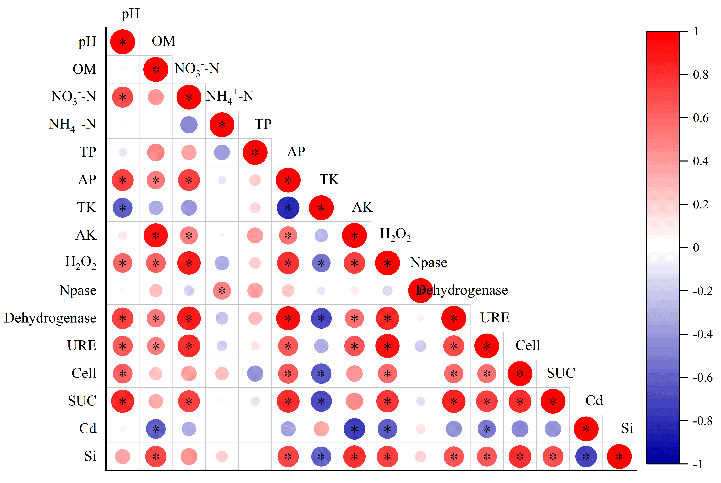
Figure S1. Spearman correlation analysis of rhizosphere soil physicochemical factors (pH, OM, NH₄⁺-N, NO₃⁻-N, TP, AP, TK, AK, Si, Cd) and soil enzyme activities (H₂O₂, Neutral phosphatase, Dehydrogenase, Urease, Cellulase, and Sucrase).
*0.01 <P ≤ 0.05, **0.001 < P ≤0.01, ***P ≤ 0.001.

Supplement table:
Table S1 Morphological characteristic parameters of faba bean roots under different treatment conditions
Treatments | Total root length (m) | Average diameter (cm) | Perimeter (m) | Surface area (m²) | Root length diameter range 1 (m) | Surface area diameter range 1 (cm²) | Surface area diameter range 2 (cm²)
MFcd | 153.59±32.00^{b} | 0.76±0.25ª | 172.12±36.76ª | 3.89±0.86ª | 50.51±4.96^{c} | 1269.48±175.89^{b} | 808.91±143.64^{b}
IFcd | 165.29±23.24ª | 0.58±0.05^{b} | 189.05±25.01^{ab} | 3.32±0.59^{b} | 53.28±2.94^{b} | 1337.84±199.46^{b} | 1000.66±88.07ª
IFcd+Si | 165.98±15.51ª | 0.61±0.11^{ab} | 202.29±18.99ª | 3.63±0.84^{ab} | 63.87±3.66ª | 1605.16±167.92ª | 955.76±61.56ª
Note: Different lowercase letters in the same column indicate significant differences between treatments (P<0.05). Data are presented as mean ± SD (n=3).

