Supplementary Material

Dual-Modality Immune Nano-Activator Harnessing Mn²⁺ and Quercetin to Potentiate the cGAS-STING Pathway for Advanced Cancer Metalloimmunotherapy
Shanshan Ma ^{a,1}, Xuequan Zhang ^{b,1}, Xiaoqi Zhu ^{a,1}, Kangning Yan ^{a,d}, Qin Wang ^{a,d}, Lei Lei ^{b}, Jiasheng Li ^{e}, Jing Guo ª, Weizhong Tang ^{e}, Junjie Liu ª, Jun Cao ^{b,*}, Duo Wang ^{c,*}, Tao Luo ^{e,*}

ª Department of Medical Ultrasound, Guangxi Medical University Cancer Hospital, Guangxi Medical University. No. 71 Hedi Road, Nanning 530021, P. R. China.
^{b} National Engineering Research Center for Biomaterials College of Biomedical Engineering, Sichuan University. No. 29 Wangjiang Road, Chengdu 610064, P. R. China.
^{c} Center of Interventional Radiology & Vascular Surgery, Department of Radiology, Zhongda Hospital, Medical School. Southeast University, No.87 Dingjiaqiao, Nanjing 210009, P. R. China.
^{d} Guangxi Key Laboratory of Early Prevention and Treatment for Regional High Frequency Tumor, Guangxi Medical University. No.22 Shuangyong Road, Nanning 530021, P. R. China.
^{e} Department of Gastrointestinal Surgery, Guangxi Medical University Cancer Hospital, Guangxi Medical University. No. 71 Hedi Road, Nanning 530021, P. R. China.

Corresponding author.
E-mail address: luotao@gxmu.edu.cn (T. Luo). Department of Gastrointestinal Surgery, Guangxi Medical University Cancer Hospital, Guangxi Medical University. No. 71 Hedi Road, Nanning 530021, P. R. China
wangduo2022@126.com (D. Wang). Center of Interventional Radiology & Vascular Surgery, Department of Radiology, Zhongda Hospital, Medical School. Southeast University, No.87 Dingjiaqiao, Nanjing 224001, P. R. China.
caojun@scu.edu.cn (J. Cao). National Engineering Research Center for Biomaterials College of Biomedical Engineering, Sichuan University. No. 29 Wangjiang Road, Chengdu 610064, P. R. China.

¹ These authors contributed equally to this work.

Supplementary methods
Migration Assay
Migration assay was performed using transwell chambers with 8 μm polycarbonate membrane inserts. The lower chamber contained a medium supplemented with 10% FBS as a chemoattractant, while Hepa1-6 cells were seeded into the upper chamber with a serum-free medium. Cells in the upper chamber were treated with different formulations (G1: Control, G2: MnCl₂, G3: Que, G4: NIR, G5: MQ, G6: MQ + NIR) and incubated for 24 hours. The concentration of manganese ions, Que and MQ were 17.5 μg/mL, 8.5 μg/mL and 50 μg/mL, respectively. Following incubation, cells that migrated through the membrane were fixed with 4% paraformaldehyde, stained with 0.5% crystal violet, photographed using an inverted microscope, and quantified using ImageJ software.
EdU Cell Proliferation Experiment
Hepa1-6 cells were seeded in 48-well plates at a density of 2 × 10⁴ cells per well. After allowing sufficient time for cell attachment, the cells were subjected to various treatments and incubated for 24 hours. Cell proliferation was then assessed using an EdU kit according to the manufacturer’s instructions. The cells were fixed with 4% paraformaldehyde, and EdU reagent was used to label proliferating cells, while Hoechst 33342 (10 μg/mL) was used to stain the nuclei. Stained cells were imaged using an inverted fluorescence microscope. The number of EdU-positive cells was quantified using ImageJ software to evaluate cell proliferation under different treatment conditions.
TUNEL Staining Analysis
Hepa1-6 cells were seeded in 24-well plates and allowed to adhere for 24 hours. Following this incubation period, the cells were subjected to various treatments as per the experimental design. After treatment, the cells were washed with PBS, fixed with 4% paraformaldehyde for 30 minutes, and permeabilized with 0.3% Triton X-100 in PBS. Subsequently, 100 μL of TUNEL assay solution was added to each well. The cells were then incubated at 37°C in the dark for 1 hour, followed by three washes with PBS to remove any unbound reagents. Apoptotic cells were visualized, and photographed using an inverted fluorescence microscope.
Immunofluorescence Staining
Hepa1-6 cells were seeded in 24-well plates and cultured for 24 hours. Following this incubation period, the cells were subjected to the specified treatments. After treatment, the cells were washed with PBS, fixed with 4% paraformaldehyde for 30 minutes, and blocked with QuickBlock™ immunostaining blocking solution (Beyotime, cat. no. P0260) for 15 minutes. The cells were then incubated overnight at 4°C with primary antibodies. Following primary antibody incubation, cells were treated with Cy3-conjugated secondary antibodies at room temperature for 1 hour. Nuclei were stained with Hoechst 33342 (10 μg/mL) for 10 minutes. Fluorescence images were captured using confocal microscopy, and relative fluorescence intensity was semi-quantified using ImageJ software.
Colony Formation Assay
For the colony formation assay, Hepa1-6 cells were seeded in 6-well plates at a density of 500 cells per well and cultured in complete growth medium at 37°C for 14 days. After incubation, colonies were fixed with 4% paraformaldehyde, stained with 0.5% crystal violet, and then counted using ImageJ software.
Wound-Healing Assays
For wound healing evaluation, Hepa1-6 cells were seeded in 6-well plates and cultured until reaching 85% confluence. A standardized wound was created in the cell monolayer by scraping with a 10 μL pipette tip. Following the wound creation, cells were washed twice with PBS and cultured in serum-free medium. Wound closure was monitored under an inverted microscope at 0, 24, and 48 hours. The gap area filled by cells was analyzed and measured using ImageJ software.
Western Blot Assay
Protein samples for Western blotting were extracted from mice tumor tissues at the end of the treatment period. Tumor tissues were first homogenized using RIPA lysis buffer supplemented with protease and phosphatase inhibitors. Protein concentrations were determined with a microvolume UV-Vis spectrophotometer (Thermo Scientific™ NanoDrop™ One, USA). Equal amounts of protein (25-50 μg) from each sample were resolved on a PAGE gel, subjected to electrophoresis at 200 V for 30 minutes, and transferred to a PVDF membrane at 400 mA for 25-50 minutes. The membrane was blocked with QuickBlock™ blocking buffer for 30 minutes and then incubated overnight at 4°C with primary antibodies. Following primary antibody incubation, the membrane was washed and incubated with fluorescent secondary antibodies conjugated with DyLight™ 680, protected from light. β-actin was used as a loading control. Protein expression was visualized using an Odyssey DLx near-infrared dual-color laser imaging system (Gene Company Limited, China) and semi-quantified using Image StudioVer 5.2.
In Vivo Fluorescence Imaging of Tumors
Five-week-old tumor-bearing C57BL/6 mice were randomly assigned to two groups and intravenously injected via the tail vein with Cy5.5 or Cy5.5-labeled MQ (1 mg/mL, 100 μL). Fluorescence images were acquired at 0, 1, 2, 4, 6, 8, 12, and 24 hours using an infrared imaging system. At the end of the experiment, major organs including the heart, liver, spleen, lungs, kidneys, and tumor tissues were collected for in vitro fluorescence imaging.
Cytokine Detection
Venous blood was collected from the orbital plexus of mice following treatment. The blood samples were allowed to clot for 60 minutes and subsequently centrifuged at 3000 rpm for 10 minutes. The resulting serum was analyzed for cytokine levels (TNF-α, IL-6, IFN-γ, IFN-β, cGAMP) using ELISA kits, according to the manufacturer's instructions.
Hemolytic Test
Blood samples from mice were incubated with various concentrations of MQ (0, 25, 50, 100, 150, 200 μg/mL), with PBS and distilled water used as negative and positive controls, respectively. The samples were then centrifuged at 3500 rpm for 10 minutes. The absorbance of the supernatant at 540 nm was measured using a microplate reader. The hemolysis rate was calculated using the formula: Hemolysis rate (%) = (A - A0) / (A∞ - A0) × 100%, where A denotes the absorbance of the MQ-treated samples, A0 is the absorbance of the PBS control, and A∞ is the absorbance of the distilled water.
Biological safety evaluation
To assess the biosafety of the MQ activator, healthy C57BL/6 mice (n=3) were administered MQ at a dose of 5 mg/kg. After a 2-week period, the mice were euthanized, and blood samples were collected for routine hematological and biochemical analysis. This included tests for liver and kidney function (ALT, AST, UREA, LDH1, CREA, total bilirubin), as well as white blood cell count, red blood cell count, platelet count, and other relevant parameters. Additionally, following treatment of Hepa1-6 tumor-bearing mice, these mice were euthanized, and major organs were collected. The organs were fixed in 4% formalin and subjected to hematoxylin and eosin (H&E) staining for histopathological examination.
Supplementary Figures

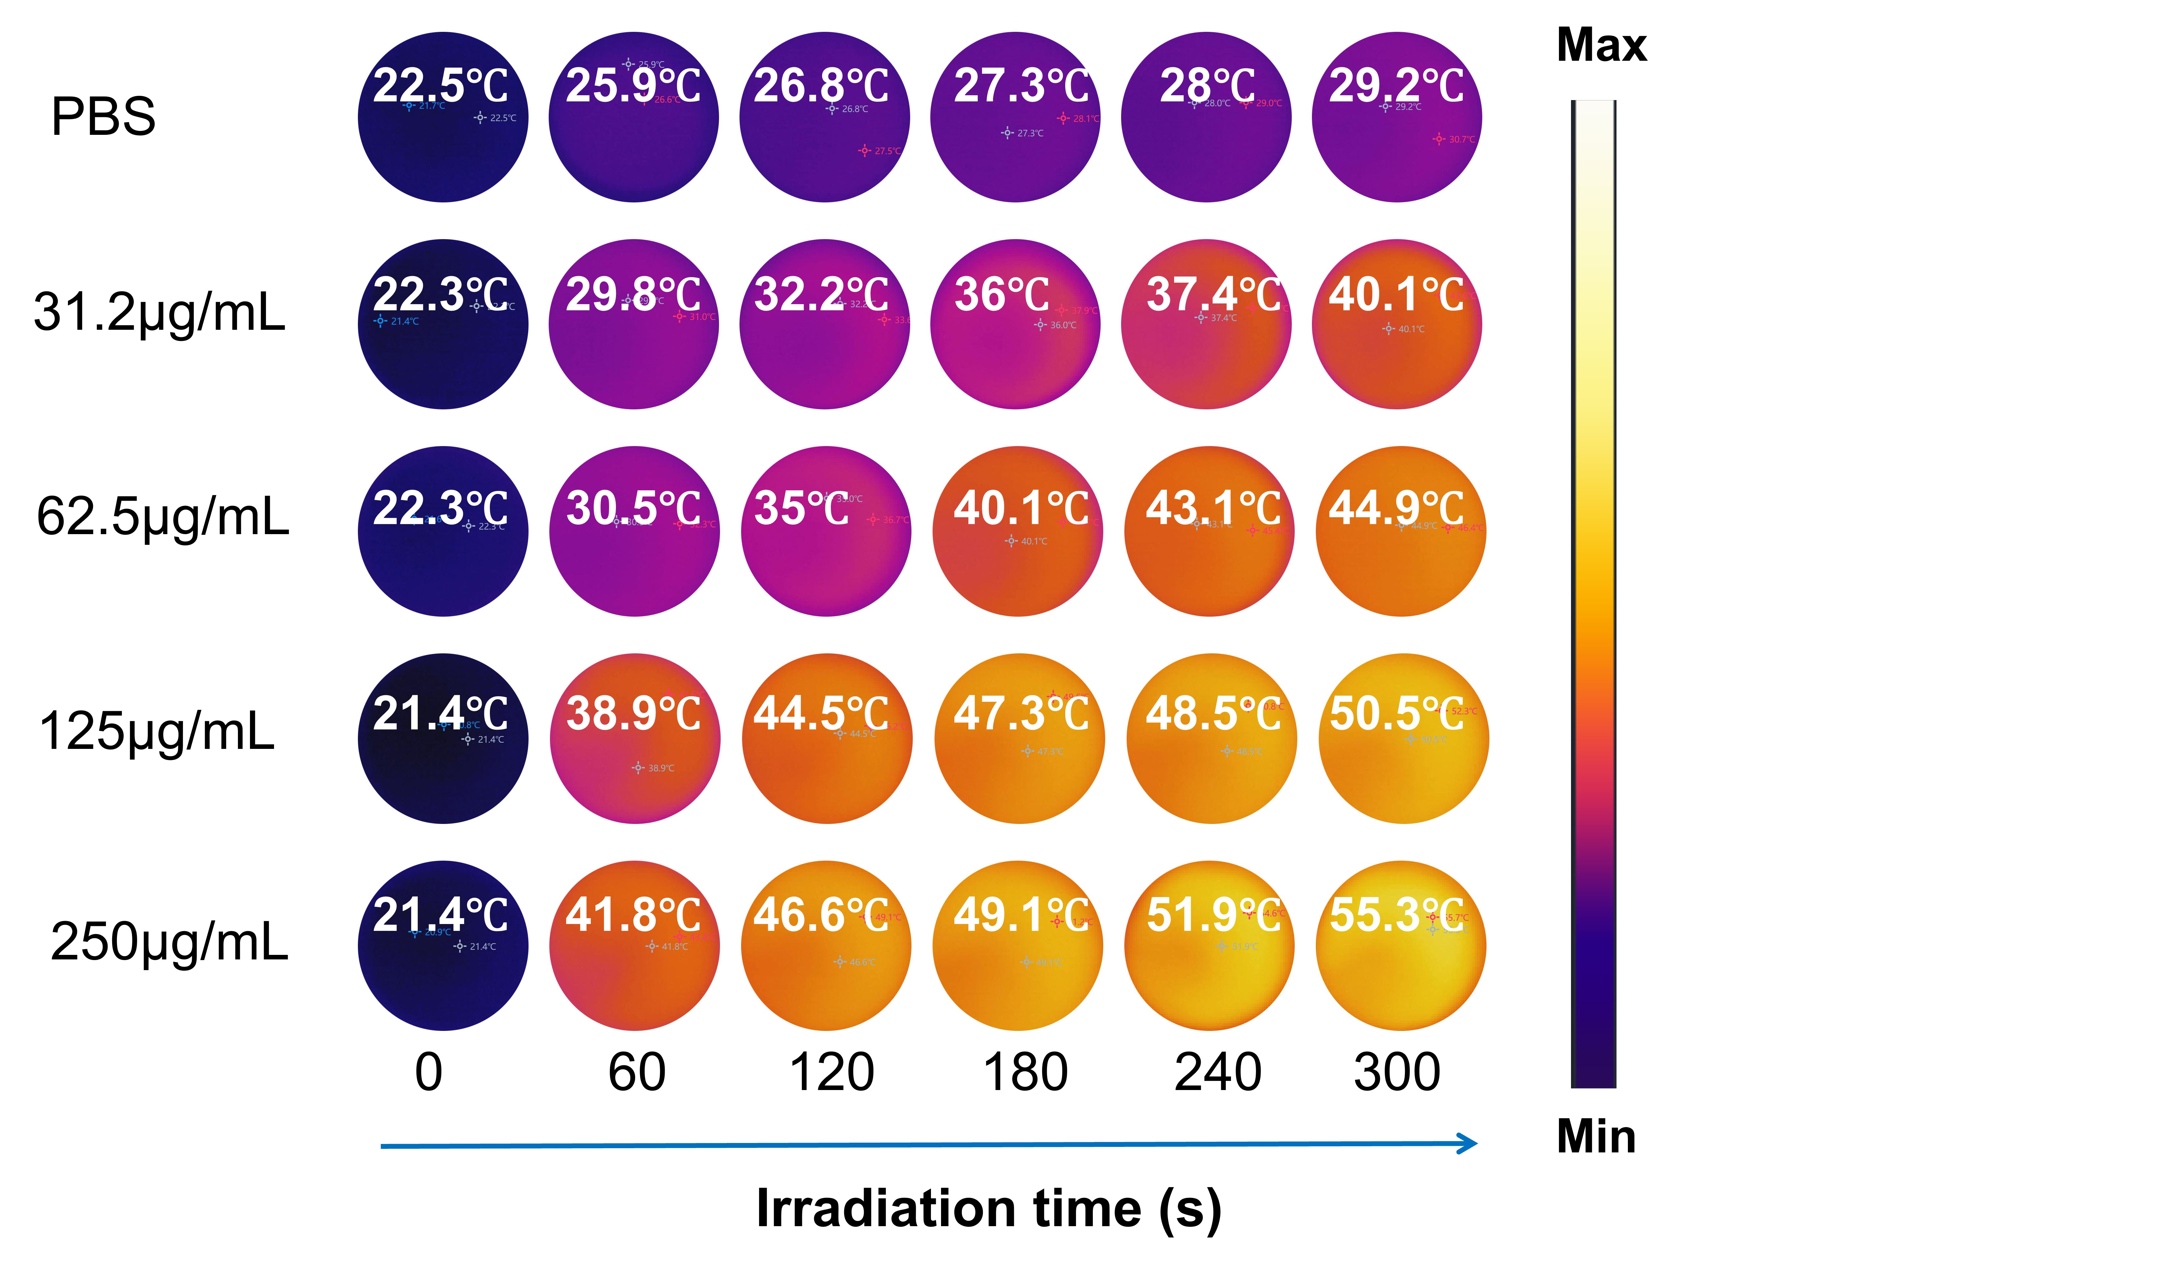
Figure S1. The representative real-time thermographic images of MQ at different concentrations over time under 808 nm laser irradiation (1 W/cm²).

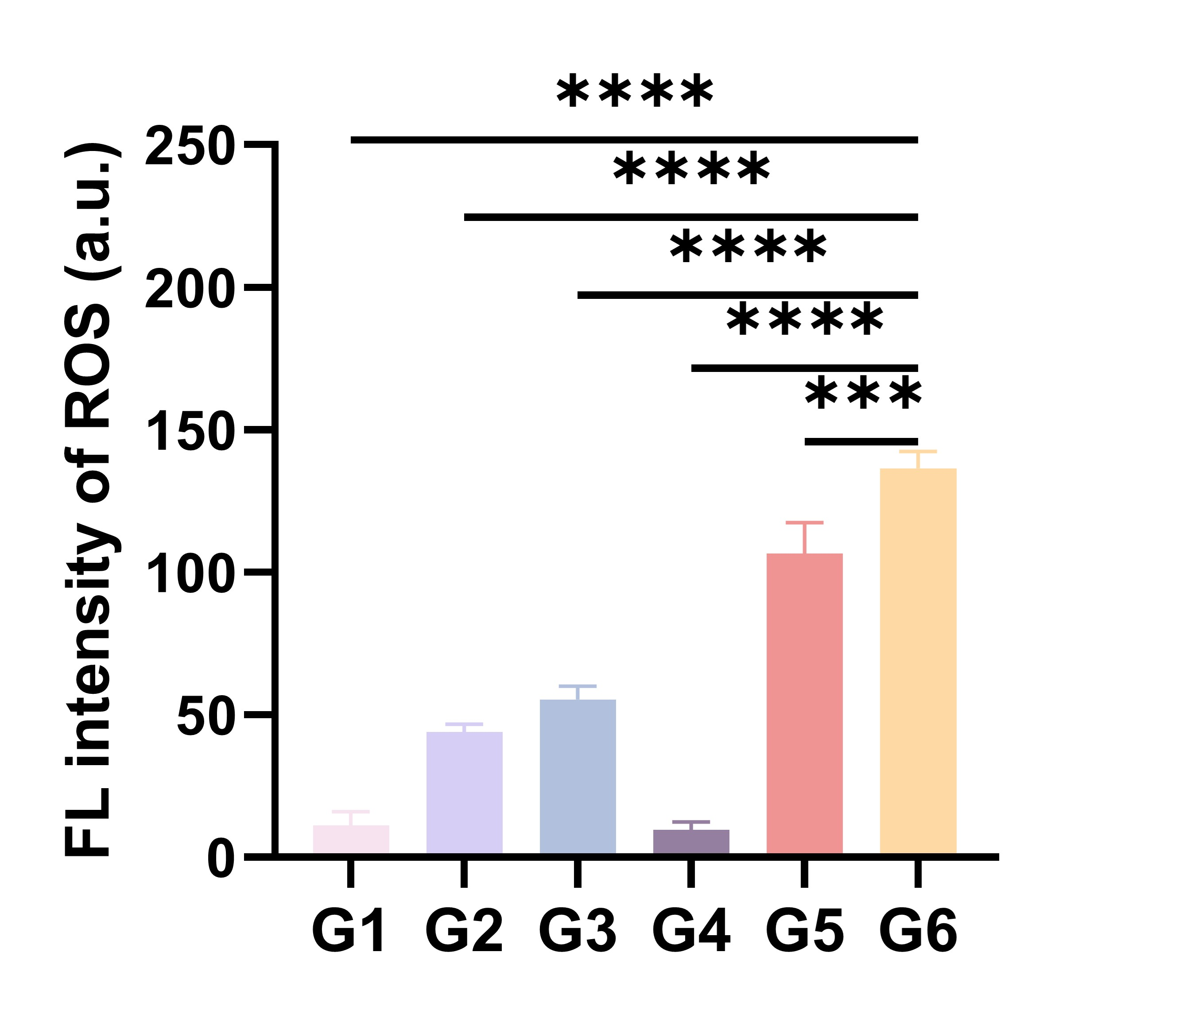
Figure S2. The levels of reactive oxygen species (ROS) generated in Hepa1-6 cells following various treatments were subjected to semi-quantitative analysis. Data were expressed as mean ± SD (n=3). Differences between groups were assessed using one-way ANOVA. Statistical significance was indicated as follows: *p<0.05, **p<0.01, ***p<0.001, ****p<0.0001. "ns" indicated no significant difference.
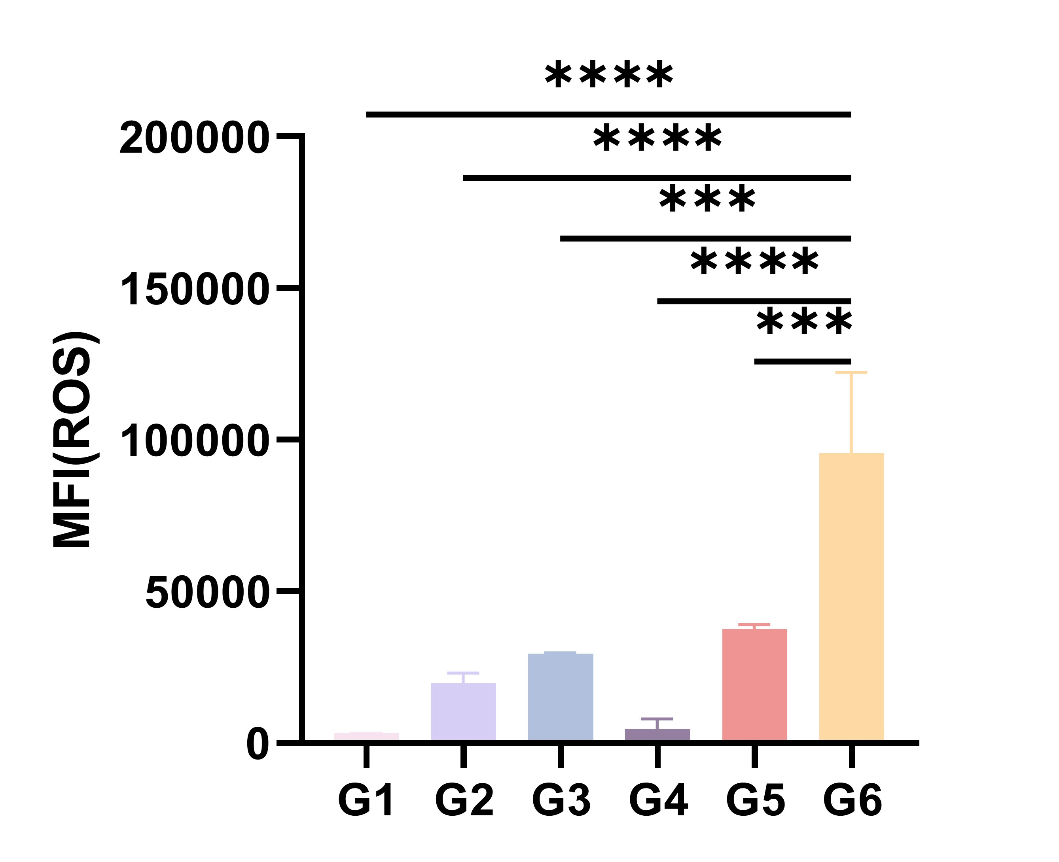
Figure S3. A semi-quantitative analysis of ROS levels from FCM for different treatment groups. Data were expressed as mean ± SD (n=3). Differences between groups were analyzed using one-way ANOVA. Statistical significance was indicated as follows: *p<0.05, **p<0.01, ***p<0.001, ****p<0.0001. "ns" indicated no significant difference.

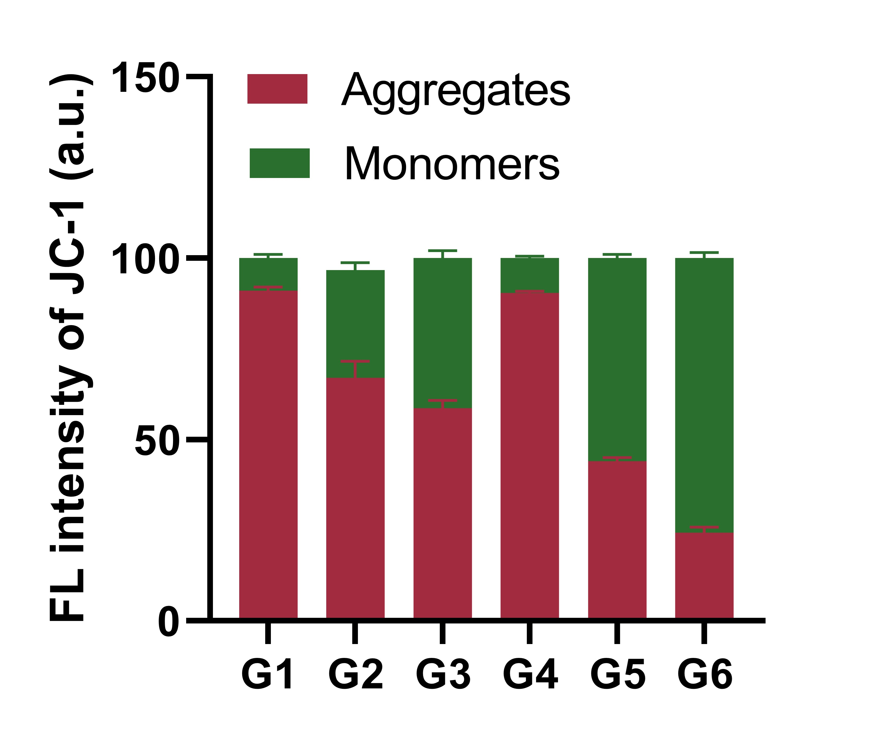
Figure S4. Semi-quantitative analysis of mitochondrial damage based on fluorescence microscopy images.

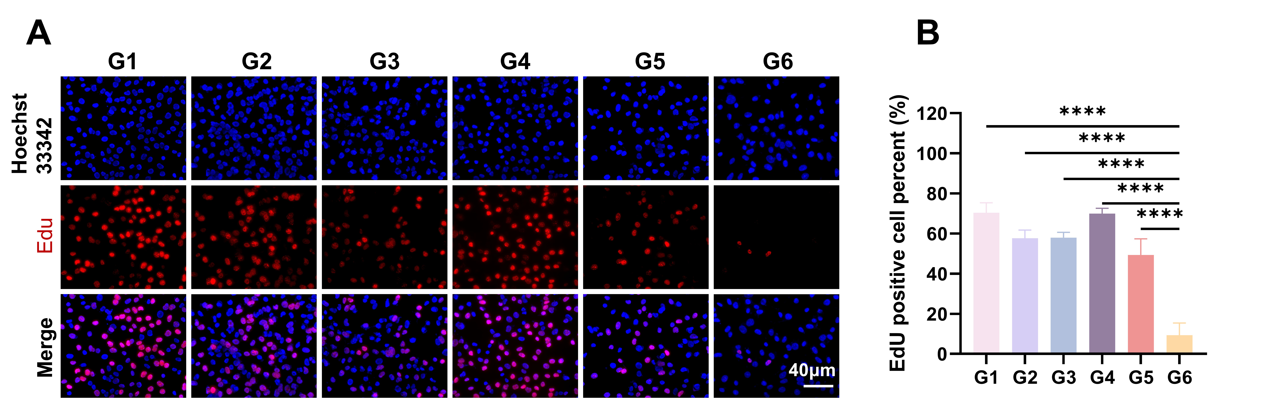

Figure S5. (A) Fluorescence microscopy images depicting EdU staining in Hepa1-6 cells under various treatment conditions. (B) Quantitative analysis of cell proliferation based on EdU staining. Data were presented as mean ± SD (n=3). Differences between groups were analyzed using one-way ANOVA. Statistical significance was indicated as follows: *p<0.05, **p<0.01, ***p<0.001, ****p<0.0001. "ns" indicated no significant difference.

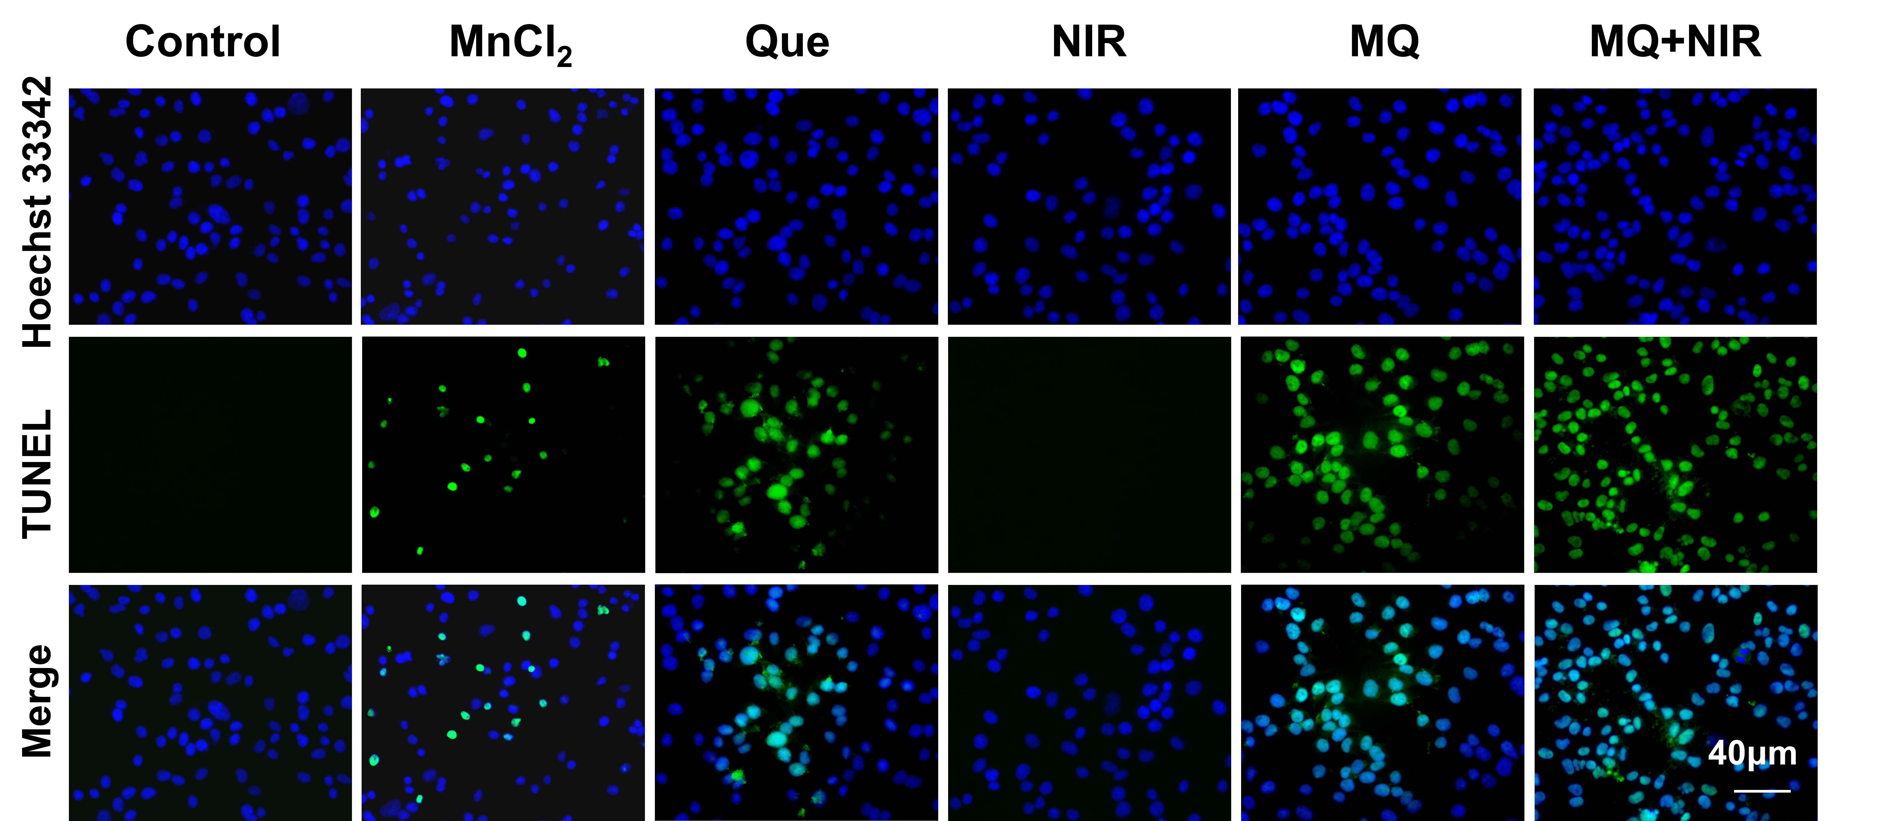

Figure S6. The TUNEL assay was employed to detect apoptotic cells following various treatments. The images obtained from the inverted microscope revealed that apoptotic cells exhibited green fluorescence, while the cell nuclei were stained with Hoechst 33342, displaying blue fluorescence.
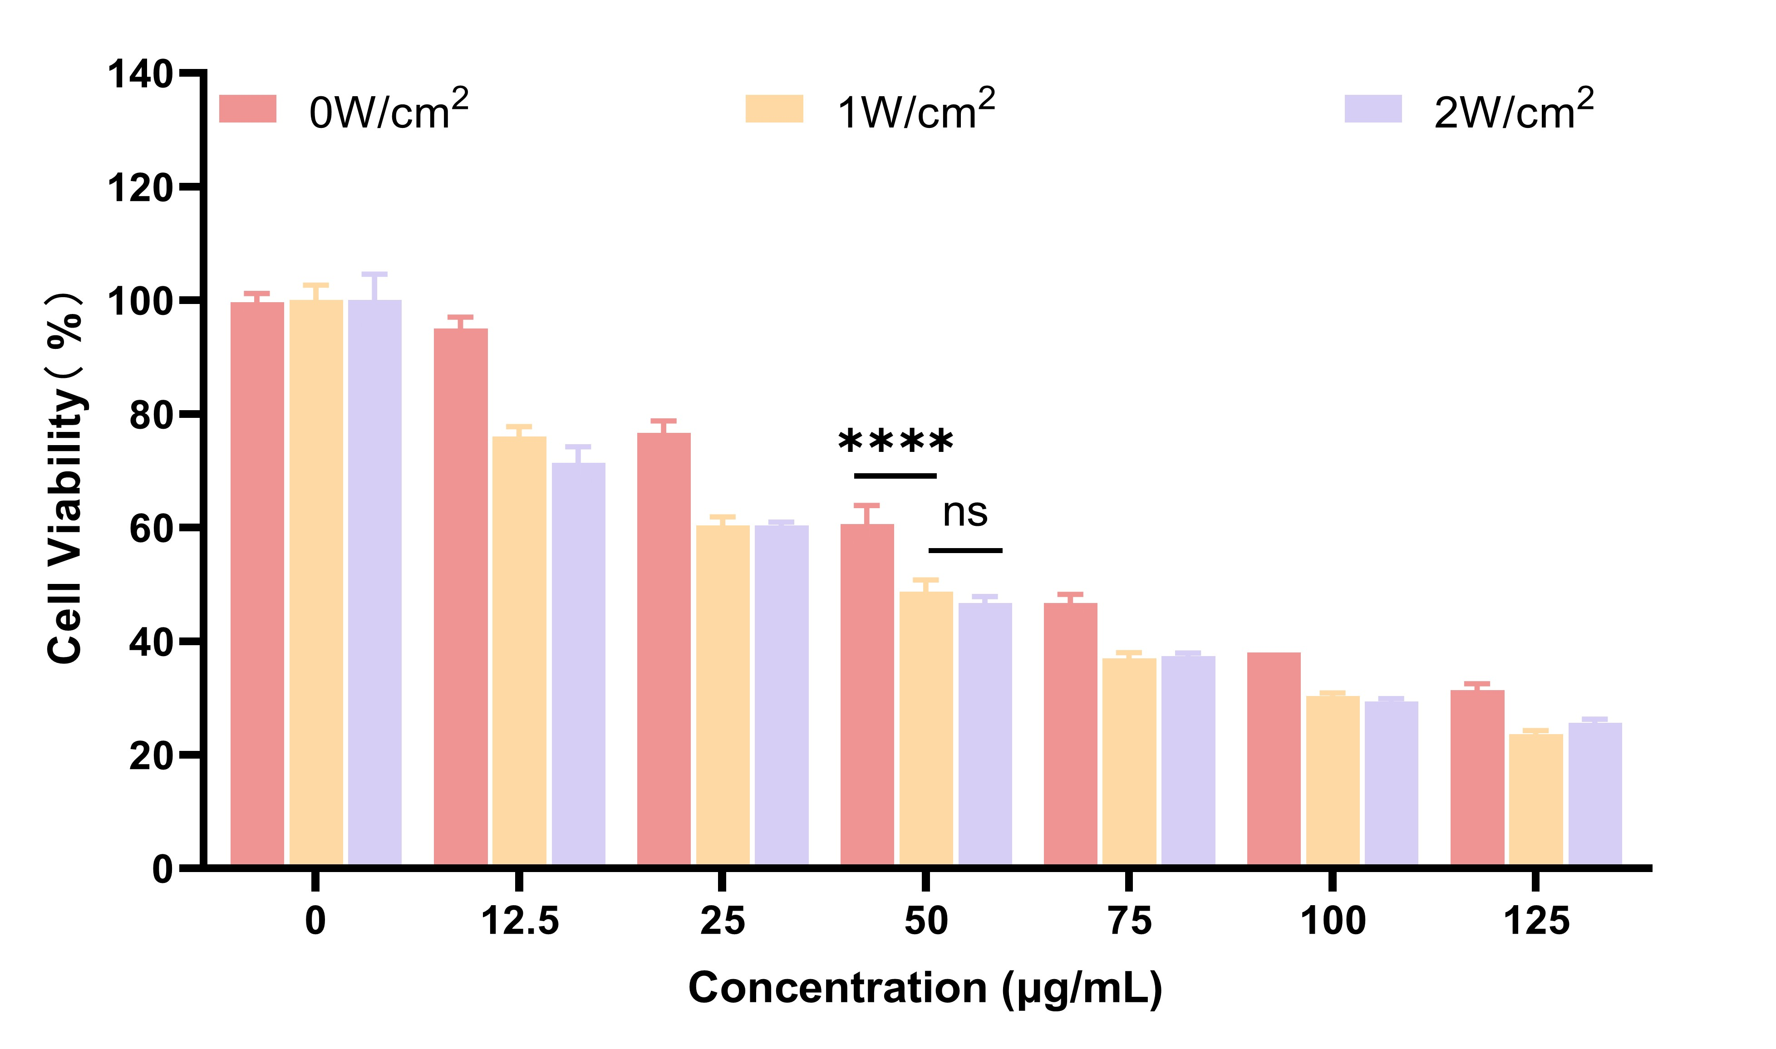
Figure S7. After treating Hepa1-6 cells with different concentrations of MQ, their survival rates under different intensities of near-infrared (NIR) irradiation were observed. Data were presented as mean ± SD (n=3). Differences between groups were analyzed using one-way ANOVA. Statistical significance was indicated as follows: *p<0.05, **p<0.01, ***p<0.001, ****p<0.0001. "ns" indicated no significant difference.

Figure S8. (A) Microscopy images and (B) semiquantitative analysis of wound healing assay of Hepa1-6 cells with different formulations after 48 h. Data are presented as mean ± SD (n=3). Differences between groups were analyzed using one-way ANOVA. Statistical significance was indicated as follows: *P<0.05, **P<0.01, ***P<0.001, ****p<0.0001. "ns" indicated no significant difference.
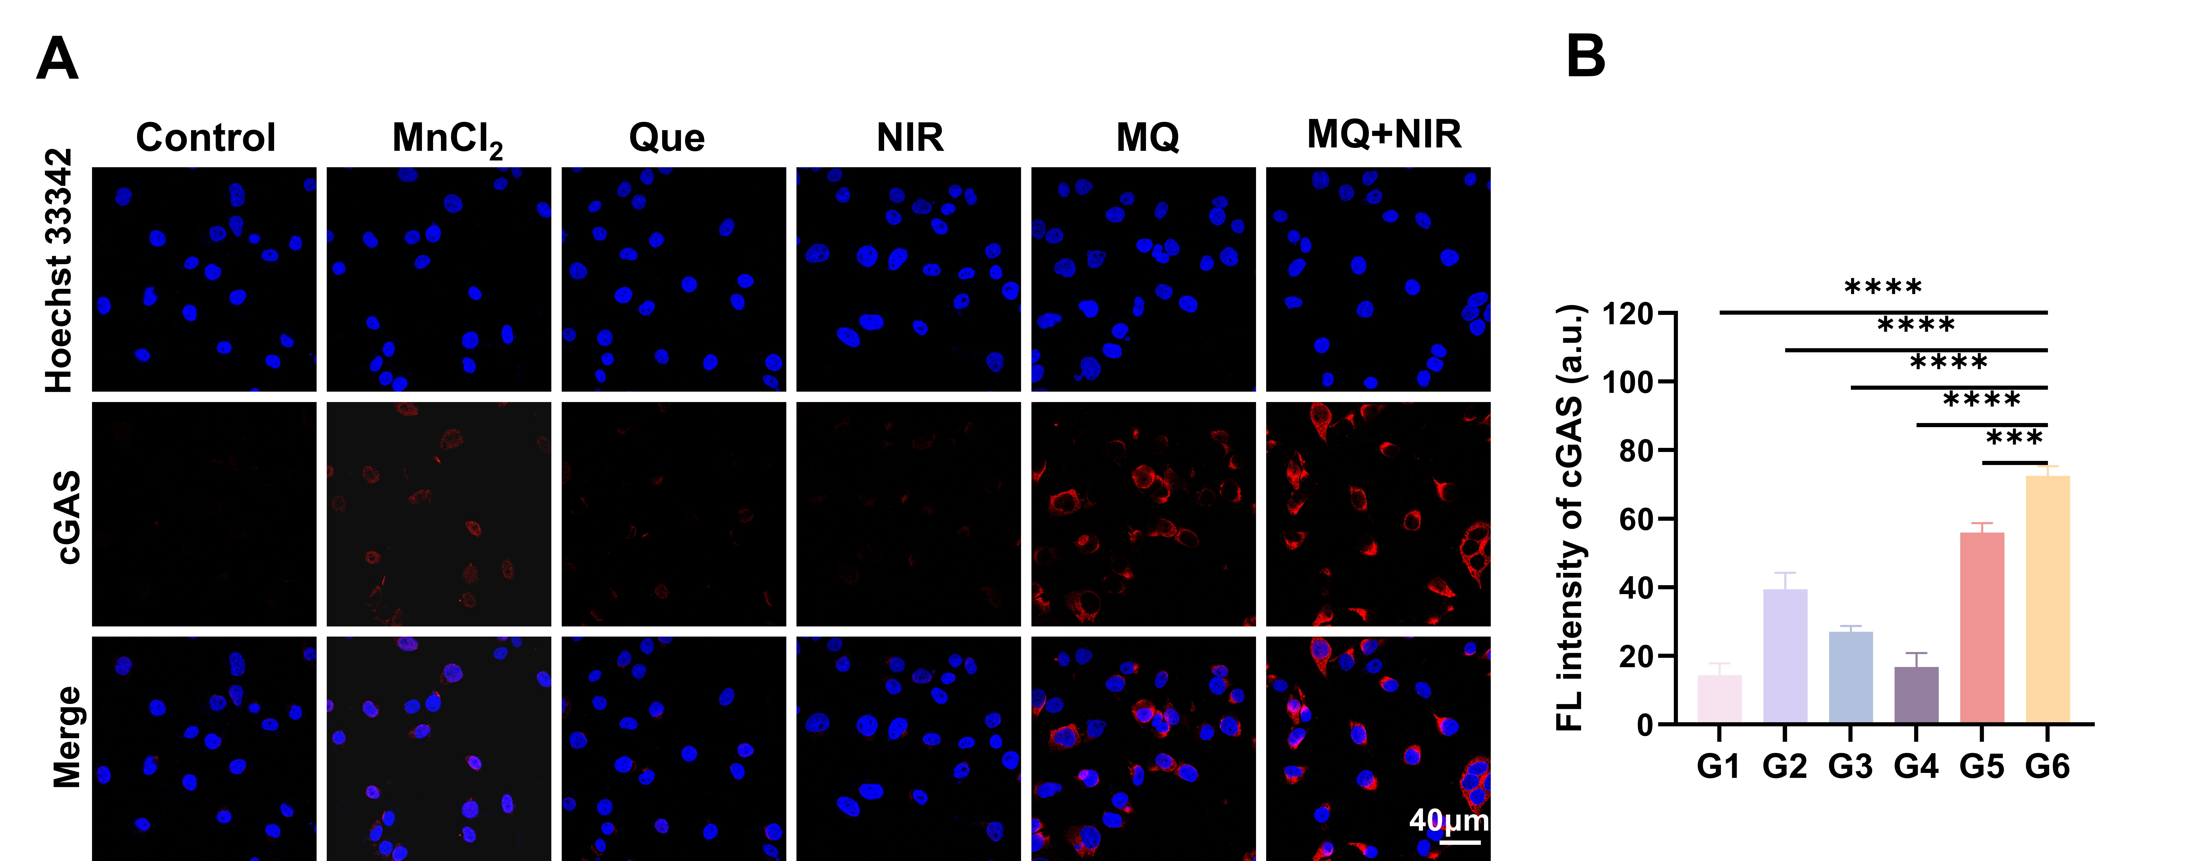
Figure S9. CLSM images obtained from cGAS immunofluorescence staining of the cGAS-STING pathway in Hepa1-6 cells. (B) Semi-quantitative analysis of cGAS. Data were presented as mean ± SD (n=3). Differences between groups were analyzed using one-way ANOVA. Statistical significance was indicated as follows: *p<0.05, **p<0.01, ***p<0.001, ****p<0.0001. "ns" indicated no significant difference.
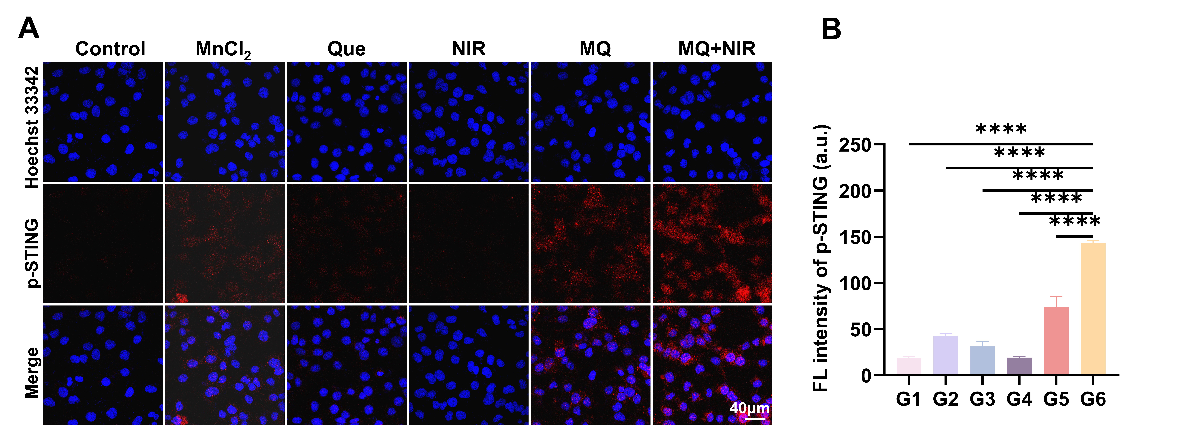

Figure S10. (A) Immunofluorescence staining results of phosphorylated STING (p-STING) activation in the cGAS-STING pathway were observed in Hepa1-6 cells through CLSM. (B) Semi-quantitative analysis of p-STING activation. Data were presented as mean ± SD (n=3). Differences between groups were analyzed using one-way ANOVA. Statistical significance was indicated as follows: *p<0.05, **p<0.01, ***p<0.001, ****p<0.0001. "ns" indicated no significant difference.
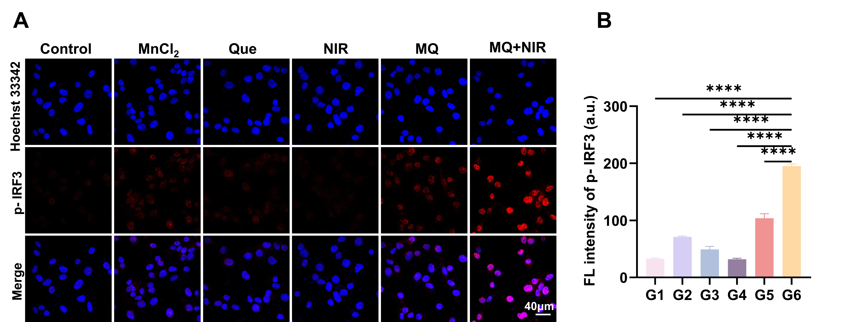
Figure S11. (A) Immunofluorescence staining results of phosphorylated IRF3 (p-IRF3) activation in the cGAS-STING pathway were observed in Hepa1-6 cells through CLSM. (B) Semi-quantitative analysis of p-IRF3 activation. Differences between groups were analyzed using one-way ANOVA. Statistical significance was indicated as follows: *p<0.05, **p<0.01, ***p<0.001, ****p<0.0001. "ns" indicated no significant difference.
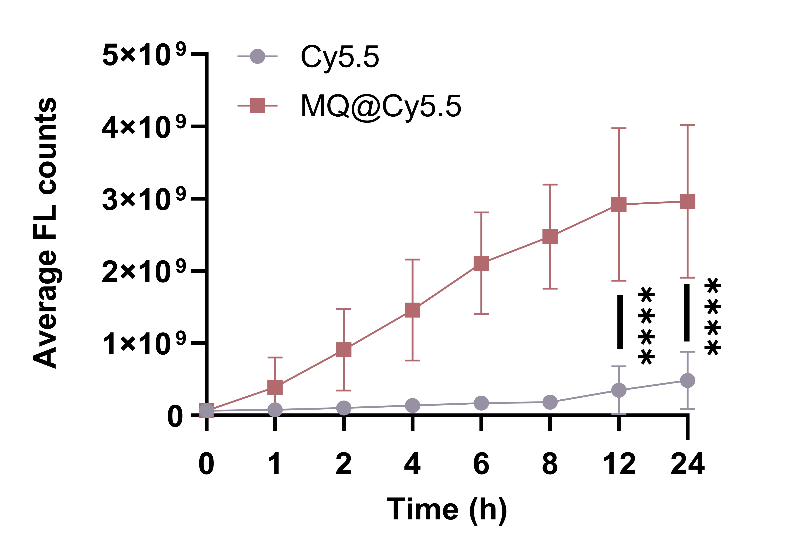
Figure S12. Semi-quantitative analysis of intratumoral fluorescence intensity over time in Hepa1-6 tumor-bearing mice following intravenous injection of Cy5.5 or MQ@Cy5.5. Data were presented as mean ± SD (n=3). Statistical significance was assessed using Student's t test , with significance levels indicated as follows: *p<0.05, **p<0.01, ***p<0.001, ****p<0.0001. "ns" indicated no significant difference.
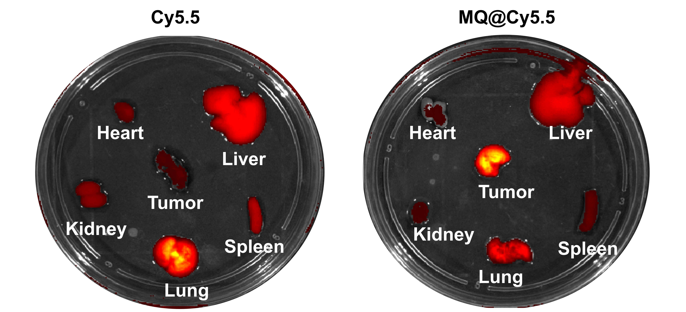

Figure S13. Fluorescence images of tumors and major organs isolated from Hepa1-6 tumor-bearing mice.
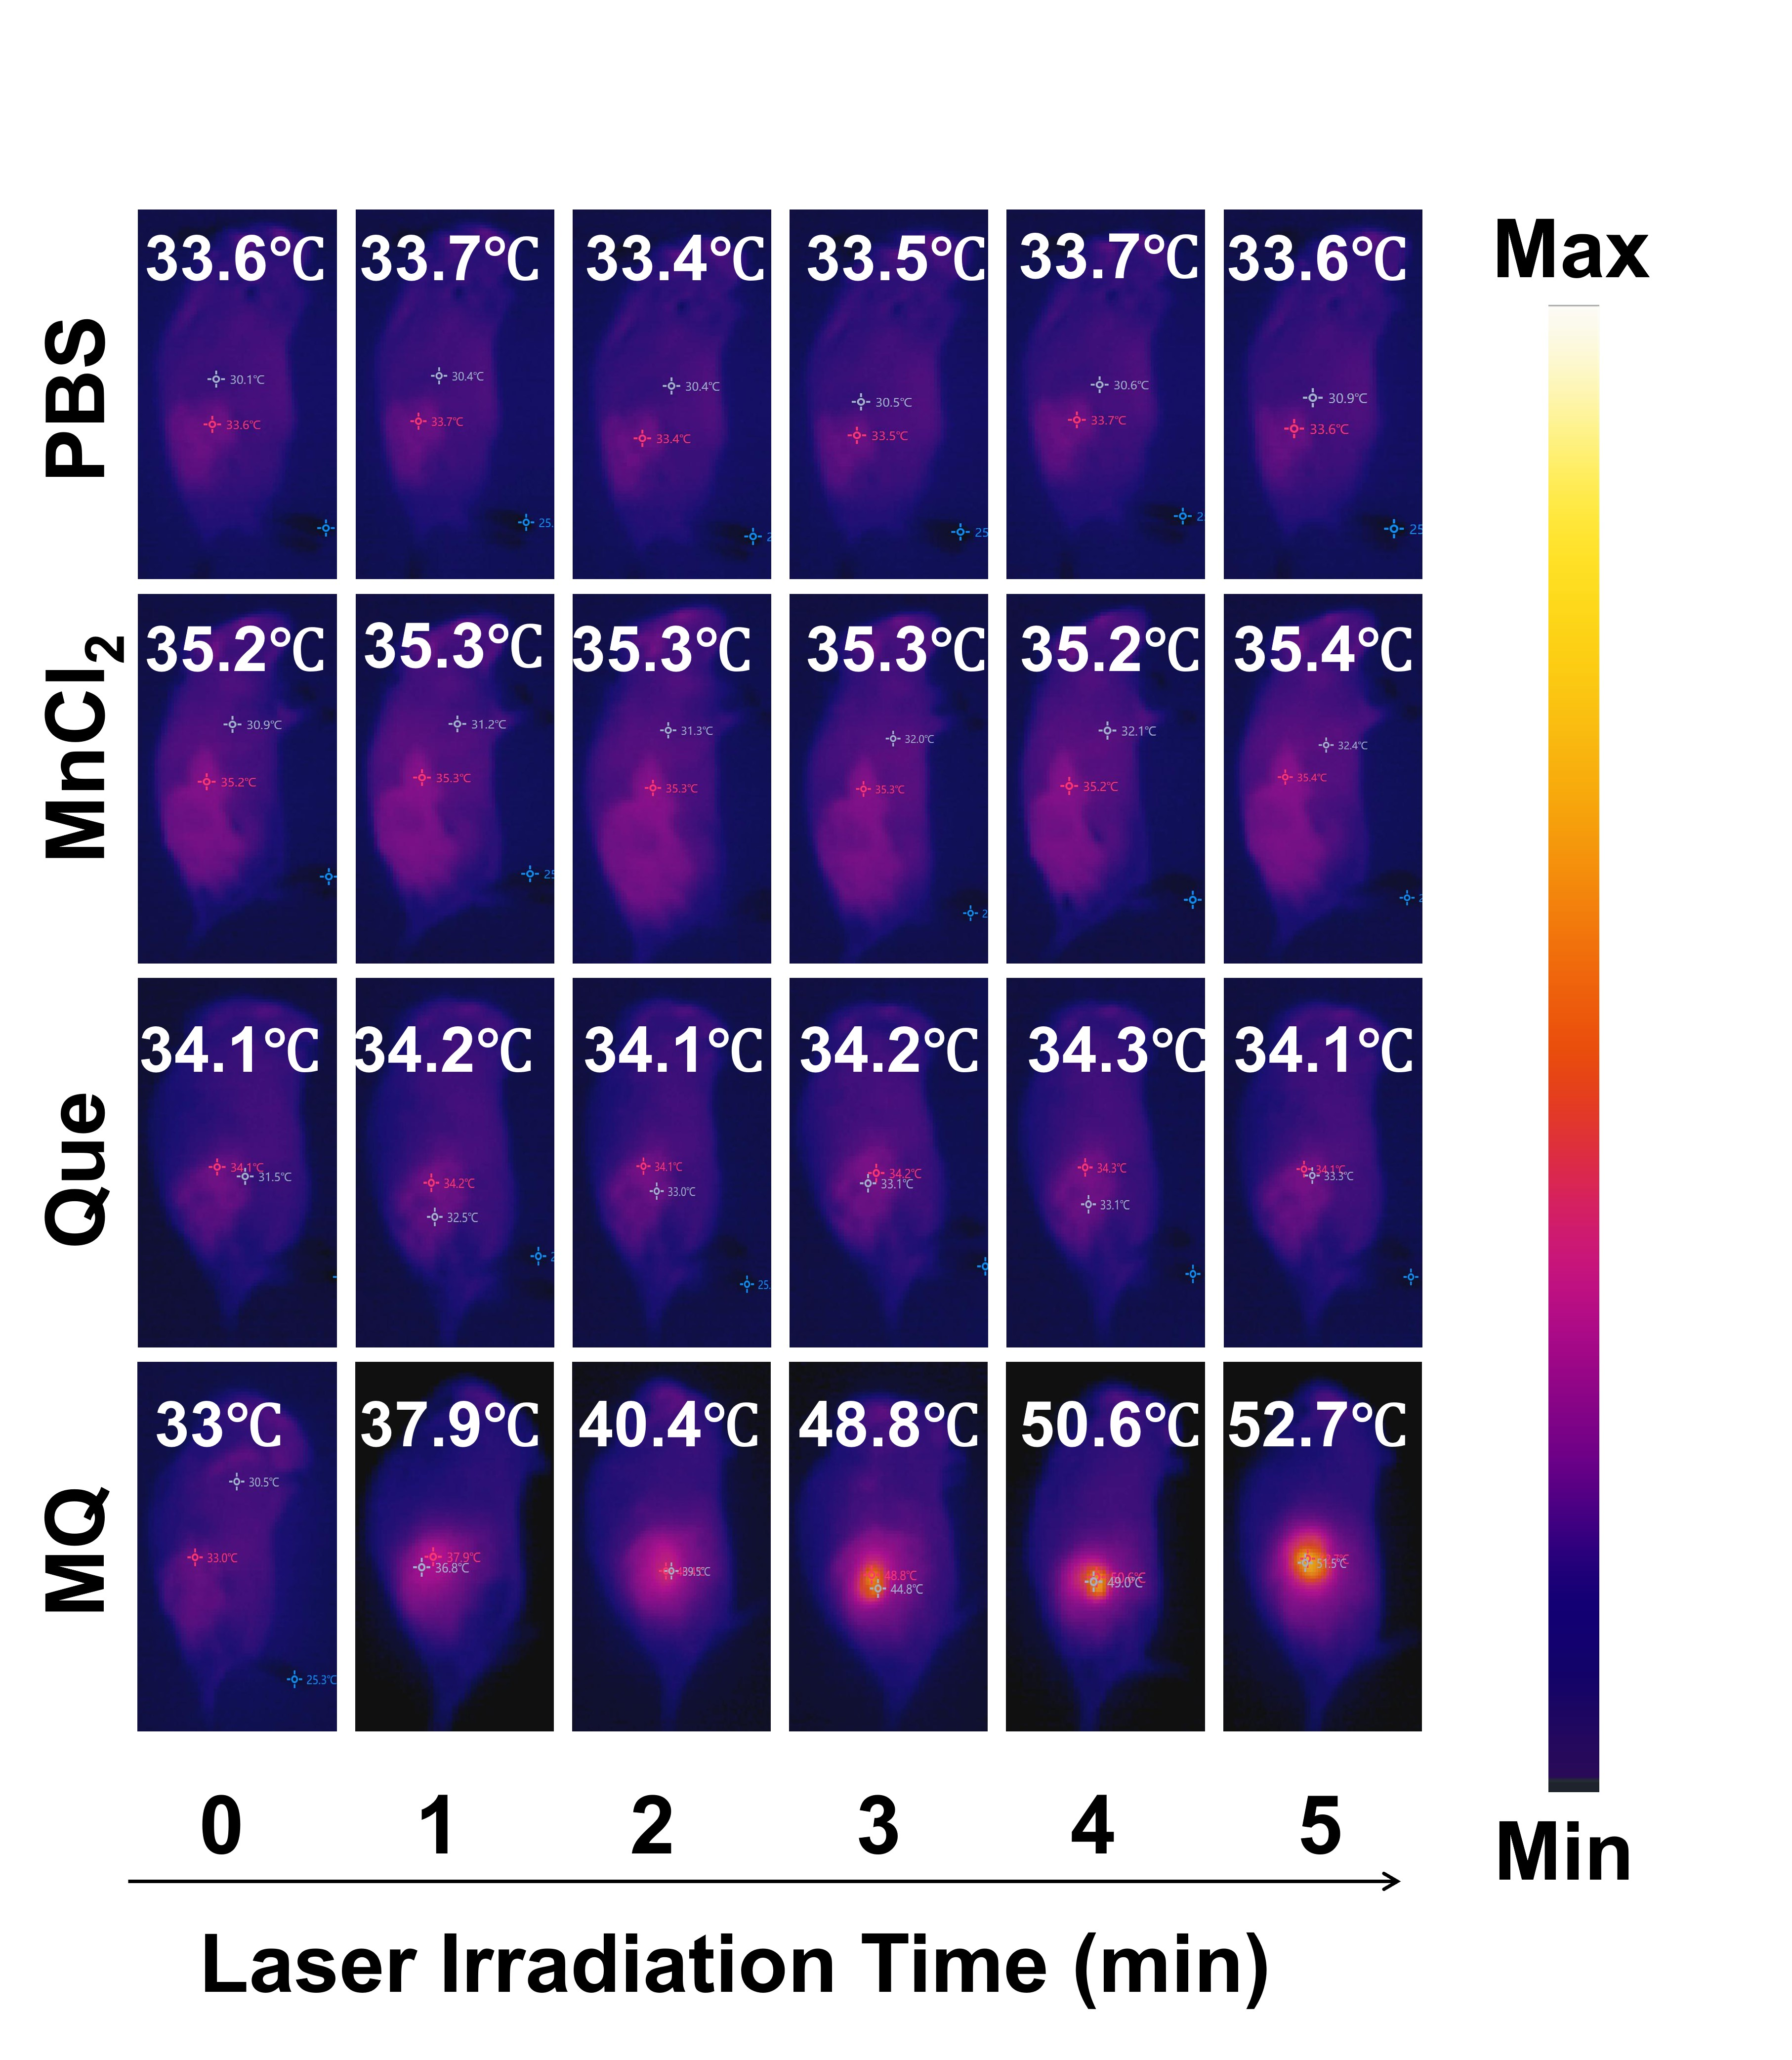
Figure S14. Tumor-bearing mice were administered different drugs, and 24 hours post-injection, the mice were subjected to infrared thermal imaging. (Note: Thermal images were acquired using an infrared thermal camera with near-infrared light at a wavelength of 808 nm.)
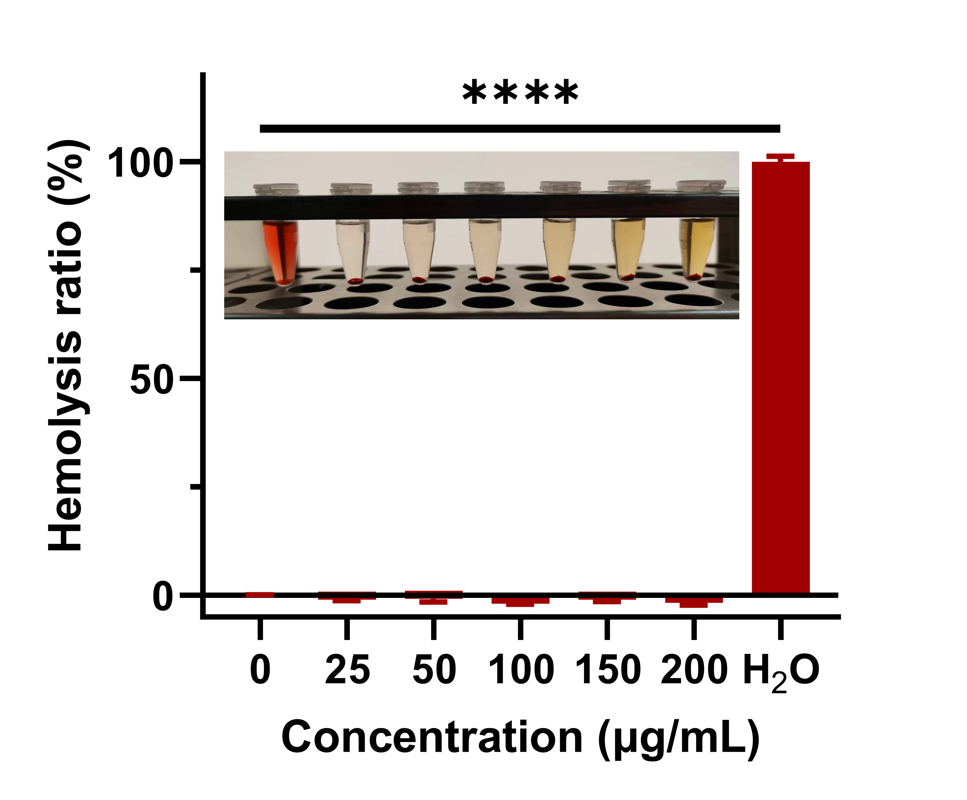
Figure S15. Representative photographs of C57BL/6 mice erythrocytes incubated with varying concentrations of MQ, along with the corresponding hemolysis ratios at these concentrations. Data were presented as mean ± SD (n=3). Statistical significance was indicated as follows: *p<0.05, **p<0.01, ***p<0.001, ****p< 0.0001. "ns" indicated no significant difference.

Figure S16. The comparison of biochemical indicators related to liver and kidney function, as well as routine blood parameters, between mice treated with MQ and normal mice. Statistical comparisons between groups were conducted using the Student's t test. Statistical significance was indicated as follows: *p<0.05, **p<0.01, ***p<0.001, ****p<0.0001. "ns" indicated no significant difference.

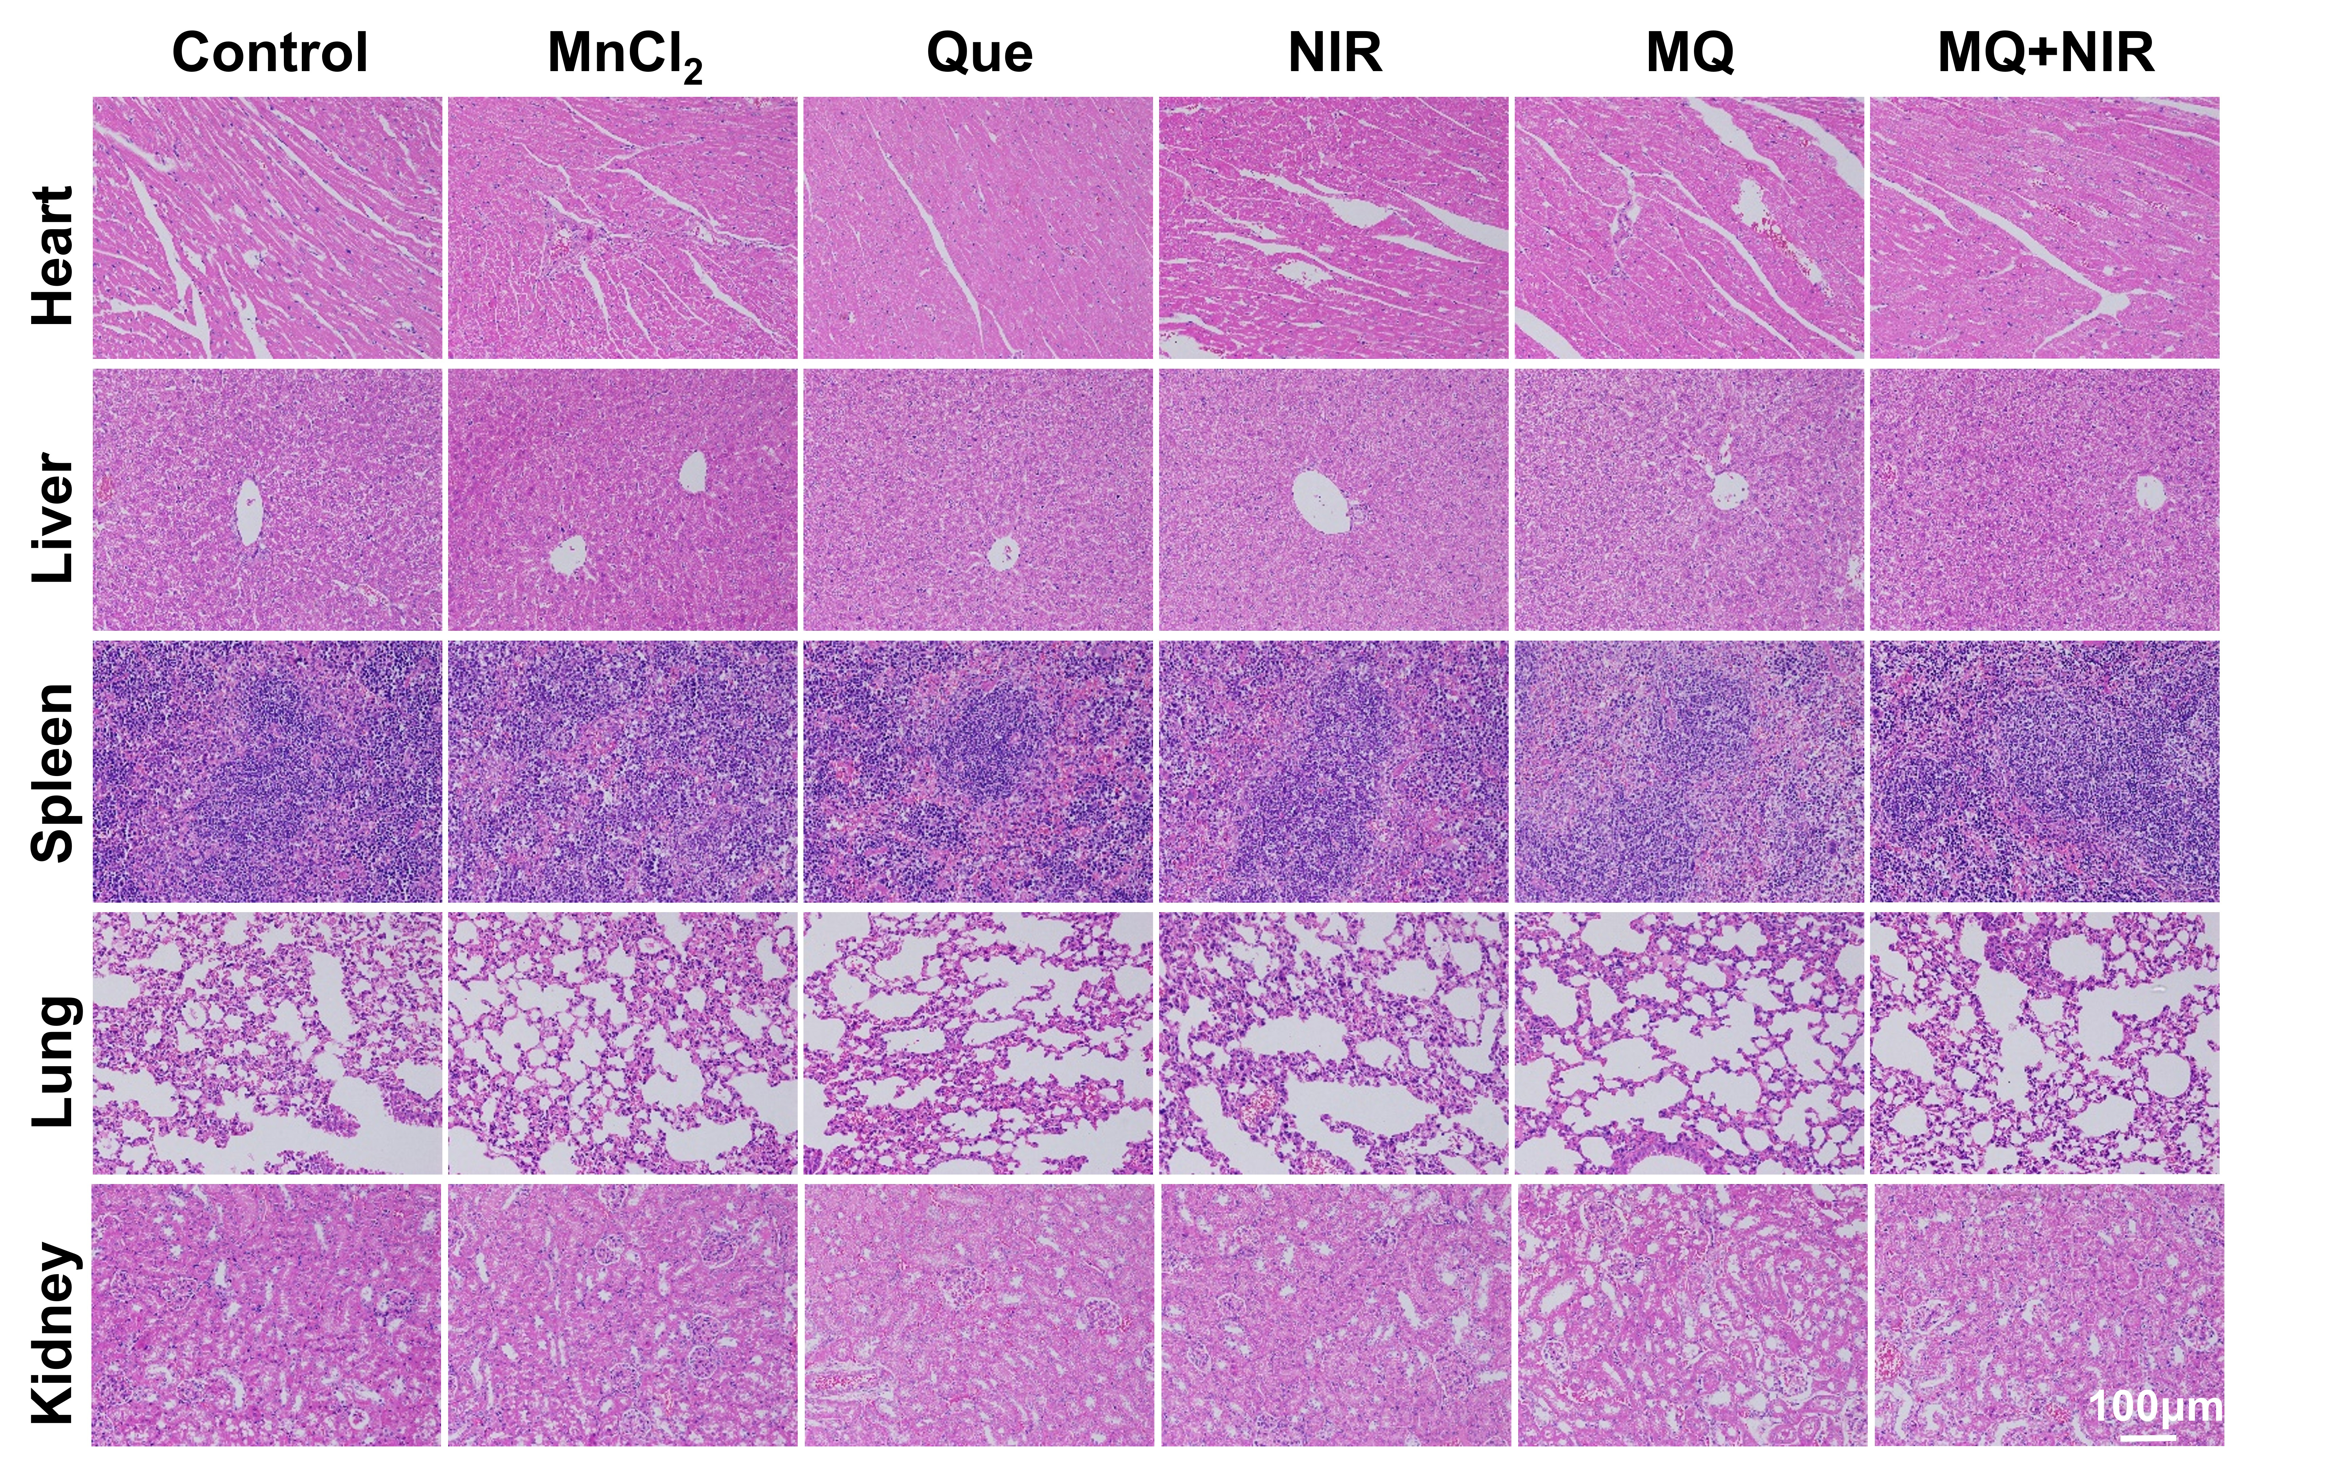

Figure S17. Representative images of H&E staining in the major organs of C57BL/6 mice subjected to different treatments.
Figure S18. Semi-quantitative analysis of the expression levels of various apoptosis-related proteins in tumor tissues (G1: Control, G2: MnCl₂, G3: Que, G4: NIR, G5: MQ, G6: MQ + NIR).
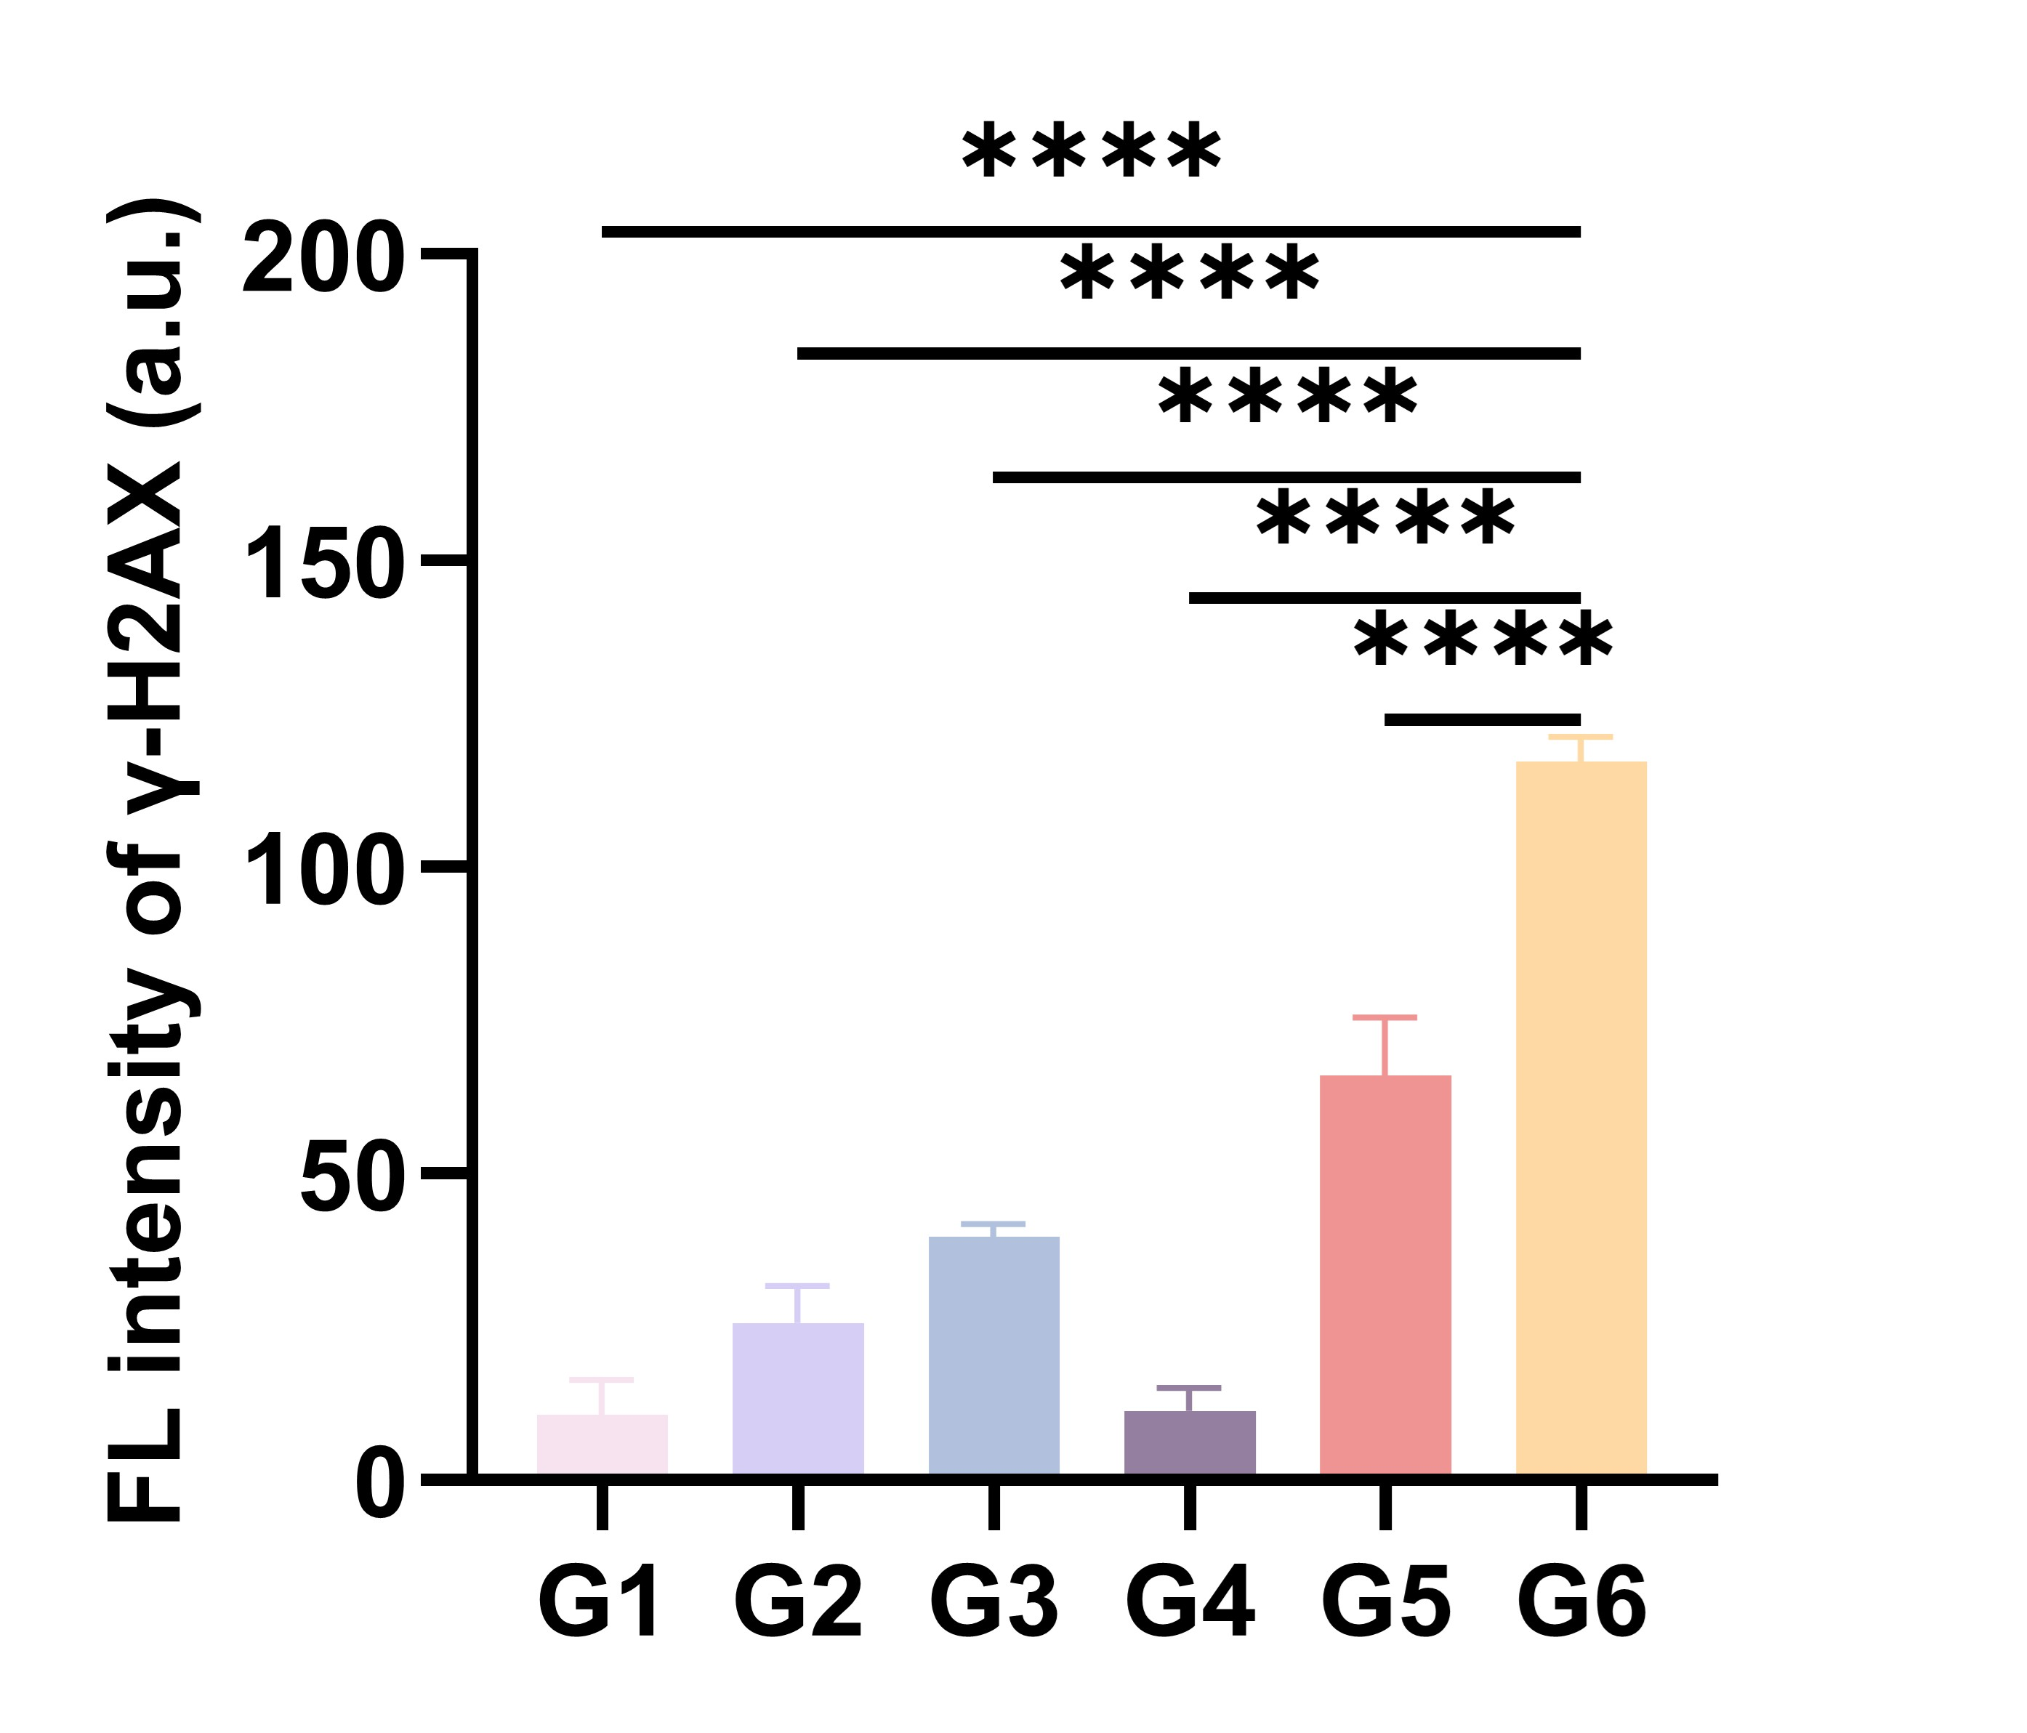
Figure S19. Semi-quantitative fluorescence analysis of DNA damage in isolated tumor sections from Hepa1-6 tumor-bearing mice, labeled with γ-H2AX. Differences between groups were analyzed using one-way ANOVA. Significance levels were indicated as follows: *p<0.05, **p<0.01, ***p<0.001, ****p<0.0001. "ns" indicated no significant difference.
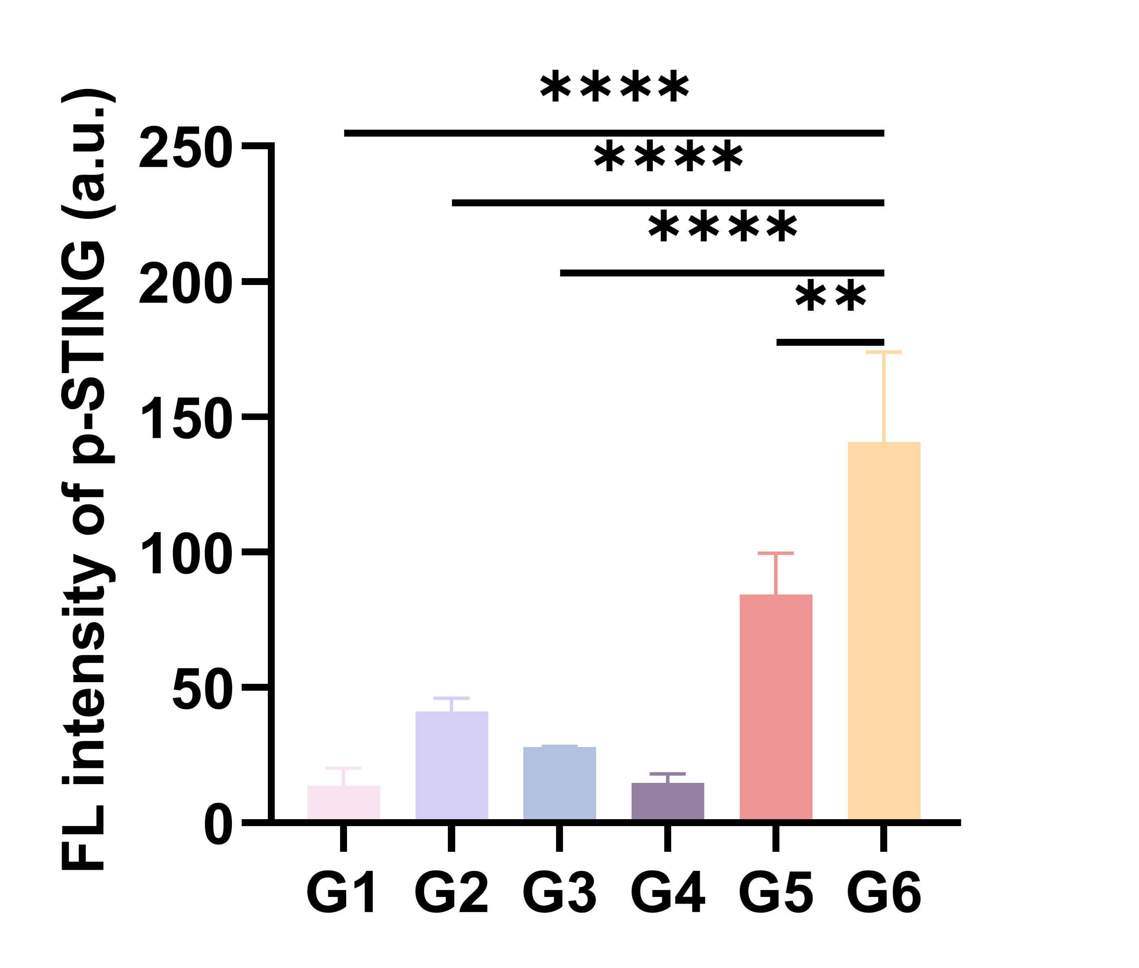
Figure S20. Semi-quantitative analysis of p-STING immunofluorescence staining for phosphorylation in Hepa1-6 tumor-bearing mice in vitro. Differences between groups were assessed using one-way ANOVA. Statistical significance was indicated as follows: *p<0.05, **p<0.01, ***p<0.001, ****p<0.0001. "ns" indicated no significant difference.
Figure S21. Semi-quantitative analysis of the expression levels of various cGAS-STING pathway-related proteins in tumor tissues (G1: Control, G2: MnCl₂, G3: Que, G4: NIR, G5: MQ, G6: MQ + NIR).

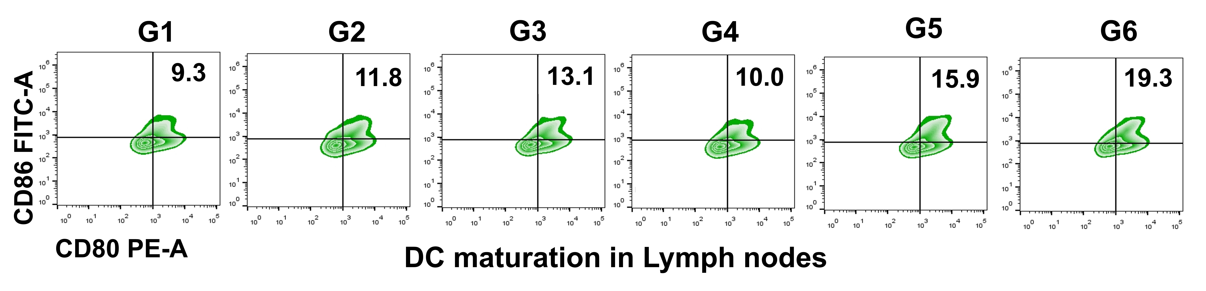

Figure S22. The percentage of CD80⁺CD86⁺ mature dendritic cells in different treatment groups was analyzed by flow cytometry. (G1: Control, G2: MnCl₂, G3: Que, G4: NIR, G5: MQ, G6: MQ + NIR).
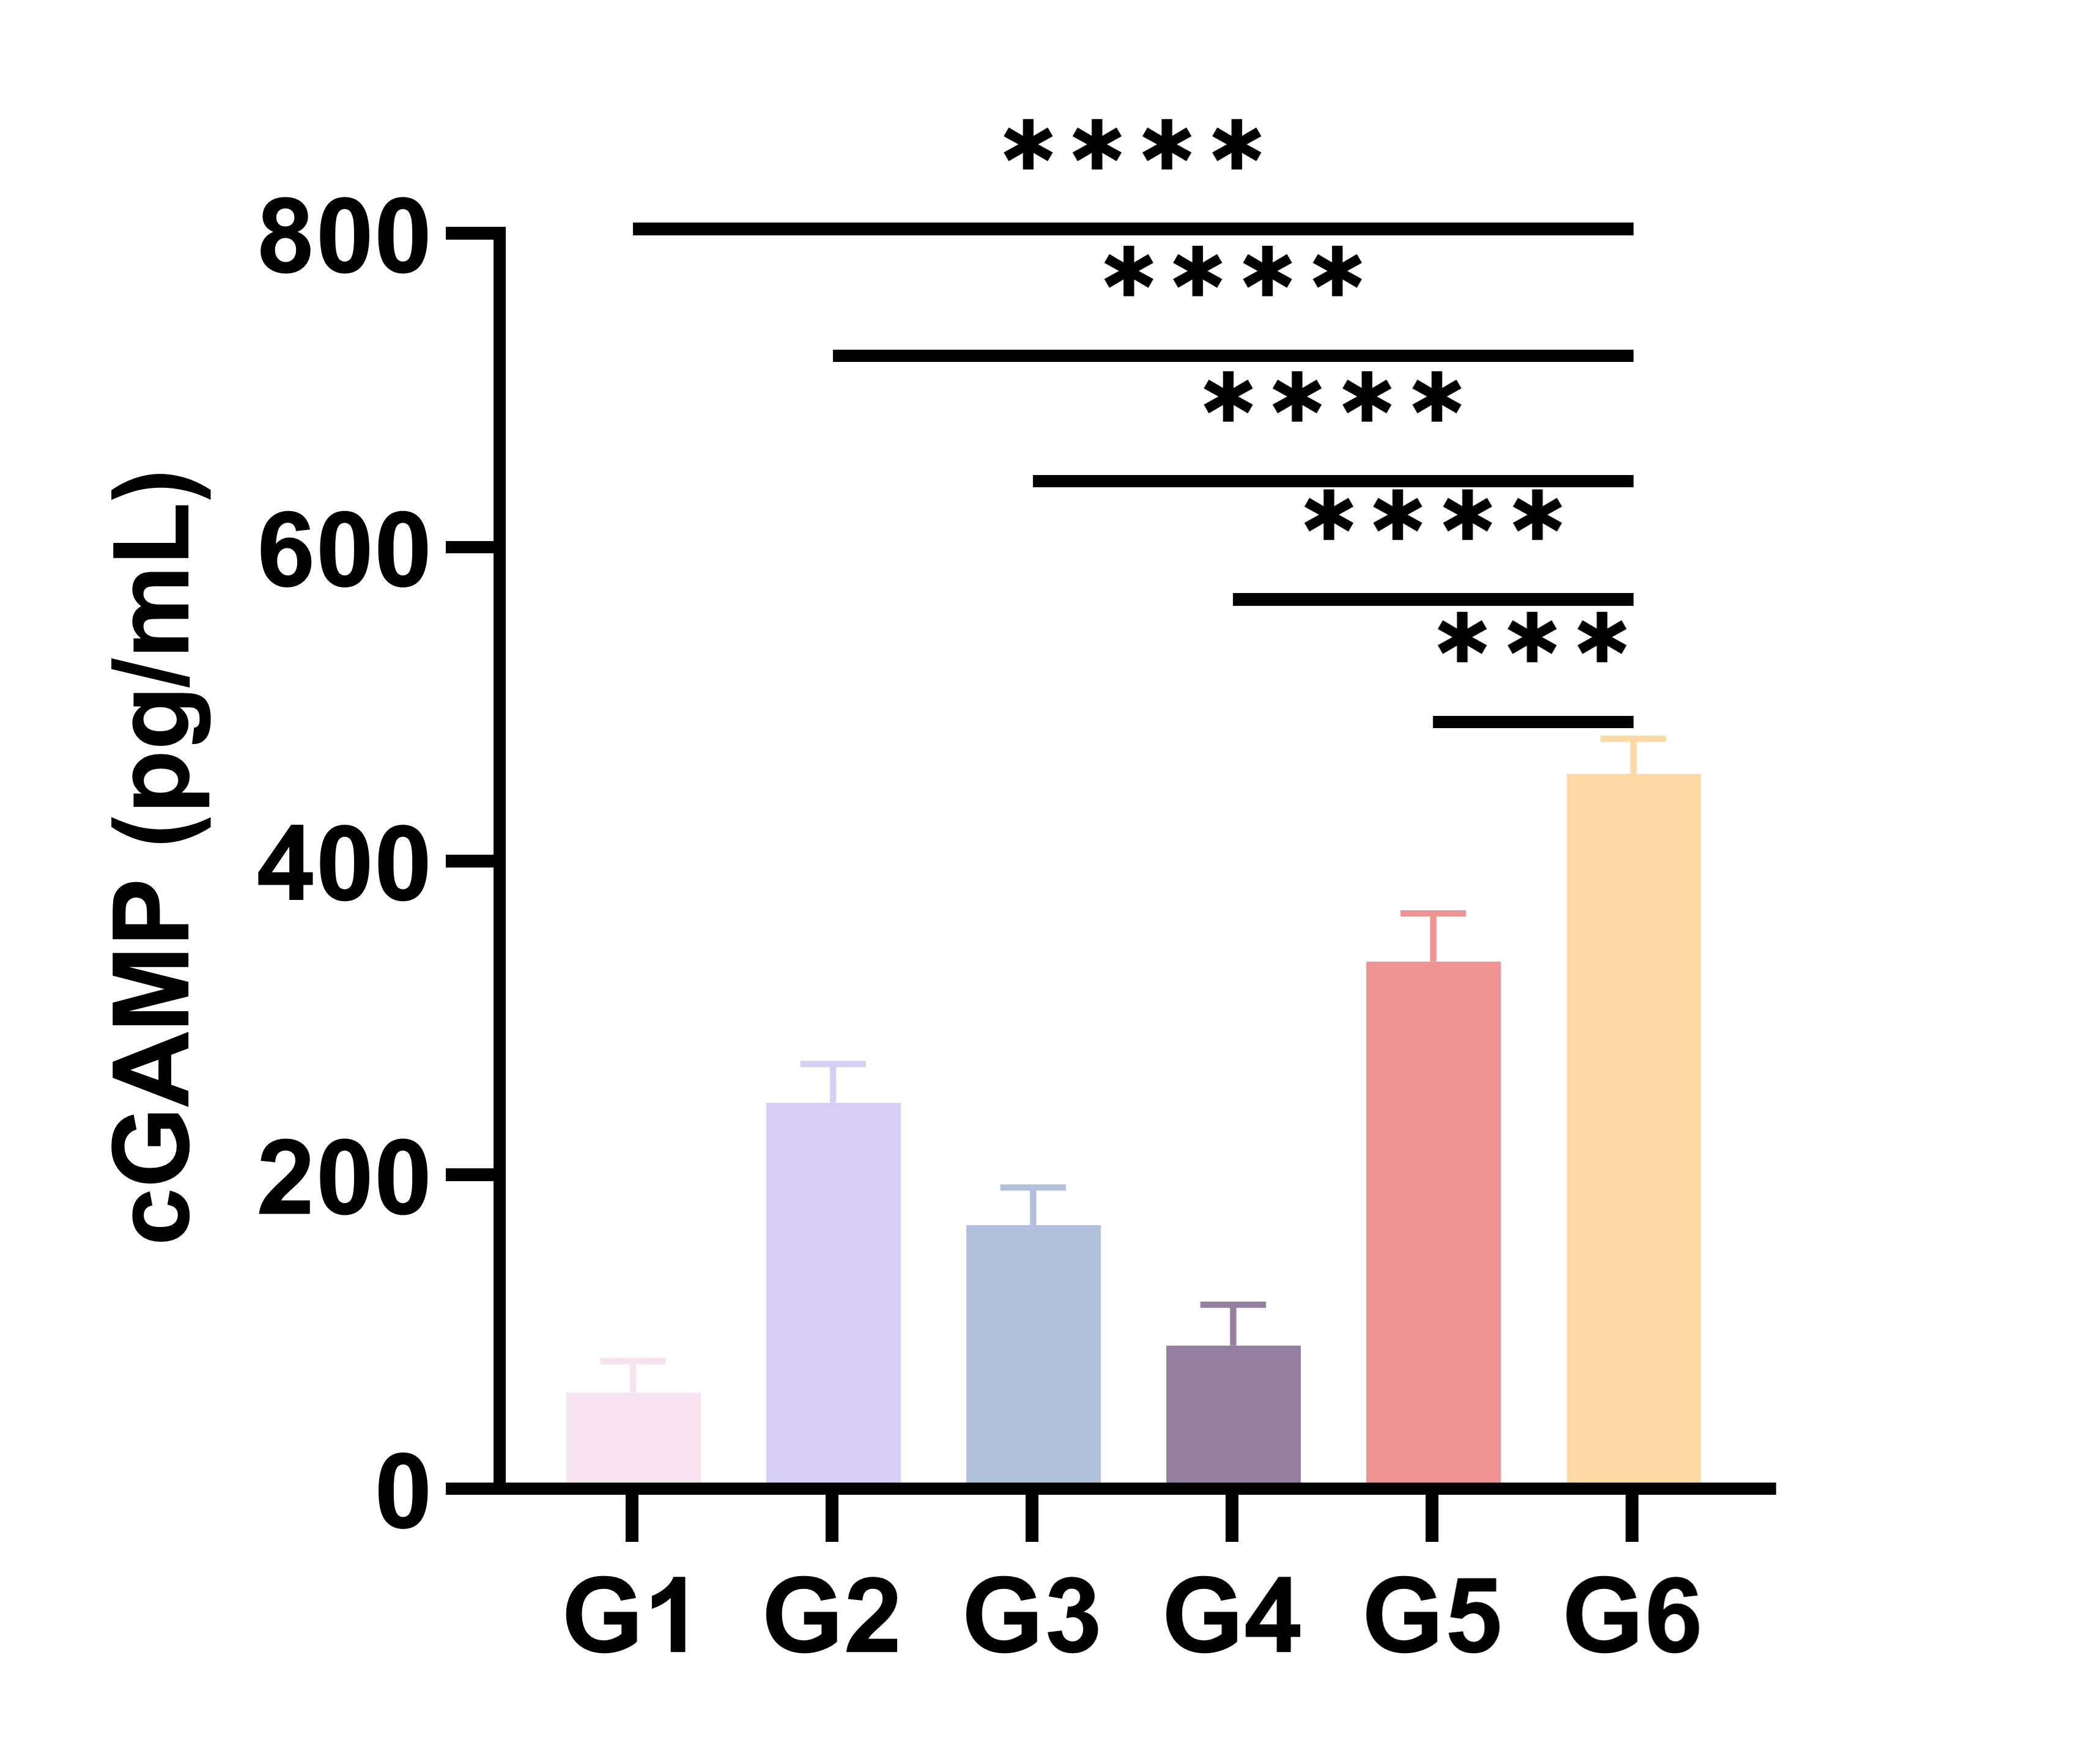
Figure S23. Levels of cGAMP in the serum of Hepa1-6 tumor-bearing mice following different treatments. Differences between groups were analyzed using one-way ANOVA. Significance levels were indicated as follows: *p<0.05, **p<0.01, ***p<0.001, ****p<0.0001. "ns" indicated no significant difference.

Figure S24. (A) Schematic representation of the experimental procedure; Tumor growth over time for the primary tumor (B) and the secondary tumor (C) in each treatment group (n = 5); (D) Time-dependent weight changes in mice from different treatment groups (n = 5); (E) Visual images of primary and secondary tumors in each treatment group; (F) FCM patterns and (G) quantitative analysis of CD8⁺ T cells within the CD3⁺ T cells population after 18 days in different treatment groups; Statistical differences between groups were analyzed using Student's t test. Significance levels were indicated as follows: *p<0.05, **p<0.01, ***p<0.001, ****p < 0.0001. "ns" indicated no significant difference.

