Supplementary figures, videos and tables
Video 1—Video of TPQGel Hydrogel Injection in Liquid Environments and Solid Surfaces
785bb7b40a5d1e41900ba8d7f1de8d5b.mp4
c761b9000ebf9050d356e8c65d0055b9.mp4

Video 2—Compression video of the GelMA, TPGel, and TPQGel hydrogels
20241122222006.mp4

Figure S1
S1. (A)The TEM and mapping of PDA. (B)Element distribution ratio of PDA.

Figure S2
S2. Element distribution ratio of TPQ nanoparticles.

Figure S3
S3.Standard curve of QK peptide

Figure S4
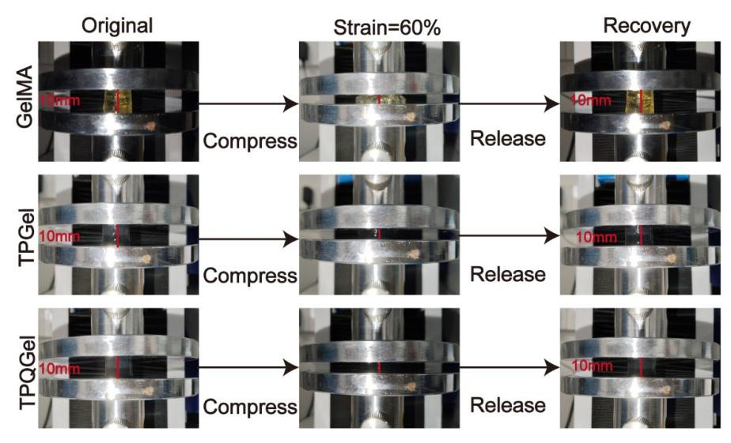
S4. Diagram of the compression process of GelMA, TPGel, and TPQGel hydrogels

Figure S5
S5. In the Control group, macrophages exhibited the M0 phenotype, characterized by their original round shape. In the simple LPS stimulation group, macrophages adopted the M1 phenotype, presenting a typical“pancake-like”spreading morphology, accompanied by the formation of multi-level branching pseudopodia. In the LPS + TPGel group and LPS + TPQGel group, some macrophages exhibited an M2 phenotype, characterized by spindle-shaped elongation and polar pseudopodia oriented elongation. The data are presented as the means±SDs (n = 3). **p < 0.01 indicate significant differences compared with the LPS + TPGel group.

Figure S6
S6. Immunofluorescence staining for RUNX-2. Scale bars: 20 μm
Figure S7
S7. Quantification of immunofluorescence staining for BMP-2, OPN, and RUNX-2 in MC-3T3-E1cells. *p <0.05, **p < 0.01 indicates signiﬁcant diﬀerences compared with the control group. ##p < 0.01 indicates signiﬁcant diﬀerences compared with the TPGel group.

Figure S8
S8. Immunohistochemical staining quantitative analysis of CD86 and CD206. Scale bars: 30 μm. The data are presented as the means ± SDs (n = 3). *p <0.05, **p < 0.01 indicate significant differences compared with the Control group. ##p < 0.01 indicates significant differences compared with the TPGel group.

Figure S9
S9. Immunohistochemical staining quantitative analysis of CD31 and VEGF. Scale bars: 30 μm. The data are presented as the means ± SDs (n = 3). *p <0.05, **p < 0.01 indicate significant differences compared with the Control group. ##p < 0.01 indicates significant differences compared with the TPGel group.

Table 1
Primers used in RT-qPCR.
Gene | Forward Primer (5′-3′) | Reverse Primer (5′-3′)
Mouse-GAPDH | TGACCACAGTCCATGCCATC | GACGGACACATTGGGGGTAG
Mouse-CD86 | ATATGACCGTTGTGTGTGTTCTGGA | AGGGCCACAGTAACTGAAGCTGTAA
Mouse-CD206 | ATGGATTGCCCTGAACAGCA | TGTACCGCACCCTCCATCTA
Mouse-IL-4 | ACGGAGATGGATGTGCCAAAC | AGCACCTTGGAAGCCCTACAGA
Mouse-IL-6 | CCACTTCACAAGTCGGAGGCTTA | TGCAAGTGCATCATCGTTGTTC
Mouse-ARG-1 | ACATTGGCTTGCGAGACGTA | ATCACCTTGCCAATCCCCAG
Mouse-CD11b | CCACACTAGCATCAAGGGCA | GCTTCACACTGCCACCGT
Human-GAPDH | GAAAGCCTGCCGGTGACTAA | GCCCAATACGACCAAATCAGAGA
Human-VEGF | CTTGCCTTGCTGCTCTACCT | AGCTGCGCTGATAGACATCC
Human-KDR | GGAAGGTTGCTTGCTCTCAC | CAGGGCAGACAAGTGGGTAT
Human-FLT1 | TCACCACGGACCTCAATACA | CGATGCTTCACGCTGATAAA
Rat-GAPDH | TCAACAGGGATGCTTACCCC | CCGATACGGCCAAATCCGTTC
Rat-Runx-2 | GACCAACCGAGTCATTTAAGGC | AAGAGGCTGTTTGACGCCAT
Rat-OPN | TCACTGCCAGCACACAAG | GCATCGGGATACTGTTCA
Rat-BMP-2 | CTGCGGTCTCCTAAAGGTCG | ACTCAAACTCGCTGAGGACG
Rat-Col-1 | CACTCAGCCCTCTGTGCCTC | AACCTTCGCTTCCATACTCG
Mouse-Tnf | CCCTCACACTCACAAACCAC | ACAAGGTACAACCCATCGGC
Mouse-CD40 | TTGTTGACAGCGGTCCATCT | TCTCAAGAGCTGTGCAGTGG
Mouse-Birc3 | AAGAGCCAAGAGCCTTCAAGT | TGCTAGGCTGATACCCTTGG
Mouse-Tnfsf13b | TTGTACCAGTTGGCTGCCTT | GCCGGTGTCAGGAGTTTGA
Mouse-Lta | GCCTTTCCTGCCTTCGACTG | GTCATGTGGAGAACCTGCTGTG
Mouse-Ltb  Mouse-Map3k14 | GATCAGGGACGTCGGGTTGAG  CCCGCTTTGTCTCAAGATTGC | CTGAGAGGCTAGAGGGTGAGG  CTCCCACTTCCTGTAGTGCC
Mouse-Tnfsf14 | TCCTGAGACTGCATCAACGTC | TGGCGTTGGCTCCTGTAAGA
Mouse-Tnfrsf11a | CTTGCACGGCTGGCTACC | CCTTGTTGAGCTGCAAGGGATG
Mouse-Bcl2 | CACCCCTGGTGGACAACATC | ATAGTTCCACAAAGGCATCCCAG

