Tumor microenvironment-responsive precise delivery nanocarrier potentiating synchronous ﻿radionuclide therapy and chemotherapy against cancer
Jie An^{123†}, Qin Zhou^{1234†}, Kaile Chu¹²³⁴, Siyuan Chen¹²³, Chenliang Niu⁴, Weiming Zhang¹²³⁴, Jie Gao⁵, Min Li¹²³, Jianbo Cao¹²³, Junping Lv ¹²³, Di Zhang¹²³, Zhifang Wu¹²³, Sijin Li ¹²³*, Hua Wei¹²³*.
¹ Department of Nuclear Medicine, The First Hospital of Shanxi Medical University, Shanxi Medical University, Taiyuan 030001, Shanxi, P. R. China.
² Shanxi Key Laboratory of Molecular Imaging, Shanxi Medical University, Taiyuan 030001, Shanxi, P. R. China.
³ Collaborative Innovation Center for Molecular Imaging of Precision Medicine Shanxi Medical University, Taiyuan 030001, Shanxi, P. R. China.
⁴ Academy of Medical Sciences, Shanxi Medical University, Taiyuan 030001, Shanxi Province, P. R. China.
⁵ CAEA Center of Excellence on Nuclear Technology Applications for Nonclinical Evaluation for Radiopharmaceutical; Shanxi Key Laboratory of Drug Toxicology and Preclinical Studies for Radiopharmaceutical, Taiyuan 030006, Shanxi Province, P. R. China.
†* Corresponding author.
*: Email address: lisjnm123@163.com (Sijin Li); jennyhua1981@sina.com (Hua Wei).
﻿†: Jie An and Qin Zhou equally contributed to this article

Supplementary Figures

Fig. S1. Zeta potentials of MIL-100(Fe), MHH, MHHD.

Fig. S2. The DOX encapsulation efficiency(a) and loading amounts(b) of MH and MHH.

Fig. S3. TEM images (a) and after 24 h of placement of pH 7.4 (b) and pH 5.5 (c) PBS of MHHD.

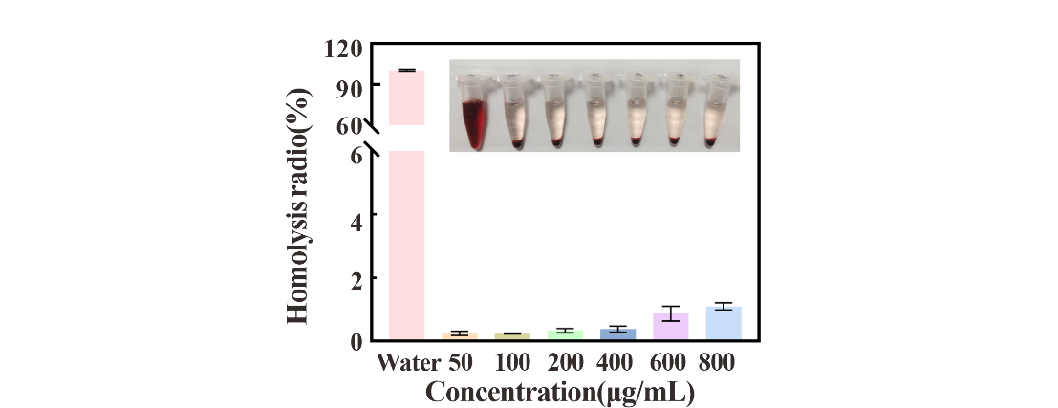
Fig. S4. The hemolysis rates of MHH, inset: digital photo showing hemolysis phenomenon.

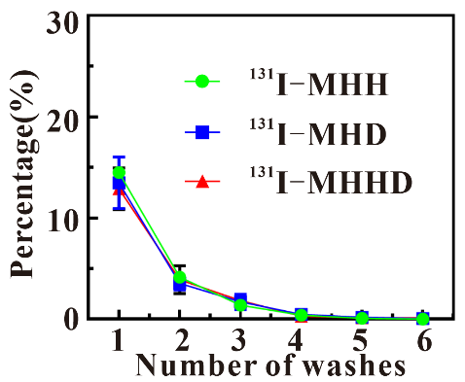
Fig. S5. The percentage of unbound ¹³¹I in the supernatant during the iterative washing process of precipitate ¹³¹I-MHH, ¹³¹I-MHD, and ¹³¹I-MHHD.

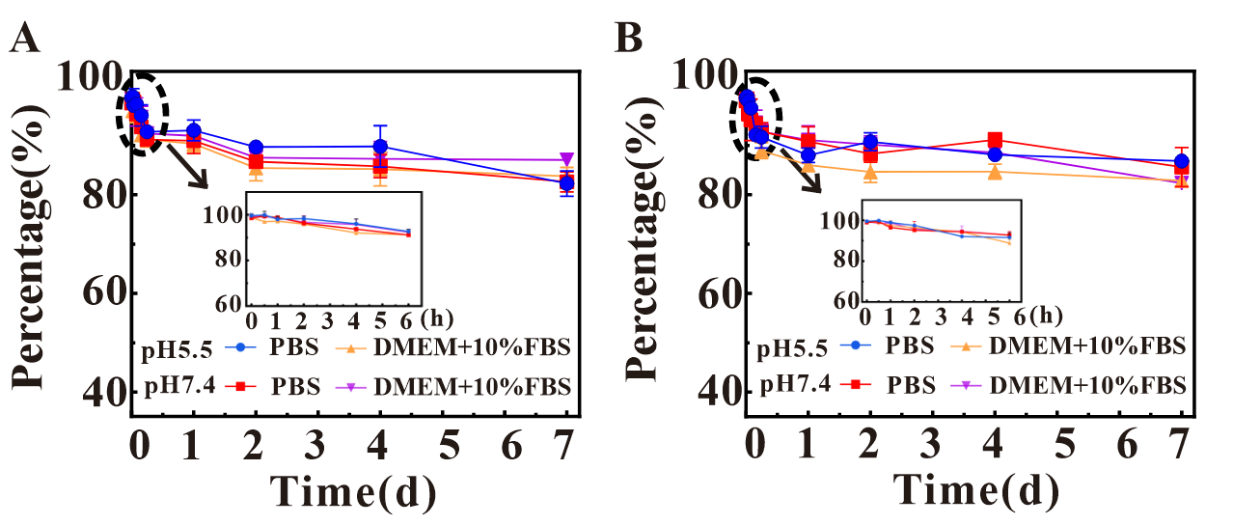
Fig. S6. The stability of radionuclide labeling of ¹³¹ I-MHD in PBS and DMEM medium containing 10% fetal bovine serum (DMEM+10% FBS) in pH5.5/7.4 after different time storage.

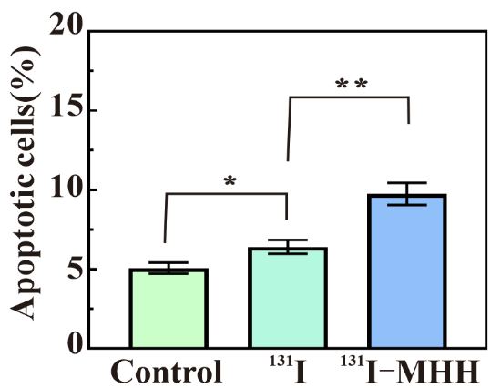
Fig. S7. The combined quantitative value of early apoptosis (Q3) and late apoptosis (Q2), as determined by flow cytometry analysis, represents the total apoptotic cell population., for the following conditions: Control, ¹³¹I, and ¹³¹I-MHH (25μCi).

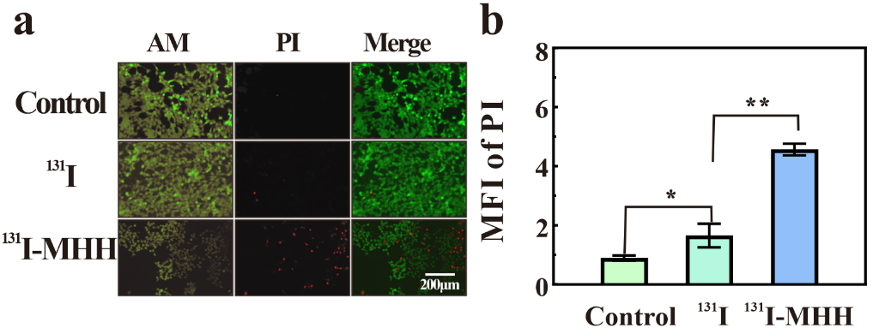
Fig. S8. Fluorescence imaging of Calcein AM/PI staining of 4T1 cells after different groups of treatments (Control, ¹³¹I, ¹³¹I-MHH) (a) and mean fluorescence intensity of PI (b).

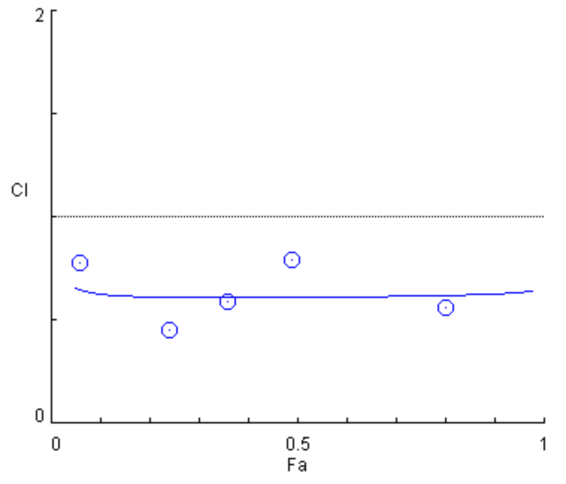
Fig. S9. The combination index (CI) values for the combined treatment of ¹³¹I radiotherapy and DOX chemotherapy were evaluated across varying fractional cell inhibition rates (Fa).

Fig. S10. SPECT imaging of 4T1 tumor-bearing mice at different time points post Intratumoral injection of ¹³¹I, ¹³¹I-MHD and ¹³¹I-MHHD. The tumors are highlighted by red circles.

Fig. S11. The distribution of radioactive substances in the tumor at different time points after intravenous injection of ¹³¹I and ¹³¹I-MHHD (n=3).

Fig. S12. H&E-stained sections of thyroid and crosscut muscle tissue were obtained 30 days post-injection of PBS and ¹³¹I-MHHD in Balb/C mice.

