Microglia-targeting nanosystems that cooperatively deliver Chinese herbal ingredients alleviate behavioral and cognitive deficits in Alzheimer's disease model mice
Peng Zhou¹, Quan Chao¹, Chen Li¹, Ningjing Wang¹, Siqi Guo¹, Pingping Wang¹, Pingyuan Ge¹, Caihong Li¹, Rui Guo¹, Nianyun Yang¹, Zhangdi Lu⁴, Zhishu Tang^{2,3}, Qichun Zhang¹, Tingming Fu¹, Qingqing Xiao^{1,*}, Huaxu Zhu^{1,*}
¹Jiangsu Botanical Medicine Refinement Engineering Research Center, Nanjing University of Chinese Medicine, Nanjing 210023, China
²State Key Laboratory of Research & Development of Characteristic Qin Medicine Resources, Shanxi University of Chinese Medicine, Xianyang 712038, China
³China Academy of Chinese Medical Sciences, Beijing 100700, China
⁴ Polymer Science and Materials Chemistry, Exponent Ltd., Hong Kong 999077, China
*Corresponding authors: xiaoqq@njucm.edu.cn (Qingqing Xiao), zhuhx@njucm.edu.cn (Huaxu Zhu)

Preparation condition | Encapsulation efficiency (%) | Drug loading capacity (%)
Membrane material ratio (w/w) | / | /
4:1 | 47.8±4.42 | 1.50±0.14
8:1 | 72.49±6.90 | 2.97±0.12
12:1 | 70.38±7.90 | 2.42±0.27
16:1 | 26.86±2.70 | 0.93±0.10
20:1 | 26.35±12.52 | 0.92±0.44
Drug-to-lipid ratio (w/w) | / | /
1:10 | 77.45±7.67 | 9.14±0.75
1:20 | 70.64±7.23 | 5.59±0.37
1:30 | 90.99±0.83 | 3.25±0.03
Ultrasound power (%) | / | /
20 | 77.45±7.67 | 2.53±0.26
25 | 37.18±3.55 | 1.23±0.12
30 | 41.25±17.82 | 1.37±0.59
35 | 37.82±6.13 | 1.25±0.21
40 | 35.31±2.67 | 1.17±0.09
Ultrasound duration (min) | / | /
10 | 69.01±3.94 | 2.26±0.13
15 | 40.53±8.21 | 1.34±0.27
20 | 56.81±11.31 | 1.87±0.38
25 | 63.28±11.02 | 2.08±0.38
30 | 77.45±7.60 | 2.53±0.25

Table S1. The Tf-Lip-Ber preparation process optimization. The membrane material ratio is the proportion of Tf-mPEG2000 to PC. The drug-to-lipid ratio is the proportion of Be to the two types of membrane materials. As results, the Tf-Lip-Ber was prepared with the membrane ratio of 1:8, the drug to lipid ratio of 1:30, the ultrasonic power of 20%, and the ultrasonic time of 30min. Data are presented as the mean ± SDs (n = 3).

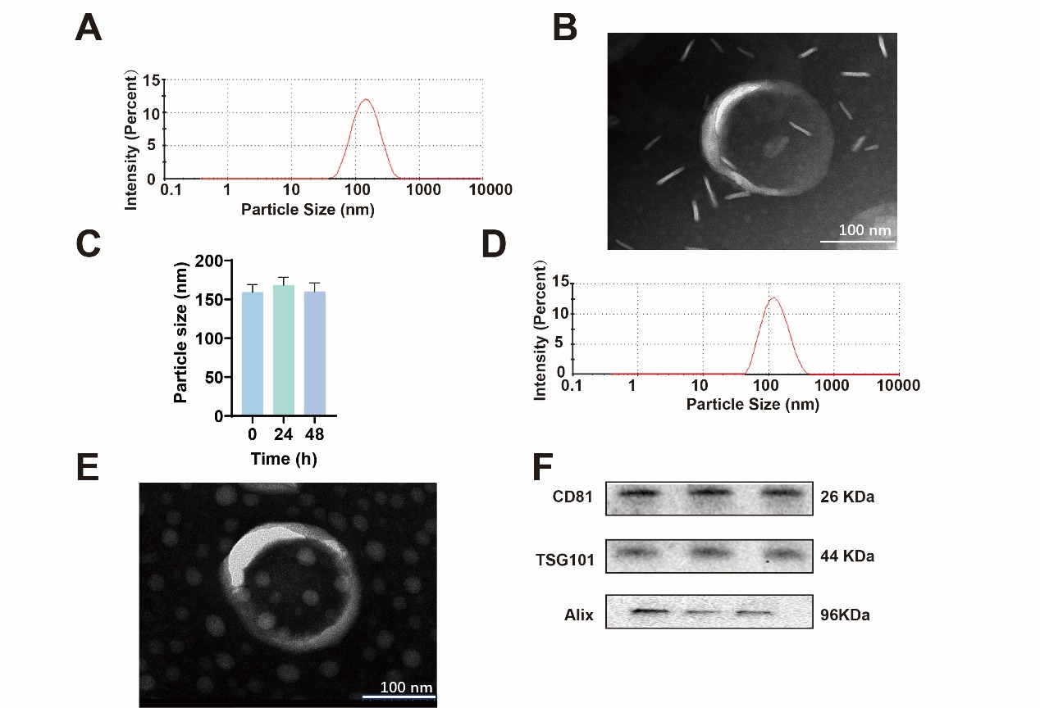

Fig. S1. Preparation and characterization of Tf-Lip-Ber and Exo. (A) The particle size distribution of Tf-Lip-Ber was determined by Marvin particle size analyzer, and the average particle size was 158 nm. (B) Representative transmission electron microscope image of Lip. Scale bar, 50 nm. (C) The stability of Tf-Lip-Ber within 48 h was measured by Malvern particle size analyzer. (D) The particle size distribution of Exo was measured by Malvern particle size analyzer, with an average particle size of 150 nm. (E) Representative transmission electron microscope images of Exo. Scale bar, 100 nm. (F) Western blot analysis of exosome characteristic proteins CD81, TSG101 and Alix. Repeat for 3 times.
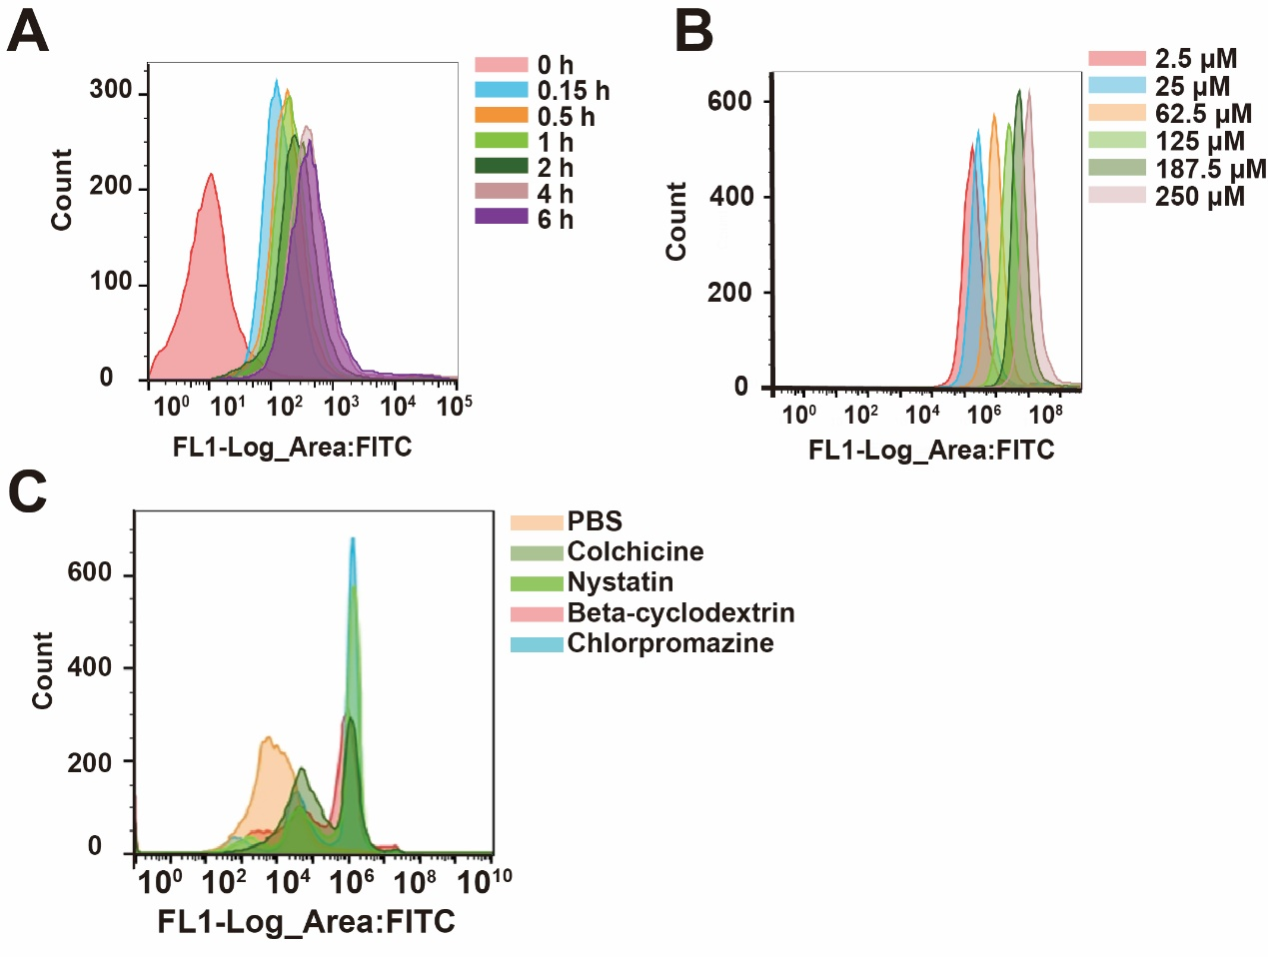

Fig. S2. Cellular uptake and in vitro uptake mechanisms of Tf-hEVs-Ber/Pal. Cellular uptake of FITC (green) labelled Tf-hEVs-Ber/Pal with increasing (A) time and (B) concentration was determined by flow cytometry. The concentration of FITC is 125 μM and the incubation time was 4 h. (C) Intracellular accumulation of Tf-hEVs-Ber/Pal was quantitatively measured by flow cytometry. BV2 cells were pre-incubated with different endocytosis pathway inhibitors for 30 minutes, followed by incubation with FITC-labeled Tf-hEVs-Ber/Pal for 2 h.
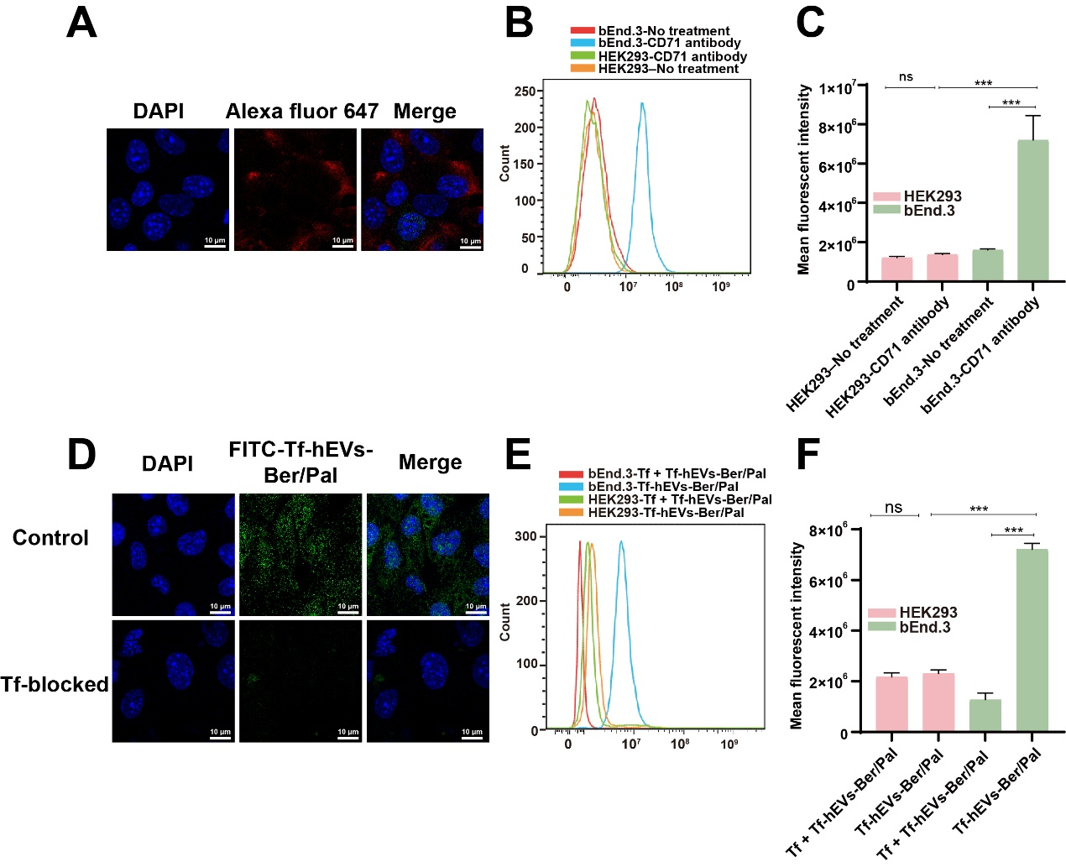
Fig. S3. Cell selection for the in vitro BBB model construction. The expression of Transferrin receptor (TfR) and Tf-hEVs-Ber/Pal interaction with TfR were observed in bEnd.3 Cells and HEK293 cells. (A) Confocal microscopy analysis of Tf expression in bEnd.3 cells. (B) Flow cytometric analysis of TfR expression in HEK293 and bEnd.3 cells. (C) Quantification of average fluorescence intensity. The HEK293–untreated and bEnd.3–untreated groups received no treatment, which was blank cells. TfR was labeled with a CD71 primary antibody and stained with Alexa Fluor 647 (red)-labeled second antibody both in the confocal and flow. (D) Interaction between Tf-hEVs-Ber/Pal and TfR which observed by confocal. (E) Flow cytometry analysis of FITC-Tf-hEVs-Ber/Pal uptake in HEK293 and bEnd.3 cells under normal conditions or Tf incubation in advance. (F) Quantitative analysis of average fluorescence intensity. Cells were pretreated with Tf for 30 min and incubated with FITC-Tf-hEVs-Ber/Pal (62.5 μM) for 4 h. The nuclei were stained with DAPI (blue). Images were acquired using confocal laser scanning microscopy. Scale bar: 10 μm. Data are presented as mean ± SD (n = 6). Statistical significance was determined using Student’s t-test: ***P < 0.001, ns indicates no significant difference.

Argument | Control | Tf-hEVs-Ber/Pal | Reference range | Unit
White Blood Cell Count (WBC) | 1.83 ± 0.57 | 1.67 ± 0.66 | 0.8 - 10.6 | 10⁹/L
Lymphocyte Count (Lymph#) | 1.5 ± 0.4 | 1.27 ± 0.35 | 0.6 - 8.9 | 10⁹/L
Monocyte Count (Mon#) | 0.03 ± 0.06 | 0.07 ± 0.06 | 0.04 - 1.4 | 10⁹/L
Granulocyte Count (Gran#) | 0.063±0.046 | 0.37 ± 0.26 | 0.23 - 3.6 | 10⁹/L
Lymphocyte Percentage (Lymph%) | 81.13 ± 0.58 | 78.93 ± 8.64 | 40 - 92 | %
Monocyte Percentage (Mon%) | 2.53 ± 0.15 | 2.13 ± 0.31 | 0.9 - 18 | %
Granulocyte Percentage (Gran%) | 16.33 ± 0.25 | 18.93 ± 8.43 | 6.5 - 50 | %
Red Blood Cell Count (RBC) | 7.48 ± 0.36 | 7.53 ± 0.77 | 6.5 - 11.5 | 10¹²/L
Hemoglobin (HGB) | 125.33 ± 8.33 | 126.33 ± 13.28 | 110 - 165 | g/L
Hematocrit (HCT) | 39.23 ± 2.06 | 39.53 ± 3.74 | 35 - 55 | %
Mean Corpuscular Volume (MCV) | 52.5 ± 1.82 | 52.57 ± 0.21 | 41 - 55 | fL
Mean Corpuscular Hemoglobin (MCH) | 16.7 ± 0.4 | 16.7 ± 0.36 | 13 - 18 | pg
Mean Corpuscular Hemoglobin Concentration (MCHC) | 319 ± 6.24 | 319 ± 6.67 | 300 - 360 | g/L
Red Cell Distribution Width (RDW) | 15.6 ± 0.9 | 14.9 ± 0.6 | 12-19 | %
Platelet Count (PLT) | 808 ± 274.56 | 1125.67 ± 269.27 | 400 - 1600 | 10⁹/L
Mean Platelet Volume (MPV) | 6.57 ± 0.37 | 6.5 ± 0.3 | 4.0 - 6.2 | fL
Platelet Distribution Width (PDW) | 16.43 ± 0.49 | 16.2 ± 0.12 | 12.0 - 17.5
Table S2. Analysis of blood routine parameters of Tf-hEVs-Ber/Pal. Blood samples were collected from the orbital vein of the control group and Tf-hEVs-Ber/Pal group to measure blood routine parameters, including white blood cell count (WBC), red blood cell count (RBC), hemoglobin (Hb), platelet count (PLT), etc. Data are presented as the mean ± SDs (n = 3).

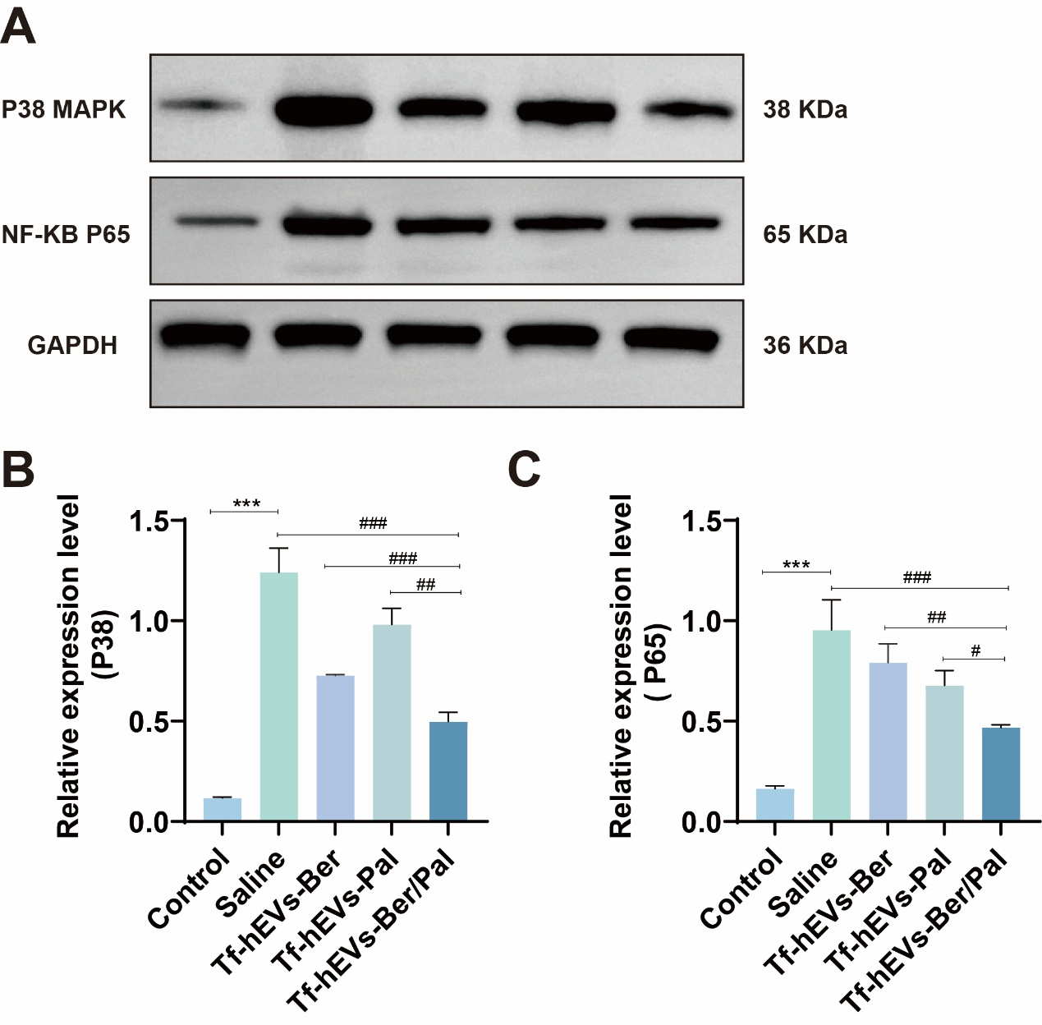
Fig.S4. Validation of regulatory pathways of Tf-hEVs-Ber/Pal. (A) Effects of TF-hEVs-Ber/Pal on NF-κB p65 expression, with (B) showing the quantitative analysis of p38 MAPK protein expression. (C) illustrates the effects of TF-hEVs-Ber/Pal on NF-κB p65 expression, while (D) presents the quantitative analysis of p38 MAPK protein expression. Data are presented as the mean ± SDs (n = 3). Statistical analysis was performed using Student’s t-test: ***P < 0.001. #P < 0.05, ##P < 0.01, ###P < 0.001.

